Student ID | 2328508
Programme | BSc (Hons) Health and Social Care
Module | Protecting and Supporting Families in Health and Care
Module Code | BMHP5021
Lecturer | Gillian Weaver
Internal Verifier | Chloe Harries
Assignment Title | Component 2: Written Report


Table of Contents
1. Introduction 1
2. Explanation of the Early Help System 1
3. Explanation of Multi-Agency Working 2
4. Evaluation of Local Authority Websites 3
4.1. Southwark Council 3
4.2. Leicester City / County (Leicester) 4
4.3. Norfolk County Council 4
5. Comparative Analysis: Strengths and Weaknesses Across Websites 5
6. Conclusion and Recommendations 6
References 7
Appendix 9

Introduction
This report examines the presentation and signposting of the Early Help system on three selected UK local authority websites: Southwark, Leicester (City and County), and Norfolk. Early Help is a key focus of safeguarding and family support, aiming to be proactive in preventing issues from developing into crises, which may necessitate statutory measures (Department for Education, 2022). This system is effective not only because of the quality of the services provided, but also due to the accessibility and comprehensibility of the information given to families in need of assistance (Selwyn, 2022). The report starts by providing a conceptual orientation of the Early Help system and the manner in which multi-agency provides the backbone of the system. All websites are then rated on their facts, readability, and accessibility, and they are critically compared to show the strong and weak areas of communication.

Explanation of the Early Help System
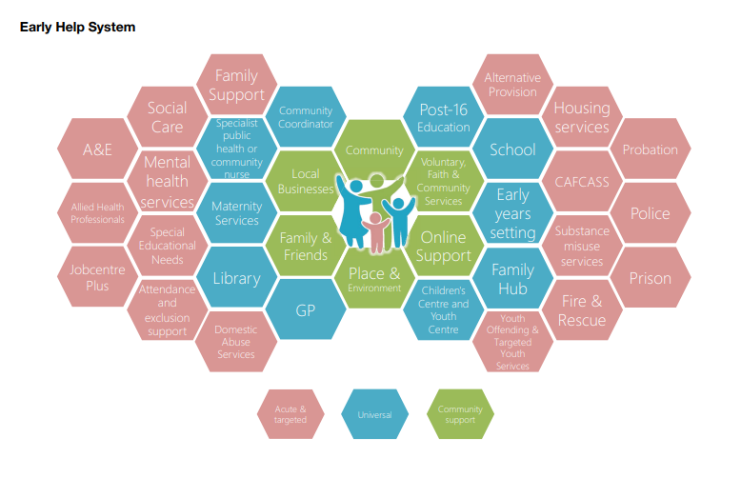
The Early Help system is intended to assist children, youth and families at the earliest stage of detecting problems, during the first signs, to avoid the necessity of statutory measures. As indicated in the Early Help System Guide (Department for Education, 2022), its goal is to provide prevention, early need identification, and commensurate intervention, and minimise the harm risks. The strategy emphasises the importance of addressing the issue before it becomes too late, when the welfare of children is at serious risk.
Figure 1: Early Help System (Source: Department for Education, 2022)

The Early Help system (Figure 1) operates within a continuous support system that may range from universal services to specific or intensive, depending on the outcome of the need assessment. This will be carried out using planned assessment instruments, such as the self- assessment (Figure 2) and plan, to determine strengths, needs, and risks, as well as a shared support plan. Next to it is the principle of meaningful engagement with families, ensuring that their voices are heard, getting consent, and promoting joint decisions. Periodic reviews of interventions are also essential for measuring progress and adjusting support as needed.
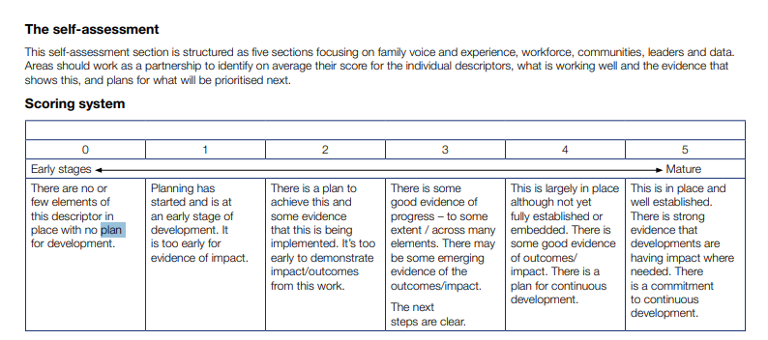
The 2023 guidance, Working Together to Safeguard Children (HM Government, 2023), restates that Early Help is not an individual service, but rather a shared strategy used by various agencies. The guidance highlights that early intervention is more effective than taking consequential action statutorily. This, therefore, concerns the presentation of Early Help services on local authorities' websites, as families need to access these services easily and struggle with understanding thresholds and the allocation of accountability for support resources.
Figure 2: Scoring System (Source: Department for Education, 2022)

Explanation of Multi-Agency Working
Multi-agency working can be defined as the strategic partnership between professionals and organisations in the areas of social services, health, education, policing, and the voluntary sector, to ensure holistic support for children and families (HM Government, 2023). It has its rationale in the fact that no single agency is capable of addressing the complex and varied requirements of families. Using the skills and resources of various organisations, a combined and joint approach is met, resulting in concerns about housing, health, education, and mental wellbeing being addressed in a marketing-like manner (Philpot et al., 2025).
The principles of shared governance and accountability, clear referral pathways, everyday language use, and standard thresholds are the pillars of effective multi-agency collaboration. There is a tendency to appoint a lead professional who will serve as the primary representative of the family and facilitate cooperation between various services to prevent duplication and fragmentation. Sharing information, with consent and in accordance with safeguarding guidelines, is a requirement to ensure continuity and efficient planning. This approach has a cultural foundation based on trust, respect, and role clarity, whereas team-around-the-family meetings represent a practical agreement to work together (HM Government, 2023).
According to the Working Together to Safeguard Children 2023 guidance (HM Government, 2023), Early Help is a shared responsibility between all services, not just children's social care. Local safeguarding partnerships have a role in entrenching multi-agency work into Early Help practice and securing their oversight (Owens and Lloyd, 2023). Local authority sites should thus ensure that this collaboration is visible in the sense that signposts to the various relevant agencies demystify roles and demonstrate how families can access multiple services through a single, integrated route.

Evaluation of Local Authority Websites

Southwark Council
The Early Help service by Southwark Council (2025) is presented through a special set of pages that distinguish between universal and targeted services. The About Early Help page (Southwark Council, 2024) outlines the essence of support and who it is available to. In contrast, the Extra Early Help page (Southwark Council, 2024a) provides more detailed information about targeted intervention efforts, including parenting support, education inclusion, and mental health support. Children under five years are also taken care of in the Children and Family Centres, further strengthening the argument for putting early years support within the broader system (Southwark Council, 2025a). Referral processes are clearly identified and outlined using downloadable forms, a charting of the procedure, and furnished with precise contact details, along with a publicly available schedule listing of the parenting programme. Navigation is generally fair, but the use of PDFs and Word files restricts accessibility, particularly for mobile users. The mixed emphasis on professionalism and parent-friendly information makes it more balanced; however, the site's format and outdated pages, which require users to scroll through different fragments, detract from the quantified response. The greatest strengths of the Southwark service are that it is very open in its referral process and that it has effectively integrated mental health as part of Early Help, although its design could be simplified.

Leicester City / County (Leicester)
Leicester City Council (2024) has a straightforward method, as it provides a prominent Early Help landing page with quick links to its offer, referral advice, and help specifically tailored for parents and carers. The Early Help Offer page outlines the service domains of the council, including family support services, early years engagement, youth work services, and education welfare services (Leicestershire County Council, 2024a). The section referred to as the referral is very entertaining, displaying thresholds, consent, and the review procedure, while also promoting both self-referral and the professional route. The Multi-Agency Referral Form is adequate in accordance with national practice, and the Duty and Advice Service has a 24/7 point of contact, which enhances accessibility (Leicestershire County Council, 2024b). The Family Help equivalent service provided to the county, which is named Family Help, demonstrates integration at the broader level but may confuse those who do not understand the distinction between the city and the county (Leicestershire County Council, 2024c). The Leicester site is generally well-planned, with logical navigation and easy points of contact; however, the balance between available strategic documents and enabling ease of use could have been improved.

Norfolk County Council
Norfolk County Council (2024) contextualises Early Help within a broader framework of safeguarding, presenting it as a strategy supported by the Norfolk Safeguarding Children Partnership. The Early Childhood and Family Service serves as the vehicle for operations related to the early years, and the Family Hubs initiative is being integrated into both health, parenting, and community sphere approaches (Norfolk County Council, 2025). There is a great emphasis on professional users through advice on plans and policy documentation, as well as family access to materials such as the Family Support Process leaflet. The information is being spread out on many different platforms, though, with the council, the NSCP, and the Just One Norfolk websites (Norfolk, 2025), such that the route is no longer traversed so effortlessly as it was once on the council site. When referring, the contact information is given, but referral paths are not as clear as in other councils; instead, they are based on professional guidance. Emphasis has been placed on strategic coherence and multi-agency practice, which is commendable, though the absence of a single and simple referral system impedes the effectiveness of families. The website of Norfolk proves to be more devoted to the concept of partnership working, though it falls short of the clarity and the ability to reach the general population.

Comparative Analysis: Strengths and Weaknesses Across Websites
The analysis shows the variation among the three local authority websites in the presentation of Early Help and web-based family support services. Southwark is primarily a utility usage community with information systemised to emphasise clarity on the groups of families visiting it first to seek help. The stratified concept, which differentiates between the universal services and the targeted services, also aids the families to know the degree of services they may obtain based on the degree of stratification. On the contrary, Leicester is remarkable for the transparency of the procedures. The clear description of the referral and assessment processes, as well as the existence of multiple access points to referral, such as self-referral and professional referral, is an expression of a systematic and non-discriminatory strategy. Well-structured navigation lends credibility to this procedural clarity, meaning the user can find the content of interest with minimal exposure to redundant complexities. The overview of Early Help within the framework of the safeguarding partnership system offered by Norfolk is handy to professionals serving in a multi-agency environment. Although this focus provides a sense of strategic consistency and is portrayed as being within the statutory guidance on safeguarding, it may restrict service accessibility in cases where the family lacks professionalism or where service provision lacks centrality.
Table 1 (Appendix) provides a comparative summary of the strengths and weaknesses of the three websites, including discrepancies in explaining what Early Help is and how to access it, whether the sites focus on multi-agency provision, and the support options demonstrated by the three websites for families. As Table 1 (Appendix) demonstrates, the essence of the advantage of the Southwark area is accessibility, applied approach, the Leicester key characteristic is the rigidity of processes and inclusive referral system, and the Norfolk key characteristic that is applied to the depth of the resources of partnership, but has a relative weakness in the convenient access of the program by the masses.

Conclusion and Recommendations
Early Help signposting in the case of Leicester City Council is the most accessible and least complicated of the three discussed local authorities. The effectiveness of its definitions, a variety of referral routes (including self-referral), and the presence of a 24-hour duty advice line make it a structure that is both transparent and comprehensive. The site is well-organised for easy navigation, with quick links that are readily available, and the steps of location, assessment, and review are clearly visualised. Such a step-by-step process gives families a sense of direction immediately and an idea of certainty that support can be availed of without throwing them through needless hurdles. Southwark is the next in line and highly supportive in a practical orientation, as evidenced by the information, parenting courses schedules, and its visible link to mental health services, including CAMHS. Complementing ample resources related to safeguarding partnerships and professional support, Norfolk offers less user-friendly sections that face the public, and instead, has disintegrated referral services, which can discourage those families that might be unsure of the technical vocabulary used. As Table 1 (Appendix) shows, the core advantage of Southwark is accessibility, applied approach, Leicester is characterised by the rigidity of its processes and inclusive referral system, and Norfolk stands out through the dimension of the depth of its partnership resources, but with a relative lapse in convenient access to the program by the masses.
Three key recommendations are proposed to enhance overall effectiveness and accessibility. To start with, the introduction of a standard and easy-to-use online referral portal is necessary (Cope et al., 2023), as families need to access support via a well-furnished web interface instead of using numerous documents or browsing outside websites. Second, both authorities should have plain-language landing pages that define Early Help using everyday language, and offer frequently asked questions (FAQs) or easy-to-understand graphics that avoid the use of technical descriptions (Richardson, Howarth and Kim, 2022). Third, transparency might be enhanced with the help of an integrated service directory or interactive map that would enable the family to find local centres, parenting courses, or mental health services within seconds. All of these improvements would help to make the Early Help presentation more coherent and family-friendly.

References
Cope, H., Lincoln‐Boyea, B., Gwaltney, A.Y., Biesecker, B.B., Moultrie, R., Alexander, A.A., King, N.M., Check, J., Corbo, A., Tzeng, J. and Porter, K.A. (2023). Use of a web‐based portal to return normal individual research results in Early Check: Exploring user behaviors and attitudes. Clinical Genetics, 103(6), pp.672-680.
Department for Education (2022). Early Help System Guide: A toolkit to assist local strategic partnerships responsible for their Early Help System. [online] Available at: https://assets.publishing.service.gov.uk/media/628de13be90e071f5f7e1bd2/Early_Help_System_Guide.pdf [Accessed 3 Oct. 2025].
HM Government (2023). Working Together to Safeguard Children 2023- A guide to multi-agency working to help, protect and promote the welfare of children. [online] HM Government, pp.1–168. Available at: https://assets.publishing.service.gov.uk/media/669e7501ab418ab055592a7b/Working_together_to_safeguard_children_2023.pdf [Accessed 3 Oct. 2025].
Leicestershire County Council (2024). Leicestershire County Council | Serving the people of Leicestershire. [online] Available at: https://www.leicestershire.gov.uk/ [Accessed 3 Oct. 2025].
Leicestershire County Council (2024a). Early Help | Leicestershire County Council Professional Services Portal. [online] Available at: https://resources.leicestershire.gov.uk/education-and-children/child-protection-and-safeguarding/early-help [Accessed 3 Oct. 2025].
Leicestershire County Council (2024b). Multi-Agency Referral Form for Early Help and Social Care services (MARF) | Leicestershire County Council Professional Services Portal. [online] Available at: https://resources.leicestershire.gov.uk/education-and-children/child-protection-and-safeguarding/multi-agency-referral-form-for-early-help-and-social-care-services-marf [Accessed 3 Oct. 2025].
Leicestershire County Council (2024c). Help for children and families | Leicestershire County Council. [online] Available at: https://www.leicestershire.gov.uk/education-and-children/social-care-and-supporting-families/help-for-children-and-families [Accessed 3 Oct. 2025].
Norfolk County Council (2024). Home - Norfolk County Council. [online] www.norfolk.gov.uk. Available at: https://www.norfolk.gov.uk/ [Accessed 3 Oct. 2025].
Norfolk County Council (2025). Home - Norfolk Safeguarding Children Partnership. [online] Available at: https://norfolklscp.org.uk/ [Accessed 3 Oct. 2025].
Norfolk, J.O. (2025). Safeguarding. [online] Just One Norfolk. Available at: https://www.justonenorfolk.nhs.uk/our-services/safeguarding/ [Accessed 3 Oct. 2025].
Owens, R. and Lloyd, J. (2023). From behaviour-based to ecological: Multi-agency partnership responses to extra-familial harm. Journal of Social Work, 23(4), pp.741-760.
Philpot, R., Levine, M., Betts, C., Nelson, M., Duck, E. and Power, N. (2025). Observing interoperability: a behavioural framework and analysis of multi-agency interactions in the UK emergency services. Safety Science, 191, p.106947.
Richardson, J., Howarth, H. and Kim, J. (2022). Developing a heuristic tool for evaluation of mobility as a service (MaaS) mobile application interfaces. Contemporary ergonomics and human factors.
Selwyn, R. (2022). Early help for children and families. Paediatrics and Child Health, 32(3), 81-87.
Southwark Council (2024). About early help | Southwark Council. [online] Available at: https://www.southwark.gov.uk/children-and-families/childrens-social-care/early-help/about-early-help [Accessed 3 Oct. 2025].
Southwark Council (2024a). Extra early help | Southwark Council. [online] Available at: https://www.southwark.gov.uk/children-and-families/childrens-social-care/early-help/extra-early-help [Accessed 3 Oct. 2025].
Southwark Council (2025). [online] Southwark.gov.uk. Available at: https://www.southwark.gov.uk/ [Accessed 3 Oct. 2025].
Southwark Council (2025a). Children & Family hubs – support and locations | Southwark Council. [online] Available at: https://www.southwark.gov.uk/children-young-people-and-families/children-family-hubs/children-family-hubs-support-and-locations [Accessed 3 Oct. 2025].

‌

‌

‌

Appendix
Table 1: Comparative strengths and weaknesses of local authority websites in communicating Early Help information
Criterion | Southwark | Leicester | Norfolk
Clarity of Early Help definition | Good, layered universal vs targeted | Strong and clear | Conceptual, but somewhat abstract
Public-facing referral route / form | Referral form, contact email, telephone | MARF, self-referral, duty line | No unified form, contact numbers and email
Accessibility / navigation | Accessible, some PDF reliance | Well-structured, quick links | Dispersed across subdomains
Multi-agency / partner information | Partner details, mental health integration | Some partner strategy documents | Strong NSCP partnership focus
Support service detail | Parenting programmes, course schedules | Broad domains of family support | Limited early years focus
Professional support / tools | Moderate, referral explained | Referral tools and strategy | Extensive professional guidance
Timeliness / currency | Some dated pages | Up-to-date strategy documents | Policy available, some dated

