
Module Name: Digital Skills for Personal Development and Business Growth
Module Code: BMSW4008
Assignment Title: Portfolio
Student Name: Larisa-Bianca Calistru
Student Number: 2521828
Lecturer: Scott James
Deadline: 16th March 2026, 09:00am

Word counted: 1715

AI Acknowledgement Statement:
Examples of AI statements if you have used AI
I acknowledge the use of Claude AI (https://claude.ai) in March 2026, to check my work using the prompt(s):
1. Please explain the meaning of the following academic terms and requirements in simple English.
1. Please check the following text for readability, grammar and syntax.
I confirm that I have not presented any AI generated text as my own work. I confirm that I have copies of my drafts, notes, and other resources I used before, and after the use of AI tools which I may be asked to provide in evidence.

Contents
Task 1: Assessment of Digital Skills (700 Words) 4
Introduction: Importance of Digital Skills 4
Overview of the JISC Digital Capability Tool 4
Summary of JISC Results 4
Strengths in Digital Skills 5
Areas for Improvement 5
Action Plan Using SMART Goals 5
Reflection and Conclusion 6
Task 1 References (Minimum 5) 6
Task 2: LinkedIn Learning Certificates – Office 365 7
Outlook Essential Training (Microsoft 365) 7
Word Essential Training (Microsoft 365) 8
Excel Essential Training (Microsoft 365) 8
PowerPoint Essential Training (Microsoft 365) 9
Task 3: Relevance and Importance of Microsoft Excel (1,000 Words) 10
Introduction 11
Uses of Microsoft Excel 11
Data Analysis 11
Budgeting and Financial Management 11
Reporting and Decision-Making 12
Practical Spreadsheet Task 12
Reflection and Conclusion 13
Task 3 References (Minimum 5) 13
Task 4: Reflective Presentation Summary (5 Minutes) 15
Overview of Presentation Content 15
Learning and Skill Development 16
Links to Task 1 16
Links to Task 2 17
Links to Task 3 18
Application to Studies and Career 18
Task 3 References (Minimum 5) 18

Task 1: Assessment of Digital Skills (700 Words)

Introduction: Importance of Digital Skills
Digital skills are the abilities to use online tools, digital devices and online platforms. They are important because in this era is hard to study or to find a good job without digital skills. At university, at work, and even at home we need technology, digital skills help us to keep in touch with costumers via email, via teams, we can expend our portfolio through social media platform or keep the team up to date with a good PowerPoint presentation. I want to start my own business in the future, so I know these skills matter a lot. Stofkova et al. (2022) explain that digital skills help people succeed in the market and communicate in the modern world. Abrosima (2020) also says that students must build digital skills to be ready for work.

Overview of the JISC Digital Capability Tool
JISC Digital Capability Tool is an online self-assessment that helps students see their digital strengths and weaknesses (Jisc, 2023)
I completed the JISC Digital capability Tool in my first week. I scanned a QR code and answered a few questions about how confident I feel using different tools. After finishing, I received a graph showing my results. I felt they were honest and accurate. All matched how I really feel about my digital skills.

Summary of JISC Results
My results showed a few areas that I need to improve but there are a few good. My best score was digital communication, where I reached ‘Proficient’. And other areas such as digital proficiency, media literacy, digital wellbeing, and digital skills for work, were rated ‘capable’. However, information literacy, data literacy, digital collaboration, and problem solving were all rated ‘developing’. Coskunserce and Aydogdu (2022) say that lots of students do not have strong digital skills in all areas when they start. This made me feel less worried about my weaker results.
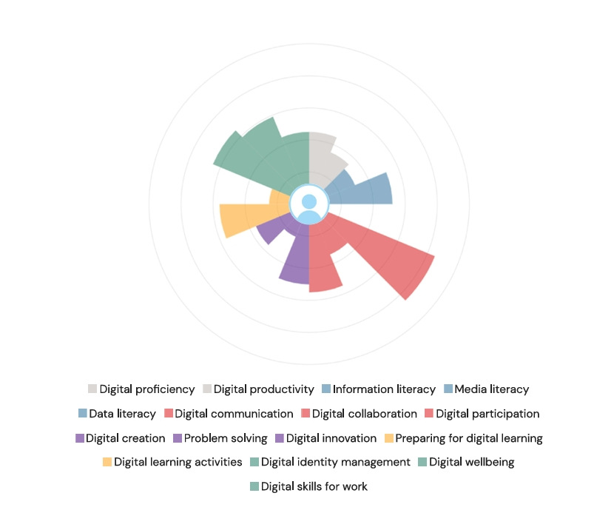

Strengths in Digital Skills
One of my strongest areas is digital communication. But even so, I did not know so well how to use Microsoft Outlook but during the lesson everything went clear to me. Now I use it almost every day to email my lecturers. I also learned how to set up an email signature. Mena-Guacas et al. (2024) found that students who are confident in digital communication engage better with their lectures and classmates. I feel comfortable use digital skills communication out for any information I need.
My second strength is media literacy, rated as ‘capable’. This means I can look at online content and judge if is real or not. (Jisc, 2023) I use social media regurlarly and I am usually aware with information spreads very fast, and I know that not everything is true. Abrosimova (2020) highlights that students who think critically about online information are better prepared for academic study. I feel this skill help me avoid using irrelevant information or share something false.

Areas for Improvement
First area to improve: Information literacy was rated ‘Developing’. This is about knowing how to search for reliable information online. I often find difficult and time-consuming to locate the right information quickly. Sometimes I get lost in search results. Abrosimova (2020) notes that many students lack confidence in finding and evaluating digital information effectively. I know I need to improve this, and I will because is important both for my studies and for making good decisions in my future business.
Second area to improve: data literacy was also rated ‘Developing’. When I started the module my Excel skills were very basic. I only knew how to make a simple table but did not understand formulas. Stofkova et al. (2022) said that people without data skills face real challenges in their careers. Since starting this module, I already feel more confident with Excel, and I know these skills will help me manage my future business finance.

Action Plan Using SMART Goals
Using SMART Goal to make an action plan to improve my weaker area: I will improve my ability to search for and find reliable information online using tools such as Google Scholar and the UWTSD online library. I will practise searching online sources until I will be able to find relevant information quickly and confident. Google Scholar and the UWTSD online library are free and accessible from home. Improve my ability in finding information online is an essential digital skill for my studies and for my future business. I will practise searching online 3 times pe week for the next four weeks.
Second goal I need to improve is Excel. I will improve my Excel skills, including formulas, charts, and data tables. I will complete the LinkedIn Excel course and create a spreadsheet for task 3. LinkedIn Learning is free through my university student email, and I can study at home. Excel is essential for business management and is tested in this module. I will finish by 16th March 2026.

Reflection and Conclusion
This module has changed how I see my digital skills. Before starting, I could do basic things in Word, Excel, and PowerPoint. Now I am much more confident. I learned Outlook and I enjoyed, also Teams Meetings was a lesson that I love it so much. I also started using HWB for first time in my life, which was hard to me, but I am getting better. I always want to try new tools and improve my digital skills. Mena-Guacas et al. (2024) say that confident student engages more with digital tools. I believe that is true for me. My confidence is growing every week, and I know will help me in my career.

Task 1 References (Minimum 5)
Abrosima, G.A (2020) ‘Digital Literacy and Digital Skills in University Study’, International Journal of Higher Education, 9(8), pp. 52-58. Available at: https://doi.org/10.5430/ijhe.v9n8p52
Coskunserce, O. and Aydogdu, S. (2022) ‘Investigating the digital skills of undergraduate students in terms of various variables’, Journal of Educational Technology and Online Learning, 5(4), pp. 1219-1237. Available at: https://doi.org/10.31681/jetol.1151461
Jisc (2023) Digital Capability Framework. Available at: https://www.jisc.ac.uk/digital-capability
Mena-Guacas, A.F., Meza-Morales, J.A., Fernandez, E. and Lopez-Meneses, E. (2024) ‘Digital Collaboration in Higher Education: A Study of Digital Skills and Collaborative Attitudes in Students from Diverse Universities’, Education Sciences, 14(1), p. 36. Available at: https://doi.org/10.3390/educsci140036
Stofkova, J., Poliakova, A., Stofkova, K.R., Malega, P., Krejnus, M., Binasova, V. and Daneshjo, N. (2022) ‘Digital Skills as a Significant Factor of Human Resources Development’, Sustainability, 14(20), p. 13117. Available at: https://doi.org/10.3390/su142013117

Task 2: LinkedIn Learning Certificates – Office 365

Outlook Essential Training (Microsoft 365)
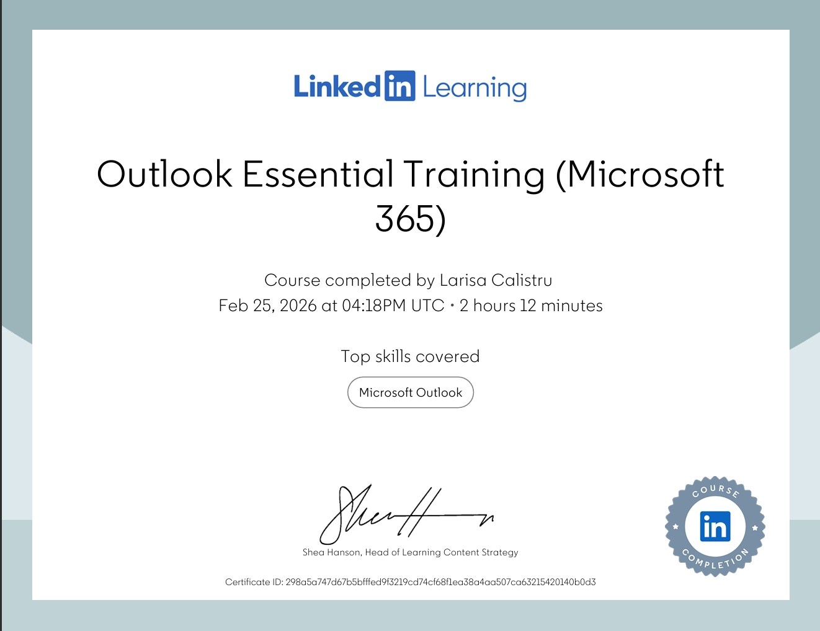

Word Essential Training (Microsoft 365)

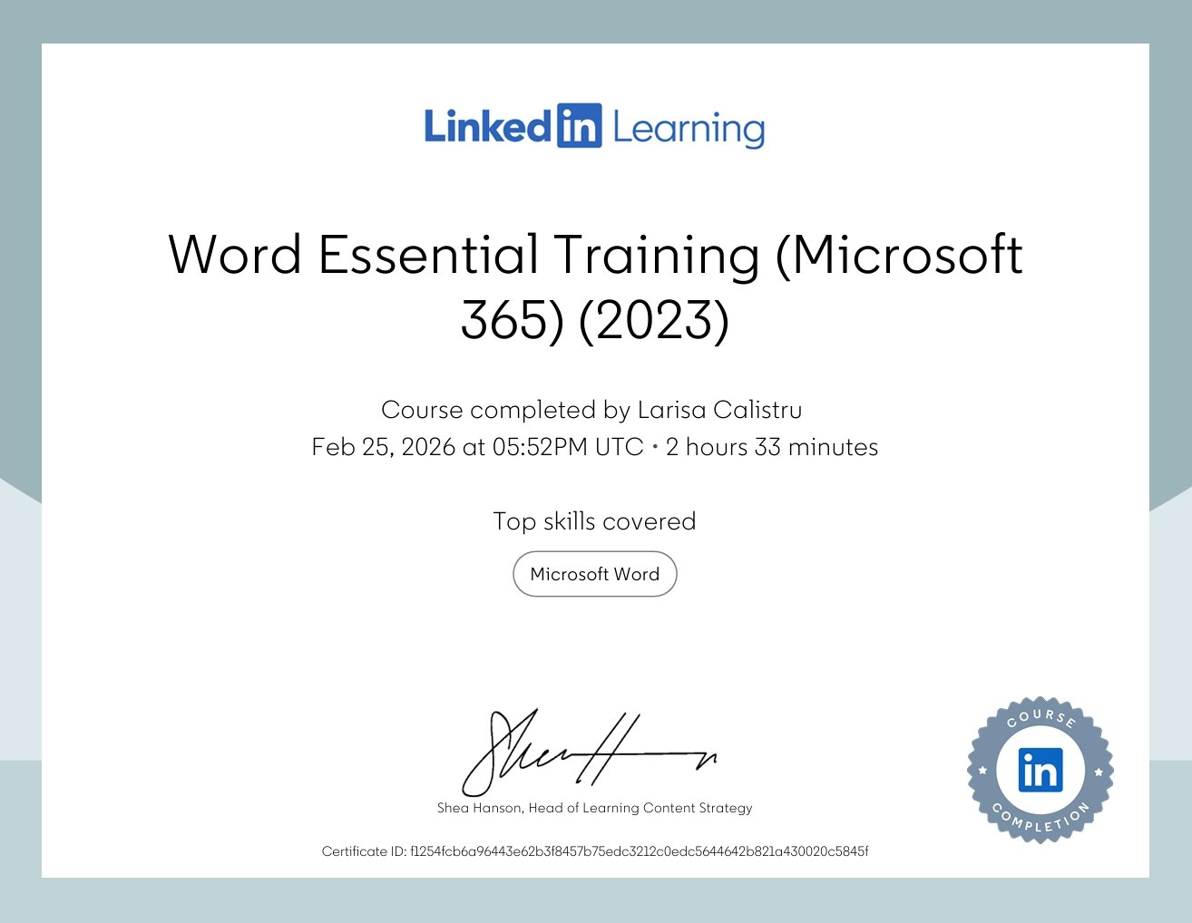

Excel Essential Training (Microsoft 365)

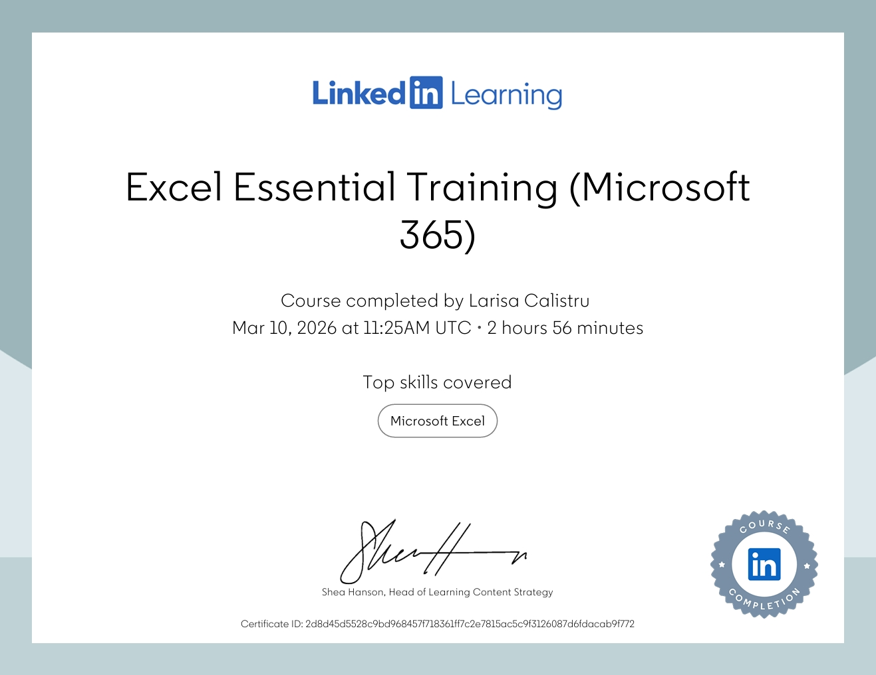

PowerPoint Essential Training (Microsoft 365)

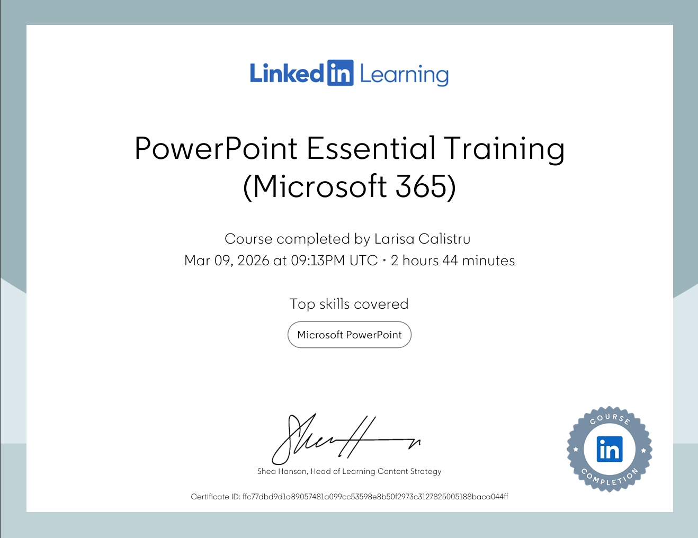

Task 3: Relevance and Importance of Microsoft Excel

Introduction
Microsoft Excel is a digital program from Office 365. It used every single day by people to organise number, keep a stock evidence, do calculations, and make charts. Excel is used in schools, businesses, and home. It is one of the most popular tools in the world. It is used for many purposes, from analysing data and managing budgets to creating reports and supporting important decisions. Excel is used by over 1,3 million small and medium companies because it is accurate, easy to use, and affordable (Bakir, Salazar and Babb ,2025) Introduce Microsoft Excel and explain its relevance in education, business, and everyday life. This shows that Excel is not just a school tool. It is a real skill that matters in work and life.

Uses of Microsoft Excel

Data Analysis
Excel is very useful for analysing data. In a study about a student-managed café, managers used Excel to clean sales data, find patterns, and make better decisions about how to run the café (Jacobs, Robinson and DePaolo, 2016). This evidence shows that Excel can turn messy numbers into useful information, even for people who are not experts. Function like =SUM() and =AVERAGE() makes everything easy to calculate totals and find average quickly. With Excel can also sort data from highest to lowest, filter data to show only what you need, and use charts to present result visual. Charts and tables in Excel also help students understand data and present it clearly to others (Grenci, 2022). This means that Excel is a powerful tool for anyone who need to work with numbers and they do not want to do mistakes.

Budgeting and Financial Management
A small catering business in Indonesia used Excel to record income and spending, and after doing this properly, the owners could make much better financial decision (Sihotang, Nita and Budiana, 2025). This shows Excel helps people to stay in control of their money. For example, a household cand use Excel to record monthly income from two wages, and list all fixed expenses such as rent, council tax, and utilities. Using =SUM() Excel can calculate the total automatically. Also, can subtracts expenses from income to show how much money is left each month. This makes it very easy to see if a household is spending too much or they have enough to save some money. Student who tracks their fixed expenses, flexible expenses, and saving are better at managing their finances (Jumawan-Powao et al., 2024).Without a tool like Excel, can be very difficult to keep on track of all these numbers accurate every month. Excel is very helpful for budgeting and managing money. This makes Excel a very practical tools for anyone who wants to manage their budget well.

Reporting and Decision-Making
Excel helps people create reports and make good decisions. Research found that 83% of finance and accounting student said that spreadsheet skills are essential for their job (Januszewski et al., 2024). This shows that excel is very useful even in school, workplace, or at home. For example, a business owner can use a chart in Excel to see which month had the lowest income. A manager can also use a data table to compare different months and identify areas where costs are too high. When data is shows in chart or a table, it is much easier to understand, and decision become easier to make. This is why Excel is used not just for recording numbers but also for planning and strategy. People with strong Excel skills get better jobs and higher salaries (Ali and Fitzpatrick, 2022). This means that learning Excel skills can have a real positive impact on a person’s future career or business, and help to make informed and confident decisions.

Practical Spreadsheet Task
Purpose of a household income and expenditure spreadsheet is to manage better family budget. A household income and expenditure spreadsheet was created to show how Excel works in a real situation. The spreadsheet covers a full year and includes two income sources, Wage 1 and Wage 2, with totals calculates using =SUM(). In spreadsheet the expenditure section includes ten categories such as rent, council tax, utilities, tv license and petrol, also totalled using =SUM(). Disposable income was calculated using =SUM(B4-B17), which subtracts total expenses from total income. The data shows that average disposable income is about £2,720, average spending is around £2,289, and average disposable income is about £431. June was the most difficult month with only £135 left, while July had the most with £845. A bar chart was created to show these changes visually each month, making it easy to see which month had more financial pressure. This type of spreadsheet can be used by anyone who wants to understand their financial situation better. It shows clearly where money is being spent and helps identify areas where saving can be made each month. This practical example shows exactly how Excel can be used to manage and understand personal finances clearly.

Reflection and Conclusion
Before starting this module, I did not know so much about Excel. I could make a simple table, but I did not know how to apply a formula or charts. After I practised in class and completed the LinkedIn Learning Excel Essential Training course, I fell much more confident. Now I know how to use =SUM(), create a bar chart. I also learned that Excel is not just about numbers. It is about understanding financial situation and making better choices. Excel is very important for my future because I want to open my own business, and managing money carefully will be essential. A business owner needs to know exactly how much money is coming and going every month. Without this information, it is very difficult to make good decisions or plan. Student with better Excel skills perform better in jobs (Bakir, Salazar and Babb, 2025). This makes me believe that learning Excel skills in this module are not just useful for my assignments, they will be use for the rest of my life for in business and my family tracking household.

Task 3 References
Ali, S.I. and Fitzpatrick, B.D. (2022) ‘Microsoft Excel expert certification MO-201: results, analysis and key tips to succeed’, Holistica Journal of Business and Public Administration, 13(2), pp. 1-8. Available at: https://doi.org/10.2478/hjbpa-2022-0011
Bakir, N., Salazar, L.R. and Babb, J. (2025) ‘Foundations of practical analytic skills: an examination of undergraduate business student’ self-efficacy using Excel’, Journal of Information Systems Education, 36(3), pp. 257-276. Available at: https://doi.org/10.62273/BOYG3545
Grenci, R.T. (2022) ‘Introducing business analytics in context: an Excel project to analyze product and sales data for inventory purchase decisions’, Decision Sciences Journal of Innovative Education, 20, pp. 190-200. Available at: https://doi.org/10.111/dsji.12277
Jacobs, A., Robinson, D.F. and DePaolo, C.A (2016) ‘Using Excel to make strategic managerial decisions’, Journal of Information Systems Education, 27(2), pp. 93-98. Available at: https://aisel.aisnet.org/jise/vol27/iss2/6
Januszewski, A., Kujawski, J., Buchalska-Sugajska, N. and Spiewak, J. (2024) ‘Digital competencies of finance and accounting students’, Procedia Computer Science, 246, pp. 4481-4491. Available at: https://doi.org/10.1016/j.procs.2024.09.298
Jumawan-Powao, A.R., Tubat, K.T., Cellero, R.C.L., Alibangbang, A.D.C and Capilitan, M.K.T. (2024) ‘Family income in relation to budgeting of accounting students in a university’. International Journal of Multidisciplinary: Applied Business and Education Research, 5(8), pp. 2973-2984. Available at: https://doi.org/10.11954/ijmaber.05.08.03
Sihotang, E.T., Nita, R.A. and Budiana, K.M. (2025) ‘Excel-based assistance in financial management of micro-enterprises in the catering industry’, Journal of Community Service and Empowerment, 6(1), pp. 11-19. Available at: https://doi.org/10.22219/jcse.v6i1.37003

Task 4: Reflective Presentation Summary (5 Minutes)

Overview of Presentation Content
This presentation reflects on my learning journey throughout the Digital Skills module (BMSW4008). It covers how my digital skills have developed, how I have used them, and how I plan to apply them in my future studies and career. The presentation links to Task 1, Task 2 and Task 3.
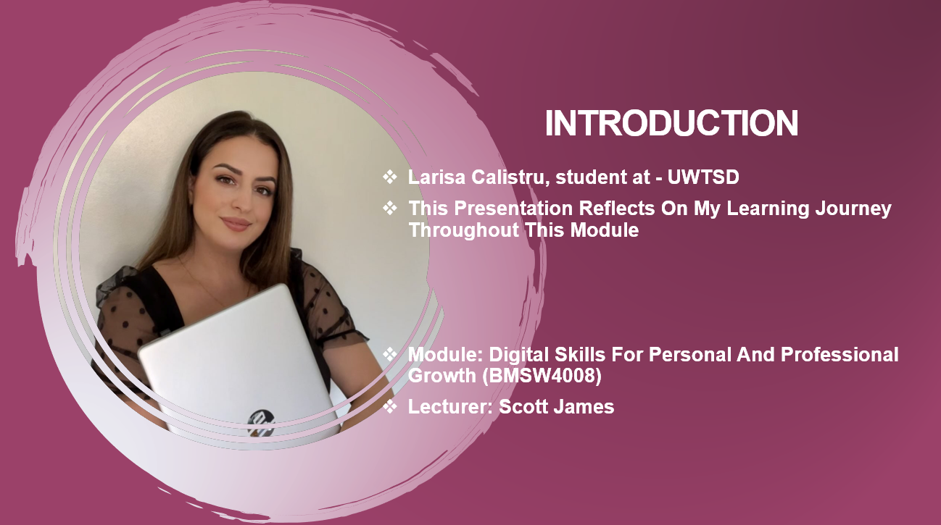

Learning and Skill Development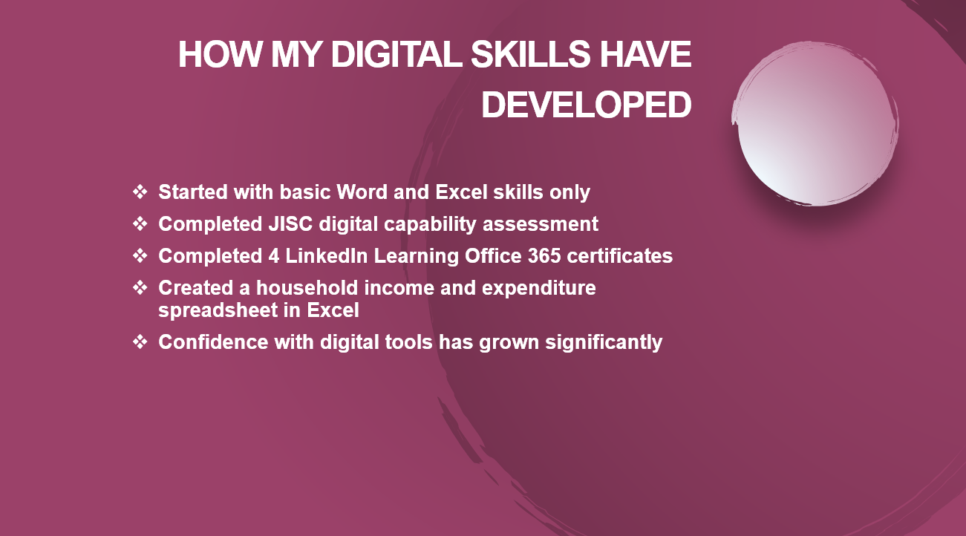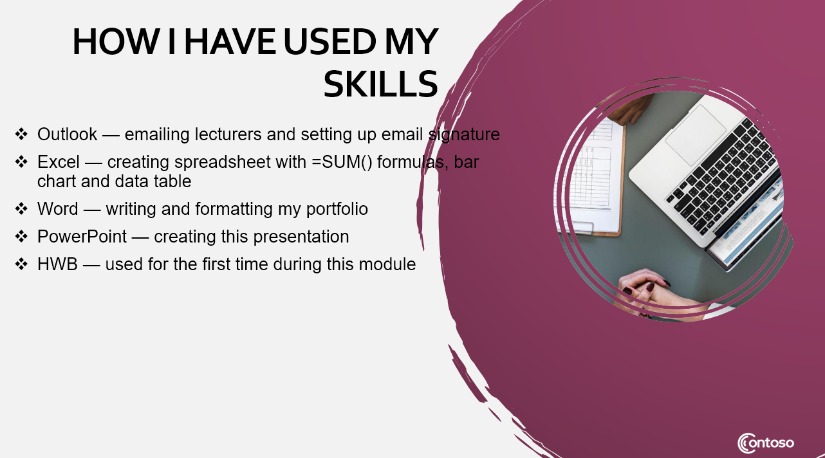

Links to Task 1
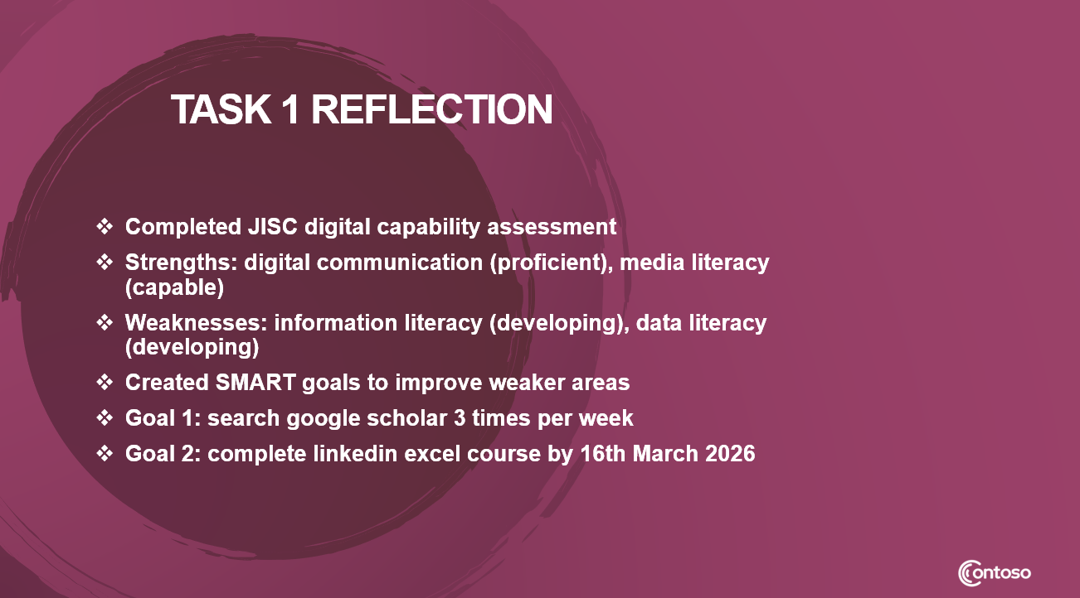

Links to Task 2
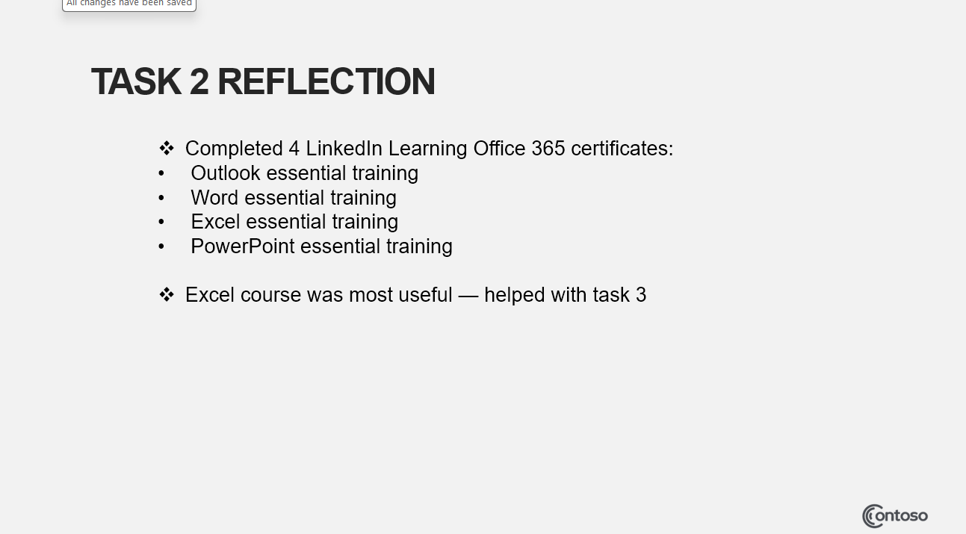

Links to Task 3
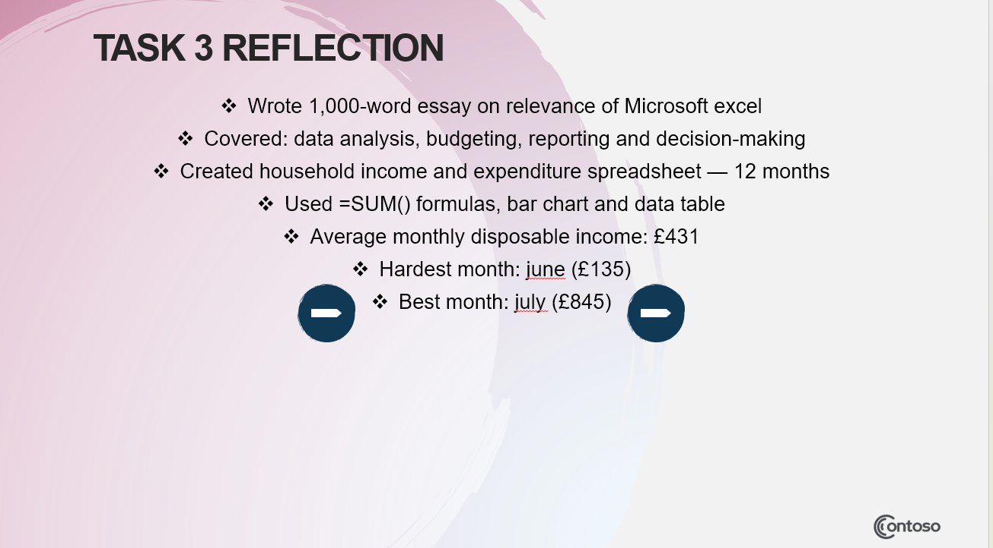

Application to Studies and Career
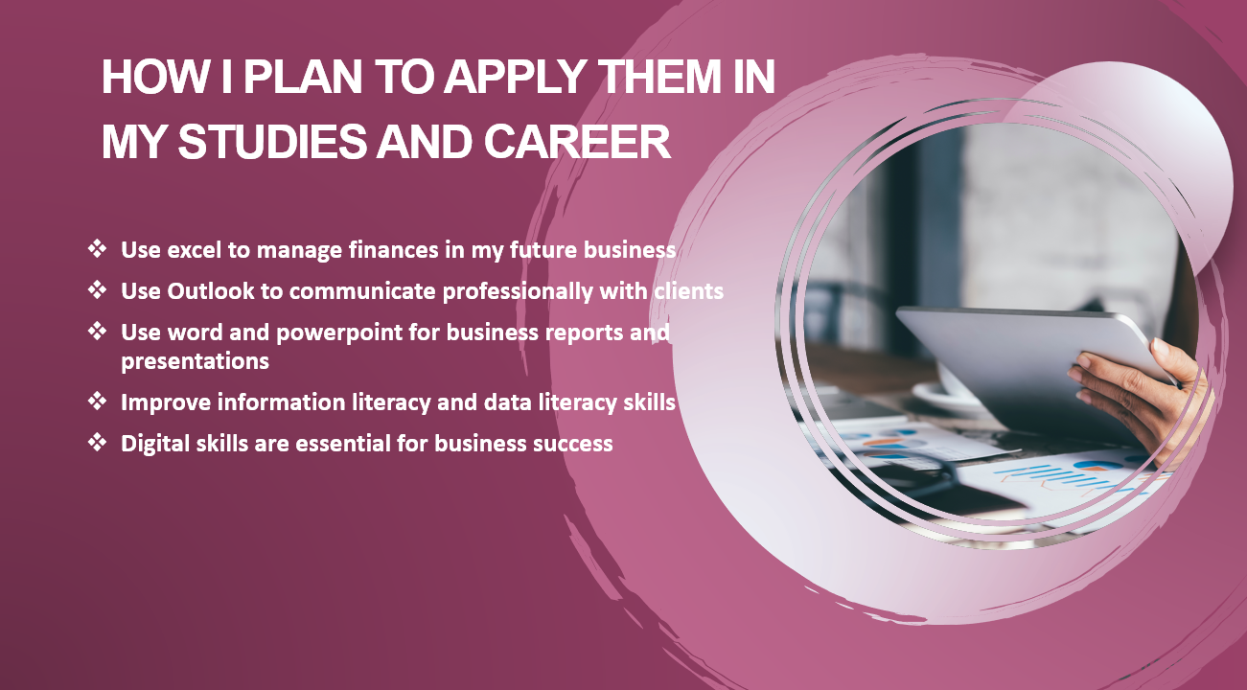

Task 3 References
Abrosimova, G.A. (2020) ‘Digital literacy and Digital skills in university study’, International Journal of Higher Education, 9(8), pp. 52-58. Available at: https://doi.org/10.5430/ijhe.v9n8p52
Bakir, N., Salazar, L.R. and Babb, J. (2025) ‘Foundations of practical analytic skills: an examination of undergraduate business students’ self-efficacy using Excel’, Journal of Information Systems Education, 36(3), pp. 257-276. Available at: https://doi.org/10.62273/BOYG3545
Jisc (2023) Digital Capability Framework. Available at: https://www.jisc.ac.uk/digital-capatibily
Sihotang, E.T., Nita, R.A and Budiana, K.M. (2025) ‘Excel-Based assistance in financial management of micro-enterprises in the catering industry’, Journal of Community Service and Empowerment, 6(1), pp. 11-19. Available at: https://doi.org/10.22219/jcse.v6il.37003
Stofkova, J., Poliakova, A., Stofkova, K.R., Malega, P., Krejnus, M., Binasova, V. and Daneshjo, N. (2022) ‘Digital skills as a significant factor of human resources development’, Sustainability, 14(20), p. 13117. Available at: https://doi.org/10.3390/su142013117

