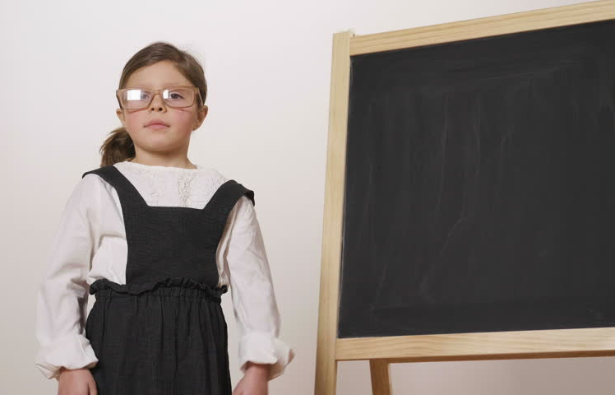
Entrepreneurial Opportunities in Education

Daria Bajkowska
Image: https://www.shutterstock.com/video/clip-34626133-stock-footage-a-happy-girl-dressed-as-a-teacher-in-front-of-a-small-blackboard-holds-her-arms-folded-and-smiles.html
CONTENTS

What is Entrepreneurship?………………………………….. pg. 3
How it links to education?……………………………………pg. 4
What does entrepreneurship give us?……………………….pg. 4
My proposal for the Entrepreneurial Project………………..pg. 5
Costs…………………………………………………………….pg. 7
The Project Schedule………………………………….……….pg. 8
Conclusion………………………………………………..……pg. 10
Appendices…………………………………………………….pg. 11
References………………………………………………………pg.

Introduction
Entrepreneurship can be a misunderstood concept. Many of us instinctively run towards the stereotypical ideas about what entrepreneurship is such as starting up own business, being a freelancer, or ability to convert a small sum of money into a much bigger amount and becoming rich (in financial terms). As Love and Marriott (2006) say themselves is that entrepreneurship has many varying perspectives and interpretations and so it is a challenge to narrow it down to one standard definition. What many people are missing is that entrepreneurship is much more than that, in fact it is a highly sought after skill in today’s world. Entrepreneurship derived from a French word ENTREPRENDRE which means ‘to undertake’ and is often a word used in business. We are now realising that as global citizens of the 21st Century enterprise skills are useful to everyone therefore we should all learn how to use them. Enterprise is based on taking initiative, undertaking a project. The University of Aberdeen (2018) describes enterprise on their careers advice website as ‘a mindset and a set of skills which enable you to seize opportunities, be creative and develop problem skills’. Enterprise as a skill can certainly improve person’s employment prospects and influence their pay rate at work but it can also positively affect person’s everyday life. BBC GCSE Bitesize (2014) explains enterprise in simple terms: a skill of willingness to take risks, undertake new ventures, and taking initiative. Enterprise is inevitably directly linked into two other skills: creativity and invention/innovation. Naturally there are many other skills that can and are involved in entrepreneurship, for example problem solving, communication, persuasion, compromise, quick thinking etc. and that is what makes enterprise such a useful, valuable subject to teach at schools! … And this is where ‘Entrepreneurial Education’ comes in…

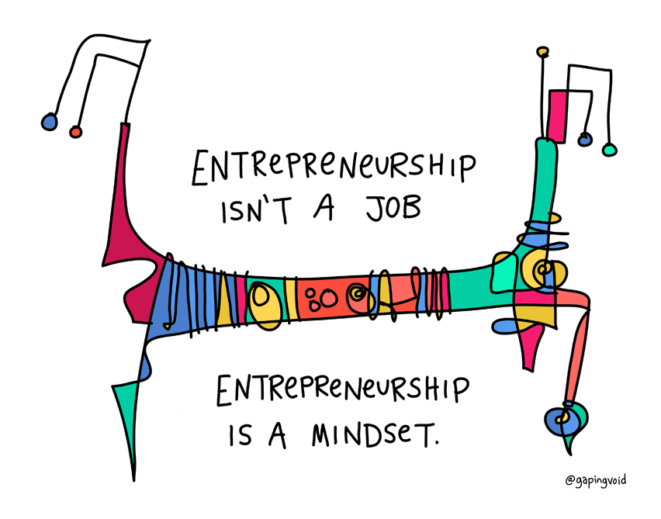
Image: https://www.gapingvoid.com/blog/2016/08/09/entrepreneurship-is-a-mindset/
Image: https://www.gapingvoid.com/blog/2016/08/09/entrepreneurship-is-a-mindset/
image: http://makambaonline.com/index.php/2017/06/28/22901/#.WrgTV2bMygQ

How it links to education?
Entrepreneurial Education is a fairly new concept that was introduced to schools, and so there are still many uncertainties surrounding it, such as: what is it exactly? How should teachers incorporate entrepreneurship education into the curriculum? how to grade it? How to do it in practice? Why is it relevant? Where can you get the teaching resources? Does it have to be included in the curriculum? When should we teach it, to what year groups? There are numerous guidance papers from OECD (Organisation for Economic Cooperation and Development) and the governing bodies ( Welsh Government) which clarify basic principles regarding the matter however there is one major challenge we are facing: schools are not officially required to provide entrepreneurship studies as they are not written into the current Welsh curriculum. That means that a school can choose either to incorporate it into their school lessons or not, and even when those lessons are incorporated the time spent on the subject each week/term, materials used, activities devised and teacher’s overall delivery of the subject is not monitored to ensure quality of teaching. It is up to each school individually to make what they want out of entrepreneurial education. This creates a barrier between our hopeful, young generations and their life success in the modern day society. As Dempster (2011) in Beckman (2011) states if we want our future generations to have the entrepreneurial skills then first we need to ensure our schools and teachers are indeed entrepreneurial themselves.

What does entrepreneurship give us?
Entrepreneurship is all about teaching children many useful skills and strengthening them by providing enough enterprise opportunities. Entrepreneurial education covers developments of KEY COMPETENCIES such as communication, people management, leadership, logical reasoning, personal development, transferable and technological skills. (Achtenhagen, 2013 )
One of the greatest possible reasons for running entrepreneurial education at schools is so we can freshen up the old-fashioned, outdated education system (schooling) which does not seem to do a particularly good job as it just is not relevant to societal and human needs within the 21st century. Putting a reviving spin on the current curriculum means we can integrate a more active, modern approach to learning within the tired subjects strictly timetabled into each day. It is no surprise that children learn through active play and by simply ‘doing’ as Dewey’s theory suggests. Entrepreneurial education involves plenty of hands-on activities to aid the learning process and that is why it is very relevant. (Claxton, 2008) One of the most useful kills of the 21st Century is thinking outside the box: coming up with alternative, unconventional, brave ideas. (Sanchez- Garcia, 2015) Through this process children’s confidence grows, they also learn how to put their ideas across while communicating with other team members. Social skills thrive during group activities. (Stokes, et al, 2010)Using creative skills to produce innovative ideas allows children to nurture their hidden talents, promote finding new interests and learning new information. (Rae, 2008)
Perseverance, self belief, self motivation are typical traits of an entrepreneurial mind. (Beckman, 2011) Our children need to learn that giving up is not an option and there are ways to go around challenges. One of the most promising developments that enterprise can offer is building and strengthening one’s character. As Martin Luther King Jr. once said ‘ Intelligence plus character - that is the goal of true education’. (in Claxton, 2008, pg. 115)
As well as promoting progression of skills enterprise can help societies establish social justice by providing opportunities for everyone and making people feel in control of their life and career which leads to happier people and that in turn improves the harmony and safety within society. (Sijde et al, 2008) Long - term enterprise also improves the economy. In addition entrepreneurship can support the Literacy and Numeracy Framework if done in a correct way. What is more is we can link IT, sciences, art, children’s philosophy, languages and sustainability to entrepreneurial education which means that we do not need to cut down on time we spend on core subjects to fit entrepreneurship into the curriculum. (When I grow Up, 2014)

I have worked at a local primary school for a year now and I believe that entrepreneurship is especially beneficial to children from less advantaged backgrounds although it is indeed beneficial to children from all socio-economic background. Entrepreneurship does not only improve thinking processes, enhances problem solving, communication, numeracy and even life skills such as choice making, consequence prediction, resourcefulness but also it gives children better chances of future work prospects whether though employment or starting up their own small businesses.(Sijde et al, 2008) This offers a way out of poverty, into a better, healthier, happier and more satisfying life. I watched many children develop greatly through getting involved in enterprise activities within the school. Based on such positive outcomes I propose another entrepreneurial opportunity for the school.

My proposal for the Entrepreneurial Project
The project I propose would be a week long ‘course’ on entrepreneurial education during one of the school terms. This means that instead of standard subject lessons during our timetabled time periods we would spend all of this time running the project while still incorporating some of the subjects within the project such as numeracy, environmental studies ( science), text type, arts and crafts. This would be a project for Key Stage 2 which includes Years 3, 4 ,5 and 6. In this portfolio I will discuss my plan of action only for my class - Year 4, as each teacher would devise it in their own way to produce goods to sell at the end of the entrepreneurial week during the school fate.
The way in which we usually start our entrepreneurial projects is by brainstorming ideas that children come up with, then refining those ideas narrowing it down to 3 most appealing options by democratic votes, then narrowing it down again to just one by voting again out of the final 3 options. This time would be no exception. For the purpose of this paper let’s say that most children voted for a handmade, recycled teddy bear idea. The idea brainstorming and votes would happen on the 1st day of the Project so that we all have enough time to collect materials needed for the production of the items as well as making a single pilot production of a teddy to make sure it is a feasible design.
The teddies would be made and stuffed out of unwanted/damaged clothes with would be collected by children within their neighbourhood and their own homes. The original idea was to use cotton as stuffing however as it is a school project we aim to keep the production costs to possible minimum and unfortunately cotton is just far too expensive in the quantities we needed it in. One of the first reasons for selecting cotton as stuffing is the fact cotton is a natural fibre and we want to make our teddies eco friendly as a kind gesture to mother Earth. As an alternative children would have to come up with a different way of filling the bears. Using nothing or cloths as stuffing as well as the outer layer of the teddy seems very simple and economic. For extra support and structure they could also use cardboard or paper for example to create pointy ears. Next task would be to run ‘market research’ . This would be done by walking around the school conducting a questionnaire to find out what the most popular choices are for toys and teddy characters. After finding out what the potential customers are interested in, the children would design their teddies/ soft toys. They would need to produce 3 designs, the first one being their initial idea, second one would be altered to eliminate any problems and challenges they might face while sawing the toys to achieve particular shapes. The third design would be their final draft. The next stage would be trying to predict any potential complications and how to avoid them. Another important task would be advertisement. Children would need to design posters to attract customers, with a catchy line ensuring poster exposure. Deciding on an appropriate item price would be based on another research activity, either involving computers or iPads. By establishing a common price point children could adjust their prices accordingly. Another marketing task for the pupils would be to create a newsletter type email advertising the teddy bears and the fate which would be sent out to all the parents as well as would be posted on our school website. Such tasks make children feel responsible, respected and trusted which makes them feel proud and it is a natural motivation booster to do the best they can. During the project we would also run economy and business lessons to teach children the basic glossary as well as to get them used to calculating costs, profits, losses. For time management children would need to design a ‘rota’ to map out who works at the stall selling teddies and when.

Costs

Soft Toy Production Cost

Fabrics/ old clothing | £0
Buttons | £2
Threads | £2
Needles | £2
Red card paper to cut out a small heart for each bear | £1
Laminator pockets to laminate the herts | £2
Total cost: | £9

Marketing Costs

 |  | Number of copies produced: | Total for each advertisement method
Paper for A4 posters, colour | £0.05 | 10 | £0.50
Paper for small leaflets ( 2 on an A4 page), colour | £0.05 | 25 (2 on each page) | £1.25
Total Cost: |  |  | £1.75

This brings the overall cost total for the project to £10.75.
Considering each child would make a soft toy each (some perhaps two if given enough time) while there are 27 children in the classroom and each teddy would be costing £2 we would make £54 gross profit. Take away the production and advertisement costs it would bring the net down to £42.

We could potentially try to minimise the costs further while caring for the environment if instead of using red card paper we simply use swap leftover paper which we keep in our scrap tray in a classroom. To reduce use of synthetics and keep the teddy bears as eco friendly as possible we do not need to laminate the paper hearts at all. Another option would be to make hearts out of the cloths which we would be already using to make the rest of teddy’s body. Button cost could also be reduced if children bring some spare unused buttons into school, as many families keep some spare ‘emergency’ buttons in their sewing kits. Although this may not eliminate the button cost entirely, it can certainly cut it down to half. That cuts down the costs by £4 ( total cost now is £6.75) which means that this money can got towards the ‘company’ profit which raises our net profit to £46!

The Project Schedule
MONDAY

9.00- 10.30: Introduction to the project

BREAK

10.50- 12.00: Why should we be ECO friendly? Lesson on our natural habitat and
environment.
LUNCH

12.50 - 2.00 Market Research and findings discussion ( lesson on how to analyse data)

2.00- 3.00 Producing the designs ( art based task)

TUESDAY

9.00- 10.30: Finishing off the designs, writing up a potential problems and solutions
document.

10.50- 12.00: Making the tester teddy, facing challenges hands on. Introduction to
marketing and its uses.

LUNCH

12.50 - 2.00: Lesson on paragraph structure and creative writing: Persuasive Texts (use
adjectives, connectives, punctuation, consider the audience you are writing
for)

2.00- 3.00: Marketing continued: designing posters, leaflets and newsletters.

WEDNESDAY

9.00- 10.30: Making soft toys.

10.50- 12.00: Making soft toys… continued.

LUNCH

12.50 - 2.00: Aims. Discussion on what we are hoping to achieve. Ethics and values
lesson.

2.00- 3.00. Finishing touches for the soft toys.

THURSDAY

9.00- 10.30: Financial Predicament: how much will we raise? Logical thinking and
reasoning.

10.50- 12.00: Instruction and Explanation Text: ‘How to make your own soft toy’

LUNCH

12.50 - 2.00: What should we do with the money? What would be most fair and
beneficial? What is fair? Social equality lesson.

2.00- 3.00: Looking at the inner self. Strengths, weaknesses, new skills learnt, talents discovered. Mental wellbeing and confidence boosting session

FRIDAY

9.00- 10.30: Finishing off instruction text and explanation text.

10.50- 12.00: Finishing off any work that has been left unfinished. Creating mind maps
on Popplet or posters on Book Creator about what we have learnt during
the Soft Toy Project.

LUNCH

12.50 - 2.00: Getting ready for the fate, set up.

2.00- 3.00: School Fate

As an example of the lesson plan structure and the scheme of work there are attachments available at the end of this portfolio. See Appendices.

Conclusion
This project is a phenomenal way of turning children into active learners by providing them with an opportunity to create something that is truly theirs, something they can take pride of. Through the project children develop their curriculum subjects such as text types understanding and knowledge, numeracy, ecology and environmental understanding, art and aesthetics. In addition they learn additional skills such as key and transferable competencies and life skills. These include leadership, teamwork, verbal and written communication, creativity, problem solving, analytical skills, organisation, ICT, logical reasoning, data analysis, decision making, taking initiative, developed sense of quality and standards, responsibility, sense of ownership, adaptability.
The project teaches children how to have a healthy attitude to money and finance. It proves to children that you can invest a small sum and make something great out of it, and just because one may have money does not mean one should spend it on immediate gratification. Enterprise projects fill children with hope and motivation, but also with self belief, and that is exactly what we need to instil in our generations as they are our only future. In addition just as Lackeus (2015) explains entrepreneurship is a way forward for improvement of our economy and social class which can notably decrease the scale and intensity of poverty within our country as well as diminishing crime. I say, what are we waiting for? Let’s employ entrepreneurship in all our schools and introduce it to our children at an early age so they can start using those skills from day one.
Appendices

Appendix 1

SCHEME OF WORK

 | Monday morning session | SUBJECT | ENTERPRISE WEEK | Module/Unit | Session on protecting the environment, why go eco friendly?
Group | Y4 | Lecturer | Daria BAJKOWSKA | Session Duration | 1HR 10 mins
Number of Sessions | 1

Session  No. | AIMS & OBJECTIVES | Differentiation | Resources/  Aids | Assessment Methods | Embedding LNF | Comments handwritten after each session for Review of Module
1 | Aims = Ecology session:  • To investigate what ecology means and how it links into the enterprise project  Objectives= By the end of the session students should be able to:  • Recognise differences between what is eco friendly and what is not  • identify dangers relating to polluting the planet  • Participate in a group task | Students will be given white boards to write answers to questions or to raise points relating to the subject by writing on the board and lifting for the teacher to see and discuss it with them  VAK learning styles will be considered throughout session | Module guidelines  Group task. Arrange cut outs of different materials and group them into the ones that do not endanger/ affect the environment and the ones that do | Children completed the paper cut out task and explained their choices during the discussion  Students summed up what they learnt within a session by coming up to the big board and writing it on | Through interactive whiteboard activities children practiced their writing and spelling skills. The discussion encouraged them to use valid points to explain their thought processes. The cut outs aided visual learners in memorising correct word spelling, also encouraged memorising correct grouping of the non toxic and toxic environment materials.

Appendix 2

Session Plan Information

Lecturer  Name: | Daria Bajkowska |  | Date: | 01/05/2018 | Time: | 12.50 |  | LSA: | N/A
Course  Name: | Enterprise Project |  | Group/  Unit: | Persuasive writing/ Text Types |  |  | Number in class: |  | 27 | Matched to  SoW No. | N/A
Lesson aim:
- To clarify what makes good persuasive writing and be able to create own persuasive writing piece
OBJECTIVES: At the end of this lesson the students should be able to:

- Pick out adjectives from samples of text
- Discuss the importance of descriptive words within a persuasive piece of writing
- Create an email newsletter that invites parents and children to their stay during the school fate

Linked to  unit outcomes: |  | N/A
Resources/Technician Support/ Health & Safety Issues (As appropriate): Resources: PowerPoint, physical examples of persuasive writing go around the classroom, thesaurus dictionaries on each table, iPads, internet, scrap paper, gel pens and pencils
Health and safety Students will be reminded of internet safety, teacher will ensure that children sit properly with bums on their chairs, legs down, no swinging. Teacher will also remind children that they cannot take their shoes/ socks off as a safety rule in case of a fire emergency. adequate moving space for safe access in the event of a fire, teacher will ask if all pupils are comfortable and able to participate in the lesson, the suitability of the room will be checked by the teacher prior to the start of the lesson. Teacher will check electronic equipment such as the interactive board and iPads prior to the start of the lesson.
Differentiation |  | All learning styles (auditory, visual and kinaesthetic) will be incorporated into the session, Pupils will be encouraged to work with others on their table to ensure peer support is provided. All instructions for tasks will be spoken and written on the interactive board as guidance. Teacher will speak clearly, using appropriate language, speed and diction. Extension activities will be given on task if pupils complete the tasks before others. Peer support as well as own research using iPads and dictionaries will be encouraged. Hand-outs will be printed for learners on different coloured paper where necessary. Recap and discussion will be continuous throughout the session.
Contingency Plan: |  | Problem with Computer/white board/ ipads: write instructions on the white board at the back of the room, iPads are not an essential part to this learning session, thesaurus dictionaries will provide enough help.

Process

Time | Key Word/question | Tutor Activity:  Content / Process /Assessment. | Differentiation | Learning Resources | Student Activity
12.50  20 minutes  10:45  5 minutes | Does everybody understand the learning objectives –  (thumbs up/middle/down)  (bawd I fyny/canol/ lawr)  Lecturer will ask a series of questions that relate to LO 1 | Introduction  Aims and Objectives  Aims and objectives will be introduced to students, along with a brief summary of the lesson. Children will be invited to ask any questions relating to the subject.  The teacher will carry out the ‘thumbs up’ process with learners to ensure learning objectives are understood and in case of any issues will happily discuss the aims again possibly by rephrasing some words  Learners will be shown a piece of persuasive writing and will need to figure out what makes the piece ‘persuasive’. the teacher will then ask several questions. Afterwards the teacher will explain what makes persuading writing and explain what adjectives are.  Students will be asked to answer questions 1-2 on their learning objective quiz sheet.  If any student has not met learning objective, this will be recapped upon – if there are time limitations, this will be recapped upon at the end of session or at a later date. | Discussion of aims and objectives will provide learners with an understanding and expectation of learning process  teacher will speak clearly and at a pace suited to all learner needs  Opportunity to ask questions before and during the lesson  Directed questions on achieving learning objective will be differentiated using the thumbs up process  Recap of aims and objectives will give students more of an understanding of the learning process | PowerPoint  Learning objectives guide staying on task  Teacher’s explanations on the board  PowerPoint  PowerPoint | Participation in ‘thumbs up’ process  Discussion of aims and objectives  Listen to instructions.  Participation in thumbs up process  Discussion on objectives  Answer directed questions  Answer questions 1-2 on LO quiz
13.10  10 minutes  11:20  5 minutes  11:25  20 mins | Getting comfortable with adjectives.  Which theories link to the case study?  Why is it important to link theory to practice? | Development  Pupils will stand in a circle, play a quick thinking game to get their brains active. Whoever catches a ball has to come up with an adjective and say it out loud, then throw it to the next person. | Students will have to work individually but they will have peer support whenever they struggle.  Visual and kinaesthetic activity will motivate students while having some enjoyment.  Recap of aims and objectives will give students more of an understanding of the learning process  .  Reading the case study collectively as a class will allow students to question anything they do not understand.  Students will be given support from tutor during activity.  Dictionaries will be provided to assist students in the understanding of words. | Soft ball  Case study  Case study worksheets  Paper  Pens  Dictionaries/online dictionaries | To listen and be responsive  Quick thinking  Using their knowledge to choose a word that is an adjective  Read case study  Complete worksheet relating to the case study.  Write a paragraph explaining the importance of linking theory to practice.  Listen to others reading their explanation
13.20  duration: 35 minutes | To identify adjectives within the text and circle them with a marking pen.  To write own piece of persuasive writing. | Teacher will carefully explain each task children need to do to ensure everyone is clear on what they need to get on with. Teacher will monitor the classroom and watch children interact using peer help and only intervene when necessary.  Children will write their own persuasive text which then will be marked. | Children will start off by doing an easy, fun activity by circling out the descriptive words | Colourful marking pens, task print outs, thesaurus, ipads  Scrap paper | To circle appropriate words, get help from peer on their group table when necessary  To write their own piece of text persuading adults and children to come to the fate and purchase a handmade soft bear.  Discussion on objectives  Listen to a student read the information on their leaflet  Read information on own leaflet  Answer directed questions about message listened to.  complete Q8-10 on LO quiz
 | Summary: did you reach the LO??

Portfolio References:

Achtenhagen L., Johannisson, B., (2013), ‘New Pedagogical Approaches to Game Enhanced Learning: Curriculum Intergration’, Hershey: IGI Global

BBC GCSE Bitesize, (2014), ‘Business Studies’, http://www.bbc.co.uk/schools/gcsebitesize/business/aims/publicsectorrev1.shtml (accessed: 22/03/18)

Beckman G. D.,(ed.), (2011), ’Disciplining the Arts: Teaching Entrepreneurship in Context’, Plymouth: Rowman & Littlefield Education

Claxton, G., (2008), ‘What’s The Point Of School?’, Oxford: Oneworld

Lowe R., Marriott S., 2006, ‘Enterprise: Entrepreneurship and Innovation; Concepts, Contexts and Commercialisation’, 1st edn., Oxford: Elsevier

Lackéus, M., (2015), ‘Entrepreneurship in Education’, OECD, https://www.oecd.org/cfe/leed/BGP_Entrepreneurship-in-Education.pdf

Rae, D. (2008), ‘Entrepreneurship: from opportunity to action’, 2nd Edition, Basingstoke: Palgrave Macmillan

Sanchez- Garcia, J. C., (ed.) (2015), Entrepreneurship in Education and Training’, (no city): InTech

Sijde, P., Ridder, A., Blaauw, G. and Diensberg, A. (2008), ‘Teaching Entrepreneurship: Cases for Education and Training’, (Eds), Heidelberg: Physica-Verlag Springer

Stokes, D., Wilson, N. and Mador, M.(2010), ‘Entrepreneurship’, Handover: Cengage

University of Aberdeen, (2017), ‘Enterprise and Entrepreneurship’, https://www.abdn.ac.uk/careers/skills-attributes/enterprise-entrepreneurship.php#panel203 (accessed: 21/03/18)

’When I Grow Up’ : A Nordic Magazine About Entrepreneurship Education in Primary and Secondary School, (2014), Copenhagen: Nordisk Ministerråd

