

Matthew Belton

Electrical and Electronic Principals

UWTSD
Electrical and Electronic Principals

Academic Year: 2026

Supervisor: Stalin Jacob
May 2026

Table of Contents
Table of Contents 2
Abstract 3
Introduction 4
Simulation Setups 5
Proteus Simulation 5
Breadboard Setup 6
Results 7
Tables 7
Graphs 8
Discussion 11
Proteus Simulation 11
Breadboard Simulation 13
Why Does Peak Resonance Occur? 16
Q Factor 17
Conclusion 19
References 20

Abstract
In this task, the author was tasked with compiling a resonance/LC circuit, simulating the circuit, gathering the results, plotting a graph to find the peak resonance, and assembling it all on a breadboard to test a real-world simulation.
This was completed on Proteus as it allows many tools for this task such as an oscilloscope for measuring results, a signal generator to input frequency, and it allows for simulations to test theories before a board is manufactured.
The breadboard was constructed using the components, a 10K resistor, 1mH inductor, and a 1uF electrolytic capacitor. These were all placed onto a breadboard, and frequency was placed through the circuit to generate the results.
From the results gathered, the author was able to calculate the peak resonance and from there, the strongest bandwidth was determined by finding the –3db which is 70.7% of the peak.
A discussion will be reported to show the differences between the simulation and the breadboard experiment and the magnitude of the differences.
It will then all be finished off with a conclusion showcasing how everything was to compile and what the experiments were like.

Introduction
In this task, the author built a resonant circuit or an LC circuit. These circuits consist of an inductor and a capacitor connected in either series or parallel. With them set up like this, the circuit resonates at a specific frequency called the resonant frequency, at which where the inductive resistance and capacitance are equal in magnitude. With this circuit, you can calculate the peak bandwidth to operate at which it will be –3db. This as a percentage is 70.7% of the peak.
These circuits are typically used within radio waves. Radio stations will use these as there can be a peak frequency that the station can broadcast at without losing quality or running interference from other parties. This circuit is also used for communication in items such as walkie talkies. By these devices having different channels within them, to stop others listening in, they have the channels that act at a different frequency to make it a more private channel.
The theory that this is based off is linear circuit theory.
“A linear circuit is an electrical circuit that adheres to the principle of superposition, meaning that the output (voltage or current) is directly proportional to the input. This characteristic allows for the application of linear differential equations and simplifies analysis techniques, making it easier to predict circuit behavior under different conditions. Linear circuits are foundational in electrical engineering and are often analyzed using various methods like nodal analysis to solve for unknown voltages and currents. [1]”
For the rest of the report, the author will conduct an experiment within Proteus to simulate the circuit. From the simulation, the author can record results on what the best bandwidth will be for the values entered. A table of results can be formed from the entered values, and from this, a graph will be plotted. This will further visualize the outcome. On the graph, there will be a spike and from this, the author will be able to calculate the best bandwidth for use

Simulation Setups

Proteus Simulation
To be able to test the circuit provided in the assignment, first the circuit had to be constructed.
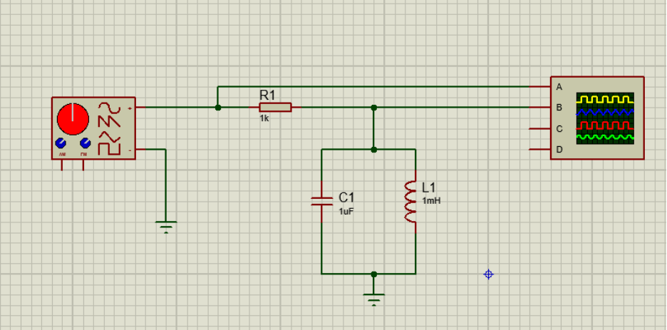Figure 1, Schematic built in Proteus
As shown in Figure 1, this is the circuit that will be tested to gather all the information required for the task in hand. With Proteus, there are options whilst running the test to allow changes to frequency inputs and voltage inputs, as well as being able to sort the settings on the oscilloscope to be able to read the waveforms correctly.
For this test, the voltage will be staying the same at 2 volts, but the frequency will differ to see a change in the outputting sine waveform. Starting off at 100Hz and increasing it up to 20KHz. For the results, the measurements will be taken from the oscilloscope, and it will be the voltage peak to peak.
These results will show that, at a certain point, the sine wave will start to reduce again. Plotting these results in a graph will allow evidence of a peak range of decibels and allow a calculation of bandwidth.

Breadboard Setup
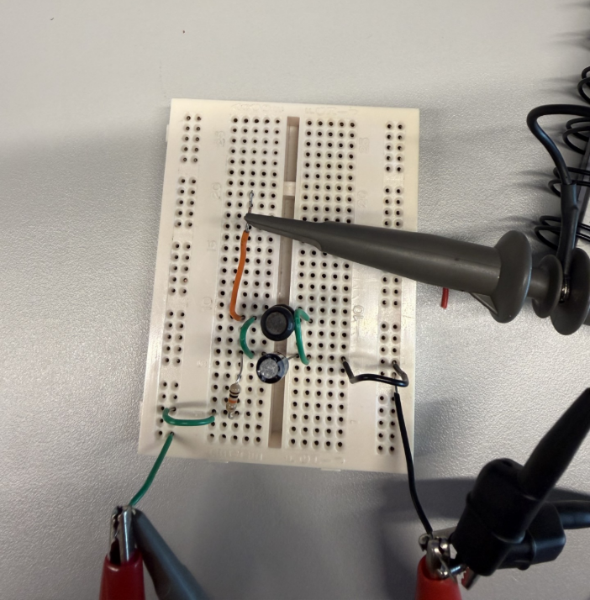
Figure 2: Breadboard of the schematic shown in Figure 1
As shown in Figure 2 above, this is the breadboard version of the test. The green wire up the top with the red croc clip and oscilloscope probe connected is the frequency in. The probe and several croc clips connected at the bottom to the black wire is the ground connection. And finally, the probe connected to the orange wire is the frequency out/results.
For the test on this board, it will be carried out the same as the simulation in Proteus. This is so that the results can be cross referenced between one another and see how a simulation and a real-world test can change results.

Results

Tables
Table 1: Proteus simulation results
Frequency (Hz) | Vin (V) | Vout (V) | db
100 | 2 | 0.0013 | -63.74173287
200 | 2 | 0.0025 | -58.06179974
500 | 2 | 0.0064 | -49.89700043
1000 | 2 | 0.0132 | -43.60912129
2000 | 2 | 0.03 | -36.47817482
4000 | 2 | 0.1375 | -23.25454595
5000 | 2 | 1.925 | -0.331985236
7000 | 2 | 0.093 | -26.65094094
10000 | 2 | 0.02126 | -39.46933471
12000 | 2 | 0.016 | -41.93820026
14000 | 2 | 0.013 | -43.74173287
15000 | 2 | 0.012 | -44.43697499
17000 | 2 | 0.01026 | -45.7976527
20000 | 2 | 0.0085 | -47.4322214

Table 2: Breadboard simulation
Frequency (Hz) | Vin (V) | Vout (V) | db
100 | 2 | 0.0034 | -55.39102157
200 | 2 | 0.0027 | -57.39332463
500 | 2 | 0.0036 | -54.8945499
1000 | 2 | 0.0037 | -54.65656543
2000 | 2 | 0.0056 | -51.05683937
4000 | 2 | 0.0148 | -42.61536561
5000 | 2 | 0.0272 | -37.32922183
7000 | 2 | 0.0126 | -44.01318901
10000 | 2 | 0.0078 | -48.17870786
12000 | 2 | 0.006 | -50.45757491
14000 | 2 | 0.0043 | -53.3512308
15000 | 2 | 0.0049 | -52.21667831
17000 | 2 | 0.0044 | -53.15154638
20000 | 2 | 0.0045 | -52.95634964

Graphs
Graph 1: Proteus simulation plotted
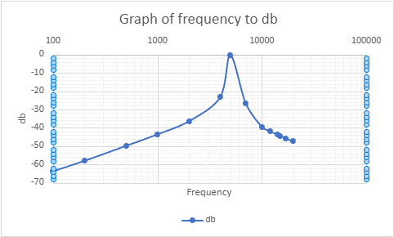

Graph 2: Proteus simulation zoomed in at the peak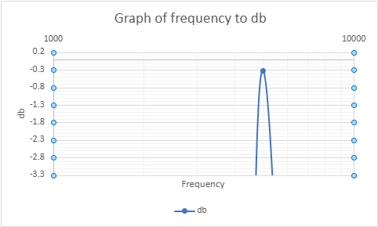

Graph 3: Breadboard results plotted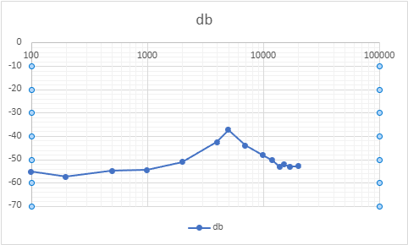

Graph 4: Breadboard results zoomed in at peak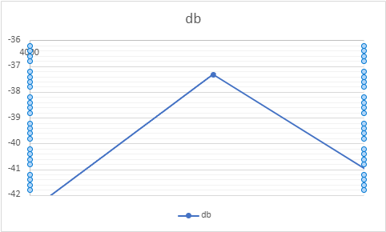

Discussion

Proteus Simulation
In Table 1, it displays what exact frequencies were used during this task as well as the voltage from peak to peak. From Table 1, the author was able to work out the attenuation of the circuit at different frequencies by using the equation,
$$A=20\log_{10}\left(\frac{Vout}{Vin}\right)$$
A is attenuation in decibels, $V_{out}$ is the voltage peak-to-peak across the inductor and $V_{in}$ is the peak-to-peak input voltage set on the signal generator.
“Attenuation is the reduction in the amplitude of a signal as it travels through a medium. Attenuation can be caused by transmission loss, reflection, or absorption. In an electrical system, attenuation is a decrease in voltage as it flows along a wire or other transmission line. Attenuated systems can also be referred to as degraded systems.
Attenuation is expressed in decibels (dB) and represents the ratio of output to input power or intensity. Attenuation values can range from zero decibels for an unobstructed or perfect transmission, to extremely large negative numbers. A perfect attenuator with 0 dB of attenuation has an infinite number of taps along the transmission line.
“Although the most accurate way to measure attenuation is through direct insertion of a calibrated attenuator into the system, an alternative method is to use test instruments that are capable of measuring voltage ratio or decibels. Attenuation can be measured with devices such as network analyzers, noise generators, and signal sources.[2]”
The results in the decibel column, shown in Table 1, sits around 5000Hz. That is the peak attenuation for this circuit. This is visually shown in Graph 1. As shown in Graph 1, the decibels gradually increase and when it gets near 5000Hz, it spikes up and almost instantly decreases. This shows the peak resonance for this simulation. From this peak, the author was able to work out what the best bandwidth would be for the circuit if it was used in a real-life scenario such as a radio signal. To calculate the most optimal bandwidth, the author had to take the peak from the results which was –0.331985 and take 3 away from it. This leaves the author with –3.331985. This is shown in Graph 2. In Graph 2, the points at the bottom show what would be the best bandwidth to operate this circuit. This is 4800Hz for the lower end of the frequency and 5200Hz for the higher end of the scale.

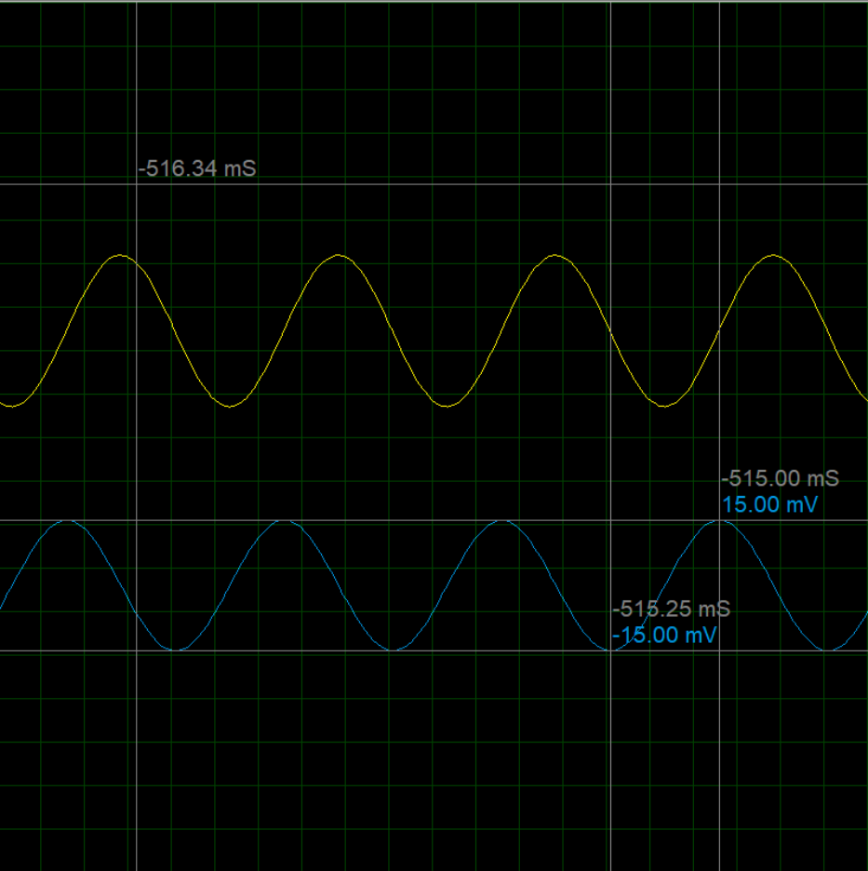 Figure 3: Digital oscilloscope readings on Proteus
Shown in Figure 3 is what the digital oscilloscope reads from the circuit. The author has plotted what the peak-to-peak voltage is for the input. This is 30mV. By doing the calculation, $20\log_{10}{(\frac{V_{out}}{V_{in}}})$, we can work out the decibels as –36.47817 with the input being 2000Hz with an input voltage of 2 volts.

Breadboard Simulation
Table 2 showcases the results for the breadboard simulation. As the table shows, it was not as effective as the simulation in Proteus. This is also shown in Graph 3. The results gave the same peak of it being at 5000Hz, but it did not reach the same decibels after completing the calculation.
For the breadboard circuit, all the inputs were the same as the Proteus simulation to compare results equally.
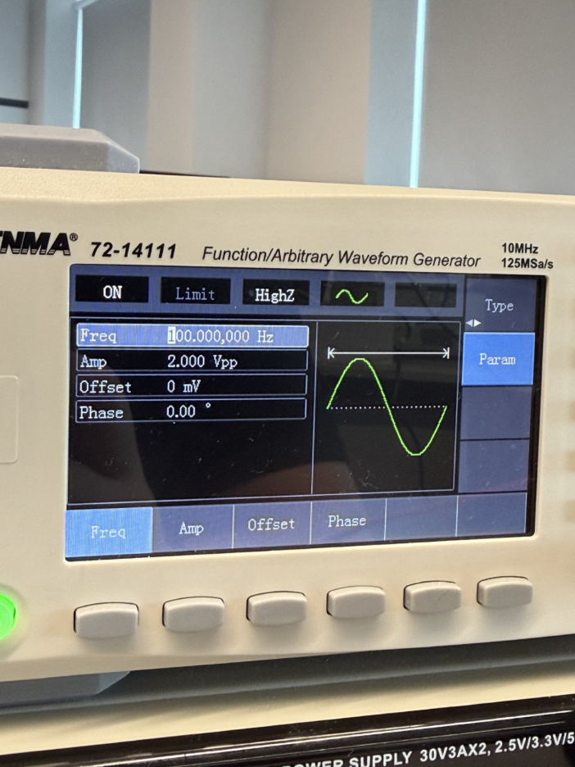 Figure 4: Frequency Generator setup
Shown in Figure 4, the amplitude of the wave and frequency is displayed. The voltage peak-to-peak is 2 volts and the frequency in Figure 4 is set to 100Hz, but the frequency input varies throughout the experiment to gather different results.
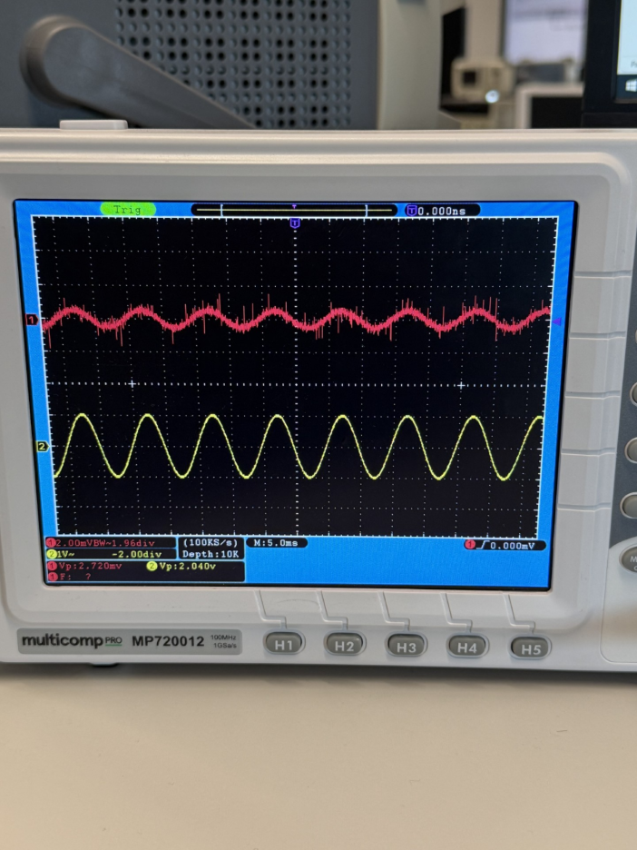 Figure 5: Oscilloscope display from breadboard

Figure 5 shows the input waveform on channel 2 and the waveform of the output of the circuit on channel 1. The oscilloscope displays what the voltage peak to peak on each channel is. These are shown in the bottom left of the display as 1 & 2 circled in their represented colour of the channel feeds. Red being channel 1 and yellow being channel 2. One of the key differences between the breadboard and simulation circuits that is visible is that the output from the circuit on the breadboard has a lot of lines coming up and down from the waveform. This can happen for a few different reasons, but the 2 most likely are, either connections between the breadboard and components were not the best, or there was electrical noise interfering with the circuit.

Displayed in Table 2 are the results from the breadboard experiment. By comparing Table 1 and Table 2, the results follow the same pattern of 5000Hz being the peak attenuation in the circuit. However, the breadboard circuit does not go anywhere near as high as the simulation circuit. This is shown in Graph 3. The peak resonance for the breadboard circuit is -37.32922183 compared to the simulation circuit at -0.331985236. This is a very big difference. Graph 4 shows the peak resonance of the breadboard circuit and what the peak bandwidth is. If the peak resonance is at -37.32922183 and –3 decibels is taken away from it, then that will be the ideal bandwidth to operate at as this would be the 70.7% of the peak. This brings the peak resonance to -40.32922183. And if the low and high frequency is worked out, it would be 4800Hz for low and 5200Hz for high. This would be the best range to operate in for using this setup.

Why Does Peak Resonance Occur?
Peak resonance occurs when the peak inductive reactance and peak capacitive reactance become equal in magnitude but opposite in phase.
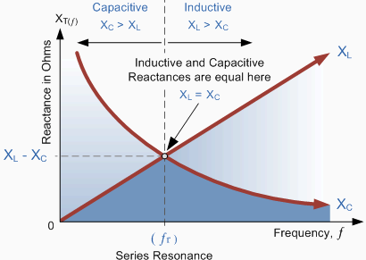 Figure 6: Shows where peak resonance occurs. [3]
As shown in Figure 6, at the point where inductive and capacitive resistance meets, this is where the peak resonance sits. In the Proteus simulation and breadboard test, this point would be at 5000Hz.
To work out the resistance of an inductor, the formula used is:
$X_{L}$=$2πfL$
Where f is the frequency in Hertz and L is the inductance in Henries.
For capacitive resistance, the formula is:
$X_{C}$=$\frac{1}{2πfC}$
Where f is the frequency in Hertz and the C is the capacitance in Farads.

Q Factor
The quality factor is the measure of how sharp the resonance of the circuit is. This has already been mentioned by the author earlier as the best/peak bandwidth.
The quality factor acts as a filter. Depending on what quality the user will want depends on how fine tuned their circuit has to be.
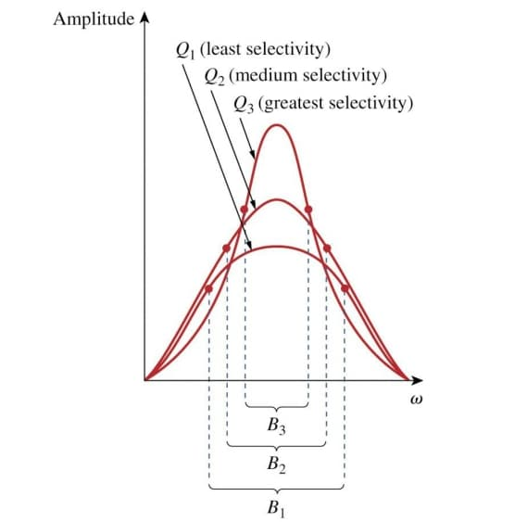 Figure 7: Display of Q Factor [4]
Figure 7 shows a visualization of the Q factor. At Q3, that will be the best quality of the output and as the scale goes down, so does the quality. This is because at Q3, the frequency is at a fine tuned point, whereas, at Q1, it is a much broader point.
As $X_{C}=X_{L}$ we can calculate the Q factor by:
$$\frac{V_{L}}{V}=\frac{IX_{L}}{IR}=\frac{X_{L}}{R}=\frac{2πf_{r}L}{R}$$
$$f_{r}=\frac{1}{2π\sqrt{LC}}$$
$$\frac{2πL}{2πR\sqrt{LC}}=\frac{1}{\sqrt{LC}}\left(\frac{L}{C}\right)$$
Q Factor = $\frac{1}{R}\sqrt{\frac{L}{C}}$
“The dimensionless Q-factor describes how much an oscillating system is damped. It is defined as the ratio of the initial energy stored in the system to the energy lost in one radian of an oscillation cycle.
A higher Q-factor represents a lower rate of energy loss with oscillations dying out more slowly (narrow-band, underdamped), while a lower Q-factor represents a lossy network (wide-band, overdamped). Examples of high-Q systems include clocks, lasers, and tuning forks, the latter displaying a Q in the region of 1000. Some high-Q lasers reach Q values of 1011 or higher. [5]”

Conclusion
In this experiment, it has been determined that the Proteus simulation gives a much more clear answer to the experiment as it will have everything running perfectly to the best of their abilities. Whereas, the breadboard test, there are a few external functions that can play a part into causing discrepancies such as bad connections or components being out of tolerance. However, the breadboard gives a more realistic answer to the circuit.
The graphs used after gathering all the results really showed what was fully conducted in this experiment visually. It allows a better understanding of how the peak resonance functions and where the peak bandwidth would sit.

References
[1]
Linear Circuit, Fiveable Content Team, August 2025, https://fiveable.me/introduction-electrical-systems-engineering-devices/key-terms/linear-circuit
[2]
What is Attenuation? Meaning & Definition, Callum Reed, December 9th 2025, https://www.keysight.com/used/us/en/knowledge/glossary/oscilloscopes/what-is-attenuation-meaning-definition
[3]
Image of Peak Resonance
https://electricalsimplified.blogspot.com/2012/03/in-series-rlc-circuit-there-becomesa.html
[4]
Image of Q Factor
https://www.allelcoelec.com/blog/quality%28q%29-factor-equations-and-applications.html?srsltid=AfmBOoqS7OyrjyXpB_rV03pHfWlFl7Y2p_6pZ4Bw7yHxLpPVWWuvBHQi
[5]
What is an RLC Circuit, Akanksha Sony, January 16th 2026, https://www.synopsys.com/glossary/what-is-an-rlc-circuit.html

