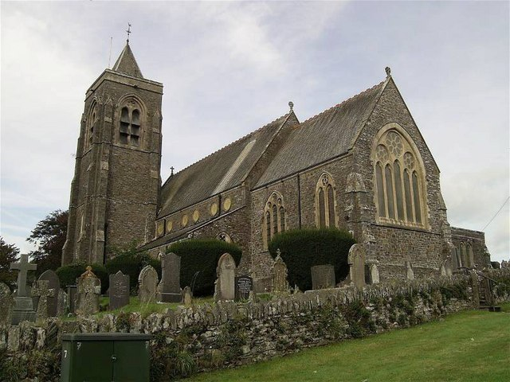
Thomas Westley
Quentin Drew
HPFY3007
10/03/2023

Graveyard Report.

Figure 1- Gregory, Dan. St Peter's Church. 20 April 2007.

Page 1 – Index and Introduction.
Page 2 – Location.
Page 3 – Theme and Methodology.
Page 4 + 5 – Data and Analysis.
Page 6 – Conclusion.
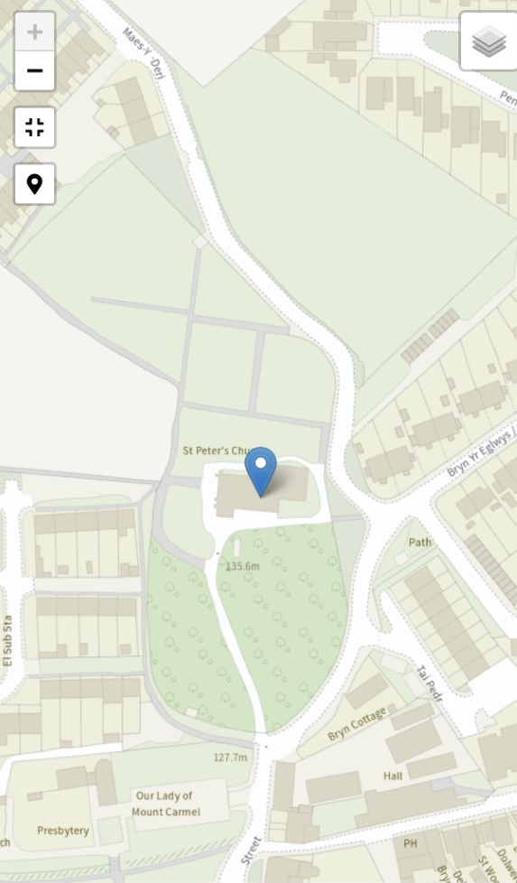
Introduction:
Figure 2 - Location of St Peter's. Coflein.gov.uk - accessed 10/03/2023.
The following text will discuss the findings of a graveyard report that took place at St Peter’s Church, Lampeter. And the intent was to attempt to identify the personal information that may have been portrayed through the use of flora symbolism on graves. As graves and graveyards have been represented in a more morbid light in modern day media, this report will also hope to counter this. By providing potential evidence to show how structures like St Peter’s bring comfort to those who visit and functions to still include the departed with the existing community.

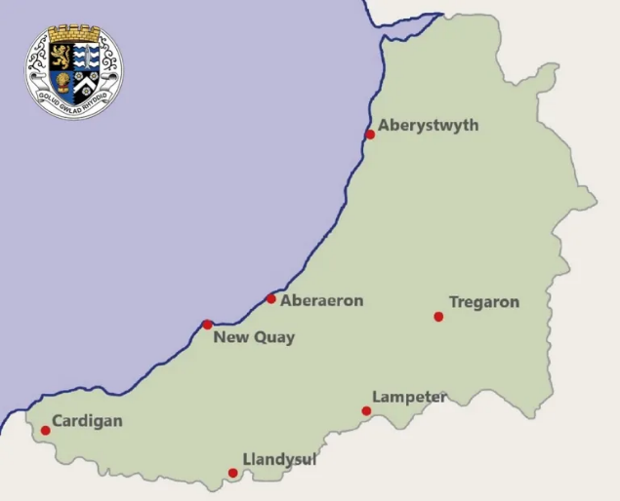
Location:
Figure 3 - Map of Ceredigion, CeredigionHistory.Wales - accessed 10/03/2023.
Lampeter Co-Ordinates: 52° 07’13”N 4°04’56”W
Grid Reference – SN578478.
The small town of Lampeter, is located in the West Wales county of Ceredigion. Llanbedr Pont Steffan, the Welsh name means “Peter’s church at Stephen’s bridge”. The town’s population fluctuates around 2,500-2,600 in regard to year round residents, according to the 2021 census. However with the introduction of University of Wales campus in 1822, the numbers are boosted by around 1,000 student that attend annually.
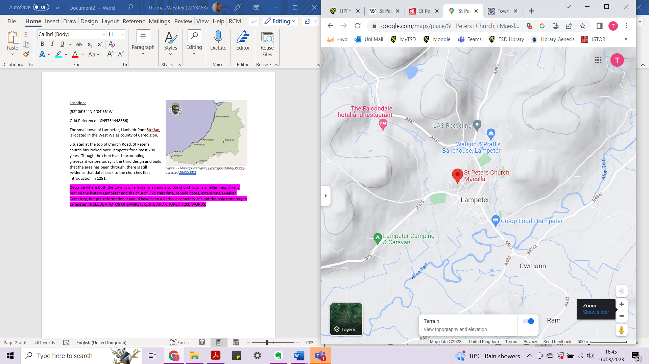
St Peter’s Church Co-Ordinates: 52° 06’54”N 4°04’55”W
Figure 4 – Map of Lampeter, showing terrain elevation with St Peter’s Church pinned. Google.com/maps – accessed 10/03/23.
Grid Reference – SN5754448356.
Situated at the top of Church Road, St Peter’s church has looked over Lampeter for almost 700 years. Though the church and surrounding graveyard we see today is the third design and build that the area has been through, there is still evidence that dates back to the churches first introduction in 1291. Although the church has been described as the best Victorian church in the county, it isnt the only church in town but just the more celebrated of five. Though it currently stands as an Anglian cemetery attached, it would have been a Catholic cemetery before the Protestant Reformation in 1517.

Methodology:
Upon my first visit to St Peter’s church, I gathered with my fellow course mates and our lecturers; Quentin Drew and Ros Coard. After a brief dive into the history of the church, we were given a tour of the graveyard surrounding. As the data I wished to collect and analyse was more on the qualitative side, I spent most of my efforts looking for gravestones that had an abundance of floral symbolism. From there, I then located where I wanted to collect my data, being the area between the road entrance to the graveyard and the church. I found four gravestones of interest, not only varying between the amount and use of floral symbolism but also in information given about the individuals buried. Using my subjectively new phone, iPhone XS Max, I proceeded to take clear photos of each grave of interest. I then noting down all the information from the gravestones.
From just the initial tour of the graveyard, it was clear that there was a vast amount of data that could be collected here. As well as data that I wouldn’t be able to easily access as I’m not fluent in Welsh. However, there was a limited amount of time provided for this graveyard report. It was also clear that the art style in which the flowers with engraved into the gravestone changed over time. This was when I decided to keep the amount of gravestones that I would analysis to no more than three.

Theme:
As my introduction briefly mentioned; this report is a result of my attempt to identify information about certain individuals that may have been portrayed through the use of flora symbolism. Whilst this information is sometimes also provided by words inscribed on the gravestone, as someone who is not remotely accurate with the native language to the town and church, this information is lost to individuals like myself. I believe its this symbolism that allows a further inclusion of the dead within modern day community. While language continues to change and transform overtime, the emotions and meanings behind certain famous flora symbolism remains. However I won’t just be looking at what floral symbols have been used, but also how they have been used and how this could further represent the individual.

Data:
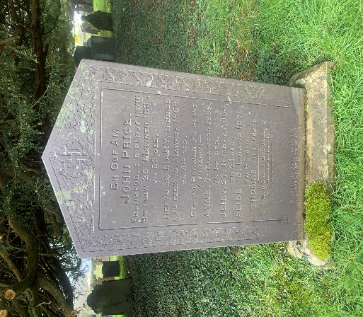
- The first collection of data was from a gravestone seemed to be primarily dedicated to “John Price” with dates placing the gravestone’s erection around the 1850’s, see Figure 5. This tombstone is located on the right-hand side of the road that leads from the gated entrance of the cemetery up to the church. There is also list of other names below the first; “Mary”, “Annie”, “John”, “Alice” and “Thomas”. All names are accompanied with presumed death dates, apart from “Thomas”. As the first individual named is the only one to have their surname also listed, it is could be thought that this is a patriarchal family grave.
Figure 5 - Author's photo. Taken 03/03/2023.
The gravestone has a border made of ivy vines and leaves. These overlap and intertwin with each other.

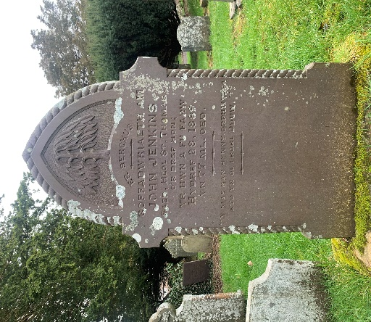
- The second collection of data came from a gravestone dedicated to “John Jenkins” and dates their passing in 1889. This gravestone is also on the right-hand side of the road into the cemetery but is ten to fifteen metres closer to the church. Unlike the last gravestone, this individual seems to have been buried alone as no other names or dates are mentioned.
Figure 6 - Author's photo. Taken 03/03/2023.
The flora symbolism featured on this gravestone is that of a willow tree standing fully-grown but alone.

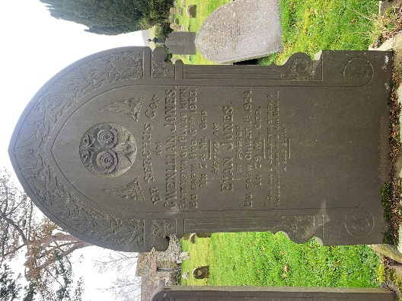
Figure 7 - Author's photo. Taken 03/03/2023.
- The next gravestone of interest to my report was one dedicated to “Gwenllian Jones” with the passing date of 1923 as well as “Evan Jones” with the date of 1924. Just below each individual is also their age at death. The location of this gravestone is on the left hand side of the road that leads to the church, roughly 10 metres for the gates.
There is a border of ivy vines and leaves on the top of the gravestone, with a lily half way up each side. In the centre, above the first named individual is a pair of intertwined roses. Each is fully bloomed and pointing outwards. Two branches of oak are positioned below the roses, to either side and feature a single acorn nestled between the leaves.

Analysis:
Although ivy is commonly depicted as symbolism for immortality as it is evergreen, there are multiple meanings that could allow us a clearer insight in regard to this gravestone. It is thought that ivy can resemble fidelity in the way that one remains loyal to a person, belief or cause, ivy has a natural tendency to attached itself to its surroundings. With this explanation in mind, and the fact that the ivy is the only floral symbol on the gravestone in Figure 5, this could be a more intimate look at these individual’s belief of family. The way that the ivy completely surrounds itself by the other overlapping vines and leaves, could represent the closeness that was felt between the family. Especially as it was chosen that they would be buried together, even though one of the children “Alice” preceded her parents by almost a decade.
The inclusion of a willow tree within floral symbolism found in a graveyard is surprising, as many of the depiction and emotions behind its symbolism are connected to grieving and sadness. The sight of a single tree engraved at the top of a gravestone in Figure 6 with inscriptions of a single individual does drive home a feeling of loneliness. However, there is more than just a sorrowful tone to this gravestone. Willow trees are seen within nature to be symbols of adaptability as well as flexibility. This, together with the way this engraved willow has been placed alone and fully grown, could represent the individual thriving in an environment that was not prosperous. When looking at evidence from the Office for National Statistics, life expectancy for mid-1800’s was 40.2. This is just one way that the adaptability of the willow tree has represented this individual’s life.
Although roses have symbolised romance since the Scottish poem “Red, Red Rose” by Robert Burns in the 18th century, the use that they are portrayed is just as important when attempting to understand the depiction. When the roses are intertwined, see Figure 7, it can been seen to reflect a strong bond, but not always romantic. This, especially being engraved on a gravestone that is dedicated to two individuals that we can assume when married, shows the emotion between the two. As the roses are also fully grown, it gives more detail to how these individuals have lived a full life, seeing the age of seventy-four and seventy-nine respectively.
Whilst the common meaning behind the oak tree is strength and longevity, the acorns which nestled between leaves can also represent humble beginnings, patience and endurance. Especially as there are two individuals buried there, it could mirror that both came from poorer backgrounds and persevered. This could also reference generations that may come from these individuals, they have sown their seed and their memories remain with the ones they leave behind.

Conclusion:
Whilst the analysis above can allow us and generations to come a small potent window into the lives and relations of those that have come before, there will always be the possibility of either miscommunication through symbolism or simply lack of symbolism itself. The flowers, trees and other natural depictions on gravestones could just be the favourite of the deceased. There is beauty to this uncertainty, as if even time is trying to allow intimate relationships to remain as just that. An intimate relationship between the living community and their dearly departed.

Bibliography:
Ceredigion Historical Society, <https://ceredigionhistory.wales/> [accessed 03/03/2023].
National Records of Wales (NMRV), <https://coflein.gov.uk/en/> [accessed 03/03/2023].
Wilkinson, Freddie, National Geographic Society The Protestant Reformation, 2022 <https://education.nationalgeographic.org/resource/protestant-reformation/> [accessed 03/03/2023].
The Joy Of Plants <https://www.thejoyofplants.co.uk/> [accessed 10/03/2023].
Better Place Forests <https://www.betterplaceforests.com/blog/articles/willow-tree-symbolism-and-significance#:~:text=A%20large%20tree%20with%20long,strong%20winds%20and%20adverse%20weather> [accessed 10/03/2023].
A Red, Red Rose. The Love Poems of Robert Burns in Original Scots and Modern English, ed. D. Scott (Morrisville; NC 2009)

Office of National Statistics, 28 June 2022. https://www.ons.gov.uk/visualisations/censuspopulationchange/W06000008/ accessed 10/03/2023.
A Red, Red Rose. The Love Poems of Robert Burns in Original Scots and Modern English, ed. D. Scott (Morrisville; NC 2009)

