Strategic Management BMMB7013D
Karen McMinn-Davies
1103350

Contents
Executive Summary 3
Introduction 5
Main findings of Strategic analysis and critical evaluation of the strategic options 7
SOAR 7
Strengths 7
Opportunities 8
Aspirations 8
Results 8
SWOT Analysis 10
Strengths 10
Weaknesses 12
Opportunity 13
Threats 15
PESTLE 16
Political 16
Economic 17
Social 18
Technological 18
Environmental 19
Stakeholder Analysis 20
Mendelow Matrix 21
Porters generic strategies 23
Three levels of strategy 25
Mintzberg/Positioning strategy 26
Conclusion 27
Recommendations 29

Executive Summary

The aim of this report is to examines the future and business improvements, along with resilience and sustainable competitive advantage against the backdrop of the pandemic. Within the report several corporate and business strategies are discussed from an academic view that leads onto internal and external analysis completed within an educational context.
A soar and swot have been completed and key areas identified from the analysis including competitors, sustainability, CSR and future performance that provides future options to Colegsirgar. Many strengths are discussed with key areas such as positive funding, technology and performance discussed. Minimal weaknesses were identified leading to some good opportunities arising from funding and restructure of business sections. The two threats identified as expansions in some other FE/HE colleges forming more competition and also overall financial stability after the pandemic.
Covid-19 has ensured that fast changers within education across the globe has taken place, with blended and distant learning now present dealing with changes including strategic planning has been explored within the report.
A further PESTLE analysis has been completed that identifies areas such as financial restrictions in funding received by the Welsh Government, taxes that are present, change within global education, PECET reform and also ICT for future new generation of learners.
Porters generic strategies have been analysed and a differential strategy has been identified form key areas of research. Strategy further explored with CSG including business, functional and corporative, and all mapped within the college future plans. Finally, an analysis on Mintzberg and identification of positioning strategy also applied within CSG.
As part of research stakeholder mapping has been completed, identifying eleven key stakeholders and further development using Mendelow’s Matrix completed demonstrating several key and high priority stakeholders need regular communication.
Stakeholder mapping was carried out which identifying eleven key stakeholders, the and further analysis using Mendlow’s Matrix completed demonstrating several key and high priority stakeholders need regular communication. These include learners, staff, Welsh Government and Colegau Cymru having becoming high power and high interest, demonstrating, therefore prioritising these for communication processes.
The pandemic has given a unique opportunity for consumers to reflect on their consumption, habit, behaviours, ethics and their impact of themselves and others on the environment. Organisations that have genuine CSR have and will build stronger rapports with their customers as consumers will feel proud they are supporting brands helping employees, supporting overcome the crisis and doing good and being conscious during unprecedented times. (Hea and Harris (2020)
Income and expenditure have proven to be a good present place and with funding that has been discussed through the research and supported the college through this pandemic means that some key areas on planning can now be moved forwards and implemented into the organisation.
In conclusion maintaining the processes that are present within the management structure of CSG will key to moving forward. The company leaders have proven their fast acting abilities and structured approaches throughout the pandemic and I believe that CSG hold a positive future including a thriving student learning environment.

Introduction
(Lynch , 2008) defines strategy as “the identification of the organisations purpose and the plans and actions set to achieve this purpose” This is a simple strategy however he expands in identifying the differences between Corporate strategy and Business strategies which have clear links to earlier discussions from (Drucker , 1961) and (Ansoff, 1969) where business address situations and align new processes and resources within their own organisations to become more successful. I believe in this strategy as its simple to follow and allows organisations to overlap within some key areas to become successful, this definition also states that planning and prioritising the areas or steps as (Porter, 2020) defines them are good, proven successful measures to put into place.
My employer Colegsirgar (CSG) is within the education sector and has clear-strategies in place, ‘inspiring leaners, fulfilling potential and achieving excellence’, these are highly publicised to existing staff, students and all stakeholders. Mckinsey (2014) states that research has identified a link between the goals, direction, purpose and strategy of the organisation that supports increased performance. People become excited when they understand the business purpose and the direction of the company, therefore being more productive (McKinsey & Company , 2018). CSG has implemented changes over the last few years to reach a wider stakeholder audience and continues to provide a positive learning environment for students with new surroundings, awarding bodies for assessment, innovative programmes and engaging technologies. (Porter, 2020) points out that there is a confusion with organisations understanding strategy which can lead to an incorrect process carried out to meet the needs for the organisation. Therefore, conducting further research around the future and direction of CSG will identify firstly, that a constructive plan is in place. Secondly, are appropriate ‘steps’ that Porter (Porter, 2020) recommends to achieve its goal been identified resulting in correct strategies devised and implemented. This including the organisations existing strategy, future-planning and views identified from various interviews with Directors, HR staff and Assistant Principle of CSG. Lastly the report includes a SOAR, SWOT, PESTLE and Porters five forces, the analysis of the internal and external environment will identify if CSG is successful in reaching the above standards, resulting in competitive advantage being obtained with the correct steps followed to support this achievement. Birkingshaw recently said ‘the challenge is how to make the rate of change inside at least as rapid as the rate of outside’ (Berkingshaw, 2017), businesses now striving for competitive advantage and reaching to the future by introducing modern day strategies to be successful.
Finally, this report examines the future and the business improvements that are in place along with resilience and sustainable competitive advantage against the backdrop of the pandemic. Recommendations to CSG will be provided based on the research completed for this report.

Main findings of Strategic analysis and critical evaluation of the strategic options

A soar will enable CSG to focus more on tactics and strategies on what’s working well rather than using a swot which only looks at a top down approach. Soar focuses on the formulation and implementation of a positive strategy by identifying strengths, building creativity in the form of opportunities, encouraging individuals and teams to share aspirations, and determining measurable and meaningful results (Caglar et al., 2012, p.10). However, a full analysis is beneficial therefore a completed swot to identify areas such as weaknesses and threats has also been included below.

SOAR
Strengths
The following assessment is based on CSG, however sources of general education within the correct context of soar will be included. There are several core strengths within CSG but for today’s purpose I have discussed a few below.
- Firstly, CSG is quick to respond to industry needs where new-innovative courses are being made available for students, another strength would be that it’s recognised as high-tech in the platforms used for staff and students (FE news, 2020) this is also discussed further in the swot analysis below. Technology is a focus in todays ‘digital era’ and the expectations of younger generations such as millennials and generation-z students and how their communication needs have altered throughout the pandemic has forced the organisation to advance their materials to meet the needs of these students. Moving forward to Generation Alpha means that education is now going to see a larger student population who are fully diverse to technology. Generation Alpha have shorter attentions spans and traditional teaching tools are not going to stimulate students therefore more interactive displays and gamification is the way forward (Ben Q, 2021).

- Innovating and implementing communication types such as more use of smart phones, apps to interact with class delivery from teachers, apps to provide more interactive activities through the classrooms with new Benq boards and Google Classroom which resembles social media or a ‘scroll like response’ feed for student learning experience. Since the beginning of Covid19, CSG is produced this and more which has become a success over the last eighteen months and we are seeing a new type of student engagement, which has continued to reinforcing the relationships between the business, all staff and students. (The Evolution, 2018) agree that this will also create a climate of trust within the organisation. Meetings on digital enhancement and the new direction over the next five years is being held on a fortnightly basis so that the learning experience improving continuously (Williams, 2021)

Opportunities
- Opportunities for the organisation can be indented as some of the strengths of technology and to grow this into a further collaborative innovative culture, being more proactive rather than reactive. This should result in building more student engagement, diversity and reputation for continuous student excellence and overall this will result in CSG recognised on a larger-scale and business recognition. Opportunities can also be included in areas such as students, facilities, curriculum and more, seen in the SWOT analysis below.

Aspirations
- Aspirations for CSG include, new programmes for Governing Awarding bodies, providing a more flexible working environment for staff and students and also looking at the overall structure of the organisation, including the HR hub and how staff expertise is managed through the organisation (Priller, 2021). An interview conducted with the Director of Finance (Priller, 2021) also identified that the College had expanded over seven campuses in the previous ten years and there was now possibilities of new innovative buildings being built on College grounds over the next five years, this is due to having some financial stability and future funding opportunities from Welsh Government.

Results
- Progression is being made, how the business is succeeding against plans and where the business can move forward from this point is of great importance, an example of CSG is that, there is an increased emphasis on equality and diversity through all campuses, increased funding from Welsh Government that has allowed some expansions into new student areas over several campuses in Summer 2021 and lastly the development of distinct curriculum with focus on digital technologies as mentioned above.
- (Welsh Government , 2020) funding of £50m to Colleges could mean that the financial burden due to lack of income through the pandemic could be eased and meet one of the visions for CSG in financial resilience, diversified income streams and operational efficiency for best use of resources. This has been shown in the internal recent reports within the CSG but is yet to be published.
The above clearly demonstrates the business is doing many things to maintain progress and succession through the pandemic, with lots of new innovative processes in place. Strengths are being turned into further opportunity which has resulted in successful outcomes.

SWOT Analysis
According to (Lynch, 2015) the swot analysis will identify key areas such as vision, innovation and technology, these are areas that are a main focus for CSG in their new strategic plan so therefore this research will look at collective and creative processes around further-education. Further development on the Soar and conducting the following Swot will establish some further key areas for CSG including the weaknesses that could be turned into opportunities.

Strengths
Further education, including vocational qualifications and the change in assessment processes was proven difficult in GCSE and A levels, under the guides form Welsh-Government, including when blended learning was in place. However, this took time to organise safely but was completed in a timely manner with positive results being placed overall which are included below. According to the Assistant Principle Mike Williams not only was a new plan put in place a week before ‘lockdown’ to be fully prepared if the inevitable was to happen, this resulting in a smoother transition into online learning than some other educational institutions (Williams, 2021).
The leaders of CSG acted quickly by conducting staff and learner surveys and using the feedback constructively to implement changes to processes that were already new to everyone at the organisation (Colegsirgar, 2021). Learner experience was essential to evaluate and throughout the pandemic positive results from student assessments were present, resulting in completion in over 80% in all areas of the college this can be seen below in image1 (Colegsirgar, 2021). These results were good compared to the national average the prior year, which was showing a decrease of 6% (Welsh Government , 2020).
Staff have been recognised for outstanding work, with leaders putting many new measures in place for well-being and working structures to support staff and their new working environment (Rees, 2021), according to (CIPD, 2022) promotion of wellbeing will prevent stress and form a good working environment where staff can succeed in the organisation. Wellbeing is an anchor to employee engagement and organisational performance.

Table 1- Completion of students. (Colegsirgar, 2021)
2020-21 | Successful completion
FE FT | 82%
HE | 87%
WBL | 80%
14-19 | 87%

Table 2 (UK Government , 2021):
Further education and skills | Education and training | Community learning participation
1,640,300 | 869,600 | 243,700
Down 6.0% from 2019/2020 | Down 0.6% from 2019/20 | Down 32.0% from 2019/2020

(Jones , 2022) stated that a shift in management styles, behaviours and culture was now noticeable, including a more democratic approach with a clear movement in stronger communication and interpersonal skills, moving towards modern management rather than the traditional approach that was present prior to the pandemic. (Lewin, 1992) identified a framework of three- leadership styles, democratic being more specific and compelling including more synergetic work. Also results from a study identified that democratic leadership had the highest quality contributions (Forbes , 2019) so there for this demonstrates positive direction for CSG.
The modern management approach, generative strategy with an organic style that helps empower stakeholders within the organisation to implemented and change the style and culture of the organisation, (Lynch , 2008) agrees that this is a powerful symbol of change in progress. (Senge, 1990) also said this style will be welcomed buy millennials and future generation of people and that more motivating, inspiration and coaching and developing will be present within the organisation. With students at the centre focus and flexibility demonstrated CSG should see positive results moving forward. (McKinsey, 2020) confirmed that sixty-percent of businesses seen a minimum of twenty-nice percent improvement processes and outputs.
Financially the college was in a negative position prior to Covid19 due to resent restructures, staff redundancies and pension adjustments. However, income from various sources totalling £41,275-year end 2020 and £46,980 (Priller, 2022) (2) has made a positive financial impact on CSG. Over the last eighteen months, it’s evident that CSG has used the pandemic to its advantage by having good financial-direction and using the correct sources of income on internal investments on four of the CSG-sites, including make-overs, , equipment for learners and also for teaching staff, website updates, lots of new technology, new buildings for more learners, teaching and learning platforms been enhanced via Google-platforms and integration of many internal systems. Work carried out during lockdown meeting the Welsh-Government rulings. Financial reports identify the total income at £6,387 at the end of 2021 and currently at £14,234 for 2021 (1).

Weaknesses
Covid19 research from (Brown & Cowling, 2021) identified ten-percent of businesses are at risk of failure from the pandemic. Newport and Swansea in Wales were identified as areas of concern, this being very close to home for CSG therefor having precautionary savings for this period was necessary. As mentioned within this research, the Government funding received meant that CSG was in a positive-financial state however prior to the funding a negative state was present.

Table 3: Total business and job risks across the UK.

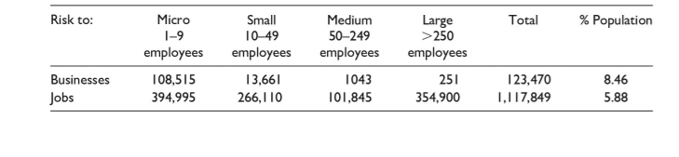
The above table shows the breakdown of business risks and the table below is identifying the Newport and Swansea risk, within the top-ten in comparison to the UK.
Table 4: Business risk: ten local business areas.

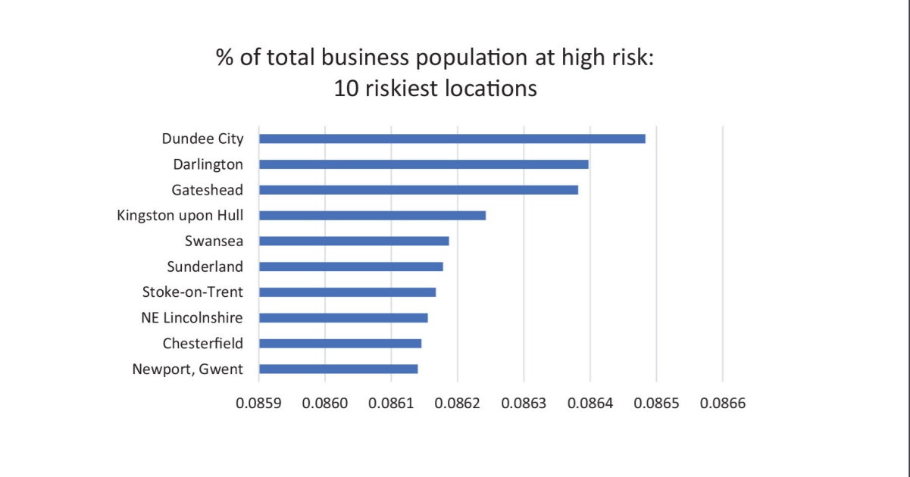

Opportunity
(Williams, 2021) explained that leading up to the first lockdown of the pandemic in 2021, preparation on a new digital strategy formed a week before lockdown, which was successfully rolled out on day-1 to support the teaching and learning experience. CSG is able to take advantage and build on this from information obtained in the review of the education-system (Donaldson, 2015). Information and communication technology (ICT) being at the forefront as (Furlong , 2015) states the systems are not-acceptable for our next generation. (Williams, 2021) confirmed that meetings are now held on a fortnightly basis to implement future ICT for engagement and student care processes.
Welsh-Government digital strategy will provide funding for ICT purposes in support of the above, details can be seen in table3 for the Welsh allocation to all FE Colleges. CSG can exercise the funding to its own digital plan mentioned above.

Table 4: Allocation of Funding (Priller, 2021)

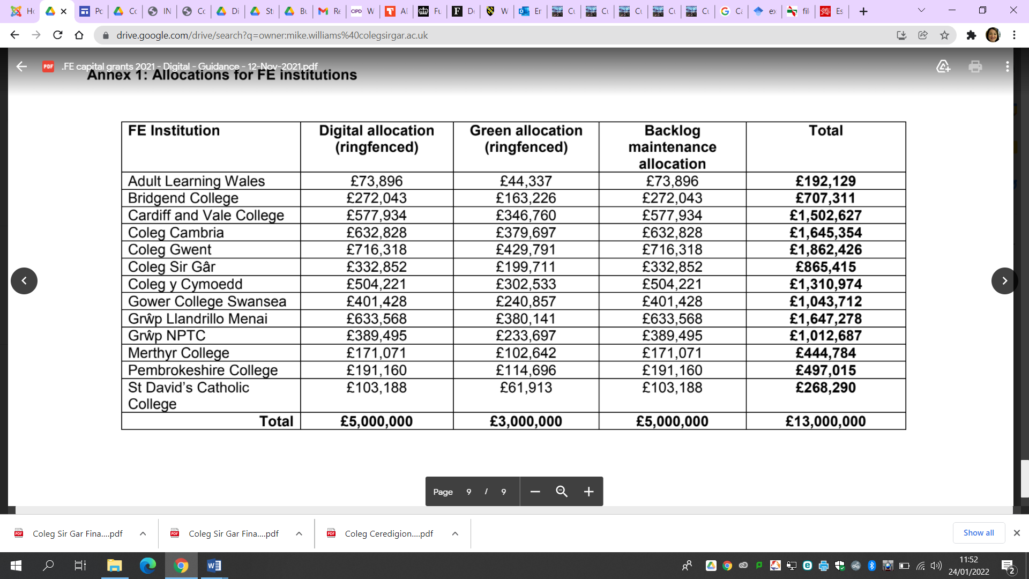
- Further financial support from Welsh Government for development of resources as mentioned above within the soar. (McKinsey, 2020) has stated that this accelerated shift in ICT and combining analytics with new-data processes means faster, better arrangements and enhancements in student care.
- CSG had a cancelled Estyn inspection two days before the lockdown in the pandemic at the start of 2021, this allows further evaluation within teaching, learning and assessment practises. Webinars are available (Estyn Annual Remit , 2021) including case studies and innovative practises. CSG has demonstrated modern flexibility in its strategy during the pandemic
- Trinity St David, part of our consortium using a different blended learning platform, real-time, innovative design and very different to the Google platform, this is called curatr (Trinity St David, 2022)

Threats
- Expansions in some other FE/HE colleges forming a main competitor, including current students of £20000 over nine campuses, and having endorsements over all educational sectors (NPTC Group, 2022)
- Financial support to other institutions and possibility of expansion with the funding to encourage more completion.
- Future Financial status at CSG and the stability including expenditure to be more than satisfactory to enable funds to be allocated for areas identified within their strategic plan (Priller, 2022).
- Risks identified within CSG continuity plan (Colegsirgar, 2022)

PESTLE

Political
- CSG is considered to pass a test in the, Finance Act 2010 and therefore it meets the definition of a charitable company for UK corporation tax purposes.
- CSG is potentially exempt from taxation in respect of income or capital gains received within categories covered by sections 478-488 of the Corporation Tax Act 2010 or section 256 of the Taxation of Chargeable Gains Act 1992, to the extent that such income or gains are applied to exclusively charitable purposes.
- CSG receives no similar exemption in respect of Value Added Tax.
- CSGs subsidiary company CCTA Enterprises Ltd is subject to corporation tax and VAT in the same way as any commercial organisation with monetary assets and liabilities denominated in foreign currencies are translated at the rates of exchange ruling at the end of the financial period with the resulting exchange differences being taken to income or expenditure in the period in which they arise.
- Tangible fixed assets, other than investment properties, are depreciated over their useful lives considering residual values, where appropriate. In re-assessing asset lives, factors such as technological innovation and maintenance programmes are considered. and projected disposal values.
- Local Government Pension Scheme, defined benefit liability depends on a number of factors that are listed within the business annual report (Colegsirgar, 2021).
- The ultimate parent undertaking and controlling party is the University of Wales: Trinity Saint David Higher Education Corporation (Trinity St David;University of Wales Trininty St David, 2021)
- Kirsty Williams the minister of education stated that PCET in Wales will become a group process to increase skills and tackle inequalities. The future will be a global network of outstanding training, research and innovation (Kirsty , 2020).

Economic
- The post compulsory education and training sector guides to recovering from the pandemic and the relationship dissolvement with the European union which will include areas in technology, environmental, demographic and cultural changes in education (Minister of Education , 2020).
- Payments received from Welsh Government for contingency or maintained are subsequent disbursements to students and institutions are excluded from the income and expenditure of the College where the College is exposed to minimal risk or enjoys minimal economic benefit related to the transaction (Colegsirgar, 2021)
- Non-exchange transactions without performance related conditions are donations and endowments. Donations and endowments with donor-imposed restrictions are recognised in income when the College is entitled to the funds.
- Strong Governance to ensure that all policies and regulations and standards are adhered to. Having governance will make this task a lot easier to manage (Estyn, 2019). This will have positive impact in the business and back the direction management are steering towards.
- (Weinger, 2021) said the pandemic has made us aware of how important CSR is and why it’s the most effective ways retain commitment and motivation from employees. Inserting CSR into CSG ‘brand and positioning strategies will support the overall marketing strategy in place (Youssef, 2017). The direction to address the global environmental and social challenges and shift of the pandemic means, Millennials and generation-z students are more aware of the importance of sustainability. Research carried out on thirty-thousand individuals within sixty counties found that seventy-three percent of millennials/generation-7 born between 1977-1995 are willing to commit more to organisations that address the global issues that are present (Curtain, 2022).

Social
(Eubanks, 2019) describes artificial intelligence (AI) as a category within several areas. CSG should source appropriate teaching and learning equipment to meet the business needs, these could be other cloud-based lenders that are in high demand and imitate social media (Josh Bersin, 2019). With AI on the rise and the imminent changes that lay ahead to support new generations of learners (Forbes, 2020) this will encourage growth and remodel business functions.

Technological
Table:5
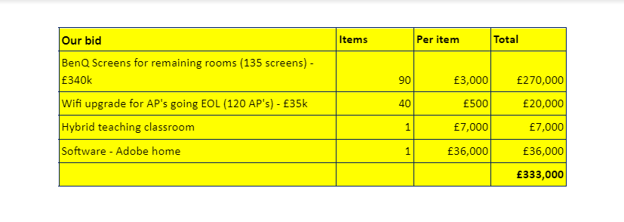
The above proposal was agreed and new equipment was implemented through the pandemic, further details on the request can be seen in (3).
Discussion of more fluidity and hi-tech rooms for blended learning and the better students’ experiences is a topic explored by all educators at present. Some of the key areas that being explored are:
- Student present in class lecture
- Guest speaker on a blended/digital approach
- Class teaching with online presence
- Whole class view with good sound engagement
- Easy technology for staff and students to operate. (CSG, 2022)

- Resources from Welsh Government to apply for grants/refunding for technology and blended learning. CSG to place bid, being sucessful in being awarded £662,852 with conditions attached (4).
- WG Digital 2030 Strategy will be implemented, addressing all eight areas in the timescale, further information in (5)

Environmental
- Covid19 will see the worst depression since the 1930s and individuals will now see the world differently with the experiences they have encountered over the last two years. This impacting on CSR and business ethics. The commitment to stakeholders has been difficult as many areas around education have seen a change that has not been done previously, with a crisis in place. A balance between profit and conformity with stakeholders is now more important than ever to achieve social, environmental and economic goals (Hongui & Harris, 2020)

Stakeholder Analysis

The following are the current list of stakeholders for CSG (Colegsirgar, 2021):
- Learners
- Parents /Guardians •
- Staff
- Governors
- UWTSD
- B-WBL Consortium
- Welsh Government
- Colegau Cymru
- Carmarthenshire County Council
- Ceredigion County Council
- Public Service Board members
- Econocom

Mendelow Matrix

Teacher development strategy (ColegsirGar, 2020), training for inspirational leaders and advancing skills, empowering individuals and peer training and coaching are in place which sits nicely again the overall arching corporate-strategy in place. Stakeholder management is also something at this level that is equally important to be managed correctly, with being such a large organisation and with the stakeholder numbers rapidly increasing again this needs to be built into business strategy and how relationships are maintained and gained. (SME Strategy, 2019) state that these engagements will mitigate potential risks, conflicts, disengagement and resistance to change.
As seen from Medlow’s matrix, priority needs are very close with stakeholders so therefore structure and approach to each one is critical. Stakeholder analysis will reduce negativity, identifying issues with better communication and direction for the company.
Table 6: CSG Matrix
Stakeholder | Definition | Key Contact  Name, job title and contact details | High Power (HP)  High Interest (HI)  Low Power (LP)  Lower Interest (LI) |  |  |  | NOTES
 |  |  | HP | HI | LP | LI
Parent/Guardians |  |  |  | X | x
Staff |  |  | X | X
Governors |  |  | X | x
UWTSD |  |  | X | X
B-WBL Consortium |  |  | X |  |  | x
Welsh Government |  |  | X | X
Colegau Cymru |  |  | X |  |  | x
Carmarrthenshire County Council |  |  |  | x | X
Ceridigion Council |  |  |  | X | X
Public service board members |  |  |  | X |  | x
Econocom |  |  |  | X |  | x
Learners |  |  | X | X

Porters generic strategies

Without strong strategic direction, a business would certainly experience difficulties and most likely result in failure within a three-year timescale. (Verleum, 2017) explained, that A real strategy involves a clear set of choices that define what the firm is going to do and what it’s not going to do. Many strategies fail to get implemented, despite the ample efforts of hard-working people, because they do not represent a set of clear choices. So therefore, for without any form of strategic plan in place would result in a loss for the business. (Forbes , 2011) also agrees with this and adds that no matter how prepared you think you are that you will always have challenges throughout the plan. Being prepared for some possible encounters will make these challenges easier along the way.
Image 2: Porters generic strategies
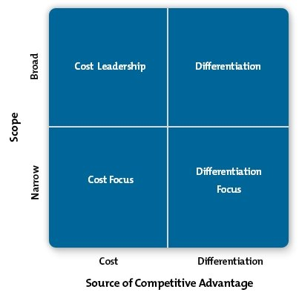
Considering Porters Generic Strategies, the educational sector is a difficult one to place, being in a market when there are several institutions means there is high competition. I believe CSG operates under a differentiation strategy, however lower costs and striving more increased revenue is visible. CSG providing more features in courses and services offered to the general-public/learners, including recent expansions within a level and a technology suite. (Porter, 1985) said that differentiation-strategy can cause a pulling affect and can have consequences in the longer term, however as education being a public-sector organisation and not striving for profits it’s evident that good strategies to deliver succession for business is in-place. However, in the longer term the business will need to review its direction as the focus into a narrower market to gain competitive advantage.
A business who produces a plan for the sake of having one or not having one at all will see, that without the thought and agreement from stakeholders it will not gain the support to implement changes, also ongoing developments in the business environment could result in difficulty for the business to move forward, again resulting in failure (Forbes , 2011). If a plan is not formulated it would be questionable, where were the leaders of the organisations at that time. This situation displays the business lacking expertise and could encounter difficulties in the near future. The complexity and tough decisions that have to be made, could be incorrect as the leaders have not understood(Forbes , 2011). Poor strategic planning and business decisions will lead to difficult periods for business to overcome. Businesses need support, agreement and direction from a range of sources to become successful in the plan that is in place for them (Swanson, 2020).

Three levels of strategy
Corporate strategy - Considering the three levels of strategy within an educational context, there are improvements with evidence pointing to structure and alignments between the three areas. Within a large educational institution, it can be difficult to align corporate-strategy to fit all levels, courses, department needs. Dr P Brazier said ‘with the backdrop of a global pandemic, the learning recovery from educational institutions that new strategies are needed (Brazier, 2014). Clear goals, missions, values and visions are in place, with management delivering appropriate messages including, structures, processes and relationships, discussed below. Corporate level strategy will achieve the overall long-term goal, so, for example, in an educational establishment, the long-term plan will be five years and over, however CSG has shown that this has become more flexible with a decrease of term of three years.
Business strategy - New workforce teams formed to manage/lead different student services over several areas. Innovation and differentiation come to the forefront as CSG demonstrates for example reaching heights in digital-technology strategies, focusing on student wants and needs by using new innovate platforms. Another successful strategy is teacher development (ColegsirGar, 2020), training for inspirational leaders and advancing skills, empowering individuals, peer training and coaching. Stakeholder are managed correctly, with stakeholder-numbers rapidly increasing, relationships are maintained and gained. (SME Strategy , 2019) state these engagements will mitigate potential risks, conflicts, disengagement and resistance to change. Further advantages for this level of strategy include, better future needs, stronger brand and trust by competitors (Chrone, 2020). Research shows that organisations must not become complacent and monitor business level strategy on a continual basis and avoid tunnel vision by innovating regularly (Chrone, 2020).
Lastly functional strategy - Involves processes, resources and people-management to-be integrated into the organisation. This level is highly operational and can be classed as one of the main strategic areas within the organisation. As already mentioned the strong direction in place within my organisation means maximising output and profitability by increasing student numbers, higher attainment levels and availability of new courses. Some downfalls with this strategy are that conflict is common as the messages can become unclear if not filtered correctly and also functional managers can sometimes lose sight to the main objective of the company due to the implementation of various resources (Ceopedia, 2020).

Mintzberg/Positioning strategy
Considering Mintzberg strategy, CSG strategy is positioning. CSG has implemented changes and is consistently demonstrating business values though it’s stakeholder management, resulting in competitive-advantage. This obtained from new leadership, direction, merging with other educational organisations to become a wider business brand and implementing the correct-steps to be successful.
A study involving Universities in America (Bilgin & Kethedu, 2016) it was identified that many are now using positioning, being unique compared to competitors with enticing new students using technology, environment, values and more was more successful than previous educational approaches such as the strategy of pattern.
CSG demonstrates resilience within business-functions, student care through delivery and learning environments for individual through the recent-pandemic. These changes continue to be monitored and adapted to the needs of the organisation, including innovative resources and modern environments for new generations of students and staff training, developing further-opportunities (Colegsirgar, 2021).

Conclusion

Overall, I believe CSG have acknowledged the change caused by the pandemic, it’s evident in the research provided, that strong leadership and direction has been provided. Strategy on all levels was seen to be reviewed regularly with new meetings placed with appropriate staff to accommodate changes that were imminent. The pandemic has meant that new stakeholders and regular commination was needed for the college to maintain stability, financially, staff wellbeing and the learner experience. The direction, goals and values of the organisation are all integrated correctly into the strategic plan, with success present in many areas that are identified in the assessment above. and its evident that success is being obtained from student successions and expansions of various campuses within the CSG group.
Strategies will differentiate, there is no particular one way or approaches that should be followed, Strategy is all about the business in question and what the visions, missions, goals, values, beliefs and output required.
Porters generic strategies, identified, differential strategy and how courses are made bespoke and cost also is present within this analysis. Building on porters’ outcome, three further strategies identified, business, functional and corporative, and all mapped within the college future plans. Structures, process and clear directive leadership was present with leaner and staff experiences resulting in positive results. Other key areas with business developments with ICT, PCET reform and Digital2030 plans demonstrated all aspects had been covered appropriately and dealt with in a timely professional manner. Finally, an analysis on Mintzberg and identification of positioning strategy also applied within CSG. It’s noticeable that the college is working on innovative and modern designs of both equipment and surroundings, supporting the new generation of learners and providing a better learner experience.
Porters generic strategy, identified a differential approach, which also maps to the modern, flexible timeframe and direction mentioned above. Finally, an analysis on Mintzberg and looking at business direction a comprehensible positioning strategy is present within CSG.
Stakeholder mapping was carried out which identifying eleven key stakeholders, the and further analysis using Mendlow’s Matrix completed demonstrating several key and high priority stakeholders need regular communication. These include learners, staff, Welsh Government and Colegau Cymru having becoming high power and high interest, demonstrating, therefore prioritising these for communication processes.
The pandemic has given a unique opportunity for consumers to reflect on their consumption, habit, behaviours, ethics and their impact of themselves and others on the environment. Organisations that have genuine CSR have and will build stronger rapports with their customers as consumers will feel proud they are supporting brands helping employees, supporting overcome the crisis and doing good and being conscious during unprecedented times. (Hea and Harris (2020)
Income and expenditure have proven to be a good present place and with funding that has been discussed through the research and supported the college through this pandemic means that some key areas on planning can now be moved forwards and implemented into the organisation.
In conclusion maintaining the processes that are present within the management structure of CSG will key to moving forward. The company leaders have proven their fast acting abilities and structured approaches throughout the pandemic and I believe that CSG hold a positive future including a thriving student learning environment.

Recommendations

The Future of CSG and challenges that are ahead some recommendations moving forward are below.
Trinity SaintDavid (“UWTSD”) group and has made a commitment to continuing to offer a strong further education provision across the county.
A number of key challenges face the College over the next few years, including:
• Improving in learner outcomes
• Developing the college as a centre of excellence for teaching and learning
• Meeting the challenges of ‘Digital 2030’
• Developing more Welsh medium provision
• Realising the benefits from merger for learners, staff and the wider community
• Maintaining a diversified curriculum portfolio across a range of sectors
• Developing more commercial training
• Developing strategies to cope with pressures in public funding
• Improving, rationalising and developing its estate in partnership with UWTSD and the County
- Identifying further CSR opportunities
- Explore further ICT opportunities for adult and WBL learners

Ansoff, I., 1969. Corporate strategy. Corporate strategy , p. ch1.
Ben Q, 2021. Is Your School Generation Alpha-Ready? How to Prepare?. [Online]
Available at: https://www.benq.com/en-us/business/resource/trends/alpha-gen-school.html
[Accessed 21 January 2022].
Berkingshaw, P., 2017. Forbes. [Online]
Available at: https://www.forbes.com/sites/stevedenning/2017/06/24/julian-birkinshaws-fastforward-how-agile-builds-action-oriented-firms/?sh=3e009dad1406
[Accessed 21 October 2021].
Brazier, D. P., 2014. Corporate strategy , s.l.: Educational development trust. .
Bridgepoint, 2021. Donald Trump-Trumping the lot. [Online]
Available at: https://www.bridgepointgroup.com.au/7-spectacular-business-strategy-failures/
[Accessed 13 October 2021].
Brown, R. & Cowling, R., 2021. The geographical impact of the Covid-19 crisis on precautionary savings, firm survival and jobs: Evidence from the United Kingdom’s 100 largest towns and cities. Business Journal, 39(4).
Ceopedia, 2020. Functional strategies. [Online]
Available at: https://ceopedia.org/index.php/Functional_strategy
[Accessed 19 October 2021].
Chrone, 2020. Business planning and strategy. [Online]
Available at: https://smallbusiness.chron.com/advantages-disadvantages-businesslevel-strategy-19209.html
[Accessed 19 October 2021].
CIPD, 2022. Wellbeing at work. [Online]
Available at: https://www.cipd.co.uk/knowledge/culture/well-being/factsheet#gref
[Accessed 22 January 2022].
ColegsirGar, 2020. ColegSirGar. [Online]
Available at: https://www.colegsirgar.ac.uk/index.php/en/about
[Accessed 19 October 2021].
Colegsirgar, 2020. Finanical statement. [Online]
Available at: https://sites.google.com/colegsirgar.ac.uk/polisiau-policies/home/cyllid-finance
[Accessed 20 January 2022].
Colegsirgar, 2021. Colegsirgar. [Online]
Available at: https://www.colegsirgar.ac.uk/index.php/en/about
[Accessed 7 January 2021].
Colegsirgar, 2021. Colegsirgar. [Online]
Available at: https://www.colegsirgar.ac.uk/index.php/en/learner-experience
[Accessed 20 January 2021].
Colegsirgar, 2022. Continuity plan. [Online]
Available at: https://sites.google.com/colegsirgar.ac.uk/polisiau-policies/home/busnes-business
[Accessed 20 January 2022].
CSG, 2022. Digital strategy. Carmarthenshire: Colegsirgar.
Curtain, M., 2022. INC:73 Percent of Millennials Are Willing to Spend More Money on This 1 Type of Product. [Online]
Available at: https://www.inc.com/melanie-curtin/73-percent-of-millennials-are-willing-to-spend-more-money-on-this-1-type-of-product.html#
[Accessed 20 January 2022].
Donaldson, G., 2015. Sucessful futures , Cardiff : Welsh Government .
Drucker , P., 1961. Mercury. The practise of management , p. ch6.
Estyn Annual Remit , 2021. Estyn Annual Remit 2021-2022, Cardiff: Welsh Government .
Estyn, 2019. Estyns Corporate Governance Framework , Cardiff: Welsh Government .
Eubanks, B., 2019. Artificial Intelligence for HR. London: Kogan Page.
Forbes , 2011. 10 reasons why strategic plans fail. [Online]
Available at: https://www.forbes.com/sites/aileron/2011/11/30/10-reasons-why-strategic-plans-fail/?sh=1e42791486a8
[Accessed 13 October 2021].
Forbes , 2019. What type of leader are you?. What type of leader are you?, 8 October.
Forbes, 2019. How Artificial Intelligence Is Transforming Business Models. [Online]
Available at: https://www.forbes.com/sites/cognitiveworld/2019/07/10/how-artificial-intelligence-is-transforming-business-models/?sh=6d5413252648
[Accessed 22 February 2021].
Forbes, 2020. Nine benefits of embracing big data in human resources.. [Online]
Available at: https://www.forbes.com/sites/forbeshumanresourcescouncil/2020/01/02/nine-benefits-of-embracing-big-data-in-human-resources/?sh=6330e8236582
[Accessed 21 February 2021].
Furlong , J., 2015. Teaching Tomorrows Teachers, Cardiff: Welsh Government .
Hecht, B., 2013. Havard Business review. [Online]
Available at: https://hbr.org/2013/01/collaboration-is-the-new-compe
[Accessed 19 December 2020].
Hongui, H. & Harris, L., 2020. The impact of Covid-19 pandemic on corporate social responsibility and marketing philosophy. Elsmear, public health emergency collection , Volume 116, pp. 176-182.
HR Technologist, 2020. Seven trends that will shape the future of HR. [Online]
Available at: https://www.hrtechnologist.com/articles/culture/7-trends-that-will-shape-the-future-of-hr-2/
[Accessed 14 February 2021].
Huckle, J., 2014. Education for Sustainability. Oxon: Taylor and Francis .
International realations , 2020. International relations. [Online]
Available at: https://www.internationalrelationsedu.org/what-is-international-business/
[Accessed 7 October 2020].
Jones , R., 2022. Lecturer [Interview] (10 1 2022).
Josh Bersin, 2019. HR Technology 2020: Disruption ahead. [Online]
Available at: https://joshbersin.com/2019/08/hr-technology-2020-disruption-ahead/?zd_source=hrt&zd_campaign=5411&zd_term=chiradeepbasumallick
[Accessed 14 February 2021].
Kirsty , W., 2020. Written Statement: Strategic Vision for the Post Compulsory Education and Training Sector in Wales, London: UK Government .
Lewin, K., 1992. Cultural contexts and scientific change in psychology.. American Psychologist, 47(2).
Lynch , R., 2008. Corporate Strategy. 5th ed. London: Prentice Hall .
Lynch, R., 2015. Strategic Management. 7 ed. Harlow: Pearson.
McKinsey & Company , 2018. McKinsey & Company. [Online]
Available at: https://www.mckinsey.com/~/media/McKinsey/Email/Classics/2018/2018-06-CL.html?cid=other-eml-cls-mip-mck-oth-1807
[Accessed 13 October 2021].
McKinsey, 2020. From survuyving to thriving. International business.
Minister of Education , 2020. Written Statement: Strategic Vision for the Post Compulsory Education and Training Sector in Wales, Cardiff : Welsh Government .
NPTC Group, 2022. NCPT Group. [Online]
Available at: https://www.nptcgroup.ac.uk/
[Accessed 20 January 2022].
Porter, M., 1985. Technology and competitive advantage. Business Strategy , 5(3), pp. 60-78.
Porter, M., 2020. What Strategy is. [Online]
Available at: https://uniwales.curatr3.com/courses/BMMB7013D-Strategic_Management_Oct_2021-GBehenna/home#object/1159784
[Accessed 13 October 2021].
Priller, R., 2021. Colegsirgar aspirations [Interview] (15 January 2021).
Priller, R., 2022. Financial income and expenditure 2021 [Interview] (20 January 2022).
Rees, E., 2021. Faculty head [Interview] (3 December 2021).
Riley , P., 2018. IES Perspectives on HR. HR Nework Paper, p. 142.
Senge, P., 1990. The leaders new work, building learning organisations. Sloan Management Review , pp. 134-41.
SME Strategy , 2019. SME Strategy. [Online]
Available at: https://www.smestrategy.net/blog/stakeholder-engagement-management-for-strategic-planning
[Accessed 19 October 2021].
Swanson, A., 2020. The myth and the reality of Donald Trump’s business empire. [Online]
Available at: https://www.washingtonpost.com/news/wonk/wp/2016/02/29/the-myth-and-the-reality-of-donald-trumps-business-empire/
[Accessed 13 October 2021].
Trinity St David;University of Wales Trininty St David, 2021. Policies. [Online]
Available at: https://www.uwtsd.ac.uk/
[Accessed 20 January 2021].
Trinity St David, 2022. Trinity :Transforming education, transforming lives. [Online]
Available at: https://uwtsd.ac.uk/about/
[Accessed 22 January 2022].
UK Government , 2021. Further Education and Skills. [Online]
Available at: https://explore-education-statistics.service.gov.uk/find-statistics/further-education-and-skills
[Accessed 20 January 2022].
Verleum, F., 2017. Harvard Business Review. [Online]
Available at: https://hbr.org/2017/11/many-strategies-fail-because-theyre-not-actually-strategies
[Accessed 10 October 2021].
Weinger, A., 2021. Learning from corporate social responsibility post-pandemic. Training Journal .
Welsh Government , 2020. Over £50 million to support Welsh universities, colleges and students, Cardiff : Welsh Government .
Williams, M., 2021. Assistant Principal [Interview] (13 January 2021).
Youssef, K. B., 2017. The importance of corporate social responsibility (CSR) for branding and business success. Journal of strategiv managment, 26(8).

Appendices

Appendix 2:
Institution: | COLEG SIR GAR / Coleg Ceredigion
 | TABLE An INCOME
 |  | Year ended
code | description | 31/07/2021
 |  | £'000
1 | WG grant
2 | Recurrent NPFS only | 21,363
3 | Other Recurrent funding | 1,339
4 | Release of WG capital grants | 1,531
5 | Other WG grants (including SPPFE) | 6,257
6 | Work Based Learning | 2,974
7 | Total WG Grant | 33,464
8 | Tuition fees and Education contracts
9 | LA contracts | 0
10 | HE - HEFCW contracts | 0
11 | HE - Franchised & associated colleges contracts | 627
12 | Other Education Contracts | 949
13 | Further Education EC fees including Home | 50
14 | Further Education Non-EC fees | 51
15 | Higher Education fees | 3,901
16 | Examination fees | 0
17 | Total Tuition Fees & Education contracts | 5,578
18 | Research grants and contracts | 0
19 | Other income
20 | Catering, conferences and residence operations | 190
21 | Non-government capital grants | 0
22 | Farm Income | 1,079
23 | Other income generating activities | 1,200
24 | Other income | 2,866
25 | European Grants | 2,297
26 | Other Grants | 301
27 | Total Other Income | 7,933
28 | Investment Income
29 | Income from investments | 0
30 | Other interest receivable | 5
31 | Pension finance income | 0
32 | Total Investment Income | 5
33 | Donations and Endowments | 0
34 | Total income | 46,980
35 | Less total expenditure from Table B2, code 39 | 46,298
36 | Surplus/(deficit) before other gains and losses | 682
37 | Gain / loss on disposal of property, plant and equipment | 4
38 | Gain / loss on investments | 38
39 | Share of operating surplus / deficit in joint venture / associate | 0
41 | Surplus/(deficit) before tax | 724
42 | Taxation | 0
43 | Surplus/(deficit) after tax | 724
44 | Unrealised surplus on revaluation of land and buildings | 0
45 | Actuarial loss / gain in respect of pension schemes | 5,877
46 | Total comprehensive income for the year | 6,601
47 | Represented by
48 | Endowment comprehensive income for the year | 0
49 | Restricted comprehensive income for the year | 0
50 | Unrestricted comprehensive income for the year | 6,601

COLEG SIR GAR/Coleg Ceredigion
TABLE A INCOME
 | Year ended
description | 31/07/2020
 | £'000
WG grant
Recurrent NPFS only | 22,038
Other Recurrent funding | 749
Release of WG capital grants | 1,295
Other WG grants (including SPPFE) | 167
Work Based Learning | 3,276
Total WG Grant | 27,525
Tuition fees and Education contracts
LA contracts | 0
HE - HEFCW contracts | 0
HE - Franchised & associated colleges contracts | 698
Other Education Contracts | 1,004
Further Education EC fees including Home | 123
Further Education Non EC fees | 69
Higher Education fees | 4,445
Examination fees | 0
Total Tuition Fees & Education contracts | 6,339
Research grants and contracts | 0
Other income
Catering, conferences and residence operations | 694
Non government capital grants | 0
Farm Income | 959
Other income generating activities | 1,321
Other income | 1,914
European Grants | 2,174
Other Grants | 316
Total Other Income | 7,378
Investment Income
Income from investments | 0
Other interest receivable | 29
Pension finance income | 0
Total Investment Income | 29
Donations and Endowments | 0
Total income | 41,271
Less total expenditure from Table B2, code 39 | 42,694
Surplus/(deficit) before other gains and losses | (1,423)
Gain / loss on disposal of property, plant and equipment | 11
Gain / loss on investments | 14
Share of operating surplus / deficit in joint venture / associate | 0
Surplus/(deficit) before tax | (1,398)
Taxation | 0
Surplus/(deficit) after tax | (1,398)
Unrealised surplus on revaluation of land and buildings | 0
Actuarial loss / gain in respect of pension schemes | (12,836)
Total comprehensive income for the year | (14,234)
Represented by
Endowment comprehnsive income for the year
Restricted comprehnsive income for the year
Unrestricted comprehnsive income for the year | (14,234)

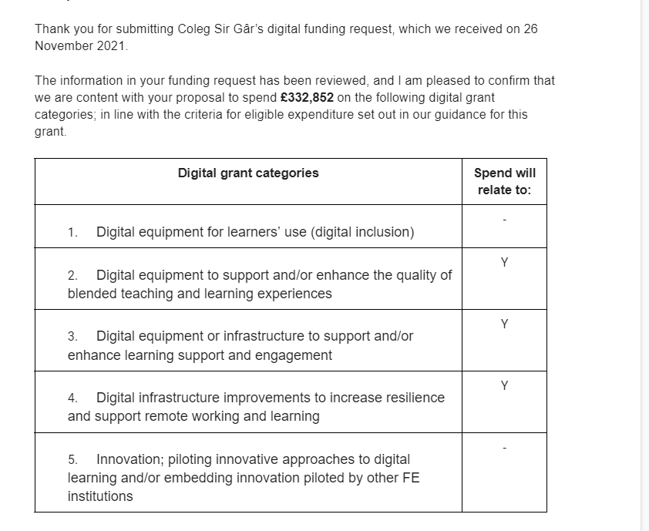

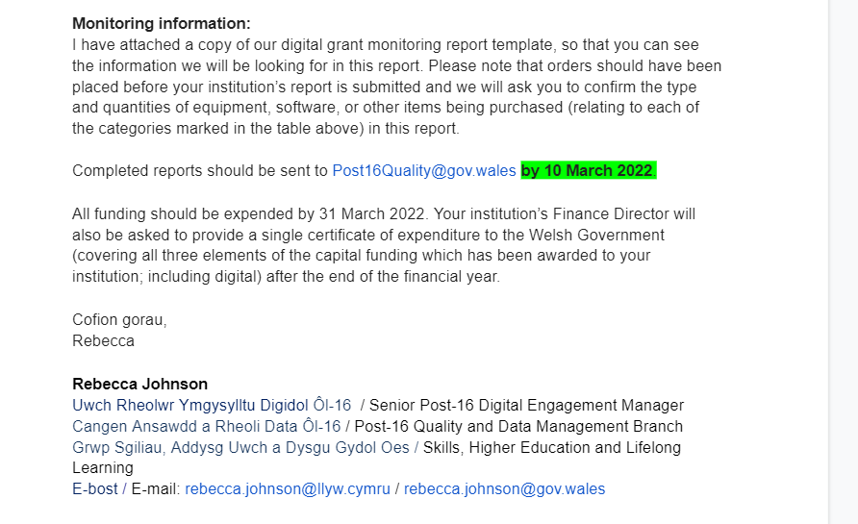

Appendicies 4 – Funding

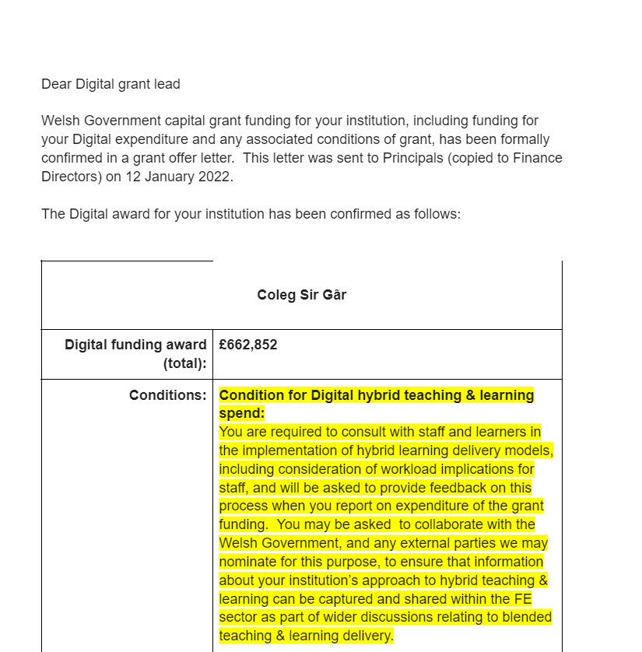
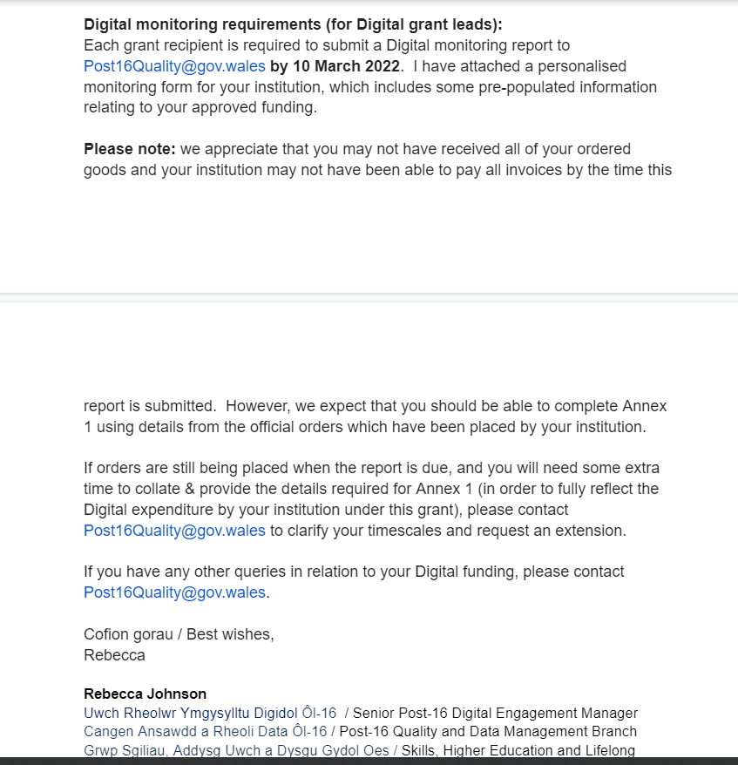

(Colegsirgar,2021)

