Anti-Hunt video report

Introduction/literature review

Aggression
Aggression is the term used to describe actions taken with the intent to injure another person (Espaillat et al., 20019). However, violence is defined as severe aggression that results in serious bodily harm. Emotional or impulsive aggression is the term used to describe aggressiveness that occurs without much thought or purpose. Cognitive aggression is defined as purposeful, premeditated aggressiveness.

Types of aggression

Verbal
In order to elicit a desired emotional response from the victim, verbal aggressiveness is the communication-based equivalent of punching them (Hammett, 2021). Bullying, which is emotional intimidation committed by someone in a position of authority over the victim and who is stronger than them, is another kind of verbal abuse.

Physical
Physical aggression is behaviour causing or threatening physical harm towards others. It includes hitting, kicking, biting, using weapons, and breaking toys or other possessions.

Gestural
People display their hostility by their body language, such as striking their own hand while looking at the target, moving their lips, or by glaring at the target.

Provocation
The tit-for-tat rule, which governs most social interaction, is followed in direct provocation aggression. A provocation or feeling of frustration results in verbally or physically aggressive behaviour that is directed at the provocation or feeling of frustration, usually matching, or slightly exceeding its intensity.

Theories of aggression

The frustration-aggression hypothesis
According to Miller (1941), the frustration-aggression hypothesis states that aggression is a result of frustration. Frustration is any event or stimulus that prevents an individual from attaining a goal and it is accompanying reinforcement quality. Likewise, frustration is a state of tension that develops when individuals’ efforts to accomplish a goal are thwarted. This hypothesis proposes that anger frequently results in aggressiveness. This distinction is crucial since variations and rewordings of the frustration-aggression hypothesis also imply this concept of frustration.

The aggressive cue theory
Leonard Berkowitz (1964) put out the theory that aggressiveness is impacted by the availability of social cues or conditions in the environment that normalise hostility. According to this idea, some environmental signals have a significant tendency to be connected with aggressiveness, and violent behaviour might serve as an aggressive trigger. A person will act more aggressively if they become frustrated in the presence of these signals.

Fox-hunting
For hundreds of years, fox hunting has been practised in various forms all across the world. In fact, numerous Greek and Roman-influenced nations, including ancient Egypt, practised utilising dogs with excellent senses of smell to track prey. As per the study of Greig (2021), the practise of using trained hunting hounds to locate, pursue, and frequently kill foxes is thought to have originated in England. However, the debate about the sport doesn't end there. On the other hand, membership in hunts has increased despite the ban, and the Masters of Foxhounds Association (MFHA) presently represents 176 active foxhound packs in England and Wales and 10 in Scotland.

Hypothesis
- H1: The anti-hunt group tends to display more aggressive behaviours in comparison to the pro-hunt group.

Methods

Design
In this research report, a quantitative content analysis research technique has been followed. This is because Graneheim et al., (2017) argues that its pros in terms of visual representation and graphical representation of the data which is considered more meaningful for the reader to understand the research problem, context of research and findings of the research (Lorca-Cabrera et al., 2021). Therefore, the current study has applied this technique to analyse the video showing the protestors protesting against the hunting of foxes on Boxing Day. The study aims to compare the aggression and the kind of aggression by both participants of this research, including anti-hunters and pro-hunters. The analysis is done on the basis of analysing mean values related to aggression shown by each category of protestors.

Participants
The video related to Boxing Day Hunt Protest shows that two groups of hunters or participants are protesting. The first group is comprised of a huge number of participants, which represents the anti-hunter group, and a number of these participants, almost 300, can be seen standing at the roadside holding banners with the slogan of anti-hunting. On the other hand, another group can also be seen, which are almost 15 protestors representing the category of pro-hunters and can be seen on the left side in the video riding on their horses along with hounds following the anti-hunter protestors. On the basis of these facts, it has been finalized that participants for this study are selected from both of the protestors-group, which is important to analyse the type of aggression shown by both groups. Therefore, participants are included in the discussion from both groups. Consequently, in total, six associates were selected from the anti-hunter groups, and three participants were selected from the pro-hunting group. All the participants were selected from the video posted on the Hunt protest on Boxing Day on YouTube in 2015. Therefore, in total, 9 participants are selected.

Materials
In order to record the data related to aggression and types of aggression shown by both types of protestors, video has been used as the material. The scoring grid provided is used to record the readings related to the type of aggression by anti and pro-hunting groups during the protest. The grid created is depicted below;
Table 1 Scoring grid measuring the aggression of anti and pro-hunter groups
Aggression Type | Anti-Hunt | Pro-Hunt
Verbal | l l l l l | l 1
Physical | l l l | l l
Gestural | l l l 1 | l
Provocation | l l 1 | l l 1

Procedure
In order to assess the behaviour of anti and pro-hunters, the video has been watched numerous times in order to develop a true understanding of the aggressive behaviour shown by each participant group during the hunting protest. It has provided a meaningful way of recording the true depiction of different aggressive behaviours. However, Graneheim et al., (2017) argues that quantitative content analysis methods lead to chances of biasness, as by watching graphical animated content, recording of behaviour cannot be done appropriately. Therefore, the chances of biasness mitigated by watching the video numerous times before recording behaviours (Lorca-Cabrera et al., 2021).

Results and Discussion
According to the arguments of Ullah et al., (2018) in order to remove the issue of biases, the inclusion of variables can be an effective way, particularly while applying the quantitative content technique for data analysis. Therefore, four types of variables are used as aggressive behaviour, which include verbal aggression, physical aggression, gestural aggression, and provocation aggression. Vogt et al., (2015) describes verbal aggression are using high-pitch noise or using slang, or shouting during the protest. Physical aggression is described by Balci and Salah, (2015) as the demonstration of physically abusing people and their belongings, riots and strikes or damaging public property during the protest. Further, gestural aggression is described as showing gestures not considered smooth, which includes hands chopping, pointing fingers, invading space, or eyeballing (Hasanagas and Bekiari, 2016). Lastly, provocation is the aggressive, emotional responses from the public holding protests.

Mean Comparison
The comparison of the types of aggression shown by both types of protestors is represented by table 2 and figure 1 below.
Table 2 Mean score of participants for showing types of aggressive behaviours
Aggression Type | Mean for Anti Hunt | Mean for Pro Hunt
Verbal | 83% | 67%
Physical | 50% | 67%
Gestural | 67% | 17%
Provocation | 50% | 100%

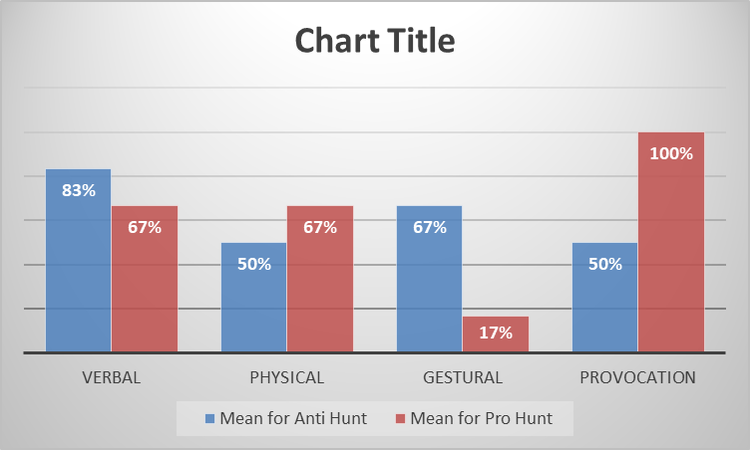
The above table and figure demonstrate that in the entire protest among 6 selected participants from anti-hunting groups, 83% showed verbal aggression that they raised their voices to prevent fox hunting. On the other hand, physical aggression, such as damaging public property, has been shown by 50% of the anti-hunters, which is described by Ābele et al., (2020) as aggressive behaviour that causes additional losses rather than benefits from protests. Moreover, 67% of the protestors have shown gestural aggression, and 50% have shown provocation aggression, such as weeping or crying or demonstrating affection with fixes to prevent their hunting. Balci and Salah, (2015) argues that it is the most outcome-oriented demonstration of aggression as emotional attachment hits a huge number of audiences in the protests.
On the other hand, among total pro-hunter protestors, 67% have shown verbal aggression, whereas physical aggression has been shown by almost 67% of the protestors, and 17% have shown gestural aggression, and lastly, 100% of the participants from the pro-hunting group have shown aggressive provocation behavior. In order to conclude these arguments, it can be said that most anti-hunters protestors have shown verbal aggression to record their protest, whereas least of them used physical and provocation aggression. On the other side, all protestors have shown provocation aggression, and the least have shown gestural aggression.

References
Ābele, L., Haustein, S., Møller, M. and Zettler, I., 2020. Links between observed and self-reported driving anger, observed and self-reported aggressive driving, and personality traits. Accident Analysis & Prevention, 140, p.105516.
Balci, K. and Salah, A.A., 2015. Automatic analysis and identification of verbal aggression and abusive behaviors for online social games. Computers in Human Behavior, 53, pp.517-526.
Berkowitz, L., 1964. Aggressive cues in aggressive behavior and hostility catharsis. Psychological Review, 71(2), p.104.
Espaillat, A., Panna, D.K., Goede, D.L., Gurka, M.J., Novak, M.A. and Zaidi, Z., 2019. An exploratory study on microaggressions in medical school: What are they and why should we care? Perspectives on medical education, 8(3), pp.143-151.
Graneheim, U.H., Lindgren, B.M. and Lundman, B., 2017. Methodological challenges in qualitative content analysis: A discussion paper. Nurse education today, 56, pp.29-34.
Greig, T., 2021. Reassessing the Rationale and Ritual of Hunting in the Changing Natural World of Post-Restoration England. The Court Historian, 26(1), pp.44-57.
Hammett, J.F., 2021. Contextual Predictors of Intimate Partner Violence Among Ethnically Diverse Newlyweds Living with Low Incomes. University of California, Los Angeles.
Hasanagas, N. and Bekiari, A., 2016. An exploration of the relation between hunting and aggressiveness: Using inmates networks at prison secondary school as an Illustration. Social Networking, 6(1), pp.19-37.
Lorca-Cabrera, J., Marti-Arques, R., Albacar-Rioboo, N., Raigal-Aran, L., Roldan-Merino, J. and Ferre-Grau, C., 2021. Mobile applications for caregivers of individuals with chronic conditions and/or diseases: quantitative content analysis. International Journal of Medical Informatics, 145, p.104310.
Miller, N.E., 1941. I. The frustration-aggression hypothesis. Psychological review, 48(4), p.337.
Ullah, S., Akhtar, P. and Zaefarian, G., 2018. Dealing with endogeneity bias: The generalized method of moments (GMM) for panel data. Industrial Marketing Management, 71, pp.69-78.
Vogt, M., Bormann, N.C., Rüegger, S., Cederman, L.E., Hunziker, P. and Girardin, L., 2015. Integrating data on ethnicity, geography, and conflict: The ethnic power relations data set family. Journal of Conflict Resolution, 59(7), pp.1327-1342.

