The Importance of Training and Exercising for Organisations under the Civil Contingencies Act (2004)
By
Amy Dauncey

Introduction
The Civil Contingencies Act (2004) was introduced to provide a framework for emergency preparedness and response across responding agencies within the UK (Civil Contingencies Act, 2004). The act identifies those agencies with a responsibility to prepare, respond and recover from emergencies. These agencies are designated within the Civil Contingencies Act as category 1 and category 2 responders. These organisations have a responsibility to conduct training and exercise events to meet statutory obligations. Failure to adequately train staff and test plans can have far reaching consequences, including causing unnecessary harm to members of the public, responders and reputational damage to the organisation.
This document will explore why testing and exercising is so important, the relevant legislation and guidance that supports the need to test organisational and multiagency response plans to maintain high standards and create an environment of continuous improvement. This document will also explain the importance of adequate preparedness and how lessons are identified, fostered and implemented and what recent public enquiries have identified about gaps in training and exercising.

- The Civil Contingencies Act (2004): Duties on responders to train and exercise
The Civil Contingencies Act (2004) was introduced in the United Kingdom to strengthen the resilience framework by placing duties on responding agencies both in the public and private sector to prepare for emergencies.
Category 1 responders as defined by the Civil Contingencies Act (2004) are described as being the core of the emergency response these include emergency services, local authorities, NHS bodies, National Resource Wales and the coastguard. Category 1 responders are required to assess risk, plan for emergencies and have adequate business continuity plans.
Category 2 responders are described as cooperating bodies who will be heavily involved in incidents that affect their sector. These include utility companies, transport operators and communication providers. Category 2 responders are required to cooperate with category 1 responders and to share information where required.
(Civil Contingencies Act, 2004)
Statutory Duties
Section 2(1) of the Civil Contingencies Act places a duty on category 1 responders to:
- Assess the risk of emergencies occurring
- Maintain and test emergency plans
- Provide training and conduct exercises to ensure the effectiveness of the emergency response plans.
(Civil Contingencies Act 2004,s.2(1))
Category 2 responders are not required to create their own emergency plans, but they must cooperate with Category 1 responders and support training and exercising efforts.
Each of the duties under the Act fits together to ensure all responders work effectively to meet the requirements set out to ensure an effective and joined up response to preparing for emergencies, which includes the testing and exercise of emergency response plans. (Civil Contingencies Act, 2004)
Compliance
Compliance with the CCA is achieved through a number of ways. This includes;
Risk Assessment -The National Risk Register (NRR) has been developed by Central Government to identify the most serious risks facing the UK. The NRR is developed as the external version of the National Security Risk Assessment (NRSA). (National Risk Register 2023). The risks identified within the NRR are deemed as those that would have a substantial impact on the safety, security and/or critical systems within the UK. Welsh Government have created a new Wales risk register with an implementation date of November 2024, this looks at the key risks that are tailored specifically to Wales and covers risks not detailed in the NRSA.
Emergency plans – The development of emergency plans to meet the requirement of the identified risk from the risk register. These plans should deal with how the responding agency will effectively respond to the identified risk.
Training and exercise – In order to ensure that the emergency plans developed are fit for purpose it is imperative that these plans are tested, and that staff receive adequate training to ensure that they are aware of the plans and are competent to carry out the duties detailed within.
Evaluation and review – Following any activation of an emergency plan, whether as a live activation or as part of a test and exercise it is important to ensure continuous improvement by completing debriefs of incidents and activations and implementing any recommendations.
Compliance with these duties ensures that organisations can respond effectively to emergencies and meet their legal requirements.(Civil Contingencies Act 2004).

- Guidance and best practice for training and exercising
Legislation alone can not ensure preparedness. Organisations must adopt guidance and best practice to maintain high standards.
Emergency Preparedness Guidance (Cabinet Office, 2012)
Central government provides comprehensive guidance which outlines how organisations are required to meet their duties under the Civil Contingencies Act. Key recommendations within the act include;
- Training – staff must be trained to conduct their role effectively
- Exercises – play an essential role in strengthening resilience, enabling validation of plans in order to deliver an effective response
- Evaluation – exercises must be reviewed to identify areas for improvement.
The guidance promotes a structured approach to preparedness, ensuring consistency and accountability. (Emergency Preparedness Guidance, 2012)
Joint Emergency Services Interoperability Principles (JESIP)
The JESIP Framework provides principles for a multi-agency response to incidents. Through a coordinated approach to training it will allow for a more effective response to an incident. In order to achieve this, emergency responders are encouraged to work together to develop joint emergency plans, provide joint training through multi-agency exercises to test interoperability and to ensure communication and coordination using decision making models such as the JDM (Joint Decision Model). (Joint Emergency Services Interoperability Principles v3.1, 2024)
ISO 22301: Business Continuity Management Systems
ISO 22301 provides international standards for business continuity planning. It promotes regular training and exercising to validate continuity plans. (International Organisation for Standardisation, 2019).
Local Resilience Forums (LRFs)
LRFs were created in 2004 as part of the civil contingencies act. LRFs are partnerships that bring together organisations defined under the CCA as category 1 and 2 responders to coordinate emergency preparedness. The LRF will organise joint exercises ensuring that organisations collaborate and share best practice to support continuous improvement.
Lessons from Major Incidents
Best practice often emerges from analysing the response to real incidents, these incidents can be local to your area or you can take learning from other areas where the response has been part of a debrief process, inquiry or review. These documents are beneficial to inform emergency planners of situations that have arisen that could be avoided. Recent examples of inquiries that have provided recommendations specific to training and exercising are;
  - Grenfell Tower Inquiry – this highlighted the importance of training staff to understand evacuation protocols and communication processes. (Grenfell Tower Inquiry, 2019).
  - Manchester Arena Bombing Review – this emphasised the need for joint exercises to improve multiagency coordination. (Manchester Arena Inquiry, 2023).
JESIP provides an opportunity to share learning through the Joint Operational Learning (JOL) portal, this allows learning and notable practice to be shared between responding agencies to feed the development and improvement of response plans.

- Training
Cabinet Office Guidance, Emergency Planning and Preparedness: Exercises and Training (updated November 2014) provides recommendations as to what should be considered in training of individuals who could be involved in an emergency response;
- The contents of the emergency plan - how the emergency is invoked, what are the key decision making processes and who else needs to be involved.
- The individuals role in implementing the plan – what is expected of them and how do they fit into the wider picture.
- The key skills and knowledge required in crisis response.
(Chapter 5 Emergency Planning and Preparedness, revised 2014)
The level of training required for individuals within an organisation is determined by the role they are expected to carry out. A cyclic process for developing, delivering and evaluating training can be used:

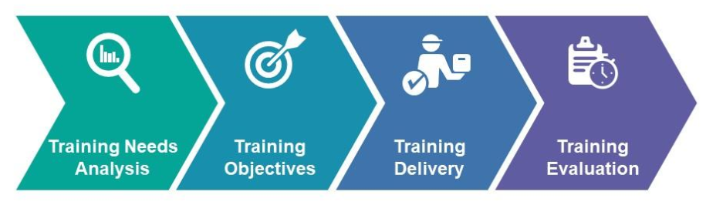

- Exercise
Once training has been delivered, the individual should confirm their knowledge through attending an exercise that will allow the implementation of knowledge gained in a controlled but challenging environment. Exercising Best Practice Guidance, published in 2024 has been jointly developed by the Cabinet Office and its Emergency Planning College (EPC), this document provides a framework for those working in the public sector to ensure that through exercising of plans that our preparedness for the risks we face are continually reviewed and strengthened.
There are three main types of exercise as detailed within the Cabinet Office Guidance, Emergency Planning and Preparedness: Exercises and Training and Exercising Best Practice Guidance (2024). These types of exercise are:
- Discussion exercises – these types of exercise are easy to prepare and run, they are essentially a talk though of a plan which are often used for training purposes to raise awareness of an existing plan.
- Table top exercises – this type of exercise is normally used to validate a plan through the use of realistic scenarios that is designed to explore weaknesses in the emergency response. These types of exercise can be run in a single room or across a number of rooms to stimulate communications between different groups of responders.
- Live exercises – this type of exercise involves the live rehearsal of plan implementation and are useful for testing logistics, communications and the physical capabilities of responding organisations. This type of exercise requires extensive preparation and can be expensive to run but provide an excellent opportunity for participants to develop confidence in their ability to respond to a specific type of incident.
(Exercising Best Practice Guidance, Cabinet Office, 2024)

- Benefits of Training and Exercising
Training and exercises are essential for building organisational preparedness and resilience.
Improved response capabilities - Through effective training and exercising it allows organisations to improve response capabilities ensuring staff can perform their roles effectively during emergencies and tests the robustness of plans under simulated conditions allowing organisations to identify gaps and put measures in place to address the issues prior to a real incident occurring.
Enhanced coordination and communication
JESIP supports the role of interoperability between responding agencies, this allows for improved communication and interoperability between organisations to provide an enhanced coordinated response.
Learning opportunities
The benefit of conducting regular training and exercise programmes is that it allows for weaknesses in plans to be identified, helps organisations identify lessons and implement changes to improve preparedness.
Organisational and public confidence
Regular training and exercising demonstrate an organisation’s commitment to preparedness, improving stakeholder trust and public confidence. Compliance with legal duties protects organisations from potential litigation.

- Identifying Lessons from Exercises and Applying Learning
The Lessons Management Best Practice Guidance published by the UK Resilience Academy in September 2024 has been designed for use as Best Practice guidance for organisations to use to assist in capturing lessons from exercises and plan activations.
The guidance states;
‘In the civil contingencies resilience context, the purpose of learning lessons and capturing positive practices is to drive continual improvements in the way that individuals, teams, departments, organisations, and multi-agency partners anticipate, assess, prevent, prepare, respond to, and recover from emergencies. Learning is therefore integral to managing risks’. (Lessons Management Best Practice Guidance, Cabinet Office, 2024, p.1)
In essence, effective organisations ensure that lessons identified from exercises are applied to improve emergency planning and response. The Lessons Management Best Practice Guidance gives a guide to evidence based learning from the point of experience, through to longer term embedding of change. Effective lessons management include
- lessons identified,
- lesson prioritisation,
- lesson implementation and
- embedding change to support continuous improvement,
as depicted in the lessons management framework illustration.
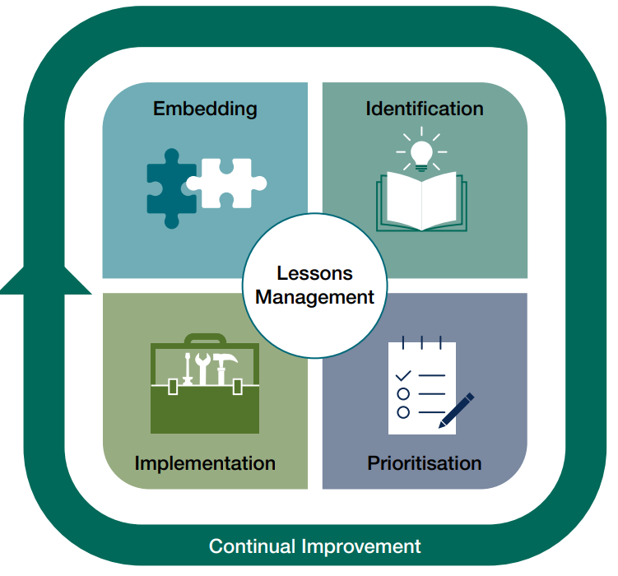

There are a number of ways that lessons can be captured, the planning for capturing lessons must start at an early stage of the planning process, much like recovery should be an early consideration of the response process. This allows for focus to be set during the planning stage with agreed structures set on how to best capture lessons and how those lessons will be shared and embedded into organisational learning.
Post Exercise Debriefs and Evaluations
- Hot Debriefs – Conducted immediately after an exercise to capture initial observations. These sessions are short and sharp, they focus on the specific objectives set for the exercise.
A popular hot debrief methodology uses a grid approach to focus on 5 questions;
  - Remember to thank for participating
  - What went well? Why did it go well?
  - What did not go so well?
  - Why did it not go so well?
  - What key issues or actions have arisen?
(Exercising Best Practice Guidance, Cabinet Office, 2024)
- Cold debrief – These are more detailed evaluations of the exercise and are held after further analysis of the exercise has taken place. A cold debrief is considered best practice and should be held within a few weeks of the exercise taking place to capture learning whilst the event is still fresh in participants minds.
- Structured reports – These reports are generally pulled together from capturing the learning from both hot and cold debriefs. The report will document key findings, recommendations and actions.
Lessons Identified vs Lessons Learned
Lessons identified during exercises must be converted into actionable learning. The difference between lessons identified and lessons learned lies in the degree of application and incorporation of the knowledge gained from an experience, in this case an exercise.
This involves:
- Updating emergency plans based on recommendations
- Delivering additional training to address gaps
- Monitoring and evaluating changes to ensure improvement.
Lessons identified become lessons learned when they are acted upon and embedded into an organisations culture.
Continuous Improvement Cycle
Organisations should adopt a continuous improvement approach to learning and embedding lessons learned.
- Plan – Develop and maintain emergency plans
- Do – Train staff and conduct exercises.
- Review – Evaluate exercises and incidents to identify lessons.
- Act – Implement changes and monitor improvements.

- Lessons from Public Inquiries: Gaps and Recommendations
Recent public enquiries have highlighted both successes and failures in organisational preparedness and training. These inquiries highlight the importance of training and exercising and provide key lessons for improvement.
Grenfell Tower Inquiry (2017)
The Grenfell Tower fire exposed significant failures in preparedness and response, including the lack of training within the fire service for dealing with incidents of this nature. It also identified a need to foster robust collaboration between emergency services, to include joint training and exercises and shared protocols.
The recommendations highlighted the requirement for enhanced training on evacuation protocols and fire safety, and regular exercise to test interoperability of responding agencies. (Grenfell Tower Inquiry, 2019).
Manchester Arena Bombing Review (2017)
The Manchester arena bombing review has highlighted several critical areas for improvement in emergency response protocols. The review identified failures in multiagency coordination and communication. Emergency services did not coordinate effectively during the initial response to this incident which resulted in unnecessary deaths occurring. It was identified that there was insufficient joint training and exercise which contributed to confusion and lack of cohesion between emergency responders.
The recommendations from the report have states that regular JESIP training is required to improve interoperability of responding organisations and that multiagency exercises are required to test communication and coordination to enhance the response to major incidents in the future. (Manchester Arena Inquiry, 2023).

COVID-19 Pandemic
The pandemic highlighted challenges in preparedness for public health emergencies. The initial findings from the COVID enquiry have shown that there was inadequate training for healthcare and public health staff and limited testing of pandemic response plans.
The report has recommended that there are regular simulations of large scale public health emergencies and that enhanced training is required on infection control. (UK Covid-19 Inquiry: Resilience and preparedness (Module 1) report, 2024)
Learning from Past Incidents
A recurring issue in public inquiries highlights the failure to implement lessons identified to make them lessons learned. There needs to be a structure to monitor implementation of recommendations and a mechanism to hold leaders accountable for improvements.
- Developing an Organisational Training and Exercise Programme
A successful training and exercise programme must align with legislative requirements, guidance and best practices. There must be governance and leadership which provide clear policies and procedures for training and exercise.
Training and exercise should reflect identified risks, using the community risk register for the area to set the prioritise for the programme.
The types of learning must be achievable and enhance the learners experience to allow them to take the most out of the experience.
Maintaining records of any exercises or training sessions is essential to demonstrate compliance with statutory duties.
Conclusion
The Civil Contingencies Act 2004 places clear statutory obligations on organisations to train and exercise, ensuring that they are prepared to respond to emergencies. Compliance with this legislation, supported by government guidance and best practice as documented in this assignment is critical for ensuring an effective and coordinated response to dealing with emergencies.
There are numerous benefits to implementing a robust training and exercise programme. These include improved response capabilities, enhanced coordination, and continuous improvement. Recent public enquiries have highlighted the consequences of inadequate training and the need to learn from past incidents. Through developing a training programme it ensures organisations comply with the legal obligations set out for them and facilitates realistic testing of emergency plans.
Providing responders with exposure to plans through an exercise programme promotes public safety and trust as the familiarisation of plans allows for responders to act more efficiently and quickly during a live incident building trust within communities when they know responders are well prepared and equipped for incidents.
Taking learning from any training and exercise event is paramount to adopting an environment of continuous improvement. Using the identified methods of capturing learning through a debrief process allows for scrutiny of plans and procedures to enhance the response to emergencies.
In summary, developing a robust training and exercise programme requires strong leadership, a risk based approach and a commitment to continuous improvement. By embedding a culture of preparedness organisations can meet their statutory obligations and protect lives, property and reputations during emergencies.

References
The author has drawn on the following sources to complete this assignment:
Civil Contingencies Act 2004: a short guide (revised). London: The Cabinet Office. Available at: Microsoft Word - 06 05 15 Short guide _final_.doc (Accessed:6th December 2024).
Civil Contingencies Act 2004, Chapter 5 Emergency Planning 2011. London: The Cabinet Office. Available at: Emergency_Preparedness_chapter5_amends_21112011.pdf (publishing.service.gov.uk) (Accessed: 6th December 2024).
Cabinet Office, (2010 revised 2013). Emergency response and recovery. [online] GOV.UK. Available at: https://www.gov.uk/publications/emergency-reponse-and-recovery (Accessed: 6th December 2024).
UK National Risk register guidance 2023, London: HM Government. Available at: 2023_NATIONAL_RISK_REGISTER_NRR.pdf (publishing.service.gov.uk) (Accessed:7th December 2024).
Joint Emergency Services Interoperability Principles (JESIP) 2024, Ed 3.1 Available at: https://www.jesip.org.uk/downloads/joint-doctrine-guide/#download-1145-PDF (Accessed: 8th December 2024)
Moore-Bick, The Right Honourable Sir Martin. (2019). Grenfell Tower Inquiry: Phase 1 report. London: Cabinet Office. Available at: HC 49-I – The Grenfell Tower Inquiry: Phase 1 Report – Volume 1 of 4 (Accessed: 8th December 2024)
Kerslake, L. (2018). The Kerslake Report: Review of the Manchester Arena Attack. Available at: The Kerslake Report 2018 - JESIP Website (Accessed:17th December 2024)
Chairman: The Hon Sir John Saunders. (2024). Manchester Arena Inquiry Volume 2: Emergency response. [Online]. Available at: Manchester Arena Inquiry Volume 2: Emergency Response - GOV.UK (Accessed: 17th December 2024)
World Health Organization (WHO), (2020). Learning from COVID-19: Building Preparedness for Future Pandemics. [online]. Available at: 9789240086531-eng.pdf (Accessed: 10th December 2024)
Cabinet Office, (2024). Exercising Best Practice Guidance. [online] GOV.UK. Available at: Exercising Best Practice Guidance (HTML) - GOV.UK (Accessed:8th December 2024)
Cabinet Office, (2024). Lessons Management Best Practice Guidance. [online] GOV.UK. Available at: https://assets.publishing.service.gov.uk/media/66f2af157da73f1717764099/14.487_CO_UKRA_Lessons_Management_Guidance (Accessed: 6th December 2024)
ISO. (2019). ISO22301:2019 – Security and resilience- Business Continuity Management Systems – Requirements. Geneva: ISO. Available at: ISO 22301:2019(en), Security and resilience — Business continuity management systems — Requirements (Accessed: 6th December 2024).
Cabinet Office, (2024). UK Covid 19 Inquiry: Resilience and preparedness (Module 1) report. Available at: UK-Covid-19-Inquiry-Module-1-In-Brief-Report.pdf (Accessed: 12th December 2024)

