

Module: Protecting and Supporting Families in Health and Care

Module code: BMHP5021

Lecturer: Amanda Jones

Student: Diyana Vasileva

Student ID :2328440

Component 2 – Written Report

The "Early Help" System in the UK

The Early Help system in the UK is a significant part of the country's plans for protecting children and supporting families. It is "designed to identify and address emerging needs before they escalate into statutory intervention." (Department for Education, 2018). Early Help is a multi-agency framework, but local administrations oversee public communication. This report aims how local government websites point families to Early Help and how Leeds City Council, Norfolk Council, and Southwark Council now communicate online.
Local government websites are places where people can find information, get help, and learn about services. In the context of Early Help, they are meant to tell families what support is available and how to get it. Digital government literature stresses that how easy it is to use and how clear it is can make online communication easier or harder to access (Margetts and Dunleavy, 2013). But, as Lips (2019) points out, the way public services communicate is typically based on how the organisation is set up rather than what the users need.

Research on public service language shows that using a lot of jargon can make it harder for people to understand and make them more anxious (Needham and Dickinson, 2018). This is especially important when it comes to family support, since parents may already feel weak or afraid of being judged.
Local government websites list the different services that Early Help offers, such as help with parenting, mental health and emotional well-being, domestic violence, financial or housing guidance, and focused juvenile interventions. This wide range of services is in line with the comprehensive philosophy of Early Help, which attempts to meet needs in families, schools, and communities (Daniel, 2015).
Effective Early Help signposting needs clear referral mechanisms. A lot of councils include self-referral options, so families can get in touch with Early Help teams by phone, email, or online forms. But these forms are generally based on professional referral processes that need a lot of specific information about the situation or from many agencies that families may not have. This intricacy can discourage self-referral.
Websites often have clear information about how to get a professional referral, usually through schools, health visitors, or GPs. But putting too much emphasis on professional routes can make it seem like Early Help isn't meant for parents to use directly, which goes against the policy goal of open, early intervention.
The way things look is also different. Digital communication research shows that multimodal resources are useful (Koltay, 2016). Websites that use diagrams, movies, or step-by-step directions make information clearer. But a lot of councils use complex material, which makes it harder for families that don't read or write well, have learning problems, or don't speak English well. Digital exclusion makes this much harder; families who don't have dependable computer access may have a hard time if Early Help content isn't suited for mobile use (Ofcom, 2023).
This is a report of how Norfolk County Council, Leeds City Council, and Southwark Council talk about Early Help and other family support programs on their local government websites.
All three councils put Early Help information online and follow the law, but they are very different in terms of how easy it is to find, how easy it is to refer someone, and how much family-facing content they use. Leeds and Southwark have clearer front-door routes and family hub framing, while Norfolk has good procedural detail but is more geared towards professionals.
In Norfolk, Early support can be found on the council's website and on related community and family hubs. There are separate pages for "Early help for children and families," uploading assessments, and making requests, although the content is spread out over several pages. This gives families a lot of options, but it can also feel like there are too many choices when they want a clear path. Definitions and process guidance are in line with the law, but many pages are more procedural and have information for professionals, which could make them seem too technical to parents. The main Early Help page for Norfolk does have family-facing statements, but professional resources can often take over search results. Has both family/friend and professional referral forms, as well as a "Request for support" website that explains triage and family hub services. However, recommendation assistance comes with professional templates and directions for uploading, which can make self-referral seem official. There is a strong connection between the procedures for uploading, triaging, and getting help from professionals through the Norfolk Safeguarding Children Partnership. However, the overlap with professional channels may make it hard for some families to see that Early Help is not mandatory.

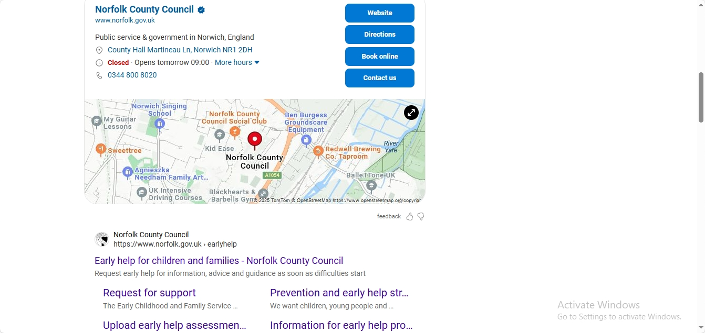
Leeds uses Family Hubs as the major access point and offers "one-minute guides" and a strong local offer. Children and families’ pages and family hubs promote Early Help, providing a clear front door. Early Help is advertised through children and families’ pages and family hubs. The content employs short, simple guides called "one-minute guides" and stresses "right conversation / right person / right time" with Family Hubs as access points. The language is more family-friendly and easy to understand. Leeds also has a Family Information Service signpost that points people to all kinds of help. Family Hubs are clearly marked as the place to go for help, Leeds also gives both practitioners and families information, with a focus on quick, conversational responses through local hubs. This makes it easier for families to find the first touch points. Explicitly frames Early Help as collaborative and open to all, with Family Hubs connecting to universal services. Leeds message highlights early talks by familiar experts. This shows why Early Help is different from statutory social care while yet illustrating how people can work together.
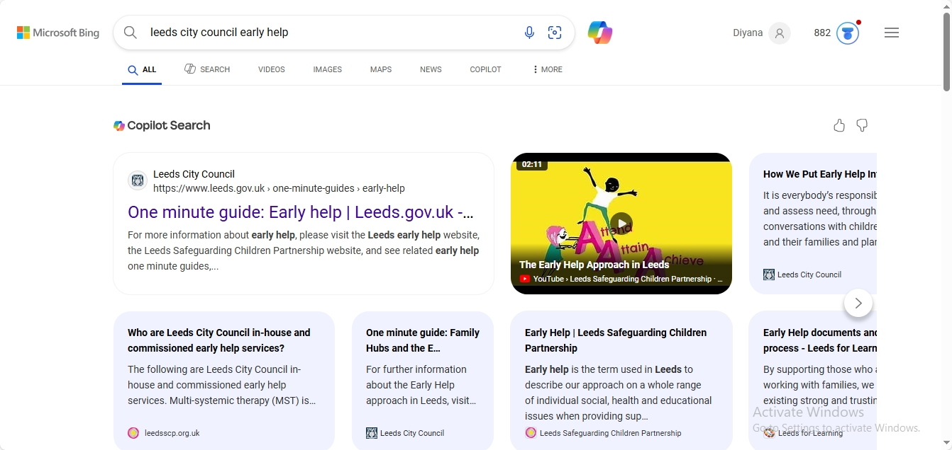

Southwark puts Early Help under Children & Families, with clear subpages that explain the difference between universal and extra Early Help and give clear directions on how to contact or refer someone (phone numbers, duty manager, school referral routes). It is easy to find the "Family Early Help" information, and it is part of the Local Offer/family support network. Pages clearly show the difference between general Early Help and Extra Early Help, and they employ family-cantered language (parenting programs, whole family casework) with real-life examples. The tone is mostly helpful and practical. It gives the Family Early Help duty phone number and clear directions for school referrals. It also makes it clear which programs are available to everyone, and which ones need extra help. Southwark's clear phone number and school referral path are easy for both families and professionals to understand. It explains the difference between universal and extra help, names partner organisations, and the Family Early Help plan. It also connects to children's social care for more serious needs. The boundaries are clearly specified in a form that is easy to understand.
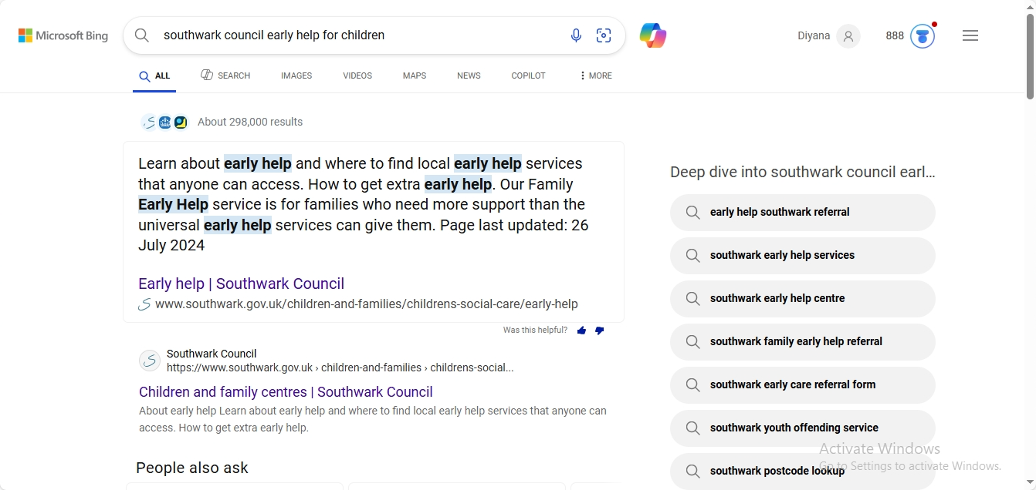
Leeds and Southwark both have one well-known access point (Family Hubs / Family Early Help) that helps families. Norfolk has a lot of information, but it's spread out over more professional-looking pages, which can make it less clear for families right away. Southwark has the clearest single-step contact (phone/duty manager) for more help. Leeds has obvious hub channels and universal signposting. Norfolk has many routes; however, the formality of referral paperwork might be a problem for some parents. Leeds and Southwark make it clearer that Early Help is voluntary and meant to prevent problems, together with partner services. Norfolk's presentation is thorough but more focused on practitioner guidance.
The Council of Norfolk County website is clear with full directions about how to do things (assessment templates, upload instructions, triage procedure).There is clear information about services and family hub models, but the referral forms and upload pages are geared towards practitioners (with templates and instructions), which can be scary. Suggestions for improvement is, all pages to be with simple language, examples, and a button to refer yourself.
City Council of Leeds website has short guide and point people to family information. Family Hubs are easy to find. Although connecting with the Family Information Service and the Local Offer makes it easier for everyone to seek general and specific help, the sites might be big, so you may need to go deep to get some information. Suggestions are to put brief movies that explain everything and easy flowcharts on the Family Hubs page to make things even easier for parents.
It's easy to get help since there are clear differences between universal and additional Early Help, and there are clear phone numbers and school referral pathways in Southwark Council official website. Connection with Local Offer and parenting programs is good, using terminology that is easy for families to understand. Suggestions for improvement is to keep the duty phone number and online referral easy to find so people can get to them quickly.
The fact that Norfolk County Council, Leeds City Council, and Southwark Council all agree that Early Help is a good way to stop problems before they start and focus on families shows that they all agree. All three give comprehensive definitions of Early Help and make it easy for families to ask for help. Leeds has good communication through its Family Hubs model and well-organised, easy-to-understand content. Southwark, on the other hand, has especially strong safeguarding information and straightforward ways to report problems. Norfolk has a lot of Early Help resources, but they are spread out over several different pages, which makes it harder to find what you need.
The investigation also shows that all three authorities have some weaknesses in common. These include inconsistent signposting, different levels of plain-English accessibility, and not enough use of real-life examples to help families understand when Early Help could be good for them. Studies regularly demonstrate that parents are more inclined to seek assistance when material is straightforward, relatable, and easily navigable (Bywaters et al., 2016; Whittaker, Malone, and Cowley, 2021). Enhancing clarity and accessibility could therefore elevate participation and diminish referrals to statutory services, in accordance with national directives that stress early, preventive intervention (DfE, 2018; EIF, 2021).
Suggestions for Improvement: Local governments should make clear, unified Early Help landing pages that are easy to navigate and use the same words to make things less confusing (Local Government Association, 2020).
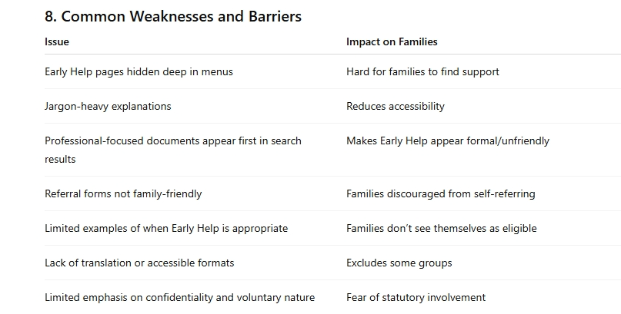
Using straightforward, family-friendly language instead of jargon will make it easier for people to get involved and would be in line with best practices for communicating with the public (Plain English Campaign, 2019).
Every Early Help site should provide a panel (phone, email, online forms) for each authority. Making Early Help available to all families, even those who require extra help with communication, would be possible by offering translated pages, Easy-Read versions, and accessibility features. Clearly stating that Early Help is optional and helpful helps lessen anxiety of getting involved with social care, which can lead to earlier engagement (Featherstone, White, and Morris, 2018).

References
Bywaters, P., Scourfield, J. and Featherstone, B. (2016) ‘Children in need and child protection: The impact of poverty, policy and practice’, British Journal of Social Work, 46(3), pp. 598–616.
Daniel, B. (2015) ‘Why early intervention matters: The evidence base’, Child and Family Social Work, 20(1), pp. 15–25.
Department for Education (DfE). (2018) Working Together to Safeguard Children. London: HMSO.
Early Intervention Foundation (EIF). (2021) Realising the Potential of Early Intervention. London: EIF.
Featherstone, B., White, S. and Morris, K. (2018) Re-imagining child protection: Towards humane social work with families. Bristol: Policy Press.
Koltay, T. (2016) ‘The media and the literacies: Media literacy, information literacy, digital literacy’, Media, Culture & Society, 33(2), pp. 211–221.
Lips, M. (2019) Digital government: Managing public sector reform in the digital era. London: Routledge.
Local Government Association (LGA). (2020) Early Help: A System Guide. London: LGA. The Early Help System Guide - Early Help System Guide (publishing.service.gov.uk)
Margetts, H. and Dunleavy, P. (2013) The second wave of digital-era governance. Oxford: Oxford University Press.
Needham, C. and Dickinson, H. (2018) The 21st-century public servant. London: Palgrave Macmillan.
Ofcom (2023) Online Nation Report. London: Ofcom.
Plain English Campaign. (2019) The A–Z of alternative words. Plain English Campaign.
Working Together to Safeguard Children 2023 - Working together to safeguard children 2023: statutory guidance (publishing.service.gov.uk)

