

Developing relationships and Workplace achievement

Performance Management

Essay & PDP
Submition Date: 17th December 2021
Pavlo Gladkyi
1918831

Task 1.

Introduction.

This essay was created on demand of Senior Lecturer Institute of Management and Health Brynach Heffernan as a part of Developing relationships and workplace achievement assignment.
To meet the BMSW5102 module assignment requirements, Pavlo Gladkyi submitted this essay on the stipulated date and time on 17/12/2021.
This essay will attempt to uncover specific aspects of effective performance management, discuss current problems and possible solutions, and how individuals and organisations can benefit from a precise and well-established performance management system.
Moreover, as a practical implementation example, Amazon's Performance management system was scrutinised and critically assessed. The research reveals the current problems of Amazon's performance management strategy and tries to uncover their root causes.
Ultimately, the author of the essay came to the conclusion that Performance management itself is a complex subject and plays a vital part in organisational success. Moreover, Performance management system stability depends on the amalgamation of various factors where employee motivation is crucial and have a tangible impact on their engagement in the work process.
Additionally, line managers must have the right abilities to approach and manage underperformance, decide on remedial actions that they should take to overcome it to forestall performance management appraisal problems.

Performance Management.

Armstrong (2018) defines Performance management as a constant personal or organisational performance improvement process. This continuous improvement should set, appraise, review and control individual, team or organisational goals achievement. Moreover, Performance management exists to identify barriers and gaps in employee performance and find a feasible solution to overcome or fix them to make individual, team or whole organisation more efficient. Additionally, the employer should provide underperformed employees needed support to develop missing skills and knowledge to improve their performance.
Furthermore, Periyasamy (2020) pointed out that a wide range of factors could negatively or positively impact employees performance. Moreover, he presumes that negative impact could be minimised or avoided if the relationship between employer and employees is well established, with efficient two-way communication, clear job description and code of conduct policies. Additionally, all employees should understand organisational strategic goals and how they are meant to be achieved.
Similarly, Deloitte Touche (2011) states that time constraints are another downside of performance management.
Current trends show significant importance of company kudos, positive Goodwill, effective Performance management systems and internal and external customer satisfaction strategies (Beardsley et al., 2007). That is why it is eminently crucial to keep abreast of all organisational key performance indicators, understand what internal and external factors could affect individual and overall performance, and identify remedial actions that must be taken to ensure that established goals are achieved in the most effective manner.
Indeed, Performance management has significantly changed from the First Industrial revolution times and is an ongoing process (Taşkan, Karatop and Kubat, 2020).
Furthermore, the organisational hierarchical structure model is also being shifted, whereby people from all organisation levels tend to share the same goals and are proactively involved in organisational success. In contrast, the vast majority of nowadays companies are still struggling to implement this followership model to overcome the outdated strict hierarchical structure of leadership (Kelley, 1988). Consequently, many employers today question the relevance of traditional performance management and, particularly, the performance evaluation methods (CIPD, 2016).
As a matter of fact, employers have to develop a practical and relevant performance appraisal, use emotional intelligence while engaging with employees, clarify the purpose and crucial points of performance assessment, define the needs and expectations of different employees generations to incentivise their motivation effectively.
Additionally, Gilchrist (2019) states that today Millenials are also renowned as Generation Y is currently the largest generation of workforce and expecting more control of their time, equity, reskilling and self-development, flexibility or remote working, compear to Generation X.
Similarly, Hastwell (2021) contended that COVID pandemic measures such as flexible work arrangements and remote working are tangible motivation points for Millenials that could affect their performance. Moreover, they are mainly motivated by an internal sense of fulfilment and expect more frequent feedback and coaching from their managers and mentors to amplify their development. As a result, they are more agile, ambitious and creative but not great team players and hardworking employees.
In contrast, Giang (2013) argues that Generation X is a revenue generator with a higher level of collaboration and teamwork, solid problem-solving skills, and innate relationship-building abilities.
Hard to disagree with Aguinis (2019) that there is a direct correlation between organisational performance and employees' behaviour. Hence, various factors need to be considered that can influence the behaviour of individuals or teams. These factors could include, but are not limited to, corporate culture, employee relations climate, level of administrative bureaucracy, leaders competency, feedback mechanism, organisational working practice and technology, recruitment process, award and recognition system, personal values and beliefs, employees motivation, external factors and environment.
It is noteworthy that today motivation at the workplace is under scrutiny, and employers have to consider its significant impact on employees performance and business success (Mullins, 2006, pp.184–185). Moreover, it is vital to understand what underlying processes or work-related factors can influence employees to perform better and be more engaged, or in contrast, what can impair their effort and make them actively disengage. As a result, companies started investing in various incentive programs to increase employees engagement, agility and job satisfaction. Therefore, companies are looking for effective, practically deployable motivation strategies based on modern management theories to make their employees happier and businesses more profitable (Brandon, 2016).

Amazon's application of Performance Management.

A fast business environment and global competition show that companies can no longer compete only on price and have to invest in their personnel development, use innovative management models where the motivation of the employees is one of the crucial factors (Mullins and Christy, 2016).
For instance, e-commerce leader Amazon seemingly demonstrates a great understanding of the aforementioned modern trends and needed adjustments in performance appraisals. However, research revealed some contradictory information about the performance management process that this tech giant deploys in practice (Kantor and Streitfeld, 2015).
According to PerformYard (2018), the company's current practice is a data-driven approach that provides coherent metrics to measure employee productivity and behaviour when the system shows underperforming rates. This scientific method has apparent merits because it can show all related to the individual performance data such as idle time, rate per hour, or attendance score that can be monitored and assessed. However, unfortunately, this method cannot consider other factors that the system could not monitor, such as personal life circumstances. And that is where the main problems start to emerge during the scheduled performance appraisal because it is not a fair and comprehensive practice.
Although Amazon has a strong leadership culture and continuously seeks the utmost recruits, not every line manager has an emotional intelligence skillset and ability to positively provide negative or constructive feedback that will incentivise employee improvement rather than create frustration (Impraise, 2014). Additionally, based on Amazon leadership principles, a performance management structure creates an unhealthy work competition environment where employees are forced to outperform each other. This meritocracy puts a significant amount of pressure on employees, and as a result, affect their morale during the performance appraisals.
From a positive point of view, the internal sources disclosed that Amazon stepped away from the "classical" annual appraisal and instead practised real-time performance feedback and provided a Performance improvement plan (PIP) to help underperformed employees improve their performance. Moreover, this formal process has a clear deadline, and unsuccessful improvement attempts can cause employee termination. Furthermore, according to Lin (2020), Amazon's PIP rate is about 10% higher than its competitors, and Amazon employees can be placed on a PIP even after a few weeks of employment.
Based on the gathered information, the following conclusions arise: Amazon unambiguously benefits from its performance management system because the company creates such a work environment where only the best performance workers can thrive. However, those best-performing employees will have constant occupational pressure and stress, which sooner or later will push them to leave the company.

Benefits for Organisation.

Undoubtedly, profit and cost-effectiveness are the intrinsically main objectives of any business. Therefore, organisations must develop and deploy effective performance management systems to cultivate and sustain a performance culture. As a result, employees will clearly understand organisational and personal goals and be supported by management on personal improvement journeys. Thus, to create the most beneficial performance management system, the company must implement practically achievable and time-proven solutions such as continuous performance evaluation, effective feedback and rewards.
Additionally, some authors are convinced that organisations will benefit if they supersede rule-based management on adaptive management (Salafsky and Margoluis, 2003). Furthermore, they should minimise organisational bureaucracy and trust employees to do their job, use transparency as a control mechanism, and always reward employees for their efforts. Another beneficial factor is access to training programs and other employees competence developing resources. It will increase employees competence in daily tasks execution and create encompassingly strong knowledge in how the company functions.

Moreover, well established self-regulating management will empower the employees, establish a quality recruitment process, and develop leaders who have the knowledge to inspire performance. As a result, the streamlined and well-calibrated performance management system will enable the organisation to boost employees morale and work attitude, increase attendance, identify needed skills and training to tackle time-critical tasks, improve workflow and labour planning, optimise a problem-solving process and reduce employees turnover.

Benefits for the individuals.

Natural HR (2019) states that the appropriate application of the Performance management system can positively contribute to employees' individual motivation and engagement, create an opportunity to identify training gaps and develop needed knowledge, skills, and abilities to be more efficient with their tasks. Moreover, it will help employees clarify organisational and individual goals and understand the company's expectations.
Additionally, regular and more frequent two-way feedback will increase the employees' motivation and engagement, encourage them to be more productive and autonomous, allowing them to self-manage their responsibilities and targets and be effective team players.
According to Asplund (2011), the benefits for the individuals are apparent because trained, motivated, and engaged personnel will share companys' values and beliefs, align them with their own ones to achieve maximum self-development and self-actualisation. Similarly, Juneja (2015) agrees that happy employees are more productive and valuable and, as a result, increase not only the company's profitability but also individual employability.

Conclusion.

To recapitulate, the demise of the traditional performance management appraisal process is apparent. The new trends in Performance management challenge leaders and make them move from managing to the inspiring performance by using motivation incentives, constructive feedback and creating carrier growth opportunities for their employees. Additionally, it has been proven that alignment between organisational and individual values and beliefs is essential as it will provide a powerful tandem for corporate and personal success. Moreover, there is no doubt that motivation and employees engagement today should be the main focal point for any organisation.

Task 2.
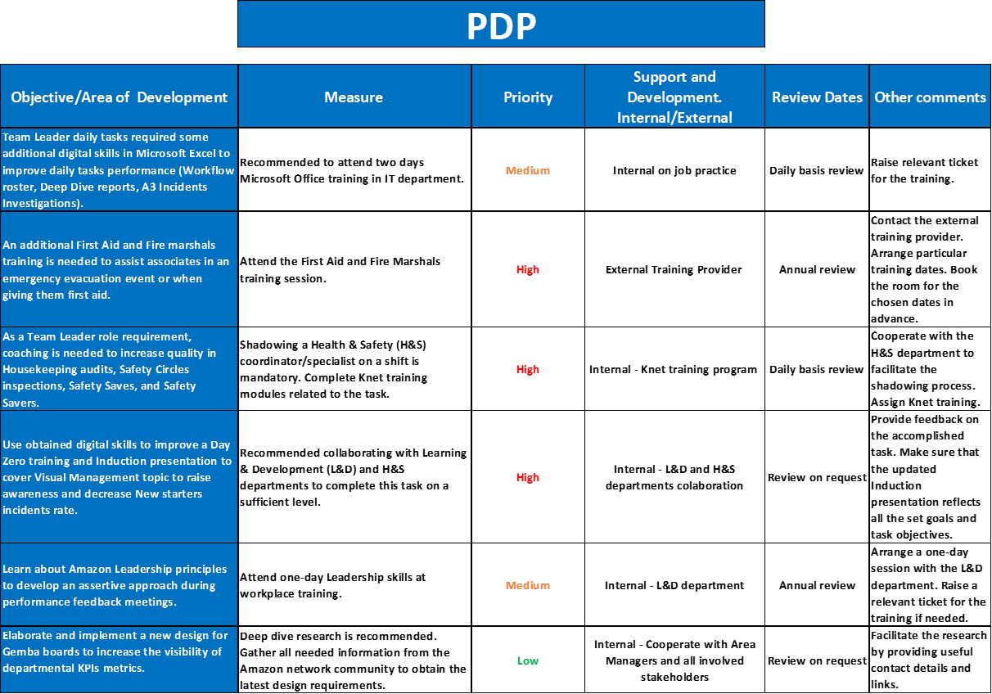

1. Team Leader daily tasks required some additional digital skills in Microsoft Excel to improve daily tasks performance (Workflow roster, Deep Dive reports, A3 Incidents Investigations).
As part of Amazon's continuous improvement strategy, Leaders should have a set of digital skills to complete daily tasks efficiently and in a timely manner. Leaders in Amason should be familiar with Microsoft Windows, Microsoft Office (Excel, PowerPoint, Word, Access, Teams, Note) because all daily and weekly reports, workflow rosters, charts, productivity trackers and A3 incidents investigations have to be completed in Microsoft Excel. The Amazon standard Visual management signs, information posters and training presentation slides are available in PowerPoint. All Process Map Visuals (PMVs), Standard operational Procedures (SOPs) exist only in Word document format and could be modified or created only in Microsoft Word.
2. An additional First Aid and Fire marshals training is needed to assist associates in an emergency evacuation event or when giving them first aid.
Amazon as an employer has a common law duty of care and has to take reasonable care to protect and support employees from the risks of foreseeable injury at work. Furthermore, due to these legal requirements, Amazon has to provide adequate training for non-medical personnel that can administrate first aid in the event of injury or support employees evacuation in case of emergency. Therefore, after a deliberation, Senior management decided that all Team Leaders and Line managers must attend the First Aid and Fire Marshal training course to obtain the needed skills.
3. As a Team Leader role requirement, coaching is needed to increase quality in Housekeeping audits, Safety Circles inspections, Safety Saves, and Safety Savers.
Amazon Team leaders have to identify and report any hazards in their department or other affiliated to the Amazon areas. Accurate risk severity needs to be evaluated and reported during audits or inspections. In addition, they have to know the Amazon policies and reporting procedures concerning workplace hazards.
4. Use obtained digital skills to improve a Day Zero training and Induction presentation to cover Visual Management topic to raise awareness and decrease New starters incidents rate.
Due to the Q4 increased incident rate, an induction training presentation for New starters has to be updated. Moreover, the Visual management information should be coherent and reflect the current COVID-19 one-way system measures to prevent employees injuries.
5. Learn about Amazon Leadership principles to develop an assertive approach during performance feedback meetings.
As an essential performance management activity, Team leaders need to have knowledge and skills on how to conduct performance feedback meetings. Amazon's Leadership skills at workplace training will reinforce feedback delivery quality, improve leaders emotional intelligence and assertive approach during the interaction with employees.
6. Elaborate and implement a new design for Gemba boards to increase the visibility of departmental KPIs metrics.
Amazon uses KIZEN methodology to identify and eliminate operational wastes, improve and streamline the work processes. These continuous improvement activities focus on operational performance enhancements. As a part of performance management control, Gemba boards exist to visualise departmental productivity metrics, also known as KPIs. The idea is to elaborate a user-friendly design where all KPIs will be easily readable.

Reference List.

Aguinis, H. (2019). Performance Management. 4th ed. Chicago: Chicago Business Press.
Armstrong, M. (2018). Armstrong's Handbook of Performance Management. Sixth edition ed. Kogan Page Limited.
‌Asplund, J. (2011). The Secret of Higher Performance. [online] Gallup.com. Available at: https://news.gallup.com/businessjournal/147383/secret-higher-performance.aspx [Accessed 10 Dec. 2021].
Beardsley, S.C., Bonini, S., Mendonca, L. and Oppenheim, J. (2007). A New Era for Business (SSIR). [online] Ssir.org. Available at: https://ssir.org/articles/entry/a_new_era_for_business [Accessed 10 Nov. 2021].
‌Brandon, J. (2016). Your Choices for Motivation Determine Your Ultimate Success. Here's Why. [online] Inc.com. Available at: https://www.inc.com/john-brandon/why-your-choices-for-motivation-determine-your-ultimate-success-heres-why.html [Accessed 27 Oct. 2021].
CIPD (2016). Could do better? Assessing what works in performance management | Report | CIPD. [online] CIPD. Available at: https://www.cipd.co.uk/knowledge/fundamentals/people/performance/what-works-in-performance-management-report [Accessed 10 Nov. 2021].
‌Deloitte Touche (2011). Human capital trends 2011 : revolution/evolution. Lulu Com.
Giang, V. (2013). Here Are The Strengths And Weaknesses Of Millennials, Gen X, And Boomers. [online] Business Insider. Available at: https://www.businessinsider.com/how-millennials-gen-x-and-boomers-shape-the-workplace-2013-9?r=US&IR=T [Accessed 13 Nov. 2021].
‌Gilchrist, K. (2019). How millennials and Gen Z are reshaping the future of the workforce. [online] CNBC. Available at: https://www.cnbc.com/2019/03/05/how-millennials-and-gen-z-are-reshaping-the-future-of-the-workforce.html [Accessed 11 Nov. 2021].
‌Hastwell, C. (2021). Top 5 Things Millennials Want In the Workplace in 2021. [online] Great Place to Work®. Available at: https://www.greatplacetowork.com/resources/blog/top-5-things-millennials-want-in-the-workplace-in-2021-as-told-by-millennials.
Impraise (2014). The Amazon controversy: what is missing in its performance management | Impraise. [online] Impraise. Available at: https://www.impraise.com/blog/the-amazon-controversy-what-is-missing-in-its-performance-management [Accessed 7 Dec. 2021].
Juneja, P. (2015). Benefits of a Performance Management System. [online] Managementstudyguide.com. Available at: https://www.managementstudyguide.com/benefits-of-performance-management-system.htm [Accessed 10 Dec. 2021].
Kantor, J. and Streitfeld, D. (2015). Inside Amazon: Wrestling Big Ideas in a Bruising Workplace. The New York Times. [online] 15 Aug. Available at: https://www.nytimes.com/2015/08/16/technology/inside-amazon-wrestling-big-ideas-in-a-bruising-workplace.html [Accessed 7 Dec. 2021].
Kelley, R. (1988). In Praise of Followers. [online] Harvard Business Review. Available at: https://hbr.org/1988/11/in-praise-of-followers [Accessed 10 Nov. 2021].
‌Lin, L. (2020). Amazon PIP: What is It & What to Do. [online] via Maven: The #1 Performance Review Generator. Available at: https://www.viamaven.com/blog/amazon-pip-what-is-it-what-to-do [Accessed 7 Dec. 2021].
Mullins, L.J. (2006). Essentials of organisational behaviour. Essex, England Pearson Education Limited, pp.184–185.
Mullins, L.J. and Christy, G. (2016). Management & organisational behaviour. 11th ed. Harlow Etc.: Pearson.
Natural HR (2019). 6 benefits of performance management. [online] Natural HR. Available at: https://www.naturalhr.com/2019/12/12/6-benefits-of-performance-management/ [Accessed 10 Dec. 2021].
Periyasamy, R. (2020). 3 Key Factors That Will Improve Your Employee Performance. [online] www.apty.io. Available at: https://www.apty.io/blog/employee-performance-factors [Accessed 15 Nov. 2021].
Salafsky, N. and Margoluis, R. (2003). Adaptive Management An Approach for Evaluating Management Effectiveness. [online] p.2. Available at: https://planet.botany.uwc.ac.za/nisl/Conservation%20Biology/Fifth_World_Parks_congress_Durban_2003/stream%20outputs/session%202b-3b%20learning%20from%20experience/Salafsky%20&%20Margoluis%20paper.pdf [Accessed 14 Nov. 2021].
Taşkan, B., Karatop, B. and Kubat, C. (2020). Impacts of Industrial Revolutions on the Enterprise Performance Management: A Literature Review. Journal of Business and Management, [online] 26(1), pp.80–83. Available at: https://www.researchgate.net/publication/339828441_Impacts_of_Industrial_Revolutions_on_the_Enterprise_Performance_Management_A_Literature_Review [Accessed 10 Nov. 2021].
‌

