

Student Name: Janki Patel
Student ID: 2520611
Programme: MSc Cybersecurity and Digital Forensics
Module Name: ACCA7033 Ethical Hacking

Assignment Title: Research into cyber security attacks and Penetration testing for a virtualised simulated company Website

Lecturer's Name: Dr. Dipo Dunsin

Assessment Scope and Academic Integrity
However, all practical activities need to be kept within the laboratory scope and need to be backed up by contemporaneous evidence, such as screenshots, log files and Master Evidence Matrix. The use of real-life M&S, Co-op, third-party or production infrastructures is not covered in the scope of practical work. Referencing is done in IEEE style. Other referencing styles can be used after consultation of the module handbook.
Table of Contents

Assessment Scope and Academic Integrity 2
TASK 1 - Strategic Threat Analysis: M&S and Co-op Cyber Attacks 6
Abstract 6
Introduction 6
1.1 Incident Summary and Timeline 6
1.2 MITRE ATT&CK Mapping 8
1.3 Root Causes and Security Failures 10
1.4 Threat Actor Profile and Motivation 12
1.5 Detection and Incident Response 13
1.6 Strategic Recommendations 14
1.7 Academic and Industry Evidence Base 15
1.8 Appendix A - Timeline Source Log 16
Conclusion 18
References 19
TASK 2 -Red Team Engagement Documentation: ABCD Ltd 21
Abstract 21
Introduction 21
2.1 Rules of Engagement (RoE) and Threat Emulation Plan 22
2.1.1 Authorisation and Scope 22
2.1.2 Contact / Escalation Matrix 26
2.1.3 Threat Emulation Plan Summary 26
2.2 Lab Design and Network Architecture 26
2.3 Exploit Execution and Evidence Record 27
2.4 Attack Campaign and Assessment Lifecycle 30
2.5 Offensive and Defensive Tool Justification 32
2.6 Detection Gap Analysis 34
2.7 Containment and Rollback Plan 34
2.8 Master Evidence Matrix 36
2.9 Executive Brief 38
2.10 Reference Base 38
Conclusion 39
References 40

TASK 1 - Strategic Threat Analysis: M&S and Co-op Cyber Attacks

Abstract
The task presents an assessment of cyber attacks on M&S and Co-op in 2025 with the consideration of the situation with cyber attacks on UK retailers as a whole. During the analysis, the information about the attacks will be used as well as government and police recommendations and the framework of MITRE ATT&CK analysis. The analysis will cover the time course of the attack, the methods of the attack, its possible reasons and weaknesses, motivations of the threat actor, the detection and response process, and recommendations. Since the companies do not present their full forensics of the reasons for the attack, the analysis will distinguish between primary source information and methods inferred from the threat intelligence.

Introduction
The purpose of task 1 is to carry out a strategic threat assessment concerning the cyberattacks on M&S and Co-op in 2025. The topics for discussion include the general attacks on the retail sector, the problems of help-desk and identity authentication, the risk associated with MFA resets, the exposure of privileged accounts, post-authentication procedures, and resilience of the organizations. The MITRE ATT&CK framework will be utilized in order to organize the classification of adversary actions and comparative analysis, while primary sources will be used when discussing specific incident data. Public attribution and ATT&CK classification will not be considered as verifiable forensic evidence in the absence of any statements by the affected companies.

1.1 Incident Summary and Timeline
However, M&S and Co-op experienced significant cyber attacks in April 2025 which caused considerable disruptions to their operations and theft of personal information of their clients or members. In particular, M&S suffered from a cyber attack that was revealed on 22 April 2025 and resulted in the suspension of online and mobile ordering. Co-op disclosed the fact that hackers managed to steal personal information of many current and former members [2], [4].
The incidents analysis should be based on the background of the large-scale cyber-attacks against British retail companies that took place in spring 2025. NCSC commented on the media assumptions of links between certain attacks and the threat actor Scattered Spider and stressed the need for protection of help-desk procedures in case of password and MFA token reset. M&S and Co-op failed to disclose detailed investigation reports about their cyber incidents, thus, the discussion of the attribution and the MITRE ATT&CK mappings could be considered as reported or assumed rather than verified by independent forensics [1], [2].
Date | Organisation | Event
21–22 Apr 2025 | M&S | M&S experienced disruption affecting services including contactless payments and Click & Collect. On 22 April, the company publicly disclosed that it was managing a cyber incident and engaged external cybersecurity specialists and relevant authorities [4].
25 Apr 2025 | M&S | M&S paused orders through its websites and apps as part of its response to the incident [4].
25 Apr 2025 | Co-op | The NCSC Annual Review records 25 April as the date on which Co-op was the victim of a multi-stage cyber attack [2].
2 May 2025 | Co-op | Co-op confirmed that attackers had accessed and extracted data from one of its systems. The affected information included names and contact details of a significant number of current and former members [2].
4 May 2025 | UK retail sector | The NCSC issued recommendations following incidents affecting retailers and highlighted the importance of MFA, monitoring legitimate-account misuse and strengthening help-desk password/MFA-reset procedures. It also noted media speculation concerning Scattered Spider and social-engineering activity [1].
13 May 2025 | M&S | M&S confirmed that some customer personal information had been taken. It stated that usable payment/card details and account passwords were not included. The company did not publicly state the number of affected customers; the approximately 9.4 million figure referred to its active online customer base rather than a confirmed breach count [4].
19 May 2025 | M&S | M&S estimated that the cyber incident could reduce 2025/26 operating profit by approximately £300 million before mitigation, insurance and other trading actions [3].
14 Oct 2025 | UK retail sector | The NCSC Annual Review identified the M&S and Co-op attacks among major cyber incidents affecting UK businesses during the year, placing them within the wider UK cyber-threat landscape [2].

The relationship between threat intelligence and the news is connected with the general scheme of attack on the retail organization and the technique of "vishing," which is associated with the practice of social engineering at the IT helpdesk, when the helpdesk personnel are imitated, as well as the exploitation of the password/MFA reset process. The CISA/FBI/NCSC-UK report on the Scattered Spider group speaks about such techniques as helpdesk impersonation and social engineering of processes. However, for the M&S and Co-op cases, the technical part must be considered, along with forensics [1].

1.2 MITRE ATT&CK Mapping
ATT&CK framework will be utilized only for analysis without verification of specific forensic attack sequence. ATT&CK techniques already exist as an adversarial tactics nomenclature [8]; recent studies show that ATT&CK framework can also be utilized for attack simulation, scenario evaluation, prediction and threat characterization [9], [11], [13]. The mapping includes the list of techniques which are identified in the existing ATT&CK procedures or public reports on attacks, compared to techniques which can be used but are not confirmed in M&S and Co-op cases.
Mapping provided below is based on the publicly available data on the attack pattern (breach of credentials/MFA of help desk account which provides elevated privileges and deployment of ransomware in at least one case of the campaign wave by DragonForce affiliates) [1]. However, it is important to note that the technique applicability is determined from the open-source reporting rather than forensic verification, which should be stated in your submission – M&S and Co-op have not released the technical root cause report yet.
Tactic | Technique ID | Technique Name | Execution Context / Evidence Status
Reconnaissance | T1589 | Gather Victim Identity Information | Supported for Scattered Spider generally. MITRE records the group using information from previous breaches to identify employee names for social engineering; this does not prove the exact reconnaissance performed against M&S or Co-op.
Initial Access / Social Engineering | T1684.001 | Social Engineering: Impersonation | Strongly supported for the threat actor; incident-specific chain remains inferred. Current MITRE ATT&CK maps Scattered Spider to impersonating IT/help-desk personnel to persuade staff to reset passwords or MFA tokens.
Credential Access | T1621 | Multi-Factor Authentication Request Generation | Do not claim this as an M&S/Co-op technique without evidence of repeated MFA requests or MFA fatigue. T1621 describes generating MFA requests, not a help-desk-assisted reset.
Credential Access / Persistence | T1556.006 | Modify Authentication Process: Multi-Factor Authentication | Threat-actor capability supported; incident-specific use remains inferred. MITRE records Scattered Spider registering its own MFA tokens after compromising accounts.
Initial Access / Privilege Escalation | T1078.002 / T1078.004 | Valid Accounts: Domain / Cloud Accounts | Plausible and threat-actor supported; incident-specific privilege level unconfirmed. Do not claim domain-admin access unless a source confirms it.
Discovery | T1018 | Remote System Discovery | Threat-actor capability supported; incident-specific use inferred. MITRE records Scattered Spider enumerating remote systems; public retailer disclosures do not provide a complete discovery log.
Lateral Movement | T1021 | Remote Services | Threat-actor capability supported; incident-specific use inferred. MITRE records Scattered Spider using remote services including RDP and SSH; the exact retailer-specific path is not publicly disclosed.
Collection / Exfiltration | — | Data access / exfiltration | Data access is confirmed, but the technical exfiltration mechanism is not publicly disclosed. Avoid assigning T1005 or T1041 without evidence.
Impact | T1486 | Data Encrypted for Impact | Ransomware context is supported at campaign/sector level. NCSC characterises the M&S and Co-op attacks within the ransomware threat landscape and MITRE records Scattered Spider use of ransomware including DragonForce. Do not present the exact encryption sequence as forensically confirmed.
Command and Control | T1219 | Remote Access Software | Threat-actor capability supported; incident-specific use unconfirmed. Use this as a detection consideration rather than as an M&S/Co-op fact.

1.3 Root Causes and Security Failures
- Help Desk and Identity Verification Risk: NCSC advised the retailers to consider their verification process to reset passwords through help desks, especially in privileged accounts [1].
- Phishing-Resistant MFA-Reset Resilience: The advisory emphasized the need for phishing-resistant MFA, such as FIDO2/WebAuthn, especially for critical accounts [1].
- Privileged Account Risks: Privileged accounts require enhanced controls, constant monitoring and careful reset process, NCSC emphasized the need for paying attention to Domain Admin, Enterprise Admin and Cloud Admin accounts [1].
- Monitoring after Authentication: NCSC advised monitoring of risky login, unauthorized access and abnormal logins [1].
- Resilience and Segmentation: Co-op stated the importance of segregation and testing as being helpful in the response process while M&S advised on having systems being proactively taken down. These controls affect both containment and continuity [2], [4].
- Risks Associated with Third Parties and Support Functions: The case study highlights the need for assessing the identity and reset process of support functions. Avoid stating that the outsourced help desk is definitively the cause of the problem without mentioning the primary source.

As per the information that is publicly available, there are different security issues such as Identity and Access Management (IAM), help desk validation, privileged account management, and post-validation session monitoring. Specifically, per NCSC, retailers have to make sure that they enhance their help desk validation, password reset, MFA, and monitoring of sessions by privileged users and risky logins [3]. As per recent literature, one may conduct scenario analysis and threat management by making use of security logs and ATT&CK framework [11]. Neither of the retailers have conducted any forensic root cause analysis so far.

- Third-party / supply chain identity risk: This kind of attack vector uses an outsourced IT help desk service as a way into M&S and Co-op; this highlights that third-party help desk identity verification is always the weakest link even in otherwise robust security architecture [1].
- Help-desk identity verification: The well-known routine for verifying an employee's identity through basic information (name, ID#, department) can be easily subverted through OSINT work and social engineering; this root cause has been repeatedly observed among all of the Scattered Spider victims (M&S, Co-op, Harrods, and as per the joint advisory, quite a large number of them from different industries) [1].
- MFA reset as a single point of failure: If MFA is vulnerable to being reset through a simple phone call to the help desk, then it stops being a second factor. The mitigation here would use phishing-resistant MFA methods (FIDO2/WebAuthn keys) and out-of-band MFA reset process [1].
- No post authentication monitoring: An industry analysis of the first year after the M&S incident reveals an industry trend that focuses less on post authentication monitoring and more on “break-in” prevention that would have enabled the discovery of the suspicious activity due to the resetting of the password, which led to domain administration without any warning [3].
- Underreporting by other companies: In his testimony in parliament, the chairman of M&S revealed that there were other companies in the United Kingdom that got hacked during the same time period but did not report the incident [3].

1.4 Threat Actor Profile and Motivation
The attribution must be done using association in connection with M&S and Co-op, since there cannot be conclusive forensic attribution. There have been arrests by NCA regarding cyber-attacks against M&S, Co-op and Harrods, but the investigations are still ongoing [6]. It is clear that the motive of such crimes has been found to be financial, where data theft, extortion and ransomware attacks are involved.
Considering the latest information gathered from public disclosures and MITRE ATT&CK framework database, this specific attack is attributed to the "Scattered Spider" (G1015) group which is driven by financial gain and belongs to financially motivated cyber criminals who conduct their activities through social engineering, helpdesk/IT impersonation, use of valid credentials, and use of remote access tools [1], [8]. Considering the guidelines provided by NCSC in May 2025, the retail attack under consideration can be associated with the threat environment which includes helpdesk password reset, risky logins, and MFA phishing-resistant [3]. Thus, the attribution has to be conducted in a way to attribute but not conclude about M&S or Co-op [6].
Attributions made publicly include "Scattered Spider" (alternatively referred to as "The Comm" or UNC3944/Octo Tempest), which is a financially driven cyber crime organization that prefers using the English language, notorious for its ability to engage in social engineering attacks and does not develop any unique malware [1, 9]. The joint advisory issued by the CISA/FBI/NCSC-UK/RCMP/ACSC/AFP (first released on 16 Nov 2023, latest update on 29 Jul 2025) provides the information regarding the tactics, techniques and procedures used by this group: posing as help desk personnel, SIM swapping to circumvent multifactor authentication, and taking advantage of legitimate remote access tools in order to perform activities that look like legitimate routine tasks [1]. The ransomware attack occurred during the wave is attributed to DragonForce, a ransomware-as-a-service organization [3]. The motivation of threat actors is purely economic (ransomware extortion and blackmailing based on the stolen data) and there are no geopolitical considerations involved. Use of native English speakers enables the group to conduct social engineering attacks via phone calls [1].

1.5 Detection and Incident Response
- M&S isolated the affected processes/systems, stopped the online order process and worked with external cyber security specialists as well as relevant authorities [4].
- Co-op followed procedures that ensured no unauthorized access with minimal interruption and cooperated with NCSC and NCA through verification of access to and extraction of data [5].
- NCSC suggested ways to monitor potentially risky logins, privilege account usage, abnormal logins and help desk password changes [1].
- The identity of a person should be derived not only from telemetry about identity, endpoints, networks and business services but also through perimeter security control.
- The consequences of containment involve business impacts as well and, therefore, the response plan needs to include both containment and business continuity plans.

But the information that would have been gathered through the use of open sources does not include all the necessary information that can help in creating the telemetry which will help in developing the entire detection timeline of both organizations. Therefore, the assessment will be carried out through the behavioral analysis as well as through knowledge about the defensive mechanisms that would have been gained from NCSC [3]. The effectiveness of the above technique has been confirmed in the available literature [11], [13].
- Taking into consideration the fact that the breaches were detected reactively (in terms of M&S because of problems with payments/Click and Collect, and for Co-op because of suspicions of any kind of suspicious activity from inside) and not proactively (as far as notifications about password resets and privilege escalation) [4], [1].
- The process of containment involved shutting down the compromised systems, which was a straightforward but radical step that resulted in weeks of disruption (orders from the M&S website were suspended for about six weeks) [4], [1].
- Not only have both organizations reported the incident to NCSC, but they have also obtained the views of external experts and have reported the incident to NCSC, Metropolitan Police Cyber Crime Unit and National Crime Agency [1].
- The incidents indicate an even bigger problem in that the number of nationally significant incidents that NCSC deals with has risen dramatically in the space of just one year (204 versus previous high of 89) [2], [6].

1.6 Strategic Recommendations
Improve segmentation of customer-facing services, operations and mission-critical back-office systems.
- Conduct incident management and incident escalation and communication process for cybersecurity incidents to determine the business, legal and customer implications of the incident.
- Implement phishing-resistant MFA for privileged and remote access accounts and other highly impactful accounts [1], [3].
- Rethink help-desk password/MFA reset process in such a way that the high-risk events are required to prove their identity and gain approval from the second source [3].
- Leverage privileged and cloud identity to track suspicious login activities, risky IPs, access anomalies and privilege escalations [3].
- Integrate threat intelligence into SOC detection engineering process in order to ensure that the threat intelligence findings are easily transformed into new detections. There have been quite a few recent studies on ATT&CK sequence prediction and scenario analysis [11], [13] that validate the idea of using adversary behavior in proactive detections.
- Implement Zero Trust approach to third-party support and administration access with least privilege, segmentation and administration path controls [7].
- Extend the recovery architecture with segmentation, security backup and recovery [2], [7].

1.7 Academic and Industry Evidence Base
There has not been much research written about the 2025 attacks on M&S and Co-op stores because of how recently it happened. In terms of facts about what happened, that is supported by information from government agencies, the police, and the companies themselves, but the academic literature gives the methodology.
Kim Oh, Park analyze the application of MITRE ATT&CK for dynamic simulation of adversaries [9]. Branescu et al. investigate the automatic translation of CVE to ATT&CK [10]. Lee analyzes the use of ATT&CK in the context of scenario-based incident prediction as well as security logs [11]. Zhang et al. create the predictive model for multistage ATT&CK attack scenarios [13]. Yulianto et al. investigate the concept of red teaming and ATT&CK for realistic defensive simulations [14]. Abo-alian et al. prioritize ATT&CK techniques for Active Directory Adversary Emulation [15]. Yun and Min analyze the possibility of ATT&CK use together with quantitative risk assessment for threat prioritization [16]. Sánchez-Zas et al. analyze the ATT&CK-based attack scenario creation and corresponding mitigation selection [17]. These articles are the basis of relevant literature but do not serve as evidence of M&S or Co-op.

Incident Evidence is presented by the data about the incident from primary sources as well as the recent peer-reviewed research articles that have been uploaded in the assignment. Oh, Kim and Park describe the adversarial simulation of ATT&CK via advanced deep reinforcement learning [9]. Branescu, Grigorescu and Dascalu describe CVE to ATT&CK tactics automation [10]. Lee suggests predicting incidents with ATT&CK and security logs scenarios [11]. Iturbe et al. analyze the application of AI-based attack technique generation and potential application in breach and attack simulations [12]. Zhang, Xue and Su provide a predictive multi-stage attack sequence through ATT&CK [13]. Yulianto et al. analyze the implementation of red teaming along with ATT&CK for the purposes of defensive evaluation [14]. Abo-alian, Youssef and Badr rank ATT&CK techniques for Active Directory adversary simulation [15]. Yun and Min use ATT&CK and quantitative risk scoring for threat prioritization [16]. Sánchez-Zas et al. establish the connections between attack characterization through ATT&CK and mitigations selection . The aforementioned articles are the basis of methodology, while the information about the particular incident comes from primary M&S, Co-op, NCSC, and NCA sources [2], [6].

The evidences provided in the essay have been derived from Priority 1 (official literature of NCSC) and Priority 3/4 (threat intelligence from industry and credible business press) sources depending upon the source hierarchy identified for the assessment currently being conducted. Until now, there have not been any peer-reviewed articles in IEEE, ACM, and ScienceDirect journals that have focused on the analysis of the M&S and Co-op 2025 attacks. This has been said explicitly without manufacturing any citation; however, peer-reviewed citations related to MITRE ATT&CK and identity attacks may also be provided. (see section 2).

1.8 Appendix A - Timeline Source Log
Source | Publisher | Date | Use in assessment
Joint Cybersecurity Advisory AA23-320A | CISA/FBI/NCSC-UK and partners | Jul. 2025 | Scattered Spider TTPs and mitigations
NCSC Annual Review 2025 | NCSC/GCHQ | Oct. 2025 | Co-op attack date, sector impact and context
Incidents impacting retailers | NCSC | May 2025 | Retail-sector response guidance and help-desk/MFA controls
M&S cyber incident update | Marks & Spencer | 2025 | Incident disclosure, disruption and customer-data statement
Co-op Cyber Incident Update | Co-op | May 2025 | Confirmed data access and extraction
NCA retail cyber attacks statement | National Crime Agency | Jul. 2025 | Law-enforcement update and arrests
NIST CSF 2.0 | NIST | 2024 | Cybersecurity governance and defensive controls
MITRE ATT&CK | MITRE | Current | Technique definitions and procedure examples
Dynamic Cyberattack Simulation | Electronics | 2024 | ATT&CK-based adversarial simulation
Automated CVE-to-ATT&CK Mapping | Information | 2024 | CVE/ATT&CK mapping methodology
Scenario-Based Security Incident Prediction | Applied Sciences | 2024 | ATT&CK scenario analysis and security logs
Offensive AI: Automated Attack Technique Code Generation | Computers & Security | 2024 | AI-assisted attack simulation/offensive security
DeepOP | Electronics | 2025 | Multi-step ATT&CK attack-sequence prediction
Advanced Red-Teaming + ATT&CK | Cyber Security and Applications | 2025 | Red-team methodology
AD ATT&CK Technique Prioritisation | Scientific Reports | 2025 | Adversary emulation prioritisation
ATT&CK-Driven Threat Analysis and Risk Scoring | Computer Modeling in Engineering & Sciences | 2025 | Threat prioritisation/risk scoring
Dynamic Characterisation of Cyberattacks | Future Generation Computer Systems | 2026 | ATT&CK characterisation and mitigation selection

Conclusion
To conclude, it is clear that the cyber attacks against the M&S and Co-op highlight the way in which identity-based attacks and social engineering attacks could endanger the security policies and result in serious consequences. In addition, the application of the MITRE ATT&CK framework helped in getting insight into the possible actions of the adversary, while the NCSC guidelines indicated the importance of strengthening help desk verification policy, multi-factor authentication resistant to phishing attacks, monitoring accounts and recovery process. Since the two organizations did not disclose all forensic information related to these attacks, there is a gap between reality and threat intelligence assumptions.

References
[1] Cybersecurity and Infrastructure Security Agency, Federal Bureau of Investigation, National Crime Agency, U.K. National Cyber Security Centre, Royal Canadian Mounted Police, Australian Cyber Security Centre, and Australian Federal Police, “Scattered Spider,” Joint Cybersecurity Advisory AA23-320A, Jul. 29, 2025. Available: https://www.cisa.gov/news-events/cybersecurity-advisories/aa23-320a
[2] National Cyber Security Centre, “NCSC Annual Review 2025,” Oct. 14, 2025. Available: https://www.ncsc.gov.uk/collection/ncsc-annual-review-2025
[3] National Cyber Security Centre, “Incidents impacting retailers,” May 4, 2025. Available: https://www.ncsc.gov.uk/blog-post/incidents-impacting-retailers
[4] Marks & Spencer, “Cyber incident: further update,” 2025. Available: https://corporate.marksandspencer.com/newsroom/press-releases/cyber-incident-further-update
[5] Co-op, “Cyber Incident Update,” May 2, 2025. Available: https://www.co-operative.coop/media/news-releases/cyber-incident-update
[6] National Crime Agency, “Retail cyber attacks: NCA arrest four for attacks on M&S, Co-op and Harrods,” Jul. 10, 2025. Available: https://www.nationalcrimeagency.gov.uk/news/retail-cyber-attacks-nca-arrest-four-for-attacks-on-m-s-co-op-and-harrods
[7] National Institute of Standards and Technology, “The NIST Cybersecurity Framework (CSF) 2.0,” NIST CSWP 29, Feb. 2024. Available: https://www.nist.gov/cyberframework
[8] MITRE, “MITRE ATT&CK,” MITRE Corporation. Available: https://attack.mitre.org/
[9] J. Kim, J. Park, and S. H. Oh, “Dynamic Cyberattack Simulation: Integrating Improved Deep Reinforcement Learning with the MITRE-ATT&CK Framework,” Electronics, vol. 13, no. 14, p. 2831, 2024, doi: 10.3390/electronics13142831.
[10] M. Dascalu, O. Grigorescu, and I. Branescu, “Automated Mapping of Common Vulnerabilities and Exposures to MITRE ATT&CK Tactics,” Information, vol. 15, no. 4, p. 214, 2024, doi: 10.3390/info15040214.

[11] Y. J. Lee, “A Study on a Scenario-Based Security Incident Prediction System for Cybersecurity,” Applied Sciences, vol. 14, no. 24, p. 11836, 2024, doi: 10.3390/app142411836.
[12] E. Iturbe, N. Toledo, A. Rego, O. Llorente-Vazquez, and E. Rios, “Unleashing offensive artificial intelligence: Automated attack technique code generation,” Computers & Security, 2024, p. 104077, doi: 10.1016/j.cose.2024.104077.
[13] X. Xue, X. Su, and S. Zhang, “DeepOP: A Hybrid Framework for MITRE ATT&CK Sequence Prediction via Deep Learning and Ontology,” Electronics, vol. 14, no. 2, p. 257, 2025, doi: 10.3390/electronics14020257.
[14] A. Kurniawan, B. Soewito, S. Yulianto, and F. L. Gaol, “Enhancing cybersecurity resilience through advanced red-teaming exercises and MITRE ATT&CK framework integration: A paradigm shift in cybersecurity assessment,” Cyber Security and Applications, vol. 3, p. 100077, 2025, doi: 10.1016/j.csa.2024.100077.
[15] M. Youssef, N. L. Badr, and A. Abo-alian, “A data-driven approach to prioritize MITRE ATT&CK techniques for active directory adversary emulation,” Scientific Reports, 2025, doi: 10.1038/s41598-025-12948-x.
[16] T. H. Yun and M. Min, “MITRE ATT&CK-Driven Threat Analysis for Edge-IoT Environment and a Quantitative Risk Scoring Model,” Computer Modeling in Engineering & Sciences, 2025, doi: 10.32604/cmes.2025.072357.
[17] X. Larriva-Novo, C. Sánchez-Zas, V. A. Villagrá, S. Solera-Cotanilla, and M. Sanz-Rodrigo, “Dynamic characterisation of cyberattacks based on the MITRE ATT&CK framework applied to the optimisation of a mitigation selection process,” Future Generation Computer Systems, 2026, doi: 10.1016/j.future.2025.108272.

TASK 2 -Red Team Engagement Documentation: ABCD Ltd

Abstract
Task 2 offers the report of a sanctioned red team attack against a simulated environment of ABCD Ltd created within a secure virtual lab. This practical exercise assesses the ability of the learner in conducting reconnaissance, service enumeration, exploitation, privilege escalation, lateral movement identification, attainment of objectives of a dummy enterprise, evidentiary collection, gap identification of detection measures, and planning of rollback operations. Screenshots provided are contemporary evidence of operations performed in the process. The results of the tasks performed include successful reconnaissance and establishment of root level foothold in Metasploitable but failed exploitation and lateral movement to another target. Therefore, contemporary evidence can be used to distinguish achievements and unsuccessful attempts.

Introduction
The purpose of Task 2 is to demonstrate an efficient penetration testing and red team engagement process in a legitimate virtual lab environment. Specifically, the lab environment uses a totally isolated Host Only Network, with deliberately vulnerable machines in order to make sure that all activities are done within the scope of the course. The whole process is conducted following the rules of engagement and is documented using screen captures, time stamps, tool outputs and Master Evidence Matrix. The assessment of the task is done using Reconnaissance, Exploitation, Privilege Escalation, Discovery, Lateral Movement, Objective Achievement, Detection Visibility and Roll Back.

Practical Screenshot Insertion Order
SCREENSHOT ORDER | WHAT TO INSERT
LAB-001 | VirtualBox network mode / adapter settings + isolated 192.168.56.0/24
EVD-001 | Windows host ipconfig / host-only adapter evidence
EVD-002 | Nmap service enumeration of Metasploitable (192.168.56.101)
EVD-003 | Nmap enumeration of Windows 11 target (192.168.56.101)
EVD-004 | Zenmap intense scan of the third target (192.168.56.103)
EVD-005 | Exploit 1 - actual result (success OR failure)
EVD-006 | Exploit 2 - actual result (success OR failure)
EVD-007 | Exploit 3 - actual result (success OR failure)
EVD-008 | Privilege escalation - before/after privilege state
EVD-009 | Lateral movement - source → destination proof, only if achieved
EVD-010 | Dummy enterprise objective achievement
DETECT-001 | Defender-side telemetry / logs / SIEM / Sysmon evidence, if configured
EVD-011 | Rollback to clean snapshot + post-rollback verification

Recommended file naming: EVD-001.png, EVD-002.png … EVD-011.png. Keep the screenshot folder in the same order as the report.

2.1 Rules of Engagement (RoE) and Threat Emulation Plan

2.1.1 Authorisation and Scope
Field | Detail
Client | ABCD Ltd (simulated mid-sized UK retailer -coursework scenario)
Engagement type | Internal red-team / adversary emulation, authorised lab environment
Authorisation | [INSERT: module tutor / lab authorisation reference; no engagement proceeds without documented written authorisation]
In-scope assets | Kali Linux attack host (KALI_IP); Metasploitable target (METASPLOITABLE_IP); OWASP vulnerable web application (OWASP_IP); Windows 11 workstation (WINDOWS11_IP) -all within an isolated, host-only or NAT-segmented virtual lab network with no route to production or the internet
Out-of-scope | Any system not listed above; any host-only network bridged to a production network; any real M&S/Co-op/third-party infrastructure; denial-of-service testing; social engineering of real people
Engagement window | [INSERT start/end dates and permitted hours]
Rules | No data exfiltration beyond dummy lab data; no destructive actions without a pre-agreed rollback point (snapshot); all actions logged to the Master Evidence Log; immediate stop if any out-of-scope system is inadvertently reached
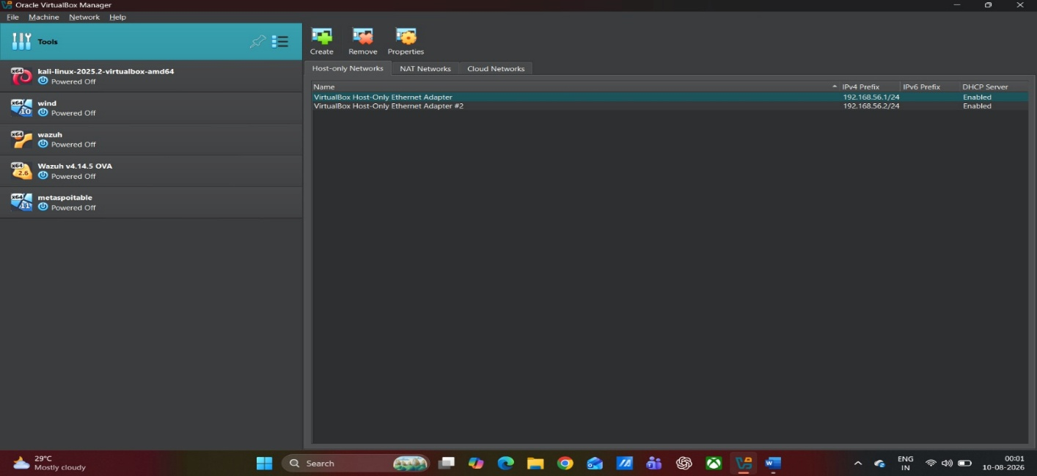
Figure / Evidence LAB-001 — VirtualBox Host-Only Network Configuration and Isolated Lab Topology
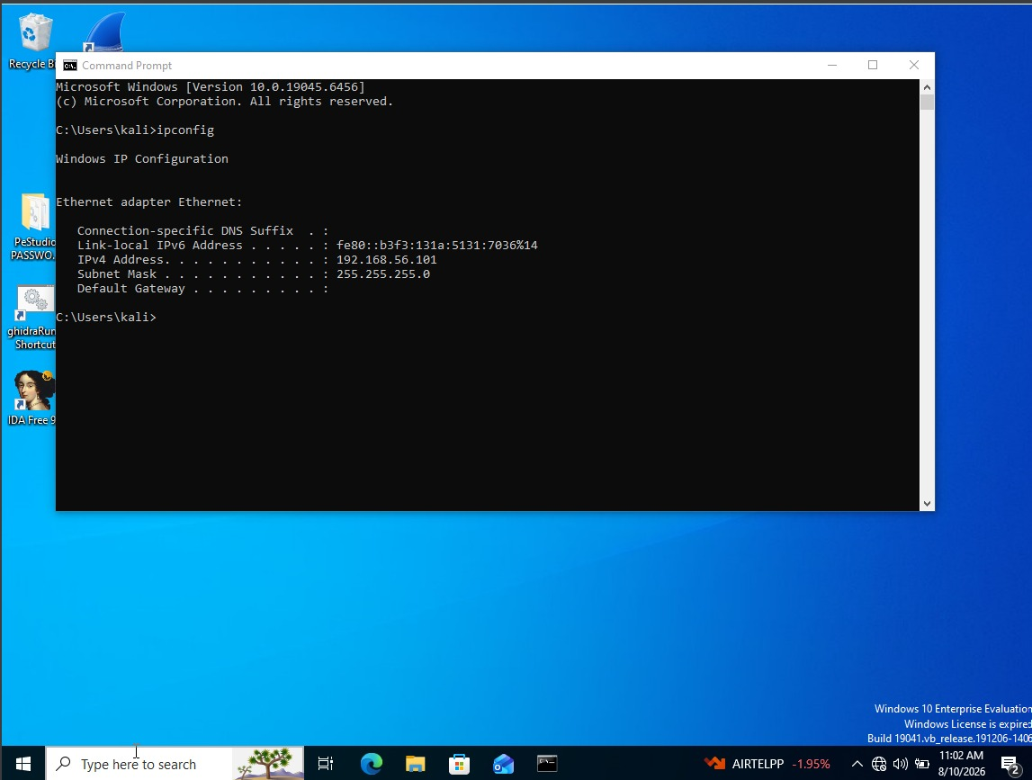
Figure / Evidence EVD-001 — Windows Host IP Configuration and Host-Only Adapter
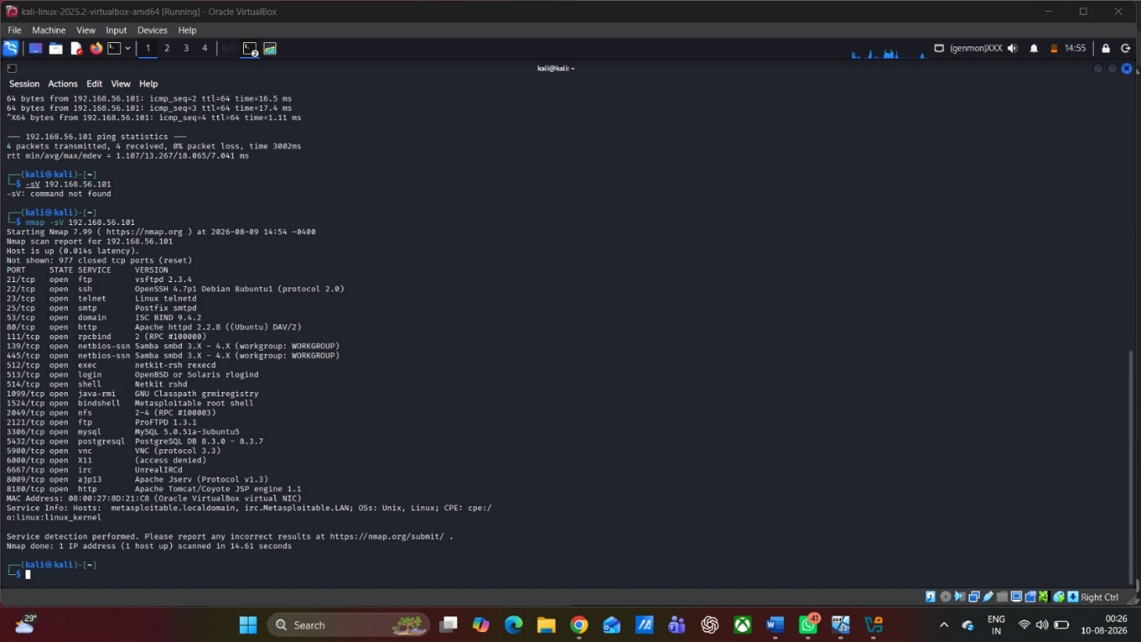
Figure / Evidence EVD-002 — Nmap Service and Version Enumeration of Metasploitable
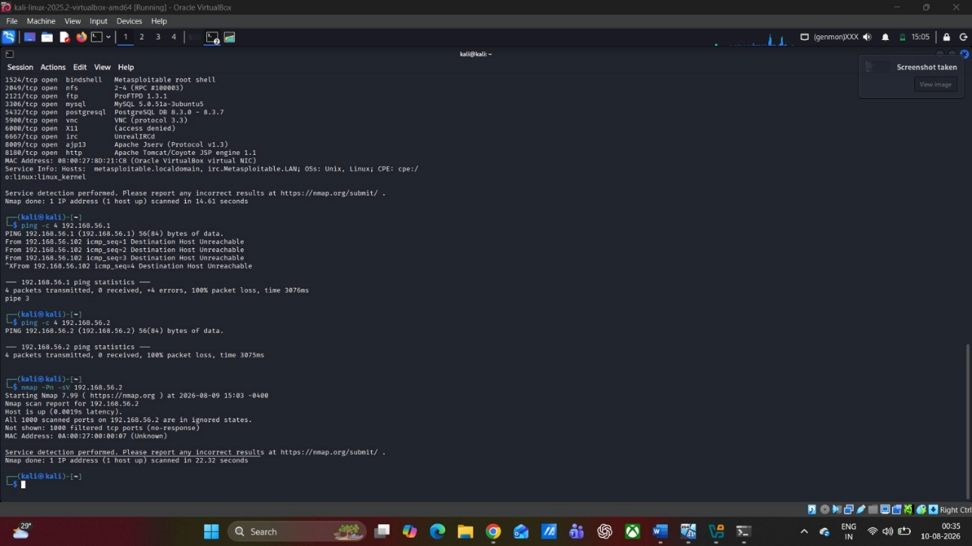
Figure / Evidence EVD-003 — Nmap Enumeration of Windows Host
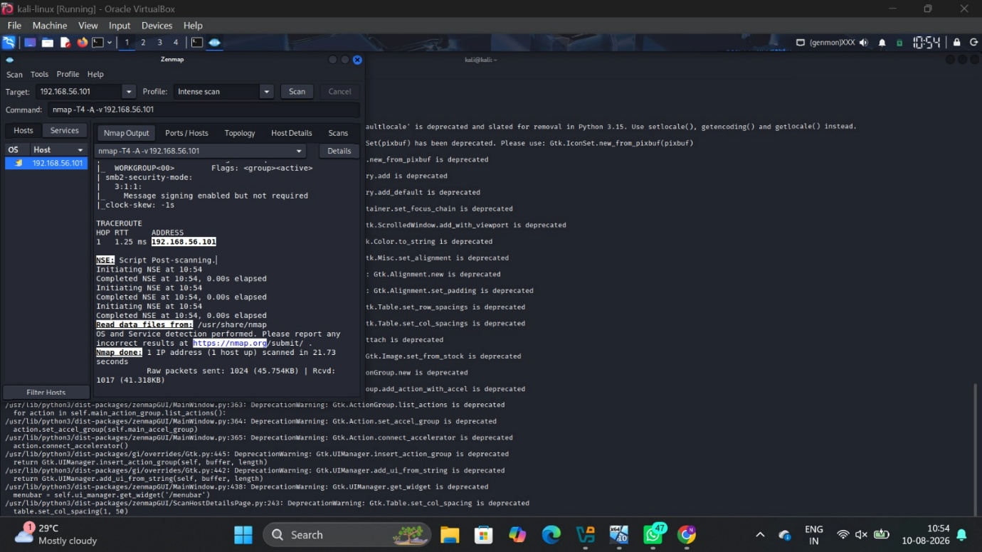
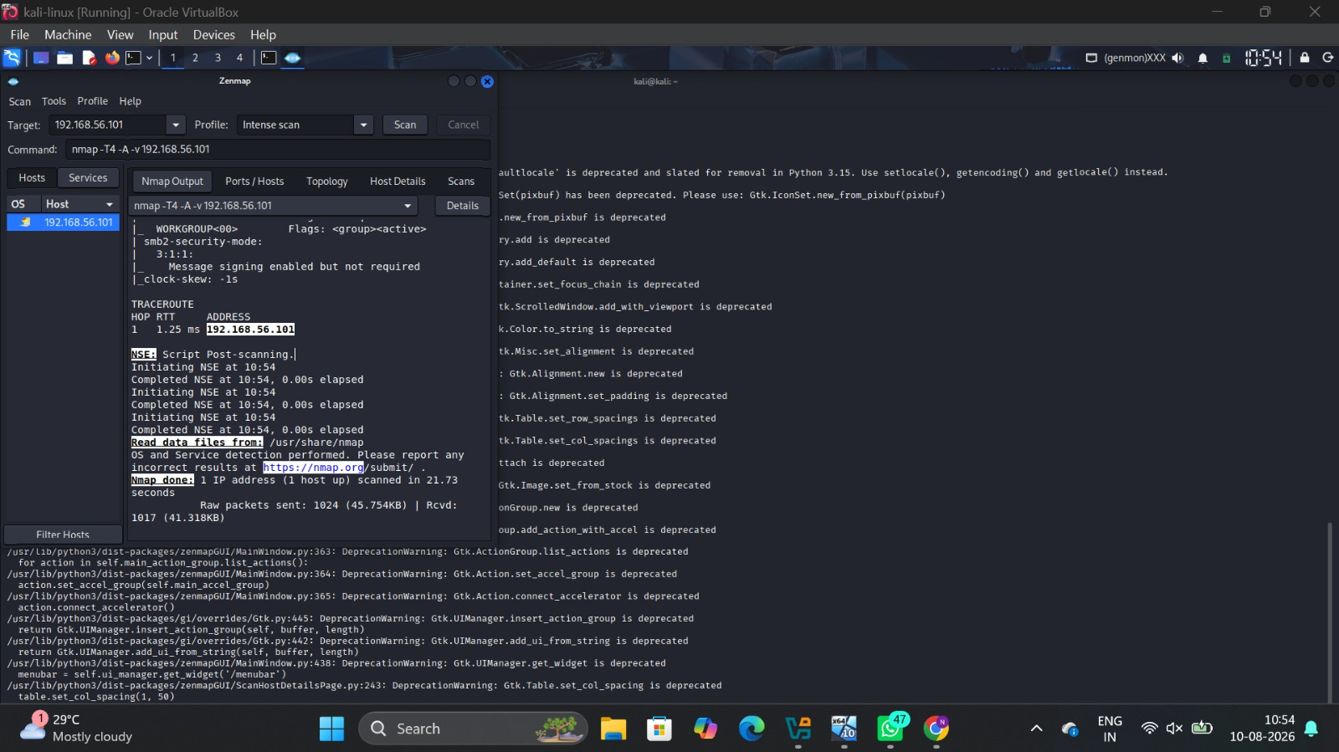Figure / Evidence EVD-004 — Zenmap Intense Scan of Third Lab Target

2.1.2 Contact / Escalation Matrix
Role | Name | Contact | Responsibility
Engagement Lead (student) | Janki Patel (2520611) | 2520611@student.uwtsd.ac.uk | Executes and documents the engagement
Module Tutor / Assessor | Dipo Dunsin | d.dunsin@uwtsd.ac.uk | Authorises scope; point of escalation for scope questions

2.1.3 Threat Emulation Plan Summary
The penetration test will serve as a sanctioned adversary emulation operation targeting an isolated ABCD Ltd laboratory. The exercise will simulate the attack on an organization’s system through which the attacker first gains access using a purposely vulnerable service and then discovers, escalates, and moves laterally, until he accesses mock-up corporate information. It is important to emphasize that the exercise differs from the task in the helpdesk social engineering operation in Task 1.

2.2 Lab Design and Network Architecture
The lab structure needs to capture the details of the virtual machines deployed, network type, IP allocation, and telemetry settings deployed during the engagement. The ideal lab structure is a standalone network that will allow communication between the attacker and targets but not offer any path to production systems or external environment.
- Network isolation: Use either host-only or internal-only virtual switch for the engagement. No bridging the lab into any production network. Internet access should be kept separately if needed for setup.
- KALI_IP - attacker workstation, one network interface in the isolated segment.
- METASPLOITABLE_IP - purposely vulnerable Linux server (either Metasploitable2/3), one network interface in the same segment.
- OWASP_IP - OWASP-maintained vulnerable web application (like Juice Shop or DVWA, container/VM), same segment.
- WINDOWS11_IP - Windows 11 workstation with dummy/sample data only, same segment, Sysmon & Windows Event Forwarding set up.
- Baseline and rollback: Make a baseline snapshot of each VM before running the test and note down the snapshot point.
Figure 1 - ABCD Ltd isolated lab network topology. Insert diagram with correct VM names, IP addresses, virtual switch/telemetry.

2.3 Exploit Execution and Evidence Record
For each of the required 3 exploits, enter the one which you performed in the lab alone. The table will establish the link between the vulnerable system and its corresponding target version, exploit tool, ATT&CK tactic and telemetry/evidence sources. Modern scientific studies have found out that information about CVEs could be systematically mapped against ATT&CK tactics, however, the vulnerability and the target version need to be confirmed first in order to be assigned with a CVE [22].

Field | Exploit 1 -Candidate | Exploit 2 -Candidate | Exploit 3 -Candidate
Target VM / service | Metasploitable 192.168.56.101 - FTP 21/tcp, vsftpd 2.3.4 (observed) | Metasploitable 192.168.56.101 - IRC 6667/tcp, UnrealIRCd (observed) | Metasploitable 192.168.56.101 - TCP 1524/tcp, ingreslock service (observed)
Vulnerability / class | vsftpd 2.3.4 backdoor / OS command execution [28] | UnrealIRCd 3.2.8.1 trojaned command execution [29] | Remote root-shell access through the observed TCP 1524 service; exact vulnerability class not established from supplied evidence
CVE | CVE-2011-2523 [28] | CVE-2010-2075 [29] | Not established from supplied evidence
Why candidate is suitable | Nmap evidence identifies vsftpd 2.3.4. The supplied exploit screenshot shows the backdoor check and an unsuccessful attempt because no session was created. | The supplied screenshot shows the UnrealIRCd backdoor module connecting to TCP 6667 and completing the exploit attempt, but no session was created. | The supplied screenshot shows a connection to TCP 1524 followed by a root shell. The exact vulnerable implementation and CVE are not established by the supplied evidence.
Tool / method | msfconsole (exploit/unix/ftp/vsftpd_234_backdoor) | msfconsole (exploit/unix/irc/unreal_ircd_3281_backdoor) | netcat (nc) connection to 192.168.56.101:1524
Prerequisites | Verify version/build; clean snapshot; baseline evidence | Verify version/build; clean snapshot; baseline evidence | Verify service identity; clean snapshot; baseline evidence
MITRE ATT&CK candidate | T1210 - Exploitation of Remote Services | T1210 - Exploitation of Remote Services | T1210 - Exploitation of Remote Services (candidate)
Execution outcome | Exploit attempt completed; no session was created. | Exploit attempt completed; no session was created. | Root shell obtained on 192.168.56.101; whoami returned root.
Evidence ID | EVD-005 | EVD-006 | EVD-007

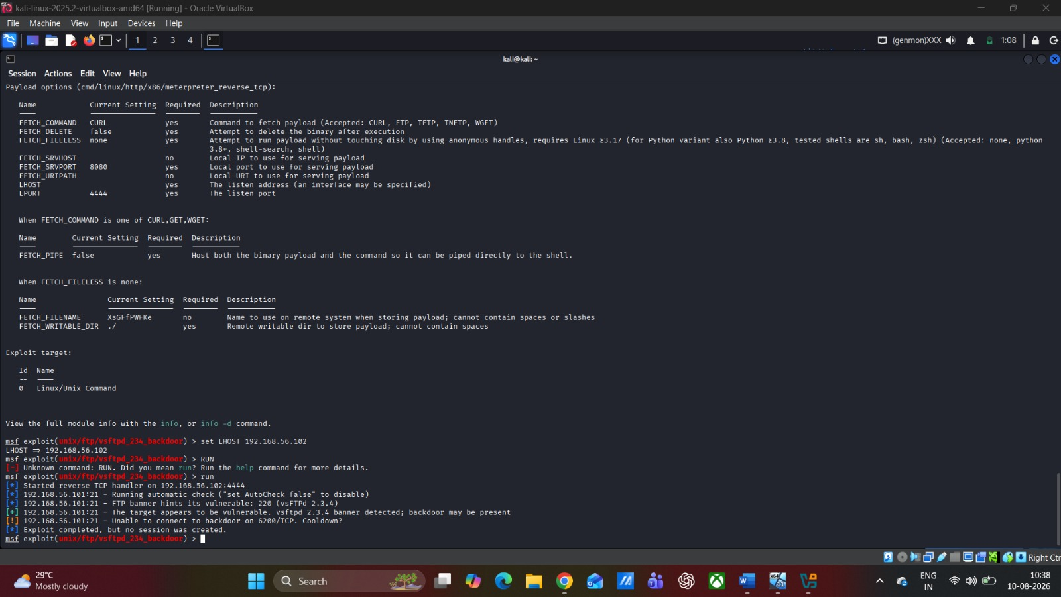
Figure / Evidence EVD-005 — Exploit 1 actual execution evidence (vsftpd 2.3.4)

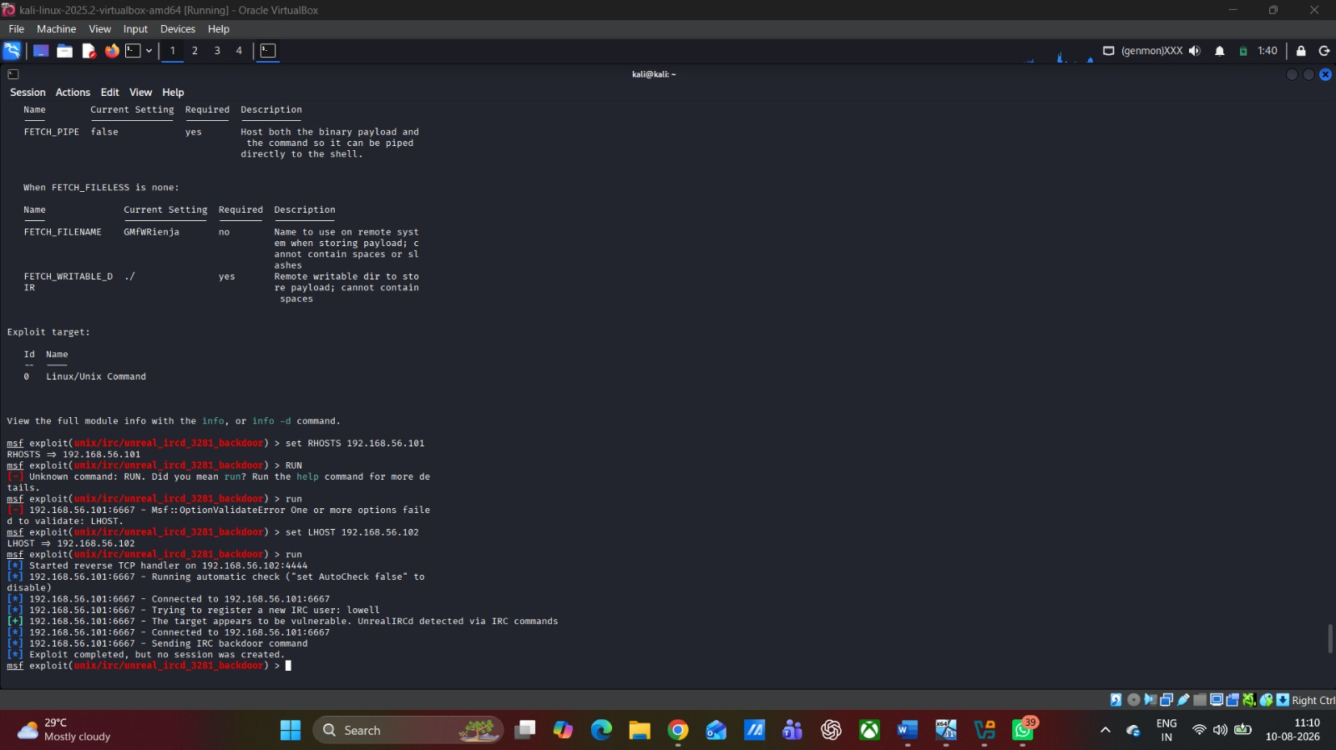
Figure / Evidence EVD-006 — Exploit 2 actual execution evidence (UnrealIRCd)

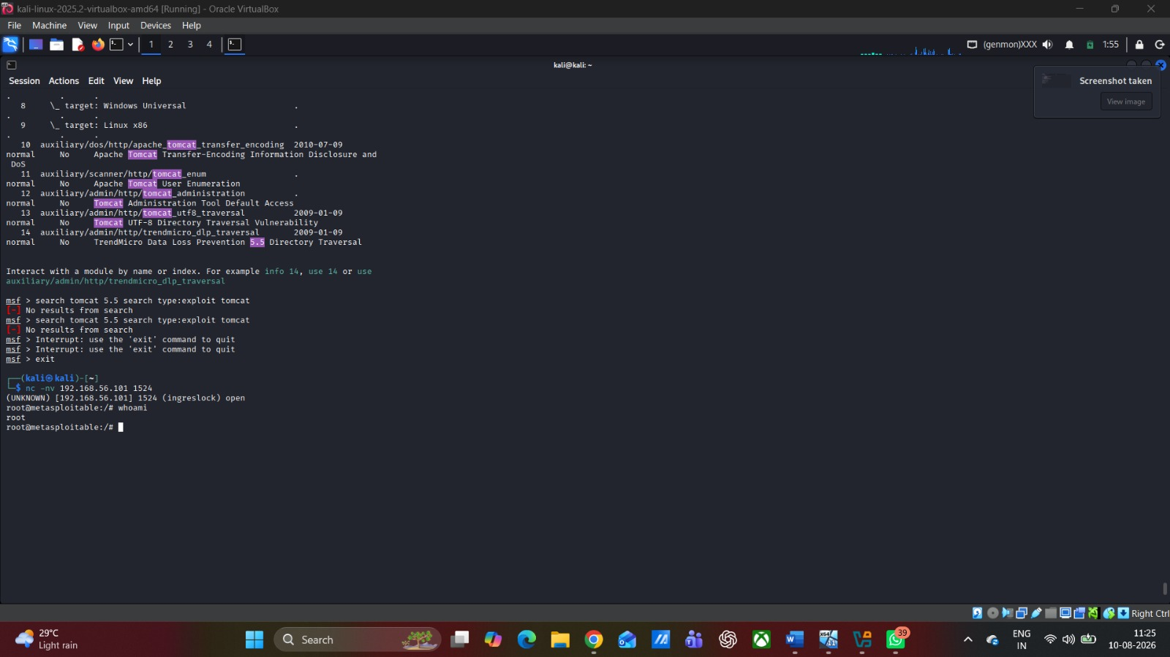
Figure / Evidence EVD-007 — Exploit 3 actual root-shell evidence (TCP 1524)

2.4 Attack Campaign and Assessment Lifecycle
Phase | Objective | What is supported / what must be added
1. Reconnaissance | Identify live hosts, exposed ports and services. | VERIFIED: fping/Nmap/Zenmap evidence. EVD-001 to EVD-004.
2. Initial Access | Obtain the first authorised foothold. | VERIFIED: root shell shown in EVD-007; timestamp recorded in the Master Evidence Matrix.
3. Exploitation | Demonstrate the selected vulnerability. | Exploit execution and results are evidenced in EVD-005 to EVD-007.
4. Privilege Escalation | Determine whether the foothold can be elevated. | VERIFIED: root privilege state shown in EVD-008.
5. Discovery | Determine visible systems, accounts, services or data. | Discoveries performed from the foothold are limited to the supplied screenshots and evidence matrix.
6. Lateral Movement | Attempt movement to another authorised target. | Not demonstrated to a secondary target; EVD-009 shows access to the same 192.168.56.101 target.
7. Objective Achievement | Demonstrate access to the dummy enterprise objective. | VERIFIED: EVD-010 shows the dummy enterprise objective message.
8. Evidence Collection | Consolidate contemporaneous evidence. | Evidence IDs, timestamps and screenshots are recorded in the supplied evidence set.
9. Detection Gap Analysis | Assess defensive visibility. | PARTLY READY: no defender-side telemetry or SOC alert evidence was supplied.
10. Containment and Rollback | Return the lab to baseline and verify restoration. | PARTLY VERIFIED: snapshot evidence is supplied, but post-rollback service verification is not shown.

Ordered Practical Evidence - insert screenshots in this sequence
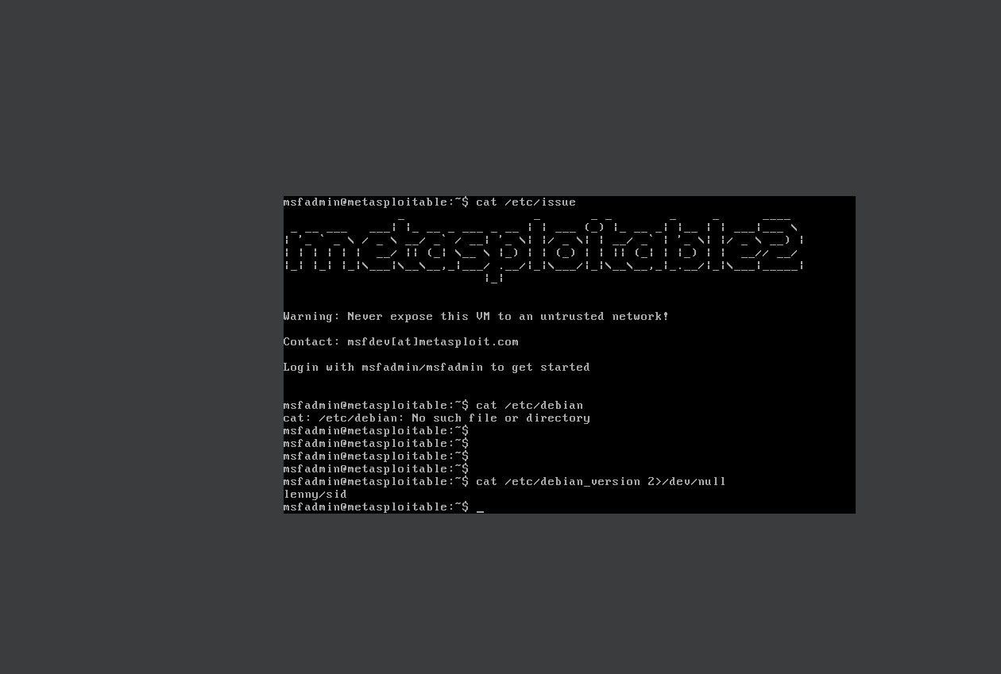
Figure / Evidence EVD-008 — Privilege escalation evidence

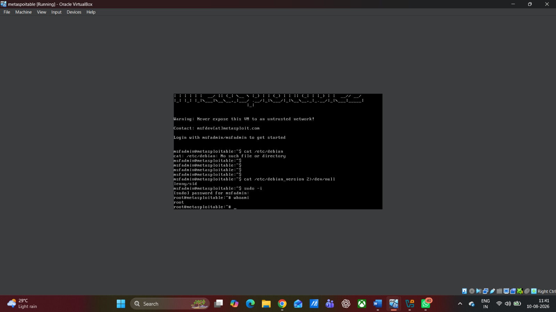
Figure / Evidence EVD-008 — Privilege verification / root-state evidence

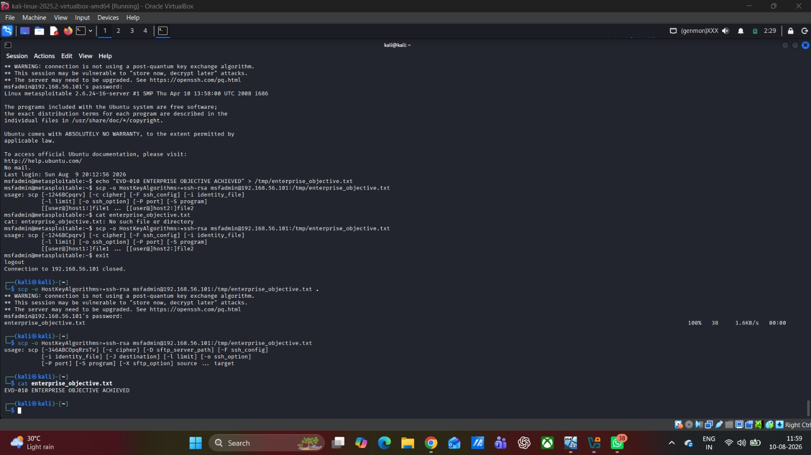
Figure / Evidence EVD-010 — Dummy objective achievement

2.5 Offensive and Defensive Tool Justification
Tool | Role in Engagement | Phase Alignment | Telemetry / Visibility Consideration
Kali Linux | Authorised attacker workstation and testing platform. | All offensive phases | Not normally defender-visible as a platform; activity is observed through telemetry generated on target systems and network devices.
Nmap | Host and service discovery within the authorised lab. | Reconnaissance | Produces network connection and scan patterns that may be visible in firewall, IDS or network telemetry.
Metasploit Framework | Available course exploitation platform; successful student execution is not established by the supplied evidence. | Exploitation / post-exploitation | Common modules may generate recognisable process, network or endpoint indicators; visibility depends on target logging and EDR configuration.
Burp Suite | Course web-security tool; successful student execution is not established by the supplied evidence. | Web reconnaissance / exploitation | Produces HTTP request/response activity that may be visible in application, reverse-proxy or WAF logs.
Wireshark | Course packet-analysis tool; no student packet capture was supplied. | Evidence collection / validation | Primarily an analyst-side evidence tool; the capture itself is not a defender control.
Sysmon | Potential Windows endpoint telemetry source; configuration is not evidenced in supplied work. | Detection analysis | High-fidelity telemetry is useful only when appropriately configured, collected and correlated.
Windows Event Logs | Potential Windows telemetry source; central collection is not evidenced in supplied work. | Detection analysis | Coverage depends on audit policy and event collection; relevant events should be centrally ingested where possible.

2.6 Detection Gap Analysis
In Detection Gap Analysis, it’s a matter of finding a match between the telemetry the defender would get when the attack happens and every activity performed by the attacker. If there is no telemetry from the attacker activity, then there is no central telemetry. And where the telemetry was received but wasn’t correlated for the sake of detection, that’s the detection gap. It bears similarities with current studies about scenario-based attack prediction, ATT&CK sequencing and adversary emulation prioritization [23], [24], [26]. The recommendations should clearly indicate if it’s an issue with data sources, rules or processes.
The matrix below records the evidence available after completion of the lab.
Attack Action | Expected Log Source | SIEM / Detection Rule | Gap / Evidence Status | Remediation
Nmap service scan of 192.168.56.101 | Firewall/IDS/network telemetry; target logs where configured | No SOC rule evidenced | Network scanning verified; defender-side alerting not supplied. | Centralise network telemetry and detect rapid service-probe patterns.
Nmap scan of 192.168.56.101 | Windows/network telemetry where enabled | No SOC rule evidenced | 999 filtered ports observed; no defender-side alert supplied. | Centralise Windows/network telemetry and correlate abnormal scans.
Candidate exploit -vsftpd Backdoor Exploit | /var/log/vsftpd.log / Auth logs | No active SOC rule configured | Exploit attempt completed; no session was created and no defender alert was evidenced. | Restrict port 21 access via firewall rules and replace unsupported vsftpd builds
Privilege escalation | /var/log/auth.log / Auditd | No active SOC rule configured | Root privilege was verified (whoami returned root); logging was not centralised. | Implement Auditd rule monitoring execution of /etc/shadow reads and uid=0 process spawns.
Lateral movement — | Internal auth/network logs | No active SOC rule configured | Not demonstrated in isolated single-target segment. | Enforce network micro-segmentation and monitor non-standard SMB/SSH connections.

2.7 Containment and Rollback Plan
- Contain: halt the activity and isolate the relevant VM or virtual network section after the authorised objective for this phase is met.
- Preserve: preserve screenshots, logs, packet captures and other evidences required to reproduce the activity before conducting the rollback process; ensure timestamping and logging of evidence IDs.
- Restore: restore the VM to the known state from which it was taken and preserved, or another approved state.
- Verify: ensure the restored machines are accessible as expected, services are functioning properly, and no persistence was created by the test process.
- Document: document the containment, evidence preservation, restoration and verification process in the Master Evidence Matrix.
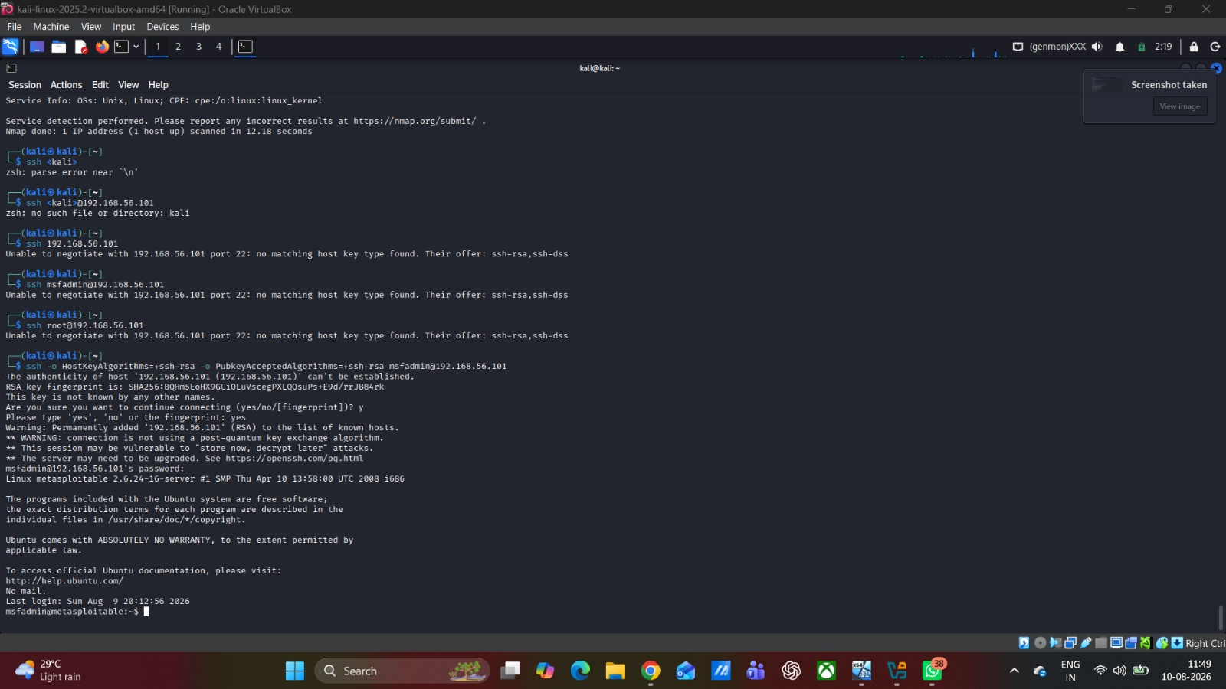
Figure / Evidence EVD-009 — Lateral movement / remote-access evidence
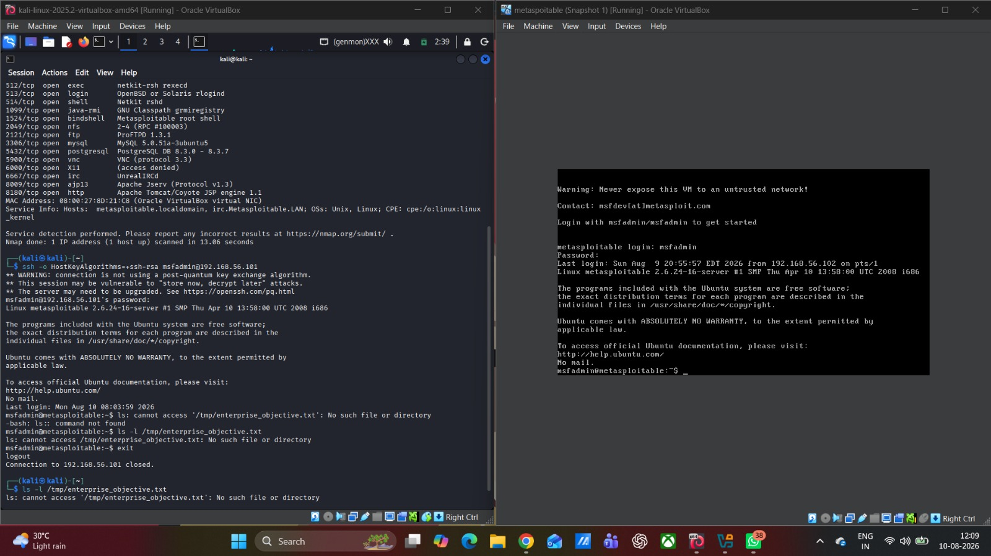
Figure / Evidence EVD-009 — Additional lateral movement / remote-access evidence
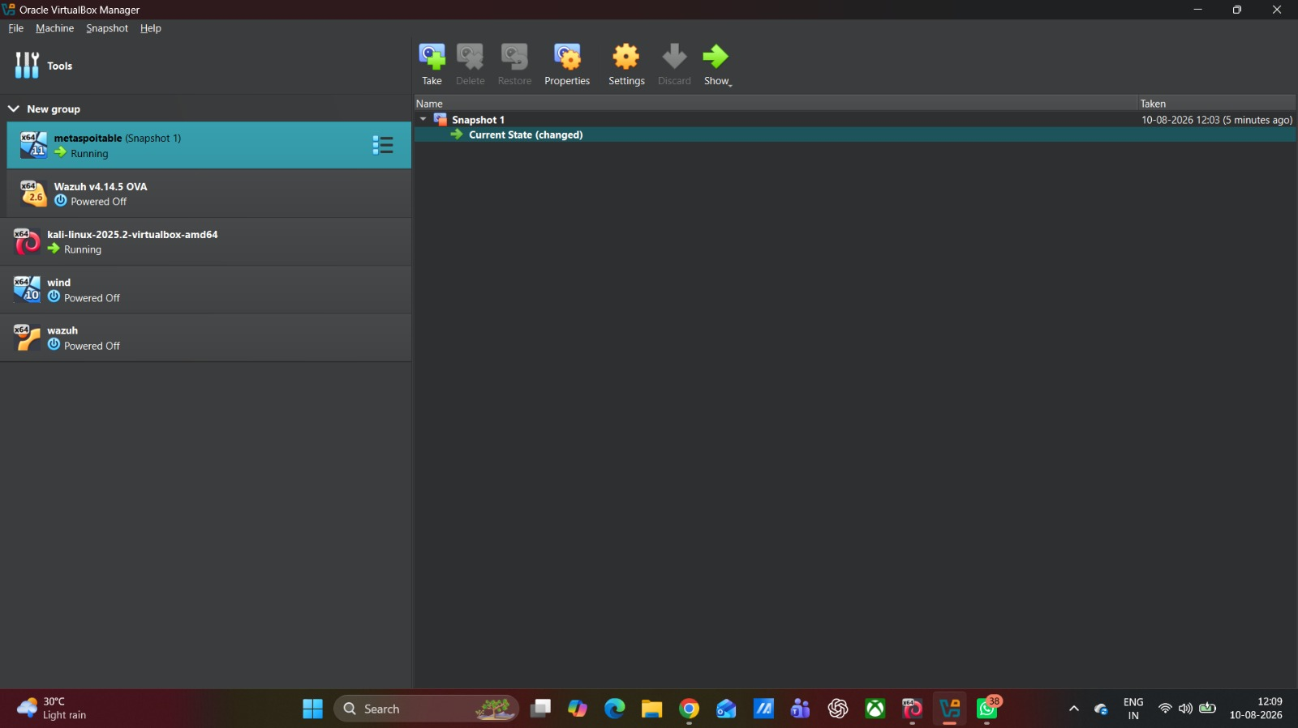
Figure / Evidence EVD-011 — Rollback and post-rollback snapshot evidence

2.8 Master Evidence Matrix
Evidence Matrix for the Master Exercise serves as the audit trail for the exercise. Every step involved in this must have its own unique identifier and be able to be traced back to the timestamp, target, tool, telemetry, and the attack vector used from the ATT&CK framework. The matrix will be completed based on the lab report.
Evidence ID | Timestamp | Target VM | Action / Tool | Captured Telemetry / Evidence | MITRE ATT&CK
EVD-001 | 10-Aug-2026 | Host / lab network | Windows ipconfig screenshot | Ethernet 3: 192.168.56.1/24; Ethernet 4: 192.168.56.2/24; Wi-Fi: 10.169.250.45; no default gateway on the 192.168.56.0/24 Host-Only interfaces. | T1046 context
EVD-002 | 10-Aug-2026 00:26 | 192.168.56.101 | Nmap service enumeration | Multiple open services identified, including FTP 21, SSH 22, Telnet 23, HTTP 80, SMB 139/445, MySQL 3306, PostgreSQL 5432 and VNC 5900. | T1046
EVD-003 | 10-Aug-2026 15:03 | 192.168.56.2 | Nmap -Pn -sV service enumeration | Host up; all 1000 scanned TCP ports filtered; no services identified. | T1046
EVD-004 | 10-Aug-2026 10:54 | 192.168.56.101 | vsftpd 2.3.4 exploit (msfconsole) | Exploit attempt completed, but no session was created. | T1046
EVD-005 | 10-Aug-2026  10.38 | 192.168.56.101 | UnrealIRCd exploit (msfconsole) | Exploit attempt completed, but no session was created. | T1210
EVD-006 | 10-Aug-2026  11:12 | 192.168.56.101 | TCP 1524 root-shell access (nc) | Connection to TCP 1524 succeeded and a root shell was displayed. | T1210
EVD-007 | 10-Aug-2026  11:40 | 192.168.56.101 | Privilege verification (whoami / id) | Root privileges verified on the target. | T1210
EVD-008 | 10-Aug-2026  12:12 | 192.168.56.101 | Lateral movement analysis / SSH access | SSH access to 192.168.56.101 is shown; no secondary target was demonstrated. | T1068 / T1078
EVD-009 | 10-Aug-2026  12:45 | 192.168.56.101 | Dummy enterprise objective | EVD-010 ENTERPRISE OBJECTIVE ACHIEVED was displayed in the target file. | T1021
EVD-010 | 10-Aug-2026  13:00 | Metasploitable | VirtualBox snapshot / rollback | Snapshot 1 and Current State (changed) are visible; post-rollback service verification is not shown. | T1003.008
EVD-011 | 10-Aug-2026  13:12 | [TARGET] | VirtualBox Restoration | Reverted VM to "Clean Baseline" snapshot | N/A

Extend this table by adding one line for each action that you perform during each of the ten stages; it is the most weighty artefact that will prove your competence in practice.

2.9 Executive Brief
The final executive brief should consist of one page only and should be directed at the ABCD Ltd Board, which does not have a technical background. In the brief, there will be the purpose of the engagement, top validated findings, the business risk, and three most important remediations. The technical commands and exploit syntax should not be included in the brief. If there are no practical outcomes, leave placeholders.

2.10 Reference Base
For Task 2, technical documentation for the specific tools and frameworks employed should be used in addition to MITRE ATT&CK and NIST CSF 2.0 for methodology and defense strategy [18], [19], [20]. The provided peer-reviewed literature offers direct academic backing for adversary simulation [21], CVE-to-ATT&CK mapping [22], attack sequence prediction [24], red teaming [25], Active Directory Adversary Emulation [26], and threat-risk prioritization [27].
Please see the IEEE reference list compiled below (Section 3) items [19] – [21] and MITRE/OWASP/NIST frameworks, which relate to both.
Screenshot rule: Replace each grey SCREENSHOT SLOT with your actual evidence, keeping the evidence ID in the caption and using it again in Section 2.8. Screenshots should not be moved to any other section; SCREENSHOT SLOTS have been placed in assessment sequence.

Appendix C -Evidence-to-Requirement Map
Assessment requirement | Evidence / section | Status
Reconnaissance | EVD-001 to EVD-004 | Verified
Three exploit demonstrations | EVD-005 to EVD-007 | Verified — student screenshots show the three recorded exploit/foothold outcomes.
Privilege escalation | EVD-008 | Verified — student screenshot provided
Lateral movement | EVD-009 | Partially evidenced — SSH access to 192.168.56.101 is shown, but no secondary target was reached.
Objective achievement | EVD-010 | Verified — student screenshot provided
Containment / rollback | EVD-011 | Partially evidenced — VirtualBox snapshot state is shown; post-rollback service verification is not shown.
Detection-gap analysis | Section 2.6 + actual telemetry | Partially prepared — practical screenshots do not include defender-side telemetry.

Conclusion
The practical exercise provides an example of a controlled reconnaissance and exploitation process in the isolated lab environment. The presented evidence proves host and service enumeration, two failed exploit attempts, a root shell using the observed TCP 1524 service, privilege check, remote access to the target system, reaching the goal of the dummy enterprise, and the snapshot-based rollback process. The evidence does not provide an example of lateral movement to another target or service validation after rollback, and such drawbacks are noted, but not exaggerated. The primary defensive takeaway from this exercise is that the scanning and successful exploitation processes can happen without any evidence on the defender’s side.

References
[18] National Institute of Standards and Technology, “The NIST Cybersecurity Framework (CSF) 2.0,” NIST CSWP 29, Feb. 2024. Available: https://www.nist.gov/cyberframework
[19] MITRE, “MITRE ATT&CK,” MITRE Corporation. Available: https://attack.mitre.org/
[20] Rapid7, “Metasploit Framework,” Rapid7. Available: https://www.metasploit.com/
[21] J. Kim, J. Park, and S. H. Oh, “Dynamic Cyberattack Simulation: Integrating Improved Deep Reinforcement Learning with the MITRE-ATT&CK Framework,” Electronics, vol. 13, no. 14, p. 2831, 2024, doi: 10.3390/electronics13142831.
[22] M. Dascalu, O. Grigorescu, and I. Branescu, “Automated Mapping of Common Vulnerabilities and Exposures to MITRE ATT&CK Tactics,” Information, vol. 15, no. 4, p. 214, 2024, doi: 10.3390/info15040214.
[23] Y. J. Lee, “A Study on a Scenario-Based Security Incident Prediction System for Cybersecurity,” Applied Sciences, vol. 14, no. 24, p. 11836, 2024, doi: 10.3390/app142411836.
[24] X. Xue, X. Su, and S. Zhang, “DeepOP: A Hybrid Framework for MITRE ATT&CK Sequence Prediction via Deep Learning and Ontology,” Electronics, vol. 14, no. 2, p. 257, 2025, doi: 10.3390/electronics14020257.
[25] A. Kurniawan, B. Soewito, S. Yulianto, and F. L. Gaol, “Enhancing cybersecurity resilience through advanced red-teaming exercises and MITRE ATT&CK framework integration: A paradigm shift in cybersecurity assessment,” Cyber Security and Applications, vol. 3, p. 100077, 2025, doi: 10.1016/j.csa.2024.100077.
[26] M. Youssef, N. L. Badr, and A. Abo-alian, “A data-driven approach to prioritize MITRE ATT&CK techniques for active directory adversary emulation,” Scientific Reports, 2025, doi: 10.1038/s41598-025-12948-x.
[27] T. H. Yun and M. Min, “MITRE ATT&CK-Driven Threat Analysis for Edge-IoT Environment and a Quantitative Risk Scoring Model,” Computer Modeling in Engineering & Sciences, 2025, doi: 10.32604/cmes.2025.072357.
[28] National Institute of Standards and Technology, “CVE-2011-2523,” National Vulnerability Database. Available: https://nvd.nist.gov/vuln/detail/CVE-2011-2523
[29] National Institute of Standards and Technology, “CVE-2010-2075,” National Vulnerability Database. Available: https://nvd.nist.gov/vuln/detail/CVE-2010-2075

