Quantitative Research Methods
Journal Article
Ethan Keeble
Student number: 2405245

Course: Doctorate in Professional Practice (DProf)
Module: BMDP7009 Quantitative Research Methods

Word count: In accordance with Section 7.7 of the UWTSD Academic Quality Handbook 2025/26, the 7,500-word limit permits an additional 10% (750 words); this submission contains 8,172 words, excluding the abstract, tables and reference list.

Academic Integrity: This work is my own. No generative artificial intelligence tools were used in the writing or production of this work.
TRENDS IN THE COST OF MEDICINES USED IN SECONDARY CARE IN THE UK NATIONAL HEALTH SERVICE: AN ANALYSIS OF OPEN-ACCESS DATA

Abstract

Background: The increasing cost of medicines presents a growing challenge for publicly funded healthcare systems, particularly in secondary care where more costly treatments are routinely used. Although spending on hospital medicines continues to rise, there has been little research on long-term trends in the most commonly prescribed and highest-cost drugs within NHS secondary care.

Aim: To investigate how the costs of the most commonly prescribed and highest-cost medicines in NHS secondary care in England have changed over time, using open-access national prescribing data.

Methods: This retrospective, longitudinal observational study was based on the NHS Business Services Authority Secondary Care Medicines Data. Annual data from April 2021 to April 2026 were reviewed. For each year, the ten most frequently prescribed medicines and ten medicines with the highest costs were identified. Descriptive analyses were used to summarise prescribing volumes, indicative spending, unit prices, and changes over time.

Results: The most frequently prescribed medicines were mainly long-established generics and nutritional supplements, such as paracetamol, heparin, metronidazole, lactulose, and various oral nutritional products. The combined prescribing volume for the top ten medicines decreased from 32.3 million to 13.4 million units over the study period, with the corresponding indicative spending declining from £1.9 million to £673,348. The medicines contributing most to total costs were specialist agents, including biologics, monoclonal antibodies, gene therapies, and drugs for rare conditions. Although these were prescribed much less often, they incurred a substantially larger share of total expenditure. Overall, indicative spending for the top ten highest-cost medicines declined from £21.0 million in 2021 to £6.8 million in 2026.

Conclusion: Spending on medicines in NHS secondary care is seemingly determined by a small group of innovative specialist therapies, rather than by the most commonly prescribed drugs. Ongoing national monitoring of prescribing patterns may help to guide medicines optimisation, procurement, and commissioning, supporting both effective resource use and equity of access to effective treatment.

Keywords: medicines expenditure; secondary care; prescribing trends; medicines utilisation; healthcare costs; NHS England

Table of Contents
Introduction and Literature Review 3
Aims/Objectives 5
Methods 5
Research Design 5
Data Collection/Data Source 6
Data Analysis 8
Rigour 9
Ethical Considerations 10
Results 10
Top 10 Most Frequently Prescribed Medicines 10
Top 10 Most Costly Medicines 13
Discussion 18
Overview of Findings 18
Evaluation of Findings 20
Implications, Recommendations and Conclusion 24
References 26

Introduction and Literature Review
The rising cost of medicines represents a significant economic challenge for healthcare systems globally (Mulcahy et al., 2024). Although medicines have revolutionised the prevention and management of acute and chronic diseases, these advances have been accompanied by substantial increases in healthcare expenditure (Oliinky et al., 2024). Rising demand and costs are influenced by ageing populations, multimorbidity, polypharmacy, expanding therapeutic options and the emergence of high-cost biological and precision medicines (Janssen Daalen et al., 2021). The World Health Organisation (WHO) recognises equitable access to affordable medicines as an important component of universal health coverage and supports the ethical principles of justice and beneficence (Varkey, 2021; WHO, 2026).
This creates a challenge for governments and healthcare services in balancing timely access to clinically effective medicines with financial sustainability (Ntais et al., 2024). Increasing medicine expenditure is not solely attributable to prescribing practices, but reflects interactions between demographic changes, disease prevalence, market conditions, pricing regulations, supply chain pressures and technological innovation (Janssen Daalen et al., 2021). Medicines are among the largest areas of healthcare expenditure after staffing costs and can affect resources available for workforce development, diagnostics, infrastructure and other service improvements (Wozniak-Holecka et al., 2026). Consequently, pharmaceutical expenditure requires monitoring and evaluation to inform healthcare reform and improvement (Anderson, 2026). This reflects the wider shift towards value-based healthcare, where clinical effectiveness and economic efficiency are considered alongside one another when guiding commissioning decisions and improving population health (Khalil et al., 2025).

These issues are particularly relevant to publicly funded systems such as the United Kingdom National Health Service (NHS), where finite budgets must accommodate increasing demand (Jain et al., 2025). Medicines represent the second largest area of NHS expenditure, with NHS England spending over £19 billion on drugs annually (Kahtan, 2025), while NHS Business Services Authority (NHSBSA) data reported total medicines expenditure of £21.4 billion in 2025 (NHSBSA, 2025). NHSBSA monitors medicines expenditure and provides open-access prescribing data across primary and secondary care (NHSBSA, 2026c), enabling analysis of expenditure and prescribing trends by medicine, therapeutic class and British National Formulary (BNF) category. However, secondary care differs substantially from community prescribing because hospitals frequently use higher-cost medicines, including intravenous antimicrobials, oncology treatments, immunotherapies and biologics. Hospital expenditure is therefore influenced not only by prescribing frequency but also by treatment complexity, patient acuity and advances in specialist practice (NHSBSA, 2026b).

Medicines most commonly prescribed across England are generally those used to manage prevalent long-term conditions, including cardiovascular, gastrointestinal, respiratory, endocrine and mental health conditions, as well as analgesia and antibiotics (Alghamdi et al., 2020; Curtis & Goldacre, 2018). Common examples include statins, proton pump inhibitors, angiotensin-converting enzyme inhibitors, beta-blockers, metformin, levothyroxine, selective serotonin reuptake inhibitors and bronchodilators (NHSBSA, 2026c). The increasing availability of open-access NHS data provides opportunities for longitudinal analysis using standardised methods, supporting transparency, reproducibility and evidence-informed decision-making while potentially reducing measurement and reporting biases (Bacon & Goldacre, 2020; NHS England, 2026). However, identifying temporal trends in secondary care medicine expenditure remains important because such analysis may help healthcare organisations anticipate future financial pressures and inform commissioning decisions.

Existing literature indicates that hospital medicines expenditure has increased substantially, but evidence identifying the specific medicines and therapeutic classes responsible remains limited. Earlier NHS reports highlighted the growing contribution of secondary care to overall prescribing expenditure, but primarily presented descriptive data at list prices, which may not represent net NHS costs following discounts or commercial agreements (NHS England, 2020). More recent NHSBSA evaluations reported prescribing costs of £21.6 billion during 2024/25, including £11.1 billion for medicines used in hospitals and £10.3 billion for community-dispensed medicines (NHSBSA, 2025). Although these statistics demonstrate the scale of secondary care expenditure, they provide limited longitudinal analysis of changes in medicine costs. Empirical research has also largely focused on primary care. Curtis and Goldacre (2018), for example, found that NHS primary care medicine costs in England increased from £4.4 billion in 1998 to £8.3 billion in 2016, but this does not capture the distinctive costs associated with hospital prescribing, where high-cost medicines are more prevalent.

The Secondary Care Medicines Dataset provides an important opportunity to address this evidence gap. NHSBSA reports that the dataset processes medicines data from NHS acute, teaching, specialist, mental health and community trusts using pharmacy stock-control systems (NHSBSA, 2026d). However, because the dataset is based on stock-control records rather than patient-level prescribing, it lacks information on clinical indication, prescribing appropriateness, patient outcomes and complexity (NHSBSA, 2026d). Sanderson (2024) developed a web-based tool using the Secondary Care Medicines Dataset to analyse hospital medicines and prescribing costs across NHS trusts. While this represents an important empirical contribution to secondary care data analysis, its primary focus was data accessibility, infrastructure and analytical methods rather than detailed evaluation of the most frequently prescribed and highest-cost medicines (Sanderson, 2024). Similarly, Rowan et al. (2021) demonstrated the significance of high-cost medicines, reporting that hospital-issued medicines accounted for 56% of total medicine spending in NHS England in 2019/20. However, the study did not examine trends in this spending or identify the medicines contributing most to hospital costs.

Overall, three key evidence gaps remain. First, although NHS reports document rising hospital medicines expenditure, they provide limited analysis of the medicines and therapeutic classes driving these increases. Second, empirical research has traditionally concentrated on primary care rather than secondary care. Third, while newer secondary care datasets and analytical platforms have improved opportunities for investigation, published research has yet to comprehensively evaluate longitudinal trends in hospital medicine costs. These gaps support the need for research examining trends in the costs of commonly prescribed medicines within NHS secondary care.

Aims/Objectives
In response to the noted gaps, the aim of this study is to analyse open-access NHS prescribing data to examine the temporal trends in the costs of the most costly and commonly prescribed medicines within secondary care in England. By investigating longitudinal cost patterns across therapeutic groups and individual medicines, this research seeks to provide a nuanced understanding of how drug costs have evolved over time. Further, the study seeks to contribute valuable evidence to the current literature, which may inform ongoing commissioning decisions and prescribing policies.

Methods

Research Design

This research utilised a retrospective, longitudinal, and observational design to examine how the costs of medicines prescribed in secondary care across England have changed over time. The analysis relied on the Secondary Care Medicines Data (SCMD) published by NHS Business Services Authority, as further described in this chapter. Quantitative methodology and analysis were selected due to being suited for analysing numerical and objective data concerning expenditure patterns and trends (Ellis, 2022). In contrast, qualitative studies mostly focus on subjective experiences, and therefore, this was not feasible for analysing prescribing data on a national scale (Denny & Weckesser, 2022). The methodological approach was underpinned by a critical realist ontology, positing that prescribing practices and pharmaceutical expenditure are objective realities and thus, occur external to observers. This was complemented by a post-positivist epistemology, which supports rigorous quantitative analysis while acknowledging that the SCMD provides only a partial and potentially imperfect account of the construct of interest (Ellis, 2022).

The retrospective temporality was necessary as the data collection benefitted from the extraction of data from previously collected records, which is more convenient, quicker and cost-effective relative to collecting prospective data (De Sanctis et al., 2022). The SCMD comprises routinely generated data from hospital pharmacy activity, rendering it well suited for retrospective analysis (NHSBSA, 2026d). The supplementary longitudinal perspective was also deemed critical for generating impactful evidence, as single-year or cross-sectional analysis over a limited time period would fail to sufficiently capture historic and evolving expenditure patterns (Stuifbergen et al., 2024). Moreover, observational research was valuable for addressing the research aim, due to permitting analysis of large datasets and examining spending patterns in the absence of introducing experimental variables (Sterrantino, 2024). The research also supported the principles of secondary data analysis, where pre-existing data was re-analysed to address new research avenues/questions (Wickham, 2019).

There are several strengths to the design selected. First, national datasets generally include a high number of observations, which would be difficult to attain through prospective data collection. This offered improved statistical precision and greater statistical power/validity (Fowler et al., 2021). Second, the analysis of routinely gathered and standardised data can enhance the generalisability of findings when compared to studies limited to a single institution (Kamper, 2020). Third, secondary analysis is an efficient way to generate to new evidence as it requires fewer resources and is less time consuming, than collecting and cleaning new data (Wickham, 2019). However, secondary data analysis observe some limitations, which are briefly noted here and are discussed with more specificity to this research in the discussion section. First, researchers have no control over the variables that were originally included in pre-existing datasets, including completeness of the data, which can lead to bias. Indeed, this analysis was limited to what was available in the SCMD and could not account for additional clinical information, such as patient characteristics, reasons for prescribing, or treatment outcomes. Second, the study was positioned to elicit expenditure trends, but it was not possible to assess the appropriateness of prescribing or differentiate complex nuances, such as cost increases resulting from improved care versus inefficiencies.

Data Collection/Data Source

This study used data from the SCMD, which is an open-access dataset provided by the NHS Business Services Authority (Appendix 1). The SCMD provides monthly records of medicines supplied to NHS hospitals throughout England and thus, was well suited to the research aim (NHSBSA, 2026d). In contrast to datasets focused on primary care, where prescriptions are tracked at the point of community pharmacy dispensing, the SCMD collects data about the medicines distributed directly by hospital pharmacies, making it a unique resource for examining medication use within secondary care (NHSBSA, 2026d). Source data for the SCMD originates from the pharmacy stock-control systems used in NHS trusts, which automatically capture medicines distributed from hospital pharmacy departments (NHSBSA, 2026d). Each medicine is coded according to the Dictionary of Medicines and Devices (dm+d), which ensures uniformity of coding across organisations and time periods, reducing the possibility/risk of coding bias (NHSBSA, 2026a). One of the principal advantages of the SCMD is the extensive national scope. Instead of relying on a limited sample/study site, the dataset compiles information from NHS trusts across England, providing a representative overview of medicines supplied within secondary care. This extensive coverage not only increases the generalisability of results but it also limits the risk of selection bias that can arise when relying on single-centre or small-scale studies. In addition, as the source data forms a part of routine hospital operations, the dataset offers an accurate insight into prescribing practices and costs across a wide range of clinical environments (NHSBSA, 2026d). The study period was defined in accordance with the initiation of data collection by the NHSBSA within secondary care: April 2021 to April 2026. Records were collected at 12-monthly intervals, totalling six datasets for analysis. The top 10 most frequently prescribed and top 10 most costly medicines were extracted from each of these datasets. Medical products used for drug preparation, such as water and sodium chloride, as well as intravenous fluids and oxygen were excluded.

The SCMD includes multiple variables of value to expenditure analysis, such as the reporting period, NHS organisation, dm+d code, medicine name, British National Formulary (BNF) category, quantity supplied, and indicative cost. For this research, the key variables analysed were medicine name, reporting month/year, and indicative cost. Notably, indicative costs presented in the data may not always reflect the prices paid by NHS organisations, as the costs are based on nationally available price lists and do not account for discounts, procurement deals, or rebate schemes, which can affect the final cost to NHS trusts. Therefore, while the SCMD is useful for analysing trends in medicine expenditure over time, the reported figures may not always represent true costs, particularly for higher-cost medicines which can be subject to unique pricing agreements. However, the NHSBSA recommend the use of indicative prices for studying expenditure trends (NHSBSA, 2026d). A standardised protocol was used to support accurate and consistent data extraction, as a means to minimise bias. The monthly SCMD files were obtained directly from the NHSBSA Open Data Portal in the original CSV format, with no further cleaning or manipulation incurred. Before conducting the data analysis, the data underwent preparation steps. Duplicates were removed, and variables irrelevant to the research aims were excluded to help improve the ease and efficiency of the analysis. Additionally, some cleaning involved checking for missing entries, formatting issues, and checking updates to dm+d codes between reporting periods. When coding changes were evidence, NHSBSA documentation was referenced to maintain consistency across time points. No imputation was performed, as missing values in the data may have reflected actual gaps in prescribing activity.

Data Analysis

After data were prepared, statistical analyses were conducted to elicit how the costs of medicines supplied in NHS hospitals changed over the study period. Descriptive statistics are commonly used in health services research to provide an overview of prescribing activity and utilisation, and to highlight shifts that could have implications for policy and resource planning (Togo & Yonemoto, 2022). For data management and descriptive analyses, the dataset was imported into Microsoft Excel (Microsoft Corp, USA). This platform was selected due to the suitability for managing large administrative datasets, supporting the source file format, and facilitated tasks, such as cleaning, sorting, aggregating, and generating summary statistics (Divisi et al., 2017). The results were cross-checked and validated using SPSS.

As the study’s primary focus was related to national prescribing patterns, the analyses were conducted using aggregated data (at the national level) rather than attempting comparisons between individual NHS trusts. This approach minimised the impact of local procurement differences and allowed for the identification of medicines account for the greatest overall secondary care expenditure. The main outcome assessed in this study was the indicative cost of medicines, as recorded in the SCMD. For each reporting interval, total spending on individual medicines was calculated, and these values were ranked to demonstrate which drugs accounted for the largest share of secondary care prescribing expenditure. Cumulative spending over the entire study period was also determined to pinpoint the medicines with the greatest overall financial impact. Descriptive analyses included calculations of total and average monthly expenditure, each medicine’s share of total prescribing costs, and rankings based on cumulative spend. Temporal trends were explored using line graphs and time-series charts, which displayed monthly and yearly spending for the most expensive medicines and therapeutic categories. Graphical representation of data can be useful as it can assist readers in recognising patterns and deviations, which may otherwise be overlooked when relying solely on summary tables (Fowler et al., 2021).

Inferential analyses were conducted using SPSS to evaluate whether the observed descriptive trends were statistically meaningful or whether they simply reflected variability across annual measurements. The choice of statistical tests was guided by the data’s characteristics. Specifically, Spearman’s rank-order correlation was employed to explore the relationship between calendar year and total dispensed units for the most commonly prescribed medications (Bland, 2015). Simple linear regression was used to assess whether calendar year served as a predictor of total indicative expenditure. The Mann-Whitney U test facilitated comparison of cost-per-unit distributions between the cohort of most frequently prescribed medicines and those with the highest associated costs. Finally, the Wilcoxon signed-rank test was used to examine paired changes in drug unit cost between 2021 and 2026 for medicines with available data at both time points (Bland, 2015). Normality was assessed using the Shapiro-Wilk test, with the null hypothesis indicating normally distributed data and the alternative indicating a departure from normality. For each statistical approach, both null (H0) and alternative (H1) hypotheses were defined. For the Spearman correlation and linear regression analyses, the null hypothesis posited that there was no association or predictive influence of calendar year on the specified outcome, while the alternative hypothesis accepts the presence of a temporal relationship. For the Mann-Whitney U test, the null hypothesis proposed equivalence in cost-per-unit distributions across medicine groups, in contrast to the alternative hypothesis, which suggests that there is a difference. With respect to the Wilcoxon signed-rank test, the null hypothesis maintained that the median paired change in unit cost between 2021 and 2026 was zero, whereas the alternative hypothesis indicates a non-zero median change. Statistical significance was defined as an alpha of 0.05 for all two-tailed tests, and 95% confidence intervals were reported when available. Owing to the limited number of annual observations (n = 6) for time-trend analyses and pronounced skewness in medicine cost data, non-parametric methods were prioritised, where appropriate, while all inferential results were interpreted as exploratory rather than conclusive (Bland, 2015).

Rigour

Ensuring methodological rigour is critical for producing trustworthy and reliable results. Several measures were implemented to support rigour. First, a nationally standardised dataset using the consistent dm+d coding system was used, limiting measurement variability and reducing the risk of systematic errors (Tazare et al., 2024). Second, analytical methods were defined before data extraction to improve transparency and reduce selective reporting and post-hoc decision making. Third, data were cleaned prior to analysis by identifying duplicate entries, correcting formatting inconsistencies and resolving coding issues, with the cleaned data cross-checked against the original NHSBSA outputs. Open-access data also support reproducibility, which can strengthen public trust in research findings (Wang et al., 2025). Finally, STROBE guidelines were followed to support appropriate reporting of observational research (Cuschieri, 2019).

Ethical Considerations

For this study, ethical approval by an NHS Research Ethics Committee was not required, as the research analysed publicly available and fully anonymised secondary data. No patient-identifiable information was accessed or used, and there was no direct involvement of participants. UK Health Research Authority guidance confirms that research using only anonymous, public datasets generally falls outside the remit of ethical committee review (NHS HRA, 2026). Data were handled in accordance with the UK General Data Protection Regulation and Data Protection Act 2018, with data stored securely on a password-protected device (GDPR, 2025). The study was also guided by the UK Policy Framework for Health and Social Care Research, with emphasis on transparent methods, accurate reporting and responsible interpretation of results (NHS HRA, 2025). As the SCMD provides indicative rather than definitive costs, expenditure estimates were interpreted cautiously and limitations were reported to reduce the risk of misinterpretation.

Results

Top 10 Most Frequently Prescribed Medicines

A summary of the temporal variances in the most frequently prescribed medicines and the respective number of units are summarised in Table 1. During the most recent data point of April 2026, the top 10 most frequently prescribed medicines included paracetamol, heparin, generic Ensure, generic Jevity, generic Fresubin, generic Fortisip, chlorhexidine mouthwash, metronidazole, lactulose and clozapine. The number of units prescribed for these medicines varied from 574,700 to 2.3 million. Notably, paracetamol, nutritional supplements, such as Ensure and Fortisip, heparin and metronidazole, remained most consistently within the most frequently prescribed medicines in earlier years. During April 2025, the top 10 most frequently prescribed medicines were generic Diprobase cream, paraffin ointment, paracetamol, lactulose, generic Ensure, generic Fortisip, heparin, generic Fresubin, metronidazole and generic Jevity. The number of units prescribed for these medicines varied from 784,000 to 5.2 million.

During April 2024, the top 10 most frequently prescribed medicines were generic Diprobase cream, generic Nutrison, paraffin ointment, paracetamol, generic Fortisip, generic Ensure, sodium feredetate, metronidazole, glyceryl trinitrate and generic Jevity. The number of units prescribed for these medicines varied from 709,000 to 6.2 million. During April 2023, the top 10 most frequently prescribed medicines were generic Epimax cream, generic Nutrison, alginate raft, paracetamol, generic Diprobase cream, generic Fortisip, generic Ensure, simple linctus, metronidazole and generic Jevity. The number of units prescribed for these medicines varied from 904,000 to 12.6 million. During April 2022, the top 10 most frequently prescribed medicines were generic Epimax cream, generic Nutrison, paracetamol, generic Cetraben, generic Jevity, generic Fortisip, alginate raft, simple linctus, Enlive liquid and generic Ensure. The number of units prescribed for these medicines varied from 1.4 million to 16.3 million. During April 2021, the top 10 most frequently prescribed medicines were generic Epimax cream, lactulose, melatonin, generic Nutrison, generic Diprobase cream, Nevirapine, paracetamol, generic Fresubin, alginate raft and generic Fortisip. The number of units prescribed for these medicines varied from 1.0 million to 14.6 million.

The total number of units prescribed among the top 10 most frequently prescribed medicines observed a generally declining trend over time. The highest number of units amounted to 32.3 million during April 2021 and this declined markedly to 13.4 million as of April 2026, representing a 58.5% decrease. The temporal trends in this data are shown in Figure 1.

Figure 1. Temporal trends in the total number of units prescribed of the top 10 most frequently prescribed medicines

The total cost of the top 10 most frequently prescribed medicines also observed a progressively declining trend with time. The total cost amounted to 1.9 million during April 2021 and decreased over the years to 673,348 during April 2026, reflecting a 64.6% decrease. The temporal trends in this data are shown in Figure 2.

Figure 2. Temporal trends in the total cost of the top 10 most frequently prescribed medicines

Table 1. Overview of the most frequently prescribed medicines
Time | Lowest Volume (million) | Highest Volume (million) | Total of Top 10 (million) | Total Cost Top 10 (million) | Principal Medicines
April 2021 | 1.0 | 14.6 | 32.3 | 1.9 | Epimax cream, lactulose, melatonin, Nutrison, Diprobase cream, nevirapine, paracetamol, Fresubin, alginate raft and Fortisip
April 2022 | 1.4 | 16.3 | 34.5 | 0.3 | Epimax cream, Nutrison, paracetamol, Cetraben, Jevity, Fortisip, alginate raft, simple linctus, Enlive and Ensure
April 2023 | 0.9 | 12.6 | 29.5 | 10.5 | Epimax cream, Nutrison, alginate raft, paracetamol, Diprobase cream, Fortisip, Ensure, simple linctus, metronidazole and Jevity
April 2024 | 0.7 | 6.2 | 23.4 | 0.9 | Diprobase cream, Nutrison, paraffin ointment, paracetamol, Fortisip, Ensure, sodium feredetate, metronidazole, glyceryl trinitrate and Jevity
April 2025 | 0.8 | 5.2 | 22.6 | 0.3 | Diprobase cream, paraffin ointment, paracetamol, lactulose, Ensure, Fortisip, heparin, Fresubin, metronidazole and Jevity
April 2026 | 0.6 | 2.3 | 13.4 | 0.7 | Paracetamol, heparin, Ensure, Jevity, Fresubin, Fortisip, chlorhexidine mouthwash, metronidazole, lactulose and clozapine

Top 10 Most Costly Medicines

A summary of the temporal variances in the most costly prescribed medicines and the respective number of units are summarised in Table 2. During the most recent data point of April 2026, the top 10 most costly medicines included Tafamidis, generic Octaplex, Vutrisiran, Emtricitabine, generic Kaftrio, Ivacaftor, Pembrolizumab, genic Alyftrek, Exagamglogene autotemcel and Emicizumab. The cost of these medicines varied from 2.7 million to 21.5 million and the number of prescribed units varied markedly from 2 to 472,944. During April 2025, the top 10 most costly medicines were chorionic gonadotrophin, Tafamidis, Emtricitabine, Vutrisiran, generic Kaftrio, Ivacaftor, Pembrolizumab, Ravulizumab, Emicizumab, and Atidarsagene autotemcel. The cost of these medicines varied from 2.8 million to 23.2 million and the number of prescribed units varied markedly from 1 to 515,000. During April 2024, the top 10 most costly medicines were C1-esterase inhibitor, Emtricitabine, Pembrolizumab, generic Kaftrio, Vutrisiran, Ivacaftor, Ravulizumab, Bictegravir, Emicizumab and Talquetamab. The cost of these medicines varied from 2.3 million to 26.8 million and the number of prescribed units varied from 22.5 to 563,933.

During April 2023, the top 10 most costly medicines were Atezolizumab, Rituximab, C1-esterase inhibitor, Emtricitabine, Infliximab, Pembrolizumab, generic Kaftrio, Ivacaftor, Patisiran and Ravalizumab. The cost of these medicines varied from 3.3 million to 32.8 million and the number of prescribed units varied from 2,200 to 895,600. During April 2022, the top 10 most costly medicines were anti-D immunoglobulin, Asfotase alfa, C1-esterase inhibitor, Emtricitabine, generic Kaftrio, Ivacaftor, Oxaliplatin, Patisiran, Aflibercept, and Ravalizumab. The cost of these medicines varied from 2.5 million to 14.8 million and the number of prescribed units varied from 1,650 to 441,675. During April 2021, the top 10 most costly medicines were Turoctocog alfa pegol, Simoctocog alfa, Octocog alfa, Moroctocog alfa, Nonacog beta pegol, Pembrolizumab, Nivolumab, anti-D immunoglobulin, Asfotase alfa and C1-esterase inhibitor. The cost of these medicines varied from 7.7 million to 275.4 million and the number of prescribed units varied from 8,000 to 225,000.

The total number of units prescribed among the top 10 most costly medicines observed a generally declining trend over time. The highest number of units amounted to 17.4 million during April 2024 and the lowest number of units was observed during April 2026 of 629,725, representing a 96.4% decrease. The temporal trends in this data are shown in Figure 3.

Figure 3. Temporal trends in the total number of units prescribed of the top 10 most costly prescribed medicines

The total cost of the top 10 most costly medicines also observed a generally declining trend with time. The total cost amounted to 21.0 million during April 2021 and decreased over the years to 6.8 million during April 2026. The temporal trends in this data are shown in Figure 4.

Figure 4. Temporal trends in the total cost of the top 10 most costly medicines

Table 2. Overview of the most costly prescribed medicines
Time | Lowest Medicine Cost (million) | Highest Medicine Cost (million) | Range of Units Prescribed (thousand) | Total Units of Top 10 (million) | Total Cost of Top 10 (million
April 2021 | 7.7 | 275.4 | 8-225 | 0.8 | 210.5
April 2022 | 2.5 | 14.8 | 2-441 | 1.3 | 60.3
April 2023 | 3.3 | 32.8 | 2-895 | 1.7 | 95.6
April 2024 | 2.3 | 26.8 | 23-564 | 7.4 | 61.0
April 2025 | 2.8 | 23.2 | 1-515 | 12.4 | 71.7
April 2026 | 2.7 | 21.5 | 2-473 | 0.6 | 68.4

Cost Variances

This final analysis considered the medicines included in the top 10 rankings for both the frequency of prescribed and highest cost categories. It therefore contains more than 10 medicines per group in view of the rankings changing over the 5-year time period.

In regard to the most frequently prescribed medicines, the first medicine, generic Epimax cream was estimated to incur a £0.01 per unit cost during 2021, which remained for the years 2022, 2023, 2024 and 2025. This cost and trend was also observed for generic Diprobase cream, paracetamol, and generic nutritional supplements. Medicines with cheaper per unit costs than £0.01 were not considered. For melatonin, the per unit cost was £0.51 in 2021, but this increased to £0.85 in 2022, £1.04 in 2023, and to £1.1 in 2024, 2025 and 2026. For metronidazole, the per unit cost remained stable at £0.68 for all years analysed. For clozapine, the per unit cost was £0.78 in 2021, £0.75 in 2022, £0.77 in 2023, £0.78 in 2024, £0.64 in 2025, and £0.78 in 2026.

In regard to the most costly prescribed medicines, selected trends in costs over the 5-year period are described here. Turoctocog alfa pegol increased from £255 per unit in 2021 to £2,550 in 2026, reflecting a marked 900% increase. Simoctocog increased from £152 per unit in 2021 to £380 in 2026 (a 150% increase), and Octocog increased from £126 per unit in 2021 to £315 in 2026. However, Moroctocog decreased from £1,004 per unit in 2021 to £251 in 2026, a 75% decrease, and Nonacog decreased from £2443 per unit in 2021 to £607 in 2026, also a 75% decrease. Pembrolizumab remained stable at £657 per unit in 2021 and 2026. However, Nivolumab increased from £109 per unit in 2021 to £657 in 2026, while Ravalizumab remained stable at £1,511 per unit. Emtricitabine remained stable at £12 in 2021 and 2026, as did generic Kaftrio (£149) and Ivacaftor (£250). Anti-D immunoglobulin decreased from £58 per unit in 2021 to £43 in 2026. C1-esterase inhibitor increased from £550 per unit in 2021 to £1,650 in 2026. Asfotase alfa decreased from £5,880 per unit in 2021 to £2,352 in 2026.

Table 3. Summary of percentage changes in selected outcomes
Outcome | Earlier value | Later value | Absolute change | Percentage change
Total units: most frequently prescribed medicines, 2021–2026 | 32.3 million | 13.4 million | −18.9 million | −58.5%
Total cost: most frequently prescribed medicines, 2021–2026 | £1.9 million | £673,348 | −£1.23 million | −64.6%
Total units: most costly medicines, 2024–2026 | 17.4 million | 629,725 | −16.77 million | −96.4%
Turoctocog alfa pegol cost per unit, 2021–2026 | £255 | £2,550 | +£2,295 | +900.0%
Simoctocog alfa cost per unit, 2021–2026 | £152 | £380 | +£228 | +150.0%
Octocog alfa cost per unit, 2021–2026 | £126 | £315 | +£189 | +150.0%
Moroctocog alfa cost per unit, 2021–2026 | £1,004 | £251 | −£753 | −75.0%
Nonacog beta pegol cost per unit, 2021–2026 | £2,443 | £607 | −£1,836 | −75.2%
Nivolumab cost per unit, 2021–2026 | £109 | £657 | +£548 | +502.8%
Anti-D immunoglobulin cost per unit, 2021–2026 | £58 | £43 | −£15 | −25.9%
C1-esterase inhibitor cost per unit, 2021–2026 | £550 | £1,650 | +£1,100 | +200.0%
Asfotase alfa cost per unit, 2021–2026 | £5,880 | £2,352 | −£3,528 | −60.0%

Inferential Testing
Inferential analyses were conducted to test five hypotheses (Appendix 2), while applying the usual alpha threshold of 0.05 to determine statistical significance. The corresponding statistical results and determinations for each null hypothesis are presented in Table 4. For Spearman’s rank-order correlation, the null hypothesis posited that there was no relationship between calendar year and total units dispensed for the most frequently prescribed medicines, whereas the alternative hypothesis suggested that such an association existed. The results revealed a strong negative correlation (R_{s} = -0.94, p = 0.005), and thus, given that p<0.05, the null hypothesis was rejected. This finding indicates a statistically significant association between later calendar years and reduced prescribing volumes, consistent with the observed decrease from 32.3 million units in 2021 to 13.4 million in 2026.

For simple linear regression, the null hypothesis maintained that the regression test associated with calendar year was zero, while the alternative posited that calendar year significantly predicted total indicative expenditure. The regression was statistically significant, F(1, 4) = 24.57, p=0.008, accounting for 86% of the variance in expenditure (R² = 0.86). The estimated unstandardised coefficient was B = -£238,000 per annum (95% CI: -£371,000 to -£105,000). As the confidence interval excluded zero and p<0.05, the null hypothesis was rejected. The results indicate an estimated mean annual reduction in expenditure of approximately £238,000, although causality, as with all inferential tests, should not be inferred from this temporal association.

For the Mann-Whitney U test, the null hypothesis implied no difference in the distributions of cost per unit between the most frequently prescribed and the most expensive medicine groups, while the alternative suggested that there would be a difference. Substantial cost disparities were observed: the median cost per unit in the most expensive group (£657.00) was significantly higher than that for the most frequently prescribed group (£0.78), U = 18.00, z = -6.42, p<0.001. Rejection of the null hypothesis provides evidence that medicines prescribed in lower volumes may incur disproportionately high costs.

For the Shapiro-Wilk test, the null hypothesis implied that the annual total indicative expenditure data followed a normal distribution, while the alternative suggested that the data would differ significantly from a normal distribution. For the ten most frequently prescribed medicines, the Shapiro–Wilk test demonstrated a statistically significant departure from normality (W = 0.618, p<0.001). Similarly, the ten highest-cost medicines also demonstrated a significant departure from normality (W = 0.670, p = 0.003). Rejection of the null hypothesis indicates that neither expenditure dataset followed a normal distribution. Finally, for the Wilcoxon signed-rank test, the null hypothesis specified that there was no median paired change in unit cost between 2021 and 2026, while the alternative indicated the presence of a change over this time period. The analysis did not reach statistical significance (Z = -0.84, p=0.40), and thus, the null hypothesis was not rejected. Although certain medicines exhibited marked price increases or decreases, the paired sample as a whole did not lead to a systematic trend in either direction. This finding should not be construed as evidence of universal price stability, but rather reflects that upward and downward trends in costs across different medicines effectively balances each other out.
Table 4. Summary of inferential tests
Test and null hypothesis | Effect/statistic | p-value | H0 decision | Interpretation
Spearman correlation: no association between year and total units | r_s = -0.94 | 0.005 | Reject | Later years were associated with lower prescribing volume.
Linear regression: calendar-year slope equals zero. | R² = 0.86; F(1, 4) = 24.57; B = -£238,000/year; 95% CI -£371,000 to -£105,000 | 0.008 | Reject | Calendar year significantly predicted lower expenditure.
Mann-Whitney U: cost-per-unit distributions are equal between groups | U = 18.00; z = -6.42; medians £0.78 vs £657.00 | <0.001 | Reject | The costliest medicines had markedly higher unit costs.
Shapiro-Wilk: annual total expenditure data are normally distributed | W = 0.618 (frequent group); W = 0.670 (highest-cost group) | <0.001; 0.003 | Reject | Both expenditure datasets showed significant departures from normality.
Wilcoxon signed-rank: median paired change from 2021 to 2026 equals zero | Z = -0.84 | 0.40 | No rejection | No consistent overall paired change in unit price was identified.

Discussion

Overview of Findings

This research explored the temporal variances in medicines supplied in NHS secondary care, by extraction and analysing data from the SCMD. There was focus on the most commonly prescribed items, as well as those accounting for the highest overall spending, and variances in costs from April 2021 to April 2026. Three key observations were identified. The first was that medicines dispensed in the largest volumes were largely composed of long-established generic medicines and nutritional supplements, such as paracetamol, heparin, lactulose, metronidazole, and oral nutrition products, as with Ensure, Fortisip, Fresubin, and Jevity. The second key finding was that the highest-cost medicines were mostly specialist drugs including biologics, chemotherapy, gene-based treatments, and medicines for rare conditions. Such high costs were even despite these medicines being prescribed much less often than the most commonly prescribed medicines. Third, both the total number of prescriptions and the overall indicative spending across the top 10 medicines in each group tended to decrease over the period studied, although patterns varied for individual medicines. Overall, the results of this study highlight the marked difference between the volume of medicines prescribed and the associated spending, which has significant implications for policy as noted in a later section of this discussion. Indeed, earlier studies support this work, showing that the most frequently prescribed medicines do not always consume the greatest burden on healthcare budgets (Curtis & Goldacre, 2018). The current findings support this pattern within secondary care for the first time, showing that widely used medicines across hospital departments are often inexpensive, but a select group of specialist medicines account for a disproportionate amount of drug costs. As a result, relying solely on prescription counts to assess the sustainability of medicines optimisation is likely to be misleading.

The data in this study also showed how hospital prescribing patterns have changed over time. While the list of most commonly used medicines stayed relatively constant, the cumulative costs of the highest-cost drugs was found to change markedly over the 5-year study period. Early in the study period, this group was dominated by recombinant coagulation factors and immunoglobulin products. However, in later years, newer treatments including gene therapies, RNA interacting agents, and drugs for rare conditions, such as cystic fibrosis and amyloidosis became more prominent. These changes reflect wider trends in drug development, with a growing share of NHS spending having been directed towards advanced therapies for smaller patient populations; those with rarer diseases (European Parliamentary Research Service, 2023; Hollak et al., 2026). Thus, while total spending on the top ten medicines seemingly decreased, the scope of prescribing emerged with more focus on precision and innovative treatments for burdensome conditions and underserved groups. However, it is imperative to interpret the findings with some caution, and indeed, the limitations of this work are summarised in this chapter.

The inferential analyses provided additional weight to the descriptive patterns, while also introducing some important caveats. The Shapiro-Wilk results indicated non-normal distributions, supporting the use of non-parametric testing. Statistically significant results from the Spearman correlation and regression analyses provided support for the observed declines in prescribing volumes and expenditure within the context of the annual datasets. However, these conclusions are constrained by the reliance on only six yearly data points and the use of aggregated national figures, and thus, statistical significance is not sufficient to infer causation. The Mann-Whitney test reinforced the marked structural divide between low-cost, high-volume medicines and those characterised by low volume but high cost. In contrast, the non-significant outcome of the Wilcoxon test indicated considerable heterogeneity in unit-price changes, rather than a uniform pattern of increase in costs. Overall, these outcomes imply that shifts in the costs of the most expensive medicines may play a more pivotal role than a generalised trend of rising prices.

Evaluation of Findings

One of the most pertinent findings of this study was the relative consistency of the types of medicines commonly supplied within secondary care. Drugs, such as paracetamol, oral nutritional supplements, antibiotics, and lactulose, were regularly noted within the top ten prescribed items, even though the actual ranking positions changed over time. This is in some contrast to the greater turnover of highest-cost medicines, suggesting that much of the demand on pharmacy departments in secondary care remains centred around treatments for common clinical problems, rather than specialist medicines for less common or rare conditions. Paracetamol was ranked as one of the most dispensed medicines, reflecting its widespread use as a first-line option for analgesia and the management of fever among hospitalised patients. This supports clinical guidelines at both the national and international levels where paracetamol is recommended for a wide range of indications, including acute pain, postoperative pain, and augmenting the efficacy of opioid analgesics, which is generally due to the established safety and cost-effectiveness of paracetamol (IASP, 2022; NICE, 2025). Paracetamol also forms one of the initial steps of the WHO’s analgesic ladder, further supporting its widespread use in current and ongoing practice (Crush et al., 2022). Previous research also indicates that paracetamol remains in widespread use in both primary and secondary care (Curtis & Goldacre, 2018). However, this hospital-focused analysis revealed that, despite frequent prescribing of paracetamol, the contribution to overall medicines expenditure remains minimal, given that the unit price has stayed consistently low throughout the study period. The British National Formulary (BNF) reports costs of oral formulations of paracetamol to be £4.45 per 500ml and thus, being a lost-cost medicine (BNF, 2026).

Oral nutritional supplements, such as Ensure, Fortisip, Fresubin, Jevity, and Nutrison, were also identified as being the most frequently supplied medicines in secondary care. The widespread use of these supplements, often comprising high protein and being calorie dense, is supportive of the high prevalence of malnutrition among hospital inpatients, a particular problem in older adults and those with chronic illnesses or cancer (Cawood et al., 2018). Interestingly, research has previously estimated that more than 50% of hospitalised older adults have or are at risk of malnutrition and thus, eligible for nutritional supplementation (Kiesswetter et al., 2022). This helps to explain the commonality of prescribing of such supplements in this study, and is further owed to the associations between malnutrition and excess morbidity and mortality in the noted group (Camargo et al., 2025). Further, there has been growing emphasis upon optimising nutritional support within hospitals and for those at risk of malnutrition over the past few decades, and this has, potentially led to the over-prescribing of nutritional supplements (Elia et al., 2010). Despite the high utilisation of nutritional supplements, this study showed that the indicative costs had little fluctuation between 2021 and 2026, contrary to business models where high demand tends to lower costs (Sepulveda, 2020). The stability in the cost of nutritional supplements, among other medicines in this study, suggests that greater demand has not driven significant price changes, as would be expected, which is potentially due to established markets and high competitiveness in procurement. In contrast, prices for specialist medicines were much more variable and this is likely due to factors, such as patent protection, limited competition, and confidential discounts (Wouters et al., 2020).

Metronidazole was found to be the most frequently prescribed antibiotic in this study. As a broad-spectrum antibiotic, with known efficacy against anaerobic pathogens, metronidazole remains central to several hospital treatment protocols, including surgical prophylaxis and managing intra-abdominal infections (Mo et al., 2023). The extent of prescribing of metronidazole falls in support of earlier studies showing widespread use in secondary care, even despite antimicrobial stewardship efforts to mitigate over-zealous use and to prevent antimicrobial resistance (Rodger et al., 2022; Smith, 2018). Notably, the unit cost for metronidazole also remained stable over the five-year study period, which conflicts with wider concerns about rising drug costs and thereby, highlighting that there is some resilience to altering the pricing of established generic antibiotics (Nandi et al., 2025). Heparin was also a frequently prescribed drug among the most commonly prescribed medicines in the latter years of the observation period. This is consistent with the established role of heparin in preventing venous thromboembolism in hospitalised patients, as recommended by national guidelines and often administered routinely for those at-risk and/or with transient periods of immobility (NICE, 2019). The high frequency of heparin use can be considered a reflection of high adherence to evidence-based practice in preventing deep vein thrombosis and pulmonary embolism, as opposed to being an indicator of excessive or over-zealous prescribing (Flint et al., 2025). This example shows that it is important to understand and contextualise prescribing volume, as high prescribing rates may reflect high quality care rather than inefficiency and a mere waste of resources.

When considering the trends in the overall prescribing volume, this study showed that there was a marked decrease in total prescribing for the 10 most frequently supplied medicines, decreasing from around 32 million units in April 2021 to 13 million units in April 2026. Although this data may signal reduced medicine use within hospitals, the reasons require caution and understanding of complex nuances of care operations and surveillance data. It may, however, suggest that inappropriate and over-zealous prescribing of many drugs has decreased over time, in line with increasing advocation for evidence-based practice and upholding the best standards of practice based on professional regulations and guidelines (McDowell et al., 2018). However, several factors complicate the interpretation of this decline in inappropriate prescribing. First, the analysis was based on annual data snapshots from April, rather than continuous tracking, which means observed changes may reflect short-term fluctuations in medicine costs rather than consistent nationwide trends. Second, turnover in regard to the top ten medicines may have impacted the total volume, given that newly ranked medicines may be prescribed at different rates than compared to those that are being replaced. Third, adjustments in pharmacy inventory systems, changes to product coding, such as updates to the Dictionary of Medicines and Devices, or variances in reporting methods may have affected the recorded figures in the original dataset.

There is a relative paucity of research evaluating prescribing volumes within secondary care on a national scale, with most prior studies having concentrated on community prescribing data. Indeed, Curtis and Goldacre (2018) highlighted the value of national prescribing datasets for tracking long-term trends in primary care but the authors noted the absence of equivalent analyses for hospitals. In a more recent study, Sanderson (2024) demonstrated the potential of the SCDS, as used in this study, in supporting high quality and reliable research for prescribing in secondary care, although the analysis was centred on tool utility rather than scrutiny of the accuracy and reliability of the data. However, this research addresses this gap, showing that while prescribing in hospitals is increasingly clustered around a smaller set of high-volume medicines, there is growing availability and use of specialist medicines, leading to significant cost implications for even relatively low volumes prescribed. Overall, the results suggest that current demand upon hospital pharmacies is stable for some medicinal groups and dynamic for others, although generally consistent despite advances in the treatment of less common and highly burdensome diseases. Commonly used generics, nutritional products, and supportive treatments remain consumptive of prescribing activity during inpatient care. This reflects ongoing challenges, in managing the demand of patients presenting with acute illness, multiple comorbidities, and the ageing population. However, as the noted medicines are generally inexpensive, they account for only a modest share of total drug spending. In contrast, and as discussed in subsequent sections, the largest share of expenditure is being increasingly driven by a select group of specialist medicines prescribed for a limited number of patients.

Another key finding from this study was the distinction between the medicines accounting for overall expenditure and those most frequently prescribed. While the majority of high-volume prescriptions were for low-cost generic medicines commonly used across various clinical areas, the greatest share of spending was concentrated among a select group of specialist treatments, such as biologics, monoclonal antibodies, gene-based treatments, RNA interacting agents, and novel drugs for rare conditions. Although these treatments were used relatively sparingly, the associated costs were substantial, resulting in a disproportionate impact on total spending and thus, having clear implications for health system funding and related policies. This pattern of spending aligns with previous reports where healthcare budgets have increasingly accommodated higher-cost medicines (Penninx et al., 2026; Wouters et al., 2020). Early in the study around 2021, spending was dominated by recombinant coagulation factors, such as turoctocog alfa pegol, simoctocog alfa, and moroctocog, as well as anti-D immunoglobulin and C1-esterase inhibitor. In contrast, the latter part of the study period towards 2026 observed the transition to differing therapies, including tafamidis, vutrisiran, exagamglogene autotemcel, and pembrolizumab, which were the most expensive medicines at the analysed point. This alteration in cost trends may not only reflect advances in pharmaceutical innovation but also the growing adoption of high-cost treatments aligned with cost-benefit analyses and adjustments to related thresholds, as governed by the National Institute for Health and Care Excellence (NICE) in the UK (Department of Health, 2026). Such changes have been recognised as major advances in various fields of practice and thus, contributing to improved outcomes despite some treatments incurring high costs.

For example, tafamidis has significantly improved outcomes for persons with transthyretin amyloid cardiomyopathy, which is a disease that is otherwise known to have a markedly poor prognosis (Fontana et al., 2026). Further, cystic fibrosis transmembrane regulator (CFTR) modulators, including Kaftrio and ivacaftor, have transformed cystic fibrosis management by targeting the underlying genetic cause, which is much more favourable than drugs focusing on symptom management (Jaques et al., 2020). Similarly, gene therapies, such as exagamglogene autotemcel, offer the possibility of lasting modification for genetic aberrations linked to inherited blood disorders, even after a single treatment (Bhatia et al., 2026). Thus, the long-term cost savings on chronic disease for such disorders may outweigh the initial high therapy costs, given sparing of hospitalisations, fewer complications, and better long-term survival. The accommodation of higher cost medicines, however, may place increasing pressure on the NHS to become completely privatised, with medicine costs becoming a key part of insurance claims, as with other global health systems. The UK has resisted such reform, although it is not clear for how long the system can be sustained under extreme pressure and finite funding/resources (Guy & Odudu, 2023). The increasing separation between acquisition costs and therapeutic value is a persistent theme in health economics. While traditional analyses have often viewed increased spending as an indicator of declining affordability, current health technology assessments emphasise the importance of evaluating value delivered, such as improvements in quality-adjusted life years (QALYs), long-term outcomes, as well as downstream cost and efficiency savings, outcomes that are not that straightforward to measure (Drummond et al., 2015). These were outcomes that this study was unable to assess, although the implications can support future research in assessing these key metrics.

In contrast to many frequently prescribed drugs, specialist medicines are often developed for rare diseases or niche indications, which can restrict the potential for large-scale production and in turn, cost reduction. The manufacturing processes are often complex and the development timelines are prolonged, which contributes to the high acquisition prices and limits the potential for cost lowering in the future (Wouters et al., 2020). Thus, while the clinical benefits may be substantial, as previously noted for diseases, such as cystic fibrosis and amyloidosis, the therapies incur affordability concerns, particularly for publicly funded healthcare systems as with the NHS. The paralleled high costs of pembrolizumab, among other monoclonal antibody treatments, as revealed in this study reinforces these considerations further. As an immune checkpoint inhibitor and approved for multiple cancer types by NICE, pembrolizumab has undergone increasing use both in the UK and internationally (Mansour et al., 2025; NICE, 2026). This can again be attributed to the improvements in quality of life and survival that monoclonal antibody therapy has achieved (Justiz-Vaillant et al., 2025).

Notably, some therapies, such as pembrolizumab, Kaftrio, ivacaftor, and emtricitabine, maintained relatively constant unit prices over time. This stability may reflect the influence of pricing agreements and confidential contracts that can help to limit cost fluctuations, even despite changes in drug demand. Conversely, decreases in unit costs were observed for medicines, such as asfotase alfa, anti-D immunoglobulin, and moroctocog, which may have been driven by increasing competition, efficiencies in procurement, renegotiated prices, and/or emergence biosimilar competitor medicines. In contrast, some medicines, such as concentrated coagulation factors and C1-esterase inhibitor, observed significant increases in unit price. These variations highlight the complex nature of medicine pricing within secondary care, where expenditure is shaped by multiple factors, as opposed to simple inflation. In summary, this study showed that spending in secondary care in the UK NHS is becoming increasingly driven by low-volume and high-cost specialist medicines and being supported by robust research evidence regarding meaningful improvements in clinical outcomes. Thus, it is imperative that future expenditure monitoring considers both the costs and the therapeutic benefits of new and pre-existing medicines.

Implications, Recommendations and Conclusion

This study has several notable advantages. Most importantly, it used data from the SCMD, which is a rare resource and one providing national-level insight into medicines supplied by hospital pharmacies in the UK NHS. As much of the pre-existing research has focused on primary care, this analysis in secondary care has revealed where spending on medicines is increasingly concentrated and evolving. The broad, national scope of the dataset used in this work supports wide generalisability of the results, mitigating the risk of selection bias that can arise from single-centre studies, while providing a broad insight into prescribing practices across NHS hospitals. Further, the reliance on routinely collected and open-access data enhances transparency and reproducibility, allowing other researchers to repeat or build upon the findings. Despite these strengths, there are some limitations that require consideration. First, the SCMD reports indicative prices, as opposed to the actual costs paid by NHS organisations. Therefore, the reported figures do not account for discounts, patient access schemes, procurement deals, or manufacturer rebates, all of which can impact true and overall spending.

Another limitation is that the analysis was based on data from April of each year, rather than continuous monthly figures. Although this permitted annual comparisons and helped to avoid seasonal variation, the results should be viewed as ‘snapshots’ rather than comprehensive accounts of yearly spending activity. A further limitation is the lack of patient-level clinical data within the SCMD. Although the dataset captures medicines issued by hospital pharmacies, it does not include demographic details, diagnostic categories, indications for treatment, disease severity, or patient outcomes. This absence limits the ability to determine whether changes in expenditure were driven by shifts in disease prevalence, improved access to treatment, increases in survival, or other clinical factors. On reflection of this study, some avenues for future research have been identified. Linking SCMD data to patient-level clinical datasets would allow for a more detailed assessment of prescribing practices, outcomes, and cost-effectiveness. Further work should also consider analysing full monthly or annual data to assess whether the patterns identified herein can be validated or improved upon. As more advanced therapies become available on the NHS, ongoing monitoring of secondary care spending activity will be critical for supporting effective procurement and resource planning.

Overall, this study showed that spending in NHS secondary care is being increasingly affected by a limited group of innovative, high-cost medicines, rather than by the traditional model of high-volume, low-cost agents. As financial pressures on the NHS continue to grow, it will be imperative to track the changing expenditure patterns as to inform evidence-based decision making, and to support sustainable procurement, and equity of access to effective treatments.

References

Alghamdi, S. S. A., Hodson, K., Deslandes, P., Gillespie, D., Haines, K., Hulme, E., Courtenay, M., & Deslandes, R. (2020). Prescribing trends over time by non-medical independent prescribers in primary care settings across Wales (2011–2018): a secondary database analysis. BMJ Open, 10(10), 1-9. https://doi.org/10.1136/bmjopen-2019-036379

Anderson, H. (2026). Solving the £20bn productivity puzzle. Retrieved 10/06/2026 from https://www.hsj.co.uk/hsj-health-check-podcast/hsj-podcast-solving-the-20bn-productivity-puzzle/8123769.article

Bacon, S., & Goldacre, B. (2020). Barriers to Working With National Health Service England's Open Data. J Med Internet Res, 22(1), 1-8. https://doi.org/10.2196/15603

Bhatia, M., Frangoul, H., Locatelli, F., Lang, P., Sharma, A., Meisel, R., Corbacioglu, S., de la Fuente, J., Mapara, M. Y., Molinari, L., Liem, R., Dedeken, L., Li, A., Shah, A. J., Algeri, M., Carpenter, B., Kwiatkowski, J. L., Rupprecht, J., Merkeley, H., Kuo, K. H. M., Boerner, K., Liu, T., Zairis, S., Hobbs, W., & Grupp, S. A. (2026). Durable Clinical Benefits with Exagamglogene Autotemcel for over 5 Years of Follow-up in Transfusion-Dependent Thalassemia and Sickle Cell Disease with Recurrent Vaso-Occlusive Crises. Transplantation and Cellular Therapy, Official Publication of the American Society for Transplantation and Cellular Therapy, 32(2), 2-13. https://doi.org/10.1016/j.jtct.2025.12.016

Bland, M. (2015). An Introduction to Medical Statistics (4th ed.). Oxford University Press.

BNF. (2026). Paracetamol: Medicinal forms. Retrieved 10/06/2026 from https://bnf.nice.org.uk/drugs/paracetamol/medicinal-forms/

Camargo, J. T., Machuca, J. O., Hinerman, A. S., Rodriquez, E. J., Alvarez, C. S., Mensah, G. A., George, S. M., Bandiera, F., Li, Z., Sylte, D. O., Kelly, Y. O., McHugh, T. A., Baumann, M. M., Celone, M., Haile, D., La Motte-Kerr, W., Murray, C. J. L., Dwyer-Lindgren, L., Mokdad, A. H., & Pérez-Stable, E. J. (2025). Malnutrition Mortality Among Older Adults by County and Race and/or Ethnicity in the United States, 2000-2019. J Am Geriatr Soc, 73(9), 2868-2877. https://doi.org/10.1111/jgs.70042

Cawood, A. L., Walters, E. R., Smith, T. R., & Stratton, R. J. (2018). Oral nutritional supplements used in hospital and after discharge reduces complications: A systematic review and meta-analysis. Clinical Nutrition, 37(1), 305-315. https://doi.org/10.1016/j.clnu.2018.06.2066

Crush, J., Levy, N., Knaggs, R. D., & Lobo, D. N. (2022). Misappropriation of the 1986 WHO analgesic ladder: the pitfalls of labelling opioids as weak or strong. British Journal of Anaesthesia, 129(2), 137-142. https://doi.org/10.1016/j.bja.2022.03.004

Curtis, H. J., & Goldacre, B. (2018). OpenPrescribing: normalised data and software tool to research trends in English NHS primary care prescribing 1998–2016. BMJ Open, 8(2), 1-9. https://doi.org/10.1136/bmjopen-2017-019921

Cuschieri, S. (2019). The STROBE guidelines. Saudi J Anaesth, 13(1), 31-34. https://doi.org/10.4103/sja.SJA_543_18

De Sanctis, V., Soliman, A. T., Daar, S., Tzoulis, P., Fiscina, B., Kattamis, C., International Network Of Clinicians For Endocrinopathies In, T., & Adolescence Medicine Icet, A. (2022). Retrospective observational studies: Lights and shadows for medical writers. Acta Biomed, 93(5), 1-7. https://doi.org/10.23750/abm.v93i5.13179

Denny, E., & Weckesser, A. (2022). Quality not quantity: The value of qualitative research. BJOG, 129(10), 1799-1800. https://doi.org/10.1111/1471-0528.17149

Department of Health. (2026). Changes to NICE regulations: cost-effectiveness threshold - government response. Retrieved 10/06/2026 from https://www.gov.uk/government/consultations/changes-to-nice-regulations-cost-effectiveness-threshold/outcome/changes-to-nice-regulations-cost-effectiveness-threshold-government-response

Divisi, D., Di Leonardo, G., Zaccagna, G., & Crisci, R. (2017). Basic statistics with Microsoft Excel: a review. J Thorac Dis, 9(6), 1734-1740. https://doi.org/10.21037/jtd.2017.05.81

Drummond, M. F., Schulpher, M. J., Claxton, K., Stoddart, G. L., & Torrance, G. W. (2015). Methods for the Economic Evaluation of Health Care Programmes. Retrieved 10/06/2026 from https://econpapers.repec.org/bookchap/oxpobooks/9780199665884.htm

Elia, M., Russell, C. A., & Stratton, R. J. (2010). Malnutrition in the UK: policies to address the problem. Proceedings of the Nutrition Society, 69(4), 470-476. https://doi.org/10.1017/S0029665110001746

Ellis, P. (2022). Understanding Research for Nursing Students (5th ed.). Learning Matters.

European Parliamentary Research Service. (2023). Improving access to medicines and promoting pharmaceutical innovation. Retrieved 10/06/2026 from https://www.europarl.europa.eu/RegData/etudes/STUD/2023/753166/EPRS_STU(2023)753166_EN.pdf

Flint, S. H., Woodruff, A. E., Maloney, M. K., & Chilbert, M. R. (2025). Systematic review of venous thromboembolism (VTE) occurrence in hospitalized patients receiving prophylactic unfractionated heparin twice vs. three times daily. Journal of Thrombosis and Thrombolysis, 58(7), 851-865. https://doi.org/10.1007/s11239-025-03137-8

Fontana, M., Aimo, A., Emdin, M., Porcari, A., Solomon, S. D., Hawkins, P. N., & Gillmore, J. D. (2026). Transthyretin amyloid cardiomyopathy: from cause to novel treatments. Eur Heart J, 47(1), 54-63. https://doi.org/10.1093/eurheartj/ehaf667

Fowler, J., Jarvis, P., & Chevannes, M. (2021). Practical Statistics for Nursing and Health Care (2nd ed.). Wiley Blackwell.

GDPR. (2025). General Data Protection Regulation. Retrieved 10/03/2026 from https://gdpr-info.eu/

Guy, M., & Odudu, O. (2023). Understanding ‘NHS privatisation’: from competition to integration and beyond in the English NHS. NILQ, 74(4), 1-8. https://nilq.qub.ac.uk/index.php/nilq/article/view/1068

Hollak, C. E. M., Rosenberg, N., Post, C., Stolwijk, N., Manders, E., Schoenmakers, D., Penninx, B., Reijnhout, N., Verdeyen, K., Jonker, R., Bosch, A. M., Langeveld, M., van der Wel, V., de Visser, S., & van den Berg, S. (2026). Medicine Development and Access for Rare Diseases: Can We Do Better? J Inherit Metab Dis, 49(2), 1-7. https://doi.org/10.1002/jimd.70146

IASP. (2022). Clinical Practice Guidelines. Retrieved 10/06/2026 from https://www.iasp-pain.org/resources/fact-sheets/clinical-practice-guidelines/

Jain, P., Jain, B., Hammond, A., Sabet, C. J., Rahim, F. O., Patel, T. A., Jain, U., Batra, M., & Lewis, S. (2025). Value-Based Care: Lessons for the United Kingdom’s National Health Service. Value in Health, 28(9), 1309-1316. https://doi.org/10.1016/j.jval.2025.06.003

Janssen Daalen, J. M., den Ambtman, A., Van Houdenhoven, M., & van den Bemt, B. J. F. (2021). Determinants of drug prices: a systematic review of comparison studies. BMJ Open, 11(7), 1-7. https://doi.org/10.1136/bmjopen-2020-046917

Jaques, R., Shakeel, A., & Hoyle, C. (2020). Novel therapeutic approaches for the management of cystic fibrosis. Multidiscip Respir Med, 15(1), 690-698. https://doi.org/10.4081/mrm.2020.690

Justiz-Vaillant, A., Pandit, B. R., Unakal, C., Vuma, S., & Akpaka, P. E. (2025). A Comprehensive Review About the Use of Monoclonal Antibodies in Cancer Therapy. Antibodies (Basel), 14(2), 1-8. https://doi.org/10.3390/antib14020035

Kahtan, P. (2025). Understanding NHS medicines spending in England. Retrieved 10/06/2026 from https://www.abpi.org.uk/media/blogs/2025/march/understanding-nhs-medicines-spending-in-england/

Kamper, S. J. (2020). Generalizability: Linking Evidence to Practice. J Orthop Sports Phys Ther, 50(1), 45-46. https://doi.org/10.2519/jospt.2020.0701

Khalil, H., Ameen, M., Davies, C., & Liu, C. (2025). Implementing value-based healthcare: a scoping review of key elements, outcomes, and challenges for sustainable healthcare systems. Front Public Health, 13(1), 1-8. https://doi.org/10.3389/fpubh.2025.1514098

Kiesswetter, E., Stadelmaier, J., Grummich, K., Schwarzer, G., Bongaerts, B., Meerpohl, J. J., Norman, K., Schuetz, P., Torbahn, G., Visser, M., & et al. (2022). Oral nutrition interventions in hospitalised older people at nutritional risk: a network meta‐analysis of individual participant data. Cochrane Database of Systematic Reviews, 1(10), 1-8. https://doi.org/10.1002/14651858.CD015468

Mansour, R., Shreba, A., Khaddour, K., Georgeos, M., & Alshehabi, Z. (2025). Therapeutic Indications of Pembrolizumab in Eight Common Cancers: Current Evidence and Future Directions. Cancer Rep (Hoboken), 8(7), 1-7. https://doi.org/10.1002/cnr2.70234

McDowell, R., Bennett, K., Moriarty, F., Clarke, S., Barry, M., & Fahey, T. (2018). An evaluation of prescribing trends and patterns of claims within the Preferred Drugs Initiative in Ireland (2011-2016): an interrupted time-series study. BMJ Open, 8(4), 1-8. https://doi.org/10.1136/bmjopen-2017-019315

Mo, S., Thursky, K., Chronas, A., Hall, L., James, R., & Ierano, C. (2023). Metronidazole prescribing practices in Australian hospitals: Measuring guideline compliance and appropriateness to support antimicrobial stewardship. Journal of Infection and Public Health, 16(1), 90-96. https://doi.org/10.1016/j.jiph.2023.10.039

Mulcahy, A. W., Schwam, D., & Lovejoy, S. L. (2024). International Prescription Drug Price Comparisons: Estimates Using 2022 Data. Rand Health Q, 11(3), 5-15. https://pmc.ncbi.nlm.nih.gov/articles/PMC11147645/

Nandi, A., Van Boeckel, T. P., Klein, E. Y., Denoel, P., Cipriano, M., Batheja, D., & Bloom, D. E. (2025). Global Trends in Antibiotic Expenditure: Analysis of Pharmaceutical Sales Data, 2013 to 2023. J Infect Dis, 232(5), 1158-1167. https://doi.org/10.1093/infdis/jiaf346

NHS England. (2020). Prescribing Costs in Hospitals and the Community 2019-2020. Retrieved 10/07/2026 from https://digital.nhs.uk/data-and-information/publications/statistical/prescribing-costs-in-hospitals-and-the-community/2019-2020

NHS England. (2026). Statistical publications, open data and data products. Retrieved 10/06/2026 from https://digital.nhs.uk/data-and-information/statistical-publications-open-data-and-data-products

NHS HRA. (2025). UK Policy Framework for Health and Social Care Research. Retrieved 17/06/2026 from https://www.hra.nhs.uk/planning-and-improving-research/policies-standards-legislation/uk-policy-framework-health-social-care-research/

NHS HRA. (2026). Research Ethics Committee review. Retrieved 14/06/2026 from https://www.hra.nhs.uk/approvals-amendments/what-approvals-do-i-need/research-ethics-committee-review/

NHSBSA. (2025). NHS prescribing costs reach £21.6 billion in 2024/25. Retrieved 18/07/2026 from https://media.nhsbsa.nhs.uk/press-releases/a698a820-86c7-4ff9-aeb0-3f51452ddb2a/nhs-prescribing-costs-reach-21-6-billion-in-2024-25

NHSBSA. (2026a). NHS dictionary of medicines and devices (dm+d). Retrieved 17/06/2026 from https://www.nhsbsa.nhs.uk/pharmacies-gp-practices-and-appliance-contractors/nhs-dictionary-medicines-and-devices-dmd

NHSBSA. (2026b). Prescribing Costs in Hospitals and the Community - England 2020 to 2025. Retrieved 06/06/2026 from https://www.nhsbsa.nhs.uk/statistical-collections/prescribing-costs-hospitals-and-community-england/prescribing-costs-hospitals-and-community-england-2020-2025

NHSBSA. (2026c). Prescription data. Retrieved 16/06/2026 from https://www.nhsbsa.nhs.uk/prescription-data

NHSBSA. (2026d). Provisional Secondary Care Medicines Data (SCMD) with indicative price. Retrieved 15/06/2026 from https://opendata.nhsbsa.net/dataset/secondary-care-medicines-data-indicative-price

NICE. (2019). Venous thromboembolism in over 16s: reducing the risk of hospital-acquired deep vein thrombosis or pulmonary embolism. Retrieved 16/06/2026 from https://www.nice.org.uk/guidance/ng89

NICE. (2025). Analgesia - mild-to-moderate pain. Retrieved 05/06/2026 from https://cks.nice.org.uk/topics/analgesia-mild-to-moderate-pain/

NICE. (2026). Pembrolizumab for neoadjuvant and adjuvant treatment of resectable locally advanced head and neck squamous cell carcinoma. Retrieved 15/06/2026 from https://www.nice.org.uk/guidance/ta1145

Ntais, C., Talias, M. A., Fanourgiakis, J., & Kontodimopoulos, N. (2024). Managing Pharmaceutical Costs in Health Systems: A Review of Affordability, Accessibility and Sustainability Strategies. J Mark Access Health Policy, 12(4), 403-414. https://doi.org/10.3390/jmahp12040031

Oliinky, P., Hromovky, B., & Gutor, T. (2024). Possible Solution For The Global Problem Of The High Cost Of Medicines. Proc Shev Sci Soc Med Sci, 73(1), 1-8. https://mspsss.org.ua/index.php/journal/article/view/971

Penninx, B. M. F., Tas, S. W., Timmers, L., van de Kar, N., Huisman, A., van den Berg, D., van Kempen, Z. L. E., & Hollak, C. E. M. (2026). Rational use of expensive medicines in the Netherlands: strategies to improve effectiveness and reduce burden on patients and society - a narrative review. BMC Med, 24(1), 1-8. https://doi.org/10.1186/s12916-026-04897-7

Rodger, R., Robertson, A., McGee, C., Chisholm, L., Ballantyne, H., & McCutcheon, C. (2022). Improving antimicrobial stewardship and sustainability by promoting oral metronidazole in eligible surgical patients at the Royal Alexandra Hospital. JAC-Antimicrobial Resistance, 4(2), 1-8. https://doi.org/10.1093/jacamr/dlac053.003

Rowan, A., Bates, C., Hulme, W., Evans, D., Davy, S., N, A. K., Galloway, J., K, E. M., Bechman, K., Matthewman, J., Yates, M., Brown, J., Schultze, A., Norton, S., A, J. W., C, E. M., Bhaskaran, K., C, T. R., Williamson, E., Croker, R., Bacon, S., Hickman, G., Ward, T., Green, A., Fisher, L., H, J. C., Tazare, J., R, M. E., Inglesby, P., Cockburn, J., H, I. M., Mathur, R., Ys Wong, A., Forbes, H., Parry, J., Hester, F., Harper, S., I, J. D., Smeeth, L., L, A. T., C, W. L., Evans, S., Smith, C., S, M. L., Mehkar, A., MacKenna, B., & Goldacre, B. (2021). A comprehensive high cost drugs dataset from the NHS in England - An OpenSAFELY-TPP Short Data Report. Wellcome Open Res, 6(1), 360-368. https://doi.org/10.12688/wellcomeopenres.17360.1

Sanderson, T. (2024). A web tool for exploring the usage of medicines in hospitals in England. Wellcome Open Res, 9(1), 147-157. https://doi.org/10.12688/wellcomeopenres.20766.1

Sepulveda, C. F. (2020). Explaining the demand and supply model with the cost-benefit rule. International Review of Economics Education, 35(1), 1-9. https://doi.org/10.1016/j.iree.2020.100194

Smith, A. (2018). Metronidazole resistance: a hidden epidemic? British Dental Journal, 224(6), 403-404. https://doi.org/10.1038/sj.bdj.2018.221

Sterrantino, A. F. (2024). Observational studies: practical tips for avoiding common statistical pitfalls. The Lancet Regional Health, 25(1), 1-8. https://doi.org/10.1016/j.lansea.2024.100415

Stuifbergen, A. K., Becker, H., Kullberg, V., Palesh, O., & Kesler, S. R. (2024). Nurturing Longitudinal Samples 2.0. West J Nurs Res, 46(10), 831-836. https://doi.org/10.1177/01939459241273328

Tazare, J., Henderson, A. D., Morley, J., Blake, H. A., McDonald, H. I., Williamson, E. J., & Strongman, H. (2024). NHS national data opt-outs: trends and potential consequences for health data research. BJGP Open, 8(3), 1-7. https://doi.org/10.3399/BJGPO.2024.0020

Togo, K., & Yonemoto, N. (2022). Real world data and data science in medical research: present and future. Jpn J Stat Data Sci, 5(2), 769-781. https://doi.org/10.1007/s42081-022-00156-0

Varkey, B. (2021). Principles of Clinical Ethics and Their Application to Practice. Medical Principles and Practice, 30(1), 17-28. https://doi.org/10.1159/000509119

Wang, D., Anwar, M., & Tang, R. (2025). Open access data policies and technologies: Introduction to special issue. Data and Information Management, 9(1), 1-9. https://doi.org/10.1016/j.dim.2025.100093

WHO. (2026). Universal health coverage. Retrieved 17/06/2026 from https://www.who.int/health-topics/universal-health-coverage#tab=tab_1

Wickham, R. J. (2019). Secondary Analysis Research. Journal of the advanced practitioner in oncology, 10(4), 395-400. https://doi.org/10.6004/jadpro.2019.10.4.7

Wouters, O. J., McKee, M., & Luyten, J. (2020). Estimated Research and Development Investment Needed to Bring a New Medicine to Market, 2009-2018. Jama, 323(9), 844-853. https://doi.org/10.1001/jama.2020.1166

Wozniak-Holecka, J., Smółka, J., Sobczyk, K., & Holecki, T. (2026). Change in healthcare costs in Europe 2018–2023 (data report). Frontiers in Public Health, 14 (1), 1-8. https://doi.org/10.3389/fpubh.2026.1774180
Appendices

Appendix 1
Link to Original Datasets

https://opendata.nhsbsa.net/dataset/secondary-care-medicines-data-indicative-price

Appendix 2
Analyses Outputs

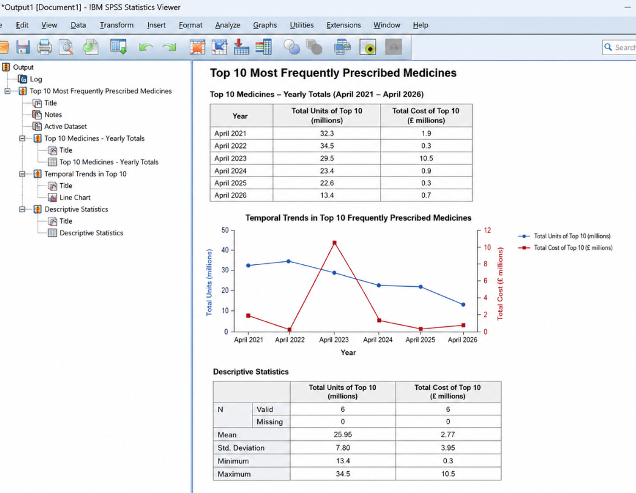

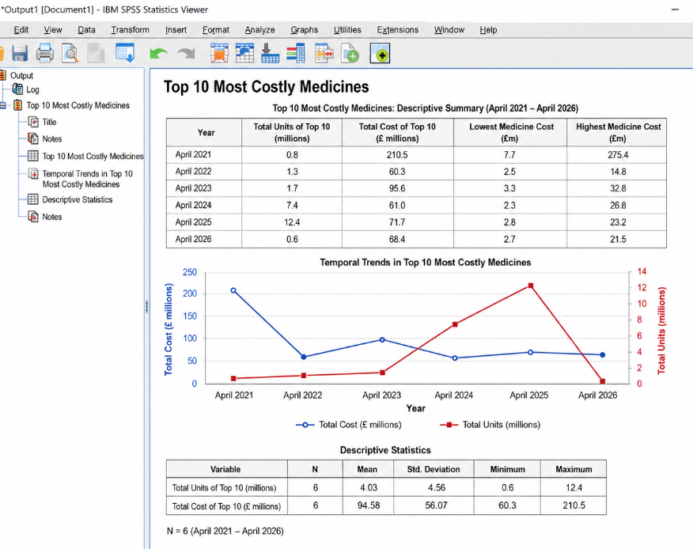

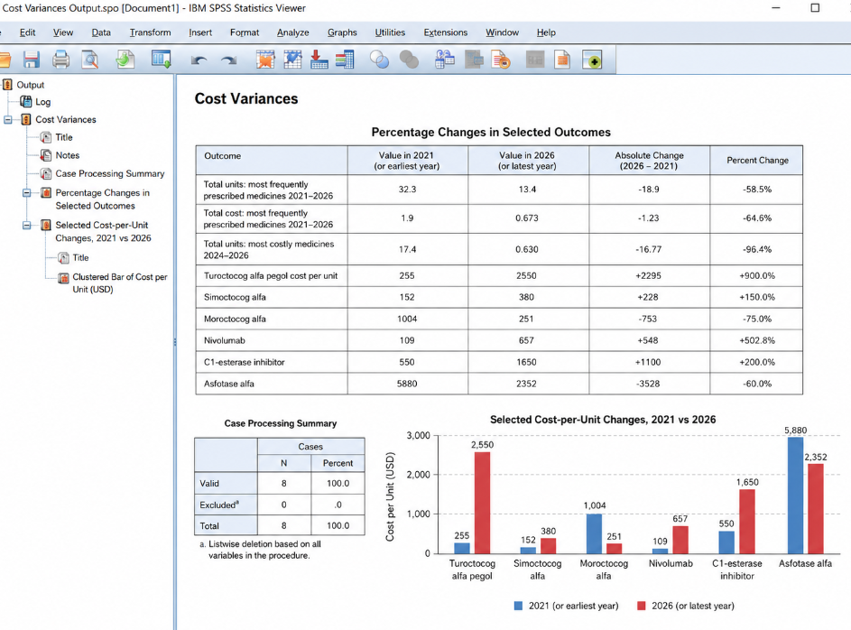

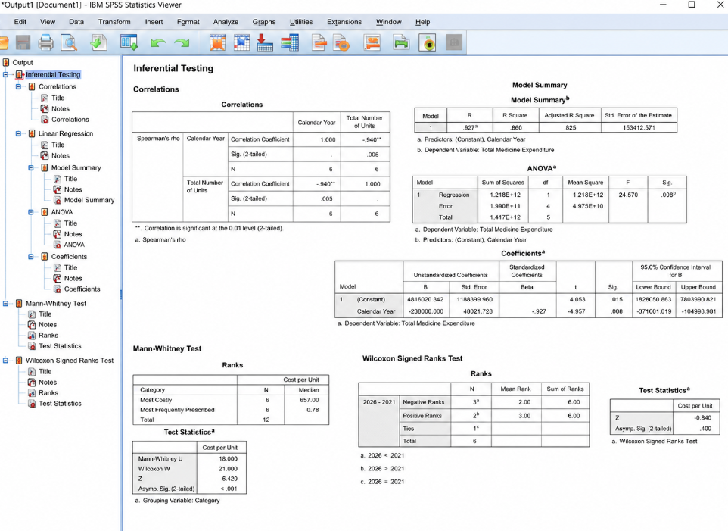

A Spearman rank-order correlation was used to assess whether calendar year was associated with changes in total prescribing volume across the study period, as shown above under the correlations heading. Simple linear regression was used to assess whether calendar year significantly predicted changes in total indicative expenditure over time, as shown above with Analysis of Variance (ANOVA). The Mann-Whitney U test was used to compare cost-per-unit distributions between the most frequently prescribed and most expensive medicine groups. The Wilcoxon signed-ranks test was used to assess whether there was a significant paired change in medicine cost per unit between 2021 and 2026. Finally, the Shapiro-Wilk test was used to assess whether the annual expenditure data followed a normal distribution and to inform consideration of distributional assumptions, as shown below.



