R-L-C Circuit Analysis
University of Wales Trinity Saint David – Swansea Campus
Electrical & Electronic Principles
Saulius Paltanavicius (2011679)
2021
Contents
1. Abstract 2
2. Introduction 2
3. Simulation 2
1.0 R-L-C in Series 3
2.0 R-L-C in Parallel 3
4. Results 4
4.1 R-L-C in Series Results 4
4.2 R-L-C in Parallel Results 5
4.3 Theoretical Calculations 6
5. Discussion 7
6.0 Bibliography 9
Appendix 10

Abstract
Inductor, Capacitor and Resistor circuitry also known as RLC circuitry, mostly used for Alternating Current (AC) applications. These uses include in compensating power loses in medium power transmission applications, using Inductive and Capacitive Reactance characteristics of RLC circuit. RLC helps to correct power factors in power supplies, Power transmissions and motors so it would run most efficiently with reduced power waste. Other applications involve to regulating sudden voltage drops and high current urges. Capacitors help to minimise voltage drop due to its ability to hold charge where inductor can stop sudden current urges damaging transformers and other loads. Presence of the resistor in the circuit reduces the peak of resonant frequency.
RLC circuits are widely used in a smaller application too, such as tunning frequencies for Amplitude Modulation (AM) and Frequency Modulation (FM) that can be found inside radios. This circuit in smaller application is most used as Bandstop or Bandpass filter. Depending on configuration of RLC components, it can form a various filters such as Low Pass, High pass, Band Stop, Band Pass and All-Pass filters which enables signal smoothing and frequency tunning.

Introduction
This report contains detailed information of RLC circuit simulation using Proteus Simulation software. During this simulation two types of RLC configurations were tested:
- Series
- Parallel.
The aim of the test is to simulate and determine Voltage and Current characteristics in both circuits and the difference between the two circuits when they are exposed to different frequencies. Both circuits were analysed using mathematical calculations to determine circuit characteristics, resonant frequencies and Q-factors of the circuit.

Simulation
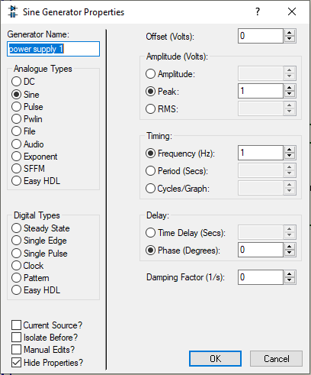
In this simulation, three electrical components were used to design and draw the R-L-C circuit using software package called Proteus. The components analysed for voltage and current characteristics across each component when they are exposed to AC power supply at different frequencies ranging from 1Hz to 20kHz.
Figure 1 - Power Supply setup
Since this test is aimed for analysing Alternating Current (AC) circuit, the power supply was set to Sine Analogue type with 1V peak to peak voltage at starting frequency of 1Hz. These setting were used for both, Series and Parallel circuit.

R-L-C in Series
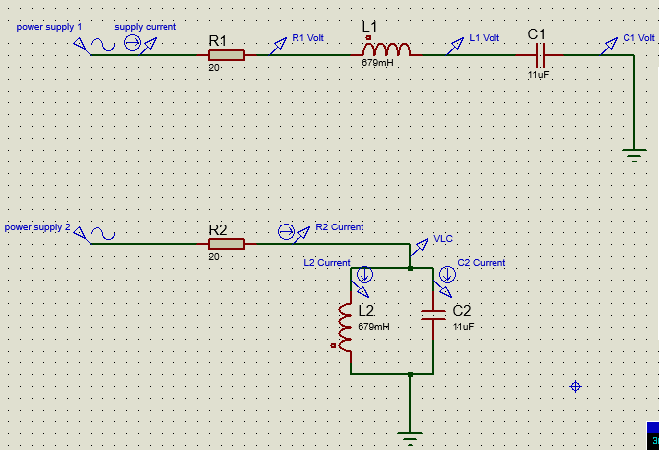
First circuit that was analysed was Resistor, Inductor and Capacitor that were connected to Alternating Current Power Supply in series as shown in the Figure 2.
Figure 2 - RLC Series schematics

Component Parameters:
Figure 3 - Component Values and naming convention

To measure voltages and current across each component in first circuit, voltage and current probes were used, using built-in functions inside simulation package. Measurement probes were added to the circuit by simply selecting a required probe, dragging and dropping on the targeted area of the circuit.
Figure 4 - Naming conventions of testing probes

R-L-C in Parallel
The second circuit that was analysed was RLC in parallel configuration. Inductor and capacitor were connected in parallel to each other and both components in series with resistor as shown in the figure 5.
Figure 5 RLC Parallel circuit schematic

Values and configuration of each component in the circuit stayed the same as in the previous, series circuit.
Figure 6 - Parallel Circuit component naming convention
In parallel circuit, more current probes were used to analyse current and voltage characteristics in this circuit. This is due to current variation in parallel circuits.
Figure 7 - RLC Parallel Circuit testing probes naming convention.

Results
This section covers the results and graphs obtained from both, Series and Parallel RLC circuits using simulation software.

R-L-C in Series Results
Current in series across all components is the same. Current value and resonance across inductor and capacitor vary based on frequency of power supply as shown in the figure. All four current measurements across 4 elements in the circuit are the same.
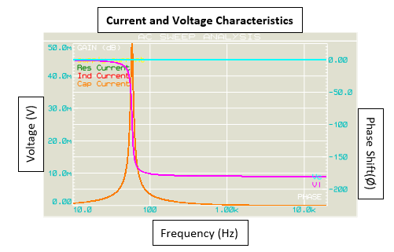
The initial voltage across resistor is in phase with current across it. The voltage across inductor (Vl) leads current by 90° where voltage across capacitor lags the current by 90° (Vc). For this reason, voltage across inductor is out of phase by 180° from voltage across the capacitor as seen in the figure 8, on the right-side axis. This is due to Inductor voltage and Capacitor voltage oposition to each other.
Figure 8 - Voltage and current characteristic results

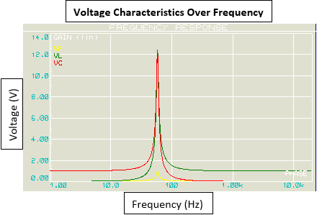
Voltage across three components is different at different frequencies. Resistor voltage never exceeds 1.00V supply voltage where capacitor and inductor have a significant voltage gain of 12.4V at resonant frequency of 58.2Hz as shown in the figure. This spike of voltage also is known as Q Factor.
Figure 9 - Voltage Characteristics of RLC components in Series

R-L-C in Parallel Results
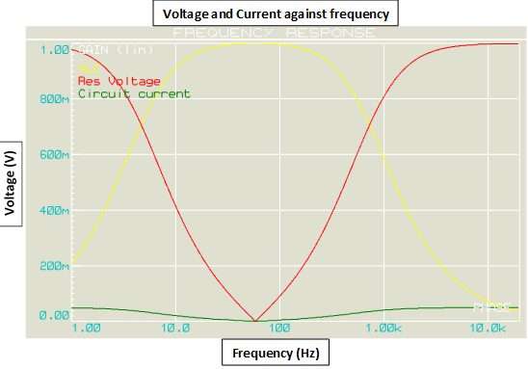
Figure show voltage response over range of frequencies in R-L-C circuit when Inductor and Capacitor were connected in parallel to each and in series with 20ohm resistor.
Figure 10 - Voltage and current characteristics of RLC parallel circuit
Voltage across resistor have dropped to very low value at the resonant frequency of the circuit of 56.1(Hz). However, a total Load voltage (VLC) has reached a peak point of 1.00 Volt at the resonant frequency. Voltage in parallel is common [1], therefore voltages across Inductor and Capacitor stays relevant to each other over the range of frequencies. As voltage increases, current reduces.

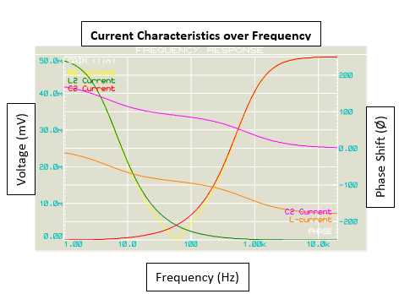
Current through resistor drop to 12.3micro Amps at resonant frequency of 58.1Hz but starts increasing as frequency increases. Current across Inductor and Capacitor have opposing affect to each other as frequency increases. Current across inductor will get smaller while current across capacitor increases.
Figure 11- Current characteristics in Parallel RLC
Inductor and Capacitor current will be equal at the resonant frequency.
Xl = Xc
There is a 180° phase shift between current and inductor currents as can be seen in the figure.

Theoretical Calculations
To ensure that simulation results are correct and accurate, they must be supported by mathematical calculations. Mathematical calculations below were used to find Current, Voltage, Q factors and resonant frequencies in both, RLC parallel and series circuits. Each formula was carried out with given values of components:
- L = 679mH Inductor
- C = 11uF Capacitor
- R = 20ohm Resistor
- f = 10Hz to 20kHz Frequency
- Vin = 1Vp-p Voltage Supply

- To determine total impedance of the circuit based on AC source, Inductive and Capacitive reactance of the circuitry must be calculated. The formulas seen in figure 12 are applied on both, RLC series and parallel circuits to find Xl and Xc. Inductive and Capacitive Reactance changes as frequency is changing (See result table in appendix section).
Figure 12 Formulas to calculate Inductive and Capacitant Reactance [5]

- To find total Impedance of both circuits, following formulas were used, where Zlc is a summed Reactance of Inductor and Capacitor. Ztotal is total Impedance of the circuit at given frequencies.
Figure 13 - Formulas for calculating Total Impedence [5]

Since parallel RLC circuit was not not pure parallel circuit, the formula in figure above had to be used to calculate total Impedance. Paralleled Inductor and Capacitor (Zlc) were connected in series with resistor (R).

- To calculate total current for both circuits, ohms law was used, where Itotal is the total current at given frequency. Current in series circuit is common [1] across all components where total current in parallel circuit is a sum of vector of each branch current (Is^2=Ir^2+(Ic-Il)^2).
Figure 14 - Ohms Law for calculating Current [5]

- To find total voltage gain on both circuits, following formulas must be used, where Vout is the circuitry voltage out put between capacitor and Inductor. Voltage across parallel components stays common where voltage in series circuit is different across. In series, total voltage supply is equal to vector sum of voltages across components (Vs=Vr^2+(Vl-Vc)^2).
Figure 15 - Calculating Load voltage output [1]
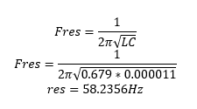
- To find a resonant frequency for both circuits a formula seen in the figure used. With given parameters, it was determined that both circuits have resonant frequency of 58.2356Hz.
Figure 16 - Resonant Frequancy formula [1]

- To determine Q factor of Series and Parallel Circuits, two formulas can be used.
Figure 17 - Q Factor formulas of Series and Parallel circuits [5]
Using formulas, it was determined that Q-Factor for Series Circuit is 12.4225V as shown in figure 17 where Q factor for Parallel circuit is 0.0805. As it can be seen from results, Series circuit have opposite results to Parallel circuit. While there is a significant voltage gain the resonant frequency on series circuit, the voltage on parallel circuit goes very low.

Discussion
Magnetic fields in the inductor are created by discharging current from capacitor, then current is charged again by discharging magnetic field (collapsing) from the inductor. This process happens repeatedly over the range of frequencies and at the certain frequency current Reactance of inductor becomes equal to Reactance of capacitor at which causes electricity to swing between the two components. This phenomenon is called Resonant frequency and it is a harmonic swinging of a current. To reduce this swinging of the current, a resistor is used which stops the resonant frequency from oscillating over the period, also known as damping effect using resistor [2].
Resonant frequency happens due to inductive reactance and capacitive reactance being equal to each other. That’s because Inductive and Capacitive reactance cancelling each other.
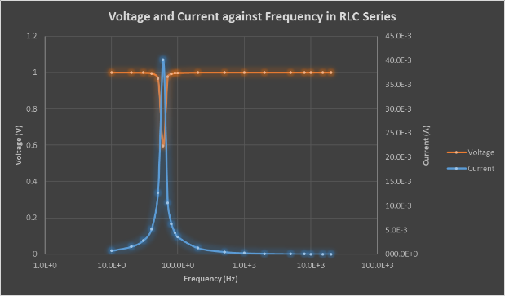
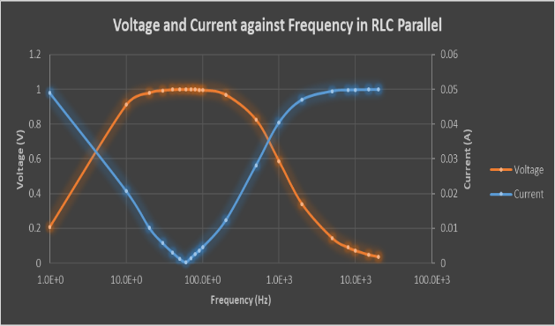
Figure 18 - RLC series voltage and current
Figure 19 - RLC parallel voltage and current

The difference between Parallel circuit and Series circuit is that at resonant frequency in series has a lowest impedance but maximum current where parallel circuit has a highest impedance, but lowest current as seen in figures 18 and 19. [3]
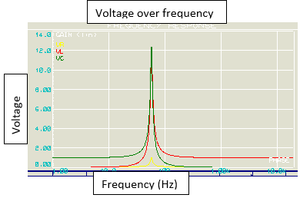
Q-Factor allows to measure the quality and performance of the bandwith of Inductor and Capacitor. The higher the value is of the q-factor, the mor narrow the bandwidth of the waveform. The narrow bandwidth and high gain in voltage, is a very acceptable characteristic in many electrical applications.
From simulation results in the figure 20, it can be seen that the voltage gain is much greater than a supply voltage. Supply voltage for this circuit was 1V but during resonant frequency, voltage increased to 12.4V on series RLC.
Figure 20 - Q-factor of Series circuit
However, using mathematical calculation for Parallel RLC circuit it was determined that the Q-factor for the circuit is an inverse factor of series circuit as seen in figures 17 and 21. In parallel circuit, the Q-factor is 0.08. The lover parallel impedance, the lower damping effect it will have on the circuit therefore as the result, Q factor for the circuit is going to be lower. This kind of characteristics is commonly used in band filter design to determine best bandwidth.
Figure 21 - Parallel Circuit q factor

6.0 Bibliography

[1] | W. Hill and P. Horowitz, “The art of Electronics,” in The art of Electronics, New York, Cambridge University, 2015, pp. 44-68.
[2] | Electrical4u, “Electrical4u,” Electrical4u, 26 10 2020. [Online]. Available: https://www.electrical4u.com/resonance-in-series-rlc-circuit/. [Accessed 26 04 2021].
[3] | Nipun, “Pediaa,” Pediaa, 02 11 2015. [Online]. Available: https://pediaa.com/difference-between-series-and-parallel-resonance/#:~:text=The%20main%20difference%20between%20series,components%20creates%20the%20largest%20impedance.. [Accessed 24 04 2021].
[4] | W. Li, Wireless considerations in ocular implants based on microsystems, Michigan State University, USA: Woodhead Publishing Series, 2013.
[5] | C. R. Robertson, Further Electrical and Electronic principles, Edward Arnold, 2002.
[6] | D. A. Fishman and S. B. Jackson, Optical Fiber Telecommunications IIIB, New Jersey: Academic Press, 1997.

Appendix
RLC Series Result Table

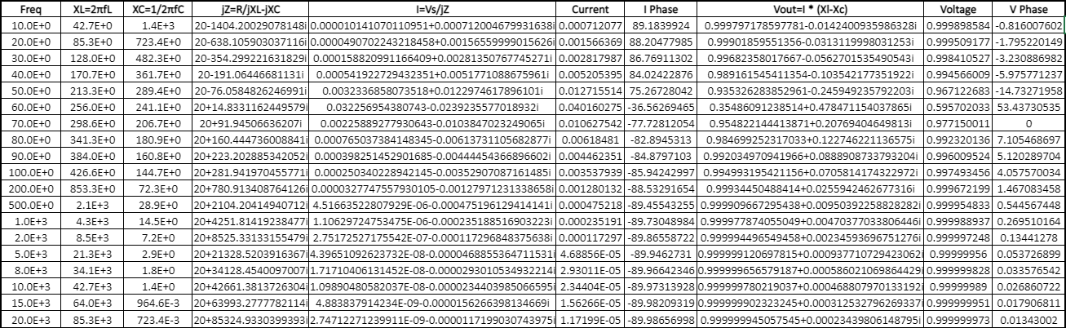

RLC Parallell Result Table



