

Figure 1 – University of Wales Trinity Saint David Logo (UWTSD, 2017)

University of Wales Trinity Saint David School of Engineering

Investigation of three forces in equilibrium

Kurt Aston Copper

P148722

Motorsport Engineering

22/1/19

Foundation Science

M3X01513

Table of Contents
Introduction 3
Experimental procedure 4
Results 5
Conclusion 5
References 5

Introduction

In this report, there will be a coverage of the aim of the experiment, which is to investigate how the angle between two strings varies as the load they are supporting is increased. The report will be covering aims which are the experimental setup, experimental procedure and results. This report has helped me record my findings and with use of diagrams and results, it will give a better understanding of the three forces in equilibrium. For the research, it has been important to justify the validity of the results, as this has ensured the experiment and the theory had a correlation.

The aims of the report are to conduct the experiment and report my findings. I have detailed the experiment in how it was set up and recorded my findings. When I wrote up the results I used pictures and graphs to aid my explanation. Research into the validity has been undertaken for accuracy into the report. There are different headings in this report. Experimental procedure is the first heading. This will be a step by step on how the experiment was set up and undertaken with results. The results heading is a recording of the results and displayed in a graph and table. The analysis and conclusion both consider the results and has considered the main findings of the experiment completed.

Experimental procedure

The experiment procedure was supplied in a document which clearly explains the task in hand with directions on how to set up, carry out the experiment, record my findings and to use my results in formulas to identify the physical principles behind the forces in hand. The apparatus was assembled for me as shown in Figure 2. This set up consisted of a piece of string attached to two springs with a mass (M) in the centre of the string. The results to measure are the two lengths of the springs and the angle shown in the diagram for each mass adding 100g each time. A table was required to record my measurements, including three columns for derived data.

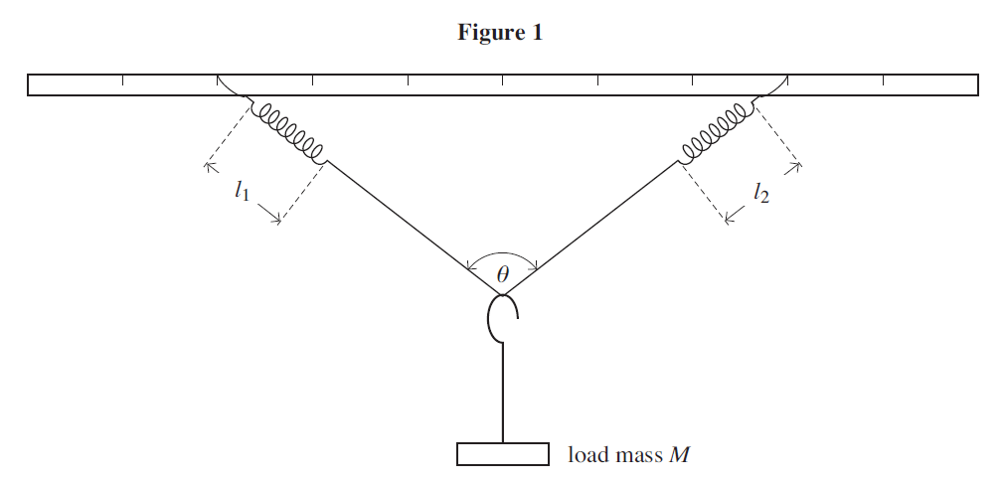
Each step was repeated adding 100g each time till total of 600g. with all the results of each mass recorded a mean result of both lengths and a mean result for the angle. All the data recorded was used to complete the table needed to complete the task. Using the data, we used the equation $\frac{M}{cos\left(\frac{θ_{m}}{2}\right)}$ to produce numerical values in engineering units to plot a graph with L (length) on the y-axis against the results of the equation $\frac{M}{cos\left(\frac{θ_{m}}{2}\right)}$ . Starting both scales at 0.
figure 2 Experiment set up (hand out)

Results

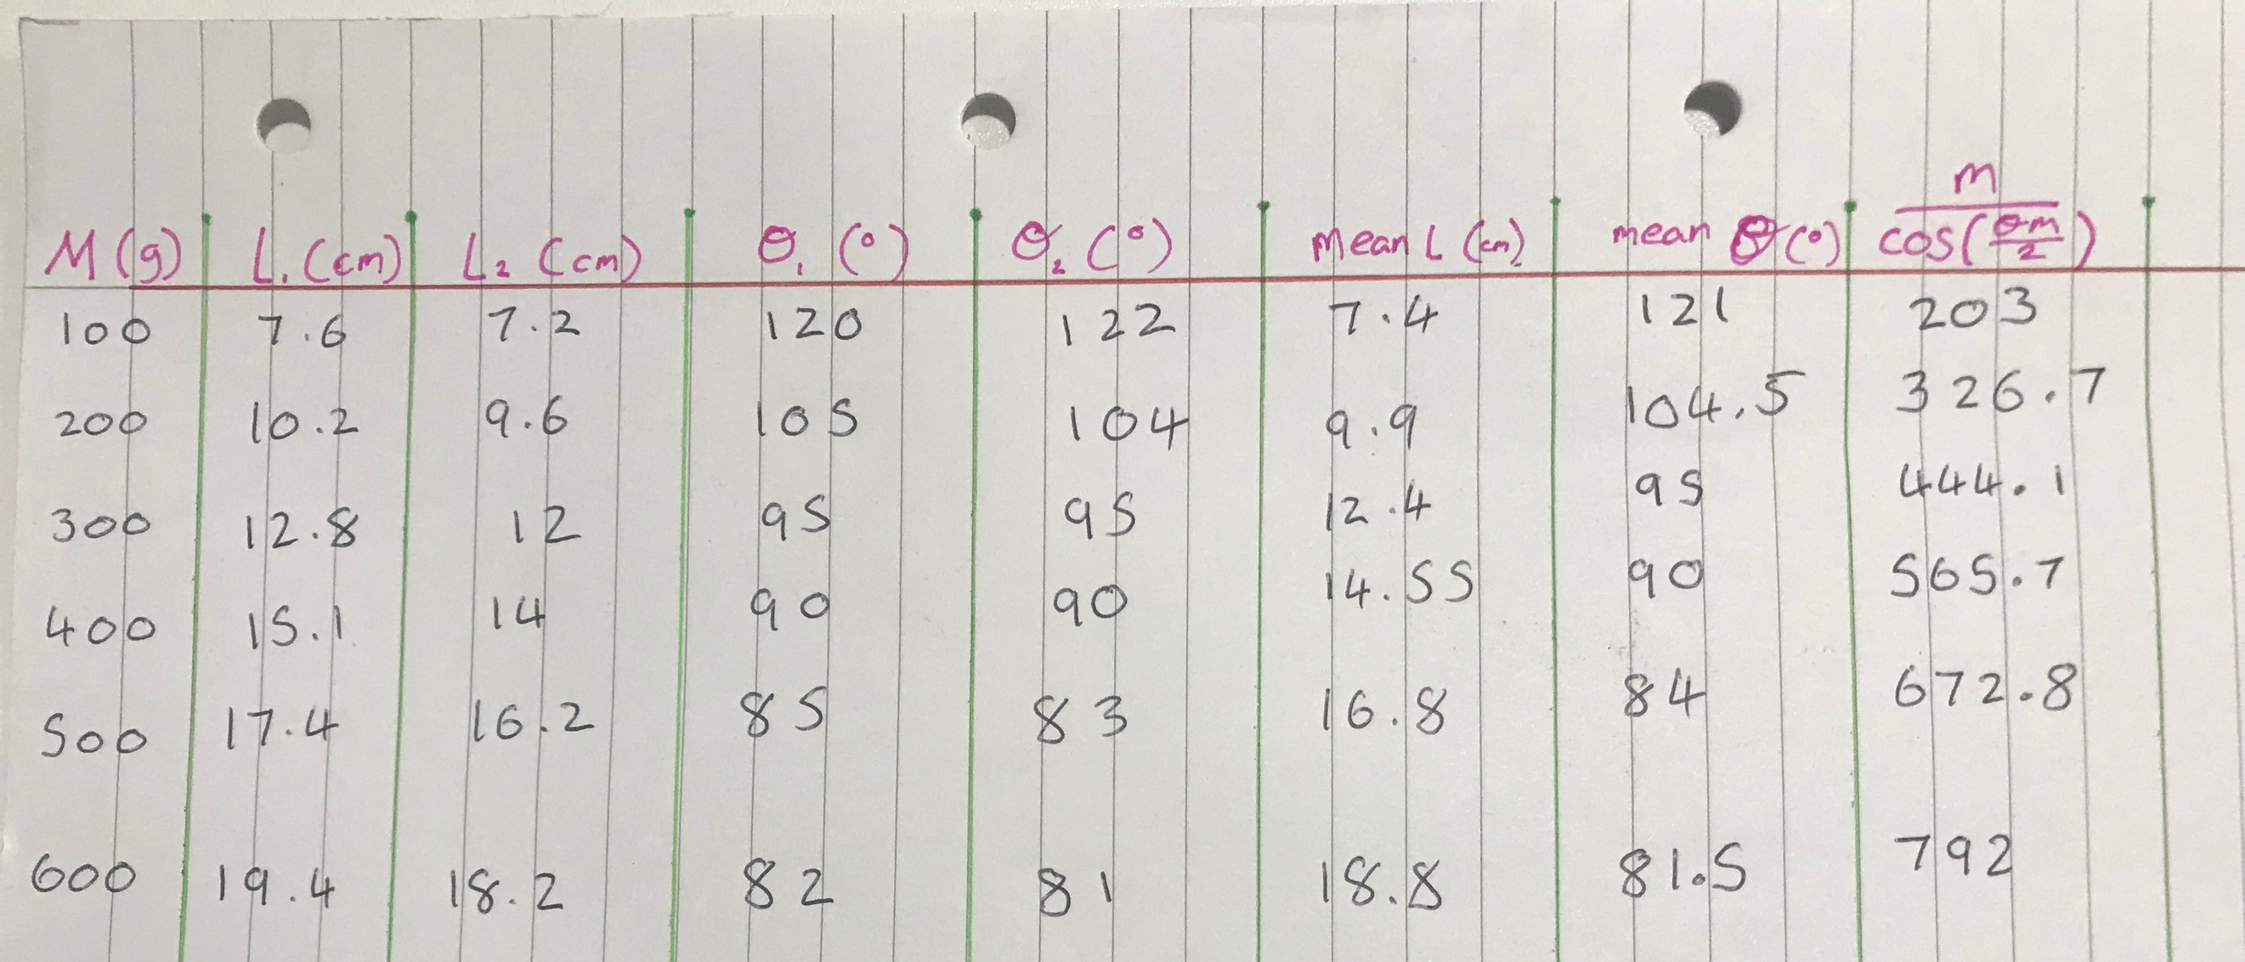

table of results Figure 3

I filled out the table with the results I obtained from my experiment ensuring a repeated recording to minimise human error and incorrect resulting. The table shows a clear pattern with the results and shows a steady increase in length of the spring each time additional mass was added. With the length increasing, the angle decreased. When using the formula to produce numerical values in engineering units, the values were rounded to one decimal place. The reduces accuracy in my resulting but helps recording the data and using for later use.

When plotting the graph, I decided to use my computer skills and inputted my results to acquire a computer-generated line graph. This increases my accuracy when using my graph to use for collecting data from.

Graph of results Figure 4

My graph shows a steady increase which made it easier to plot a line of best fit (figure 5)

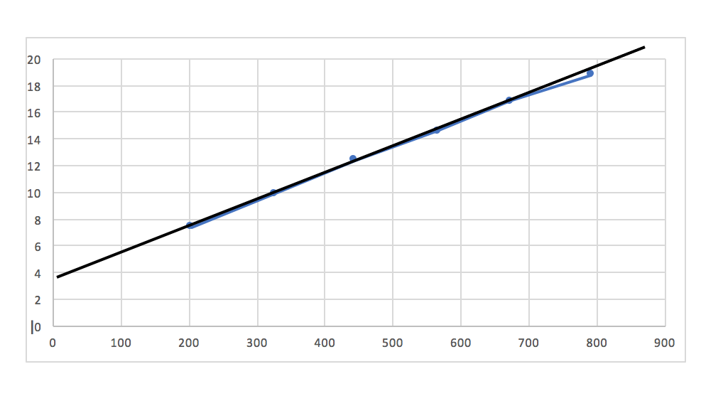
line of best fit Figure 5

Conclusion

To conclude this report and experiment, I found that there would be an area where human error had a part of the resulting. Setting up the experiment using the same string and springs over would influence the results as repeating the methods would not be the same.

The whole experiment was the identify, apply appropriate physical principles and relationships in the solution of engineering problems and to manipulate equations to produce numerical values in engineering units. The experiment has a clear outcome from carrying it out and using program to produce my graph made it easier to show the results clearer.

References

Figure 1 – University of Wales Trinity Saint David Logo (UWTSD, 2017)

