

Academic and Employability Skills

Gerardo Cacciapaglia
1912609
Academic and Employability Skills
BMSW4001
University of Wales Trinity Saint David
04 May 2020

Table of Contents
Abstract 3
1. Introduction 4
2. Methodology 5
3. Results 6
4. Discussion 8
5. Recommendations 9
6. Conclusion 13
References 14
Appendix 15

Abstract
In order to be competitive, one needs to possess high level of academic and professional skills. However, for the development of these skills, it is important that the Higher Education department must align their academic goals with the professional objectives. A strong association was found among employer and sandwich understudy/academic perspective on the relative needs among professional aptitudes. Abilities, for instance, excitement, unwavering quality and gathering working scored higher than subject data aptitudes, while business care, course of action and frameworks organization were given least need. To evaluate the priority based academic and employability skills, a brief qualitative and literature-based research was conducted. The results ensure and confirms the significance of aligning the employability skills with the academic objectives to improve the employability level of the individuals.

Introduction
Academic and professional competence is a key issue for Higher Education. In this two-segment study understudy professional aptitudes have been evaluated from the perspective of sandwich trainees and academics in biomolecular science, and the employers. A strong association was found among employer and sandwich understudy/academic perspective on the relative needs among professional aptitudes. Abilities, for instance, excitement, unwavering quality and gathering working scored higher than subject data aptitudes, while business care, course of action and frameworks organization were given least need. Besides, the most negligible situated aptitudes were those that sandwich trainees/academics were reviewed to be least fit in. For the most part social abilities of new academic employees were assessed less uncommonly by the employers than by the academics themselves. In the second bit of the assessment a professional aptitudes profile was accumulated and appropriated to biomolecular science trainees at levels 1, 2 and 3, as a significant part of mindfulness orchestrating. Level 3 trainees evaluated themselves more outstandingly than level 1 and level 2 trainees in subject data, most focus abilities and individual attributes, except for protection from push. Consequences of this examination, including the estimation of understudy self-evaluation of the aptitudes and utility of the profile to help personal growth masterminding and teach academic selection structures, are inspected and recommendations made.
The universe of work continues progressing rapidly. As money related, social and imaginative advances drive forward the pace of progress, the current youths ought to be more prepared to change than some other age. The abilities employers are putting a motivator on are changing and new openings are rising.
With the quick improvement of society, the contentions between associations are also growing, what the employer requirement for the academics are revolve around the degree just as give more thought to the professional aptitudes. In order to win the opponents in the incensed contention, employers need academics who have a wide extent of aptitudes to bring to the working environment and need the employees with multi-gifted to fulfill a wide scope of occupations (Messum et al. 2017). Along these lines, academics who coming into the workforce must have what it takes required by employers.
To make ourselves end up being progressively genuine later on work exhibit first we ought to find what the professional aptitudes the employer requirement for academics, by then as showed by the professional abilities do the individual assessment and make an action plan to create ourselves.

Methodology
For conducting this research, descriptive qualitative approach along with review of literature was adopted. The approach helped in identifying, verifying and prioritizing the academic and employability skills along with the importance of aligning the professional goals with academic objectives of the students.
Secondly, the results will also be based on my personal assessment and evaluation of my academic and professional competencies and skills.

Results
  - Personal Skills and Competencies

Based on my personal assessment and evaluation, following are my strengths and weaknesses.
My strengths are:
- Creativity
- Versatility
- Flexibility
- Focused
- Taking Initiative
I’ve always preferred to work in groups and find that my collaborative nature is one of my strongest attributes. On projects that I directed, I work well to inspire diverse team members and work side by side with them to achieve the project goals. In fact, I’ve increased productivity by ten percent over the course of two years.
My weaknesses are:
- Self-criticism
- A Particular Software
- Too sensitive
I'm not familiar with the latest version of the software that you use. I’ve spent my time recently focused on generating a positive user experience and have always been willing to learn new things. Throughout my career software has always changed and I’ve always been willing to adapt to changing technology. I will put in the time it takes to learn this new software.
  - Professional Priority Skills and Competencies
The importance of courses of action, temporary employments and work-based learning
• Perhaps above all, the composition and our own revelations have overwhelmingly highlighted that employers, trainees, academics and ACADEMIC agents regard work-based learning, (for instance, circumstances and temporary situations) as particularly incredible approaches to manage advance the professional of academics.
• Opportunities, for instance, positions and temporary occupations not simply seem to offer a reasonable applied system for ingraining fitting care, abilities and limits in academics anyway can in like manner advance profitable joint exertion and associations among ACADEMICs and employers, fabricating increasingly conspicuous perception between these accomplices. The importance of circumstances and temporary employments has been seen by policymakers and maintained by financing and the regard is also affirm by longitudinal examinations (Suleman, 2018).
The assessment allude to writing to help the comfort of work courses of action and the way that academics who have done a circumstance or work-based learning have greater accomplishment making sure about academic-level positions.
• ACADEMIC representatives acknowledge that, where present, the academic respect programs add to improving trainees' ability to ensure about employment and perform well in the occupations. These projects are seen as significant considering the way that they not simply urge trainees' passage to work-based learning and relative chances yet moreover license these experiences to be accounted for. This is then a wellspring of evidence of abilities and characteristics that can be acquainted with employers. Nevertheless, an incredible piece of the ACADEMICs' confirmation for the more broadened term impact of the professional projects and measures was related rather than subject to exact evaluative research.
Assortment in ACADEMIC response to propelling professional
• The composition on academic professional, and our investigation, shows that there has been an extent of attempts by ACADEMICs to address academic professional (Messum et al. 2017). In any case, how much such progressions are going on and the level to which they are embedded over the Higher Education section is dark yet has all the earmarks of being uncommonly factor. This is regardless of key upgrades in government game plan to ask ACADEMICs and employers to coordinate to make moves toward that add to academic professional.
• There are different models in the composition (checking CBI site sources) and in our investigation of good work on concerning employers and ACADEMICs attempting to propel academic professional. Regardless, there are still issues and obstructions among employers and countless those at risk for course of action in ACADEMICs, particularly to the extent differentiates in viewpoint, wants and needs concerning professional.

Discussion
Today, regardless of the degree, associations are giving more thought to the professional aptitudes of the academics, yet there is no uniform standard of professional abilities. What professional aptitudes the academics should have are depend upon association's certifiable working conditions and different associations have different rules. Through a wide extent of composing research, the eventual outcome of what the professional abilities required by associations are almost the comparable, and can be commonly isolated into the going with eight basic aptitudes: "Relational abilities, Teamwork aptitudes, Problem handling aptitudes , Self organization abilities, Planning and sifting through abilities, Technology aptitudes, Life-long learning aptitudes and Initiative and try aptitudes." (Tsitskari et al. 2017).

Recommendations
While a continuous report (Tsitskari et al. 2017) has exhibited that the vast majority of employers are content with the academic enrolled individuals there is a striking minority who are unquestionably not. The budgetary setting and work exhibit situation have seen an extension in academic unemployment and these issues, nearby the ever-present trial of overall money related competition, suggest that we can't act naturally fulfilled about the constraint of academics to ensure about and take care of employment, to make inside a particular action and can continue ahead to new sensible employment at whatever point required. Taking into account this, the disclosures of this assessment offer climb to different issues for thought:
Embedding support for professional over the association
• It is proposed that ACADEMICs and government explore how jobs organizations can be redesigned and resourced to propel professional activities even more enough at staff and departmental level. Our assessment shows that strategy drove, rather than exceptionally selected, adventure drove, professional measures are presumably going to have a progressively critical and progressively bolstered impact on academic professional. Professional assessments ought to be exact and embedded into departmental and staff practice: else they are exposed against changes in work power.
• Government should consider strategies for reflecting and propelling the professional aptitudes and attributes in sponsoring instruments, for instance, the Research Excellence Framework (REF). To date financing structures have not set professional at the point of convergence of colleges' vision and key masterminding, and this has all the earmarks of being certain to have affected the lead. Sponsoring streams henceforth need to invigorate an institutional culture consistent of professional abilities. It is predicted that bit of the profile for the REF will be allowed dependent on the unquestionable points of interest (influence) of colleges' investigation on the economy, society, open methodology, culture and individual fulfillment. This could, perhaps, be composed by an equivalent extent of the undeniable points of interest of ACADEMICs' undertakings to make and support trainees' professional.
• Developing academic professional abilities and characteristics should be associated with ACADEMICs' vital and workforce/departmental level orchestrating. Colleges need to reflect the progression of professional abilities and qualities in the mission statements, learning and indicating strategies, course frameworks, indispensable reports and helpful heading.
• Professional also ought to be maintained at senior organization level in ACADEMICs and reflected in approaches that are changed over decisively over all levels. The investigation disclosures reveal that while college jobs organizations will customarily hope to propel the professional of trainees, the expansion and profundity of such undertakings varies unfathomably across assets and divisions. A factor in this is the mindset of some staff to unequivocally watching out for professional abilities and qualities in the courses.
• Staff should be encouraged to see that these objectives are flawless with propelling academic breaking point and progressively broad essential capacities. Legitimate sparks for ACADEMIC staff should be used as a driver for change in propelling professional measures at workforce/departmental level.
The criticalness of circumstances and seeing experiential learning
• ACADEMICs and employers ought to continue to progress and stretch out open doors for trainees to get the opportunity to work-based learning. One of the most fundamental evaluations ACADEMICs can grasp to raise professional is to fuse appropriate facilitated circumstances, temporary positions and work-based learning chances of vital length into the courses. . A bit of the more 'professional' and business-orientated courses starting at now use these strategies anyway humanities courses could similarly profit by progressively vital usage of such measures.
• These experiential open doors require mindful orchestrating and time for reflection must be characteristic if they are to be a convincing strategy for giving college trainees relevant employment abilities, data and cognizance of employer culture. They furthermore call for incredible, proceeded and fair associations among ACADEMICs and employers.
• Other precise projects to make and confirm or see trainees' experiential and business related learning are proposed.
For example, the closeness of academic respect programs over various colleges has all the reserves of being uncommonly regarded by academics and employers. These projects are seen as significant in light of the fact that they urge trainees' passageway to business related learning practices in colleges and work-based chances, for instance, courses of action. In any case, game plans and business related and work-based experiences ought to be chronicled with the objective that trainees can offer employers confirmation of the cutoff points and abilities.
Reflecting progressively broad fiscal needs in ACADEMIC courses.
• Those subject for Higher Education game plan ought to consider trainees' employment needs including the nonexclusive aptitudes and limits required in the workplace and reflect them in the instructive program and course structure. The arrangement of degree courses and understudy contribution with general ought to verbalize with the necessities of business and ascend out of a strong working relationship with employer affiliations. At the same time academic quality, substance, focus and the uprightness of courses should not be sabotaged.
• A point rising up out of employers' observations in the composition and our relevant examinations is that ACADEMICs, the agent bodies and plan makers should research ways to deal with ensure an unrivaled fit between the sorts of degree courses being given and what is required to address the more broad financial environment. Regardless, a noteworthy stipulation should be that Higher Education similarly needs to give finding that watches out for increasingly broad social issues and needs.
Significant employer enthusiasm on ACADEMIC warning gatherings
• ACADEMICs and employer associations should be empowered and strengthened with employers having a logically unique activity in ACADEMIC professional procedures and approaches. Research on employer consideration in government-sponsored business-related guidance and getting ready shows that it is difficult to ensure about employer duty in training programs. It is possible that ACADEMICs ought to be the initiators of associations with employers. The composition and our investigation reveal that where affiliations are bolstered employers can influence professional moves close, particularly when drawn in with connected with course structure.
• Employers' substance on ACADEMIC boards should not be a token measure yet allowed to empower a significant duty. Our examination found that employers' points of view on course setup were consistently excused.

Conclusion
There is no vulnerability that employees who having a respectable degree will expand a great starting stage, since an average degree helps employees with opening the portal of getting another profession, in any case, a degree alone isn't adequate, employers need fundamentally more from the academic employees, they need employees can convey focal points to the association and let the association in a safe circumstance during the wild contention.

References
Messum, D., Wilkes, L., Peters, C. and Jackson, D., 2017. Senior Managers' and Recent Graduates' Perceptions of Employability Skills for Health Services Management. Asia-Pacific Journal of Cooperative Education, 18(2), pp.115-128.
Suleman, F., 2018. The employability skills of higher education graduates: insights into conceptual frameworks and methodological options. Higher Education, 76(2), pp.263-278.
Tsitskari, E., Goudas, M., Tsalouchou, E. and Michalopoulou, M., 2017. Employers’ expectations of the employability skills needed in the sport and recreation environment. Journal of hospitality, leisure, sport & tourism education, 20, pp.1-9

Appendix
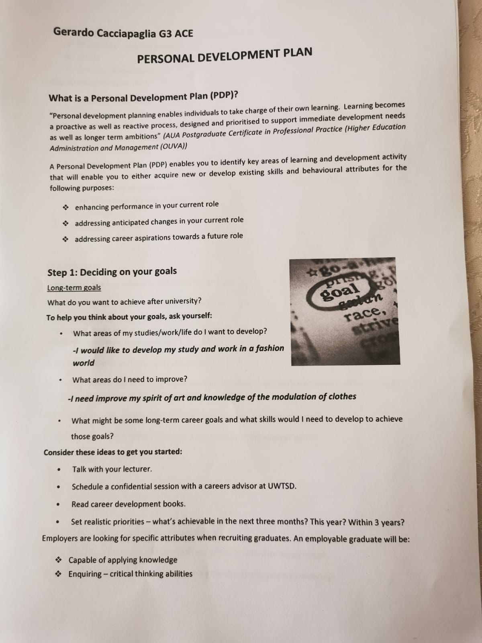
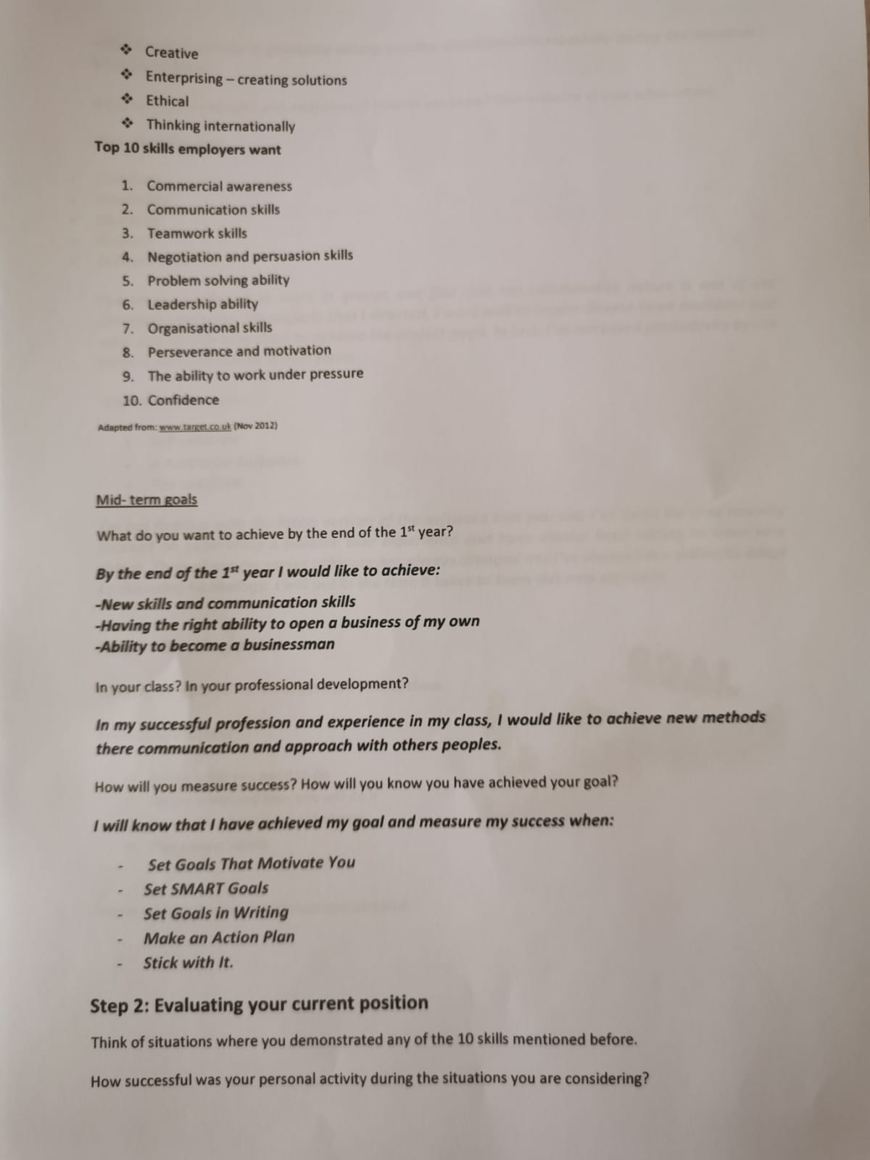
Following are the homework of employability skills. 1.PDP

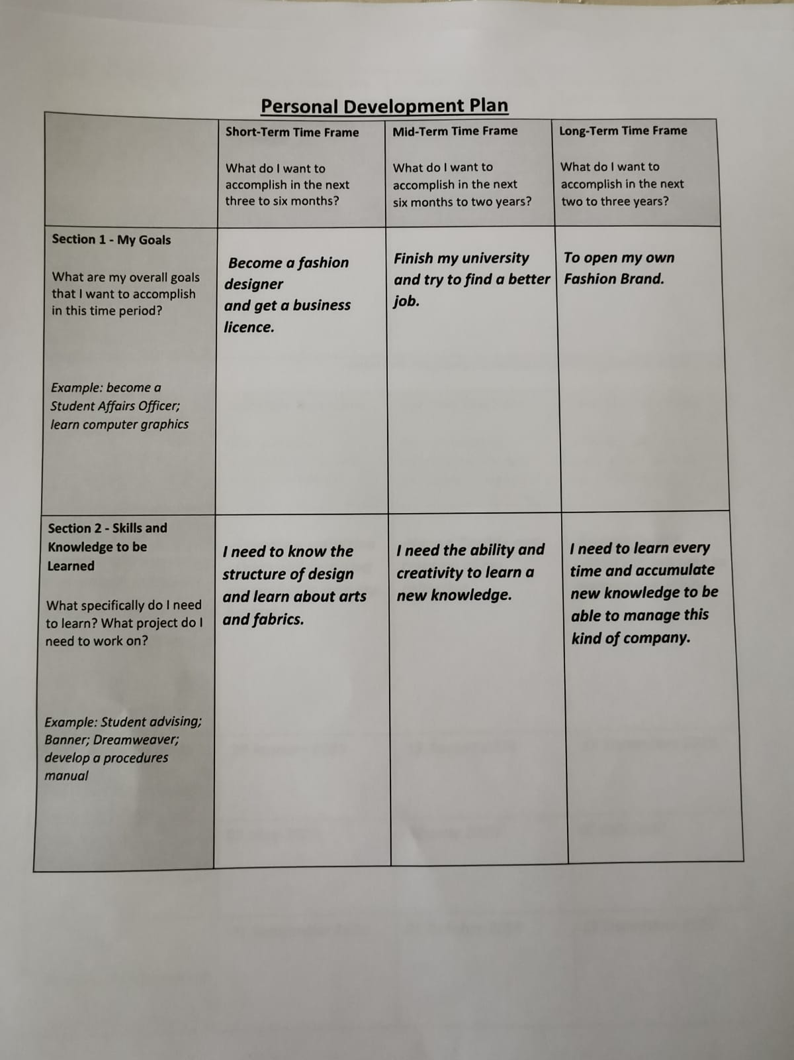
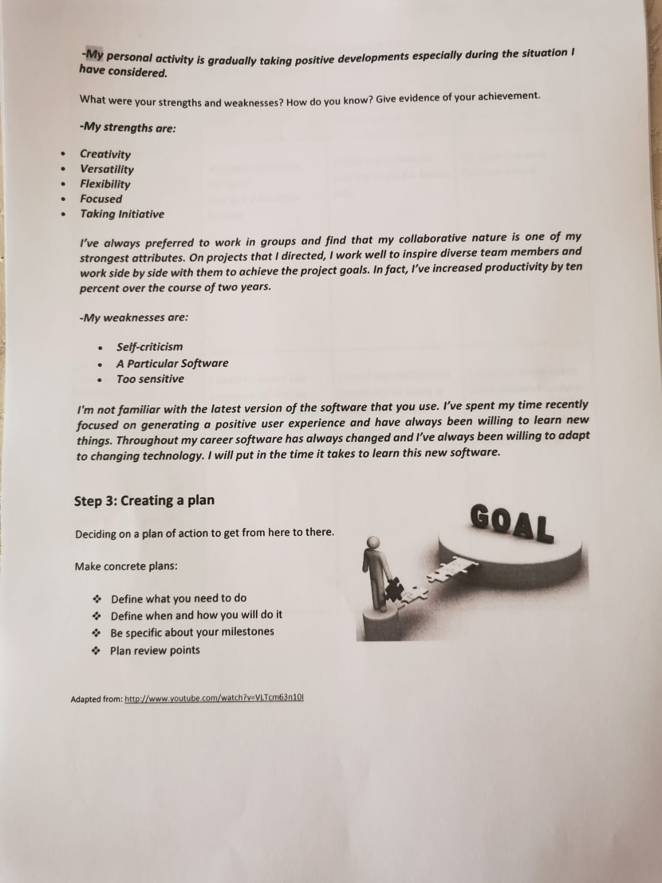

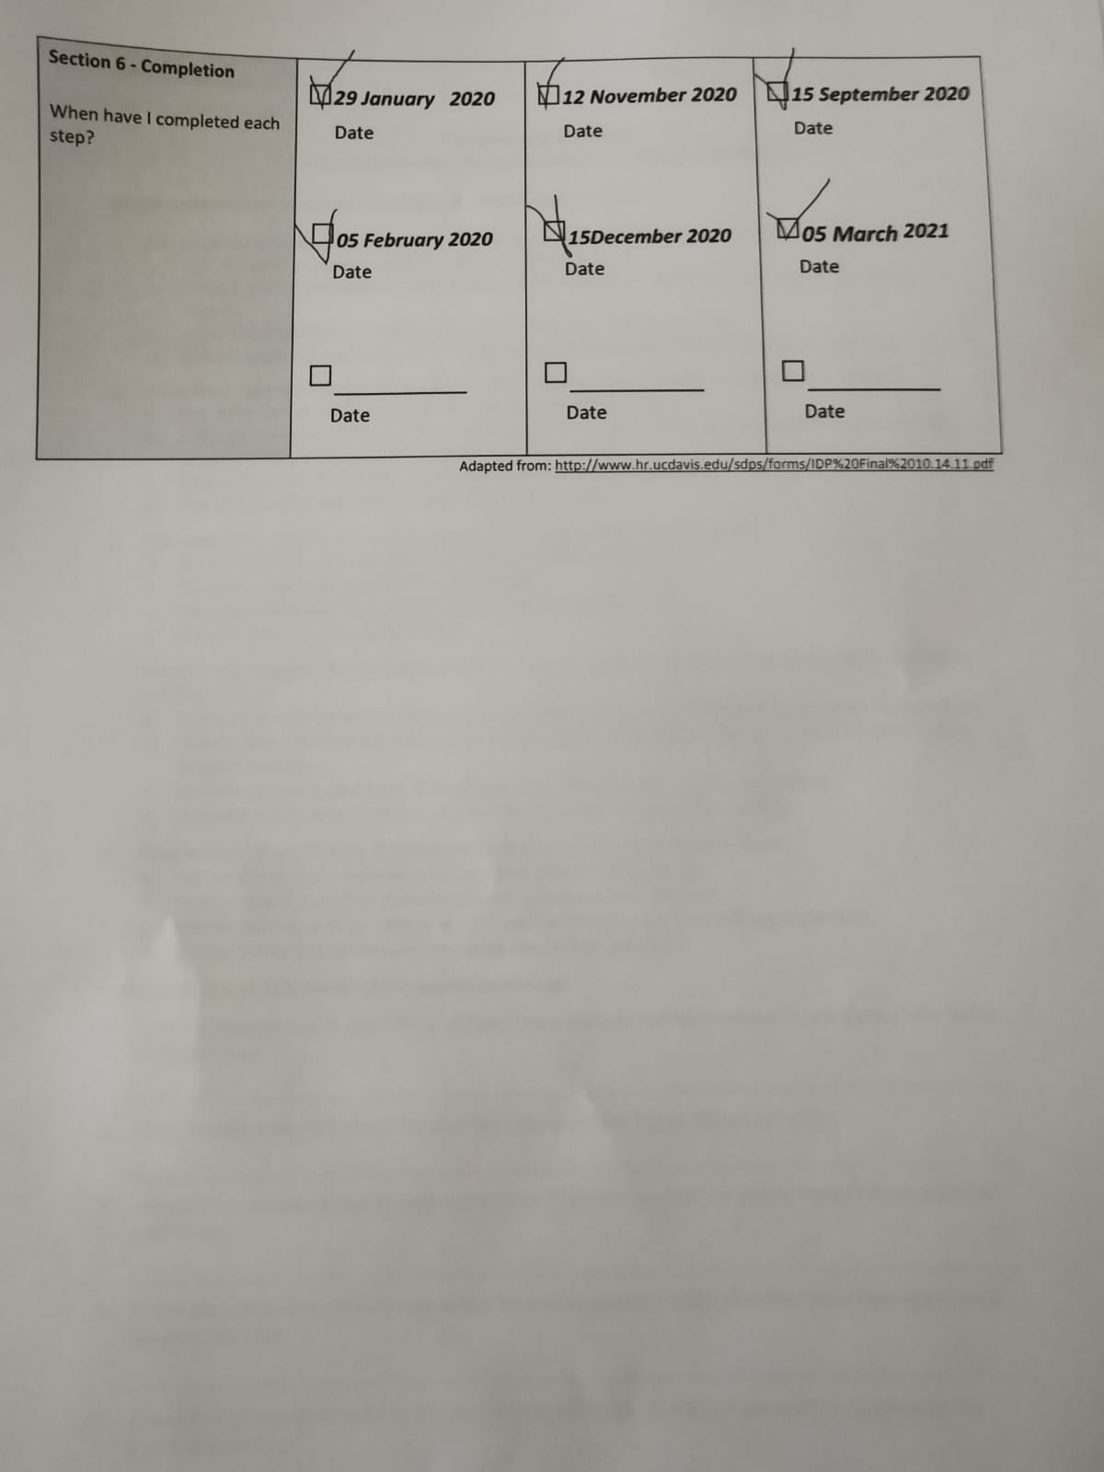
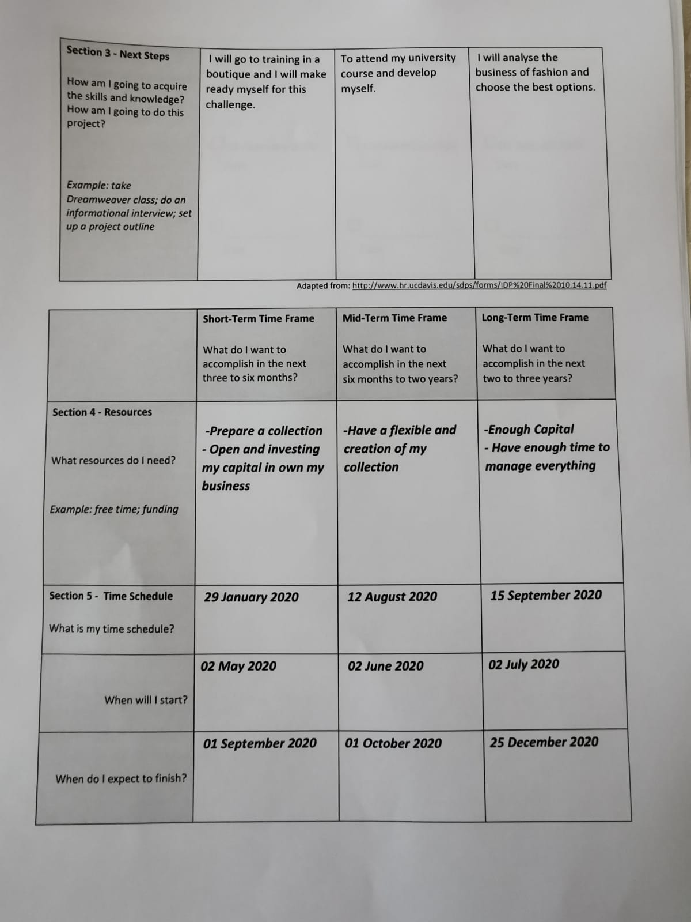

2. SWOT Analyst

3.Tamp

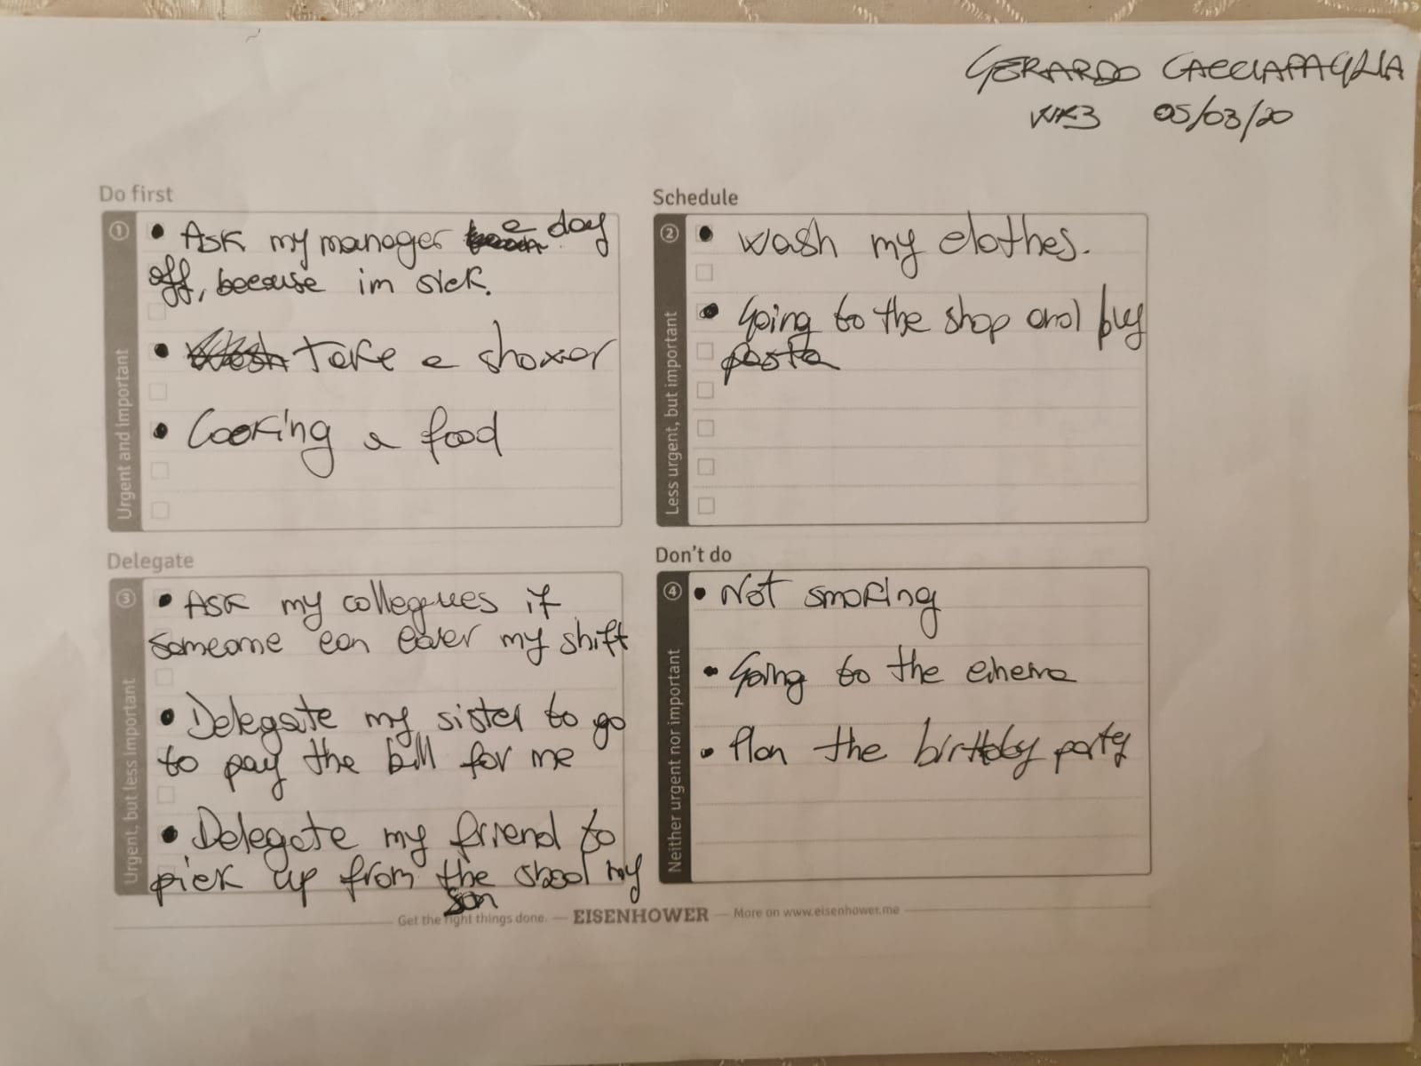
2. SWOT analyst

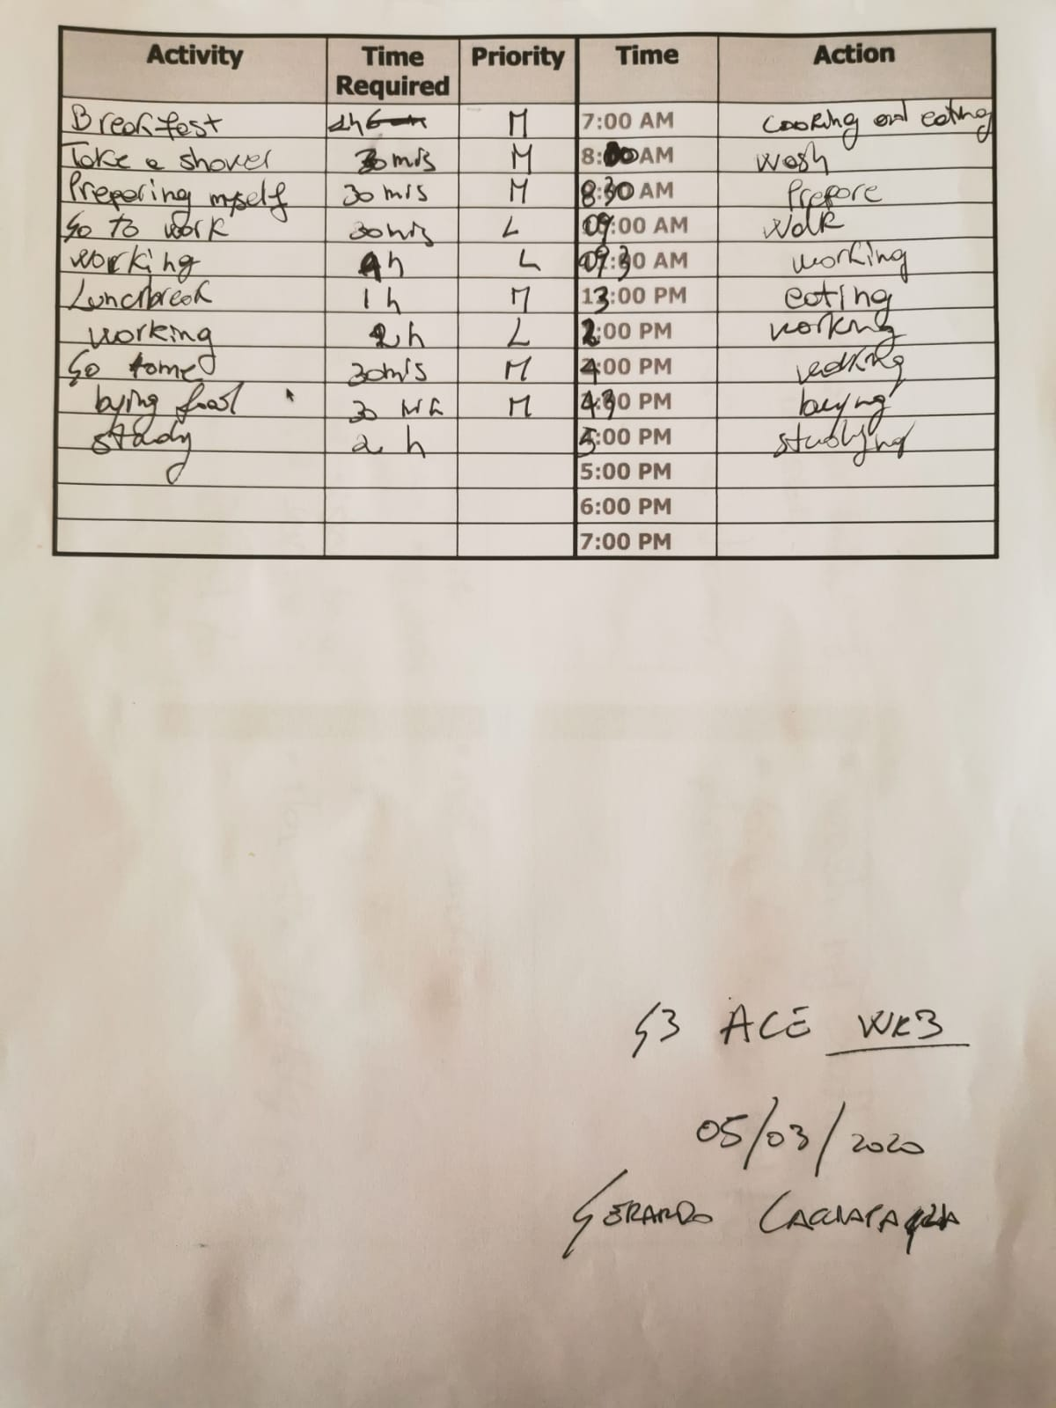
3.Temple of action

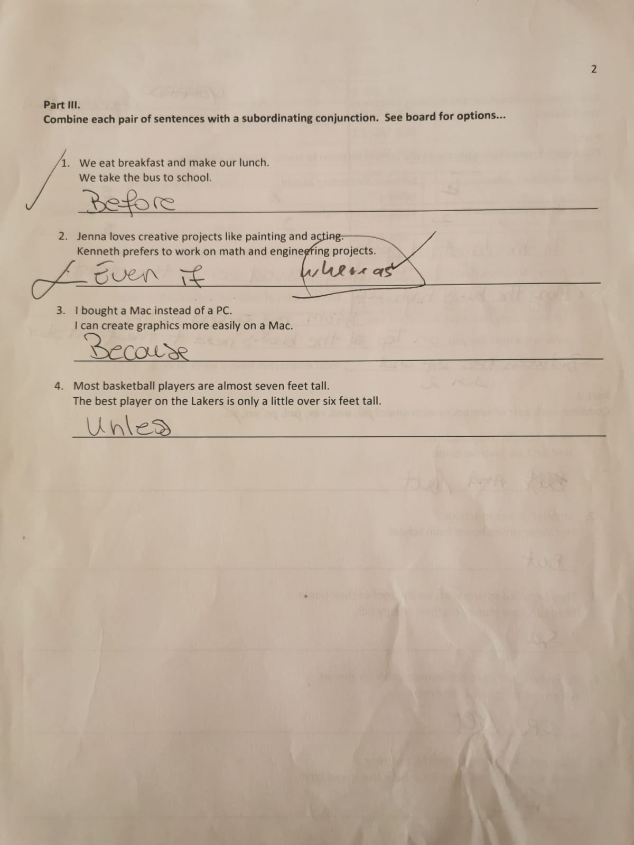
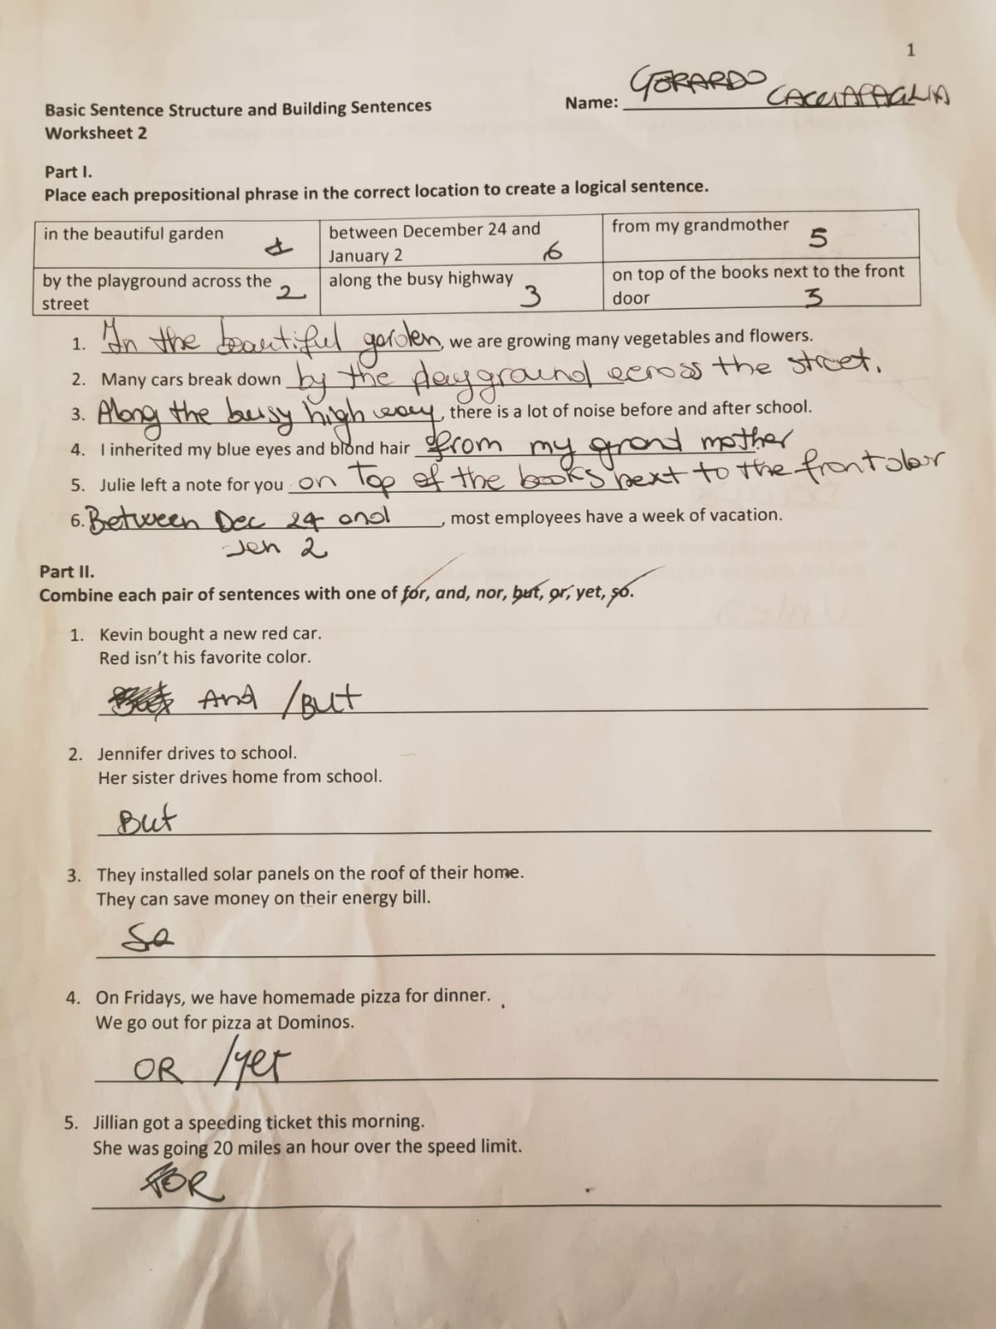
4.Sentences

5.Paraphrasing
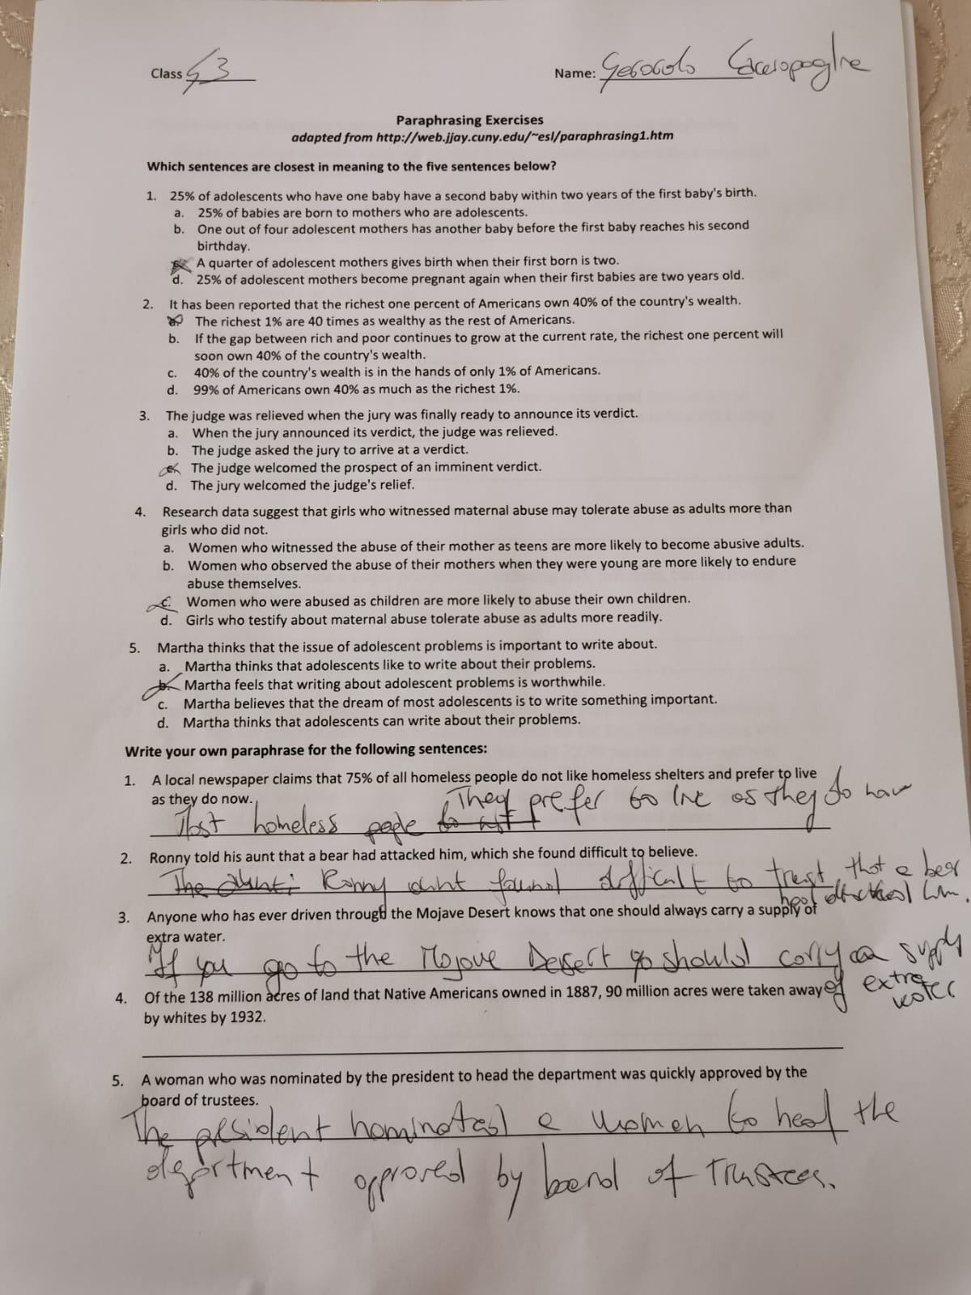

6.Referencing


