

Programme: BA (Hons) Leadership and Management Skills for the Workplace
Module: Leading and Implementing Change (LIC)
Module Code: LCLM6003

Jaguar Land Rover
Accelerating Digital and AI-Led Transformation

Lecturer`s name: Dr Eric Osei

Student name: Cornel Andrei
Student ID: 2323448

Executive Summary
This report presents a strategic change management plan for Jaguar Land Rover (JLR), Britain's largest automotive manufacturer and a subsidiary of Tata Motors since its £1.7 billion acquisition from Ford in 2008 (Bailey and De Propris, 2019). JLR faces converging pressures threatening its long-term competitiveness: delayed electrification relative to technology-led rivals such as Tesla (Perkins and Murmann, 2018), production constraints from the COVID-19 pandemic and semiconductor shortage, Brexit-related trade frictions, and tightening regulatory mandates, including the UK ban on new petrol and diesel sales from 2030 (Department for Transport, 2020). Following peak revenues of £30.9 billion in 2017–18 (SMMT, 2021), the company experienced declining sales, approximately 4,500 job cuts in 2019 (Campbell, 2019), and estimated lost revenues exceeding £2 billion during 2021–22 (Jolly, 2022), before recovering toward pre-pandemic levels from 2022–23 (JLR, 2024). The report evaluates JLR's transformation, centred on the "Reimagine" strategy announced in February 2021 (JLR, 2021), through established change management frameworks. Kotter's Eight-Step Model (Kotter, 1996) reveals that urgency was communicated later than optimal and that execution gaps between vision and delivery created stakeholder uncertainty. Lewin's Three-Stage Model (Lewin, 1947) indicates unfreezing was only partially achieved and refreezing remains incomplete (Burnes, 2004), while the McKinsey 7-S Framework (Peters and Waterman, 1982) highlights strategy and structure changes outpacing systems, skills, and cultural evolution. Leadership analysis identifies transformational characteristics at executive level (Bass and Avolio, 1994) but a "frozen middle" struggling to translate vision into operational action (Huy, 2002).
In response, the report proposes a three-year, £2.8 billion plan to accelerate digital transformation and AI integration across JLR's operations. Measurable objectives include a 20% manufacturing efficiency improvement, 35% reduction in quality defects, 30% faster model development, £500 million in annual digital services revenue by 2029, and reskilling 60% of the workforce within 36 months. Implementation proceeds through three phases — Foundation, Acceleration, and Transformation — supported by stakeholder-specific communication, a 200-strong change champion network, and robust evaluation and risk management. The programme is projected to deliver £1,170 million in annual benefits by Year 5, a 42% annual return on investment with a 3.2-year payback period, positioning JLR for sustainable competitive advantage in the premium electric vehicle segment.

Contents
Executive Summary 2
1. Introduction 5
2. Analysis of Recent History and Environmental Impact 6
2.1 Internal Environmental Changes 6
2.2 External Environmental Changes 7
2.2.1 Technological Disruption and Digitalisation 7
2.2.2 Regulatory and Legislative Environment 8
2.2.3 Economic and Market Factors 8
2.2.4 Social and Cultural Trends 9
2.3 Strategic Position: PESTLE and SWOT Synthesis 9
3. Evaluation of Change Management Models 11
3.1 Kotter’s Eight-Step Model 11
Establishing Urgency 12
Creating a Guiding Coalition 12
Developing Vision and Strategy 12
Communication and Implementation 13
3.2 Lewin’s Three-Stage Model 13
Unfreezing 13
Moving 13
Refreezing 14
3.3 McKinsey 7-S Framework 14
4. Leadership and Organisational Culture in Change Management 15
4.1 Leadership Approaches in JLR’s Transformation 15
Transformational Leadership Analysis 15
Situational Leadership Considerations 16
4.2 Organisational Culture Impact on Change Management 16
Cultural Dimensions Analysis 17
Cultural Barriers to Change 17
Cultural Enablers 17
5. Proposed Change Management Plan 18
5.1 Change Objectives 18
5.2 Financial Plan 19
Funding Sources 20
Financial Returns 21
5.3 Communication Plan 22
Communication Principles 23
Change Champion Network 23
5.4 Implementation Approach 24
Phase 1: Foundation (Months 1–12) 24
Phase 2: Acceleration (Months 13–24) 25
Phase 3: Transformation (Months 25–36) 25
5.5 Evaluation Plan 26
Key Performance Indicators 26
Continuous Improvement 27
5.6 Risk Management 27
6. Conclusion 28
7. References 30

1. Introduction
Jaguar Land Rover Limited (JLR) stands as Britain’s largest automotive manufacturer, headquartered in Whitley, Coventry. The company operates as a subsidiary of Tata Motors, the Indian multinational corporation that acquired the business from Ford Motor Company in 2008 for approximately £1.7 billion (Bailey and De Propris, 2019). JLR encompasses two distinct British automotive brands: Jaguar, founded in 1922 and renowned for luxury sports cars and saloons, and Land Rover, established in 1948 and celebrated globally for premium all-terrain vehicles.
This report presents a strategic change management plan for JLR, a British automotive manufacturer facing significant challenges from digital disruption, electrification mandates, and volatile global markets. Having experienced declining revenues, market share erosion, and operational difficulties, JLR requires a comprehensive transformation strategy to remain competitive. The analysis reveals that JLR’s challenges stem from delayed electrification efforts, supply chain vulnerabilities exposed during the COVID-19 pandemic and semiconductor shortage, Brexit-related trade complications, and intensifying competition from established manufacturers and new entrants like Tesla and Chinese EV producers. The company’s “Reimagine” strategy, launched in 2021, represents a significant change initiative, though implementation has faced obstacles.
This report evaluates JLR’s change management approach through established theoretical frameworks including Kotter’s Eight-Step Model and Lewin’s Change Management Model, examining how leadership and organisational culture have influenced transformation outcomes. The analysis identifies gaps in stakeholder engagement, communication consistency, and pace of implementation. The proposed change management plan centers on accelerating digital transformation and AI integration across operations, with clear objectives, a £2.8 billion investment framework, comprehensive communication strategy, and robust evaluation mechanisms. Key recommendations include establishing cross-functional digital centers of excellence, implementing AI-driven manufacturing and customer experience platforms, and developing workforce capabilities for the digital era. Successful implementation of this plan will position JLR to achieve operational efficiency gains of 15–20%, reduce time-to-market for new models by 30%, and establish sustainable competitive advantage in the premium electric vehicle segment.

2. Analysis of Recent History and Environmental Impact

2.1 Internal Environmental Changes
JLR’s internal environment has undergone substantial transformation over the past five years. The organisation has experienced significant leadership transitions, with Thierry Bolloré assuming the role of Chief Executive Officer in September 2020, bringing experience from Renault and advocating for accelerated electrification (Tovey, 2020). This leadership change signaled recognition that JLR’s previous strategic direction required fundamental recalibration.
Financial performance has demonstrated considerable volatility. Following peak revenues of £30.9 billion in 2017–18, the company experienced declining sales and profitability, exacerbated by the COVID-19 pandemic, which forced temporary production halts across all facilities (SMMT, 2021). The global semiconductor shortage subsequently constrained production capacity, with JLR unable to fulfil customer orders despite robust demand, resulting in estimated lost revenues exceeding £2 billion during 2021–22 (Jolly, 2022). Performance recovered strongly from 2022–23 as chip supply eased and order banks were converted, with revenue returning toward pre-pandemic levels (JLR, 2024). The trajectory is illustrated in Figure 1.
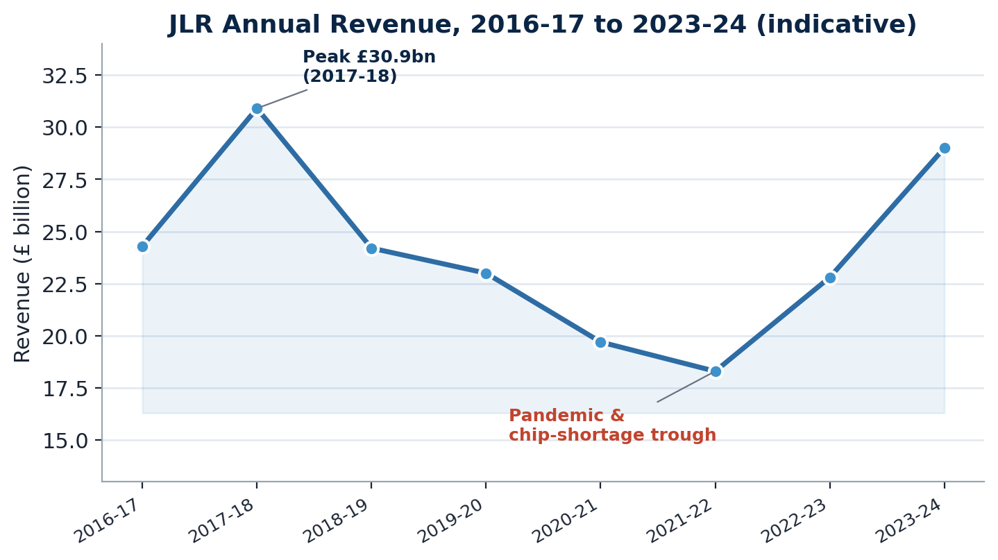
Figure 1. JLR annual revenue, showing the 2017–18 peak, pandemic and chip-shortage trough, and subsequent recovery (indicative figures).
Organisational restructuring has been substantial. JLR announced workforce reductions of approximately 4,500 positions in 2019 and implemented further redundancies during subsequent years as part of cost optimisation programmes (Campbell, 2019). These structural changes, while financially necessary, created uncertainty among remaining employees and challenged organisational morale and institutional knowledge retention.
The “Reimagine” strategy, announced in February 2021, represents JLR’s most ambitious internal transformation initiative. This strategy commits Jaguar to becoming an all-electric luxury brand by 2025, with Land Rover introducing six pure electric variants by 2030, and the entire portfolio achieving net-zero carbon emissions by 2039 (JLR, 2021). Implementation has required fundamental reconfiguration of engineering capabilities, supply chain relationships, and manufacturing processes.

2.2 External Environmental Changes

2.2.1 Technological Disruption and Digitalisation
The automotive industry faces unprecedented technological disruption driven by electrification, autonomous driving development, connected vehicle technologies, and artificial intelligence integration. Tesla’s market capitalisation surpassing traditional automotive giants demonstrated investor confidence in technology-led transformation, fundamentally altering competitive dynamics (Perkins and Murmann, 2018). Digital transformation in this context is best understood not as a discrete IT project but as a strategic, organisation-wide reconfiguration of value creation (Vial, 2019).
Digital disruption extends beyond powertrain technology to encompass the entire customer journey. Direct-to-consumer sales models, pioneered by Tesla, challenge traditional dealership networks. Connected vehicle platforms generate valuable data enabling predictive maintenance, usage-based insurance, and personalised services, blurring the boundary between product and service. JLR has invested in digital customer experience platforms, though competitors have achieved more advanced integration.
Artificial intelligence applications are transforming automotive manufacturing and product capabilities. AI-powered quality control, predictive maintenance, supply chain optimisation, and autonomous driving systems represent critical competitive capabilities, yet capturing value from AI depends on embedding it within operational processes rather than treating it as a standalone technology (Davenport and Ronanki, 2018). JLR has established partnerships with technology companies including NVIDIA for autonomous driving development, though the pace of AI integration has lagged industry leaders (JLR, 2023).

2.2.2 Regulatory and Legislative Environment
The United Kingdom’s legislative environment has created both pressure and clarity for automotive transformation. The government’s announcement banning new petrol and diesel vehicle sales from 2030, with hybrid vehicles permitted until 2035, established clear electrification timelines. The Zero Emission Vehicle Mandate, implemented from 2024, requires manufacturers to achieve escalating proportions of zero-emission vehicle sales, with non-compliance resulting in significant financial penalties (Department for Transport, 2020).
European Union regulations, despite Brexit, continue influencing JLR’s strategy given export market significance. The EU’s “Fit for 55” package and proposed 2035 combustion engine ban create harmonised pressure for electrification across JLR’s primary markets (European Commission, 2021). Differing regulatory timelines across global markets complicate strategic planning and investment prioritisation.
Brexit has introduced trade frictions affecting JLR’s integrated European supply chains and export competitiveness. Rules of origin requirements for electric vehicles, demanding substantial local content to qualify for tariff-free EU access, have influenced battery sourcing and manufacturing location decisions. The complexity of post-Brexit trading arrangements has increased operational costs and administrative burden.

2.2.3 Economic and Market Factors
Economic volatility has characterised JLR’s recent operating environment. Pandemic-induced demand collapse was followed by supply-constrained recovery, with semiconductor shortages demonstrating fragility in globalised supply chains. Inflation, energy cost increases, and raw material price volatility have compressed margins and complicated pricing strategies.
The premium automotive segment has experienced demand shifts toward sustainable luxury, with environmentally conscious consumers increasingly factoring sustainability into purchase decisions. Chinese market dynamics have been particularly challenging, with domestic EV manufacturers gaining market share and geopolitical tensions affecting consumer sentiment toward Western brands.
Currency fluctuations, particularly sterling weakness following Brexit, have created both opportunities (enhanced export competitiveness) and challenges (increased import costs for components and raw materials). JLR’s global footprint provides natural hedging but requires sophisticated treasury management and strategic currency exposure decisions.

2.2.4 Social and Cultural Trends
Changing mobility preferences, particularly among younger demographics in urban areas, challenge traditional vehicle ownership models. Car-sharing, subscription services, and mobility-as-a-service concepts require automotive manufacturers to develop new business models beyond vehicle sales. JLR has launched the “Pivotal” subscription service, though penetration remains limited compared to dedicated mobility providers.
Environmental consciousness has elevated sustainability from peripheral corporate responsibility concern to core strategic imperative. Consumers, employees, and investors increasingly evaluate organisations on environmental, social, and governance criteria, influencing brand perception and access to capital. JLR’s premium positioning requires demonstrating authentic commitment to sustainability beyond regulatory compliance.
Workforce expectations have evolved, with employees seeking purpose-driven work, flexible arrangements, and development opportunities. Advances in automation and machine learning are simultaneously reshaping the skills required on the factory floor and in engineering. Attracting talent, particularly in software engineering, data science, and AI disciplines historically associated with technology companies presents recruitment challenges requiring cultural and operational adaptations.

2.3 Strategic Position: PESTLE and SWOT Synthesis
The internal and external factors discussed above can be consolidated using two established strategic tools. A PESTLE analysis (Figure 2) organises the external macro-environment into political, economic, social, technological, legal, and environmental forces, clarifying the pressures to which JLR must respond. A SWOT analysis (Figure 3) then sets the organisation’s internal strengths and weaknesses against the opportunities and threats arising from that environment. Together they frame the strategic rationale for the transformation programme proposed in Section 5.
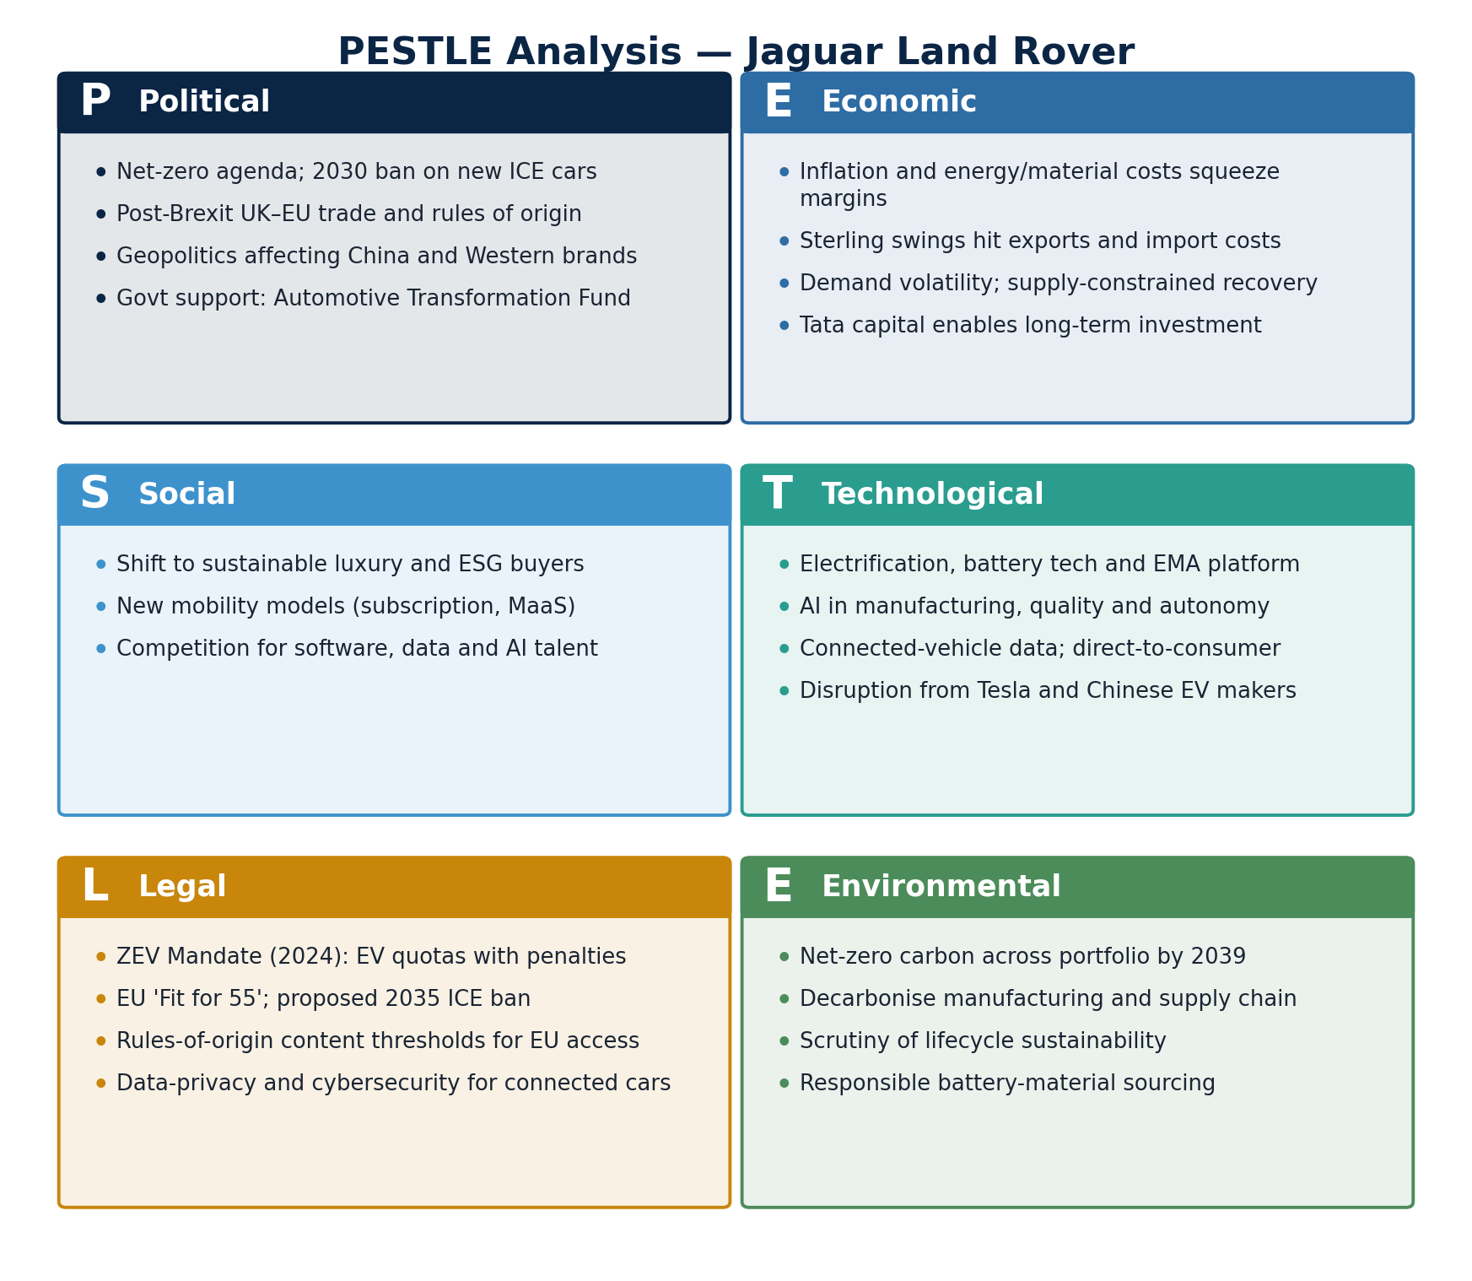
Figure 2. PESTLE analysis of JLR’s external macro-environment.
Read alongside the macro-environment, JLR’s position shows a clear pattern: durable, heritage-based strengths and a substantial digital opportunity set, offset by capability and cultural weaknesses and by intensifying competitive and regulatory threats. The SWOT below captures this balance.
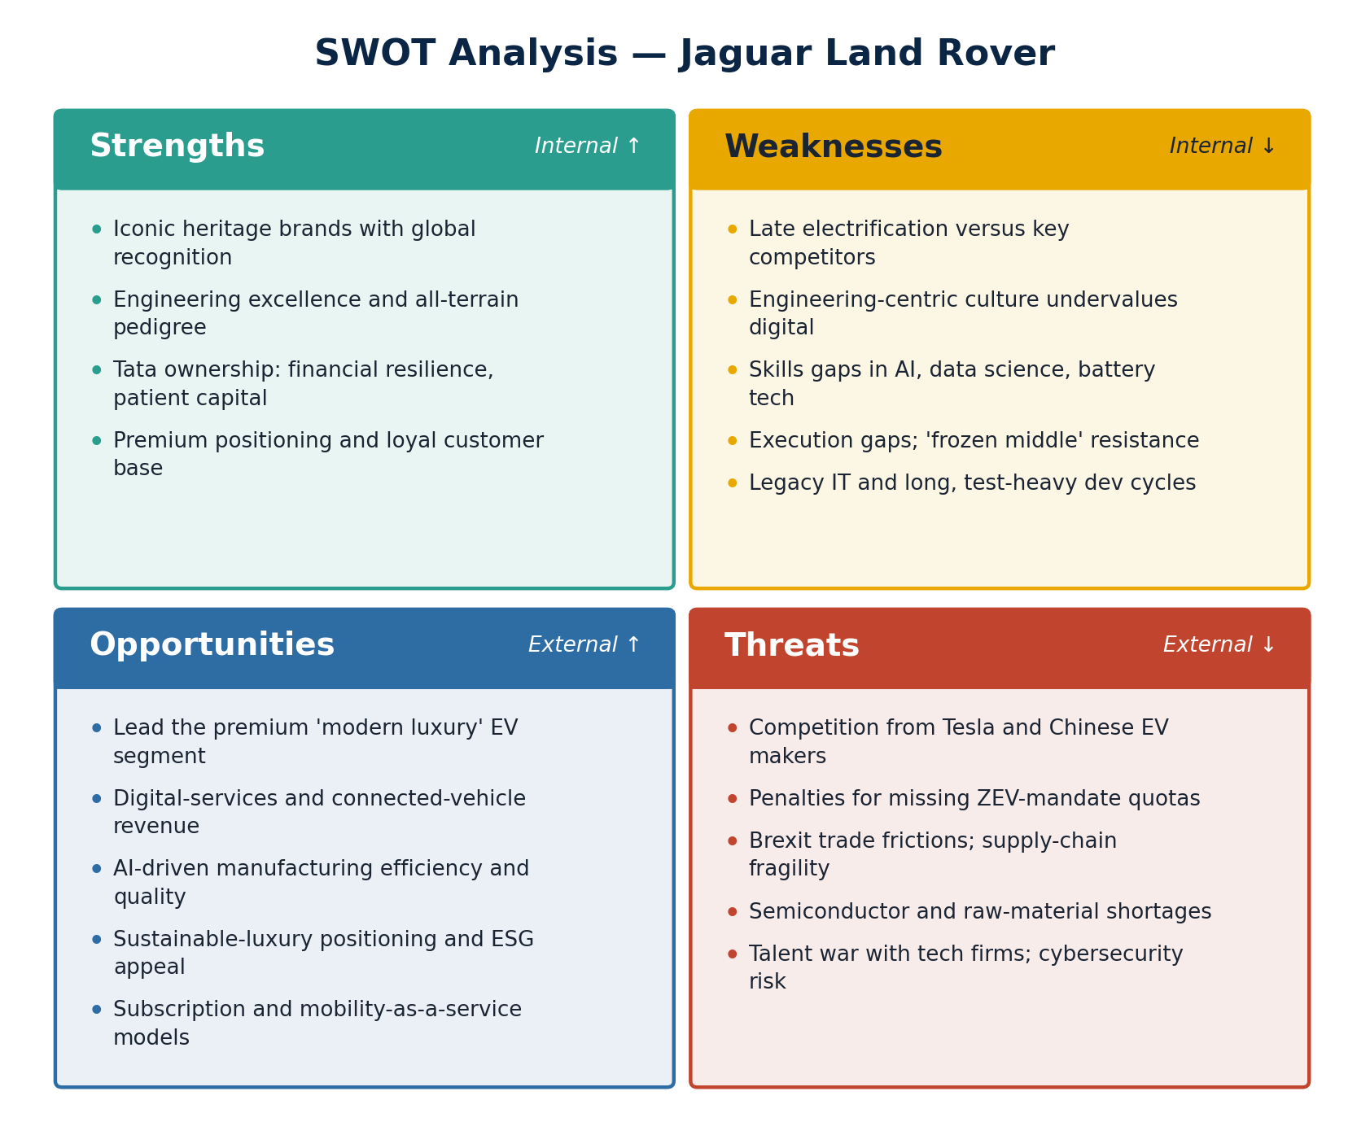
Figure 3. SWOT analysis positioning JLR’s internal capabilities against external conditions.

3. Evaluation of Change Management Models
Understanding JLR’s transformation through established change management frameworks illuminates both strengths and deficiencies in the company’s approach.

3.1 Kotter’s Eight-Step Model
Kotter’s (1996) influential change management framework provides a structured methodology for organisational transformation, emphasising sequential progression through eight stages, summarised in Figure 4: establishing urgency, creating guiding coalitions, developing vision and strategy, communicating the change vision, empowering broad-based action, generating short-term wins, consolidating gains, and anchoring change in culture.
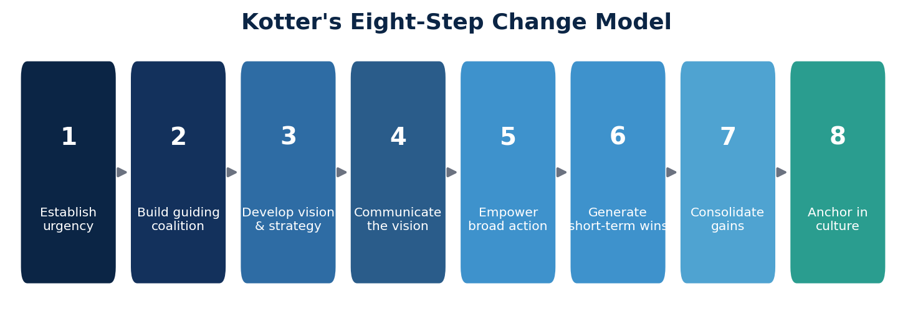
Figure 4. Kotter’s eight-step model of organisational change (after Kotter, 1996).

Establishing Urgency
JLR’s leadership effectively communicated urgency surrounding electrification and digital transformation, with CEO Bolloré’s “Reimagine” announcement explicitly acknowledging existential competitive threats (JLR, 2021). However, urgency communication arguably came later than optimal, with competitors establishing EV credibility while JLR remained dependent on combustion engines. Kotter (2012) emphasises that 75% of management must be genuinely convinced of transformation necessity achieving this threshold across JLR’s traditional engineering culture presented challenges.

Creating a Guiding Coalition
JLR established executive-level transformation leadership, including Chief Digital Officer appointments and dedicated electrification programme management. The guiding coalition incorporated external expertise through board appointments and strategic partnerships. However, coalition effectiveness was potentially compromised by leadership transitions, with several senior executive departures during implementation creating continuity challenges.

Developing Vision and Strategy
The “Reimagine” strategy articulated a clear vision: Jaguar as an all-electric luxury brand, Land Rover offering electrified options across all models, and organisational transformation toward a modern luxury enterprise. The vision’s clarity regarding electrification outcomes contrasted with less precise articulation of digital transformation, AI integration, and operational model evolution.

Communication and Implementation
Communication of the change vision has demonstrated inconsistency, with ambitious public announcements sometimes misaligned with internal messaging and capability development. Kotter’s model emphasises utilising every communication channel and leading by example JLR’s progress has been evident but execution gaps between vision and delivery have created stakeholder uncertainty (Kotter, 1996).

3.2 Lewin’s Three-Stage Model
Lewin’s (1947) foundational change management model conceptualises transformation through three phases, unfreezing existing patterns, implementing change (moving), and refreezing new practices into organisational routine, as depicted in Figure 5.
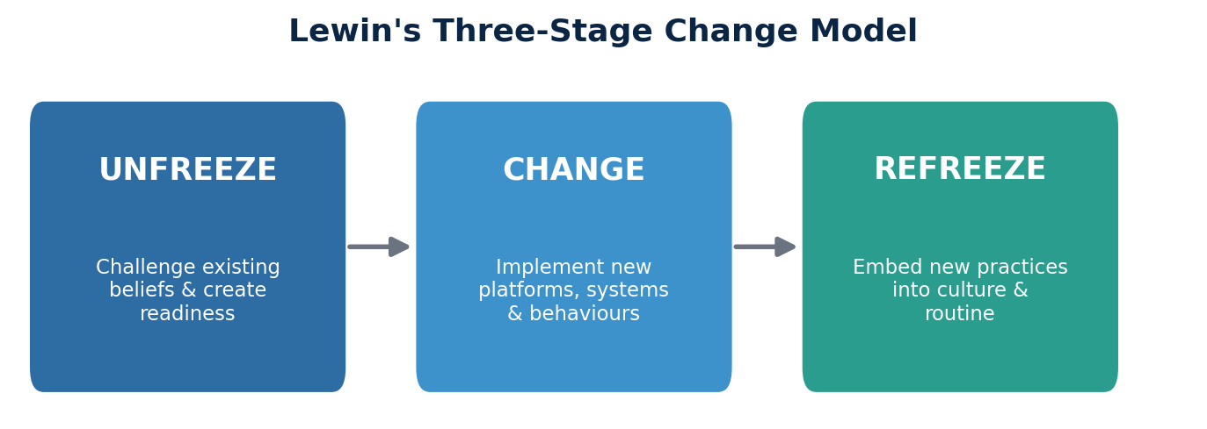
Figure 5. Lewin’s three-stage change model (after Lewin, 1947).

Unfreezing
The unfreezing stage involves preparing organisations for change by challenging existing beliefs and practices. JLR’s unfreezing was partially accomplished through crisis recognition, declining financial performance, competitive pressure, and regulatory mandates created conditions for acknowledging change necessity. However, Lewin emphasises psychological safety during unfreezing, and workforce reductions potentially undermined employees’ security and receptiveness to transformation (Burnes, 2004).

Moving
The transition phase involves implementing new practices, systems, and behaviors. JLR’s moving stage encompasses substantial investment in electric vehicle platforms (Electrified Modular Architecture), battery manufacturing partnerships, software development capabilities, and manufacturing facility reconfiguration. The complexity and simultaneity of multiple change initiatives risks what Lewin warned against: insufficient consolidation before introducing additional changes.

Refreezing
Institutionalising changes requires embedding new practices into organisational culture, processes, and systems. JLR’s transformation remains ongoing, making refreezing assessment premature. However, indicators suggest incomplete institutionalisation: reports of resistance from traditional engineering functions, inconsistent digital capability development, and continued organisational restructuring suggest the refreezing stage has not been achieved (Burnes, 2004).

3.3 McKinsey 7-S Framework
The McKinsey 7-S Framework (Peters and Waterman, 1982) provides a holistic assessment of organisational alignment across seven interconnected elements: strategy, structure, systems, shared values, skills, style, and staff (Figure 6).
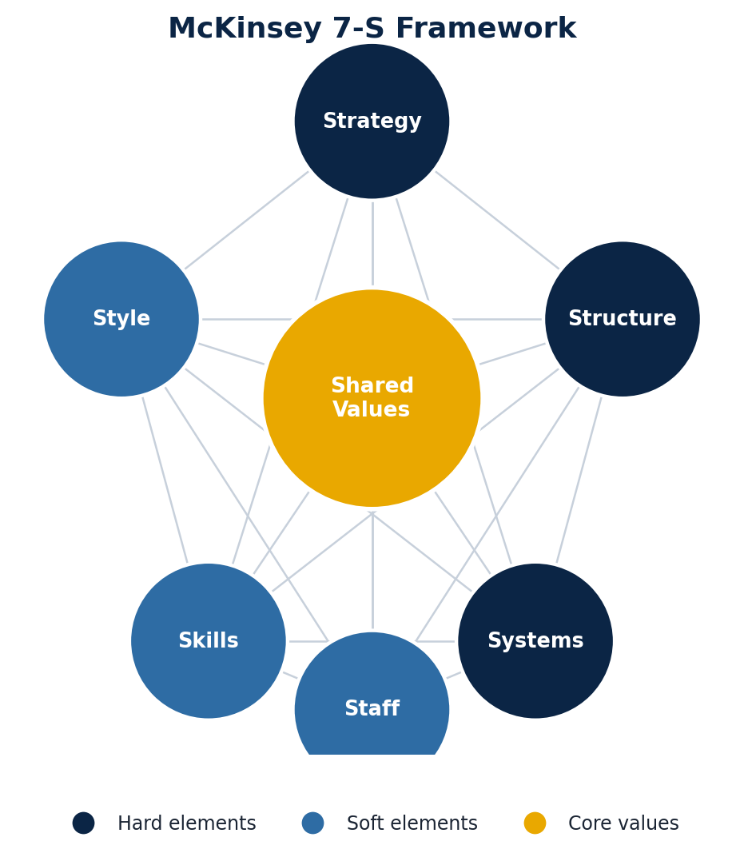
Figure 6. The McKinsey 7-S Framework of organisational alignment.
Applied to JLR, strategy alignment with environmental requirements appears sound at the directional level, though implementation pace and resource allocation have faced criticism. Structure has undergone modification, with the creation of digital units and electrification programmes, though integration with traditional functions remains challenging. Systems transformation is ongoing, with legacy IT infrastructure, engineering processes, and supply chain systems requiring substantial modernisation.
Shared values present complexity given JLR’s heritage brands. Preserving brand identity while transforming toward electric, digital, and sustainable positioning requires nuanced cultural evolution rather than revolutionary change. Skills gaps are evident, particularly in software engineering, data science, battery technology, and AI disciplines where JLR competes for talent against technology companies. Style of leadership has evolved with new executive appointments, though embedding consistent leadership approaches across the organisation takes time. Staff considerations include capability development, retention of critical knowledge during restructuring, and attraction of new talent profiles.
The framework’s value lies in highlighting interdependencies strategy changes necessitate corresponding adjustments across all elements. JLR’s transformation has arguably progressed unevenly, with strategy and structure changes outpacing systems, skills, and cultural evolution (Peters and Waterman, 1982).

4. Leadership and Organisational Culture in Change Management

4.1 Leadership Approaches in JLR’s Transformation
Effective change management requires an appropriate leadership style aligned with transformation requirements and organisational context. JLR’s leadership during the “Reimagine” transformation demonstrates characteristics of transformational leadership, though with implementation variations affecting outcomes.

Transformational Leadership Analysis
Bass and Avolio’s (1994) transformational leadership framework identify four components: idealised influence, inspirational motivation, intellectual stimulation, and individualised consideration. CEO Bolloré’s leadership has demonstrated inspirational motivation through articulating a compelling future vision and intellectual stimulation through challenging traditional automotive assumptions. His external recruitment to JLR signified board recognition that transformation required leadership unbounded by organisational precedent (Bass and Avolio, 1994).
However, transformational leadership effectiveness depends on consistent behavior across leadership tiers and translation into operational execution. Evidence suggests middle management layers at JLR had trouble translating executive vision into departmental action plans, creating execution gaps characteristic of transformation failures (Huy, 2002). This disconnects between senior leadership inspiration and operational implementation echoes findings in the change management literature regarding “frozen middle” management resistance.

Situational Leadership Considerations
Hersey and Blanchard’s (1988) situational leadership model suggests effective leaders adapt their style based on follower readiness. JLR’s workforce comprises segments with varying change readiness: engineers experienced with combustion technology requiring reskilling, newer employees recruited for digital capabilities, and a manufacturing workforce facing automation threats. Differentiated leadership approaches across these segments would enhance change receptiveness (Hersey and Blanchard, 1988).
Leadership during JLR’s transformation has arguably applied insufficient differentiation, with uniform messaging inadequately addressing diverse stakeholder concerns. Production workers require reassurance regarding job security and reskilling opportunities; engineers need clarity on career relevance as technologies shift; commercial teams require understanding of changing customer engagement models. Each segment benefits from tailored leadership engagement rather than generic transformation communication.

4.2 Organisational Culture Impact on Change Management
Organisational culture profoundly influences change management outcomes, with culture frequently cited as the primary cause of transformation failure (Schein, 2010). Understanding JLR’s cultural characteristics illuminates both enablers and barriers to successful change implementation.

Cultural Dimensions Analysis
JLR’s organisational culture reflects heritage brand identity, engineering excellence traditions, and acquired company integration complexity. Cameron and Quinn’s (2011) Competing Values Framework provides a useful analytical lens. JLR’s culture demonstrates characteristics of a hierarchy culture (structured processes, traditional automotive manufacturing discipline) combined with clan culture elements (strong brand loyalty, long-tenured workforce relationships).
Transformation toward digital, agile, and innovation-oriented operations requires cultural migration toward adhocracy characteristics: flexibility, entrepreneurialism, and risk tolerance. This cultural transition presents challenges given the countervailing pull of established engineering disciplines and manufacturing process rigor (Cameron and Quinn, 2011).

Cultural Barriers to Change
Several cultural barriers have impeded JLR’s transformation. An engineering-centric culture, while producing exceptional products, has historically undervalued software development and digital capabilities. Legacy approaches to vehicle development, emphasising long development cycles and extensive physical testing, conflict with the agile software development methodologies required for connected vehicle features.
“Not invented here” syndrome has challenged integration of external partnerships and acquired capabilities. Traditional automotive culture emphasising vertical integration contrasts with the platform ecosystem approaches prevalent in technology industries. Overcoming these cultural barriers requires sustained attention beyond structural and strategic changes (Schein, 2010).

Cultural Enablers
However, JLR’s culture also contains transformation enablers. Brand heritage emphasising innovation (Jaguar’s motorsport legacy, Land Rover’s pioneering all-terrain capability) provides narrative foundations for positioning electrification as evolution rather than departure from brand essence. Workforce pride in British manufacturing heritage can translate into determination to lead the industry transition rather than follow competitors.
Tata ownership has provided financial resilience enabling long-term investment despite short-term volatility. Tata’s stated commitment to JLR’s British identity and workforce provides a stability foundation supporting transformation, though patience is not unlimited, sustained transformation progress is expected (Bailey and De Propris, 2019).

5. Proposed Change Management Plan

5.1 Change Objectives
The proposed change management plan centers on accelerating digital transformation and AI integration to establish sustainable competitive advantage. Specific, measurable objectives are set out below.
Primary objectives
- Achieve full digital integration across customer journey touchpoints, enabling personalised engagement from initial awareness through ownership, by December 2027.
- Implement AI-driven manufacturing systems across all UK production facilities, achieving a 20% efficiency improvement and 35% quality defect reduction by March 2028.
- Develop a connected vehicle platform generating a minimum of £500 million annual revenue from digital services by 2029.
- Establish AI centers of excellence with 500 qualified AI/ML specialists by December 2027.
- Achieve industry-leading customer satisfaction scores (top quartile in J.D. Power rankings) through digital experience enhancement.
Supporting objectives
- Reskill 60% of the existing workforce in digital competencies within 36 months.
- Reduce new model development time by 30% through digital twin and simulation technologies.
- Achieve carbon neutrality in UK operations by 2028 through AI-optimised energy management.
- Establish real-time supply chain visibility and AI-driven demand forecasting across global operations.
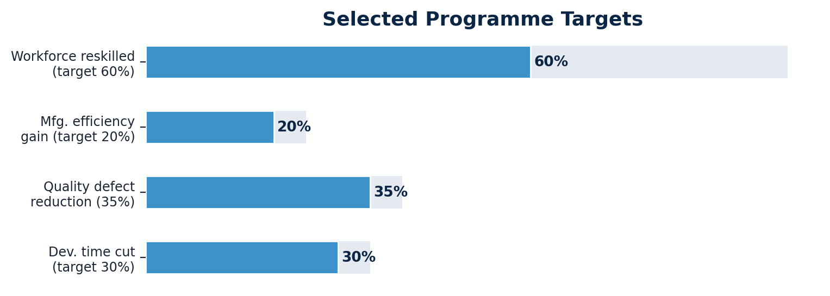
Figure 7. Selected quantified programme targets.

5.2 Financial Plan
The proposed transformation requires substantial investment, structured across three phases. Figure 8 shows the phasing of the £2.8 billion programme by investment category.

Category | Year 1 | Year 2 | Year 3 | Total
Technology infrastructure | £400m | £350m | £250m | £1,000m
AI / digital platforms | £300m | £350m | £300m | £950m
Workforce development | £100m | £120m | £130m | £350m
Facilities modernisation | £150m | £200m | £150m | £500m
Total investment | £950m | £1,020m | £830m | £2,800m

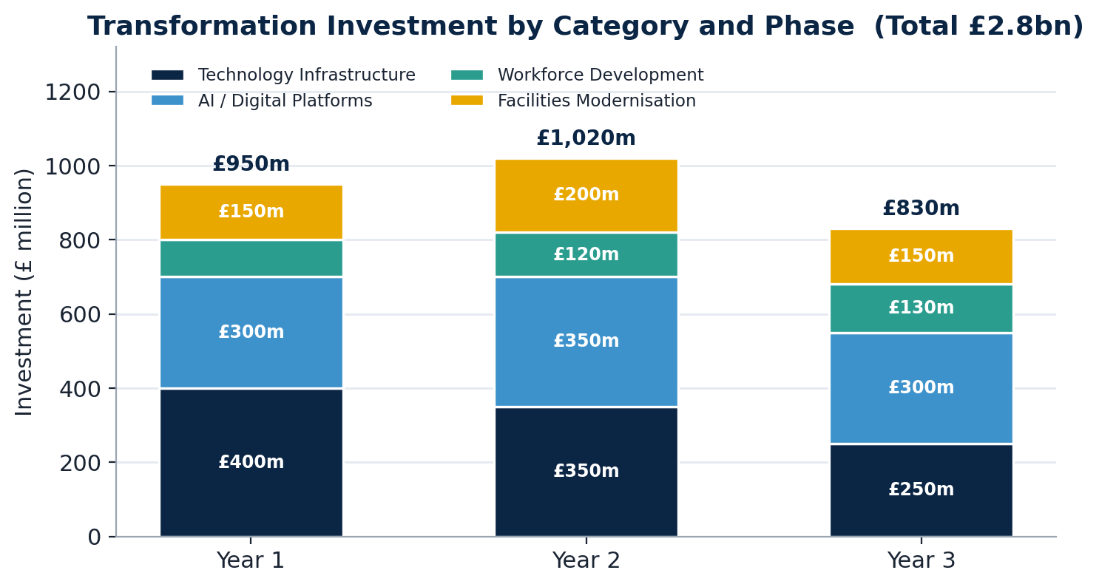
Figure 8. Transformation investment by category across the three-year programme.

Funding Sources
Investment will be funded through a blend of internally generated cash, existing credit facilities, government support and strategic partner co-investment, as shown in Figure 9.
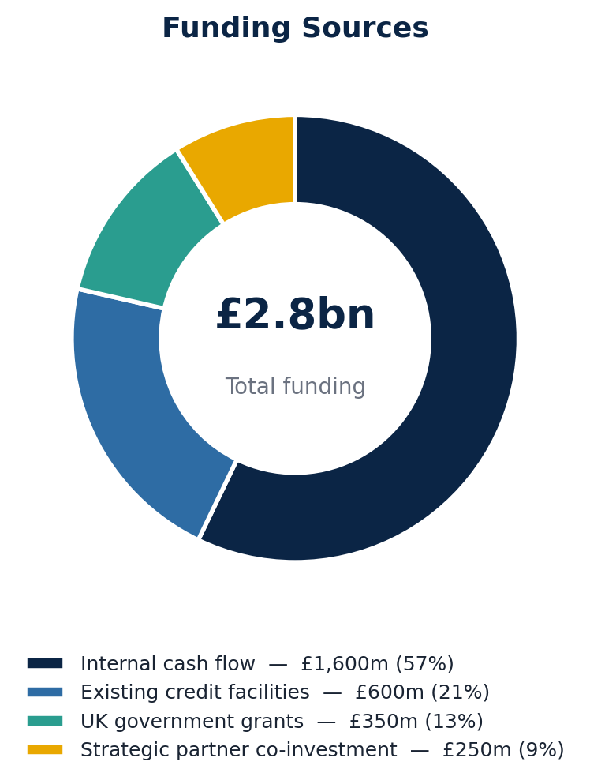
Figure 9. Composition of the £2.8 billion funding package.

Financial Returns
The programme is expected to deliver £1,170 million of recurring annual benefit by Year 5, equivalent to a 42% annual return on investment and a payback period of 3.2 years from programme completion. Figure 10 disaggregates the projected annual benefit.

Benefit category | Annual value (Year 5)
Manufacturing efficiency gains | £280m
Quality cost reduction | £120m
Digital services revenue | £500m
Supply chain optimisation | £180m
Reduced warranty costs | £90m
Total annual benefit | £1,170m

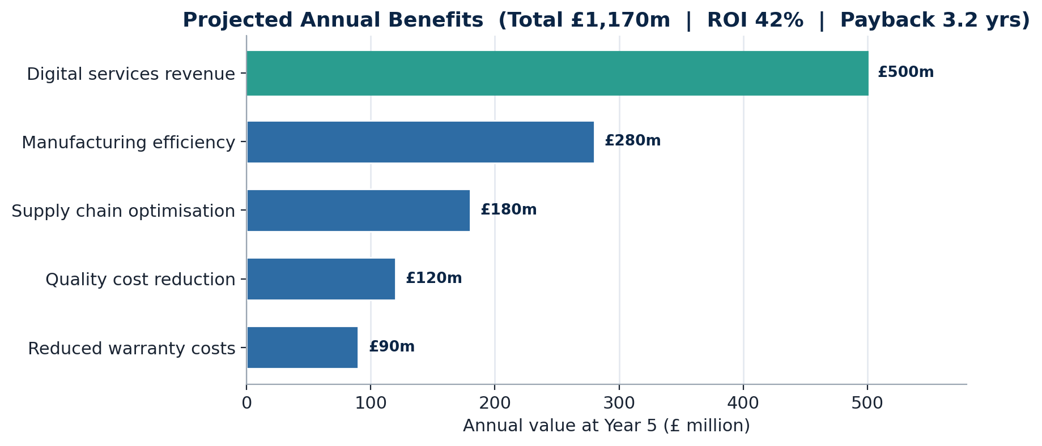
Figure 10. Projected annual benefits at Year 5 by source.

5.3 Communication Plan
Effective communication is fundamental to change management success. The proposed communication plan encompasses stakeholder-specific strategies, channels, and timing, as summarised in Table 1.

Table 1. Stakeholder analysis and communication strategy
Stakeholder | Key concerns | Approach | Primary channels | Frequency
Board / Executive | ROI, risk, competitive position | Strategic progress reporting, milestone tracking | Board presentations, executive dashboards | Monthly
Middle management | Role clarity, resourcing, team impact | Implementation guidance, change-champion network | Management forums, collaboration platforms | Bi-weekly
Workforce | Job security, reskilling, daily impact | Transparent updates, success stories, Q&A | Town halls, briefings, intranet, app | Weekly
Trade unions | Employment protection, training, consultation | Early engagement, collaborative planning | Joint working groups, formal consultation | Monthly
Suppliers | Partnership expectations, capability needs | Strategic alignment, development support | Supplier conferences, individual reviews | Quarterly
Customers | Product and service improvements | Brand benefit communication, demonstrations | Marketing channels, ownership touchpoints | Campaign-based
Investors | Returns, progress, risk mitigation | Transparent reporting, credible milestones | Investor relations, analyst briefings | Quarterly

Communication Principles
- Transparency: honest communication regarding challenges and setbacks, not solely successes.
- Consistency: unified messaging across channels, avoiding contradictory signals.
- Two-way dialogue: active listening mechanisms, feedback incorporation, and visible response.
- Leadership visibility: senior leaders regularly communicating and demonstrating commitment.
- Storytelling: individual success stories that humanise transformation impact.

Change Champion Network
A network of 200 change champions will be established across all functions and locations. Champions will be selected for being respected, positive influencers with strong communication skills; they will receive comprehensive change-management education and messaging frameworks; their role is to provide local translation of transformation messaging, act as a feedback conduit, and offer peer support; and their contribution will be recognised through visible acknowledgement and linkage to career development.

5.4 Implementation Approach
Implementation follows three sequential phases over 36 months, balancing early momentum with disciplined scaling and embedding. Figure 11 presents the integrated roadmap.
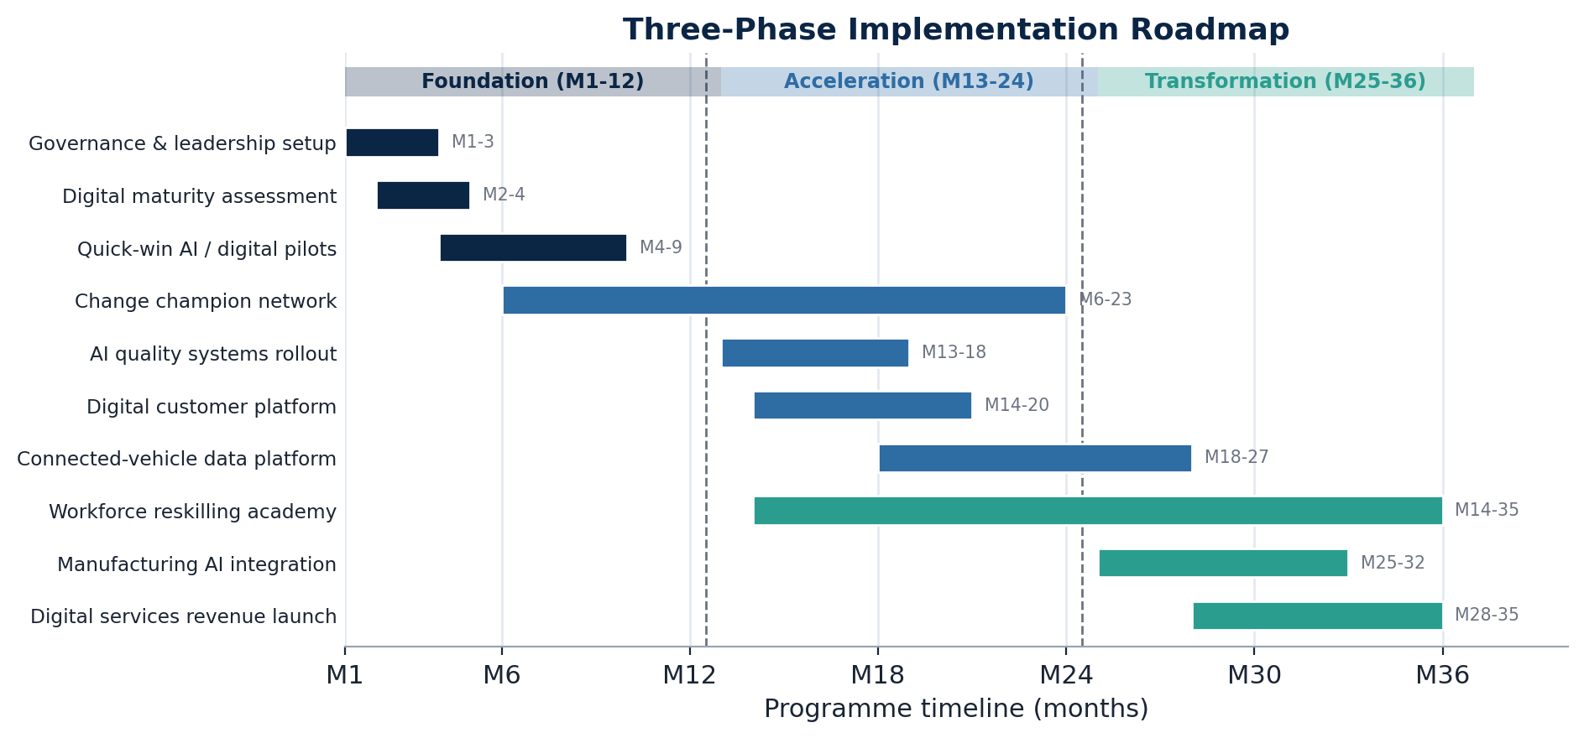
Figure 11. Three-phase implementation roadmap with indicative task scheduling.

Phase 1: Foundation (Months 1–12)
Objectives: establish transformation governance and leadership structures; complete current-state assessment and detailed planning; initiate quick-win projects demonstrating value; and launch workforce capability assessment and development.
- Appoint a Chief Digital Officer and Transformation Programme Director.
- Establish a Transformation Steering Committee with executive representation.
- Complete a comprehensive digital maturity assessment across all functions.
- Launch five quick-win AI/digital projects (e.g., AI quality inspection, customer service chatbot, predictive maintenance proof-of-concept).
- Launch a digital skills assessment for the entire workforce and begin change-champion recruitment and training.
- Establish technology partnerships with leading AI and cloud providers.
Key milestones: governance operational (M2); digital maturity baseline (M4); quick wins demonstrating value (M8); 100 change champions deployed (M10); Phase 2 plan complete (M12).

Phase 2: Acceleration (Months 13–24)
Objectives: scale successful pilots to production; achieve measurable operational improvements; establish a digital talent pipeline; and transform customer-facing digital capabilities.
- Roll out AI-driven quality systems across all manufacturing facilities.
- Implement digital twin technology for vehicle development.
- Launch the redesigned digital customer experience platform.
- Establish an AI/ML academy for workforce reskilling and deploy the connected vehicle data platform.
- Integrate supply chain AI capabilities and expand the change-champion network to 200 individuals.
Key milestones: AI quality systems operational across all facilities (M18); digital customer platform live (M20); 2,000 employees reskilled (M24); connected vehicle platform generating insights (M24).

Phase 3: Transformation (Months 25–36)
Objectives: achieve full digital integration across operations; realise planned financial benefits; embed digital capability as a core competency; and establish an innovation engine for continuous advancement.
- Complete manufacturing AI integration, achieving efficiency targets.
- Launch digital services revenue programmes.
- Achieve AI center of excellence staffing targets.
- Implement AI-driven demand forecasting and supply chain optimisation.
- Complete the workforce digital upskilling programme and establish continuous improvement mechanisms.
Key milestones: manufacturing efficiency targets achieved (M30); digital services revenue on track (M33); all workforce capability objectives met (M36); full benefits-realisation trajectory confirmed (M36).

5.5 Evaluation Plan
Rigorous evaluation ensures the transformation delivers intended outcomes and enables course correction when required. Performance is tracked across strategic, operational and financial dimensions.

Key Performance Indicators
Strategic: digital maturity score; customer satisfaction indices (J.D. Power, Net Promoter Score); employee engagement; innovation metrics (patents filed, ideas implemented); and market share in target segments.
Operational: manufacturing efficiency (units per labour hour); quality performance (defects per million, warranty costs); development cycle time; supply chain performance (inventory turns, delivery reliability); and digital channel adoption.
Financial: transformation ROI; cost reduction achievement; revenue from digital services; and investment adherence to plan.
Table 2. Evaluation mechanisms
Mechanism | Purpose | Frequency | Responsibility
Executive dashboard | Real-time progress visibility | Continuous | Programme Management Office
Steering Committee review | Strategic direction, issue resolution | Monthly | Transformation Steering Committee
Phase gate reviews | Milestone achievement, go/no-go | Quarterly | Executive Committee
Independent audit | Objective assessment, assurance | Bi-annually | Internal Audit / external consultants
Benefit realisation review | Financial returns tracking | Quarterly | Finance Director
Stakeholder pulse surveys | Engagement, sentiment monitoring | Monthly | HR / Communications

Continuous Improvement
- Establish a lessons-learned process capturing insights from each phase.
- Benchmark against industry leaders and cross-sector digital exemplars.
- Maintain flexibility to adapt the approach based on emerging technologies and competitive developments.
- Create an innovation sandbox for testing emerging technologies before integration.

5.6 Risk Management
Principal programme risks have been assessed by likelihood and impact (Figure 12), with mitigations set out in Table 3.
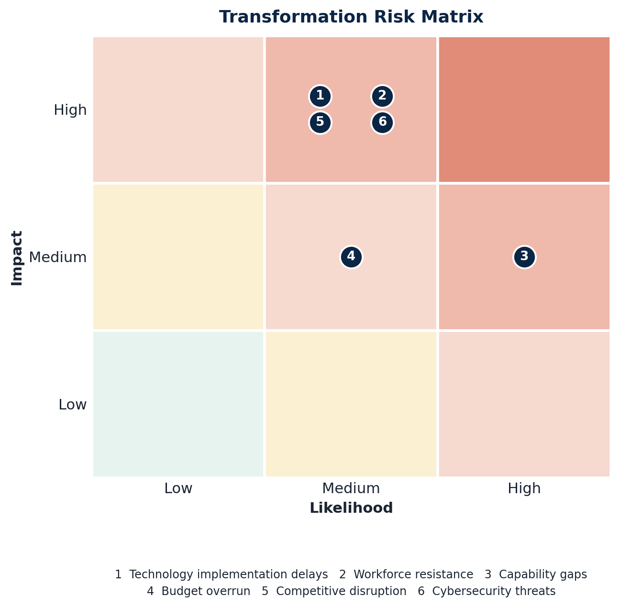
Figure 12. Transformation risk matrix (numbered risks correspond to Table 3).

Table 3. Key risks and mitigations
Risk | Likelihood | Impact | Mitigation
Technology implementation delays | Medium | High | Agile delivery, contingency resources, phased rollout
Workforce resistance | Medium | High | Comprehensive change management, visible leadership, reskilling
Capability gaps | High | Medium | Strategic partnerships, targeted recruitment, accelerated development
Budget overrun | Medium | Medium | Rigorous governance, contingency reserves, benefit-linked funding
Competitive disruption | Medium | High | Continuous environmental scanning, agile strategy adaptation
Cybersecurity threats | Medium | High | Security-by-design, specialist capability, continuous monitoring

6. Conclusion
Jaguar Land Rover faces a critical juncture where successful transformation will determine long-term viability in an industry experiencing unprecedented disruption. This report has analysed the internal and external environmental factors driving the necessity for change, evaluated JLR’s transformation approach through established change management frameworks, and proposed a comprehensive change management plan for digital and AI transformation.
The analysis reveals that while JLR’s “Reimagine” strategy establishes appropriate directional intent, implementation has faced challenges characteristic of complex organisational transformation. Applying Kotter’s and Lewin’s models highlights incomplete progression through the change stages, particularly regarding cultural embedding and middle-management alignment. Leadership has demonstrated transformational characteristics, though consistent translation across organisational levels requires strengthening.
The proposed change management plan provides a structured approach to accelerating digital transformation with clear objectives, a £2.8 billion investment framework, stakeholder-specific communication strategies, and robust evaluation mechanisms. Success will require sustained leadership commitment, authentic workforce engagement, and disciplined execution over the three-year implementation horizon.
Ultimately, JLR possesses foundational strengths, heritage brands, engineering excellence, and committed ownership, that provide a transformation platform. Realising this potential requires treating digital and AI transformation not as a technical programme but as fundamental organisational evolution, engaging hearts and minds alongside systems and processes. The recommendations in this report, faithfully implemented, will position JLR to emerge as a digital leader in premium automotive, securing sustainable competitive advantage for decades ahead.

7. References
Bailey, D. and De Propris, L. (2019) ‘Industry 4.0: regional disparities and transformative policies’, Regional Studies, 53(10), pp. 1451–1456.
Bass, B.M. and Avolio, B.J. (1994) Improving organizational effectiveness through transformational leadership. Thousand Oaks: Sage Publications.
Burnes, B. (2004) ‘Kurt Lewin and the planned approach to change: a re-appraisal’, Journal of Management Studies, 41(6), pp. 977–1002.
Cameron, K.S. and Quinn, R.E. (2011) Diagnosing and changing organizational culture: based on the competing values framework. 3rd edn. San Francisco: Jossey-Bass.
Campbell, P. (2019) ‘Jaguar Land Rover to cut 4,500 jobs’, Financial Times, 10 January.
Davenport, T.H. and Ronanki, R. (2018) ‘Artificial intelligence for the real world’, Harvard Business Review, 96(1), pp. 108–116.
Department for Transport (2020) Government takes historic step towards net-zero with end of sale of new petrol and diesel cars by 2030. London: HM Government.
European Commission (2021) ‘Fit for 55’: delivering the EU’s 2030 climate target on the way to climate neutrality. Brussels: European Commission.
Hersey, P. and Blanchard, K.H. (1988) Management of organizational behavior. 5th edn. Englewood Cliffs: Prentice Hall.
Huy, Q.N. (2002) ‘Emotional balancing of organizational continuity and radical change: the contribution of middle managers’, Administrative Science Quarterly, 47(1), pp. 31–69.
Jaguar Land Rover (2021) Reimagine: Jaguar Land Rover’s new global strategy. Coventry: Jaguar Land Rover.
Jaguar Land Rover (2023) Annual report and accounts 2022–23. Coventry: Jaguar Land Rover.
Jaguar Land Rover (2024) Annual report and accounts 2023–24. Coventry: Jaguar Land Rover.
Jolly, J. (2022) ‘Jaguar Land Rover sales halve due to chip shortage’, The Guardian, 13 January.
Kotter, J.P. (1996) Leading change. Boston: Harvard Business School Press.
Kotter, J.P. (2012) Leading change: with a new preface by the author. Boston: Harvard Business Review Press.
Lewin, K. (1947) ‘Frontiers in group dynamics: concept, method and reality in social science’, Human Relations, 1(1), pp. 5–41.
Perkins, G. and Murmann, J.P. (2018) ‘What does the success of Tesla mean for the future dynamics in the global automobile sector?’, Management and Organization Review, 14(3), pp. 471–480.
Peters, T.J. and Waterman, R.H. (1982) In search of excellence: lessons from America’s best-run companies. New York: Harper and Row.
Schein, E.H. (2010) Organizational culture and leadership. 4th edn. San Francisco: Jossey-Bass.
Society of Motor Manufacturers and Traders (SMMT) (2021) UK automotive: key facts and figures. London: SMMT.
Tovey, A. (2020) ‘Jaguar Land Rover hires new chief executive from Renault’, The Telegraph, 15 July.
Vial, G. (2019) ‘Understanding digital transformation: a review and a research agenda’, The Journal of Strategic Information Systems, 28(2), pp. 118–144.

