
Assignment
Course:BA Business Management

Module name: Accounting Fundamentals

Module code:4001

Lecture name :Nadeem Mirza

Student name :Tsveta Lyushtova

Student number :2124712

Table of Contents
Introduction...............................................................3
Question 1..................................................................3
Question 2..................................................................6
References..................................................................9

Introduction
The primary purpose of this report is to prepare an income statement of Wales Plc for the financial year-end 31st December, 2021 with the help of financial data that has been provided in the assessment. However, the importance or significance of the financial statements have also been provided in this paper.
Furthermore, with the help of financial accounting ratios,the financial performance and financial position of Sweets Plc have been interpreted and analysed for the financial period 2020 and 2021. Lastly,based on the financial ratio’s outcomes and analysis, a recommendation with respect to the company’s financial position have been provided.

QUESTION 1
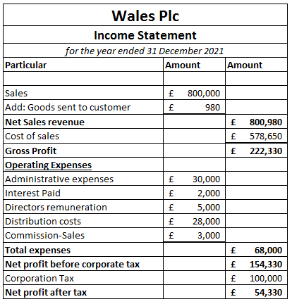
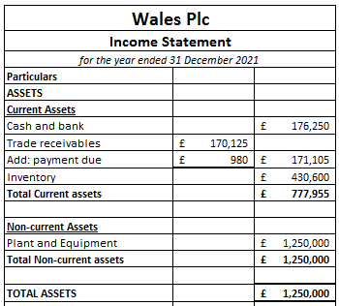
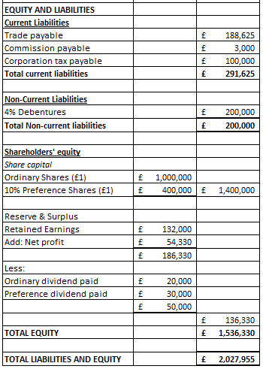
B) Financial Statements are extremely important because they precisely reflect the firm's financial position and financial performance. In addition, it assist all the stakeholders which includes investors, financial analyst, and management in evaluating or measuring and make appropriate economic decisions by contrasting current and past results, and thus; forecast growth and future performance of the firm.
However, financial statements include all the vital information which is being needed by the potential investors with respect to decisions how much they wish to invest into the company.It is also beneficial in the process of decisions-making with regards to price/share that the investors wish to invest.
Therefore, an increment in the size and complexities of components influencing the business operational activity require an analytical as well as scientific approach in the Modern business enterprises management. In addition ,it also delivers snapshot of company’s financial performance, providing insight into its cash flow, operations and performance.
The statement of financial position is always balanced due to the double-entry accounting principle. According to this principle, for every debit entry there is a corresponding credit entry for the same amount. It also acts as a measure to check whether the entries are consistent and arithmetically correct. It provides the comprehensive knowledge about the financial position of the company by depicting what the company owns (assets) and what it owes (liabilities). Each financial transaction impact at least two different accounts of the company, which is the main reason behind the balance of statement of financial position.

QUESTION 2

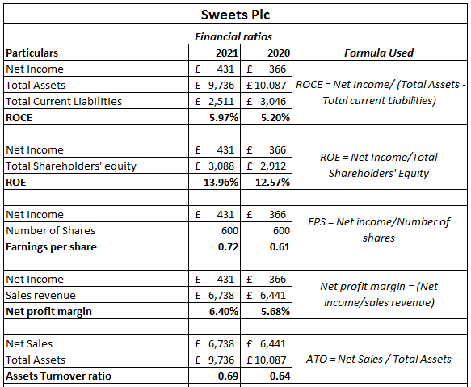
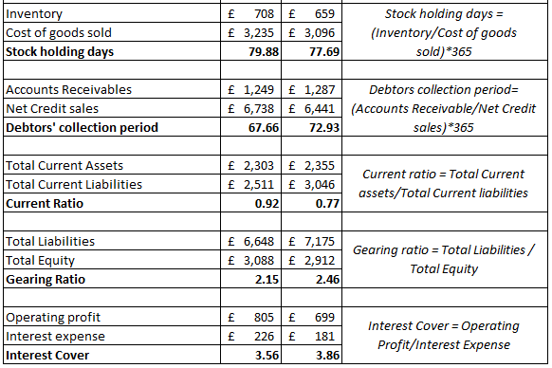
B) The financial performance of the company can be evaluated using several financial ratios. The Return on capital employed has increased from 5.20% in 2020 to 5.97% in 2021. The ROE of the company also increased from 12.57% in 2020 to 13.96% in 2021, which shows that the company is able to generate higher profit from the last year (Guo and Wang, 2019). Similarly, the net profit margin has also increased from 5.68% to 6.40%. The efficiency of the company is also analyse using the assets turnover ratio, stockholding days, and debtors collection days (Campisi,2019). The liquidity position evaluated through current ratio has also improved from 0.77 to 0.92. The financial gearing ratio shows that the company is relying on debt fund for financing the activities. The interest cover has reduced from 3.86 times to 3.56 times in the current year. Overall, the company’s performance has improved in the current year when compared to the previous year.
On the basis of financial accounting ratios calculation that has been presented above or in the excel spreadsheet, it can be seen that there is an overall improvement in the company’s profitability position which implies,the the company has generated more amount of income or earnings from its shareholders equity and capital employed. The primary reason behind this is that there is an increment in the total revenue or a reduction in the costs. Monitoring areas that might be racking up ineffective or excessive cost is an essential part of an operational effectiveness. Decreasing liabilities, thereby paying off all the liabilities, can also enhance the company's ROCE.
While,on the other hand,the net profit margin also increased to 6,40% in 2021,implying the Sweets Plc is quite efficient or productive in terms of generating net income in the current year in comparison to previous. This occurs mainly due a reduction in the production cost and the businesses expenditures or may an increment in the total sales revenue. In the case of market position, the EPS ratio has increased which means that the firm is earnings or generating more incomes in order to distribute it to the shareholders. This happens because number of shares stays constant or increase in the profit. In terms of operational efficiency position, it can be seen that there is marginal increment in the asset turnover because the company has utilised total assets efficiently in terms of generating net sales.
Moreover, it is also effective in the process of credit collection and this is a sign of increasing efficiency or effectiveness. With respect to to liquidity position, the company does not have sufficient cash to cover all of its debts obligations as the value of current assets does not exceeds the value of current liabilities.
Lastly, in the case of solvency positions, there is a marginal reduction in the financial leverage and financial risk of the company because the dependency of debt is less in term of financing or funding the assets.

References
Campisi, D., Mancuso, P., Mastrodonato, S.L. and Morea, D., 2019. Efficiency assessment of knowledge intensive business services industry in Italy: Data envelopment analysis (DEA) and financial ratio analysis. Measuring Business Excellence, 23(4), pp.484-495.
Guo, L. and Wang, Z., 2019. Ratio analysis of J Sainsbury plc financial performance between 2015 and 2018 in comparison with Tesco and Morrisons. American Journal of Industrial and Business Management, 9(2), pp.325-341.

