Student Name: Arry Jaffa Student Number: 1605600
LECTERER: Dr Amare Desta
Developing Innovation and Creativity for Business Advantage
BMSK6002

Table of Contents
Abstract 2
Introduction 2
Stockholm Products Approach to innovation 3
Critical assessment of the R&D project leader (Michael Glass) within Stockholm Products 6
An open model and closed model of innovation, analysing how they could be applied within the teeth whitening project 9
Proposal to the board of Directors considering a further prospective investment of £10nmillion to the organisations new product 14
Conclusion 18
Appendix A 19
References 20
Bibliography 22

Abstract

Innovative and extremely desirable merchandise within the teeth whitening sector, known as plasma cleaning, which was lately enhanced by an establishment recognised within Sweden, identified as an industrial business identified as ‘Stockholm Products’. Following a year of research was achieved by the organisations research and development sector and utilised within a provided budget of one million pounds, with conferences being overseen by the R&D manager known as Michael Glass. A proposal will be made to the board about whether Munich Gases should invest £10million in to this new product development. The author intends to significantly evaluate the complete innovation procedure of the plasma cleaning scheme, using an applicable business model, the prospective market place of this development and identify which products could possibly be manufactured as an outcome. The author who is currently employed within the establishment Stockholm Products, undertaking the role recognised as an independent advisor for teeth whitening.

Introduction

This report will critically reflect on the innovation concept of Stockholm Products’ approach to innovation. It can be seen by (Dance, 2008) that innovation involves a specific business process for new products and organic changes that develop wealth or social welfare. The author will choose a representative of the executive group within their organisation, clarifying their role in the teeth whitening project, contemplating their personal and organisational expertise and knowledge. The author will display one open model and one closed model of innovation and evaluate how they could be utilized within the teeth whitening project. An explanation, including explanations of which model the author would suggest should the project continuing to go ahead. The author will evidently explore and differentiate between the identified models of innovation. The author will clearly convey that the report has demonstrated evidence of wide research and reading, using academic theories and models to support applicable knowledge relating to Developing Innovation and Creativity for Business Advantage.

Stockholm Products Approach to innovation

Successful innovators develop and build practical resources and management skills through time; there are numerous of prospects to learn by consuming, collaborating with other companies and asking customers, nevertheless all rely on the company's willingness to realise innovation less as a chance than as a method that can be continually enhanced. The crucial view point is that numerous measures ought to occur as Stockholm Products shift across the segments of the process model of innovation and correlated with each are several reliable sessions regarding efficient innovation management procedures:

Do we have a positive innovation strategy?
Capture: exactly in what manner are we going to gain the advantages from it?

Pursuit how can we determine prospects for innovation?

Implement: In what manner are we going to make that happen?

Select: Something the business is going to accomplish and why we are aiming to accomplish it?

Do we contain an innovative organisation?

Figure 1.0: Development model of innovation modified from (Tidd & Bessant, 2013)

Search: The initial stage seen in Figure 1.0, displays innovation identifying signals within the world regarding possibility for transformation. These may possibly take on the structure of innovative technical prospects, or shifting constraints on the sector of the marketplaces; they may possibly remain the effect of governmental force or challenger for Stockholm products. The organisations innovations stem since the interchange of a number of forces, a few arriving from the requirement for transformation pulling across innovation and others since the push, evolving from brand-new prospects.

Selection: Innovation is fundamentally precarious, and still well-endowed companies cannot take limitless risks. Precise data is produced from the several marketplace and technical prospects, and that the selections constituted ﬁt together with the general corporate approach of Stockholm Products, however, develop upon proven areas of technical and marketing experience. The objective of this segment is to determine the ideas into an innovation theory which can be advanced beyond throughout the development of the organisation.

Implantation: Following collecting the appropriate trigger indicators and preparing a strategic outcome to engage in a few of them, the subsequent vital stage is in element revolving those probable philosophies into some type of certainty by Stockholm Products announcing new products or services, a procedure change, a business model modification, etc. This advancement process can be observed in more than a few ways as one that gradually creates various fragments of knowledge simultaneously and merges them into an invention. There is a great degree of ambiguity in the initial phases, specifically of technological sustainability, market requirement, competitor performance and behaviour, monitoring and other components. Each of them being limited and strategy choice must be founded on a sequence of 'greatest presumptions.'

Fulfilling the project: This stage arranges the sentiment of the innovation procedure. Stockholm Product contributions are a vibrant strategic idea and certain original philosophies for comprehending the perception. Its outputs are equally developed innovation and a organised market (external or internal), prepared for ﬁnal promotion. This is essentially a test in project management beneath undefined circumstances.

According to it can be seen that when innovation appears to occur is after change has taken place within the business. Change can come around in several forms; the author has identified the four 4p’s of innovation below:

- ‘Process innovation’ – shifts in the approaches available which they exist to be produced and distributed;
- ‘position innovation’ – Adjustments in the framework in which the services or products remain established;
- ‘product innovation’ – Variations through ideas (services or products) which a business extends;
- ‘paradigm innovation’ – Alterations in the fundamental intellectual models which structure what corporations accomplish.

For instance, a brand-new model of a vehicle, a brand-new-found home-based entertainment system would completely remain exemplars of product innovation, however, for Stockholm Products, product innovation takes place for their new teeth whitening product being offered. Transformation in the production techniques and equipment utilised towards supplying the new teeth whitening product, would be another example of process innovation within the business.

Incremental to Radical to disruptive Innovation:

Incremental innovation:
A subsequent component to modifications is the amount of innovation implicated within a business. Incremental innovation is the utmost popular method of innovation. From the views of (Muckersie, 2016), it allows organisations to increase on their current enhanced technology and develops value to the consumer (characteristics, project alterations, etc.) contained by the continuing within the market. Practically the entire business engage in incremental innovation in some type of way or another. Cases consist of increasing additional elements to current services or products or at the same time eliminating elements (benefit across oversimplification).

Radical Innovation:
Radical innovation is whatever a team or someone believes or thinks of particularly once the innovation has been taken on board. It can been by , that it offers birth to innovative businesses and includes forming radical knowledge and technology. For instance, Aeroplanes were not the opening method of transport, however it is revolutionary for the reason that it commercialised airborne journeys to thrive and expand.

Disruptive innovation:
Disruptive innovation, similarly known as stealth innovation, entails utilising different technologies or procedures to within Stockholm Products current market. According to According to (Bhasin, 2019), it is covert within the environment from the time when fresher technology desires to regularly be substandard to the prevailing technological. It is merely following a limited reiterations that the brand new technology exceeds the older tech and disrupts the entire current corporations. There remain to be a some exemplars of disruptive innovation, Apple being more prominent for the disruption of the mobile phone market. Previous to the release of the innovative iPhone, generally many standard handsets were dependent on push buttons, keypads or even scroll wheels used designed for the customers input. The iPhone remained the effect of a technological change that took a long period within the production, typically restated by Palm Treo telephones and personal digital assistants.

Category | Product Innovation
Classification | The development of the teeth whitening product that enhances customers satisfaction to extremely satisfied with their service or product.
Associated Ideas | - Product launch  - Product positioning  - Product development  - Product Innovation  - Customer accessibility  - Productivity
Table 1.0 below displays an overview of product innovation for Stockholm Products:

Table 1.0: Overview of Product Innovation adapted from (Spacey, 2017)

Critical assessment of the R&D project leader (Michael Glass) within Stockholm Products

Firstly, Michael Glass the manager of the R&D group, provided a short-term summary of the overall project. The author understands that matters can be deemed within liquid, gas or solid or the fourth structure, plasma, is the world's highly popular form. Plasma is an ionised gas, which conducts voltage and consume vitality after the establishment. Being As gas grasps electrical power, it increases its temperature, triggering the ions to tremble sooner. The plasma has remained being utilised by several customers for more than a few years to cleanse surfaces, just like washing a wafer coating prior to attaching steel. New-found knowledge is regularly applied as a resourceful substitute. Technical and systematic developments exist to be the source of advancement that the business and R&D project leader cannot afford to ignore. Corporations that fail to adjust to fresh breakthroughs or innovations, encouraged modifications are intended for breakdown within the workplace. Moreover, additional experiences could possibly be fulfilled throughout each part of the organisation, from understanding extra regarding customers towards analytics, adjusting the supply chain, and employing the most excellent personnel with relevant knowledge and skills.

Doctors within universities were claiming that researchers within organisations were pursuing and applying simulated plasma to purify teeth, and side effects consisted of teeth whitening. This took place as soon as R&D unit and manager from Munich Gases started to discover the concept of applying synthetic plasma for teeth washing and whitening. An animal which was pig was utilised to test the new teeth whitening product, humans teeth was the subsequent obtainable alternative. Following being visible to the plasma idea, experiences produced by Michael Glass uncovered several extraordinary alterations in the colour of an individual’s teeth, stained, yellow teeth shifted to the white colour visibly. These signs display accomplishment of the new product. The R&D project leader took on countless tasks and responsibilities within his sector. He related immediately to the departments head R&D Manager when undertaking nay issues. Michael Glass lead the entire Plasma Cleaning Project from beginning to end. Below shows a list of certain the R&D project leader’s additional responsibilities and tasks within the R&D department within Stockholm Products:

- Launch a project success plan, deadlines being fulfilled, cost scope of project, consider shareholders and consumer prospects.
- Harmonise and coordinate to the development squad to encounter project purposes set out by the project manager.
- Endorsing the project team and structuring a working environment, which permits everybody to operate to the best of their ability.
- Observe and trace project development consistently.
- Oversee project strategy changes, modify and if essential, require complementary explanations from the department.
- Certify that the assets required to carry out the plasma cleaning project remain accessible within a time frame and within the £1million budget.
- Appraise and examine the R&D departments findings.

Mr Glass contributes applicable knowledge and experiences as the R&D manager of teeth whitening project, containing robust leadership skills and aptitude to cooperate through senior management and the staff within the project.. The author intends to emphasise the individual assets and knowledge of Mr Glass, For instance displays excellent interaction and interpersonal proficiencies, consistent IT abilities and the capability to operate and manage a culturally diverse team and environment. Moreover, he demonstrates knowledgeable competences within planning development and project management, specifically in the case of pragmatic hypotheses, arranging, and risk management within the project.

In request to develop shared organisational knowledge of technology push and market pull actions, certain structural factors ought to be established. Dealing with technology push requires to manage separate phases of research and consequently, extraordinary executive responsibilities and tasks (view Figure 1.1). The phases of technology growth and pre-advancement endeavours to be appropriate to technology management within Stockholm Products. The ﬁeld of R&D leadership is defined through combining upstream essential exploration as well as product invention and procedure development. Ultimately, innovation management contains the creation and marketplace opening stage.
Innovation
Creation
Model
Technology
Theory
Marketplace and product overview
Process and product development
Pre-development activities
Technology development
Major research

Technology Management

R&D Management

Innovation management
Figure 1.1: Classiﬁcation of knowledge and technology, R&D and innovation management adapted from (Brem, 2009)
Attribution | Market Pull | Technology Push
- Requirement for change of customer comportment.  - R&D for customer incorporation.  - Types of marketplace research.  - Technological ambiguity.  - R&D period.  - R&D expenses.  - Timeframe to market.  - Sales related insecurity. | - Lowest  - Straightforward  - Quantitively-validating  - Low  - Brief  - Low  - Specific  - Low | - Extensive  - Challenging  - Qualitative-uncovering  - High  - Lengthy  - High  - Ambiguous  - High
Table 1.1: Disparity amongst technology push and market pull adapted from (Gerpott, 2005).

Table 1.1 displays technology push within the organisation showing incentive for innovative products and practices occurring since (internal or external) research of the R&D project leader. The aim is to create business utilization of new-found know-how. The inclination is triggered by the product push of a technological aptitude. Consequently, there no issues if particular demands before now remain existent or not. In this framework, (Gerpott, 2005) creates a disparity amongst high and low ‘originality’ of the innovation within Stockholm products and therefore among incremental innovations (market pull). radical innovations (technology push).

An open model and closed model of innovation, analysing how they could be applied within the teeth whitening project

Growing awareness has remained committed to the theory of open innovation, together in academic circles and practices within organisations. It can be seen by (Chesbrough, 2003) who devised the term open innovation, communicates in what manner corporations have transferred from certain closed innovation procedures in the direction of a further wide open approach of innovating within a business.
Conventionally, fresh business development methods and the promotion of new-found inventions occurred within the organisation Stockholm Products (Figure 2.1).
Research
Development

Firm Boundaries
Research
Projects

Markets

Figure 2.1: Closed Innovation adapted from (Chesbrough, 2003)

The closed innovation model contains numerous issues that have steered to the destruction of closed innovation Firstly, the flexibility and accessibility of extremely knowledgeable individuals has risen within the last few years with the teeth whitening sector. The outcome is that significant quantities of knowledge occur beyond the research workshops of huge organisations. Furthermore, when members within Stockholm Products shift positions, they carry their understanding together with them, stemming in knowledge and information movements throughout businesses. Following, the accessibility of undertaking investments has expanded substantially in recent times, which allows the possibility for excellent and encouraging concepts and enhanced technology to be additionally acquired beyond Stockholm Products, for example, following the processes that innovative organisations take on board to be successful.

Moreover, the opportunities to advance in cultivating visions and technologies beyond the corporation, for example, within the structure of spin-offs or all through licensing contracts, as they are mounting. Ultimately, additional businesses within the supply chain, for example, suppliers within Stockholm Products perform a progressively further valuable role within the innovation procedure. Consequently, corporations such as Stockholm Products must begin to consider for new approaches to enhance the productivity and efficiency of their innovation methods. For instance, all the way through effective research for innovative technologies and proposals outside of the organisation, nevertheless, additionally throughout collaboration with Stockholm Products suppliers and competitors, in demand to generate a consumers values. A further aspect is the added advancement or out-licensing of proposals and technologies, which do not match the approach and strategies implanted throughout Stockholm Products.

Open Innovation is recognised through merging external and internal initiatives, alongside external and internal routes to market in order to increase the advancement of new-found technologies.

Research
Development

New Market

Research
Projects

Current Market

Firm Boundaries

Figure 2.2: Open innovation adapted from (Chesbrough, 2003)

Firstly, the shift explained directly above (Figure 2.2) implies that businesses need to develop awareness of the progressively significance of open innovation. Not completely terrific theories are formed within Stockholm Products and every proposal should not essentially be beyond established in the interior of the personal organisation's limitations. The Table 1.2 on the commencing page additionally demonstrates this:

Open Innovation | Closed Innovation
- Not every intelligent individuals operate within organisations  - Exterior R&D could possibly generate value for Stockholm Products in the future.  - Interior R&D is necessary towards comprehending that significance that has been produced.  - Each and every individual within the research and development (R&D) sector are obliged be engaged in fundamental exploration to gain advantage from the information over competitors, however, the invention or findings does have to be Stockholm Products.  - The organisation ought to enhance the outcomes of Stockholm Products, merging the transaction or authorising of the firm’s innovation along with the acquisition of exterior innovation methods at any time that they are further economic and efficient  - If Stockholm Products create improved utilisation of internal and external proposals in addition to combine the knowledge produced, we will be more successful than most competitors. | - The intelligent individuals within a field work within the organisation.  - To gain revenue from R&D Stockholm Products are required to unearth, cultivate and distribute almost everything through their own team.  - Merely if the organisation realises it, then we would be required to administer in the direction to make first within the market.  - If Stockholm Products is the earliest to commercialise an innovation process before our competitors, the organisation could possibly be more successful  - If the business produces the highest and finest proposals within our market, Stockholm Products will be successful.  - If Stockholm Products contain maximum control throughout the innovation method our business competitors will certainly not be capable to gain profit since the innovative concepts have been implemented.

Table 1.2: Values of Open Innovation and Closed Innovation adapted from (Chesbrough, 2003)

For instance, the initial theory of the closed innovation paradigm possesses that the entire experiences supplied the foundation for the advancement of R&D persisted to be generated internally within Stockholm Products. Nevertheless, (Allen & Cohen, 1969)suggest that’s the recognised responsibility of the ‘doorkeeper’ within businesses, which transpired to unite the groups and internal scientists beyond the corporation. Moreover, according to (Rothwell & Zegveld, 1985), it can be noticed that the prose on innovation for several years underlined social communication, which allows the prospect to swap over opinions and concepts.

The next principle of closed innovation may possibly remain differed with the
contentions within the 1970s and 1980s technological collaborations advanced by an extremely abrupt level. Together With the expense of R&D rising continuously, no company can remain viable if it persisted around technical segregation. Consequently, the forming of planned coalitions would frequently have been the explanation implemented as a result that businesses may possibly succeed. According to (Grow & Nath, 1990), it can be comprehended that collaboration and alliance amongst corporations does not exist to be anything brand-new, because they remain to be an element of commercial training intended for a lengthy period. The perception of open innovation give the impression to indifference examination continuously through knowledge and enhancing technology to allocate capacity through precise orientation to the requirement to connect forces, not merely through admiration towards accessing the knowledge or technology, nevertheless, as well as in relations to R&D, allowing Stockholm Products to gain advantage through technology advanced exterior from the business.

Evaluating the third theory of closed innovation, (Trott & Hartmann, 2009) refer to two corporations as exemplars, recognised as Corning and Xerox. Corning is mentioned as deciding to create tactical coalitions established upon technology, whereas Xerox, regardless of containing pioneering technology, did not seem to develop any strategic alliances. Current variations completed by establishments relating in the direction of the processing of technological properties and R&D are revealed and additionally stipulate the three significant aspects acknowledged (Rothwell & Zegveld, 1985), which are the globalisation of technology, technology detonation; the shortening of today’s existing technology. The position of extremely knowledgeable and technology founded businesses attaining knowledge and technology specifies a change since the interior emphasis happening through R&D by relocating it externally, considering that technology within an corporation is an advantage that characterises its actual ability in relations of financial, technological and human properties (Rothwell, 1991).

According to (Trott & Hartmann, 2009) , it can be seen that during the year 2000, the 1994 exploration engine Altavista and Explorer was surpassed exceedingly by Google. The essential point of view is that Stockholm Products acknowledge that accomplishment in innovation as it includes a massively further than merely being the earliest to create or develop a product within the market. It can be seen by (Freeman, 1982) that the four innovation strategies embraced by technology-demanding organisations are assertive through leadership, quickest follower (defensive), price minimisation and specialisation in conventional sectors. These label the strategic attitudes probable for several companies with admiration in the direction of technological innovation, containing exterior procurement and licensing (Sjöberg, et al., 1992), signifying the massive economic assistances primary to the rights of intellectual property (Bainbridge, 1996).

The fifth hypothesis derives to the older concept of additional R&D. This is simply essentially accurate if the effect of R&D within the workplace is consequently utilised to cultivate innovative teeth whitening products. Additionally, the knowledge and technology ought to permanently be formed in conjunction with the competitive marketplace in which the corporation manages remained resolutely in mind. R&D is exactly one potential contribution that companies need for innovating, (Hoffman, et al., 1998)For these circumstances R&D demands are controlled in an approach that is entirely cohesive within the strategic management of a business (Dussauge, et al., 1987).

The final Principle explains as an unreasonable assumption for the reason that, for example, the transaction of copyrights or organisations acquiring and proposing one another licences has existed to be an appropriate method of executing big business. This shared significance in obtaining licensing arrangements amongst businesses is a universal denominator and possibly will necessitate exceptional products for successful business (Tidd, et al., 1997).The effort to diminish the progression of the idea of innovation and the subjective technique to a theory among closed innovation and open innovation and emerges to be a concept that is mutually overstated and misleading, similarly in philosophy and in routine. During the theoretical stage for the reason that it confounds the notion of innovation, implying a intangible reversion to the ‘technology-push’ model.

Conferring to the author, the exceedingly appropriate innovation paradigm for Stockholm Products would remain as closed innovation mixed with disruptive innovation. (Govindarajan & Kopalle, 2005) familiarise a changed customary of structures, performance, and value qualities in relation to existing products, displaying as an unappealing mixture for majority of the customers during that period of product introduction since mediocre performance arranged on the potentials of the customers worth and an extreme value, whereas diverse customers sector possibly will value the innovative qualities of the product or idea. The entire exploration and developing effort remained merely accomplished by Michael Glass, Stockholm Products R&D project leader. The further justification for mixture along with disruptive innovation is that innovation is joining the before now formed market of teeth whitening and mouth washing products, as the author stated previously within this paper.

Proposal to the board of Directors considering a further prospective investment of £10nmillion to the organisations new product

Following a comprehensive evaluation of each of the situations provided and the whole knowledge given by the representatives of the committee involving Michael Glass, the author would propose a further £10million investment in the Plasmas teeth cleaning project. The 4Ps of innovation which could possibly support the organisation to map innovation adequately and occur all along an axis going from incremental throughout to radical modification; the extent specified by Figure 3.1 is the possible innovation room inside which Stockholm Products could be capable of operational success. Whether it essentially discovers and uses the entire space is a matter intended for innovation approach. When managing the innovation procedure, these disparities are valuable to an organisation to recognise. The techniques in which we move towards incremental innovation, everyday adjustments will vary since those utilised intermittently towards coping with a radical phase shift within specific processes or products. Stockholm Products ought to consider that it is the apparent level of originality which concerns the organisation; innovation is exceedingly considerably from the views of a beholder.

Paradigm

Incremental -Radical

Incremental -Radical
Innovation
Incremental - Radical

Process
Product

Incremental -Radical

Position

Figure 3.1: Innovation Space to be successful adapted from (Tidd & Bessant, 2013).

In the direction to gain further investment the organisation should certify that they prepare for a culture of creativity, therefore, they would be capable of evolving at a rate that the forthcoming and customer demands. For this reason, the author suggests that they imagine around inspiring a culture of individual and business innovation through operating with the team, they should take on board the following ‘6 C’s of Innovation.’:

- creativity and rebellion
- Creating excitement everyday
- Collaboration
- Change
- Courage
- Curiosity

Creative businesses encourage a culture of curiosity, and urge their team to explore for movements, portents of transformation and prospects universally. They understand that originality could arise from conflict, and that hostility can happen from individuals that do not match the conventional business shape or culture. If Stockholm Products establish a cooperative culture in which data distribution is specifically supported. According to (Caroll, 2006) individual are required to understand that achievement occurs from incorporating adjustment, not from just letting it happen without understanding why change is taking place. sustainable achievement can simply happen since performing ideas inversely and of this one necessitates courage, for the reason that change entails risk management.

Innovative products are the essence of the business although they remain particularly susceptible and the majority in no way attain commercialisation. Accessible through economical marketplaces, the greatest and fiercest businesses sustain expansion across launching different commodities and customer services to gather the shifting demands of the customers. Each product give a limited life duration and this is affected through the nature of creation and the supervision of the invention through the life cycle, as well as the market places where it can be marketed. It can be seen by (Francis, 2010), that each invention desires to ultimately deteriorate and ought to be substituted through new-found ones and firms must be proficient by the side of modifying marketing approaches towards reacting to the dynamic forces of the settings or environment, consequently, to accomplish the creation finished within its life cycle efficiently. Innovative invention development is the procedure of forming an invention after the preliminary phase of design to tangible experiences applying notion of planning, production advancements and further financial attributes. The objective of product development remain to be the following:

- Production optimisation of the new creation.
- Cost-effectively utilising the product to elevate the creation.
- Marketplace the invention.
- Transforming strategy into natural existence.
- Strategy enhancement of the production development.

The author presents several stages of brand-new product development beneath:

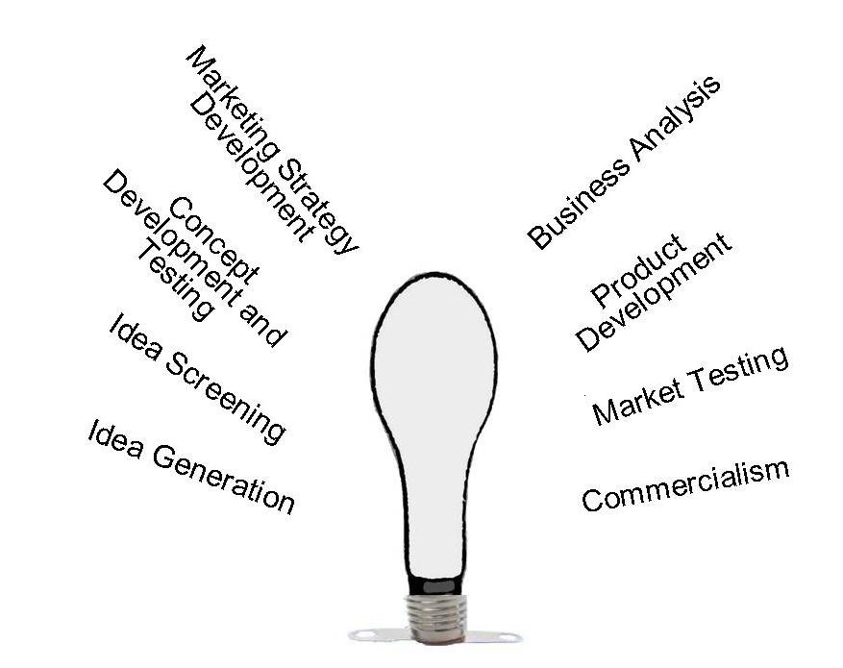
Source: (Francis, 2010),

- Idea Generation:
Is the specific proposal value contemplating?
The innovative creation development method begins in conjunction with a quest for concepts. New-found inventions occurs since various resources from clients, researchers, personnel, rivals, network representatives and senior management within Stockholm Products. The creators of the brand-new proposals required to characterise the creation and marketplaces alongside through asserting exactly how much energy is necessary to be attentive in acquiring breakthrough products, transforming remaining manufactured goods, and replicating competitors’ creations.

- Idea Screening:
Every corporation can entice proposals through managing the situation appropriately. In screening ideas Stockholm Products necessitate to avert two forms of blunders. A drop miscalculation where in the business set aside a decent concept and a go miscalculation anywhere the firm approves a mediocre suggestion towards stepping into advancement and commercialisation. The objective of screening is to decrease destitute thoughts as promptly as possible.

- Concept Testing and development:
Appealing proposals ought to be processed into testable creation ideas. (Creation idea is an developed edition of the concept conveyed in significant end user terms). The invention theory requires to document on and remain altered to a product idea. Idea analysis demands for analysis of product ideas with a suitable alliance of target users, before receiving individual user responses.

- Marketplace Approach Development:
Subsequently assessing the brand-new creation the manager is required to expand an initial marketing approach plan intended for launching the latest invention within the marketplace. The marketing approach plan within Stockholm Products contains three elements:
- Focus on marketplace scope, composition, consumer comportment, prepared invention placing and sales marketplace segment and revenue aspirations requested within initial few years shape component one.
- Following element contains summarising the inventions proposed value, distribution approach and promoting costs for the opening year.
- The third component is the extended lead sales and revenue targets promoting a mixture of approaches within the future.

- Business Analysis:
Following the managing phases builds the creation idea and promoting tactic; it can assess the applications to commercial desirability. Management demands to assess whether trades will be excessive adequately to generate agreeable revenue.

- Production Development:
If the invention approves the company to experiment, production progresses to R&D and creation towards expanding into natural creation. The R&D sector and manager will acquire one or another natural adaptations of the creation idea. The objective is to obtain a model that users perceive as exemplifying the vital qualities explained within the creation declaration, that operates carefully underneath typical consumption and circumstances and that may possibly remain supplied with the accounted production budgets.

- Market Testing:
Following that management is convinced through the inventions psychological and operational execution, the creation is prepared on the way to be set with a product brand name, advertising and primary advertising plan. The purpose is to assess the invention in new accurate customer situations and to discover in the provided marketplace is around what approach customers and suppliers respond to managing utilising and repurchasing the tangible production. Marketplace analysis provides administration sufficient knowledge to decisively introduce a new-found creation.

- Commercialisation:
Commercialisation is a few of the major expenses that the corporation force to cope with such as opposed to the prices encountered by Stockholm Products. The corporation need to contract intended for production or construct or lease a maximum range production capacity. Similarly other aspects the business will need to take on board through commercialisation are planning and scheduling. For instance, market opening period, geological scheme anywhere to introduce the creation specific locality along with regions and marketplace possibilities, for example, within the rollout marketplaces, the corporation should focus on its delivery and advertising to the finest potential end users.

Conclusion

This report displayed the innovation concept of Stockholm Products’ approach to innovation. The author evidently took one representative of the executive team within their organisation and clearly explained their responsibilities within the teeth whitening project, contemplating their organisational and personal knowledge and experience. The author utilised one open model and one closed model of innovation, evaluating exactly in how they could possibly be exploited within the teeth whitening project. A justification, with explanations was comprised of which model the author would suggest should the project continuing to go ahead. The author will clearly explored and differentiated amid the recognised models of innovation. The author clearly communicated that the report has exhibited evidence of wide research and reading, using academic theories and models to support applicable knowledge relating to Developing Innovation and Creativity for Business Advantage.

Appendix A

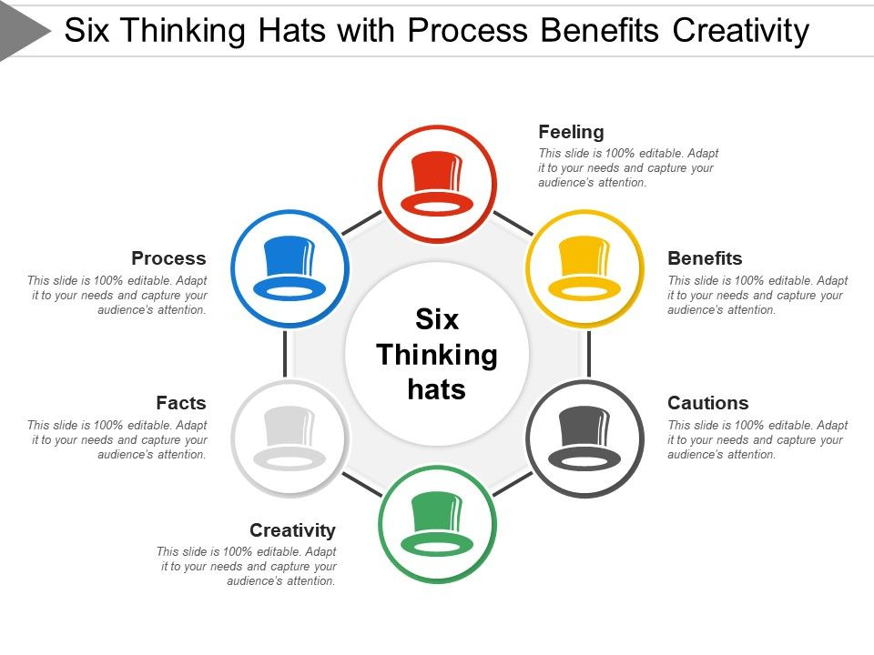
This is the process that Stockholm Products takes on board within their group meetings. Source: (Slide Team, 2019)

References

Allen, T. J. & Cohen, S. I., 1969. Information flow in research and development laboratories. Administrative Science Quarterly, 14(1), pp. 12-19.
Bainbridge, D. I., 1996. Intellectual Property. Financial Times. 3rd ed. London: Bitman Publishing.
Bhasin, H., 2019. Marketing91. [Online]
Available at: https://www.marketing91.com/what-is-disruptive-innovation/
Brem, A., 2009. Integration of market pull and technology push in the corporate front end and innovation management—Insights from the German software industry , Nuremberg: Elsevier.
Caroll, J., 2006. Jim Caroll. [Online]
Available at: https://jimcarroll.com/2006/11/how-to-be-innovative-with-the-six-cs-of-innovation/
[Accessed 27 December 2019].
Chesbrough, H., 2003. Open Innovation: The New Imperative for Creating and Profiting from Technology. Boston: Harvard Business School Press.
Dance, J., 2008. Fresh. [Online]
Available at: https://www.freshconsulting.com/what-is-innovation/
Dussauge, P., Garette, B. & Ramanantsoa, B., 1987. Technologie et stratégie d’entreprise. 1st ed. Paris: McGraw Hill.
Francis, A., 2010. MBA Knowledge Base. [Online]
Available at: https://www.mbaknol.com/marketing-management/stages-of-new-product-development/
[Accessed 28 December 2019].
Freeman, C., 1982. The Economics of Industrial Innovation. Second ed. London: Frances Pinter.
Gerpott, T. J., 2005. Strategisches Technologie- und Innovationsmanagement. Essen: Schäffer-Poeschel.
Govindarajan, V. & Kopalle, P. K., 2005. Measurement and an assessment of reliability and validity. Disruptiveness of innovations, 27(2), p. 15.
Grow, M. M. & Nath, S., 1990. An assessment of market and government influences. Technology strategy development in Japanese industry, 10(5), pp. 333-346.
Hoffman, K., Perren, L., Bessant, J. & Parejo, M., 1998. A literature review. Small firms, R&D, technology and innovation in the UK, 18(1), pp. 19-35.
Muckersie, E., 2016. Decidedly. [Online]
Available at: https://decidedly.com/incremental-breakthrough-radical-innovation/
Newman, D., 2018. Forbes. [Online]
Available at: https://www.forbes.com/sites/danielnewman/2018/05/08/preparing-for-the-future-by-embracing-radical-innovation/#714f511b718e
Rothwell, R., 1991. External networking and innovation in small and medium-sized manufacturing firms in Europe. Technovation, 11(2), pp. 93-112.
Rothwell, R. & Zegveld, 1985. Reindustrialisation and Technology. 3rd ed. Amsterdam: Longman.
Sjöberg, N., Bohlin, E. & Granstrand, O., 1992. External technology acquisition in large multi-technology corporations. R&D Management, 22(2), pp. 111-133.
Slide Team, 2019. Slide Team. [Online]
Available at: https://www.slideteam.net/six-thinking-hats-with-process-benefits-creativity.html
[Accessed 28 December 2019].
Spacey, J., 2017. Simplicable. [Online]
Available at: https://simplicable.com/new/product-innovation
Tidd, J. & Bessant, J., 2013. Success routines in innovation mangement. 5th ed. San Francisco: John Wiley & Sons Ltd.
Tidd, J., Bessant, J. & Pavitt, K., 1997. Managing Innovation: Integrating Technological, Market and Organizational Change. 3rd ed. Chichester: John Wiley & Sons.
Trott, P. & Hartmann, D., 2009. Why open innovation is old wine in new bottles. International Journal of Innovation Managemen, 13(4), pp. 715-736.

Bibliography

Almirall, E. and Casadesus-Masanell, R. (2010). Open Versus Closed Innovation: A Model of Discovery and Divergence. Academy of Management Review, 35(1), pp.27-47.
Caniëls, M. and Rietzschel, E. (2013). A Special Issue of Creativity and Innovation Management: Organizing Creativity: Creativity and Innovation under Constraints. Creativity and Innovation Management, 22(1), pp.100-102.
Dubina, I. and Carayannis, E. (n.d.). Creativity, innovation, and entrepreneurship across cultures.
Managing advancing technology. (1972). [New York]: American Management Association.

