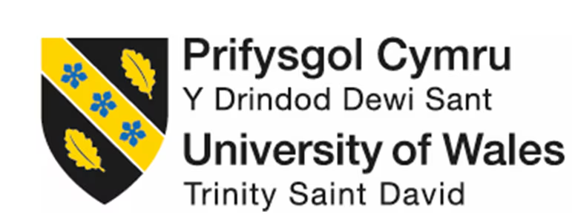

Managing projects in the organizations BMSW5009CARD

Student Name: Ciprian Grosu
Student Number: 2209375

Executive Summary
This report critically evaluates the use of project management tools and techniques applied during the Bucovina Project, a cultural food event aimed at promoting Romanian and Eastern European traditions. The report examines the five key project phases, Gantt chart usage, while reflecting on stakeholder communication and team collaboration. The report also shows the importance of structured planning and adaptability, showing how these elements contributed to the project’s successful delivery. The lessons learned show the importance of balancing planning with flexibility.

Table of Contents
1. Introduction 1
2. Findings 1
2.1 Project Management Phases 1
2.2 Gantt Chart 1
2.3 Communication and Stakeholders 1
3. Conclusion 1
4. Reference List 1
Appendix: Thank you from ROUCA 1

1. Introduction
In the words of Cicmil (1997), effective project management plays a vital role in ensuring that our ideas can be successfully transformed into tangible outcomes, especially when managing events that involve multiple stakeholders, limited timeframes, or cultural sensitivity. In this report, we will conduct a critical assessment of project management tools and techniques used to manage a real-world project and initiative, The Bucovina Project: Bringing Romania’s Culture to the New Generations, which was delivered in a community and cultural setting. The purpose of the Bucovina Project was to create an interactive and inclusive cultural experience where children could explore and enjoy traditional Romanian and Eastern European food, promoting curiosity, respect and understanding of different backgrounds. Therefore, the report will start with an overview of project management, defining its key phases and introducing tools and techniques for delivering successful projects. The report will then explore the specific tools applied for the Bucovina Project in order to accentuate their practical use and effectiveness. Furthermore, the report will examine how project plans were communicated to relevant stakeholders and conclude by reflecting on lessons learned and identifying key areas for future improvement in managing similar projects.

2. Findings
In the words of Schwalbe (2009), a project is a temporary endeavour with a clear beginning and end, undertaken to create a unique product, service, or result. This means that project management involves the structured use of processes, knowledge, skills, and tools to achieve specific outcomes within set time and budget limits (Kerzner, 2025). Unlike general management, which focuses on ongoing operations, Heagney (2016) states that project management is tailored to finite, often complex tasks that require clear direction and adaptability.
To succeed, project managers rely on structures, tools and methods to track progress, assign responsibilities, manage budgets, and identify potential risks (Richardson and Carstens, 2019). Depending on the project’s complexity and level of uncertainty, managers may apply predictive (traditional), adaptive (agile), or hybrid approaches. To support these methods, they use tools such as the Quad Chart, Gantt Chart, Work Breakdown Structure (WBS), the Iron Triangle, and a Stakeholder List (Celestin and Vanitha, 2017). These tools help ensure team alignment, enhance collaboration, and keep the project on course.
Moreover, a project manager will also structure their work around clearly defined phases that guide the project from conception to completion (Lock, 2017). The five key phases are initiation, planning, execution, monitoring and controlling, and closure, and they provide a framework that supports good decision-making, progress tracking, and stakeholder communication throughout the project lifecycle (Wysocki, 2004; Tonnquist, 2008). This means that each phase will play a distinct role in ensuring that the project remains feasible and aligned with its intended goals.
In other words, effective project delivery depends on the strategic use of structured tools and phased approaches. This is because project management is driven by a suite of methodologies designed to guide complex initiatives from conception through to completion (Bryde, 2003). Among the most widely applied methodologies are the five key project management phases, the Gantt chart, and risk analysis because they provide clarity, control, and informed decision-making throughout the project lifecycle, helping teams plan, monitor, and respond effectively to challenges (Westland, 2006; Kanda, 2010).

2.1 Project Management Phases
The five key phases of project management are initiation, planning, execution, monitoring and controlling, and closure, and in the words of Lock (2017), they aim to provide a structured framework for delivering feasible and successful outcomes because their purpose is to guide a project through a logical progression, ensuring that each stage contributes to measurable and aligned deliverables (Bryde, 2003; Kanda, 2010).
Houston and Bove (2007) state that the initiation phase is the first step in the project management process, where the project begins to be defined, authorised, and linked to the organisational strategic objectives. De Valence (2013) adds to this by stating that the initiation phase focuses on defining the project’s purpose, scope, and feasibility while securing necessary resources and a buy-in from the stakeholders. In other words, the positive aspect of the initiation phase is that it aims to add clarity and discourages weakly defined projects from progressing further. On the other hand, a negative of the initiation phase would be that it is time-consuming and prone to issues if scoping is incomplete.
The Bucovina Project: Bringing Romania’s Culture to the New Generations exemplified the principles of effective project management by focusing on defining the project’s purpose (see Image 1.0), which was to create an interactive and inclusive cultural experience where children could explore and enjoy traditional Eastern European food, promoting curiosity, respect, and understanding of different backgrounds. By establishing this clear purpose during the initiation phase enabled our five-person project team to align on shared objectives (see Image 2.0) and ensure clarity from the beginning. In exchange, this strong foundation helped the team avoid an unfocused or poorly structured approach and allowed for a smooth transition into the planning phase.
Image 1.0 - Showing Aim of Bucovina Project
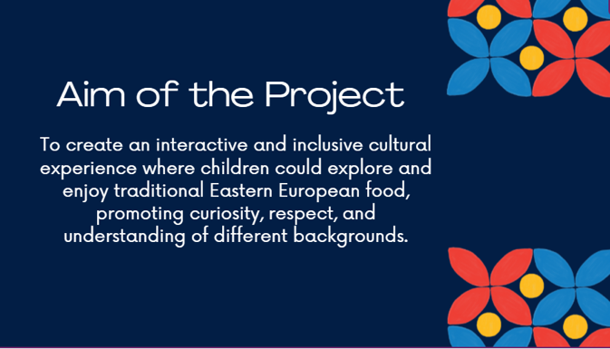

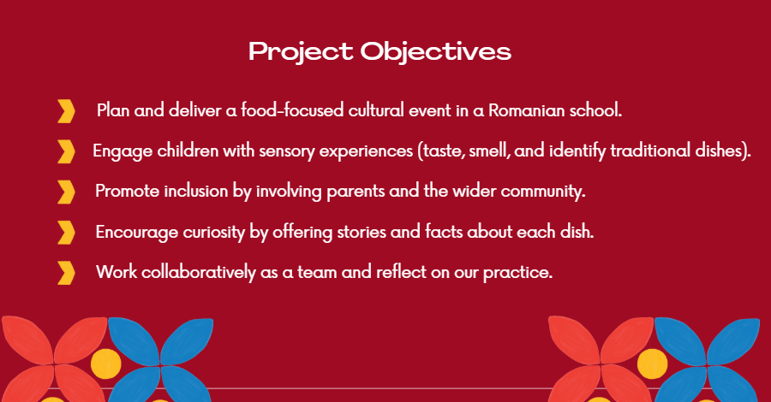
Image 2.0 - Showing Objectives of Bucovina Project
In the words of Burke (2013), the planning phase establishes timelines, roles, and risk responses. In other words, during the planning phase, a team will map out the required tasks, timelines, resources, budgets, and create a structure to support execution. A positive aspect of the planning phase would be that it reduces uncertainty and enhances coordination among the team. However, one negative aspect of the planning phase would be that it can lead to inflexibility and may fail to anticipate unforeseen changes. During the planning phase of The Bucovina Project, we used a basic Gantt chart to allocate roles (see Image 3.0) and defined our budget (see Image 5.0). On top of this, to ensure compliance with regulations, the team also conducted a risk assessment (see Image 6.0). While this phase improved our team coordination, a limitation was our limited contingency planning, which became apparent when one team member faced a last-minute scheduling conflict.
Image 3.0 - Showing Project Gantt Chart
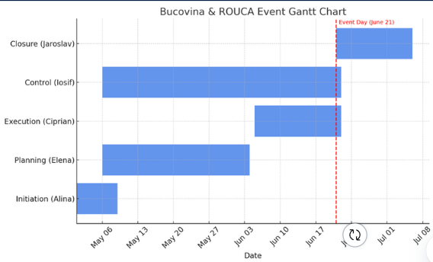

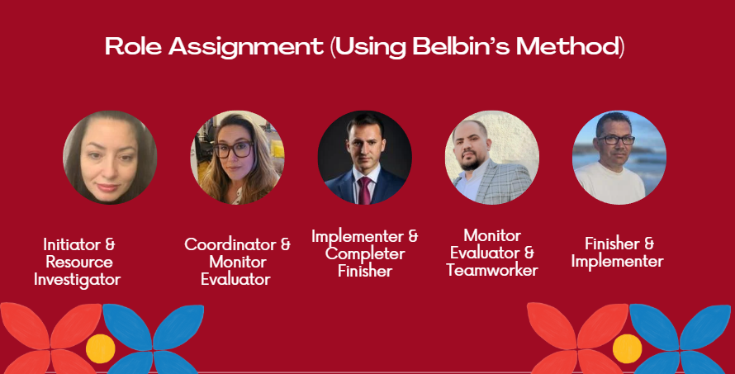
Image 4.0 - Showing Role Assignment during the Bucovina Project
Image 5.0 - Showing Project Initial Budget
Image 6.0 - Showing Bucovina Project Risk Assessment
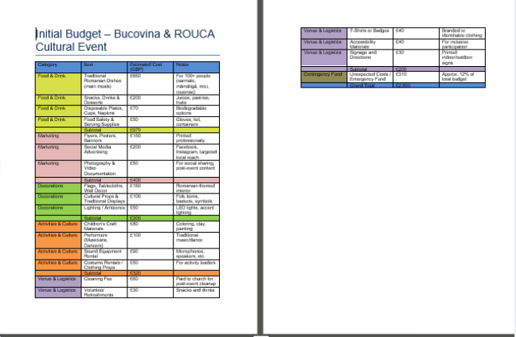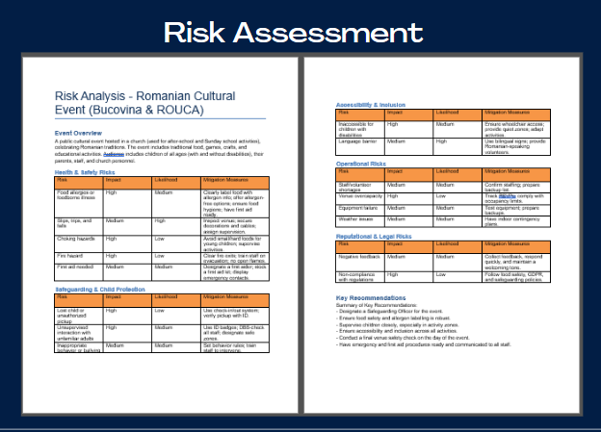

Image 7.0 – Showing Event flyer



Houston and Bove (2007) state that the execution phase is the most time and resource-consuming because it is the phase where the work and activities defined in the initiation and planning phases start to be completed. In other words, the execution phase involves carrying out the tasks outlined in the plan and achieving the intended deliverables by building momentum (Cozzi, 2008). One positive aspect of the execution phase is that it provides a sense of progress and motivation for the team. However, one negative aspect of the phase is that effective execution relies on the quality of prior planning.
The Bucovina Project further demonstrated the principles of effective project management by using an additional Gantt Chart for the execution phase (see Image 7.0) to ensure that the tasks outlined in the plan are adhered to and on schedule. The team member responsible for the execution phase used the Gantt chart to provide regular updates, track the progress, and maintain transparency, which also served to keep the team motivated and informed. The execution phase progressed with fluidity, largely because of the strength of the planning phase, which had clearly outlined project objectives, team responsibilities and realistic timelines. However, one limitation was that the execution phase proved to be more time-consuming than anticipated, showing the challenge of translating even well-structured plans into action within tight time constraints.
Image 8.0 - Showing Individual Gantt Chart
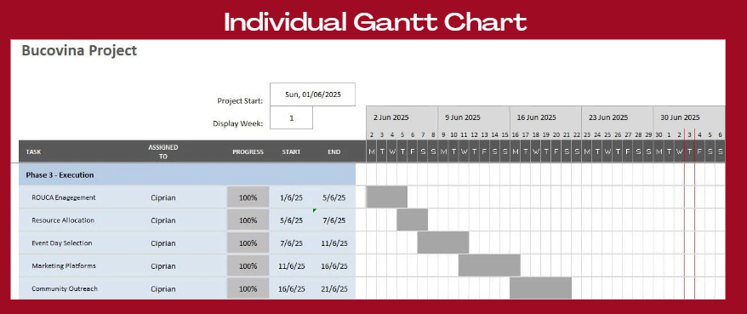

In the words of Burke (2013), the monitoring and controlling phase is the phase that ensures the project stays on course by tracking progress, identifying deviations and making the necessary adjustments. One positive aspect of the monitoring and controlling phase is that it enables real-time adjustments and increases the likelihood of staying on target (Sima, 2022). However, a negative aspect of the monitoring and controlling phase would be that excessive monitoring can hinder team autonomy, and reactive control measures may fail if issues are identified too late (Lock, 2017).
Houston and Bove (2007) state that the closure phase formalises the completion of the project by finalising activities, releasing resources, and evaluating outcomes. In other words, the closure phase is the stage where lessons learned are captured. One positive aspect of the closure phase is that it facilitates learning. However, a negative aspect of the closure phase is that it is often rushed or neglected, which leads to missed opportunities for real reflection and learning (Cicmil, 1997; Burke, 2013). In the Bucovina Project, the closure phase was effective because of the strong foundation laid in earlier phases. The project had a defined scope, a well-structured risk assessment, and a detailed budget plan (see Image 8.0), all of which contributed to a smooth event delivery. Significantly, no significant risks or issues were encountered during the execution, and the event was delivered on time and within budget. Moreover, the project objectives were fully met, and the team was able to conduct a brief but focused evaluation of outcomes, which highlighted the value of having a structured approach throughout the project lifecycle (Westland, 2006; Cozzi, 2008; Kanda, 2010).
Image 9.0 - Showing % of Budget Allocation
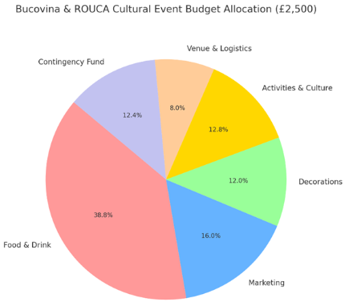

2.2 Gantt Chart
The Gantt chart is a tool developed by Henry Gantt (1861–1919), recognised as the father of planning and control techniques (Morris, 2011). Gantt charts are bar graphs used in project management to represent tasks over time. The length of each bar indicates how much time is allocated to each task (Bianconi, 2024). In other words, a Gantt chart is a visual project scheduling tool which project managers visualise their project timeline, track task completion, and stay aligned with their deadlines.
In the Bucovina project, one major benefit of using the Gantt chart was the clarity it brought to the planning process because the team could quickly see what needed to be done and when. However, a limitation of the Gantt charts is that it doesn’t show task priority, which sometimes confuses which activities need the most immediate attention, meaning they fail to communicate task complexity. In the words of Maylor (2001) and Vasankari (2024), Gantt charts are highly valuable tools for project managers because they support planning, track progress, and maintain communication with stakeholders. And while challenges may arise during the project, as Wadhwa (2024) stated, an experienced and well-prepared project manager with a well-structured plan can navigate these difficulties and continue to use the Gantt chart effectively. In conclusion, Gantt charts are highly effective tools for project managers, and as illustrated in Image 3.0 and Image 7.0, their use contributed significantly to the successful delivery of the event on time and within budget.

2.3 Communication and Stakeholders
Communication in project management refers to the process of exchanging information so that all stakeholders maintain a shared understanding of the project’s goals, progress, issues, and changes (Zulch, 2014; Goudar, 2010; Reems, 2023). In the words of Karlsen (2002), stakeholders in project management are any individuals, groups, or organisations that may affect, be affected by, or perceive themselves to be affected by a decision, activity, or outcome of a project. In the Bucovina project, the team used WhatsApp and face-to-face meetings as a method of communication to discuss the project and its objectives. To prioritise communication, the Bucovina project team also conducted a stakeholder analysis, identifying key parties such as the ROUCA Cardiff coordinator, school staff, volunteers, and the food sponsor (Bucovina store). Additionally, the team also used a power-interest grid (see image 9.0), and they shaped their approach by updating high-power stakeholders more frequently while keeping others informed through WhatsApp group chats. This method was employed by the team to streamline messaging and reduce miscommunication (Rick, 2013). Overall, direct communication and stakeholder mapping were effective in the Bucovina Project. However, implementing a more formalised communication strategy could have improved consistency and ensured that all stakeholder groups remained fully engaged throughout the project (Hogg, 2004).
Image 9.0 - Showing Bucovina Project Power-Interest Grid
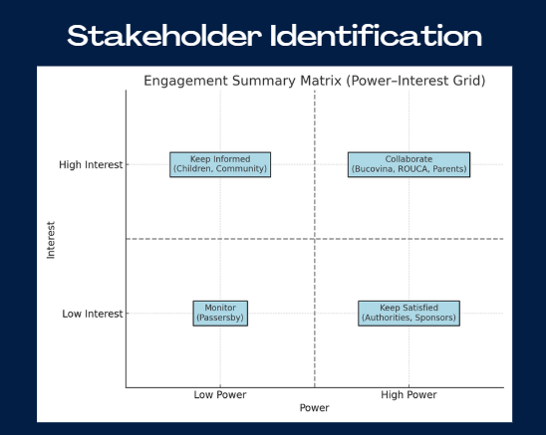

3. Conclusion
In conclusion, the Bucovina Project pointed out how essential project management tools and techniques are for delivering successful projects. Tools such as the Gantt chart, stakeholder analysis, and risk assessments helped structure the process, align the team, and maintain control throughout each phase of the project. However, the project also emphasised that even if a project manager has the best tools, they require adaptability because unexpected challenges may arise, and flexibility and responsive thinking must be used. In other words, this means that having a well-structured plan laid out during the initiation and planning phases proved vital for the project execution.

4. Reference List
Bryde, D. J. (2003). Project management concepts, methods and application. International Journal of Operations & Production Management, 23(7), 775-793.
Bianconi, F. (2024). Gantt Charts. In Data and Process Visualisation for Graphic Communication: A Hands-on Approach with Python (pp. 175-181). Cham: Springer Nature Switzerland.
Burke, R. (2013). Project management: planning and control techniques. John Wiley & Sons.
Cicmil, S. J. (1997). Critical factors of effective project management. The TQM magazine, 9(6), 390-396.
Cozzi, F. (2008). Project Execution Phase. In Industrial Project Management (pp. 177-197). Springer, Berlin, Heidelberg.
Celestin, M., & Vanitha, N. (2017). Beyond Gantt charts: Innovative tools every project manager should know. International Journal of Interdisciplinary Research in Arts and Humanities (IJIRAH), 2(2), 298-304.
de Valence, G. (2013). Project initiation. In Building in value: Pre-design issues (pp. 23-36). Routledge.
Goudar, J. (2010). Effective project communication management. The Project Perfect White Paper Collection.
Hogg, S. (2004). Development of formal communication strategies to increase the transfer of information in a human service organisation (Doctoral dissertation, Murdoch University).
Heagney, J. (2016). Fundamentals of project management. Amacom.
Kerzner, H. (2025). Project management: a systems approach to planning, scheduling, and controlling. John Wiley & Sons.
Karlsen, J. T. (2002). Project stakeholder management. Engineering management journal, 14(4), 19-24.
Kanda, A. (2010). Project management: A life cycle approach. PHI Learning Pvt. Ltd..
Lock, D. (2017). The essentials of project management. Routledge.
Morris, P. W. (2011). A brief history of project management.
Maylor, H. (2001). Beyond the Gantt chart:: Project management moving on. European management journal, 19(1), 92-100.
Rick, A. (2013). The benefits of miscommunication. Mimeo.
Richardson, G. L., & Carstens, D. S. (2019). Project management tools and techniques: A practical guide. CRC Press.
Reems, M. (2023). Definition of Communication.
Schwalbe, K. (2009). Introduction to project management. Boston: Course Technology Cengage Learning.
Sima, K. (2022). Executing, Monitoring and Controlling a Project, the right way. Tonnquist, B. (2009). Project management. Academica.
Vasankari, P. (2024). The Effect of Project Communication and Project Performance: The Role of Detailed Gantt Chart in Substation Construction Project.
Wysocki, R. K. (2004). Project management process improvement. Artech House.
Westland, J. (2006). The project management life cycle: a complete step-by-step methodology for initiating, planning, executing & closing a project successfully. Kogan Page Limited.
Wadhwa, K. (2024). The Role of Gantt Chart in the Project Management.
Zulch, B. G. (2014). Communication: The foundation of project management. Procedia Technology, 16, 1000-1009.

Appendix:

Thank you from ROUCA



