NETWORK OPERATING SYSTEMS AND SECURITY

Thomas Molner
1804564
Administering Network Infrastructures utilising Core Intrinsic Network OS Services
Terry Walcott

Contents
1
Worksheet 1 2
Worksheet 2 3
Worksheet 3 10
Worksheet 4 16
Worksheet 5 20

Worksheet 1
Active Directory Domain Services has been installed on Server2 and Server2 was promoted to a Domain Controller:
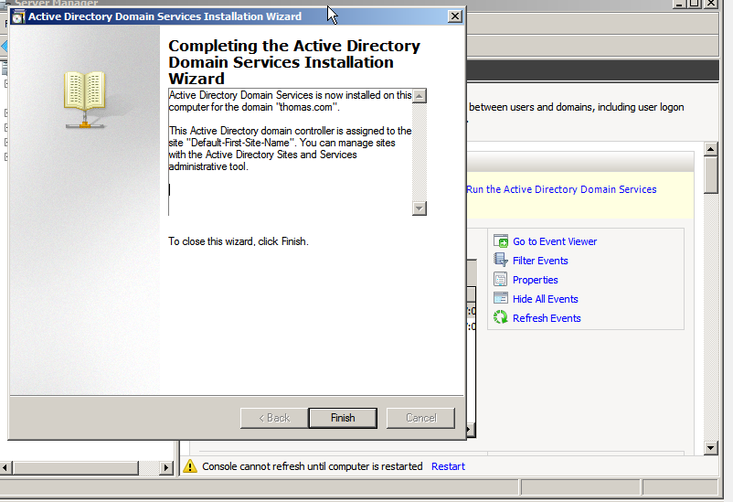
Client 2 has been added in the domain thomas.com:
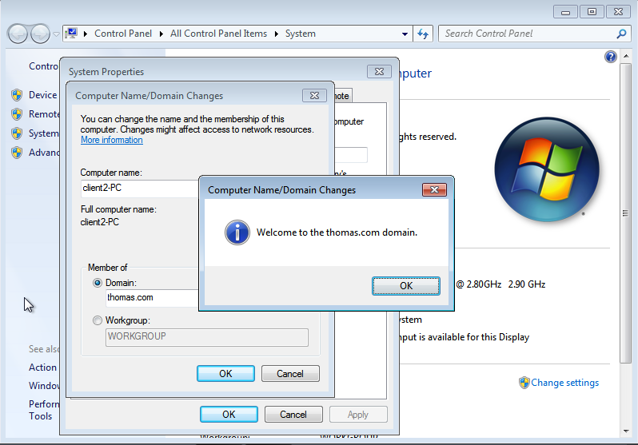

Client2 vs Server2:
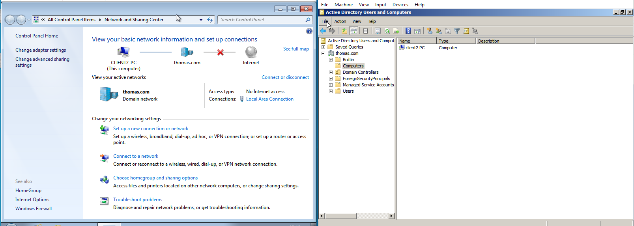

Worksheet 2
Creation of OU hierarchy:
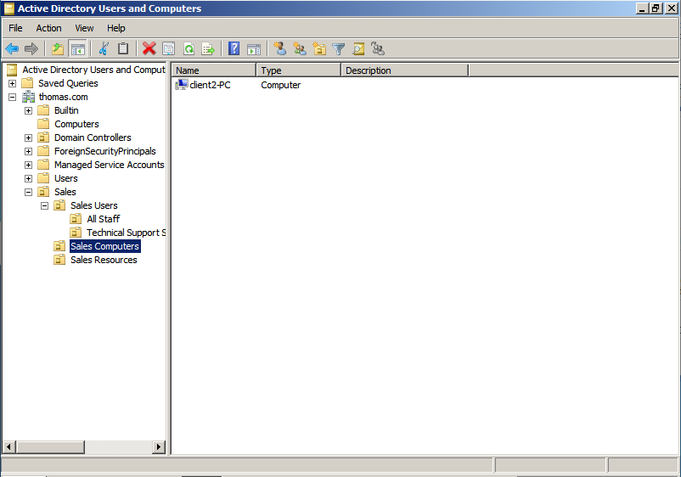

Modification of Password Policy, disabling the complexity requirements and modifying the account lockdown threshold:
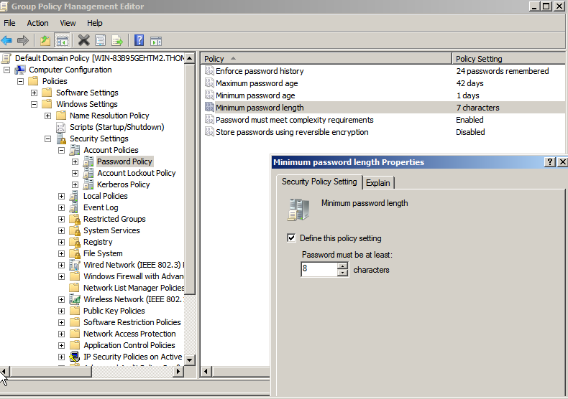
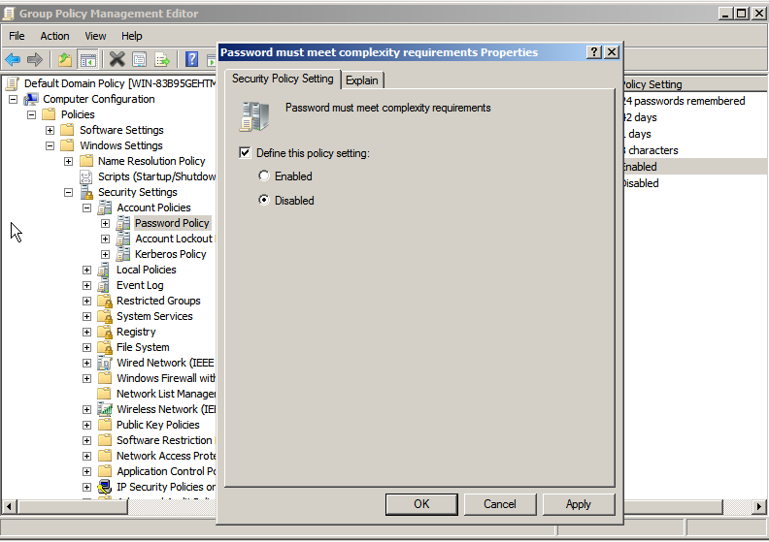
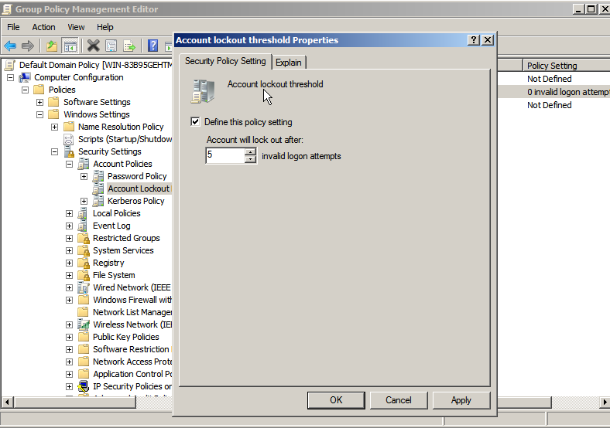
Creation of admin users under the Technical Support Staff:
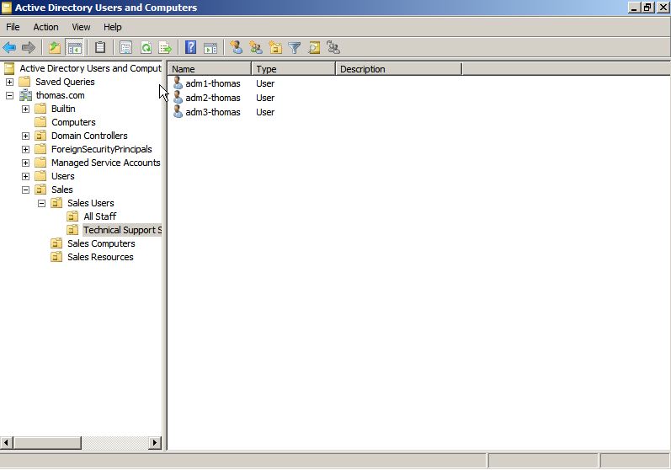

Creation of user account under All Staff:
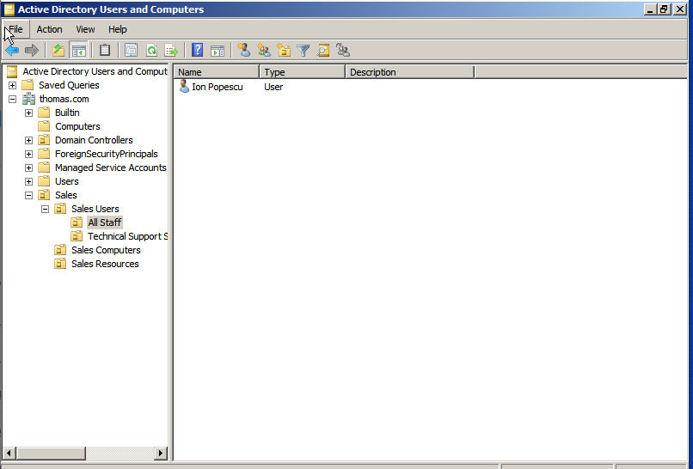
Logging on the client machine with the newly created user account:
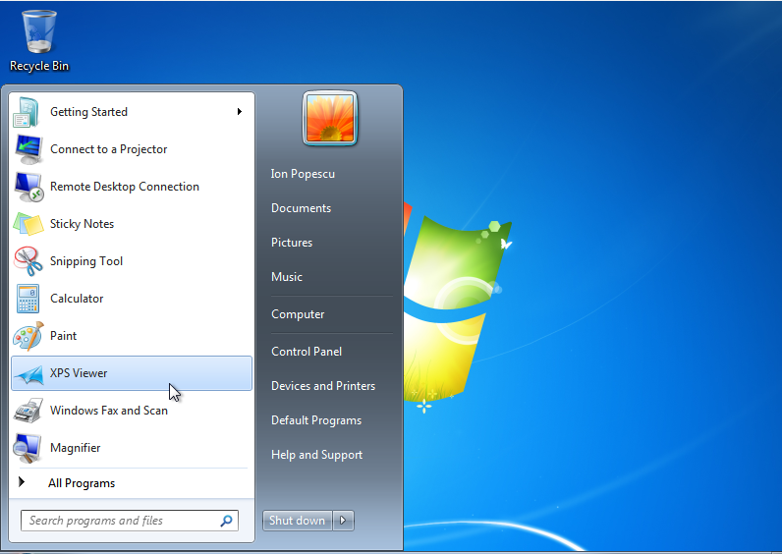

Searching for an account:
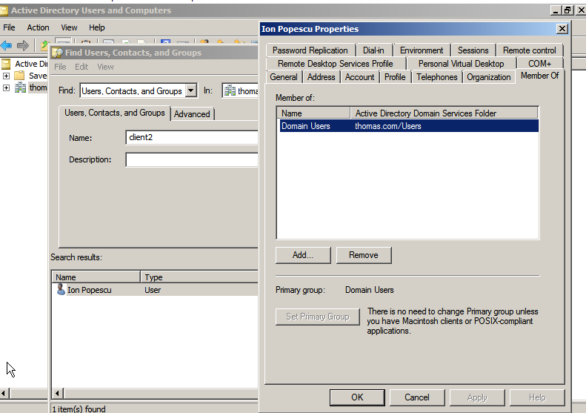
Adding one of the tech staff (adm01) to the Domain Admins:
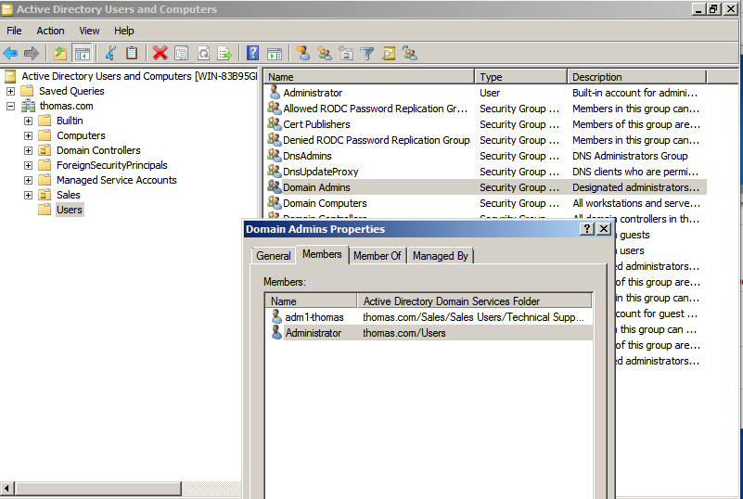

Adding the user account to a Domain Local Group I’ve previously created:
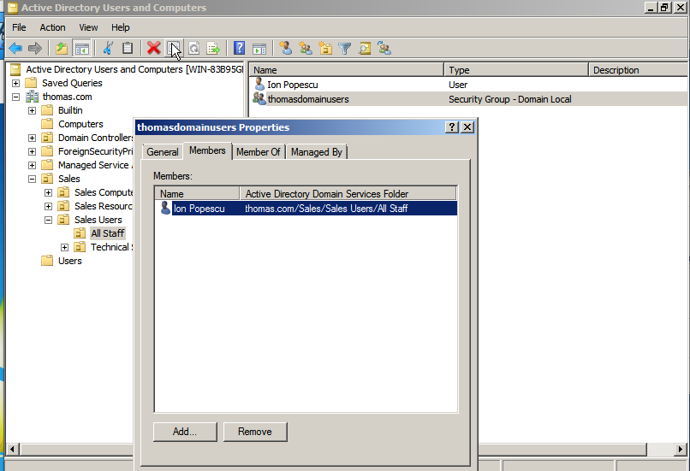
Adding all tech support members and the user account to the newly created Global Group:
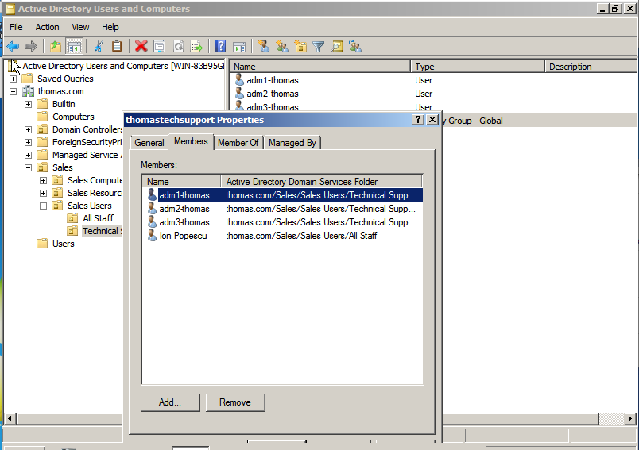

Worksheet 3
Managing permissions on the newly created directory Debt Database, fullcontrol for the tech support and read rights for the domain users group:
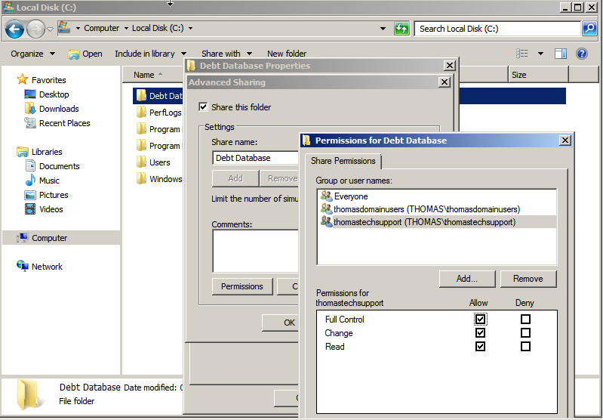
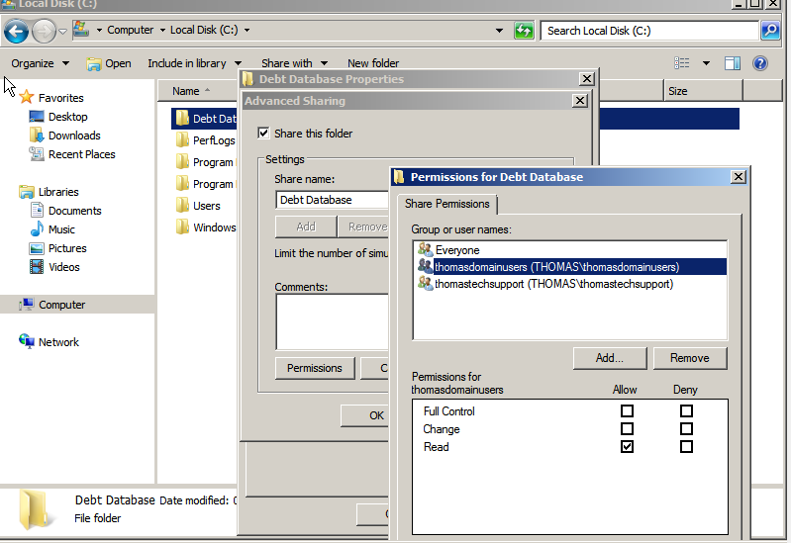
Managing advanced security settings on the file “salesdatabase” created inside the directory “Debt Database”:
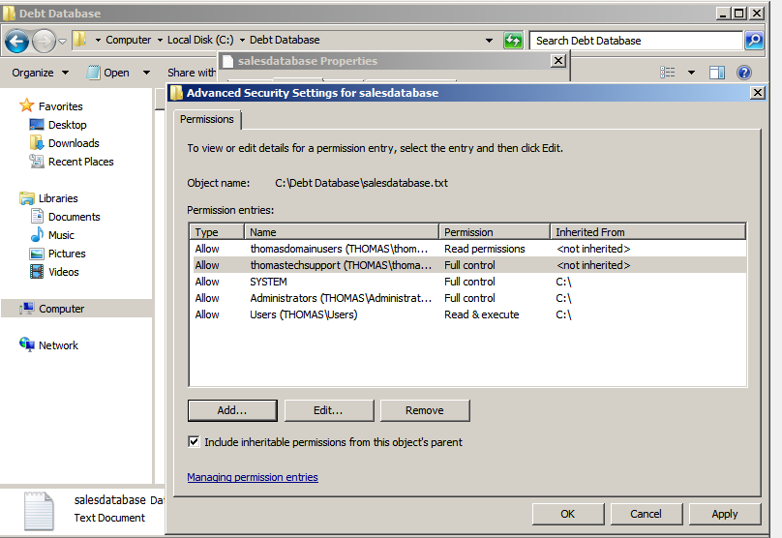
The directory can now be accessed from the client machine (client vs server below):
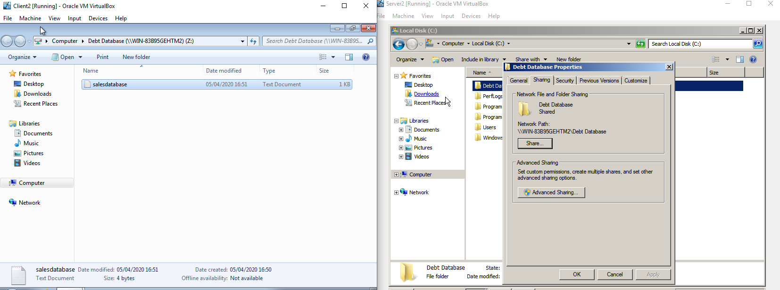
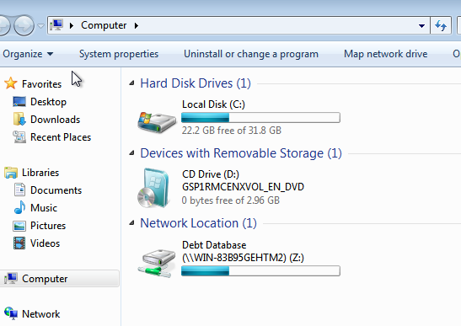
User is able to see the content, but is not allowed to do any modification, since he is part of the group that only has the read rights:
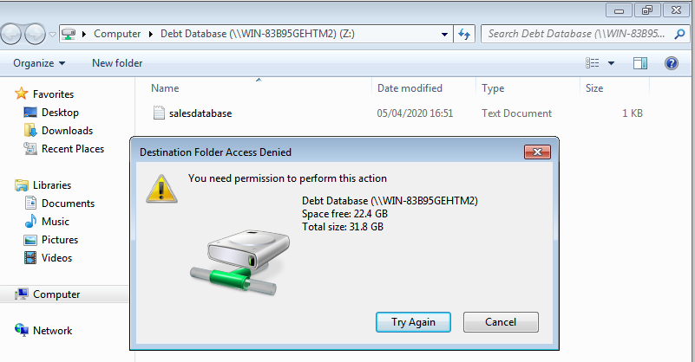
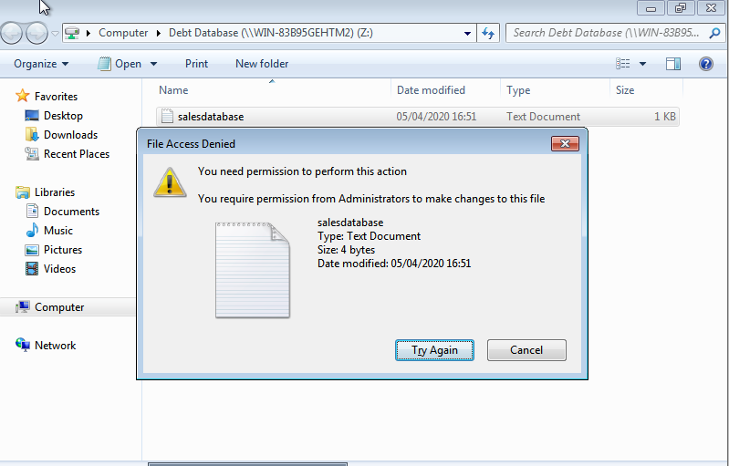

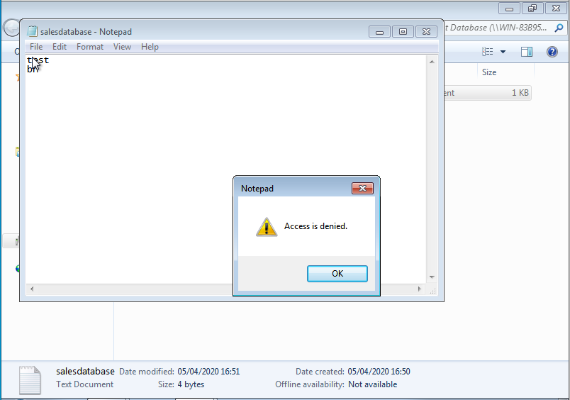

I have logged in with one of the admins with full access rights and I am able to modify inside the directory:
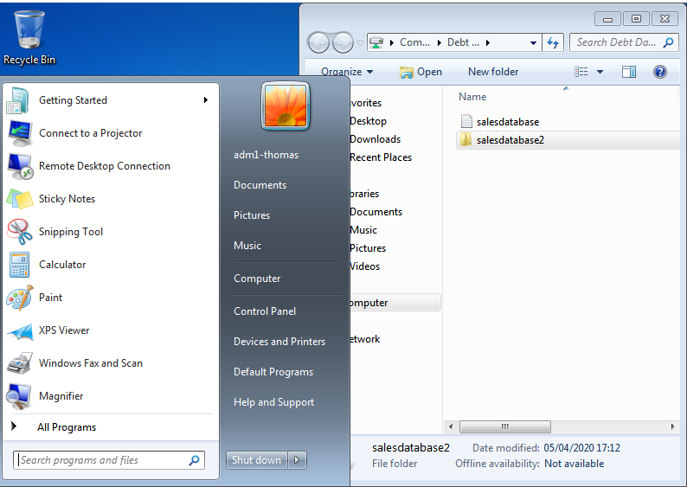
Creation of OUs:
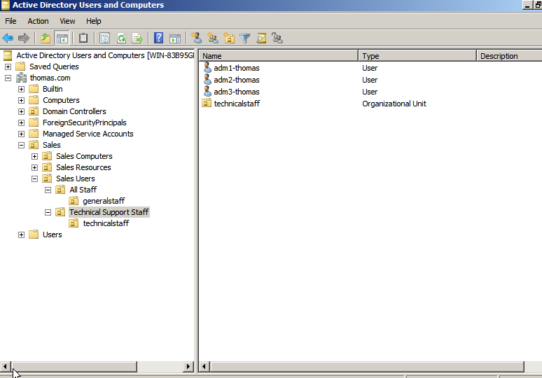
Creation of Group Policies- policy for right click not to work on the taskbar. After enforcing this group policy, user from general staff is unable to right click on the taskbar:
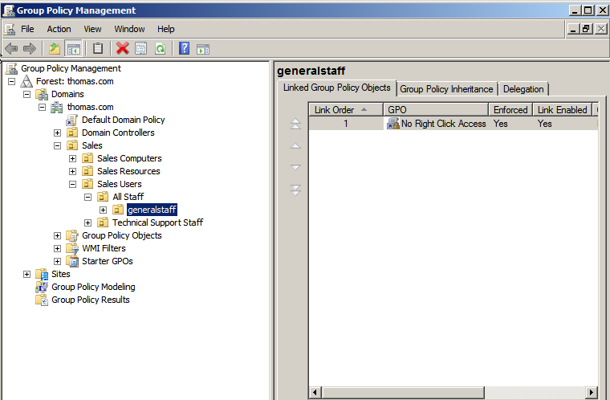
Creation of group policy for the recycle bin to disappear from the Desktop. After enforcing the group policy, user part of general staff does not have the recycle bin on the desktop after restart:
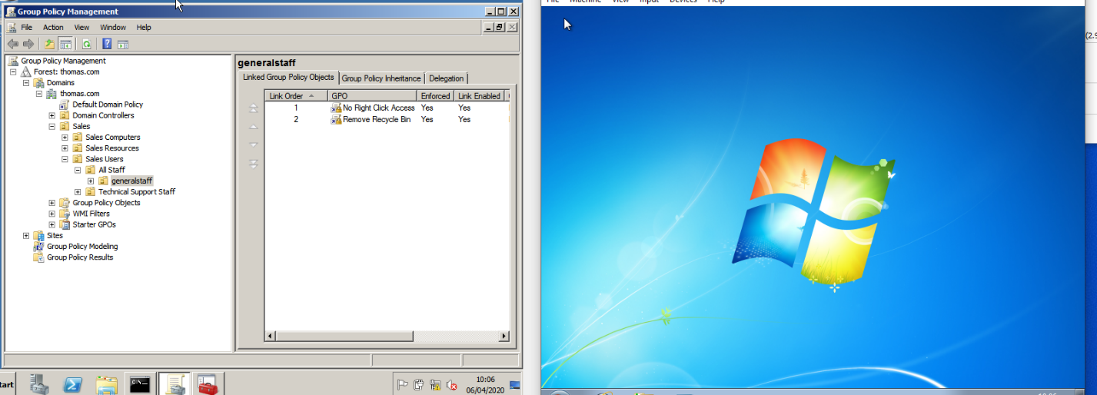

Creation of policy for the Pictures Icon to disappear from the Start Menu:
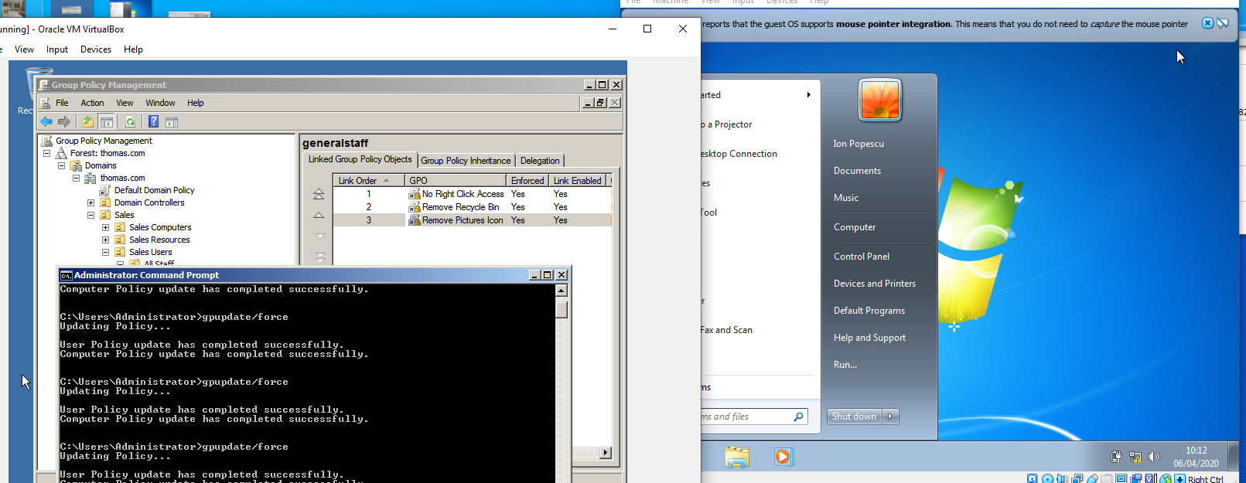

Worksheet 4
Successfully installed DHCP Role:
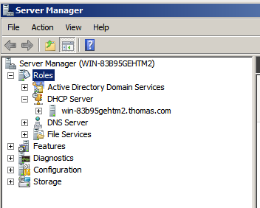

New scope SalesClient:
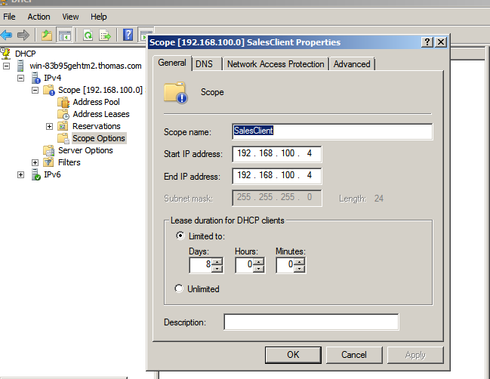
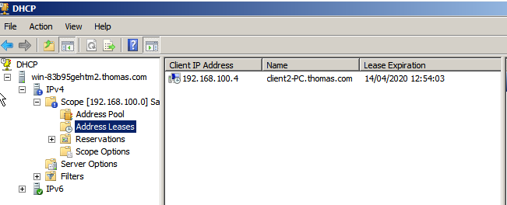

Logging on Client with Administrator account:
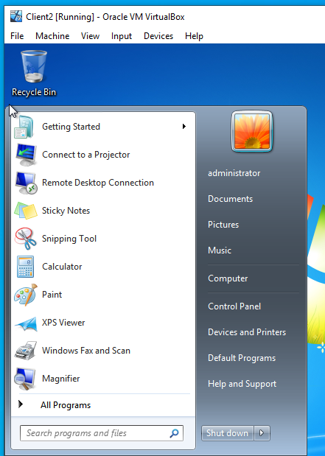
After disabling the IPv4 manually entered and checking the “Obtain an IP address automatically” and “Obtain DNS server address automatically”, I’ve ran the following to obtain the IP Address automatically:
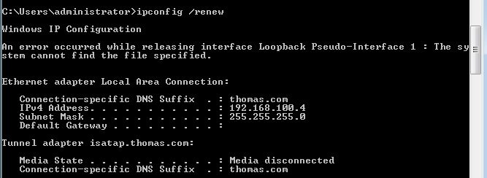

Checking DHCP and automatically allocated IP:
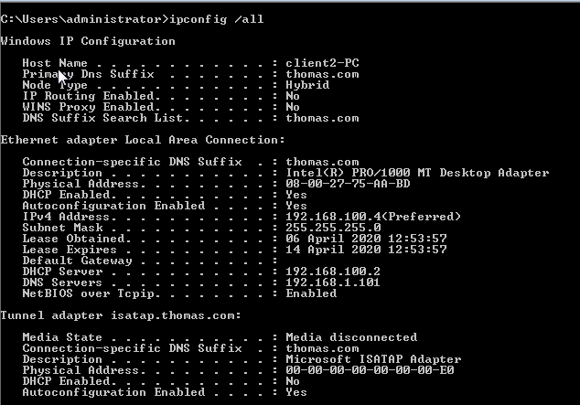
Configuring DHCP Scope Options:
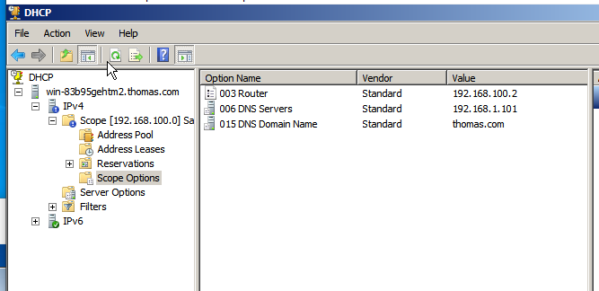

Worksheet 5
Main Server (Server2) and secondary server (Server 1)
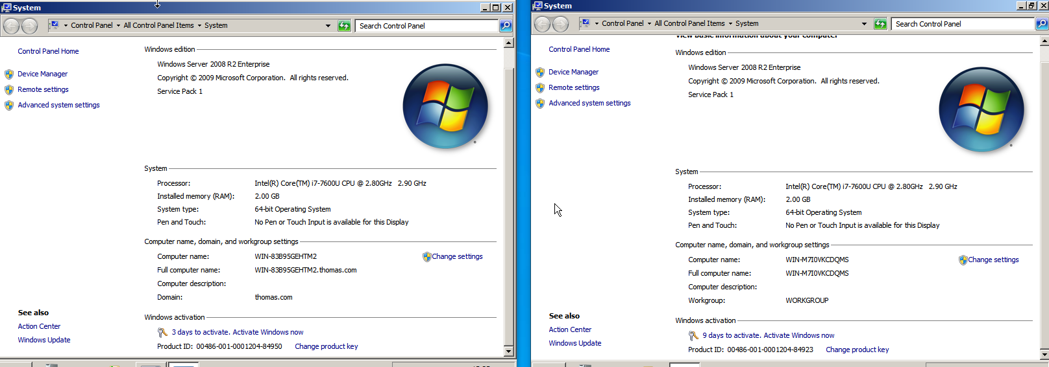
DNS Installation on low number server (Server1):
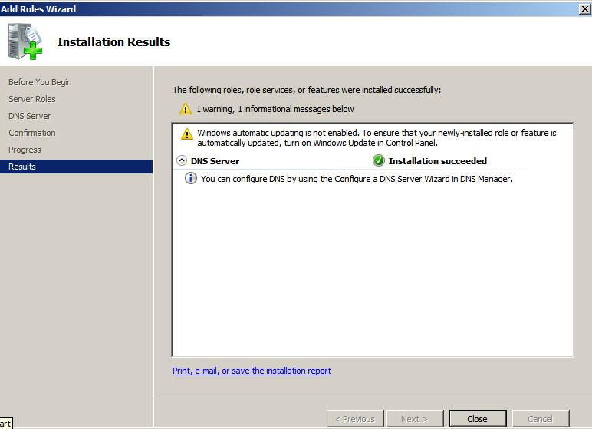

DNS has been installed on secondary server:
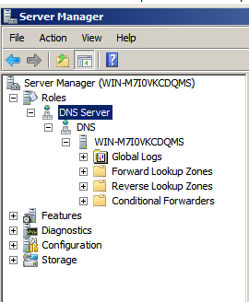
Forward lookup zone created (primary zone):
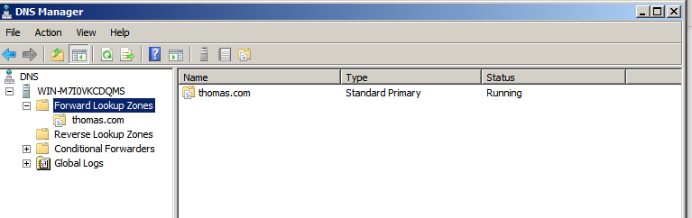
IIS Role has been installed on the main server:
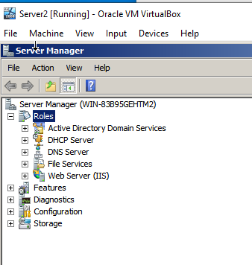
Virtual directory has been created:
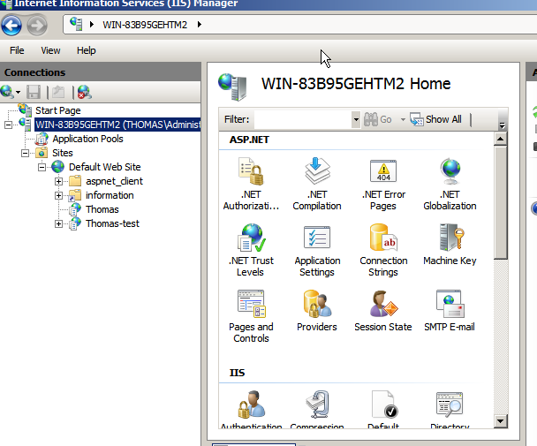

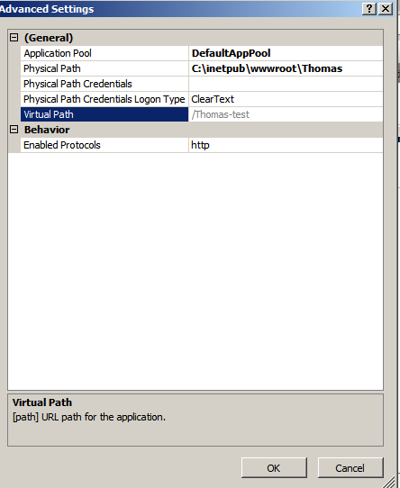

I have placed a test html file inside C:\inetpub\wwwroot\Thomas:
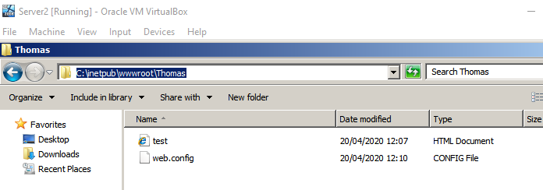
I have enabled the Directory Browsing from the IIS Features View:
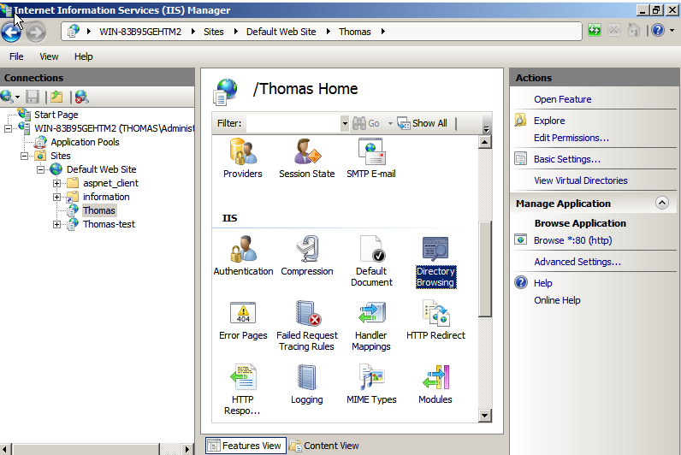
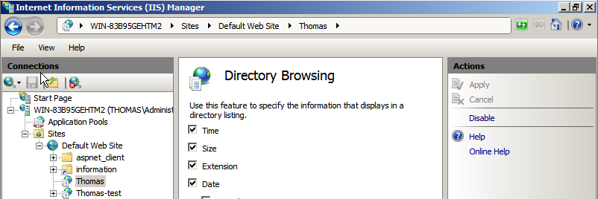
The Website can be accessed locally as shown in the Screenshots:
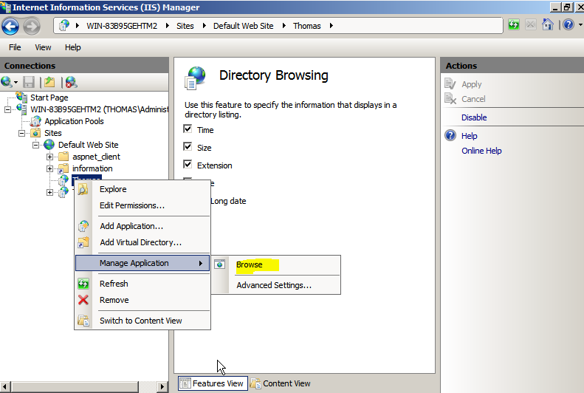
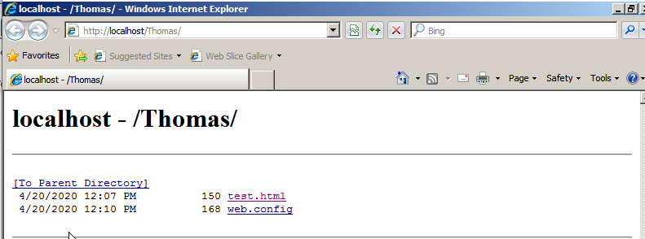
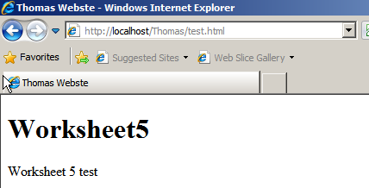
The website can also be accessed remotely from the secondary server by typing in the browser the name of the main server followed by the path of the html file from the main server:


