Scenario

You are to assume that the University has received planning consent for a single, two storey detached domestic building with a loft room. [See attached floor plans and elevations].
The University want to build it adjacent to the new student accommodation on the SA1 site with access directly on to a public highway. This will be accommodation for a full-time caretaker and their family.
The proposed foundations are concrete strip to a depth of 1m with standard cavity wall construction; block and block with partial fill cavity insulation and a smooth render externally. Plinths, soldier courses over all openings and porch pillars are to be natural sandstone.
There is to be a suspended concrete beam and block ground floor and upper floors are to be traditional solid timber with particleboard sheet covering.
Doors and windows are to be light oak wood effect uPVC with sealed Double-glazed units.
Roof structure is to be trussed rafters at a 40⁰ pitch with a natural slate covering and closed eaves.
Work is proposed to start on 6th May 2021.

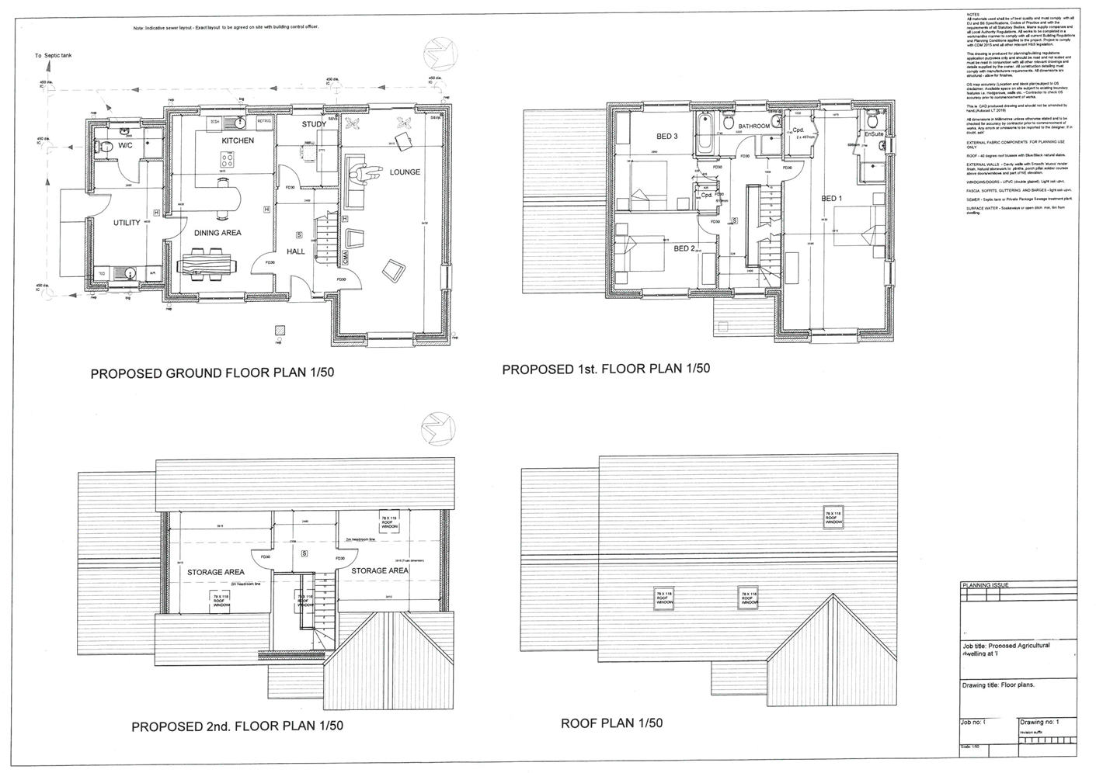

- Produce a detailed Construction Phase Plan for all the major activities related to this project – from start until completion.

Your name Company | BD Construction
Name and address of client  Contact details of architect/principle designer | UWTSD, Kings Rd, Swansea SA1 8PH  Ben Davies 01792 123321 bendavies123@hotmail.co.uk
What is the job | Accommodation for Caretaker
Key dates | Start: MAY 2021 finish: NOV 2021
Where are your toilets, washing and rest facilities? | On Site
Who else is on site – and their contact details? | Architect, Builders, Bricklayers, QS’s, Engineers, foremen, contractors, supervisors, Local Authority officials
Who is the principle contractor | Jon Jones 01792 123456
How will you keep everyone on site updated during the job? | Constant Contact with site members through emails, phone, texts and notices

What are the main Dangers on site? E.g. | Hazard is present | What controls do you have?
Falls from height  Make sure ladders are in good condition, at the correct angle and secured  Prevent people and materials falling from roofs, gable ends, working platforms and other open edges using guardrails, mid rails and toe boards | Yes, as there will be scaffolding and high floors etc. | Make sure everything is secure and install railings to avoid falling
Collapse of excavations  Shore excavations; either cover or barrier excavations to stop people and plant falling in | Yes, as when foundations are built, we will need to excavate | Make sure netting and so on are attached to the walls to avoid any collapse or rockfall
Collapse of structures  Support structures (such as walls, beams, chimney breasts and roofs) with props; ensure props are installed by a competent person | Yes, as roofs and beams will be present | Make sure everything is steady and secure
Exposure to building dusts  Prevent dust by using wet cutting and vacuum extraction on tools; use a vacuum cleaner rather than sweeping; use a suitable, well-fitting mask | Yes, as dust and particles will be there while building | Wear suitable ppe
Exposure to asbestos  If you suspect that asbestos might be present, don’t start work until a demolition/refurbishment survey has been carried out  Make sure everyone on the site is aware of the results | Yes, as asbestos is very dangerous | All workers must go on courses so they can identify asbestos and know what procedures are when they are found
Activities or workers requiring supervision  Who will be supervising | Supervisors are vital as safety is priority | During activities we will be having site supervisors consistently
Electricity  Turn electricity supply and other services off before drilling into walls  Do not use excavators or power tools near suspected buried services | Yes, as electricity might already be present | Turn electricity supply and other services off before drilling into walls
Risks to members of the public, the client and others  Keep the site secure to prevent unauthorised access; net scaffolds, use rubbish chutes | Yes, as there are many hazards to the public on a building site. | Keep the site secure to prevent unauthorised access; net scaffolds, use rubbish chutes

2.Produce specific Method Statement for the three major work activities identified. (25%)

Method Statement 1

Project: | Installing New Foundations
Site address: | UWTSD, Kings Rd, Swansea SA1 8PH
Date of work: | May 2021
Description of activity: | Installing new foundations at the sa1 caretaker’s accommodation site.  Involves:  - Installation of new concrete strip foundation to a depth of 1m.  Access on-site to be after hours between 11pm-4am
Supervision and personal: | Ben Davies 01792 123321  Ben Jones 02912 656786
Training: | All operatives are adequately trained to carry out required tasks.  All site operatives hold current certification and have the following training:  - CSCS certification  - ECS certification  - JIB trade cards
Legislation: | - Health and Safety Work Act 1974  - The Management of Health and Safety at Work Regulations 2006  - Workplace Regulations 1992  - The Control of Asbestos Regulations 2012  - Provision and Use of Work Equipment Regulations 1998  - Control of Substances Hazardous to Health Regulations 2002  - The Work at Height Regulations 2005  - The Personal Protective Equipment at Work Regulations 2002  - The Manual Handling Operations Regulations 1992  - The Construction (Design and Management) Regulations 2015  - Electricity at Work Regulations 1989  - The Pressure Systems Safety Regulations 2000  - Pressure Equipment Regulations 1999 (SI 1999/2001
PPE: | - Hard hats  - Safety boots  - Hi-vis vest  - Safety gloves  - Safety glasses
Welfare: | All sites have welfare facilities which comply with schedule 2 of the construction Design & Management Regulations 2015, these include  - Washing facilities  - Toilets  - Rest facilities  - Drinking water  - Changing Rooms
First aid: | A first aid box with enough equipment to cope with the number of workers on site should be provided for by the client or contractors  We will appoint first aiders based on the number of employees
Emergency procedures: | Closest hospital is Singleton Hospital, Sketty Ln, Sketty, Swansea SA2 8QA

Method Statement 2

Project: | Installing Roofing
Site address: | UWTSD, Kings Rd, Swansea SA1 8PH
Date of work: | SEPT 2021
Description of activity: | Installing roofing at the caretaker accommodation site  Involves  - Installing Roof structure with rafters at a 40⁰ pitch with a natural slate covering and closed eaves.  Access on-site to be after hours between 11pm-4am.
Supervision and personal: | Ben Davies 01792 123321  Ben Jones 02912 656786
Training: | All operatives are adequately trained to carry out required tasks.  All site operatives hold current certification and have the following training:  - CSCS certification  - ECS certification  - JIB trade cards  - Working at heights training
Legislation: | - Health and Safety Work Act 1974  - The Management of Health and Safety at Work Regulations 2006  - Workplace (Health, Safety and Welfare) Regulations 1992  - The Control of Asbestos Regulations 2012  - Provision and Use of Work Equipment Regulations (PUWER) 1998  - Control of Substances Hazardous to Health Regulations 2002  - The Work at Height Regulations 2005  - The Personal Protective Equipment at Work Regulations 2002  - The Manual Handling Operations Regulations 1992  - The Construction (Design and Management) Regulations 2015  - Electricity at Work Regulations 1989  - The Pressure Systems Safety Regulations 2000  - Pressure Equipment Regulations 1999 (SI 1999/2001
PPE: | - Hard hats  - Safety boots  - Hi-vis vest  - Safety gloves  - Safety glasses
Welfare: | These should be in line with Schedule 2 of the Construction Design & Management Regulations 2015 Which include:  - Toilets  - Washing facilities  - Drinking water  - Changing rooms and lockers  - Rest facilities
First aid: | A first aid box with enough equipment to cope with the number of workers on site should be provided for by the client or contractors  We will appoint first aiders based on the number of employees
Emergency procedures: | Closest hospital is Singleton Hospital, Sketty Ln, Sketty, Swansea SA2 8QA

Method Statement 3
Project: | Installing Doors and Windows
Site address: | UWTSD, Kings Rd, Swansea SA1 8PH
Date of work: | AUG 2021
Description of activity: | Installing Doors and Windows at our constructed caretaker accommodation  Involves  - Installing doors and windows that have a light oak wood effect uPVC with sealed Double-glazed window units.  Access on-site to be after hours between 11pm-4am.
Supervision and personal: | Ben Davies 01792 123321  Ben Jones 02912 656786
Training: | All operatives are adequately trained to carry out required tasks.  All site operatives hold current certification and have the following training:  - CSCS certification  - ECS certification  - JIB trade cards  - Working at heights training
Legislation: | - Health and Safety Work Act 1974  - The Management of Health and Safety at Work Regulations 2006  - Workplace (Health, Safety and Welfare) Regulations 1992  - The Control of Asbestos Regulations 2012  - Provision and Use of Work Equipment Regulations (PUWER) 1998  - Control of Substances Hazardous to Health Regulations 2002  - The Work at Height Regulations 2005  - The Personal Protective Equipment at Work Regulations 2002  - The Manual Handling Operations Regulations 1992  - The Construction (Design and Management) Regulations 2015  - Electricity at Work Regulations 1989  - The Pressure Systems Safety Regulations 2000  - Pressure Equipment Regulations 1999 (SI 1999/2001)
PPE: | - Hard hats  - Safety boots  - Hi-vis vest  - Safety gloves  - Safety glasses
Welfare: | These should be in line with Schedule 2 of the Construction Design & Management Regulations 2015 Which include:  - Toilets  - Washing facilities  - Drinking water  - Changing rooms and lockers  - Rest facilities
First aid: | A first aid box with enough equipment to cope with the number of workers on site should be provided for by the client or contractors  We will appoint first aiders based on the number of employees
Emergency procedures: | Closest hospital is Singleton Hospital, Sketty Ln, Sketty, Swansea SA2 8QA

3.Develop, evaluate and produce site specific Risk Assessments for three of the work activities. Highlighting significant hazards, control measures and mitigation. (25%)

To be assessed |  |  |  |  |  |  |  |  |  |  |  | Assessment Number
Installing Foundations |  |  |  |  |  |  |  |  |  |  |  | 1
Persons undertaking or affected by the activity
 |  |  | Workers |  | Contractor |  |  | Public |  |  | Service User
Identified Hazards and Associated Risks |  |  |  |  |  |  |  |  | Likelihood |  |  | Severity |  | Risk Level
1 | Falling Rocks in excavations |  |  |  |  |  |  |  | 4 |  |  | 4/5 |  | 5
2 | Excavation Collapse |  |  |  |  |  |  |  | 3 |  |  | 5 |  | 5
3 | Heavy loads could fall |  |  |  |  |  |  |  | 3 |  |  | 3 |  | 3
4 | Dangerous equipment |  |  |  |  |  |  |  | 2 |  |  | 3 |  | 2
Existing Control Measures / Additional Control Measures Required
1 | Secure support for excavation sides like netting etc to avoid rockfall
2 | Fastened netting on excavation sides to avoid collapse
3 | Heavy loads must be carefully handled with more than 1 individual handling it at a time
4 | Only trained workers can use the dangerous digging equipment as its dangerous as drilling etc is involved
Reassessment of Activity Hazards |  |  |  |  |  |  |  |  | Likelihood |  |  | Severity |  | Risk Level
1 | Falling Rocks in excavations |  |  |  |  |  |  |  | 2 |  |  | 4/5 |  | 5
2 | Excavation Collapse |  |  |  |  |  |  |  | 1 |  |  | 5 |  | 5
3 | Heavy loads could fall |  |  |  |  |  |  |  | 2 |  |  | 2 |  | 2
4 | Dangerous equipment |  |  |  |  |  |  |  | 1 |  |  | 3 |  | 2
Ben Davies  Construction manager |  |  |  |  |  | Signed  B. Davies |  |  |  |  |  | Date of Completion:  16/11/2020

to be Assessed |  |  |  |  |  |  |  |  |  |  |  | Assessment Number
Installing Roofing |  |  |  |  |  |  |  |  |  |  |  | 2
Persons undertaking or affected by the activity
 |  |  | Workers |  | Contractor |  |  | Public |  |  | Service User
Identified Hazards and Associated Risks |  |  |  |  |  |  |  |  | Likelihood |  |  | Severity |  | Risk Level
1 | Falling of Scaffolding |  |  |  |  |  |  |  | 3 |  |  | 4/5 |  | 4/5
2 | Slabs falling on workers |  |  |  |  |  |  |  | 3 |  |  | 3 |  | 3
3 | Roof being unstable |  |  |  |  |  |  |  | 2 |  |  | 4 |  | 4
4 | Fragile Surfaces |  |  |  |  |  |  |  | 2 |  |  | 4/5 |  | 4
5 | Steep Slopes |  |  |  |  |  |  |  | 3 |  |  | 3 |  | 3
Existing Control Measures / Additional Control Measures Required
1 | Harnesses can be required for workers and also railings and a lot of secure stability will be installed on the scaffolding to be safe on the roof level
2 | Roof slabs will be securely built with safe and strong adhesives so there will be no risks of slabs coming lose during bad weather or force.
3 | The roof will be built with safe and secure materials that will not make it unstable for workers to stand on
4 | The surfaces will also be built with safe and secure materials to make sure it doesn’t have any risk of falling through it etc.
5 | Workers will not be allowed to stand on steep slopes and will require safety harnesses to avoid slipping or falling.
Reassessment of Activity Hazards |  |  |  |  |  |  |  |  | Likelihood |  |  | Severity |  | Risk Level
1 | Falling of Scaffolding |  |  |  |  |  |  |  | 2 |  |  | 4 |  | 3
2 | Slabs falling on workers |  |  |  |  |  |  |  | 2 |  |  | 3 |  | 2
3 | Roof being unstable |  |  |  |  |  |  |  | 1 |  |  | 2 |  | 1
4 | Fragile Surfaces |  |  |  |  |  |  |  | 1 |  |  | 4 |  | 1
5 | Steep Slopes |  |  |  |  |  |  |  | 2 |  |  | 3 |  | 2
Ben Davies  Construction manager |  |  |  |  |  | Signed  B. Davies |  |  |  |  |  | Date of Completion:  16/11/2020

to be Assessed |  |  |  |  |  |  |  |  |  |  |  | Assessment Number
Installing Doors and Windows |  |  |  |  |  |  |  |  |  |  |  | 3
Persons undertaking or affected by the activity
 |  |  | Workers |  | Contractor |  |  | Public |  |  | Service User
Identified Hazards and Associated Risks |  |  |  |  |  |  |  |  | Likelihood |  |  | Severity |  | Risk Level
1 | Windows could smash |  |  |  |  |  |  |  | 2 |  |  | 3 |  | 3
2 | Overhead structures could collapse |  |  |  |  |  |  |  | 1 |  |  | 4 |  | 3
3 | Dangerous equipment |  |  |  |  |  |  |  | 2 |  |  | 3 |  | 3
4 | Strong adhesives and seals |  |  |  |  |  |  |  | 3 |  |  | 2 |  | 3
Existing Control Measures / Additional Control Measures Required
1 | No sharp objects near glass windows or anything that could damage it or smash it as it can cause injury
2 | Make sure structures are secure before installing the doors and windows to them
3 | Make sure only trained workers operate any equipment
4 | Wear a mask while installing the windows as strong adhesives and seals could have bad fumes
Reassessment of Activity Hazards |  |  |  |  |  |  |  |  | Likelihood |  |  | Severity |  | Risk Level
1 | Windows could smash |  |  |  |  |  |  |  | 2 |  |  | 3 |  | 3
2 | Overhead structures could collapse |  |  |  |  |  |  |  | 1 |  |  | 3 |  | 3
3 | Dangerous equipment |  |  |  |  |  |  |  | 1 |  |  | 2 |  | 2
4 | Strong adhesives and seals |  |  |  |  |  |  |  | 1 |  |  | 1 |  | 2
Ben Davies  Construction manager |  |  |  |  |  | Signed  B. Davies |  |  |  |  |  | Date of Completion:  16/11/2020

KEY
Likelihood | 1 Very Unlikely 2 Unlikely | 3 Likely | 4 Very Likely 5 Certainly
Severity | 1 Nuisance 2 Minors | 3 Medical treatment | 4 Majors 5 Fatal

4. Identify which Health & Safety legislation, based upon this construction project, is relevant and identify who is the responsible person/duty holder under those separate regulations. (25%)

The Health and Safety Work Act 1974 at work act is the most important legislation in any field of work of the construction industry. The Health and safety at work 1974 act ensures the safety of nearly all aspects of construction work and pretty much all manual labour, but it specifically states that it applies to all workers including employees, employers, and suppliers, it states employers must ensure the safety of staff, maintain and provide personal protective equipment, maintain all workers correctly do handling, provide complete adequate training, information, instruction and maintain government policy, they must carry out risk assessments and provide H&S law, this is important to our site because we need to adhere to all these rules as it’s the most important legislation. The employer is the duty holder in this legislation and will make sure every worker adheres to this.

The building regulations 2010 require that building work shall be carried out with adequate and proper materials which are appropriate for the circumstances in which they are used, are mixed and prepared properly, and are applied and fixed to perform the functions they were designed for in a workmanlike manner, we need to do this on site because we will need to use the complete correct materials for our building and we will need to make sure our workers know what they are doing. The construction manager will be responsible that this legislation is followed

The construction regulations act 2015 states that excavations need to be thoroughly inspected and must provide reports to ensure complete safety of workers in the excavations to avoid collapse or burial of workers. No loose material can be in the roof on any of the excavations as it can be dislodged and cause collapse or and fall and bury a worker. Excavations need adequate support to support the deeper walls down the excavation to keep it safe It also states that all structures need to be checked to ensure complete structure stability like foundations, scaffolding etc as that can be a falling from height hazard to any worker, and the construction manager will also be responsible for this legislation.

The working at height regulations 2005 tries to prevent death and injury caused by a fall from height. If you’re an employer or you control work at height the regulations apply to you. Employers and those in control of any work at height activity must make sure work is properly planned, supervised and carried out by competent people. This includes using the right equipment for working at height. It should be low-risk, and a relatively straightforward task that should require less effort when it comes to planning.

The Provision and Use of Work Equipment Regulations 1998 require that equipment is completely suitable for its intended use and is also safe for usage, that it is maintained in a very safe condition and inspected constantly to ensure it is correctly installed, That it is used only by people who have received adequate instruction and training. Also, that it is accompanied by correct health and safety measures, such as protective PPE and devices. These will include emergency stop buttons, kill switches, visible markings and warning components, and finally that it is used in accordance with H&S requirements.

The Personal Protective Equipment at Work Regulations 2002 are regulations created under the Health and Safety Work Act 1974. These regulations place the duty on every employer to ensure that suitable personal protective equipment is provided to employees who may be exposed to risks of their health or safety while at work.
The manual handling operation regulations 1992 states that employers have a legal requirement to make sufficient and suitable assessments of risks to employees from handling of loads. The Manual Handling Operations Regulations require employers to carry out risk assessments on every single manual handling task that poses an injury. Employees also have a duty to take care of their own and others safety.
The Pressure Systems Safety Regulations 2000 is legislation that covers the design and use of pressure systems. The aim of the legislation is to prevent and avoid serious injury from hazards of stored energy (pressure) as a result of the failure of a pressure system or one of its component parts in equipment

The ​Electricity at Work Regulations 1989 apply to every aspect of the use of electricity within a workplace. These place duties on employers and employees to prevent danger and to carry out work on all electrical systems in a way that eliminates danger and risks to health and safety.

The Control of Substances Hazardous to Health Regulations 2002 require that all materials are regulated under law, and all employers must control the substances that are hazardous to health and prevent workers exposure to hazardous materials

https://www.legislation.gov.uk/uksi/2015/51/regulation/22/made
https://www.hse.gov.uk/work-at-height/the-law.htm

