Integrating Project Technical Report



By Edward Walden, Alex White, Megan Gwilym and Louis Jongejan
Contents
Introduction 3
Chassis and Shell Design 3
Analysis and Calculations 5
Conclusion 6

Introduction
For this project, the group decided to design the soapbox based on the Mystery Machine from the popular television show Scooby Doo, and this can be seen from the designs the group made using CAD. It was decided that using the Mystery Design was beneficial, not only from an appearance aspect, but also when looking at the requirements the soapbox had to fit in order to successfully compete in a soapbox race.

Chassis and Shell Design
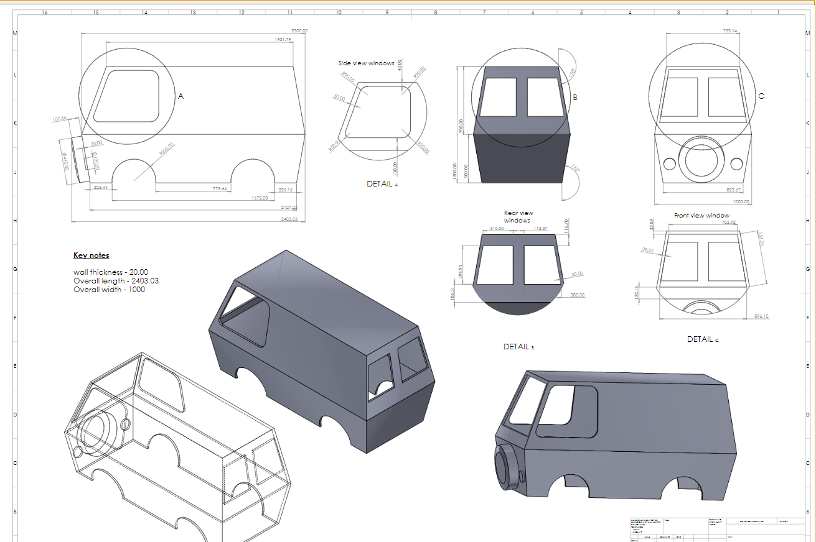

As is clearly visible on the CAD drawings produced, the soapbox consists of a very box like shape. With sharp angles and flat edges. We decided this would be best as it would make the soapbox easier to construct out of materials such as sheets of wood or sheets of metal, this is because all that would have to be done to the materials is cutting them to the right size and attaching them together.
Additionally, part of the soapbox races is having interesting designs that people will find entertaining or recognisable. The Mystery Machine, being from the popular TV show Scooby Doo, is very recognisable due to its shape and bold colour scheme, meaning it will be easily noticed and enjoyed by any spectators.
The design process started out with wanting something fun and recognisable, and base the soapbox off that, recreating it with cheap materials and parts, but also constructing a physically sound soapbox which could handle going down a track, using nothing but gravity as propulsion, as per the soapbox rules and regulations. The reason the Mystery Machine was chosen is because the group decided it was not only entertaining, but the general shape, size and weight of it would be beneficial, as the weight would grant extra speed downhill but also, ideally, improving steering quality, meaning the soapbox wouldn’t tip over when going round any corners.
As for materials, the main body of the soapbox is made from steel tubes. This not only adds a comfortable amount of weight to the soapbox, but also will prevent the soapbox from sustaining any serious damage during the run, and additionally, protect the drivers in the event of a crash or a roll by mean of a roll hoop, which is required in Section 2.14 of the Soapbox rules and regulations.
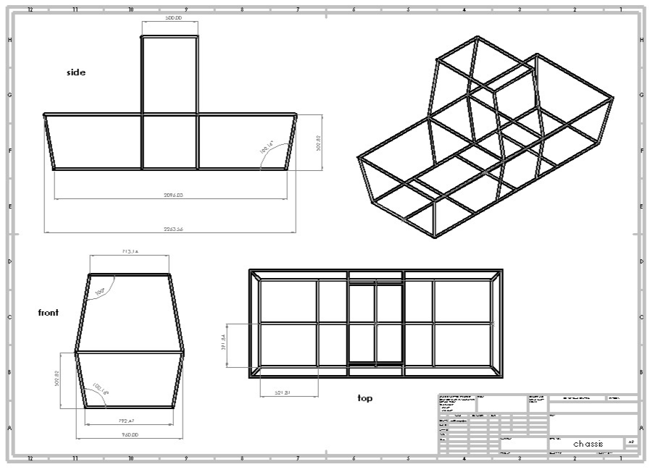
The body shape is clearly seen to match the shape of the shell, meaning both parts will fit together nicely, and won’t be sticking out or misshapen, therefore improving the quality of the run, and the quality of the soapbox overall.

Analysis and Calculations
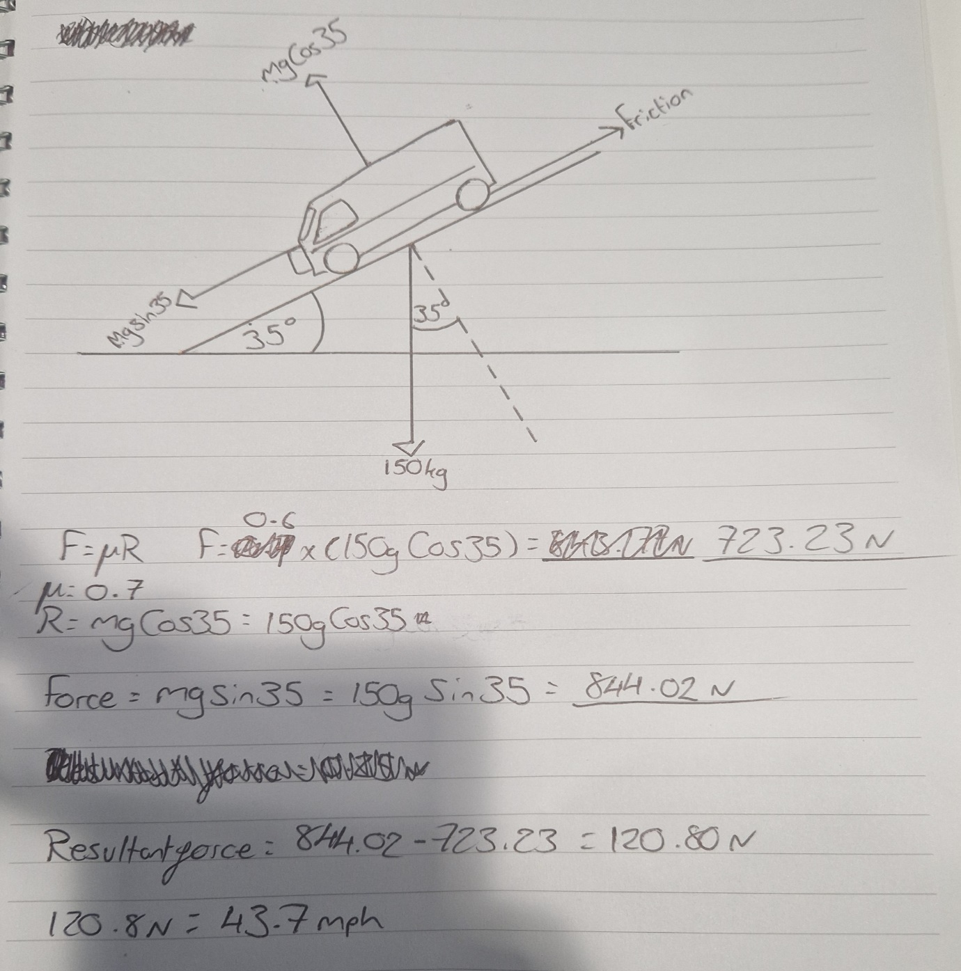
When analysing the soapbox, research showed that the average weight for a soapbox car is roughly 68kg. Taking into account the fact that this soapbox is bigger and using materials like steel and 6mm thick wood sheets, we estimate the Mystery Machine soapbox to weigh roughly 75kg. The weight of the lightest member of the group was used, as that is who ideally would be driving the soapbox on its runs, and that was an additional estimated 75kg, making the total weight of the soapbox approximately 150kg. This is the weight used in calculations.
The above calculation is a hypothetical situation on an estimated top speed for the Mystery Machine. A researched average for the coefficient of friction, at a value of 0.6 was used in this calculation to gain a rough estimate of the Frictional force that would oppose the forward acting force. Once an estimated value had been calculated for the force acting down the slope, which an angle of 35 degrees was used, the resultant force was calculated by subtracting the opposing forces from each other. This gave a resultant force of approximately 120.8 Newtons. Which converts to a top speed of roughly 43.7 Miles per hour, which is believed to be a very competitive speed, which would dominate on the soapbox track.
As for how the Mystery Machine would handle in the corners, the weight of the vehicle would greatly assist in maintaining speed through the corners as the 150kg weight would keep the soapbox car firmly planted through the corners.
If the track had any jumps, the likes of which on the runs used for Red Bull Soapbox Racing, the groups soapbox would be able to handle it, even with a lack of suspension, the frame and chassis ideally would hold and keep the soapbox on a straight course throughout and after the jump.

Conclusion
In conclusion we believe although our soapbox won’t be the fastest due to is lack of aerodynamics it will still be fun to watch and very safe for the driver. However, saying this due to its rather bulky, heavy design it will be able to pick up momentum quickly downhill reaching terminal velocity faster giving it a slight edge of the competitors. If we were to redo this project in the future some things, we would do differently include completing a CAD design of the frame assembled to the shell and to also have a mystery machine livery that we can add to the shell. Something else we would have liked to investigate is instead of buying all the steering and brake parts new online, making our own components out of old bicycles and scrap parts to bring the overall cost down. On top of this it would have been beneficial to add some kind of simple suspension to the soapbox which would make it more comfortable and handle better in the corners.

