Developing Professional Practice

Name: Julia Thompson

CIPD Membership Number: 48697920

Date: 16/11/17

Word Count: (Max 2600 words)

I declare that this assignment is my own work and that any information obtained from books and other sources have been appropriately referenced.

Signed: Julia Thompson Date: 16/11/17

Contents

Activity 1 – What is a HR Professional? 3
1.1 – Personal Experience 3
1.2 – HR Profession Map 4
Activity 2 5
2.1 – Area of Conflict 6
2.2 – Listening 6
2.3 – Mediation 7
Activity 3 7
3.1 – Project Management Techniques 8
3.2 – Problem Solving 8
3.3 – Successful Influencing, Persuasion and Negotiation 10
Activity 4

References

Activity 1
What is a HR professional?
A professional can be defined in many ways. Johns & Perkins (2016) say that in order, to be a professional it is likely you will show the following skills:
Professional competence and behaviour: - Maintaining knowledge and skill, able to provide a current professional service and be responsible for own actions and decisions.
Ethical standards and Integrity: - Establishing relationships and maintaining them based on competence and trust, show personal honesty and integrity at all times, demonstrate empathy and understanding of other people’s beliefs and thoughts, promote equality, inclusion and diversity throughout employment and business practice, ensure data protection and safeguard sensitive material with confidentiality.
Representative of the profession: - Always act in ways that support the professions reputation and brand, comply with laws and code of conduct, role model own leadership to maintain high standards and conduct.
Stewardship: - Be fair and reasonable to people within their influence, challenge others if you suspect unlawful or unethical behaviour, promote development and people management practices to influence and enable the achievement of business objectives.
The need for professional code of conduct remains however, if people abide by these guidelines professionalism can be attained.
1.1 Personal Experience
My place of work Tesco, has a code of business conduct which helps employees ensure they are performing within the law and company values. (Tesco, 2015). It covers raising concerns, speaking up if something is wrong, Leadership skills, Legal aspects, equal opportunities, inclusion and diversity, unacceptable behaviour, data protection, conflicts of interest, social media guidelines and more.
Within my role it is important to be able to use a range of professional skills:
Active listening: For me to allow colleagues and managers to feel listened to and supported, I have to make appropriate time to ensure people are heard and action is taken when people approach me for assistance.
Empathy: It is important for me to be able to empathise with colleagues as an HR professional I am often seen as the ‘go to’ person when it comes to sensitive or personal matters that people need support with either directly or through coaching their manager.
Collaboration: I often work within teams to solve a problem or deliver a project, this is where I often share knowledge and skill with others and make use of different types of people.
Resilience: I am regularly faced with re-occurring operational issues which I am asked to assist with, this is where I will try to help individuals get to the ‘root cause’ of a problem so that we can work different solutions to fix the issue.
Responsiveness: I must be adaptable and react quickly to problems to keep up with the pace of business changes.
Self-Development: Keeping up to date is important to me personally and legally, with changes in law and less often policy its paramount to be ahead of the curve.
Integrity: I have had to use my personal integrity many times during my career, in some cases to deliver a message I do not necessarily agree with or to stand up for someone who has not been treated fairly – I always try to think ‘treat people how I want to be treated’.
(ibid)
At work I draw on my leadership skills in order to remain professional at all times – I have strong personal values that I have built upon throughout my career and personal life, like the importance of being listened to, confidentiality of even the smallest things, credibility and ensuring I deliver on something I have agreed or committed to, use my knowledge to help and develop others either through personal coaching or group training sessions.
1.2 HR Profession Map
Both sources spot the need for Continuous Professional Development (CPD) to allow a person to keep up to date with current and relevant aspects of their field.
“The HR profession map sets out in detail the competencies which HR professionals will need in the foreseeable future.” (Woodhams et al, 2016)
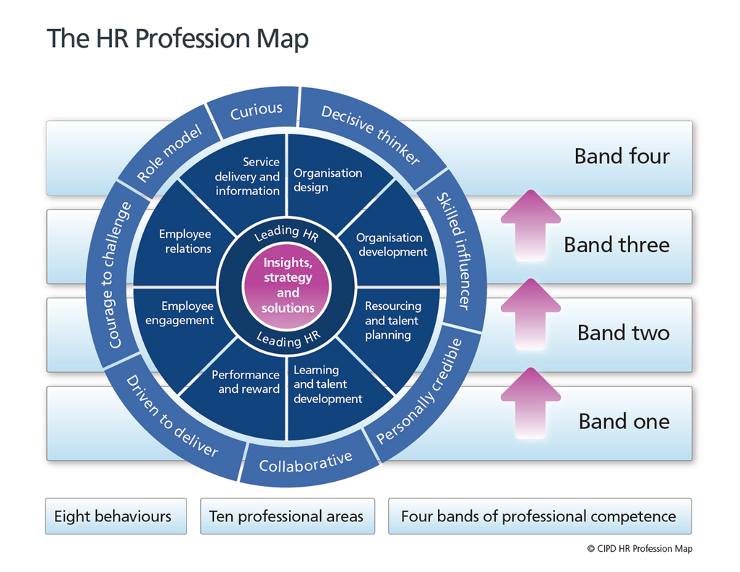
Figure 1
(ibid)

Core Professional Area | Simple Definition
Core: Insights, strategy and solutions | Understand the organisation to assist planning and problem solving.
Core: Leading HR | Role model excellent behaviour, coach and support others to develop.
Professional Area | Simple Definition
Organisation design | Ensure organisation can perform in short and long term.
Organisation development | Identify capability requirements and support a plan to achieve this.
Resourcing and talent planning | Ensuring correct resource for the present and talent/succession planning for the future.
Learning and development | Building knowledge to meet requirements and encouraging a life long learning approach.
Performance and reward | Creating and maintaining a high performing team culture, recognising key skills, behaviours and performance indicators.
Employee engagement | Build relationships across organisation to encourage more fulfilment and participation.
Employee relations | Clear guidelines for colleague relationships, manage poor behaviour appropriately following good practice and the law.
Service delivery and information | Service focussed HR is delivered across the individuals employment history, process, project management and effectiveness will help to deliver improvement.

Brief own description of the profession map?

Activity 2
Group Dynamics
The dictionary term for group dynamics:
“The interactions that influence the attitudes and behaviour of people when they are grouped with others through either choice or accidental circumstances”. (Dictionary, 2017)
Belbin (2017) has described nine team roles that can be found in the workplace and has defined them as follows:
Plants: Creative and innovative – introverted and sometime radical. Will challenge convention, provide solutions and is a problem solver.
Resource Investigators: Extroverts, natural communicators and social. Able to negotiate and explore opportunities. Not particularly original but will champion and promote others. Warm natured, likeable, relaxed and inquisitive – needs to remain stimulated to be productive. Good at developing resources within and outside of the team. Will set up contacts and network.
Co-ordinator: Helps others to achieve shared goals – capable and delegates confidently. Spots talent and helps develop qualities in others. Could be looked upon as manipulative. Able to take the lead and remains calm when problem solving.
Shaper: Highly driven, goal focussed and determined to challenge obstacles. Competitive and develops quickly due to high drive and results delivered. Likely to be insensitive or argumentative. Ideal managers and work well under pressure.
Monitor Evaluator: Serious and calm, likely to be a slow decision maker as tends to overthink situations. Able to think critically and takes all factors into account when making decisions. Decision making is a key skill as weighs up all options.
Implementer: Practical, highly disciplined and self-aware. Hardworking and sticks to the process. Loyal and unlikely to not seek a personal agenda. Reliable, efficient and has a good sense of relevance to current situations. Hardworking and does what is needed even if the task is difficult.
Team Worker: Crowd pleaser, likes to be liked. Important role and often goes unrecognised or noticed. Able to solve issues within the team (interpersonal). Rises to senior roles as well liked and listens to others.
Completer – Finisher: Pays attention to detail, likes perfection. Quiet and often introverted, hardworking and achieves deadlines. Can be anxious and struggles to trust and delegate to others. Useful when there is a need for accuracy as only accepts perfection.
Specialist: Multifunctional, technically proficient and other attributes within the team. Enjoys self- development and improving knowledge. Seen as an expert. Will avoid a lack of structure and does not react well to personal challenge. Has an in-depth knowledge and is a good coach or mentor to other members of the team.
2.1 Area of Conflict
It was brought to my attention by a team manager that two colleagues within his department were having conflict. Colleague 1 was working well for months and suddenly became, lazy, messy and stopped completing tasks as they used to. They were incorrectly filling in the legal documentation required by the department to show due diligence and were rude and unresponsive to Colleague 2 when this was brought up. The manager also described they had received several complaints from customers about the poor service they had received from colleague 1 and that this was out of character. Colleague 2 always starts their shift directly after colleague 1 and is fed up of coming in to an untidy department where they have to clean and tidy before they can continue working – also colleague 2 feels obliged to complete the legal documentation which is a breach of policy as they were not actually witness to the checks at the time. The manager found the two colleagues shouting at each other on the department and came directly to me for advice.
2.2 Listening
Initially I had to actively listen to the manager to understand the facts of what had happened. I then considered what needed to happen following the incident and supported/coached the manager to come up with the actions that he would need to take. I had to coach the manager on active listening skills to allow them to confidently approach the task.
Investigate the accuser first, to understand why they had initiated the conflict, what had started it.
Encouraged the 5 W’s technique (Wikipedia, 2017) to assist in the problem solving asking open questions – Who, what, where, when and why to understand the full story and if there were any external factors.
Investigate the accused to understand what had happened from their point of view and ask specifically about the feedback received from colleague 2 and customers and explore the legal implication.
The manager would need to paraphrase and summarise to ensure they fully understand the responses given.
Listen to witness statements or customer feedback to help build the case.
2.3 Mediation
I then needed to understand the findings from the investigations and allowed the manager to feed this back to me. I was then happy to facilitate a mediation session with both colleagues in order to resolve the issues between them – the manager was also present as a witness and so I could coach them through mediation so they were more confident in the future.
Colleague 1 had recently been through a break up which they had kept to themselves.
Colleague 1 did not realise that their work was being impacted and was surprised and upset to think they had impacted another colleague so much.
Colleague 1 was aware of the legal implications and describes they had simply forgot due to what was on their mind.
Colleague 1 was apologetic and was visibly upset to know that they were so distracted that they had upset customers.
Colleague 1 was happy to take part in a facilitated mediation session to resolve the matter with colleague 2.
Colleague 2 realises that something should have been said sooner either directly to colleague 1 or to the manager.
Colleague 2 was happy to attend the mediation session to allow colleague 1 to explain in a controlled environment.
A mediation session took place and a ‘Let’s Talk’ (appendix 1) was issued to both parties outlining the next steps that needed to follow the meeting. The outcomes were successfully reviewed four weeks later and mediation process was found to have resolved the issue.

Activity 3
Project Management
I recently led a team of people managers in a project in a local Tesco (Llansamlet). The objective of the change was to successfully consult with 300 plus colleagues informally, 100 plus colleagues formally and deliver a re-structuring change within the store and recruit approximately 150 new colleagues in a short space of time. This project ran alongside a re-purpose of the store structure and operational changes which were run by a separate team.
The team consisted of myself leading 6 people managers, 6 team managers and 2 admin support roles. We began by understanding what changes were due to be made and identified which store colleagues would be affected by either removal of roles (removal of the night crew) and or significant change to departments, this helped us know who would be ‘at risk of redundancy’ (formal) and who was not and therefore dealt with informally. In the early stages the main objective aimed to find suitable roles for those who wanted them.
I allocated roles to each team member which changed throughout the course of the project. I quickly identified abilities within the team utilise these to best advantage.
The project was successful with appropriate roles being found for those that wanted them and a smooth transition for those opting for redundancy. Alongside this I managed and completed a large recruitment campaign to complement the changes.
3.1 Project Management Techniques
Using a project management tool to help identify the elements of project management will help keep on track and cover all aspects (Maylor, 2005). Adapted to suit my project.
Element | Description
Strategy  Structure  Systems  Staff  Skills  Style/Culture  Stakeholders | To communicate to all colleagues, identify affected and unaffected and follow the correct process with each group.  Project group to be skilled to carry out formal consultation process, action redundancies and follow recruitment campaign.  Ensure use of checklists so all colleagues are treated equally and fairly – check work for consistency.  The team were recruited for the project with the behavioural needs in mind: Flexibility, empathy, knowledge and experience.  The suite of Tesco leadership tools were available to use – team members were chosen due to their range of skills, all letters, checklists and equipment were available prior to the start of the project, in the planning stage.  Discussion and agreement at the planning stage of the project to agree ways of working/ground rules: Professional, Integrity, empathy, Communication with the person affected, fair, honest, sense check for consistency.  CEO and Directors – High profile project due to new concepts being trialled at store with new roles, equipment and processes  Regional/Senior Managers – want to choose the right people to ensure the project runs smoothly and is successful  Store – vested interest in recruitment and calibre of colleagues who remain due to having to run store once project is complete  Colleagues – keen to receive clear communication and timescales.

It was important to communicate regularly and review progress to ensure we were sticking to timescales and milestones as a team. Due to the range of varying shifts that we did, we would endeavour to meet weekly (all) and each member would have a daily catch up with me so I was able to ensure a consistent approach to each meeting and outcome. I also centrally tracked progress of each individual which was fed in by the team.
3.2 Problem-solving
I was able to identify a couple of problem-solving tools to help cover all aspects firstly a five-step process used in education, simple yet effective (Meintjes, et al 2015)

1 | Recognise and identify the problem
2 | Define the problem that was identified
3 | Generate various solutions to the problem
4 | Choose the best option from the various alternatives
5 | Identify how to implement the solution

Another model, I found more applicable to the problem I faced:
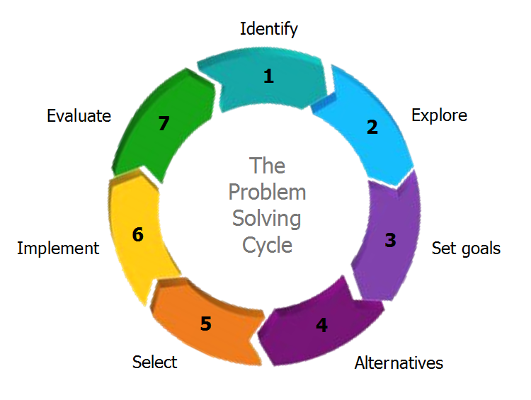
Figure 2
(Kovac, 2017)
1 – Identifying the Problem – During the project we identified that the vacancies that we had advertised externally were not being filled fast enough and we were fast approaching the deadline.
2 – Defining Goals – We had a goal of employing 100 colleagues by a certain date as this was not currently being achieved I had to break the goals down into smaller pieces.
3 – Brainstorming – Together we identified that we would have to draft in some extra support for interviewing, had to advertise a bit further afield E.g. in other local stores and on different career websites, we thought about increasing the numbers that we could interview by holding group interviews, lowering the pass mark from 90 to 85 per cent to allow more applicants through the initial screening, review of existing workforce to see if an increase of hours would be applicable/beneficial.
4 – Assessing Alternatives – Potential cost implications to more team members and additional advertising, Potential to have a lower calibre employee with changing the initial screening score, increasing hours of existing workforce could lower flexibility within departments.
5 – Choosing the solution – I decided that a selection of solutions could be used as each idea brought benefits to the problem.
6 – Active Execution of the Chosen Solution – Once we had increased the advertising, decreased the initial screening score and employed additional support for group interviews we were quickly back on track and achieved the goal within the timescale.
7 – Evaluation – The outcome was a great success and using a process to help solve the problem ensured that all aspects were considered and no negative impact occurred.
3.3 Successful Influence, Persuasion and Negotiation.
During the project and when solving the problem, I had to Influence my Lead People Partner who was a key liaison and sounding board. When considering the additional advertisement of vacancies there was an additional cost involved and I had to describe the benefits and show what the end goal looked like in order to have the additional costs agreed.
I had to Persuade the store team to release an additional manager to join my recruitment team, the Store Manager understood the benefits of doing this once I had explained that in doing so we would then meet the goal and therefore benefit us all, including them and the store.
I had to Negotiate with the central recruitment team to lower the initial screening score. Once I had described that we had not received enough applicants to fill all positions and if the score remained at 90% then there was potential for having to re-advertise at an additional cost and therefore our idea would be cost saving and also benefit us as it gave us more people to interview.

