Student Name：Yuqian Fu
P Number：2108598
Program Name：BA on Graphic Design
Module：Research in Context（ADAD5003）
Word Count：

Contextual Practices
“Why is Information Design important? Explore how Information Design helps to shape the world around us as well as our understanding of it.”

“Today we are witnessing an increased use of data visualization in a range of domains and genres”（Kennedy 2020）. More and more information charts appear in our daily life, such as speeches and reports at work, roadside signboards, and shop billboards. You must have seen a series of icons in the following figure somewhere in your life (see fig1).
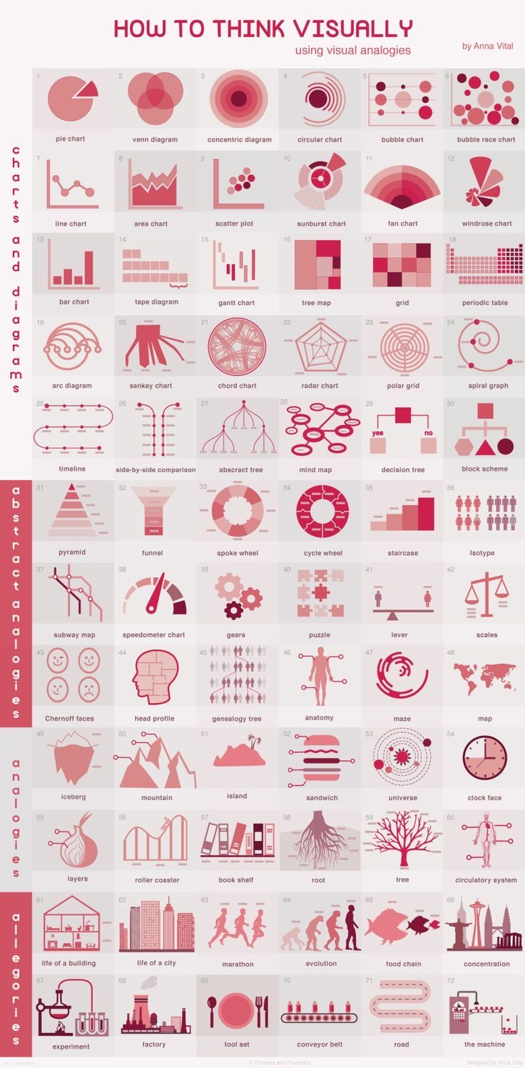"In fact, in all kinds of human development processes, these processes refer to the increase of material wealth, such as economic growth and the increase of human welfare, such as goods and services provided by welfare states. In these dimensions, information plays an important role" (Castells 2014). Historically, human development is inseparable from the use of information. In essence, human consciousness cannot be separated from the symbolic order. Here, the symbolic order refers to the abstract meaning system generated by symbolic information, such as language (Silverman 1983). Therefore, information is our tool to understand the world, and information design is to help us better shape our understanding of the world. Fig 1 Pinterest（2017）Information Design

"Since the rise of romanticism in the early 19th century, artists have been encouraged to express their feelings and worldviews through art. However, this is not the case for designers. The goal of the latter is to explain, not to be skilled" (Bergemann 2019). Designers do not want to impress people with complex visual effects, but use simple visual means to let readers discover these knowledge. Common visual design often uses simple patterns to depict complex information (see Figure 2).
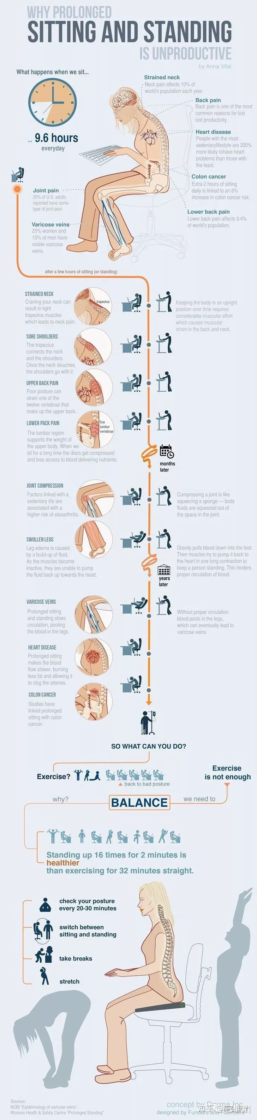
Fig 2 ZhiHu（2016）Information Cases Analysis
As a result, it seems that vision has been excluded from the digital humanities debate for a long time, although its potential as the common foundation of other disciplines is obvious. In fact, as early as the childhood of human beings, they began to cultivate the ability of basic information and figure recognition called literacy. At the same time, such capabilities are also accompanied by the development of our future capabilities. The research report says that in the group-controlled experiment on whether children in Hebrew speaking kindergartens intend to cultivate their map reading ability, the results show that in the group of cultivating map reading ability, literacy, narrative ability, listening comprehension and other aspects have improved to a certain extent. Children use tables, timelines and other charts to support their memory (Vaknin Nusbaum 2021). Obviously, Children gain advantages in the experiment through simple visual processing of information.
Similarly, in today's highly information intensive world, information visualization, as an act of gaining insight into data, almost everyone will do so, converting data into images to make understanding easier (Spence 2014). The visual work in the following figure examines the relationship between immigration and crime in American cities over the past 40 years (see fig 3).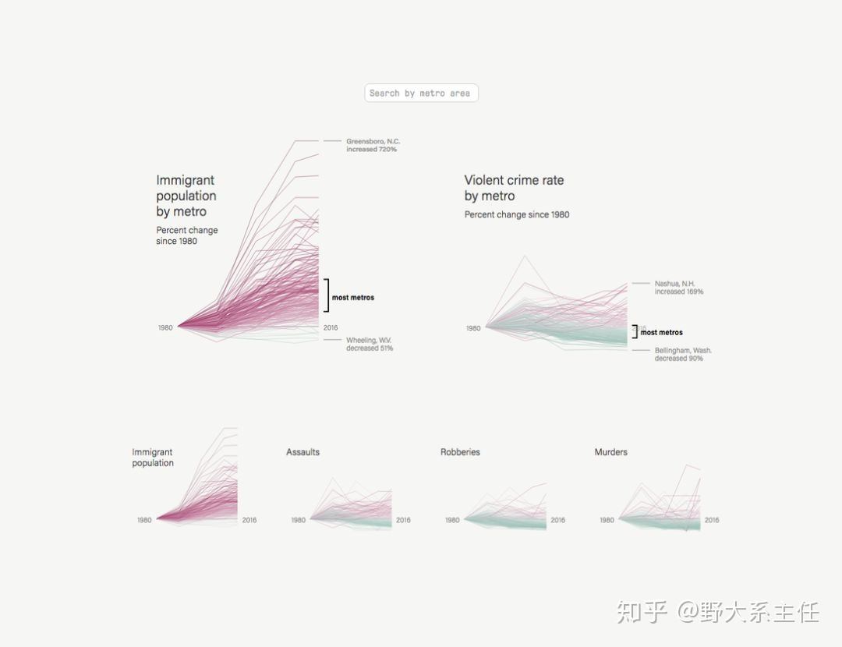
Before that, almost half of Americans believed that the increase in local crime rate was caused by immigration. It seems that with the
Fig 3 Zhi Hu （2016）Excellent information chart rapid development of information technology, crimes are constantly exposed in the public's view, giving people the feeling that the crime rate is gradually increasing. Compared with the newspaper headlines, boring text data is always passed by and cannot attract people's attention. Some people may have noticed that, but simple numbers are hard to associate with specific phenomena. Through this diagram, perhaps people can start to really think about the relationship between crime rate and immigration. Such information design for public relations is even more numerous. You may have seen similar posters on the corner of your way home. They are trying to imperceptibly affect your perception of society and change potential social conflicts.

Of course, the significance of information design is far beyond this, not only reflected in the social value level, but also to bring benefits to individuals. From very early on, designers have adhered to the design principle of people-oriented, and the same is true of information design. In a variety of social environments, as well as in the process of working, learning, and playing with tools as the intermediary, information design plays an important role in human activities (spinuzzi 2003). Sometimes good information is crucial for effective operation and decision-making at all levels of the enterprise. How can managers correctly use information and smoothly link the complex internal and external of the R&D department (kaye 1995)? Google is the best case in this regard. It maximizes the use of data through visual atlases. Google uses professional information design teams to graphically depict dense and complex information to help managers make decisions. In this way, the time cost generated by the original need for a large amount of data is greatly reduced. This is what we call visual management. It is a system composed of information data display, signs and color coding. Google relies on it to carry out abnormal conditions and strengthen standards and convey work instructions through the displayed capacity status. It can reduce the chance of error communication and highlight exceptions and deviations. When problems and deviations are obvious to everyone, corrective actions can be taken immediately to improve the efficiency of the process. It is easy to see that information design plays an important role in company decision-making and personal work.
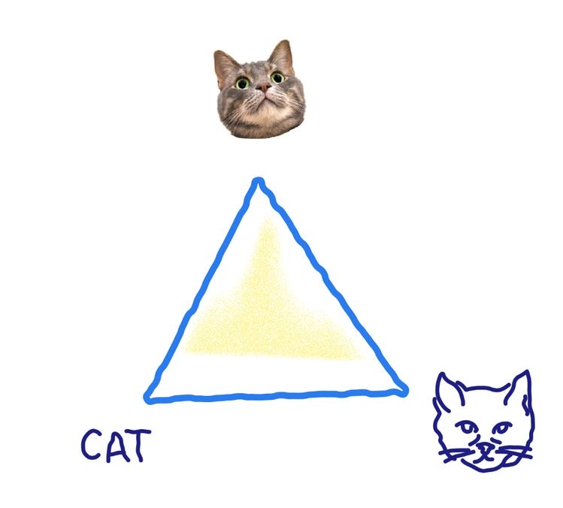As for how information design plays an important role in human development, I think a better perspective is from its evolution. Today, when graphic design has developed so significantly, in traditional cognition, the main function of graphic design is to promote commercial activities, but today it is far more than that. Effective design now turns to the mature principles of information design, social interaction and user experience to inform the audience how to interpret visual information (Marchese 2021). Its rich history can be traced back to the earliest map making, and later thematic mapping, statistical graphics, medicine, etc. Its evolving role has been influenced by information technology, our environment, and local culture in the past decade. What I want to mention here is the application of semiotics in information design and the impact of information design on people through its application. In the semiotics of the Paris School, it is believed that once two or more people master the same code, they can associate the same meaning with the same sound or figure, to understand each other, such as the highway code (). In fact, I am more inclined to think that semiotics is a post-modern philosophy, a way of understanding and observation. In anthropology, semiotics is unique research, which focuses on all scientific matrices and reveals the focus of history on the overall understanding of the cause, which is carried out through the cultural norms maintained separately. Beyond personal insight, common or shared mentality defines language (English), disciplines (literature, physics) and the ultimate civilization itself, providing the structure of human daily experience (Deely 2005). To take a simple example, in the following figure (see fig 4). The image of the cat on the top is widely recognized, which is the look of the cat in people's eyes. The portrait on the lower right is a slightly artificial artistic treatment, which retains certain characteristics of the cat itself and symbolizes the image of the cat. The artificial pattern can still see the characteristics of cats, so it is easy to associate with cats, which already belongs to the category of symbolization. The text on the lower
left corner is a completely symbolic language, which is extracted from
Fig 4 Yow，M（2017）The Loyalty of Images visual resources developed over the centuries, The product under the rule of forming a complete connection between symbols and meanings. It helps people get more efficient understanding and information transmission with less effort and time cost.

In fact, our life and the world around us are all surrounded by symbols. Until rationalism and the beginning of the Enlightenment era, people began to explore the essence of symbols. And the sign, as a product formed under the use of symbols, is a thing that does not belong to stimulus, but can change behavior. The stimulus here refers to the direct reaction in the sense of "muscle or gland action". For example, when a dog hears the sound of a meal bell, he subconsciously associates the bell with the original stimulus (food) to produce saliva. Sign is more like one kind of preparatory stimulus will affect the response of another stimulus (Noth 1990). It is a tool to help us better understand symbols and thus understand visual information. Among them, icon is a representative and widely used sign in visual information. It plays an important role in the interaction between human and digital interface. Because graphical symbols can represent objects in the real world, indicating some operations, such as copying, pasting, and even serving as error warnings. Compared with a single text, it can overcome language barriers, effectively reduce the cognitive burden of readers, and reduce the complexity of content. Compared with other semiotic languages, icons tend to more intuitively represent the object itself, and their internal characteristics are often directly related to the symbolized object (see Figure 5).
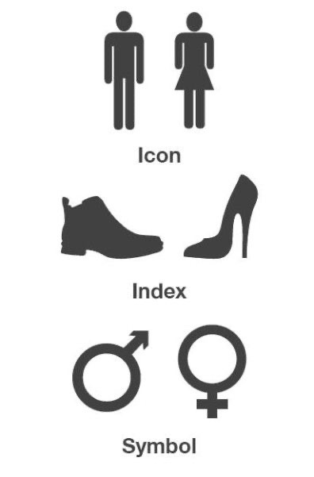The following figure is an example of symbol with different degrees of specificity. The icon at the top is easier to be recognized than the other two categories that require certain association. The following two are the products obtained from the extraction of male and female identity and the extraction of human culture. These icons can improve people's ability to understand information in different scenarios. As early as in research, it has been shown that users can identify specific icons more accurately and quickly. Simple icons can effectively improve users' visual retrieval ability (Shen 2020). Information design makes use of this advantage of icons to achieve the purpose of influencing user behavior. The process of information design can be simply understood as the process of persuading and being persuaded by the views of the sender and a single receiver. For example, the user interface of a game is a very common case of using icons as an aid for information design to help users take the next step. Make the symbols have the explanation of
Fig 5 Pinterest（2016）7 Arts action suggestions, which is universal in the case of single player games. Although most information designers cannot decide all the actions of users, they can influence and even predict the results to a certain extent (Bergemann 2019). Take the screenshot of the game as an example (see Figure 6).
By controlling the size, color, and even the position of the icons, the user can guide the click sequence. Obviously, the larger the icon is, the more obvious it is. And the implicit icon (the combination of red and exclamation point) with emphasis on prompting can increase the priority of the icon. Compared with the use guidance in a long speech, these implicit information plays a more guiding role in the actual user experience. This shows that the internal characteristics of icons have an important impact on human complex cognition. At the same time, when people gather generous similar implicit hints around them, they will make subconscious behaviors on such icons. Designers make use of this to help people make reasonable order choices among plenty tasks, thus improving task efficiency. Although the general characteristics of each person's information processing behavior are different, that is, there are differences in cognitive styles, research shows that this is not an appropriate determinant to predict the individual's decision-making process. Cognitive style does not affect the user's behavior in a specific environment, so from here we see that icon and
Fig 6 Pinterest（2021）Animal Restaurant other information environment factors have an important impact on decision-making behavior is general (Spence 1997).
"The ability of people to extract shapes from shadows is well known" (pentland 1988). Therefore, since a very early time, people will extract information from images, such as judging the shape of objects and the direction of light sources through the shape of shadows (see Figure 7).

This is the result of the experience precipitated by the continuous recognition of the surrounding environment graphics. Therefore, although the use of information seems to be a subjective process, it is still affected by the surrounding environmental factors (Dermer 1973). Among them, the influence of graphic information is naturally included. The expression "I see" in English means
Fig 7 Pinterest （2014）The Light I understand. This way of expression also shows the deep-rooted intuition of human beings, that is, vision and clever images seem to be a shortcut to understanding. In the process of human development, information abstraction has been used as a tool to assist thinking, and thus information design is to enhance our cognition by using the interactive vision of abstract data (Ware 2004). In children's experiments on cognitive development, the results show that people's learning in childhood is cross modal, and information is not only displayed in plain text, but also transmitted through images, audio, etc. Therefore, people spontaneously learned to receive information with multiple senses and combine it to form cognition in their childhood (Esposito 2021). Just like this, visual display is also ubiquitous in human communication, especially with the development of computer graphics, this phenomenon has become commonplace. At the same time, many different subjects pay attention to the display and effect of information design, maps, statistics, and so on. Visual display stores information from the outside through its own external representation and releases working memory resources for other aspects of thinking (Hegarty 2011). Of course, information design does not stop at vision. As mentioned above, human cognition is cross modal. Sound and light can also transmit information, and this information can be shared to a certain extent (Lupton 2018). Therefore, information design can also express sensory information, especially when barrier free design is increasingly valued today. The following figure (see Figure 8) is a visual diagram of Beethoven's works.
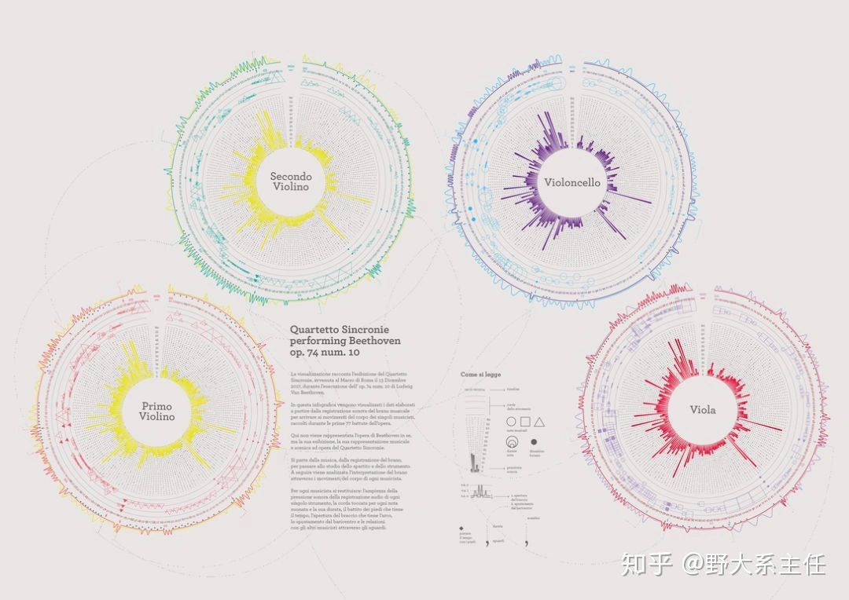
Fig8 Zhi Hu (2020) 100 cases of information visualization
Through the research and data collection of his works, the invisible music can be visualized. Through the contrast between colors and figures, the emotion of the music can be accurately conveyed to the hearts of people who cannot hear the music itself. In my submission the only difference between the disabled and the able-bodied is the way they perceive the world. The significance of information design may be to let light shine into every corner.

Summary outline
Human cognitive development, as well as human ideology and visual expression are inseparable
（Therefore, human development cannot be separated from information expression. Information design is a form of optimizing information expression. It helps people shape their values through various means, such as symbols, marks, charts, etc.）
The principle of information design (people-oriented).
（The existence of information design itself is to serve the better cognitive world of mankind.）
In the current information age, how do designers create data art, participate in network culture, and help people shape cognition. （reflect）

Bibliography

Books

Bolají, V.V. (2007) Database aesthetics art in the age of information overflow. 8th ed. Minneapolis, Minn: University of Minnesota Press.

Castells, Himanen, P. and Castells, M. (2014) Reconceptualizing development in the global information age. Oxford: Oxford University Press.

Kim, H.H. and Geissbühler, S. (2018) Graphic design discourse : evolving theories, ideologies, and processes of visual communication. First edition. Edited by H.H. Kim. New York: Princeton Architectural Press.

Krug, S. (2014) Don’t make me think, revisited : a common sense approach to web usability. Third edition. Berkeley: New Riders.

Lupton, E. and Lipps, A. (2018) The senses : design beyond vision. 1st ed. New York, N.Y: Cooper Hewitt, Smithsonian Design Museum.

McCandless, D. (2012). Information is beautiful. London：Collins.

McCandless, D. (2014). Knowledge is beautiful. London：Collins.

Noth, W. (1990). Handbook of semiotics. Bloomington：Indiana University Press.

Silverman, K. (1983). The subject of semiotics. New York：Oxford University Press.

Spinuzzi, C. (2003). Tracing genres through organizations: A sociocultural approach to information design. Hongkong：MIT Press.

Ware, C. (2004) Information visualization: perception for design. 2nd ed. San Francisco, Calif: Morgan Kaufmann.

Websites

Bergemann, D. and Morris, S. (2019) ‘Information Design: A Unified Perspective’, Journal of economic literature, 57(1), pp. 44–95. Available at: https://doi.org/10.1257/jel.20181489. （Accessed 16th November）

Dermer, J. D. (1973). ‘Cognitive Characteristics and the Perceived Importance of Information’. The Accounting Review, 48(3), pp511–519. DOI：http://www.jstor.org/stable/245149 （Accessed 16th November）

Deely, J. (2005). Basics of Semiotics [Online] Available at：https://core.ac.uk/download/pdf/79117629.pdf （Accessed 16th November）

Esposito, A.G. et al. (2021) ‘Relating a picture and 1000 words: Self-derivation through integration within and across presentation formats’, Cognitive development, 60, pp. 101099–. Available at: https://doi.org/10.1016/j.cogdev.2021.101099.（Accessed 16th November）

Fleischmann, K.R. (2014) Information and human values [Online] San Rafael, California (1537 Fourth Street, San Rafael, CA 94901 USA): Morgan & Claypool. Available at: https://doi.org/10.2200/S00545ED1V01Y201310ICR031.（Accessed 16th November）

Giordano, D. (2002) ‘Evolution of interactive graphical representations into a design language: a distributed cognition account’, International journal of human-computer studies, 57(4), pp. 317–345. Available at: https://doi.org/10.1006/ijhc.2002.1020. （Accessed 16th November）

Hegarty, M. (2011) ‘The Cognitive Science of Visual-Spatial Displays: Implications for Design’, Topics in cognitive science. Received 15 July 2010; received in revised form 6 January 2011; accepted 27 February 2011, 3(3), pp. 446–474. Available at: https://doi.org/10.1111/j.1756-8765.2011.01150.x. （Accessed 16th November）

Kennedy, H. and Engbretsen, M. (2020) Data Visualization in Society [Online] Edited by H. Kennedy and M. Engbretsen. Baltimore, Maryland: Project Muse. Available at: https://doi.org/10.1515/9789048543137. （Accessed 16th November）

Kaye, D. (1995), "The importance of information", Management Decision, 33（5）, pp 5-12.DOI：https://doi.org/10.1108/EUM0000000003897. （Accessed 16th November）

Marchese, C. (2021) Information design for the common good: human-centric approaches to contemporary design challenges. [Online]. London: Bloomsbury Visual Arts. Available at: https://doi.org/10.5040/9781350117297. （Accessed 16th November）

Pentland, A. (1988). Shape information from shading: a theory about human perception [Online]. Available at: https://www.cnbc.cmu.edu/~tai/readings/shading/pentland.pdf (Accessed: 6th December)

Regan, D. (2000). Human perception of objects [Online] MA: Sinauer. Available at：https://www.sinauer.com/media/wysiwyg/tocs/HumanPerception.pdf （Accessed 16th November）

Shen, Z. et al. (2020) ‘The effects of icon internal characteristics on complex cognition’, International journal of industrial ergonomics, 79. Available at: https://doi.org/10.1016/j.ergon.2020.102990. （Accessed 16th November）

Spence, J.W. and Tsai, R.J. (1997) ‘On human cognition and the design of information systems’, Information & management, 32(2), pp. 65–73. Available at: https://doi.org/10.1016/S0378-7206(97)00012-8. （Accessed 16th November）

Spence, R. (2014) Information Visualization An Introduction [Online]. 3rd ed. 2014. Cham: Springer International Publishing. Available at: https://doi.org/10.1007/978-3-319-07341-5. （Accessed 16th November）

Twyman, M. (1982). ‘The graphic presentation of language’. Information design journal, 3(1), pp2-22. DOI：https://doi.org/10.1075/idj.3.1.01twy. （Accessed 16th November）

Vaknin-Nusbaum, V. and Nevo, E. (2021) ‘What can children learn from exposure to visual-graphical representations?’, Thinking skills and creativity, 40,. Available at: https://doi.org/10.1016/j.tsc.2021.100830. （Accessed 16th November）

Wang, M. and Shen, R. (2012) ‘Message design for mobile learning: Learning theories, human cognition and design principles’, British journal of educational technology, 43(4), pp. 561–575. Available at: https://doi.org/10.1111/j.1467-8535.2011.01214.x. （Accessed 16th November）

Photos

Fig1
Pinterest （2017）Information Design Available at：https://pin.it/14xRRdb1（Accessed 16th November）

Fig2
Zhi Hu （2016）Information Case Analysis Available at：https://zhuanlan.zhihu.com/p/266032987 （Accessed 16th November）

Fig3
Zhi Hu （2016）Excellent information chart Available at：https://zhuanlan.zhihu.com/p/149141991 （Accessed 16th November）

Fig4
Yow，M（2017）The Loyalty of Images Available at：https://pin.it/2t6GmrP（Accessed 16th November）

Fig5
Pinterest （2016）7 Arts Available at ：https://pin.it/5z33kCE （Accessed 16th November）

Fig6
Pinterest（2021）Animal Restaurant Available at：https://pin.it/6HB6RAV （Accessed 16th November）

Fig7
Pinterest （2014）The Light Available at：https://pin.it/5iHhmd3 （Accessed 16th November）

Fig8
Zhi Hu (2020)100 cases of information visualization Available at https://zhuanlan.zhihu.com/p/107441350 （Accessed 16th November）

