Mel Squire

SAMSUL ISLAM 1914178
DATE: 30 OCTOBER 2020
MODULE: BMSW4002

UNIVERSITY WALES TRINITY SAINT DAVIDS
(UWTSD)
EFFECTIVE TEAMWORK AND COMUNICATION
CERTIFACATE FOR HIGHER EDUCATION FOR SKILLS IN THE WORKPLACE
Contents
Executive Summary 2
1.0 Terms of Reference 3
2.0 Procedure 3
3.0 Importance of team work 4
3.1 How theories of teamwork help in the workplace 4
4.0 Belbin theory 5
5.0 Tuckman theory – forming, storming, norming adjourning, performing, different stages. 5
5.1 Forming 5
5.2 Storming 5
5.3 Norming 6
5.4 Performing 6
5.5 Adjourning 6
6.0 Difference between groups and teams 7
7.0 Conclusions 7
8.0 Recommendations 7
9.0 Appendices 8
10.0 References 10

Executive Summary

The purpose if this report is to help all types of companies and individuals understand how teams and groups are important as Prichard (1999) and Morgan (2017) explain Belbin’s theories and Chapman (2017) and Lumens (2020) explain Tuckman theories. By exploring how a working environment like Sky Tv functions and do they use these two theories.

Terms of Reference

This project was to write a report as part of an assignment from, UWTSD (University Wales Trinity Saint David) and lecturer (Melanie Squire) for the access level course higher education for skills in the work place (CERT HE). Importance of teams and groups. Deadline for this report is 30/10/2020. This report will go over theories and hypothesis of individuals that help develop teams and groups structure and made aware of its importance,

2.0 Procedure

This report will be created from researching journals, books, articles, questionnaires from in class and further from the World Wide Web. Researching Belbin and Tuckman to understand why or if teams and/or groups are vital to organisations. All relevant exercises that will be completed to are attached to appendices.

3.0 Importance of team work

Effective teams have the ability to increase efficiency by taking on more complex tasks, think "two heads are better than one", improve communication by facilitating open discussion and cooperation among team members, maximize output by leveraging each team member's strengths, provide opportunities for personal growth, and act as a support mechanism for staff.
Unsurprisingly, teamwork has also shown to increase innovation and creativity by allowing team members to bring unique and distinct perspectives to the table. When leveraged, effective teamwork drives company growth and boosts performance and success by tapping into each individual's unique strengths and attributes. In Lumen (2020), teams also can effectively handle conflicts, such as: -
Talk with the other person. ...
Focus on behaviour and events, not on personalities. ...
Listen carefully. ...
Identify points of agreement and disagreement. ...
Prioritize the areas of conflict. ...
Develop a plan to work on each conflict. ...
Follow through on your plan. ...
Build on your success.
Table included within appendices to show process of this.

3.1 How theories of teamwork help in the workplace

Teamwork means that people will try to corporate, using their individual skills and providing constructive feedback, despite any personal conflict between individuals. It plays a vital role in all types of industries. Like football, teammates passing to one another to find the perfect shot, each teammate plays a specific, meaningful role. Good teamwork structures provide your organization with a diversity of thought, creativity, perspectives, opportunities, and problem-solving approaches. A proper team environment allows individuals to brainstorm collectively, which in turn increases their success to problem solve and arrive at solutions more efficiently and effectively. (Wehbe 2017). Also, in Maund (2017) says teams can achieve lots more than a specific individual can how ever teams also have issues such as lack of commitment, productivity losses, interpersonal skills and poor leadership which is why a team also needs structure.

4.0 Belbin theory

Belbin suggested that knowledge, skills and attitudes influence successful performance just like combinations of the traits or personalities of individual team members do. Training may alter knowledge, skills and attitudes. However, personality is considered as “by definition” to be stable and deeply rooted in predispositions. Personality as such appears to be resistant to change by training.
In Neville (1999), tested Belbin’s theories as believed the effectiveness of teams varies greatly. Considerable research has been conducted to discover the formula for success. Team working is an essential facet of any successful organisation. Although there is a good deal of use of self-perception inventories for identifying preferences for team roles within commercial and training environments, there has been little in the way of analytical research to critically assess the utility of such approaches. Activities conducted would therefore help to determine how team-role theory can be applied to many aspects of the team environment, from advancing the understanding of the dynamics of effective teamworking, to team building and the recruitment of team members, to team training and its transferability to the workplace (Prichard 1999). Morgan (2017) has a table of showing Belbin’s team roll and abbreviation’s, coordinator, implementer, shaper, complete-finisher, resource investigator, specialist, monitor-evaluator, plant and team-worker. These rolls structure a team.

5.0 Tuckman theory – forming, storming, norming adjourning, performing, different stages.

In 1965, a psychologist named Bruce Tuckman said that teams go through 5 stages of development: forming, storming, norming, performing and adjourning. The stages start from the time that a group first meets until the project ends. (chapman 2017)

5.1 Forming

In this stage, most team members are positive and polite. Some are anxious, as they haven't fully understood what work the team will do. Others are simply excited about the task ahead.
As leader, you play a dominant role at this stage, because team members' roles and responsibilities aren't clear.
This stage can last for some time, as people start to work together, and as they make an effort to get to know their new colleagues.

5.2 Storming

Next, the team moves into the storming phase, where people start to push against the boundaries established in the forming stage. This is the stage where many teams fail.
Storming often starts where there is a conflict between team members' natural working styles. People may work in different ways for all sorts of reasons but, if differing working styles cause unforeseen problems, they may become frustrated.
Storming can also happen in other situations. For example, team members may challenge your authority, or jockey for position as their roles are clarified. Or, if you haven't defined clearly how the team will work, people may feel overwhelmed by their workload, or they could be uncomfortable with the approach you're using.
Some may question the worth of the team's goal, and they may resist taking on tasks.
Team members who stick with the task at hand may experience stress, particularly as they don't have the support of established processes or strong relationships with their colleagues.

5.3 Norming

Gradually, the team moves into the norming stage. This is when people start to resolve their differences, appreciate colleagues' strengths, and respect your authority as a leader.
Now that your team members know one another better, they may socialize together, and they are able to ask one another for help and provide constructive feedback. People develop a stronger commitment to the team goal, and you start to see good progress towards it.
There is often a prolonged overlap between storming and norming, because, as new tasks come up, the team may lapse back into behaviour from the storming stage.

5.4 Performing

The team reaches the performing stage, when hard work leads, without friction, to the achievement of the team's goal. The structures and processes that you have set up support this well.
As leader, you can delegate much of your work, and you can concentrate on developing team members.
It feels easy to be part of the team at this stage, and people who join or leave won't disrupt performance.

5.5 Adjourning

Many teams will reach this stage eventually. For example, project teams exist for only a fixed period, and even permanent teams may be disbanded through organizational restructuring.
Team members who like routine, or who have developed close working relationships with colleagues, may find this stage difficult, particularly if their future now looks uncertain.

6.0 Difference between groups and teams

The terms groups and teams, both have similar literal definitions, organisational definitions and the implications that are paired with each have great differences. Armstead (2016) states when describing a number of people working or sharing a common purpose, the growing complexity of tasks is often beyond the cognitive capabilities of individuals which therefore, necessitates a team approach. Groups are defined as two or more people who contribute to a common goal and perform their own work relatively independently of each other. Such as Sky TV has various groups like outbound, inbound, Technical service and retentions. Each group contribute in helping Sky TV customers experience a great service. Withing these groups are teams that have a leader for each group that maintain the level of service Sky TV wants to provide. The team that answer inbound calls have a range to tools at their disposal to offer customer and they have a level of service they provide to ensure customer satisfaction. Outbound teams have a different range of tools to use to offer existing customers with a particular service to ensure they have maximum use of Sky’s services. Retentions teams help solve customer that may not be happy with the service they received by Sky therefore they have various different tools than the rest to resolve problems. Technical help customers that have issues with the hardware and programmes and telephone and broadband lines. Each group has a large team use to the demand for Sky Tv’s service. Taplin (2015) describes teams as two or more people who interact dynamically, interdependently, and adaptively to achieve a common, valued goal. Saltman (2007) shows a chart providing comparisons of groups and teams roles and defines differences.

7.0 Conclusions

With Belbin and Tuckman theories shows how the structured teams and groups preform and various weaknesses that can also develop as stated in Maund (2017) book and how Belbin’s and Tuckman theories can help develop skills to overcome these weaknesses stated by Morgan (2017). Lumen (2020) has explained what types of conflicts that can occur and Saltman (2007) chart provides groups and team roles where Chapman defines Tuckman 5 important stages.

8.0 Recommendations

By slitting groups into small teams then using Tuckman theory explained by Chapman (2017) or Belbin theory a team can have structure and according to Saltman (2007) and Taplin (2015), by developing teams and groups using the 2 theories benefit the individual extensively and develop a unique or various skill and also benefit the organisations growth. According to Maund (2017) a experienced team leader would provide a good structure for a team as a leader can help give directions and keep a team focused at the task and select and utilise which individual’s skill within the team would be suited where so all team members strengths are capable of using to full potential. (wehbe 2017). Thus following Sky Tv’s structure.

9.0 Appendices

Criteria | Group
Accountability | Individual | Individual and collective
Commitment | Individual | Shared
Conflict resolution | May be part of process | Essential part of process
Creativity and contribution | Not confined to tasks | Within tasks
Effectiveness measures | Direct external assessment of individual performance | Direct
Interactions | Information sharing | Problem solving
Leadership | Shared, determined by task | Strong leader
Measure of productivity | Sum of individual bests | Single
Operation | Discuss, decide, delegate | Discuss, decide, collaborate
Ownership | Individual work | Whole project
Participative decision making | Optional | Expected
Personal development | Optional | Expected
Purpose | Discrete for each member | Devised by team and management
Size | Small or larger | Defined and small
Skills | May be overlapping | Discrete for each member and sometimes under development
Trust | Optional | Developed and essential
Understandings | Can be different | Work towards shared goals
Work products | Individual | Unified, more than the sum of parts

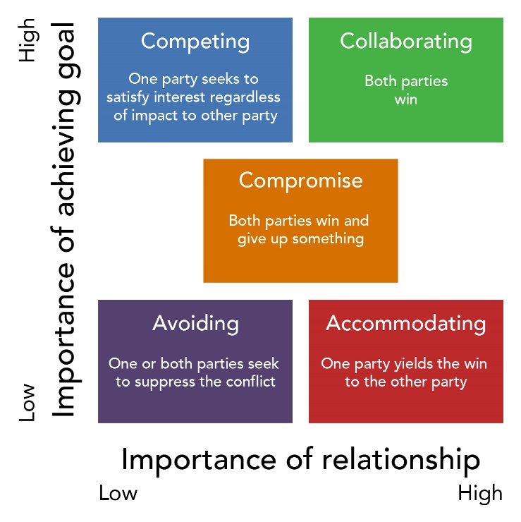

10.0 References

Armstead C, ET AL. (2016). Groups vs. Teams: Which One Are You Leading? 14. 179-182.

CHAPMAN A. (2017). Tuckman: Forming, Storming, Norming, Performing model. Available: https://www.businessballs.com/team-management/tuckman-forming-storming-norming-performing-model/. Last accessed 28 OCTOBER 2020.

Lumen. Organizational Behaviour and Human Relations. Available: https://courses.lumenlearning.com/wm-organizationalbehavior/chapter/conflict-management-styles/. Last accessed 26/10/2020.

Maund A, ET AL. (2017). COMMON PROBLEMS. In: CERTIFICATE IN HIGHER EDUCATION: SKILLS FOR THE WORKPLACE STUDENT YEAR BOOK. LONDON: SAGE PUBLICATIONS LTD. 546.

MORGAN P (2017). THE BUISNESS STUDENT'S GUIDE TO STUDY AND EMPLOYABILITY. LONDON: SAGE PUBLICATIONS LTD. 458.

Neville A, ET AL. (1999). Conclusion. In: Testing Belbin's team role theory of effective groups. Bradford: Emerald Group Publishing Limited. 652-665.

Prichard J, (1999). Testing Belbin's team role theory of effective groups. Southampton: Eprints.

Saltman D, ET AL. (2007). Groups or teams in health care: finding the best fit. journal of evaluation in clinical practice, International journal of public Health and Service research. 13. 55-60.

Taplin S, ET AL. (2015). Teams and Teamwork During a Cancer Diagnosis: Interdependency Within and Between Teams. Journal of Oncology Practice. 11.

Wehbe S, (2017). 5 important reasons why teamwork matters. In: potential. 3.

