

Christopher Budden
P148323

Andrew Harrison

LEVEL/ LEfEL 5

SEMESTER 1

MODULE CODE/ Cod Y modIwl:
m5x00938 (QinetiQ)
Computer Aided Engineering

aSSESSMENT TYPE/ mATH O ASESU: aSSIGNMENT

Assessment/Component/ AsESIAD/CYDRAN: 1

Contents Page

Introduction to CAE Tools 1

Task 1
- Critical Review on CAE Tools 1 – 2

Task 2
- Solidworks® Applicability & Model study example 3 – 9

Conclusion 10

Bibliography 11

Introduction
In this assessment, the topics that will be discussed are; critically reviewing the advantages, techniques & limitations of Computer Aided Engineering Tools. The following document will demonstrate how CAE software tools can affect and support various industries by analysing the tools within CAE. I will also be evaluating on this by giving an example that I have created to aid me in my profession of work and by using examples that have been undertaken in my place of work.
Task 1
Computer Aided Engineering Tools, or CAE Tools, are grossly used in various industries such as; automotive, aeronautical, maritime, space and military defence. To which CAE Tools are implemented to ‘simulate performance in order to improve product designs or assist in the resolution of engineering problems’ [1]. The major benefit of using CAE Tools in these types of industries is its flexibility of analysing and altering components or assemblies without the need for physically building prototypes. The avail of CAE Tools to designers is the user friendliness and aids that the software’s features have. CAE Tools have a major benefit, as multiple designers can work on the same design, at the same instance of time, anywhere in the world. As described by Solidworks®; ‘The multi-user environment provides read/write access control and tracking for two or more users working with the same files concurrently’ [2]
For example, a new component or assembly requires Finite Element Analysis (FEA) in order to pass the design stage before proceeding to manufacture. FEA analyses the designed part or assembly to model a simulation, for example; when a load or force applied to a component, the CAE Tool will calculate the maximum yield or displacement points on sections of the design. As quoted by Multiphysics Cyclopedia, this process is called meshing; ‘The finite element mesh is used to subdivide the CAD model into smaller domains called elements, over which a set of equations are solved’ [3] This then requires optimisation of the part, only if the simulation flags up any weak points, in that changes may need to be made to the initial drawing to reduce, increase, alter the material and reinforce features or components in order to pass the design and analysis stage. The optimisation of the part or model is governed by the Factor of Safety. Factor of Safety or F.O.S is defined as; ‘the ratio of the maximum stress that a structural part or other piece of material can withstand to the maximum stress estimated for it in the use for which it is designed.’[4]
Factor of Safety is calculated as;
Maximum permissible Load = $\frac{m × F}{F.O.S}$ Where; m = Calculated F.O.S
F = Force
F.O.S. = Factor of Safety limit
There are a number of tools and features within CAE software that can analyse a part. An example of this is using SolidWorks® CAE Software for Motion Study Analysis. This tool can also support the feature of Finite Element Analysis, when imported from a motion study on a single component from an entire assembly with many moving parts. Motion loads can be applied onto one particular part within that assembly, then a study is carried out on that individual component in the assembly to analyse its stresses, strain and displacements.
The impediment with CAE Tools, such as Solidworks® can be contributed by factors as follows; the cost of purchasing up-to-date versions of the software packages costs in the regions of several thousand pounds, and that can be for just one licence for one workstation. In a drawing office however, that could cost tens to hundreds of thousands of pounds.
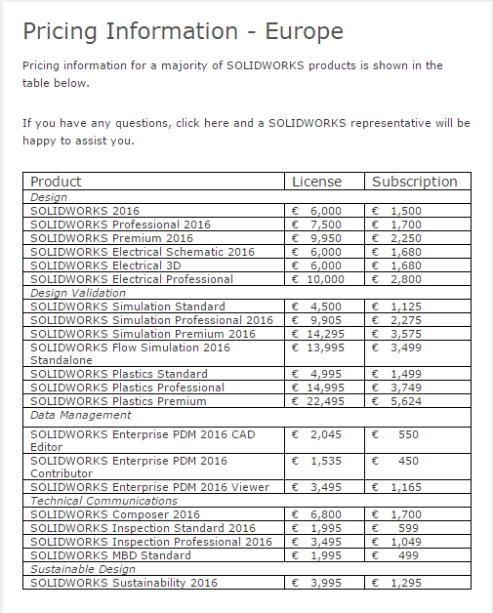
Shown here in Fig 1.1 is the latest online quote which was requested that gives a breakdown of licence and subscription costs for various packages.

Ref 1.1

Fig 1.1 [5]

Converting the quoted price for Solidworks® Professional Ref 1.1 shown above for 2016, equates to £6366.61 for the license and £1443.10 for subscription. For a company that’s either starting up a new design office, or an existing company that is upgrading their CAE Tool package, this is a huge cost when buying multiple licences.
Task 2
The applicability of Solidworks® in my profession of industry greatly benefits from the design and evaluation of prototyping and modifying test equipment on the test ranges. In the industry of work that my profession lies with, the need for ‘one off’ testing hardware or rigging is relied on in order to proceed with tailored trials. Many asset hardware, such as rigging systems require ‘in house’ designs to meet the trial or customer specifications, thus proves near impossible to buy an ‘off the shelf’ product to suit the trial’s needs. For example, a rigging system is needed to suspend an aircraft dropped munition above a pool of aviation fuel to simulate a liquid fuel fire. The air dropped munition has specific load bearing lugs that are suited for transportation on a particular model of aircraft. So in order to adapt this munition to simulate it being suspended at the height of which it would be in combat ready status, a rigging system needs to be designed for the trial to which the munition is subjected to.
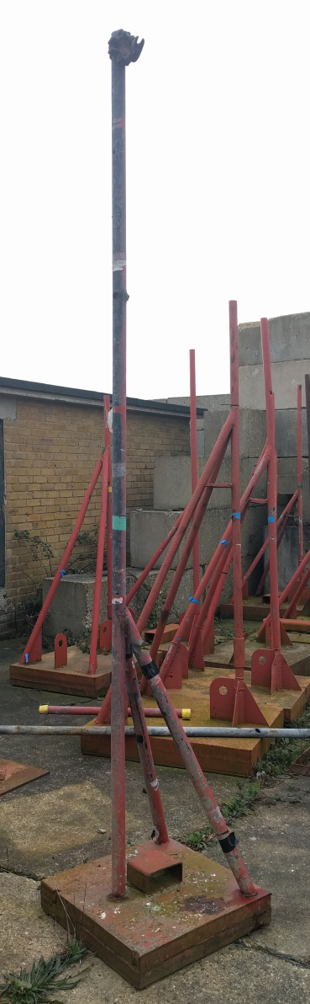
A practicable demonstration that the CAE Tool is used for my purpose of work is the use of mounting instrument equipment, such as sensors that are subjected and require the measurement of severe conditions when various munitions are tested to the worst outcome.
A particular engineering solution to mounting instruments to, (such as a piezo transducer blast overpressure gauge) is a heavy base blast stand. This rigging needs to be designed to and withstand blast overpressure against large scale munitions as close as 5m to the point of detonation. The blast stand needs to be sturdy enough so that it has as little movement as possible when subjected to blast.
Shown here in Fig 1.2 is the heavy base blast gauge stand used to mount blast transducers. The base weighs approx. 282Kg using 7.85g/cmᶾ for the density of mild steel and the dimensions of 600x600x100mm. The tubing is standard scaffold tube with a diameter of 48.3mm outer diameter and wall thickness of 4mm.
Using Solidworks® to replicate the physical design, it can be modelled and then simulated to identify the structures weak points when subjected to a force.

Fig 2.1
Fig 1.2
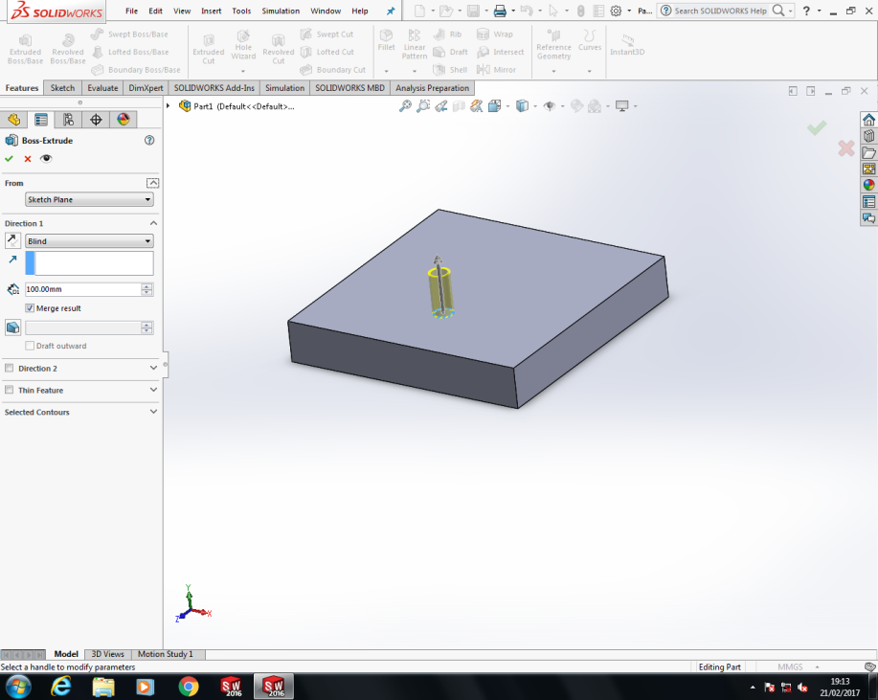
Base Pole Extrude.
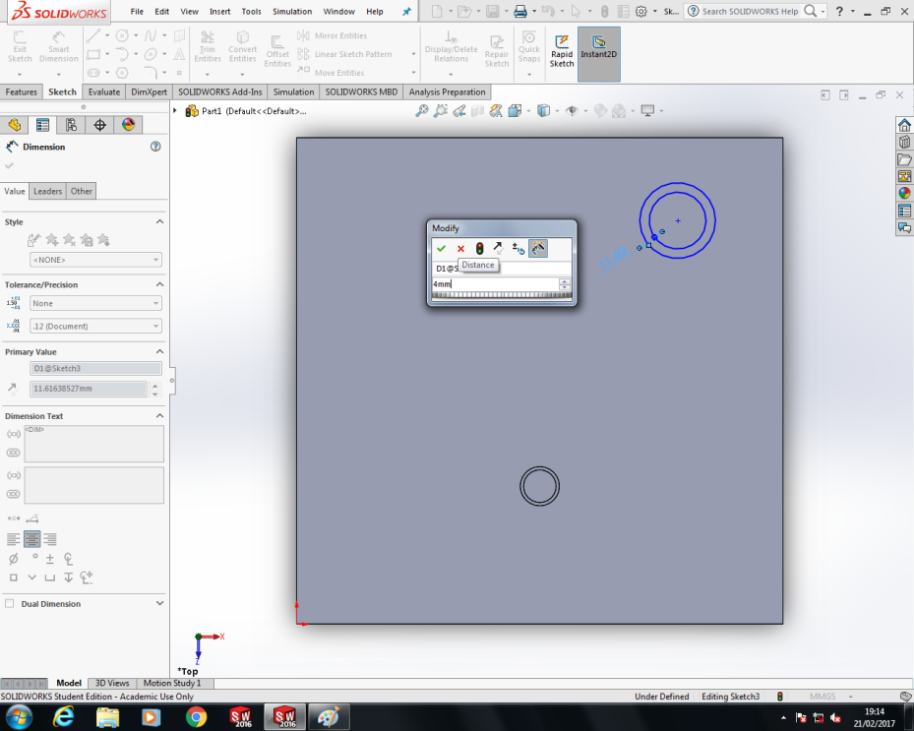

Fig 2.2
Smart Dimension rear support Pole base.

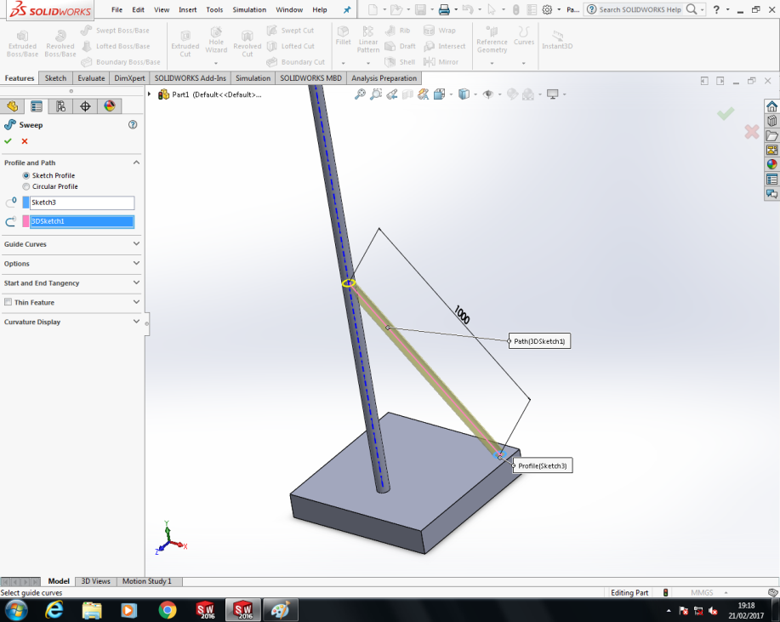
Fig 2.3
Rear Support Pole Swept Boss is only possible to sketch between planes by using ‘3D Sketch’ feature under ‘Sketch’ menu.
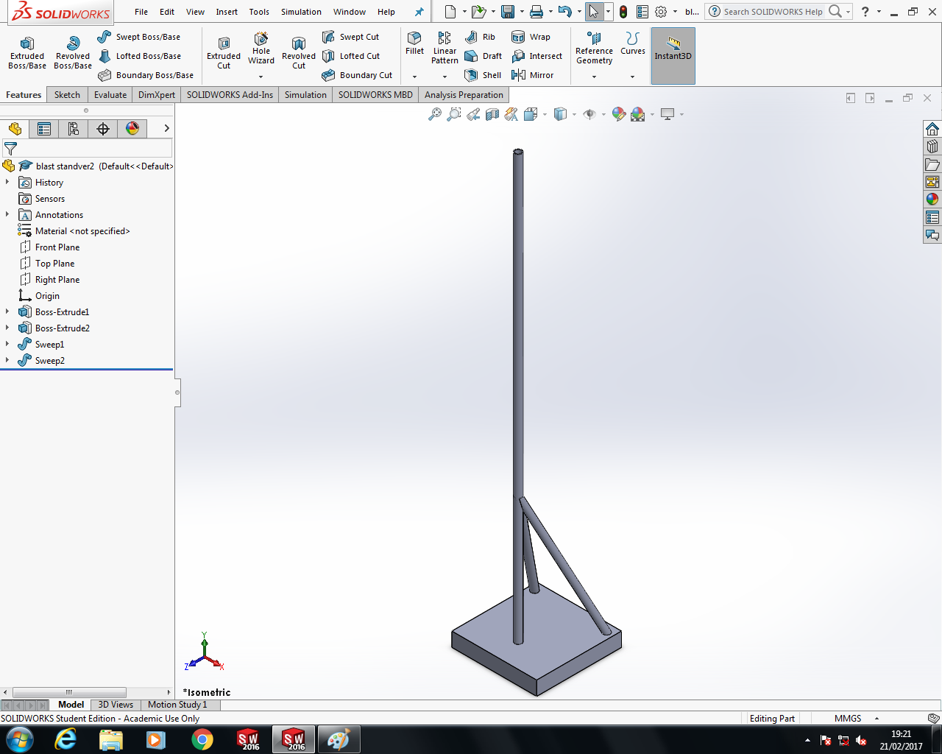

Fig 2.4

Fig 2.5
Finished Design Sketch
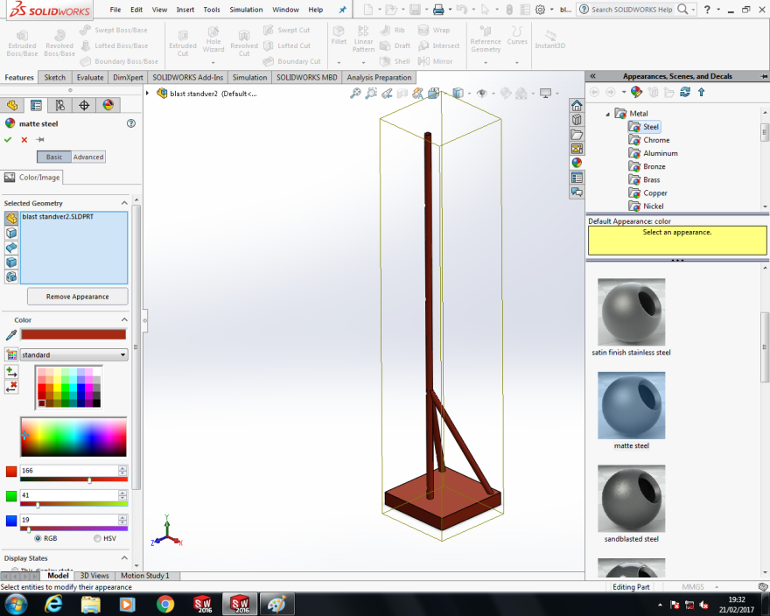
Fig 1.6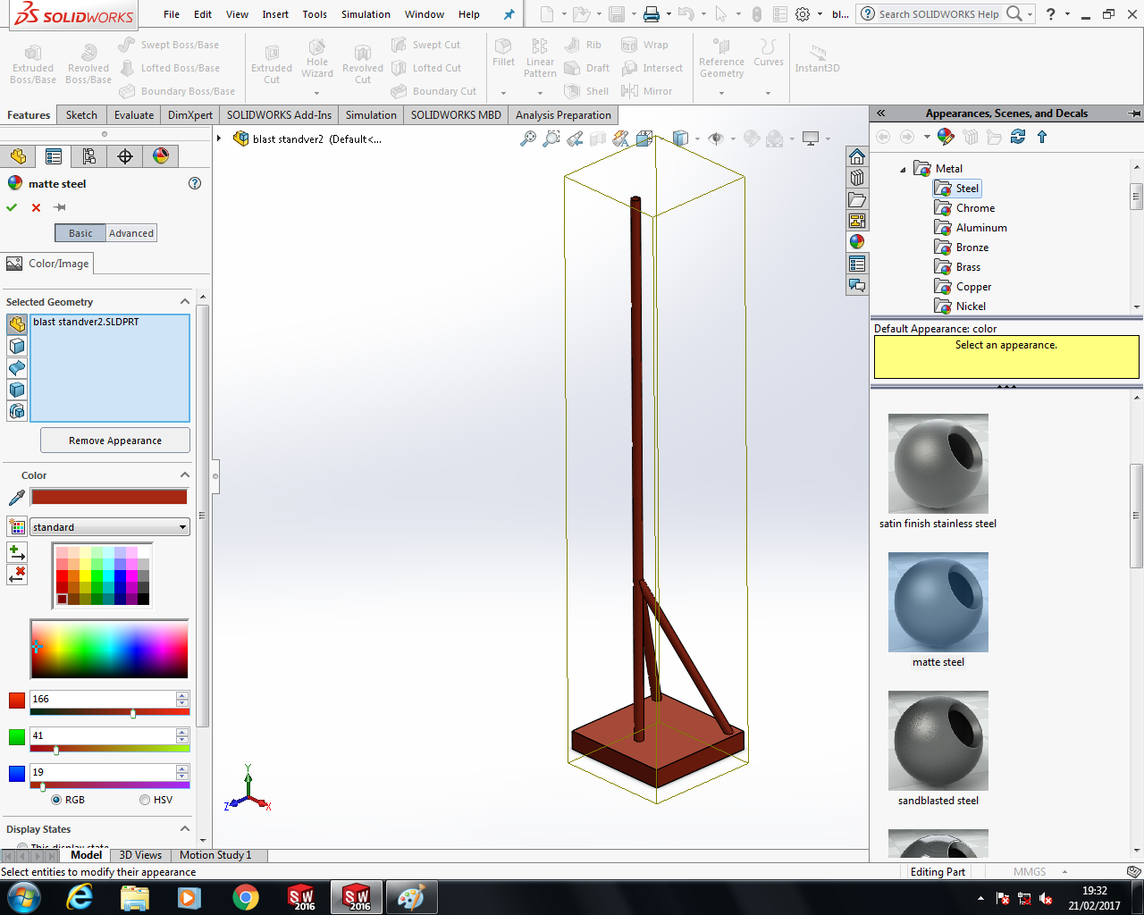

Assigning material type and changing aesthetics.

Fig 2.6

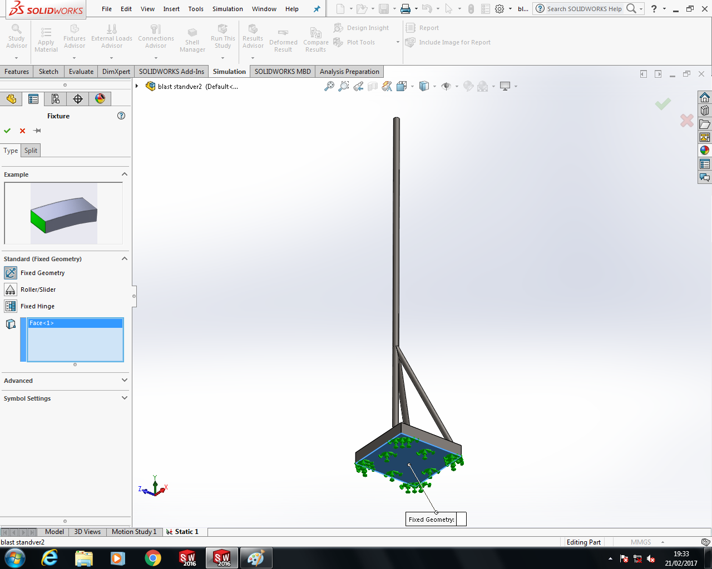
Utilising Solidworks® Study Advisor to apply a force to the structure in this screen capture.
The Study Advisor requires the model to be fixed on its given surface in order to calculate the stresses, strains and displacements.

Fig 2.7

Applying a Load or a Force on this next stage can define where on the model the force can be exerted. The part that is of interest is the vertical upright pole to which the transducer is mounted to.
Here a 200lb Force is applied.
Specifying the force direction is done by selecting one of the three planes (Front, Top & Right). This changes the forces direction that it will apply to the selected part.
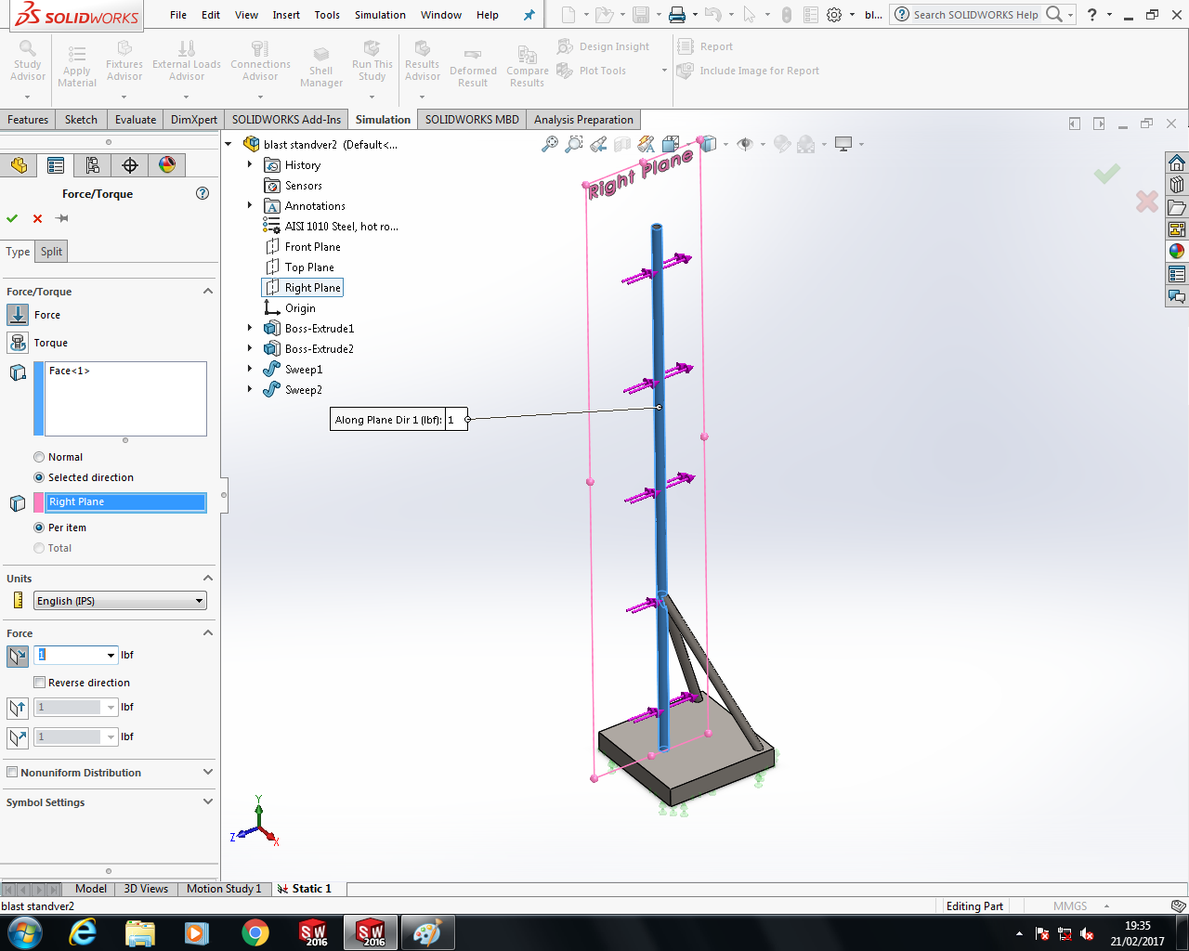

Fig 2.8

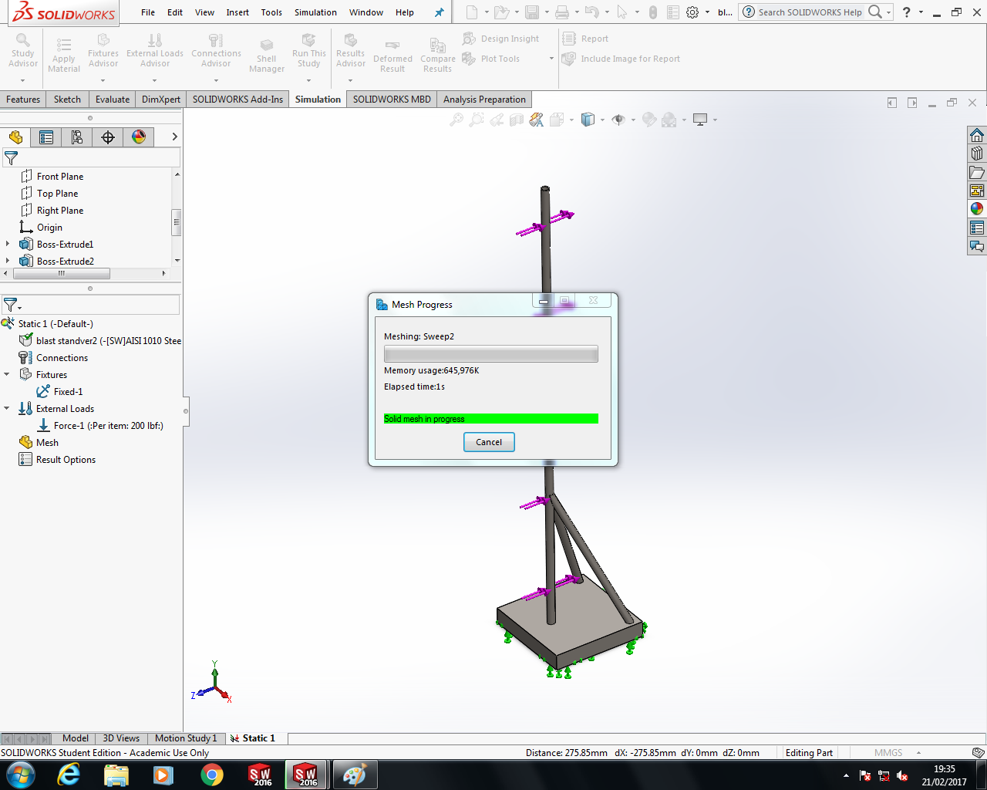

Meshing the design is required, as this overlays a tetrahedron net over a solid component. Applying a course or fine mesh will govern the results accuracy.

Fig 2.9
The results from the meshing analysis give plots that show the minimum to maximum extremities of the von Mises plot shown here in Fig 2.10. Von Mises gives a Scalar value (In psi), that plots the critical points on the model where the materials yield points are. Von Mises is expressed as ‘The yielding of materials that begins when the second deviatoric stress invariant reaches a critical value.’[6]
Analysis of this model shows that the maximum yield point is where the rear supports are joined to the vertical pole.
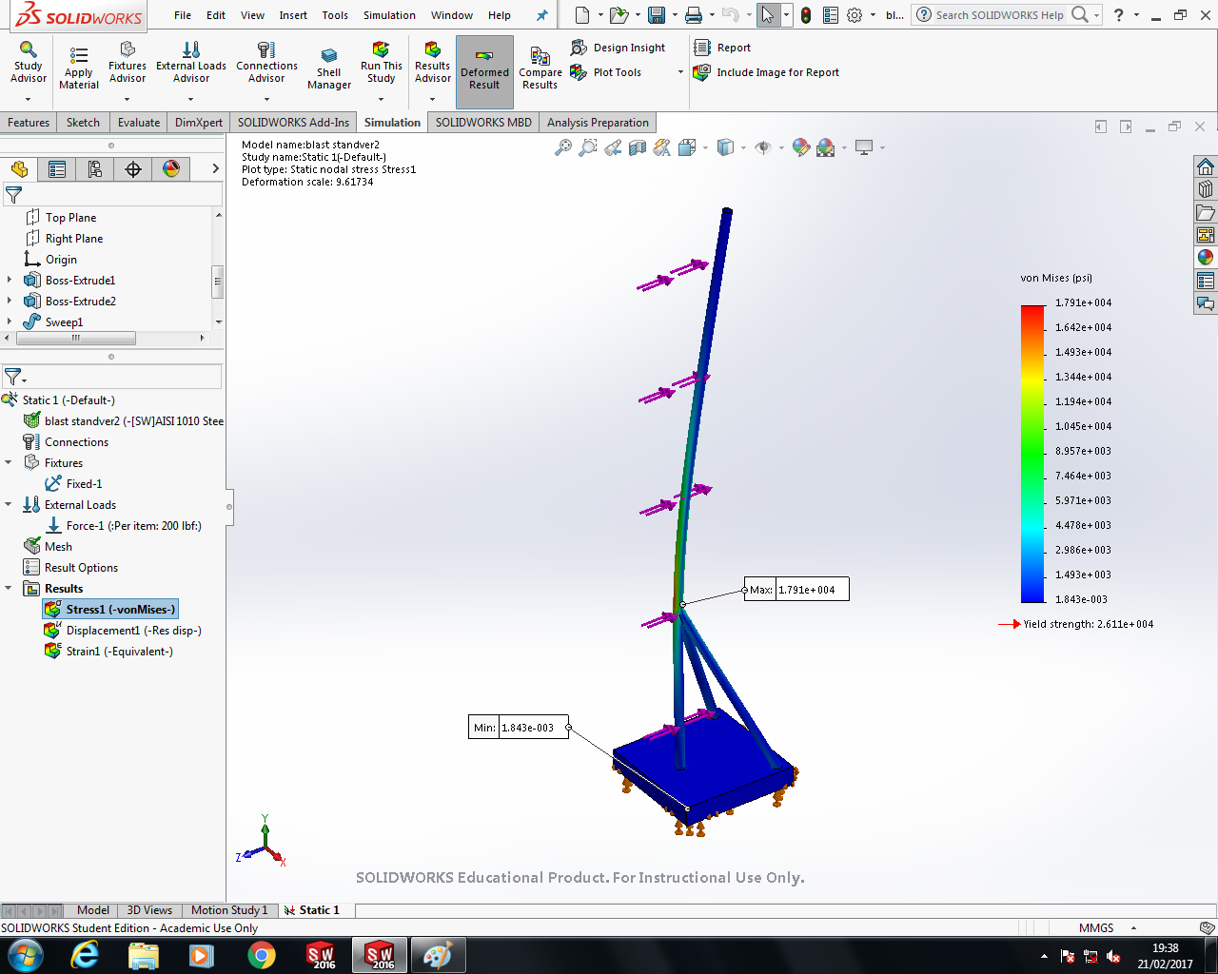

Fig 2.10
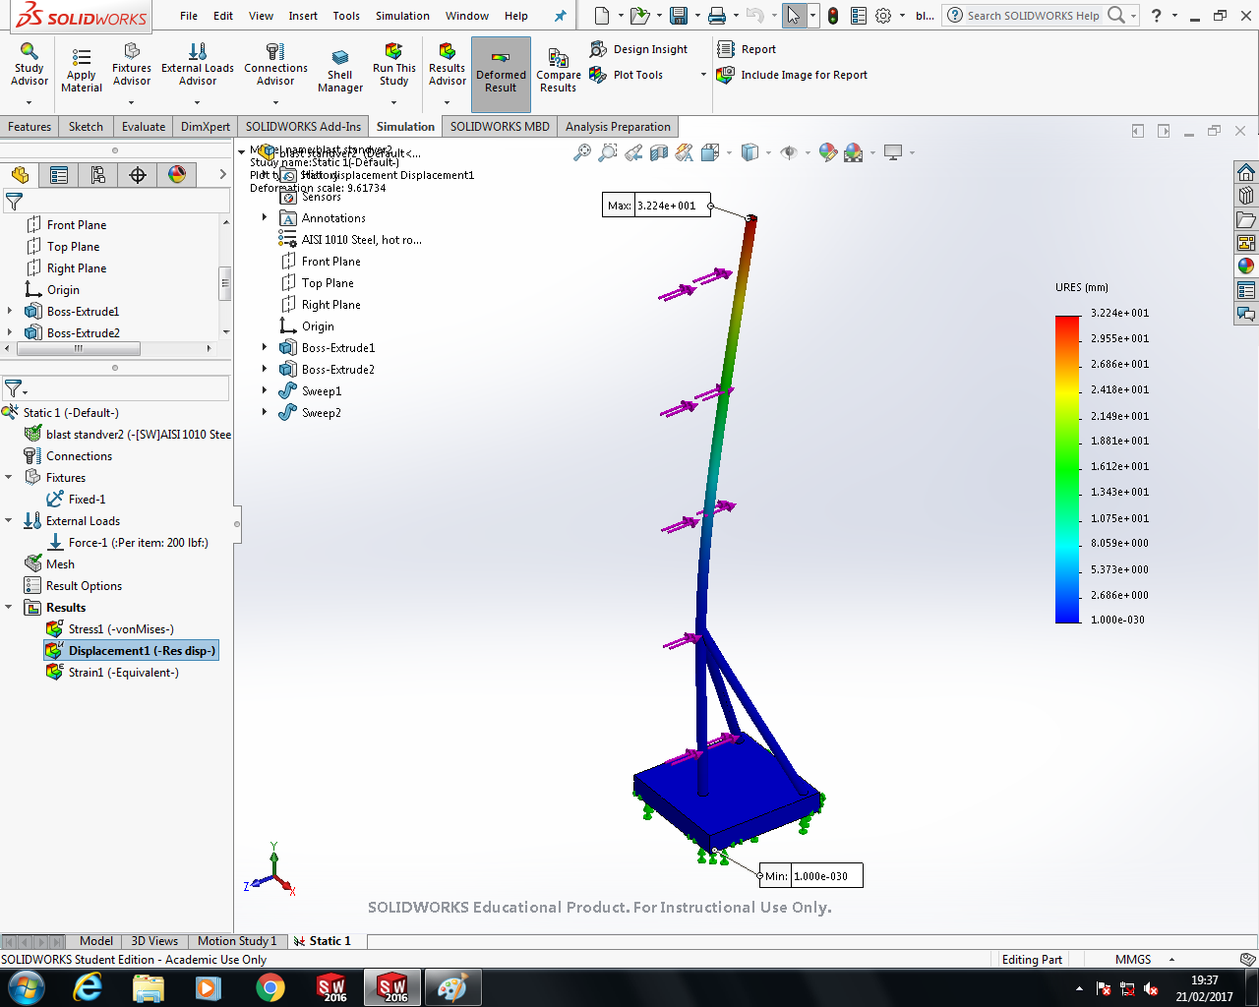

Displaying here the URES Scale, or resultant deflection, to which it is the summation of the displacement of the vectors in the X, Y & Z axis.

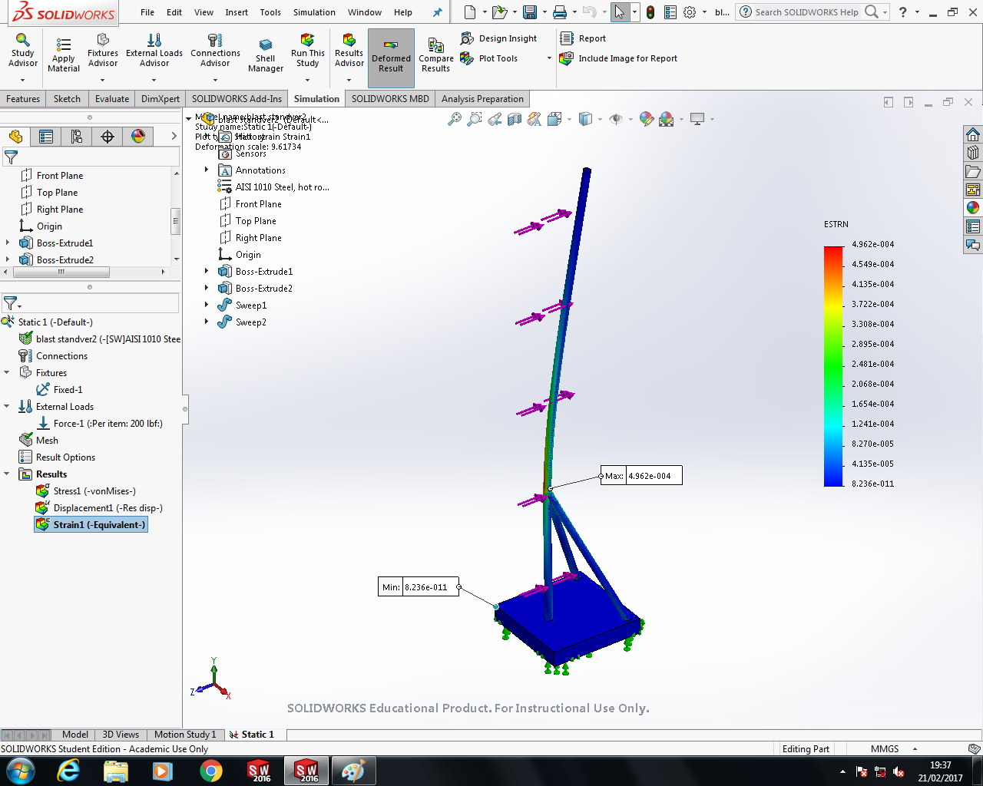
Fig 2.11
In this screenshot, this displays the results for ESTRN, short for Equivalent Strain, to which it plots the elongation of the material at critical points. As we can see here, it is also predictable that the critical strain is also where the rear supports are attached to the vertical upright. This is because that is a supported fixed point, and so the length above this has no support, resulting in the maximum strain where the supported and un-supported portions meet.

Fig 2.12

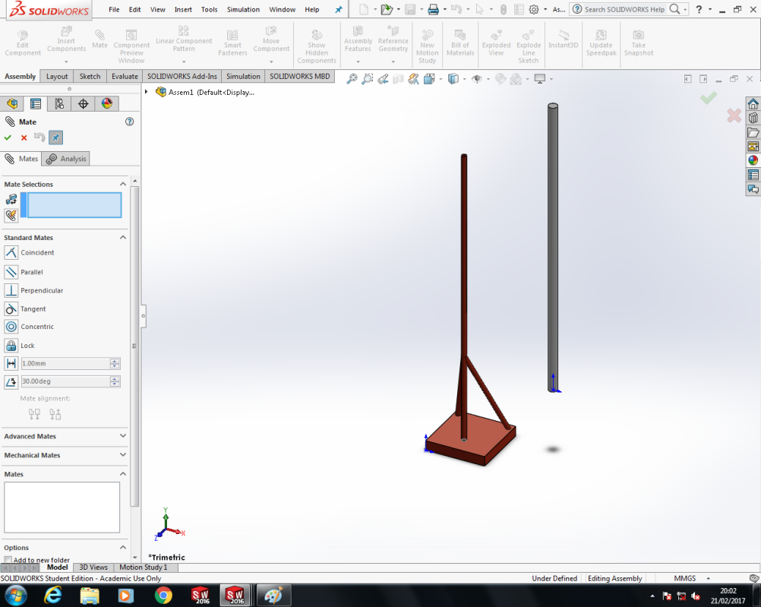
To counteract this prone failure of the model, the structure can be re-designed or modified to decrease the unwanted yielding, displacement and strain. And so, the modification for this is to re-inforce the upright. This is because we cannot add any additional support bars to the upright as this would limit the freedom of the Piezo Transducer Blast Gauge installation at various heights.

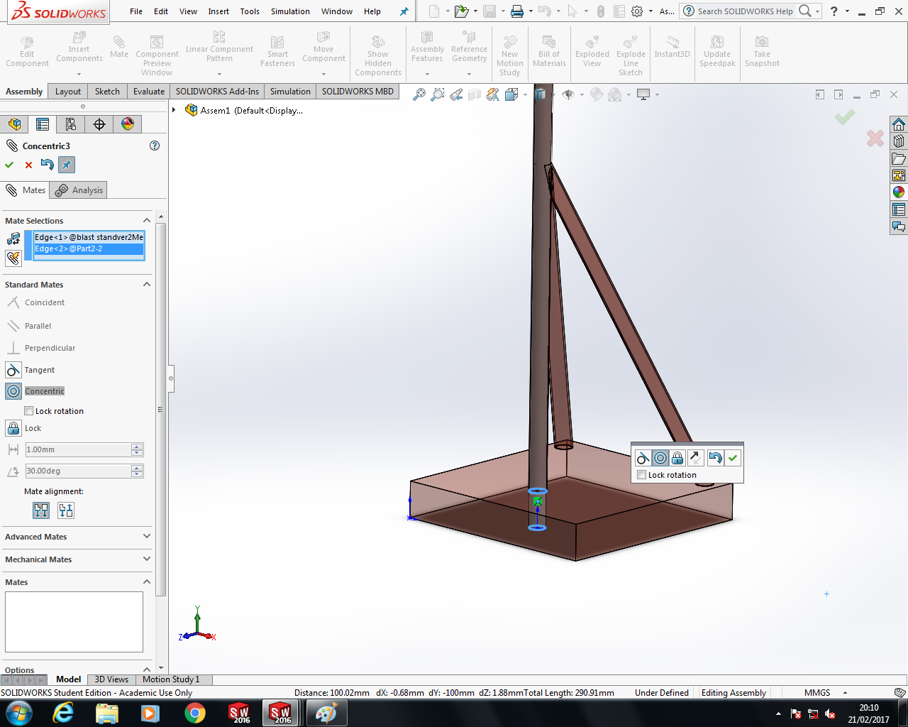
Fig 2.13
The issue that was introduced with using Solidworks® to implement the design and modification of this is the limitation of the materials list.
As the suitable choice for re-enforcing the upright vertical scaffold pole is to simply ‘fill’ the cavity with a mix of concrete and sharp sand, Solidworks® had a limited list of materials that does not include this.

Fig 2.14
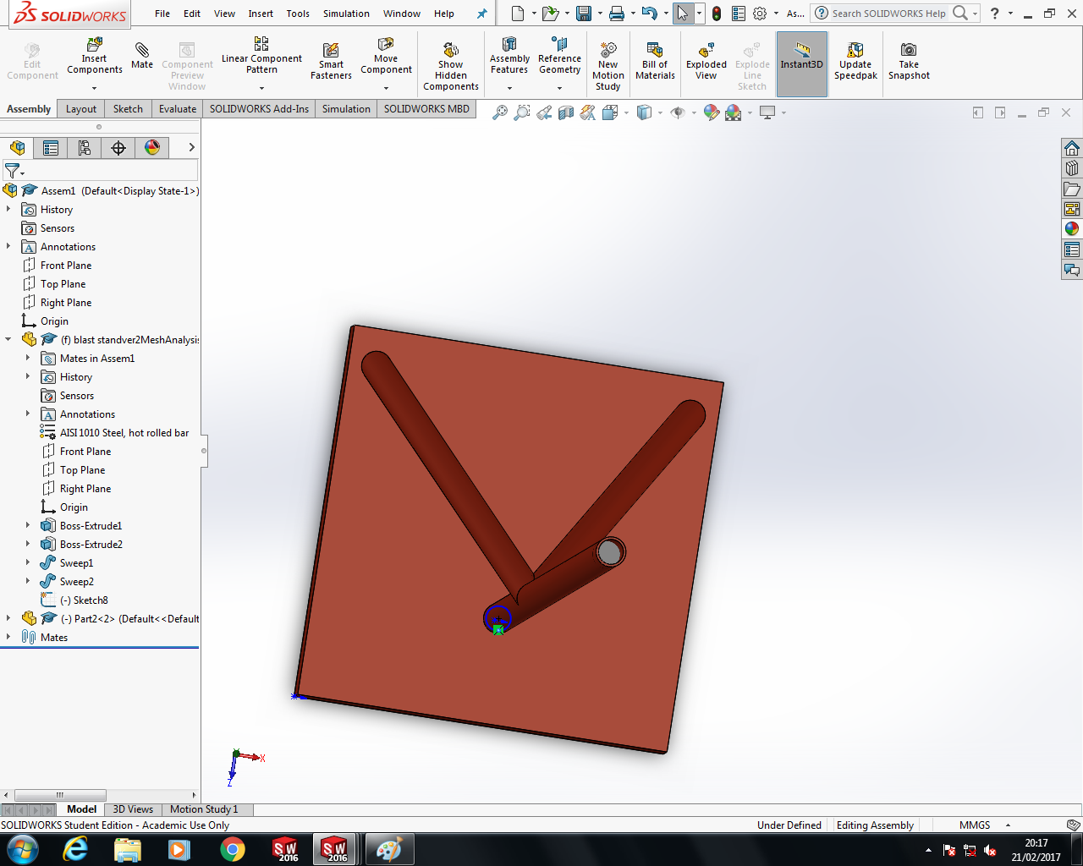
The only suitable choice of material that Solidworks® has in its library is HDPE (High Density Polyethylene) as this is readily available on site.
This HDPE is then sketched and extruded into the dimensions that will fit inside the uprights cavity. Then the parts are assembled as an assembly drawing and using a mate function.

Fig 2.15
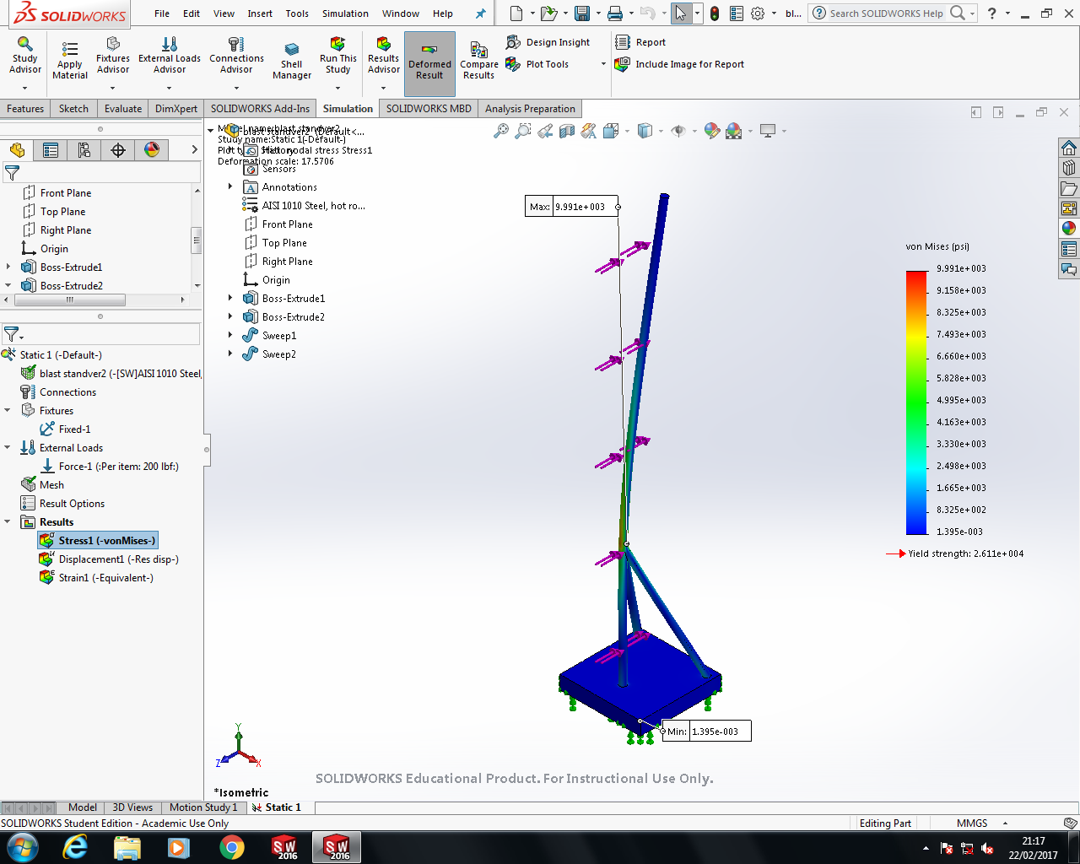
Re-meshing the model with the HDPE upright core support gives results that dramatically reduce the initial meshing analysis. Here we can see that the Von Mises yielding has reduced from 17,910 psi to 9991 psi on the upright pole above where the rear supports intercept.

Fig 2.16
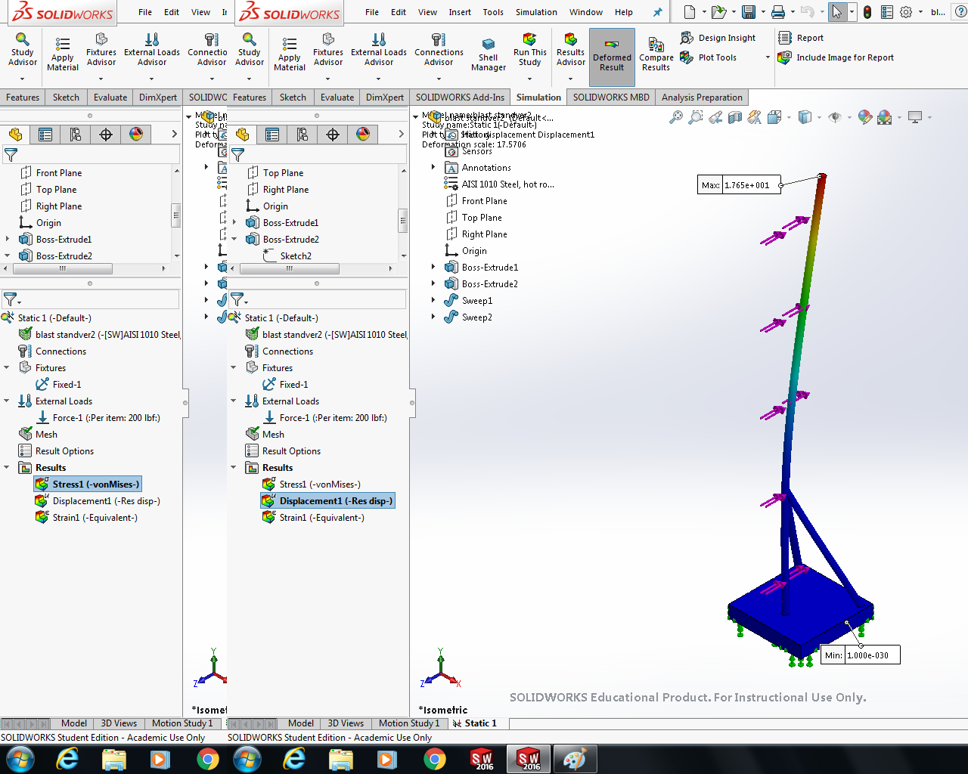

And here the URES displacement has reduced from 32.24mm to 17.65mm.

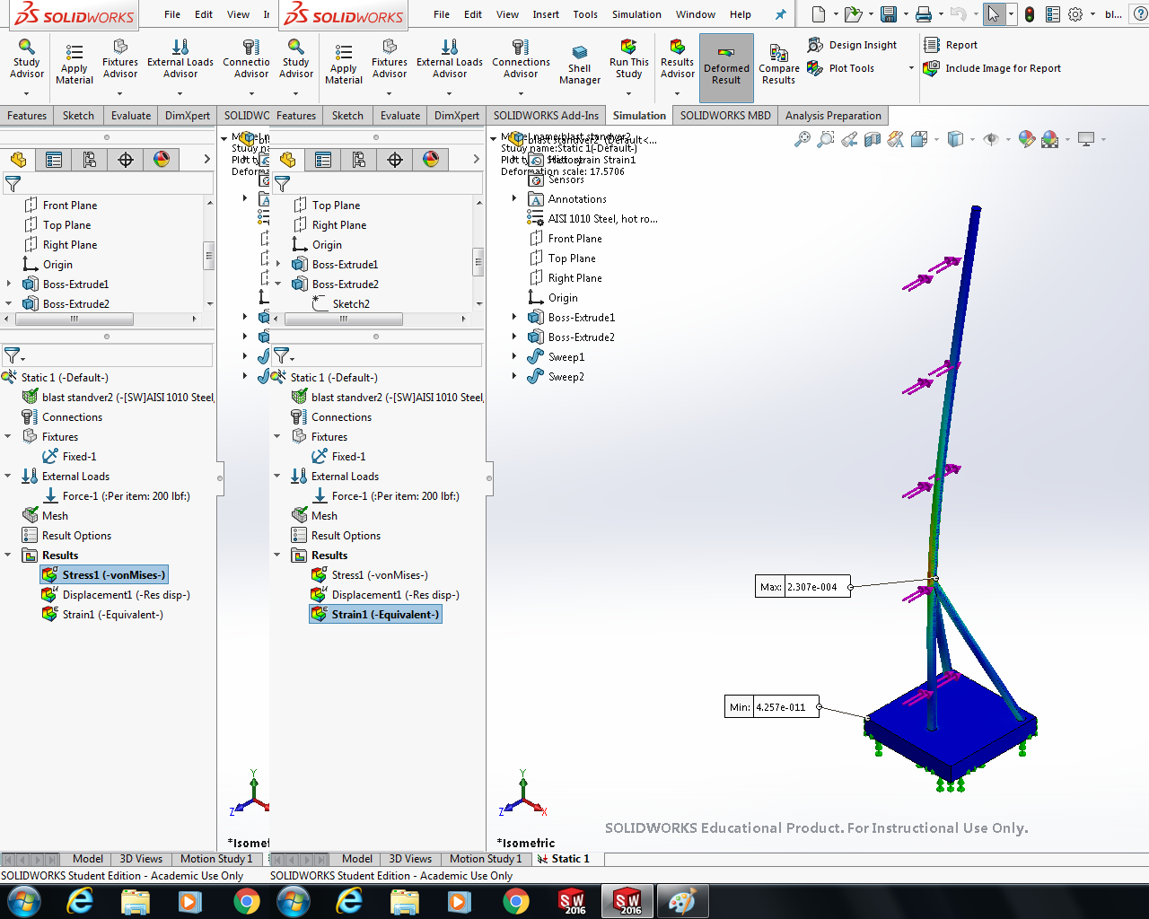
Fig 2.17

The Equivalent strain has also reduced from 496.2µε (Micro Strain) to 230.4µε.

Fig 2.18
Conclusion
To summarise the topics discussed about CAE Tools, it is a highly dependable utility that eases the implementation of engineering drawings and analysis. However, the drawbacks to this comes at a price, and the forever changing climate and technological advance requirements needs the adaptation and more complex versions of CAE Tools. The features that the CAE packages include remove the need for physical full scale replicas or prototypes to be manufactured, so the Finite Element Analysis can be carried out within minutes and then the original design can be adapted accordingly.
Drawbacks with CAE Tools are also introduced by the requirement for powerful computing platforms, both graphically and by processing power. The cost of new or updated packages is the downside, along with training for the designers or newly drafted designers.
The drawbacks that I have found with using Solidworks® FEA is its limitation to the real world scenario and the selection of materials in the library, however, custom materials can be created and the materials parameters can be inputted so that the FEA can calculate on the figures defined.
In order for FEA to work and calculate effectively, a lot of pre-processing is needed, as described here by FEACOM solutions; ‘Speed and accuracy of simulation and analysis depends solely on the quality of meshing or the ability to prepare model geometry correctly.’ [7] This is because the FEA is calculating from a model that is geometry based, and one of the downfalls with CAE Tools is that if there is a geometry issue with a part or an assembly, for example, two ‘mates’ of two components have some degrees of movement, then a force or load will not be transferred through the bodies as intended.

Bibliography
[1] http://www.plm.automation.siemens.com/en_gb/plm/cae.shtml
[2] http://help.solidworks.com/2016/English/SolidWorks/sldworks/c_multi_user_environment.htm
[3] https://www.comsol.com/multiphysics/mesh-refinement
[4] http://www.dictionary.com/browse/factor-of-safety
[5] http://www.solidworks.co.uk/sw/pricing-information-europe.htm
[6] https://www.capinc.com/2014/02/12/frequently-asked-questions-on-von-mises-stress-explained
[7] http://feacomsolutions.com/cae-about-us-engineering-design-analysis-simulation-3d/finite-element-analysis-fea/pre-processing/

