Component 2 - Research Report
Student Name:Roxana Daniela Lemnariu
Student Number:2118526
Lecturer Name:Ngozi Ibeji
BMSW4003_BIRM
Digital Skills and Research Methods

Abstract

The concerned study will discuss the importance of collaboration tools for conducting online classrooms. However, the interview will be conducted based on the research questions to identify their individual opinions regarding this case. The suitability of the chosen methods for conducting the research will be done as well.

Table of Contents
1. Abstract 2
2. Introduction 4
3. Research design 4
3.1 Research Question 4
3.2 Method 5
3.3 Ethical Considerations 6
4. Results 6
5. Discussion 10
6. Conclusion 11
7. Reference List 12
8. Appendix A 13

2. Introduction
Collaborative learning has received huge importance nowadays. By following the research question it was asked which digital tool can be identified as the most appropriate medium for ensuring collaboration at UWTSD. It has been identified from the previous assessment that among various digital tools the use of collaboration tools to carry out online education can be proven highly effective. There are different teacher education courses that have been designed by UWTSD. To accomplish these courses among the teachers it has become important to ensure collaborative working interface.
The aim of the study is to identify the most appropriate digital tool that is commonly used in University of Wales Trinity Saint David.
The research problem can be derived by understanding to what extent the university has been implementing the digital tools for encouraging online education. The primary issue that the university might face is lack of understanding about which digital tool could be chosen here for having a seamless platform of online education as there are many (Clark, 2020).
The concerned study will encompass the discussion of different collaboration tools and its use along with the reason behind choosing digital tools nowadays. The chosen research methods and gathered data will be critically analysed.

Research design

3.1 Research Question
The following research question upon which the study will be conducted is:
“Which digital tool is most commonly used for collaboration at UWTSD?”

3.2 Method
For successful completion of the research the researcher has chosen several research methods.
Data Collection and Data Analysis
Data collection method can be identified as one of the most important aspects that cannot be overlooked by the researcher. For collecting data there are primarily two mediums such as primary and secondary (Taylor and Owen, 2021). Considering the wideness of the research question the researcher has decided to employ both primary and secondary methods of collecting data. Primary data can be collected through direct intervention and face to face conversation with the participants. It mainly denotes the way of gathering first-hand information. On the other hand, there is another way of collecting data that is a secondary medium. It has been identified that to maintain the quality of the data and reliability the researcher has used a secondary way by which information from already published journal articles can be gathered. Not only has that it also helped the researcher to understand the viability and real application of the data.
Data collection method is not sufficient to complete a research with appropriate conclusion. That is why it is necessary to employ different data analysis methods too. Data analysis refers to critically analysing the data that has been collected from different mediums such as primary and secondary sources. The major two types of data analysis methods are quantitative and qualitative methods. In this case to reduce cost of the research and increasing accessibility of the data the researcher has decided to utilise qualitative data analysis methods (Raskind et al., 2019). The reason behind choosing qualitative data analysis is to employ a multi method process that could involve both observational and evaluative conceptualisation of the data. By following this method, a semi structured online interview has been conducted on the other hand to analyse secondary data thematic analysis and various content analysis tools have been used by the researcher.
Research Philosophy
The concept of research philosophy can be recognised as another most important aspect of conducting research. It is a belief regarding the way by which the data collection could be done regarding a particular phenomenon. Not only that, the particular way by which the data could be analysed and used also can be determined by research philosophy. There are various research philosophies that can be used to conduct a research among which the researcher has chosen pragmatism research philosophy (Kaushik and Walsh, 2019). It has helped to bring different research strategies to complete the research and accomplish the goals.
Research Approach
The concept of research approach can be identified as a procedure that consists mainly of different steps of broad assumptions. Not only broad assumptions but it helps to combine detailed methods of data analysis, collection and interpretation. There are various types of research approaches, among which the most suitable one that has been chosen by the researcher is the inductive research approach. The inductive approach has involved a set of seeking patterns in those observations, empirical observations, and then understanding those patterns (Hoelzel and Scheiner, 2022). That is why choosing this method can be found appropriate.

3.3 Ethical Considerations
Ethical Consideration is an equally vital aspect that should be followed by every researcher while conducting research. It can be outlined that the first and foremost ethical concerns for the staff are confidentiality and safety. The shared data of them should be maintained and managed with utmost confidentiality. The most common ethical issues that the research could face are anonymity, informed consent and secrecy. That is why at the time of asking the participant’s questions, gathering their shared data and keeping them secure all these above concerns must be followed by the researcher. In this case an informed consent form has also been sent to the participants in order to assist them in conducting the study. Not only that, the informed consent form can help in gathering written consent from the staff based on which the further research has been conducted.

Results
Primary Research
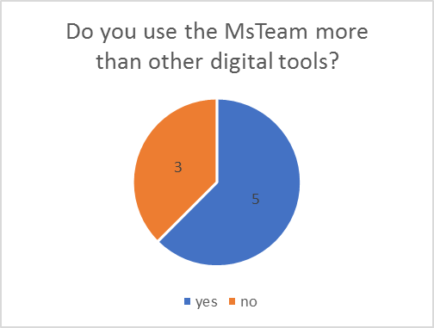
- Looking at the the graph clearly can be seen that most students prefer using MsTeam to collaborate with colleagues and teachers over others digital tools.

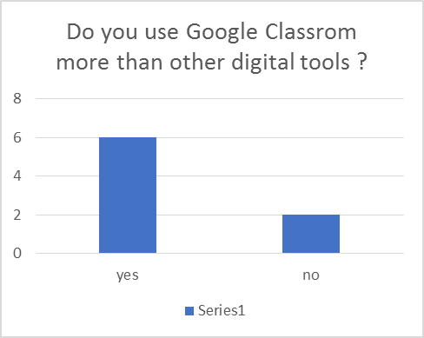
- This graph relates that students prefer to use the Google Classroom app to communicate with students and teachers to fulfil their tasks.
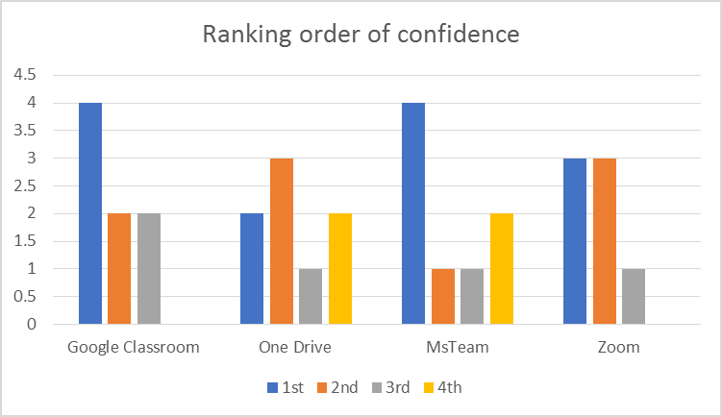
- From the graph above is understood that MsTeam and Google Classroom are the two top apps which students feel most confident using them.
- One Drive and Zoom falls on 3rd and 4th place in students and teachers preferences.

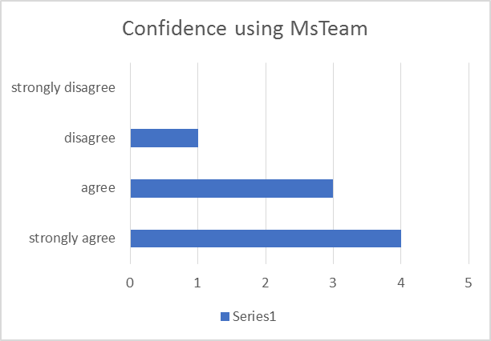
- Majority of students and teachers use and prefer MsTeam over Zoom for being easy to navigate on.
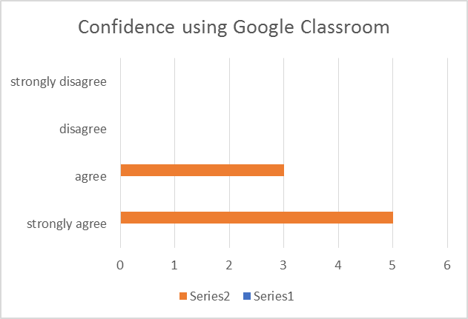

- In completion of this survey we can see in the graph most of the students and teachers are confident using Google Classroom to achieve their goals.

Secondary Research
Collaborative Learning for Virtual Environment
According to Alkhowailed et al., (2020), the use of collaboration tools in the current era has shifted the traditional educational method into online classrooms. On the other hand, the use and application of virtual environments has increased radically. The students and teachers have been observed to prefer digital and collaboration tools to continue learning.
Issues in using digital tools
Different issues can be listed here that may take place in this case. Lack of knowledge about the use of digital tools and increased price could be the major constraints (Parsons et al., 2019).

Discussion
Based on the asked questions and gathered facts different results can be drawn. Firstly, as per the first research question, to what extent digital tools can be found appropriate to conduct online classes among the students. To give a response in this regard the staffs has shared mixed responses. According to them, digital tools are found most important to conduct online classrooms. However, use of digital tools is not enough to conduct online classes as the physical presence of the supervisors to monitor individual performance is equally important.
According to the second question, the most common digital tools that are being used by the staff in UWTSD are Zoom, Microsoft Teams, Skype, and Google Classroom. Almost all the staff and teachers have responded equally in this regard. These collaboration tools help them to stay connected with the workplace and the students even during lockdown. The results have shown their clear knowledge about the use of online collaboration tools.
As for the most effective collaboration tools, the colleagues and teachers have stated that Google Classroom, Zoom and Skype are the most effective. Most of them have supported that the use of Google Classroom can be proven highly appropriate for conducting online classes.
In the next question, while asking about pros and cons of the digital tools they have enlisted many of these. Unstructured files, limited flexibility are the cons of MS Teams and Zoom. On the other hand, increased focus and enhancing team productivity are the pros found. While using Google Classroom, lack of a standard grading system has been identified as the most important con. However the easy accessibility has made this tool highly appropriate among the peers.
However, in response to the last question, they have faced several issues and that is why they should improve these aspects. Some of them have also stated that due to lack of technological knowledge they have been facing issues to conduct digital tools. They have also decided to take online training classes in this.
By conducting secondary research it is also found that the faced issues are real as many organisations encounter these constraints while using digital tools (Chick et al., 2020). Therefore the gathered data through both of these mediums are representing almost similar responses.

Conclusion
It can be concluded from the above discussion that the use of collaborative learning is highly appropriate for UWTSD. The students have preferably shifted towards a virtual environment and that is why the use of digital tools has become important in this case. The use of research methods have also proven highly appropriate in this case based on its suitability. Based on the my form and secondary data an appropriate discussion has been made that clearly show the importance of digital tools in UWTSD and major issues that the teachers and staffs could face.

Reference List
Clark, J.T., 2020. Distance education. In Clinical engineering handbook (pp. 410-415). Academic Press.
Alkhowailed, M.S., Rasheed, Z., Shariq, A., Elzainy, A., El Sadik, A., Alkhamiss, A., Alsolai, A.M., Alduraibi, S.K., Alduraibi, A., Alamro, A. and Alhomaidan, H.T., 2020. Digitalization plan in medical education during COVID-19 lockdown. Informatics in medicine unlocked, 20, p.100432.
Parsons, D., Inkila, M. and Lynch, J., 2019. Navigating learning worlds: Using digital tools to learn in physical and virtual spaces. Australasian Journal of Educational Technology, 35(4).
Taylor, S. and Owen, M., 2021. Challenges to school-based physical activity data collection: Reflections from English primary and secondary schools. Health Education Journal, 80(1), pp.106-118.
Raskind, I.G., Shelton, R.C., Comeau, D.L., Cooper, H.L., Griffith, D.M. and Kegler, M.C., 2019. A review of qualitative data analysis practices in health education and health behavior research. Health Education & Behavior, 46(1), pp.32-39.
Kaushik, V. and Walsh, C.A., 2019. Pragmatism as a research paradigm and its implications for social work research. Social sciences, 8(9), p.255.
Hoelzel, D. and Scheiner, J., 2022. Mapping opportunity in time and space: An inductive approach. Journal of Transport and Land Use, 15(1), pp.207-229.
Chick, R.C., Clifton, G.T., Peace, K.M., Propper, B.W., Hale, D.F., Alseidi, A.A. and Vreeland, T.J., 2020. Using technology to maintain the education of residents during the COVID-19 pandemic. Journal of surgical education, 77(4), pp.729-732.

Appendix A
Primary Research



