Understanding and engaging in the customer experience.

Liliana Calin
ID NUMBER – 181714
BMSW5103_LON
Report.
Table of Contents
1. Introduction
2. The major key to persuasive the core values in Amazon.
3. Customer service / centrality
4. Customer agreements
5. Manage the data of CRM
6. Connexion Amazon employees experience to its customer experience.
7. Dealing with customer’s beliefs and assumptions.
8. Searching process of the commercial sellers.
9. Requirements and administrations of procedures in Amazon that achieve the customer’s necessities.
10. Assurance of quality products and effective expectations of customers.
11. Customer Value.
12. Conclusion
13. Reference

Introduction.
In the world of Business industry, Amazon it’s one of the biggest and successfully company around the world. Apart that this organization provide jobs to people it also help us to access different accessories and products we would like by only going online and search for the product you want. This company provide us different expectations in terms of how deals with customer feedback, as the most important factor are the satisfaction of customers.
In 1995 Amazon launches an online books sells then the E-books arrives at Amazon had a good strategic plan to become a successfully brand on the market .
In 1995 Amazon become the biggest sell platform in the world, in 2005 Amazon launches prime membership that brings a high number of customers and offering a quicker shipping to selected items.
In 2007 Amazon launches its first technologic platform product which it’s the KINDLE.
Perhaps the company launched the first smart device the echoes speaker called ALEXA which it’s an artificial intelligence system.
By December 1996, and the endings of next year October 1997, Amazon had around 1,000,000 customer accounts. The number of employees working for this company it’s surrounded by billions of people working for this company.
This company clearly showed that they offer us different easy products and accessories, which it’s very easy to access. They also demonstrated that they want the well features for the customers by developing devices to make it more comfortable and affordable.
In this report I included the main introduction about how the company developed different technologies, including the customer accounts and the number of employees. I would also support and provide how they adopt and focus on the higher part which it’s the customer satisfaction.
I would also be able to core the values and customer agreements including the feedback and customer evaluations of how they are part or how they find it in terms of the quality, good service, deliveries at the right time and the different facilities.
In resume I will cover the extract information of this company and the treasure of how important this company it’s for the people and the strategies they used for the marketing to be able to provide a trade marketing for people. We can clearly see that amazon it’s an important player on the market and its diversity make this company more approachable and researchable in the online platform by thousands persons around the world.

2. The major keys to persuasive the core values in Amazon.
Amazon have a constant focus on the next factors to make easy the organisational ability to improve consumer perception engagement and customer values .
1 Key Customer service is the principal and most important service that amazon satisfied their consumers following this steps. The report which accumulate 75.000 satisfaction survey s quantifies customer experience by counting scores on a 100 point scale amazon receive an 87 in customers satisfaction .
2 Convenience Clearly amazon has a great pact to do with the online retailers customer experience . The availability of the products, self service , Returns. Special delivery , Live chat and a large variety of the technology is clearly a point of a customer satisfaction.
3 Research personalization. Amazon adapt a nice strategy that you can browse and search a product that is coming with a lot of recommendations and feedback . Also they offering specials kits trough that particular order .
4 Trust of brand . Amazon ensure good quality , diversification , innovation , fast delivery and much more . Even if doesn’t no offer discount or deals , costumers still buying from the site amazon . com . This can be a amazon aptitude to keep its costumers, which can be exposed in word of trust that amazon has create for self . This confidence still essential as it shows the consumers trust , to keep long term its efficiency of the organization.
5 The expectation of consumer
Amazon is visible important and influential business on customer behaviour . The most important change that amazon effect on costumers prospects looking through to the accessibility and quick delivery process on online shopping . This among with the customer service clearly put the the most important factors which are the consumers has altered supply management importantly .
Supply change management
All the customers preferred a fast delivery and expect more fast . Great customer service impacted online and offline shops similar to maximize their logistic to meet customers requests . The arrival of information has developed a necessity for supply chain vision that can scale . This intensified difficulty has created a enormous tension on supply chain management , and made real time solution to produce an effective logistic .

3 Customer service / centrality
The next step what amazon take in consideration are the customer service/ customer centrality , The founder Jeff Bezos declare for BBC news “ we see our customers as invited guests to a party , and we are the hosts . Its our job every day to make every important aspect of the customer experience a little bit better” this protocol is followed in this brand . The steps that are included of the customer service / centrality are : A – customer focus is a way to develop a good customer experience by produce fast ordering and delivery, making use of data to personalize customer preferences . The aim for amazon is to centralize customer importance . Their assignment is to rise the experience of the costumer making use of the technology and the internet to help the costumers find , discover and buy diverse products and empower the organization and his content creators to maximize their success . They trust in their mission is important empower their customers and business by improving good standards and drives economic competitiveness and productivity in a global economy. Amazon reinforces workers to stay focus on customers demands and needs. The organization in continuous is adopting best strategies and change in costumers preferences . Through this characteristic amazon maintains an effectiveness process to satisfy their customers as the e-commerce business expansion. Amazon . com structural culture implicate individuality . The organizations encourage its employees to feel themselves and their work as important and familiarize in the way of doing own business . They motivate their staff think bigger and large to maximise business potential, and bright ideas and solutions. Amazon has spent so many years perfecting their customer centric value to there are well poised to give a big treat to many stores worldwide . They create over years a corporate culture around the customer and their needs . I have experience their service many times and strongly feel their amazing commitment in delivering customer service . In any organization there is no doubt that customer friendly or customer centric behaviour is the key to organization success. Customer centric is not just about offering amazing customer service is more than that . Is a mindset of putting customer first and at the core of the business. A famous leader in 1890 Mahatma Ghandi had said in a speech in south Africa . “ A customer is the most important visitor on our premises. He is not dependent on us. We are dependent on him. He is not an interruption of our work. He is the purpose of it. He is not an outsider of our business, he is part of it. We are not doing him a favour by serving him, he is doing us a favour by giving us the opportunity to do so.”
This is the words well worth centralize of all customers connections . If we consider the idea of expanding warm, welcoming the customers with courtesy and attentiveness, sooner than offering good technical effectiveness on a transactional basis, receiving costumers with polite to us rather than the nearby way , then we will discover the truth about what really customer satisfying service can be .

4 Customer Agreements CRM
Amazon keeps a good relationship has one of the benefits of CRM . In conclusion to get costumer happiness and devotion amazon is making use of Customer Relationship Management system to take background of the customers . All the personal details of consumers , their personal credit cards details, their profile , the history of order are recorded on data base . The system process the orders using a secured transaction method and it delivery instruction for delivery driver .
Amazon has advanced software that already includes all its requirements. CRM offers customers the answer without help of human intervention. The system shows all product details and the date of arrival of the product description and recommendation , payments, return policy , stage of delivery . This mean it can be done without the need for customer service personnel. Benefits of using a customer relationship management in a organization is a important process who brings a lot of benefits, and involve some facts .Improve customer relationship this is the most important benefit because involve the customer satisfaction. Using service marketing, and sell products to the consumers and will be managed in a systematic way . This can offer a best service to consumers understanding subjects /needs this will get to a stronger consumers devotion .
Improving own CRM strategy amazon keep customers, and adapt its service near the individual, and surely its helped to sell to its thousands of engaged customers not one time but over and over fighting with strategies of competitors amazon interface is keeping customers coming back and is simple and easy to use. Amazon making use of CRM has been involved in a good way on the growth of its sales . Its devotion to its customers treat to the creation of the Kindle, though amazons online Kindle marketplace give a big experience with every book suggestions. Amazon prime video become massive streaming services everywhere . It gives hand picked film and tv choices for every customer, which was something imposible without a good use of customer relationship management .
“we see our customers as invited guests to our party, and we are the hosts its our job everyday to make every important aspect of the customer experience a little bit better.”- Jeff Bezos. Founder and CEO of Amazon.
5 Manage data of customer relationship management
.Improve customer relationship this is the most important benefit because involve the customer satisfaction. Doing service , marketing, and selling goods to their consumer can be solved in a systematic way . This can offer a best service to customers futurity issues /wants this will help to a stronger customer loyalty. Amazon has a successful customer relationship which I will present below:
- Collection of data. Customers shopping from amazon must create an account which makes easier buy futures purchases. This fact is a opportunity marketing for the company because customers can be emailed with the promotions based in their own past purchase .
- Personal data storage . When the costumer create the account all its personal details adress, email, and contact details are stored for a quick and easy purchase . This is making customers a quick way of purchase .
- Recommendations . Amazon is the king in giving recommendations of a product. When a costumer is login in he can see a lot of recommendations and deals of a product . This can be based in the past purchase or in new deals of a product.
- Amazon Kindle . This device is showing us that amazon is the king of innovation. Customer can enjoy free books. Music, games, access to libraries, dictionary . Obviously customers are satisfied whit this technology and gratefully surprised .

6. Connexion Amazon employees experience to its customer experience.
Buyer seller relationship mean a good interaction and engagement between the consumer and company . In this case Amazon the buyer-seller relationship implicates the relationship between the company and its individual customer. For example Rain design has been selling a aluminium laptop sell on amazon for a long period of time it was a best seller on its category . the product has a 5 star ratting and 2,460 reviews . By quantifie and measuring the strenght of a relationship is the success of a good relationship between buyer and seller . example of types of relationship that amazon follow .
- Create and interact user interface .The interface is minimal ,navigable and simple to understand . I can give some example of why amazon is a winner of good crm .
High quality images of the product , precise description of a product , clearly prices , easy and clear checkout process .All these elements help customer buy easy way.

- Provide human support .Amazon have a lot useful ways to communicate with company . can be done via email, live chat or by phone . This support resources is available 24/7 which means the availability of customer service is making amazon be the most succsefully online company worldwide .
- Loyalty . Amazon have a loyalty program which is amazon prime . This subscription is offer a fast delivery or a same day delivery, amazon best deals , best discounts . Customers willing to become part of the prime membership have to pay 120 usd annually .
We can clearly see that amazon have a lot of contents to offer to their customers , offering the best support and deals for making an amazing experience to their buyers. We can see its easy to build a good relationship between the company and consumers using the crm keys to amplify the trust of brand and get a successfully productivity.

7 Dealing with customer’s beliefs and assumptions
Normally some customers want much more for a company that they can do . To solve this problem some companies apply different strategies to amplify the customers expectations of the offer products. Statistics show that only 40 % of consumers expects the quality of a product and 20% expect less . To resolve this issue amazon applies a few strategies in managing costumer assumptions . Loyalty incentives with amazon prime membership costumers pay 10£ per week to have the fast and next day delivery . This brings a lot of benefits for the company because majority has open an account and subscribes to be a membership. This make amazon leader place that prime member shop. This program also include occasional discounts offer, free shipping , free products with purchase. This subscription brings a lot of discussion between customers . Some of them are agreed with this subscription if they want to have a quick delivery and good promotions and make use of this benefits comparing with the normal account. People are free to choose

8 Searching process of the commercial sellers.
Amazon is owner of the best 3 spots of almost every single customer questionnaire in relation with costumer service , technology , and revolution , company trust of company development . Regardless of the questions what, where, when amazon has a irresistible interaction in the market manufacturing . They see that continue to influence their buyers and seller interaction in the world . To get a better idea of how potentially is amazon and how influenced on the people buying feels . Loock trough how the product has changed customers behaviours , prospects and effects . Having a good and easy platform of how buy and sell amazon makes costumers fell more comfortable . Amazon share of the us commerce market is now 49 % or 5% of all retail spend. Their attempts is developing costumers trust in online research transactions this evolutionary program buyer behaviour has involved on the strength of amazon to convince their costumers they could trust an the brand and buy their products with confidence . Amazon changed when costumers shops buy making shopping online convenient and competitive . A study report that 24/7 costumer access to amazon to buy and look their products even if is working, relaxing, or be in a bathroom. We can se amazon has addictive costumers and trust brand in any circumstances. Amazon has regularized the idea of quick an free delivery . A 62% of online shoppers rank free shipping as the most important service when its come to e commerce . Amazon is sale search engine . Its help people find exactly what they wants , recommendations, costumer profile , history of research and much more . Practically is making a easy way to their costumers to handling the correct product.

9. Requirements and administrations of procedures in Amazon that achieve the customer’s necessities.

The most common and important aspect that the customer is looking for in any organization is the quality of a product . This can be the most important piece to build the customer satisfactions and the customer trust of brand . Amazon make a big work to build a good customer satisfaction by sitting best ideas to maximise the quality of any operation . They focused in continuous improvements to raise the quality standards of their e-commerce business . These are the steps which amazon follow to get a success strategic quality management :
Leadership Amazon have some leadership principals that are set and follow by their employees . The management expect to unify the employee to have a good teamwork and help managers achieve the aims of this organization. Another important aspect of amazon is that they saying to employees to use their instinct , show their ideas and issues to improve and eliminate their scare and create trust and confidence with the company .

Planning
Maintain an organization successfully requires handling a good strategic plan that’s its introduced into levels of a company that will bring best results and efficiency in count to standards to be made . Amazon ensure that every employee and staff must be unifies and having a good understanding of their tasks and make be well managed .Over 20 years amazon begin with a small online book retailer back in 1995 and in 2015 has celebrate 20 years birthday with a capitalisation market around 245bn ( Quinn 2015).

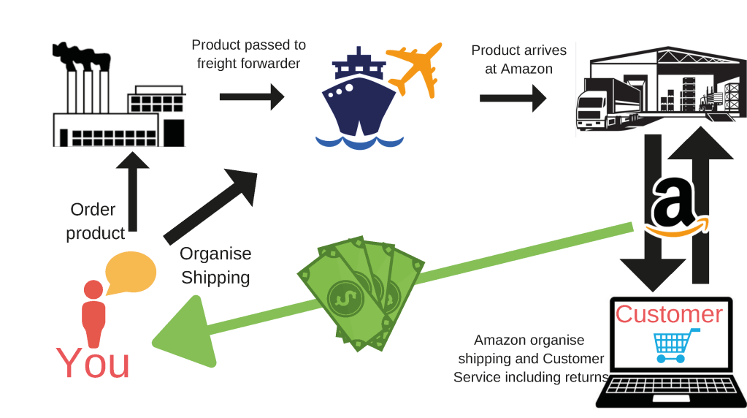
Once a strategy has been applied and developed they evaluate and choose the best one . Amazon follows few test to ensure precise evaluation . The first is check that the strategy has consistent goals and polices , how to adapt a good strategy , and how to manage the external factors .

Design quality /assurance
Is a important aspect the design quality of the e-commerce website packaging , delivery and the way how they make look like the operation management. Improving and implementing the quality system of an organization is the assurance of elimination of upcoming errors . Amazon make sure offer to their customers different information about the product . The customers can search information of each product read their description, and check their reviews . With more than 261 million products amazon library can easily break up the difficulties that some customer can meet in a normal library . The amazon warehouses make sure that their employees is treating each product and wrap carefully putting the best attention and offer satisfaction to customers orders. Amazon in order to be the first cloud service to achieve the iso9001 certification. The quality system is implementing effectively as has been premier as an result . Maintain a high quality content and images on amazon is one of the priorities that company wants to keep it high , most of the buyers start looking these aspects what brigs it all together to crate a passion and trust in their products.

Constantly improvement
This factor is very important for any organization to grow up and face the upcoming challenges in further . Every organization wants to be the most successful maintaining high standards offering best services and evaluate their values of each products . Amazon clearly grow up with time and innovate ways to gain the competitive edge and meet the expectation of the best performance . Amazon is one of the largest player in global market in information technology and online service . Having a lean mindset is a strong culture that was built at amazon. The core mission of amazon is offer to customers what they want and need. The employees are empowered to own action and achieve higher standards . The company believes in the senior managers and the way that they try to improve the business . This mindset is making amazon to be the giant technology that is today , and its start with a strong belief which is deliver to their customers the value and continuous improvement to built biggest thigs.

10. Assurance of quality products and effective expectations of customers
Quality its go first when customers think to buy an product , and the organization are request to maintain a good level of quality . quality control is essential factor which forces an organization to produce every product which should meet the basic expectation of every customer checking the quality control helps to eliminate the waste of the organizations production and amplify productivity. Amazon is trying to recognize their customers needs and is making possible by achieving information and offer suggestion on its own research . When an organization is concerned about the quality all the staff and the other parties like suppliers are focused to offer the best quality products . Amazon always focused on their products , design and quality . The online platform that amazon have is clearly visible all the feedback and reviews from customer as they rating and share their opinion for each product that they buy it. So is impossible for amazon have a poor quality products because the negative feedback can be present all time . Maintain a good customer satisfaction is also a fact that amazon taking into account . Because having a happy customer is the key for success for any organization . The word of mouth we know is the most efficient strategy and the most successful.

11 Customer value at amazon
The definition customer value is defned as the difference between perceived benefits and perceived costs. There are 3 terms define value which are: customer needs, the attributes of a product or service and the overall cost . In other word customer value is the level of how satisfied a costumer regarding the product and for what we paid and what benefits is receiving back . Quality , packaging, price, Amazon have 3 customer value proposition which are Low prices, Fast delivery speed , vast selection. Amazon CEO Jeff Bezos has drawn up a virtuous circle that they taking as example and using on the organization . Selling products lowest was the first objective that amazon have when founded this company . Amazon has the selection to move their lower cost structure into higher profits and give some of the profits to the shareholders via dividends. Amazon creates value for its consumers by offering best services to maintain customers satisfied . Operational efficiency is the strength of amazon command supports the management to get the competitive advantage and develop a high performance .Amazon .com create value for the customer by offering a large list of products and ensure the right time delivery . Amazon adopt with time a lot of strategies by focusing of their customer experience of online shopping and delivery best services with complete convenience to their customers.
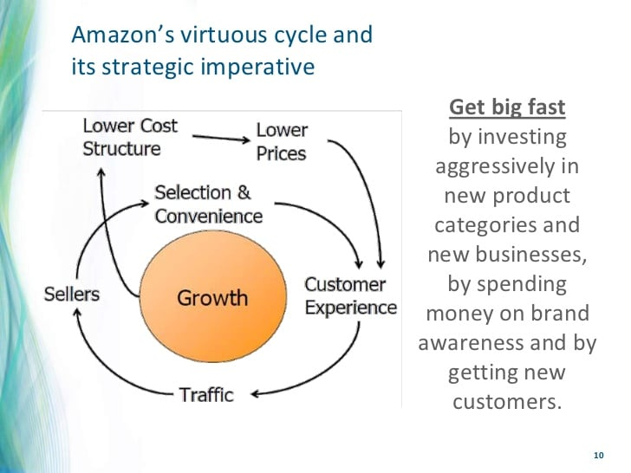
FIGURE 1 AMAZON VIRTOUS CYRCLE , Zentail. Com12 Q a
We can see amazon is maximizing costumer value by focusing in the most valuable consumers.

12 Conclusion
Nowdays customers are free to compare and create ideas and their preferences when is time to choose an organization. This is why their expectation and the behaviour fact toward loyalty and buying intention has been introduced. In this report we discuss and analyse the customer experience, the expectations , and involvement of the company in order to have satisfied customers, how important are the customer expectations and the way that the organization trying to provide . Customers loyalty is a self -reinforcing system in which the organisation deliver a great value consistently to fiind an keep a high quality to customers . We can see amazon achieve a better marketing implementation . Amazon is the king of the marketing strategy , publicity, technology, prices, fast services, low prices, diversity , and best service customer. Amazon is Higley strategic company , and it has been since its inception. It will continue to use its customer – centric philospy as a compass in the future . Amazon has developed an unprecedent customer support only in the span of last 15 years with its unique business model of online business . It overpass all the supply chains to reach to the consumers through it innovative e-comerce approach . The company hires the distribution channels and warehouses in the areas where the cost of dumping inventory is extremely low and forward its saving to the consumers in the form of copeetitive prices. Amazon needs to keep focusing on the research and development of better and more innovative way of serving to the customer, which its not only maintain its market leadership in the online business but also allows it to be all time favorite to millions of its loyal costumers around the globe .

13 References

Lemon, K.N. and Verhoef, P.C., 2016. Understanding customer experience throughout the customer journey. Journal of marketing, 80(6), pp.69-96.
Kamaladevi, B., 2010. Customer experience management in retailing. Business Intelligence Journal, 3(1), pp.37-54.
Rawson, A., Duncan, E. and Jones, C., 2013. The truth about customer experience. Harvard Business Review, 91(9), pp.90-98.
Adcock ,R& Collier,D., (2001), “Measurement Validity”:A Shared Standard for Qualitative Research, the American Political Review”, The International Journal of Social Economics ,Volume .33,No.1,pp 529-546.
Duffy,D.L.,(1998), “Customer loyalty strategies”, Journal of consumer Marketing , Volume 15,No.5,pp435-448.
Spector, Robert,2002. Amazon.com:Get Big Fast , New York : Harper Business.
Stone , Brad. 2013. The Everything Store: Jeff Bezos and the Age of Amazon . New York : Litlle , Brown .
Conelly, P.J.and Yoger ,T. (2001). “ Can CRM win and retain loyal repeat customers?”, Info World ,17 April, pp.58-9.
Lee E.J.and Overby J. W. (2004) . Creating Value for Online Shoppers : Implications for Satisfaction and Loyalty . Volume 17, 2004.
Arora , R. (2017) . The influence of trust and brand image on purchase intention in online shopping : A comparative study between Amazon and Flipkart. Adarsh Journal off Management Research , 10 (2), 1 – 13.

