Lewys Thorne
UWTSD – 2214464
Lecturer – Richard Sutton
Reflective Project Report
Group Project – ACMA5009

Contents
1. Introduction 2
1.1.1 Aims and objectives of this report 2
1.1.2 Aims of the report 2
1.1.3 Objectives of the report 2
1.2 Project Background 2
1.2.1 Aims of the project 3
1.2.2 Objectives of the project 3
2. Gantt Chart 3
2.1.1 What is a Gantt Chart 3
2.1.2 How a Gantt Chart was used for this project 3
2.1.3 The Benefits of using a Gantt chart in a project. 4
3. What is organisational change 5
3.1.1 The importance of organisational change 5
3.1.2 The importance of organisational change for this project 5
4. The Project 6
4.1.1 Comparative testing of measurement devices 7
4.1.2 Master Encoder Inspection 8
4.1.3 Readhead calibration and stability 9
4.1.4 Gain and accuracy testing across scale types and ring sizes of known product 9
4.1.5 Failure testing 10
4.1.6 Volume Production 10
5. Project management techniques 11
5.1.1 Critical Path Method 11
5.1.2 Scrum 12
5.1.3 Kanban 13
5.1.4 Waterfall 14
6. Review of the project and the techniques used 15
7. Analysis and Conclusion 16
8. Bibliography 17
9. Appendices 20

Introduction

Aims and objectives of this report
This report is a reflection of a project which was conducted over a time period of three months, dating from November 2022 to January 2023.

Aims of the report
The aim of this report is to analyse the efficiency and effectiveness of the project management techniques which were applied by the relevant employees, managing the change.

Objectives of the report
The objective of this report is to compare the project management techniques which were used throughout this project. Process changes and management theories will be researched to explain how they may benefit a project.

Project Background

The project in which this report will be evaluating was conducted within the Engineering manufacturing facility, Renishaw, located in Miskin, Wales. Renishaw is a global engineering company which prides itself in creating high precision metrology and healthcare equipment. (Renishaw plc, 2020).
The process change occurred within the encoder ring department at Renishaw. Encoder rings are rotary or angular sensors, which place a highly accurate scale on the outside diameter of the circular object. The device can provide feedback on the position and speed of the rotation (eltra-encoder.eu, 2019). These rotary encoders are ablated using a 10kW laser which burns lines onto the surface of these rings. Once the rings have been ablated, they will be tested with a readhead at the place they have been burnt. The read head is equipped with an optical system and electronics that produce an electrical output signal that indicates the readhead's position and motion in relation to the scale on the ring (Renishaw.com, nd). Once the ring has been tested where it was burnt, it will then be taken to a final test rig which will perform an identical test with slightly different tolerances. Two good tests are required for the ring in order for it to be sent to the customer. This report will focus on the implementation of a new final test rig.

Aims of the project
The aim of this project was to implement a new final test rig (also known as a calibrator) which can test encoder rings which have been ablated. There were currently four final test rigs within the production area. This project would be a duplication of these test rigs. The reason for this extra calibrator was due to the potential increase in orders for encoder rings. It was unsure if the current four calibrators could withstand the extra throughput of rings, so it was decided a new final test rig would be needed.

Objectives of the project
For the project to run smoothly, a team of one engineer and two technicians were chosen to undertake the prove out of the final test rig. The prove out report was written by the engineer, and it was the responsibility of the technicians to follow the instructions to produce a fully functioning calibrator.

Gantt Chart

What is a Gantt Chart
A Gantt chart is a very common tool used in project management. The Gantt chart is a visual display of activities (tasks or events), plotted against the estimated time it should take to complete those activities. A bar is used to symbolise each activity. The length of the bar indicates the activities start, middle and finish dates (Gantt, 2019).

How a Gantt Chart was used for this project
A Gantt chart was created by the project manager/engineer of the team. It was agreed between the engineering team managers and the production team managers the maximum time required to complete the prove out of the new production facility. During the meeting, a list of all the relevant activities were created, and an estimated time it would take to complete these tasks was also recorded. These activities/times were then plotted into a Gantt chart as seen below:

The Benefits of using a Gantt chart in a project.
Using a Gantt chart for this project was very beneficial for many reasons. Firstly, the Gantt chart detailed all the relevant tasks/activities which needed to be completed for the production facility to be fully operational. The Gantt chart can highlight potential limitations or constraints in the project, this allows project managers and team members to identify the issue early on and make the necessary adjustments (Ramos, 2021).
The Gantt chart is an easy visual tool for everyone to understand, it includes the order in which the certain tasks will start and finish (Donato, 2018). This was beneficial for the project as some members of the production team had not seen or used a Gantt chart before, however they were able to easily understand the tasks which would be completed and the estimated time it would take.

For the Gantt chart for this project, please see the appendices at the end of the report. The Gantt chart illustrates the planned time it would take to complete each task in the prove out plan.

What is organisational change
Organisational change is the actions a business takes to alter or adjust a significant component of its organisation. Some changes to the organisation may include increasing in size by implementing more production facilities, new technology, company culture or new management/hierarchy change (Miller, 2020).

The importance of organisational change
It is incredibly important for an organisation to constantly research and develop, to ensure they do not fall behind in the competitive market (Simens, 2023). Organisational change allows an organisation to adapt to new technologies, potentially leading to cost reduction over time (Ross, 2021). Malik (2021) on the contrary believes that organisational change can also be potentially negative if it not performed correctly. Ineffective change communication is one of the main reasons organisational change fails. If the change is not communicated throughout all employees from high management to operator level, confusion can arise, potentially decreasing the employee performance.

The importance of organisational change for this project
Organisational change is a constant within the Engineering company Renishaw. This project was implemented due to the foresight of increased orders. It was calculated that the current production facilities would struggle with the estimated increase of orders, so it was decided ahead of time to install and prove out a new final test rig in preparation for the higher potential throughput. Thorough planning allows goals and objectives to become easier to achieve, and potentially receive greater results (Lambert, 2022). The average throughput of encoder rings ablated in each lab from January 2022 to July 2022 was approximately six thousand rings a month. It was estimated that the orders would increase to around eight thousand rings a month from the beginning of 2023. These figures were communicated to the engineering and production team from managers higher up in the company. The engineering team then advised the production managers that a new calibrator would be beneficial for both teams and the company. This good communication between team managers enabled the process of the new production facility to begin.

The Project
# | Test | Expected result | Result
1 | NCTD probe vs Mu checker results | Within 1um of each other at tooling offset of 10um | Good
2 | Master encoder inspection | Good result with a recorded error of less than 0.4 arc seconds | Good
3 | Readhead calibration and stability | Calibrated readheads to hold calibration value to 2% over full test time period | Good
4 | Gain and accuracy testing across scale types and ring sizes of known product | All product to pass/fail with values within 3% of those seen on control test rig. | Good
5 | Failure testing | Rings to fail as expected | Good
6 | Volume production | All product to pass/fail with values within 3% of those seen on control test rig. | Good
Once the final test rig was in place, the prove out of the calibrator could now commence. The prove out would consist of different tasks and activities which would need to be performed before signing the machine off as fully operational. The prove out testing was designed to ensure that the new calibrator componentry was functioning correctly and that all mechanical and measurement devices were correctly aligned. The test results would then detail gain and accuracy results of known products to ensure all final test machinery in the Miskin production facility could operate to the same level and return results in a comparative way. The new test rig was a duplication of the other four final test machines which were currently signed off and handed to production. Below is a table detailing the tasks which would be involved in the prove out plan:

Figure 1. Table of the prove out performed on the final test rig.

Comparative testing of measurement devices
Figure 1 shows that the first step of the prove out was to perform the MU checker/NCDT Probe comparisons. The MU checker and NCDT probe are both types of measuring device. The MU checker is very much a DTI which is placed onto a surface, and the flatness/runout and straightness can be recorded (www.judgetool.com, n.d.). The NCDT probe or non-contact probe works in the same way, however the probe is able to tell the distance from what is being measured without any contact.

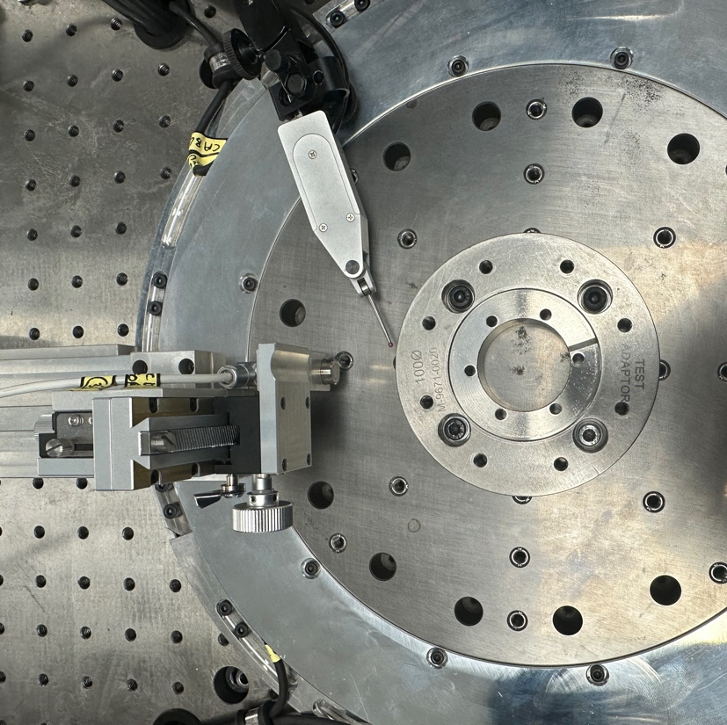

Figure 2. MU checker and NCDT Probe next to 100mm ring adapter.

The comparative test is performed by setting up an adapter onto the final test rig. (The rings which have been ablated in the labs will be installed onto the adapter using allen bolts. This is so that the ring is secure when it is tested with the read head on the final test rig). The adapter is secured down to the top plate of the final test rig (as seen in fig 2) using four M5 allen bolts. The first check was to clock the adapter up to within ten microns using the MU checker. Once the adapter was bolted down with ten microns of runout, the NCDT probe would then measure the adapter’s runout. The idea was that when the adapter is rotated around, both measurement devices show ten microns of runout.

The test was then repeated, clocking up the adapter to a runout of one micron using both measurement devices. The results are shown below:
Figure 3 and 4. Graphs showing the comparability of the two measurement devices.
The graphs above show that both the MU checker and the NCDT probe gave comparable readings over the two different set runouts.

Master Encoder Inspection
The next stage of the prove out was to test the master encoder on the final test ring. The top plate in which the adapter and rings are bolted down to spins due to an air bearing underneath it. Within this air bearing there is a “master encoder” ring. This ring is a 300mm high accuracy ring which tells the system its position down to a very high accuracy. This prove out test ensures that that master encoder ring is suitable for production. To complete this test, a jig with a 300mm ring is placed on top of the top plate of the calibrator. Once bolted down, the ring is using a readhead in multiple places around the ring. Each test would give an accuracy result in arcseconds. The overall average of the accuracy around the ring is plotted below.
Figure 5. Result for master encoder test in arc seconds
The result in figure 5 shows that the testing of the master encoder ring resulted in an arc second error of less than the design spec (0.4 arcseconds).

Readhead calibration and stability
The read head calibration was a very important test for the prove out of the final test rig. The purpose of the read head is to read the ablated scale on the encoder ring. For this reason, it was paramount that the read heads were calibrated and reading correctly. To complete the calibration, a calibration artifact was used. This calibration artifact was a piece of known ablated scale ranging from 20, 30 and 40 micron lines. This scale artifact is placed in front of the 20, 30 and 40 micron readheads. The readheads returned a repeated and stable gain result which was comparable to the other calibration test rigs.

Gain and accuracy testing across scale types and ring sizes of known product
A variety of tests were conducted using a set of known ablated product to see whether the new system would obtain test values for both gain and accuracy compared to the current final test equipment. The new final test machinery was used to process a set of highly accurate REX rings with extensive historical data, and the results were compared to past findings, whether good or bad, to make sure that the gain and accuracy levels were comparable. The matrix of known test products table, Figure 6, below, shows the rings that were used. Current and previous test values are shown with the results.
List of known products
Ring type | Serial number | Result (Historic) | Result (Current)
REXA30USA075 | 1W6L41 | Bad (acc) | Bad (acc)
REXA30USA100 | 2892P2 | Good | Good
REXA30USA150 | 070R18 | Good | Good
REXA30USA255 | 77F606SS2 | Bad (gain) | Bad (gain)
REXA30USA417 | 2128K6 | Bad (gain) | Bad (gain)
REXM20USA057 | 1PPP21 | Bad (acc) | Bad (acc)
REXM20USA100 | 089J11 | Good | Good
REXM20USA100 | 76Y416SS2B | Good | Good
REXM20USA255 | 76U19SS4 | Bad (acc) | Bad (acc)
REXM20USA417 | 76U199 | Good | Good

Figure 6. Table of results detailing historic known products tested on the new test rig
The result of the above testing displayed that the measuring system used in the final test calibrator would present gain and accuracy results comparable to that of the current final test machinery.

Failure testing
Failure testing is a way of comparing the new test rig to the current final test rigs already proven out. Failure testing is gathering a quantity of rings which are historically known for failing final test due to the accuracy being out of the required specification. As seen in figure 6, there are multiple rings which have a historic test of failing on the final test rigs for either gain or accuracy. When these rings were placed on the new test rig, the rings failed for the same issue. These results showed that all test machines failed the product in a comparative way.

Volume Production
Finally, the last stage of the prove out plan was the volume production. The volume production ensures that the new final test rig is capable of being handed over and used by production. There were several volume tests which took place to ensure that the calibrator was proficient and able to run in production. Large batches of the most common high running rings were taken from production jobs to be run through the test rig. All ring types and all scales were used (20,30 and 40 micron scale) to ensure that the calibrator could run large batches of every ring type produced by the department.
All products tested as part of the above prove out work were re-tested using one of the standard final test rigs, this ensured the final test result for each ring was from a proven production system. These secondary test results would also then be used to verify the new system was operating to a comparative level.

Project management techniques
“Project management can help teams plan, manage and ensure a project’s success” (Wojno, 2021). There are many different types of project management techniques which are used by organisations in industry to efficiently manage a project to ensure a smooth process and successful overall result.
Some of the management techniques which are adopted by organisations are:
- Critical path method
- Scrum
- Kanban
- Waterfall
(Wojno, 2021)

Critical Path Method
The critical path analysis is one of the most used project management tools within organisations. Harrison (1997, pp. 1) suggests that critical path analysis is a tool in which promotes logical thinking, and it is most effective when it used to analyse projects.
Tasks that make up projects must follow a schedule in order to finish them by the deadline. While the project appears straightforward, if the work isn't mapped out, the project's scope could easily spiral out of control and become unmanageable. The critical path method is very important when managing a project because it specifies all the tasks in the project which are required in order to complete the project. The tool will identify the tasks which must be completed on time, tasks which could potentially be pushed back and how much slack there may be. (Project Manager, 2022)
One advantage of using the critical path analysis for the management of a project is that the project managers are able to compare the actual progress of the project compared to the planned progress (Harrison, 1997, pp,4). Ramos (2022) believes that using the critical path analysis tool allows for easier prioritisation. The tool allows project managers to prioritise certain tasks within the project, depending on how critical they are for the completion of the project. Some tasks will have a float value, meaning that it is not crucial for that task to be done by the expected set date. These different float values and critical times allow for project managers to keep on track with the progress of the project.

Scrum
A small team is guided by a Scrum master in this project management style, whose primary responsibility is to eliminate any barriers to getting work done. A team meeting will commence every day (usually at the start of the working shift) to review upcoming tasks and any obstacles that need to be removed. Work is completed in brief cycles known as sprints. Scrum is a project management approach that promotes quick testing and development, especially within small teams. (Wrike, 2019)
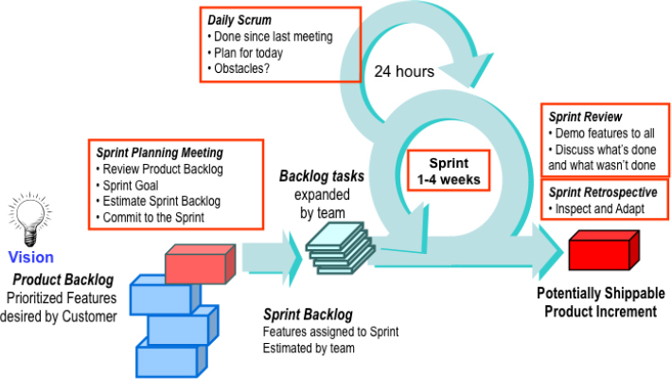

Figure 7. The original scrum framework. Source: Sliger, (2019)
Figure 7 shows the original scrum framework. A product backlog is created by the product owner, this is a log of all the tasks needed to complete the project. The product backlog will rank the tasks in priority order. The scrum team will then read the product backlog, dividing major tasks into smaller more capable tasks which are easier to complete. Once all the tasks have been analysed, the scrum team will create a sprint backlog. Within this backlog, the length of each sprint is determined. From here, daily meetings are held to review the progress of the project, and potential obstacles which may need to be avoided in upcoming sprints (Vasiliauskas, 2022).

Kanban
Kanban is another useful tool used in project management. The aim of Kanban is to visualise and optimise workflows, decrease waste, increase efficiency and enhance the teams focus. Kanban is a term that originated with Toyota engineer Taiichi Ohno and is derived from the Japanese word for "sign" or "visual board” (www.wrike.com, n.d.).
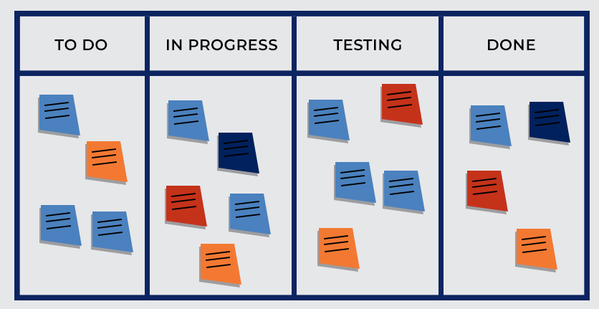

Figure 8. Kanban Board. Source: Adam, (2021)
Kanban does not rely on sprints, ceremonies, or roles, like Scrum does. Instead, by grouping jobs on a Kanban board into the To-Do, In Progress, and Complete production phases, Kanban is adaptable and conforms to current responsibilities and team structures. Figure 8 shows a typical Kanban board. The workflow of a project and how tasks progress through it from beginning to end are mapped out on the Kanban board, which can be physical or digital. With the help of a Kanban board, the workflow is standardised, and team members can quickly see where each activity fits into the bigger picture.
Each task or activity within the project is given a card. This card is a representation of the activity, and it is placed onto the Kanban board within the column it currently suits. As the task develops, the card will be moved along the board. Each card will include relevant information such as: A description of the task, the name of the person responsible for the task, a time estimation for the task and the requirements needed to move onto the next column (www.wrike.com, n.d.).

Waterfall
The waterfall method is one of the most traditional methodologies for project management, due to its ease of use and linearity. The waterfall approach is a procedure in which the project phases flow downward. The waterfall method suggests that the project should only advance onto the next stage once the previous stage is fully completed (Westland, 2021). Hoory and Bottorff (2021) agree that in the waterfall method, the workflow must be completed at each stage before continuing to the next. It is also states by Hoory and Bortorff (2021) that “Waterfall is well suited for projects where the objectives are clearly outlined from the beginning”.
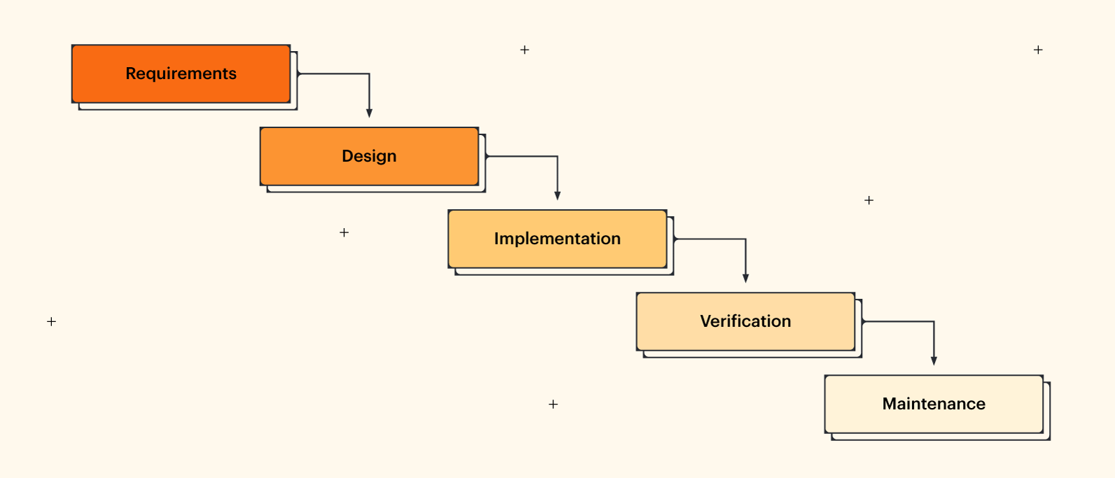

Figure 9. Waterfall methodology. Source: Lucid chart, (2017)
Figure 9 displays the five general stages of the waterfall method. These are: Requirements, design, implementation, verification and maintenance. Each stage must be completed before moving onto the next.

Review of the project and the techniques used

For the final test rig prove out project to be a success, multiple management techniques were utilised. The first management technique which was used was the scrum methodology. As stated earlier in the report, the scrum methodology for project management promotes quick testing and development, especially in small teams (Wrike, 2019). This methodology was ideal for this project as the team who were working on the prove out of the test rig comprised of two technicians and one engineer. The engineer of the team represented the “scrum master” and ensured that all potential obstacles were avoided. A product backlog was created by the engineer, in the form of a prove out document. This prove out document detailed all the tasks required to produce a final test rig capable of being supplied to production. The next reason as to why the scrum method was adopted for this project was due to the regular meetings every day. This was ideal for the team as there was shift work. The engineer of the team would work regular day shift, the two technicians would work the opposite shifts (mornings and afternoon shift). At 2 o’clock each day, all members of the team would be present, it was at this point the engineer would communicate the work or sprints which needed to be completed next.
The second type of management technique which was implemented for this project was the waterfall methodology. In the waterfall method, each stage must be completed before moving onto the next stage. This was important for this project as the next stage of the prove out would not work until the previous stage had been finished. For example, the first stage of the prove out was to make sure the measurement devices were working correctly. It was paramount that this was completed first as the adapters and rings are bolted down to the final test rig using these measurement devices. If they were reading incorrectly then the operator may bolt the ring down to the adapter using too much torque, potentially stripping the thread on the bolt or in the top plate of the test rig. Due to this test rig being an identical duplication of the previous test rigs, it made it very easy to follow the five stages of the waterfall method.
Kanban was not used for this project for one main reason. Each task of the prove out had to be completed before moving onto the next. This meant that if a Kanban board was made for this project, all tasks would be placed in the “to do” column, and only one task would progress throughout the board until it was completed. For this reason, Kanban was not beneficial for the project.

Analysis and Conclusion
Overall, the management and overall process change for this project was a success. The aim of the project was to implement a new final test rig which would be capable of testing the encoder rings which are ablated in the rotary scale department. The reason for this final test rig was due to the expectation of orders to increase. This calibrator would help with the higher demand for rings, ensuring that orders were not missed due to higher throughputs. The calibrator was a duplication of the other final test rigs which were already in production. Because of this, a prove out plan was already in place. This made it a lot easier to plan the project as the team were able to read the previous process change document for the current final test rigs. This document detailed all the results and issues which arose when proving out the final test rig. The process change document was used to plan the Gantt chart for the upcoming project, which meant it was easier to predict the time period for each task and the potential issues which could arise when doing the task due to the equipment being identical.
Once the Gantt chart was completed and the prove out plan made for the new final test rig, the engineer of the section organised meetings each day, delegating the tasks which needed to be completed before moving onto the next (waterfall method). As the team was very small, it was easy to plan and discuss the tasks which needed to be done each day. Each member of the team knew their role and completed the tasks within the time period set. There were no major issues with the tasks as each member of the team was experienced in the department and had been involved in the proving out of other test rigs which were identical. This created a stress-free environment which in turn increased the work completed in the prove out.
One of the issues which arose during the prove out of the final test rig was the absence of one of the technicians (myself) one day a week due to a university day. This was not thought of when planning the tasks at the beginning of the prove out, so it did slow down the overall project slightly due to there only being one technician working on the project per shift. This meant that on a Friday, there were six hours of downtime where the prove out was put on hold. This was not a major issue as the production team did not need the final test rig urgently. As stated at the beginning of the report, the final test rig was built due to the foresight of production increasing. At the current time, the four final test rigs which were already in place were more than capable of testing the encoder rings which were passing through the department.
One improvement which could have benefited the write up of this report would have been using a Gantt chart/critical path analysis to plan each section and how long it would take to write. This way it would have been easier to stay on track with the write up and most likely finish it earlier.
Once the test rig prove out was completed by the engineering team, it was handed to the production team to run product. There were no issues reported by the production team with the machine malfunctioning. Due to this, it can be concluded that the overall project was a success as it met the requirements and expectations of the production team.

Bibliography

‌ Adam, J. (2021). The Kanban system for agile software development explained. [online] KruscheCompany. Available at: https://kruschecompany.com/kanban-method-agile-software-development/ [Accessed 21 May 2023].
Asana (2021). Critical Path Method: How to Use CPM for Project Management • Asana. [online] Asana. Available at: https://asana.com/resources/critical-path-method#:~:text=The%20critical%20path%20method%20(CPM)%20is%20a%20technique%20where%20you [Accessed 20 May 2023].
Associates, B.D. | M. (2023). Understanding Research and Development in Business: A Comprehensive Guide. [online] www.myriadassociates.ie. Available at: https://www.myriadassociates.ie/news/2023/understanding-research-and-development-in-business-a-comprehensive-guide/ [Accessed 20 May 2023].
Business Studies. (2017). Profit as the Objective of the Business - Ultimate Goal of Business. [online] Available at: https://thebusinessstudies.com/profit-as-the-objective-of-the-business/ [Accessed 18 May 2023].
Donato, H. (2018). Advantages and Disadvantages of Gantt Charts. [online] Project-Management.com. Available at: https://project-management.com/advantages-and-disadvantages-of-gantt-charts/. [Accessed 20 May 2023].
Gantt (2019). What is a Gantt Chart? Gantt Chart Software, Information, and History. [online] Gantt.com. Available at: https://www.gantt.com [Accessed 20 May 2023].
Eltra encoder official distributor. (n.d.). Encoder Wiki. Encoder working, definition, function. [online] Available at: https://eltra-encoder.eu/encoder-wiki [Accessed 20 May 2023].
Harrison, A. (1997). A Survival Guide to Critical Path Analysis and the Activity on Node Method. Butterworth-Heinemann, p.1.
Hoory, L. and Bottorff, C. (2021). What Is Waterfall Methodology And How Do I Use It? [online] Forbes Advisor. Available at: https://www.forbes.com/advisor/business/what-is-waterfall-methodology/ [Accessed 22 May 2023].
Inc, P. (n.d.). The Prosci ADKAR® Model | Prosci. [online] www.prosci.com. Available at: https://www.prosci.com/methodology/adkar#:~:text=The%20word%20 [Accessed 22 May 2023].
Lambert, P. (2022). Why Is Preparation Important in Business? [online] Small Business Bonfire. Available at: https://smallbusinessbonfire.com/why-is-preparation-important/ [Accessed 21 May 2023].
Lucidchart (2017). What the Waterfall Project Management Methodology Can (and Can’t) Do for You. [online] Lucidchart.com. Available at: https://www.lucidchart.com/blog/waterfall-project-management-methodology. [Accessed 19 May 2023].
Malik, P. (2021). 7 Barriers to Organizational Change (And How to Overcome Them). [online] The Whatfix Blog | Drive Digital Adoption. Available at: https://whatfix.com/blog/barriers-to-organizational-change/ [Accessed 18 May 2023].
Miller, K. (2020). 5 Critical Steps in the Change Management Process | HBS Online. [online] Business Insights Blog. Available at: https://online.hbs.edu/blog/post/change-management-process#:~:text=Change%20management%20is%20the%20process [Accessed 18 May 2023].
plc, R. (n.d.). Renishaw: Introduction to encoder systems. [online] Renishaw. Available at: https://www.renishaw.com/en/introduction-to-encoder-systems--47256#:~:text=The%20encoder%20readhead [Accessed 19 May 2023].
Project Manager (2022). Critical Path Method. [online] ProjectManager. Available at: https://www.projectmanager.com/guides/critical-path-method [Accessed 21 May 2023].
Ramos, D. (2021). The Pros and Cons of Gantt Charts | Smartsheet. [online] www.smartsheet.com. Available at: https://www.smartsheet.com/content/gantt-chart-pros-cons [Accessed 18 May 2023].
Ramos, D. (2022). Advantages & Disadvantages of Critical Path Method | Smartsheet. [online] smartsheet. Available at: https://www.smartsheet.com/content/critical-path-advantages-disavantages [Accessed 21 May 2023].
Ross, S. (2021). What Are the Benefits of R&D (Research and Development)? [online] Investopedia. Available at: https://www.investopedia.com/ask/answers/043015/what-are-benefits-research-and-development-company.asp [Accessed 17 May 2023].
Sliger, M. (2019). Agile project management with Scrum. [online] Pmi.org. Available at: https://www.pmi.org/learning/library/agile-project-management-scrum-6269 [Accessed 21 May 2023].
Simens, J. (2023). Organizational Change and Competitive Advantage: Cultivating a Capacity for Change. [online] Velosio. Available at: https://www.velosio.com/blog/organizational-change-and-competitive-advantage-cultivating-a-capacity-for-change/ [Accessed 25 May 2023].
Vasiliauskas, V. (2022). 14 Scrum Advantages and Disadvantages in 2022. [online] teamhood. Available at: https://teamhood.com/agile/scrum-advantages-disadvantages/ [Accessed 21 May 2023].
Westland, J. (2021). Project Management Methodology - An Overview. [online] ProjectManager.com. Available at: https://www.projectmanager.com/blog/project-management-methodology [Accessed 22 May 2023].
Wojno, R. (2021). 8 project management techniques every project manager should know. [online] monday.com Blog. Available at: https://monday.com/blog/project-management/8-project-management-techniques-every-project-manager-should-know/ [Accessed 20 May 2023].
Wrike (2019). What is Scrum in Project Management? [online] Wrike.com. Available at: https://www.wrike.com/project-management-guide/faq/what-is-scrum-in-project-management/ [Accessed 21 May 2023].
www.judgetool.com. (n.d.). Mitutoyo - Mu-Checker - Lever Head Probes - 519 Series | Judge Tool & Gage. [online] Available at: https://www.judgetool.com/products/mitutoyo-mu-checker-lever-head-probes-519-series/#:~:text=Lever%20head%20probe%20for%20the [Accessed 19 May 2023].
www.wrike.com. (n.d.). Beginner’s Guide to Kanban Project Management | Wrike. [online] Available at: https://www.wrike.com/kanban-guide/ [Accessed 21 May 2023].
‌

Appendices


