Professional Developed within Health and Social care

Assignment title: Personal Development Portfolio

Name: Jawid Hussain
Student number: 2506911
Module code: LCHS4009
Lecturer’s name: Wafa Nasir

Jawid Hussain


Experienced care worker I Retail management I Butcher I Customer Service I Community Volunteer



07842325525 Jawidh78@gmail.com Birmingham LinkedIn

Dedicated and compassionate professionals with strong experience in caregiving, retail management, and customer-facing roles. Proven track record of delivering patient centred care in residential environments and maintaining a calm, efficient approach in high pressure situations. Currently expanding expertise through an advanced qualification in Health and Social Care, with a strong commitment to support individuals’ independence and well-being as a Healthcare Assistant.

Education  Certificates  Work  Volunteered Experience  Core skills  Interests and hobbies  References |  | Yardley Secondary School 1991  Math Level 4  English Language and Literature Level 5  Level 2 Food safety and hygiene 2012  Care Certificate 2016  I completed this when working in the care home as I had  to have the basic knowledge about patients’ privacy, duty  of care, dignity, safeguarding vulnerable adults, essentials for medical emergencies and much more to ensure that I was providing the best care.  University of Wales Trinty Saint David  Level 4 Health and Social care 2025 – Present  Asda Small Heath 2012 - 2017  I worked as a Manger and Butcher, where I developed strong leadership, organization and customer service skills. I was responsible for managing daily department operations, supporting and training team members, maintaining high standards of food quality and hygiene and ensuring excellent customer service. I have strong expertise in meat preparation, cutting, portion control, stock management, and reducing waste while following strict health and safety procedures. My role required excellent communication, problem solving skills and the ability to work effectively under pressure in a fast-paced retail environment.  All seasons care Ltd 2016 - 2019  This role required me to complete different training  to gain knowledge to be able to help patients.  I was able to provide compassionate and person-centred support to residents with their daily needs. I assisted with personal care, mobility, nutrition, medication support, and maintaining residents’ comfort and dignity. I developed stronger communication and interpersonal skills by building trusting relationships with residents, families, and colleagues.  Tesco Butcher and Manager 2020 – Present  The Shakespeare Hospice  I volunteered at a hospice, supporting patients, families, and staff, assisting with daily activities, proving companionship, and helping with fundraising events to support the service. I learnt how to make the atmosphere easier and welcoming as everyone needed support in different ways emotionally, so this is where I learnt to remain helpful and professional at the same time.  Birmingham Voluntary Service Council (BVSC)  I volunteered with BVSC, supporting community focused projects and activities designed to assist local people and organizations. In this role, I used my communication, teamwork and organization skills while working with a diverse range of individuals and contributing to community initiatives. I gain valuable experience in service support, stakeholder engagement, and working responsibly with a voluntary organization.  - Leadership skills  - Safeguarding awareness  - Attention to detail/problem solving  - Organization and time management skills  - Teamwork and collaboration  - Food safety and hygiene  - Staff training and support  - Butchery and food preparation  - Stock control and inventory  - Communication skills  - Volunteering and supporting local groups  - Learning new skills and personal development  - Cooking and experimenting with recipes  - Gardening and growing fresh ingredients  - Reading and growing my knowledge  - Staying active and doing outings with my family  Name: Wafa Nasir  Email: w.nasir@uwtsd.ac.uk
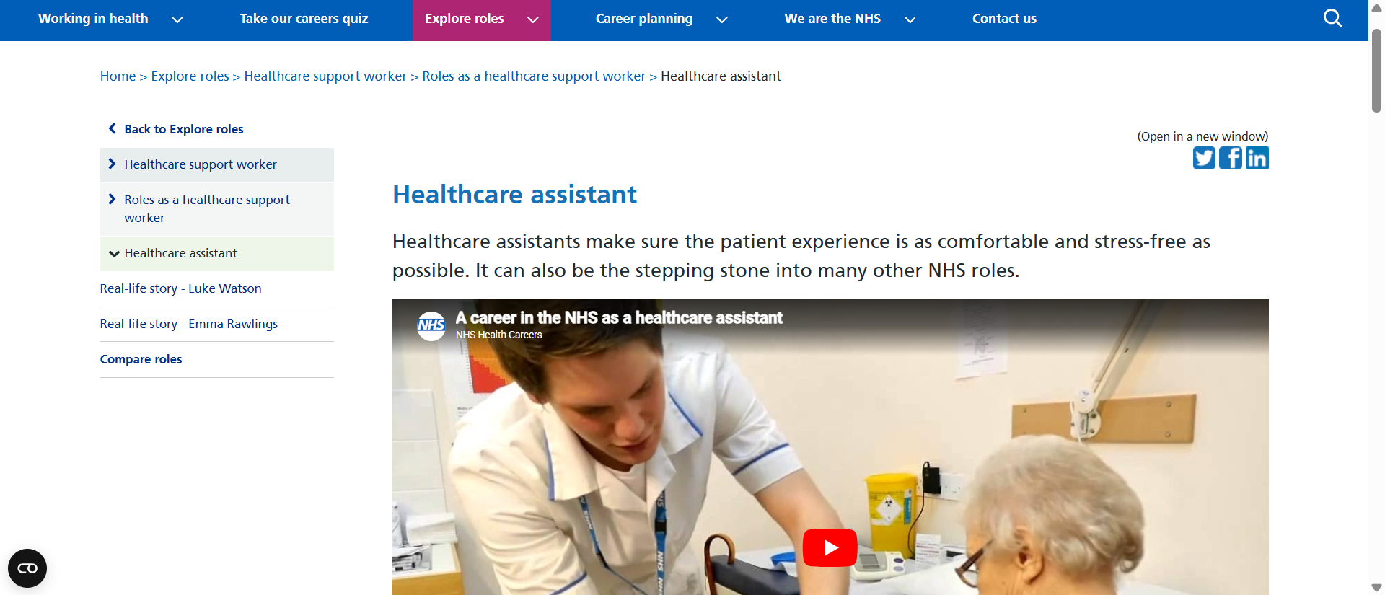





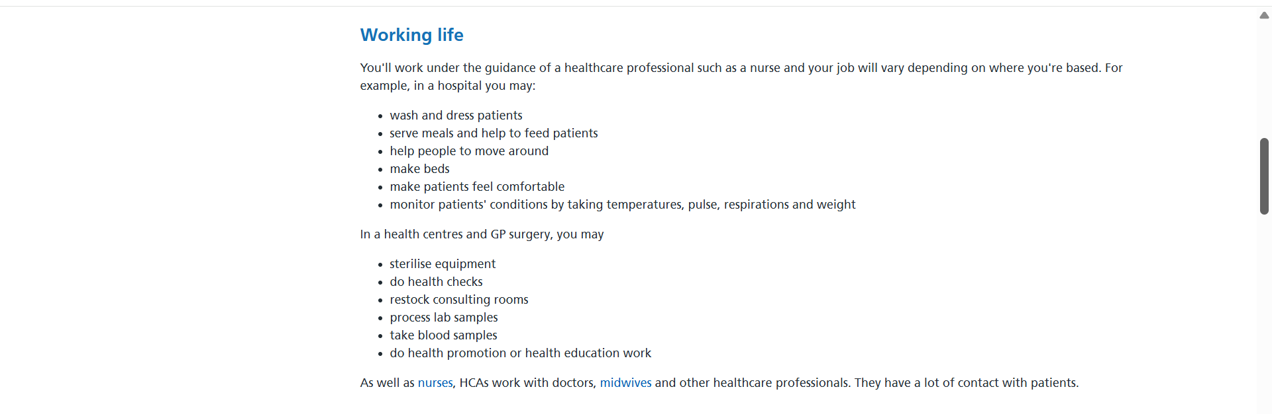

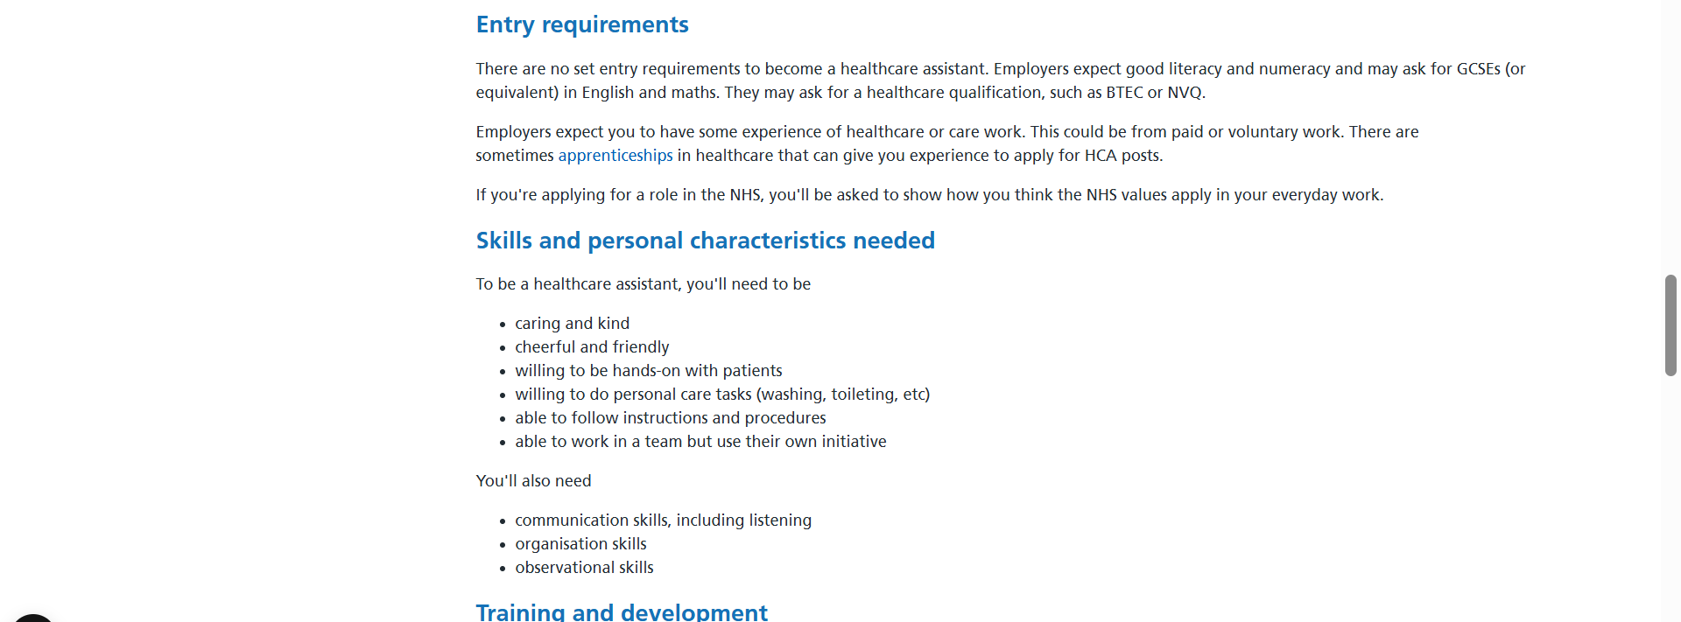

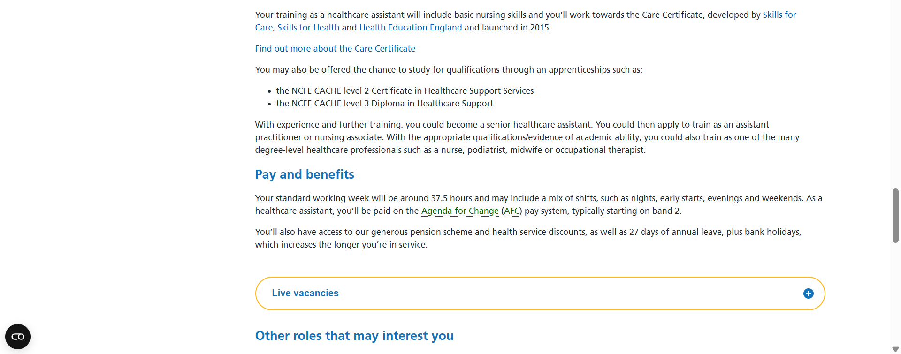

Task 2: My personal statement to become a Healthcare Assistant

I am a dedicated, compassionate, and hardworking individual with experience in health and social care, retail management and voluntary work. My career goal is to continue developing as a Healthcare assistant, where I can provide high-quality, person-centred care that promotes dignity, independence, and wellbeing for everyone. I am passionate about supporting people with their daily needs and I believe everyone deserves to be treated with kindness, respect, and compassion. I enjoy working with people from different backgrounds and always aim to make a positive difference in their lives.

My experience working in a care home has given me a solid understanding of the responsibilities involved in supporting vulnerable individuals. I assisted residents with personal care, mobility, nutrition, medication support, and daily activates while maintaining their privacy and dignity. This role taught me the importance of safeguarding, effective communication, infection prevention and working as part of a multidisciplinary team. I developed the ability to remain calm under pressure, respond to individual needs, and provide care that respects each person’s choices and independence.

In addition to my care experience, I have spent several years working as a butcher and manager at Asda and currently Tesco. These roles have strengthened my leadership, organization, and problem-solving abilities. I have been responsible for supervising staff, maintaining high standards, managing stock, and ensuring excellent customer service in busy environments. These experiences have taught me how to priorities tasks, manage my time effectively, and work effectively under pressure. I believe these transferable skills are valuable in healthcare, where teamwork, responsibilities, and attention to details are essential.

My voluntary work with The Shakespeare Hospice and Birmingham Voluntary Service Council has further developed my understanding of compassionate care and community support. I provided companionship, practical assistance, and emotional support to patients, families and members of the local community. These experiences helped me improve my listening skills, empathy and ability to build trusting relationships with people facing different challenges. They also reinforced my commitment to supporting individuals with dignity and respect.

I have completed a Care Certificate and Level 2 Food Safety and Hygiene qualification. I am currently studying a Level 4 qualification in Health and Social Care at the University of Wales Trinity Saint David. I am committed to continuing my professional development by expanding my knowledge and learning new skills, attending training opportunities. I value constructive feedback and use it to improve my performance and knowledge, ensuring I give high-quality care that meets professional standards.

My greatest strengths are my compassionate, reliability, patience and strong work ethic. I communicate confidently with colleagues, services users and families. I understand the importance of safeguarding, confidentiality, infection prevention, and following policies and procedures to ensure safety, well-being and always maintaining professional standards. I work both independently and as part of a team and I am always willing to take responsibility and support others when needed.

I believe I would be a valuable member of any healthcare team because I am passionate about helping people live with dignity and independence while providing the highest standard of person-centred care. I am eager to keep on learning, take on new challenges, and make a positive contribution to any organization by delivering high-quality care to every individual I support.

Task 3 Part A: SWOT Analysis

Strengths

- I have experience working in a care home, I supported residents with personal care, mobility, nutrition, and daily living activities while promoting dignity and independence.
- My management experience at Tesco and Asda has developed my leadership, communication, organization, and problem-solving skills.
- Volunteering at The Shakespeare Hospice and BVSC strengthened my empathy, patience and ability to communicate with people from different backgrounds.
- I work well under pressure, remain calm in challenging situations.

Weaknesses

- Although I have experience in residential care, I have limited experience working with people who have complex healthcare needs, such as dementia.
- I am learning to priorities task and ask colleagues for support when needed as I sometimes take on too many responsibilities as I want to help everyone.
- As I am still completing my Leve 4 health and social care qualification, I know there is more knowledge and practical experience for me to gain.
- I would like to become more confident when supporting individuals with complex physical and emotional needs and I plan on achieving this through further training and practical experiences.

Opportunities

- Completing my level 4 Health and Social Care qualification will improve my knowledge and increase career opportunities.
- I can attend additional training in dementia care, medication awareness, infection prevention, mental health, and safeguarding to broaden my skills.
- Working alongside experienced healthcare professionals will allow me to learn new skills and improve my confidence.
- With continued experience and training I hope to progress to a Senior Healthcare Assistant role and eventually work towards becoming a Nursing Associate or Registered nurse.

Threats

- Healthcare is physically and emotionally demanding, so it is important to maintain my own health and wellbeing.
- Staff shortage and increased workloads can make it challenging to provide the level of care I always aim to deliver.
- Healthcare policies and best practice continue to change, meaning I must stay committed to ongoing learning and professional development.

Task 3 Part B: Personal Development Plan (PDP)

Goal 1: Complete my Level 4 Health and Social Care qualification

My main professional goal over the next year is to successfully complete my level 4 Health and Social Care qualification. This qualification will help me to develop a deeper understanding of person centred care, safeguarding, laws and legislation, and professional practices which will mean that I would be able to give patients the best care possible. To achieve this goal, I will attend all lectures, complete my assignments and seek guidance from my tutors whenever I need additional support. I will monitor my progress by reviewing my assignment grade and will listen to all tutor feedback that is given to me to then apply it on to my work. Once I have successfully completed the qualification that will be proof of achieving this goal.

Goal 2: Develop my knowledge and practical care skills

Over the next two years, I want to expand my knowledge and practical skills by gaining more experience supporting individuals with complex needs, including those living with dementia and those requiring end of life care. I plan to achieve this by attending workplace training, completing continuing professional development courses, and learning from experienced colleagues through observation and practical experience. I will monitor my progress by keeping a record of complete training, reflecting on what I have learned and asking my manager and colleagues for regular feedback. I will evaluate my development by considering how much more confident and competent I feel when providing care in different situations.

Goal 3: Develop my leadership and communication skills

My long-term goal is to develop my leadership and communication skills so that I am prepared to progress into a senior Healthcare Assistant role. To achieve this, I will volunteer for additional responsibilities, actively contribute during team meetings, support new colleagues when appropriate and continue improving my communication with service users, families and other healthcare professionals. I will monitor my progress by reflecting on my experiences, seeking feedback from my manager during supervision and appraisals, then I will be identifying areas where I need to improve. I will evaluate my success based on how confident I feel about taking on more responsibilities and my readiness for career progression.

Task 4: Reflection on presentation

The Gibbs Reflective Cycle (1988) is a model that helps people reflect on their experiences in a clear and structured manner. It helps to consider what happened, how it felt, what they learned and how they can improve their practice in future situations. I will now be using it to reflect on my presentation.

Description
As part of one of my assignments, I was required to prepare and deliver a five-minute presentation on effective communication in healthcare. I researched the topic using reliable sources and created a PowerPoint presentation with clear and relevant information. I also made notes to support me while presenting. On the day of the assessment, I was given five minutes to present it to my lecturer Wafa Nasir. After I had finished presenting, I was asked some questions, which I answered confidently and accurately, demonstrating my understanding of the presentation and my research.

Feelings
While preparing my presentation, I felt calm and confident because I found the topic straightforward and interesting as I had access to good resources which made me feel confident about communication. I believe I had prepared well by creating a clear presentation and making notes. However, on the day of the presentation I became nervous and slightly anxious as I didn’t want to make any mistakes. I felt uncomfortable with the layout of the room, particularly because the presentation board was beside me. I was worried about making mistakes, so I found myself looking at the slides more than my lecturer, even though I had prepared resources such as my notes. Although I felt nervous, I was pleased that I stayed within the five-minute limit and was able to answer the questions confidently at the end.

Evaluation
Overall, I believe my presentation was successful. My research was relevant and the presentation was well structured with clear information about effective communication in healthcare. I managed my time effectively by completing the presentation within the time given and I demonstrated my knowledge by answering the follow up questions accurately.

However, there were also areas that I can improve on. My biggest weakness was maintaining eye contact with my lecturer. Instead of speaking confidently, I often looked at the slides because I was worried about forgetting what I needed to say.I now understand that eye contact is an important part of effective communication because it helps to build trust, shows confidence and keeps the audience engaged.

Analysis
The experience showed me that preparing good content alone is not enough to deliver an effective presentation. Although I understood my topic well, I did not rehearse it enough to feel confident speaking without the slides. Practicing my presentation aloud several times would have helped me become more familiar with the content, improve my confidence and reduce my anxiety. I also realized I cannot always control the environment in which I present in. As a future healthcare professional, I will need to communicate confidently in different settings, so it is important that I learn how to adapt rather than letting my surroundings affect my performance. Overall, it shows that effective presenting is not just about speech, it is also about eye contact, being confident, clear and engaging with any audience.

Conclusion
This experience increased my awareness of the importance of combining knowledge with effective presentation skills. It highlighted areas for personal development and gave me greater confidence in recognizing what I need to improve to become a more effective communicator in both my studies and future healthcare practice.

Action plan
In future, I will rehearse my presentation more thoroughly to improve my confidence and reduce my reliance on presentation slides. I will also focus on maintaining eye contact and adapting to different environments to become a more effective communicator.

Reference list

Stonebridge College (2025). What does a Healthcare Assistant do? A complete guide, Available at: https://www.stonebridge.uk.com/blog/distance-learning/what-does-a-healthcare-assistant-do-or/ Accessed on: 27/06/2026.

Prospero Health and Social Care (2023). Career progression: Level 4 Health and Social Care jobs. Available at: https://royalopencollege.org/blog/healthcare/common-challenges-healthcare-assistants-face/ . Accessed on: 27/06/2026.

Peoplesafe (2020). Health and safety risks for carers and care homes. Available at: https://peoplesafe.co.uk/blogs/health-safety-risks-for-carers-and-care-homes/ . Accessed on: 28/06/2026.

Royal open college (2026). Common challenges Healthcare Assistant face in the UK. Available at: https://royalopencollege.org/blog/healthcare/common-challenges-healthcare-assistants-face/ . Accessed on: 28/06/2026.

Florence (2024). How to become a senior care assistant: a step-by-step guide. Available at: https://www.florence.co.uk/resources/blog/become-senior-care-assistant. Accessed on: 29/06/2026.

Simply Psychology (2025). Gibbs Reflective Cycle. Available at: https://www.simplypsychology.org/gibbs-reflective-cycle.html. Accessed on: 01/07/2026.

