Technological Change and Innovation (BMSP5001)

Sustainable Medical Waste
Sophie Evans (2108843)

Contents Page

Executive Summary ……………………………………………………………….2
Introduction …………………………………………………………………………..2
The Problem Statement …………………………………………………………3-4
The Proposed Solution …………………………………………………………..4-8
Stakeholders ………………………………………………………………………….9
Swot Analysis …………………………………………………………………………10
Justification …………………………………………………………………………..11-12
Conclusion ……………………………………………………………………………..12
References ……………………………………………………………………………..13

Executive Summary
This report will undertake research and will include a proposal for an innovation plan for a sustainable business idea. The report will examine the research and analysis of medical waste management and will propose viable solutions for modifying the way it is currently managed. The research will look into the stakeholders required to realise this innovation and highlight the contributions that each stakeholder will make to the success of the innovation. The report will justify the transition to make medical waste sustainable, as well as highlight potential benefits and challenges.

Introduction
The world today produces a vast amount of waste and sustainability is a goal the world is actively seeking and its paramount that its acted upon as according to Blu Glacier (n.d.) sustainability raises living standards, preserves the environment, and safeguards natural resources for future generations. Business around the world are generating solutions to achieve sustainability change as its important for businesses to adopt sustainability as according to Abul (2021) businesses that use sustainable methods have a beneficial influence on the environment and society. This report will be looking at a business innovation solution to make medical waste sustainable by reducing, reusing or eliminating the amount of medical waste that is produced in the health sectors and to look at prospective waste management strategies that are environmentally safe and sustainable.

The Problem Statement
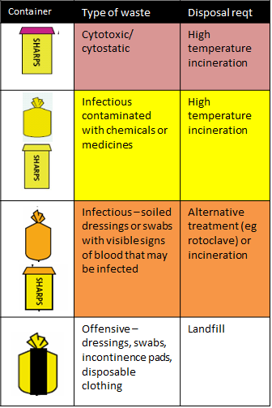
The issue is that medical waste is produced in large quantities by the NHS and private health sectors which includes dental practices, GPs and Nursing homes, and many more who all have systems in place to dispose of medical waste. The bulk of this waste is non-recyclable and is sent to landfills or incinerators. Medical waste is made up from items such as Personal Protective equipment such as gloves, apron face masks. Used bandaged, dressings, incontinence aids, syringes and many more. According to Bre (n.d.) up to 600,000 tonnes of waste is generated by the NHS annually, which is more than 1% of all household waste in the UK. (360 Environmental, 2023) Since the Covid 19 pandemic there has been a rise in medical waste according to the World Economic Forum (2022) between February and August 2020, PPE use in England increased the nation's carbon emissions by 1%. Glove utilization had the most impact; the nation utilised 3 billion PPE products, generating 591 tonnes of waste per day. As the World Health Organization (2018) mentions Indirect health concerns associated with medical waste disposal include the release of infections and harmful substances into the environment. Drinking, surface, and ground waters may get polluted by the improper disposal of medical waste in landfills. Pollutants are released into the air as a result of insufficient incineration or the burning of inappropriate materials, which also produces ash residue. The incineration of certain materials can have a negative impact on the environment and cause health effects. Looking at how much medical waste there is especially with the use of gloves, mask and aprons, which between all the health sectors are used on a daily basis. According to Islam (2021) over a billion pieces of PPE were distributed across the UK in 53 days between February 25 and April 18, 2020. This total includes 875 million products delivered to NHS Trusts in England. The Department of Health and Social Care provided the following breakdown: 132 million masks, 145 million aprons, 1.2 million gowns, and 470 million pairs of gloves. Over a 53-day period, this amounts to 748 million products, or 14 million items every day. With the utilisation of all this PPE, has generated an enormous amount of medical waste. The increase of medical waste is immense, and it continues every day. The research presented in this report solely analyses medical waste generated by the NHS; however, given that nursing homes, dental practices, and GP surgeries all produce medical waste, it is impossible to know how much more is deposited in landfills or incinerated. According to Historic Cornwall (n.d.) there was enough landfill area, according to a 2016 Welsh Government study, to accommodate 8 years' worth of waste disposal in Wales. PPE such as gloves can take years to degrade according to Manning (2023) a single pair of disposable nitrile gloves takes a century to completely degrade if left to decay naturally. With landfills overflowing and the pollutants incinerators emit, there must be a solution where medical waste may be eradicated, reduced or reused. However, in a world where climate change is a growing issue, it is imperative to choose ecologically responsible strategies for managing medical waste that is sustainable. It would be more advantageous to look at prospective waste management strategies that are more environmentally safe and sustainable.

The Proposed Solution
The proposed solution is to look at a sustainable method on how reduce, eliminate or reuse medical waste which in turn could be problematic as a percentage of medical waste is hazardous. Peter Seeger Quoted “If it can’t be reduced, reused, repaired, rebuilt, refurbished, refinished, resold, recycled or composted, then it should be restricted, redesigned or removed from production.” (Goodreads, n.d.)
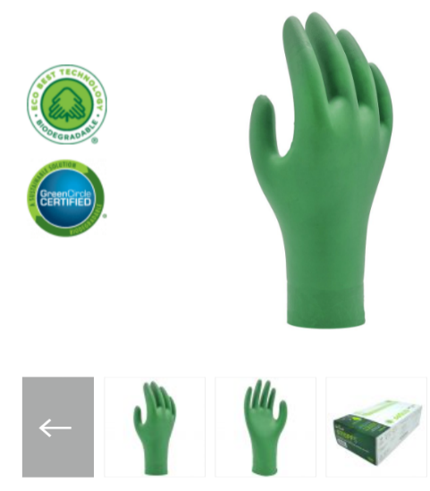
Part A - The solution would be to look at making Personal Protective equipment environmentally friendly such as gloves and aprons as they are used on a daily basis in all health care settings and generate a large amount of medical waste. The proposal would be to make products such as gloves and aprons biodegradable as with items such as these it is recommended not to re-use these items as according to Doos, Barach, Sarmiento & Ahmed (2022) reusing PPE raises health care workers risk of infection and self-contamination. However with making them biodegradable, could be a better solution rather than PPE sitting in a landfill for decades or being incinerated which is detrimental to the environment. The benefits of biodegradable products are as Conserve Energy Future (n.d.) explains biodegradable plastics can naturally degrade in the environment since they are biodegradable. Because of the nature of biodegradable materials, natural microbes may quickly break them down, resulting in an environmentally friendly final product. There are biodegradable gloves and aprons available, each with a specific industry they are appropriate for along with varied statistics on how long they take to biodegrade. Research conducted found a company named Showa that according to Showa (n.d.) is located in several countries such as Europe, Africa, Canada, Japan, USA and Australia with the nearest location from the UK being Amsterdam. Showa offers a range of biodegradable gloves that according to Showa (2023) Showas Eco Best Technology gloves are designed with components that encourage faster biodegradation in biologically active landfills. When tested in a lab the 6110PF gloves degraded by 82% in just 386 days, making them environmentally friendly, whereas gloves without Eco Best Technology only degraded by 1.9% during the same period. They also state that these single use biodegradable gloves are waterproof can be used in laboratories. If these biodegradable gloves can be used in laboratories, why not utilise them in the health sectors? Liaison with the manufacturer regarding these biodegradable gloves would be addressed for this innovation to be achievable. In order to amplify the biodegradable gloves for usage in all health care industries, the gloves would need to be adopted and tested to be protected against infectious agents and hazards. With the manufacture already having the technology to create biodegradable gloves the next solution would then be using the technology Showa already used to create biodegradable gloves and adapt it to create biodegradable single use aprons as they are used on a daily basis in health care settings. Who knows after technology like this developing biodegradable gloves and aprons suitable for health care settings, what other medical waste can be made biodegradable?
An innovation like this could be a breakthrough for the whole of the UK, to manufacture biodegradable gloves and aprons which will prevent medical waste sitting in landfills for a long period of time. For the innovation to be successful, the introduction of biodegradable PPE would be distributed to parts of the UK at first with the end result being the whole of the health sectors in the UK. For an example locations for the business could be firstly set up in regions of South Wales and South West England and introduced to counties such as Carmarthenshire and Bristol where samples of the biodegradable gloves and aprons could be trialled in their intended environment of use in several health sectors, and on success of the innovation and their biodegradable properties should see a new approach for management of medical waste. To assist in the execution of this innovation, highlighting the relevance of sustainability to the health care industry might increase the demand for businesses to use sustainable PPE.

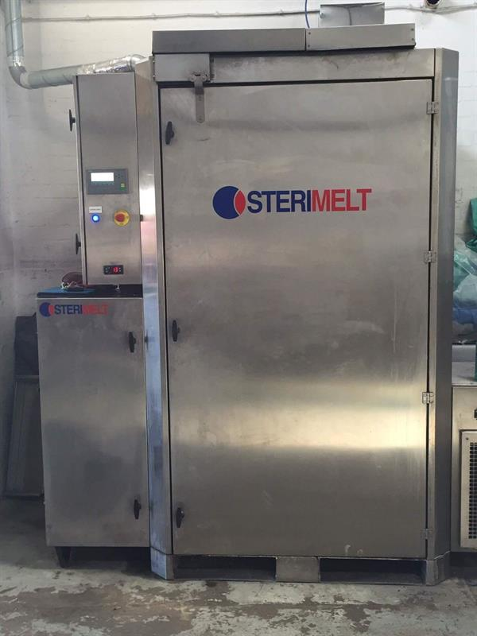
Part B – Many items that are utilised in healthcare facilities are just discarded in the waste without any intention of repurposing that item. Just when you thought used PPE couldn't be reused, an alternative solution for reusing face masks emerged as the pandemic created a great amount of medical waste. On conducting research a company named Thermal Compaction Group (TCG) which is based in Cardiff has created a solution for the use of single use plastics as TCG (n.d.) explains with the use of sterimelt technology, single-use plastic may be (Microsoft Bing , 2023)
removed from a costly waste stream, recovered, and converted back into an inert supply of polypropylene that can subsequently be used in a variety of products. TCG (n.d.) explains they emphasize on environmentally friendly, carbon-reducing, and sustainable waste management technologies that provide affordable answers to common waste management problems. By minimising waste volume through collection and reuse, TCG has created a variety of products that support the circular economy. The processing of single-use plastics through the usage of TCGS products reduces the quantity of plastic that ends up in landfills, incinerators, waterways, and seas. According to Whitehead (2021) technology by TCG enables the on-site conversion of single-use masks, curtains, and other medical waste into metre-long blocks, which in turn can be processed and evolved into a variety of different goods, such as toolboxes and school chairs. TCG has 4 types of thermal compaction machinery Sterimelt, Massmelt, Styromelt, and Curtainmelt available that can process a variety of materials and compact them into recyclable blocks.
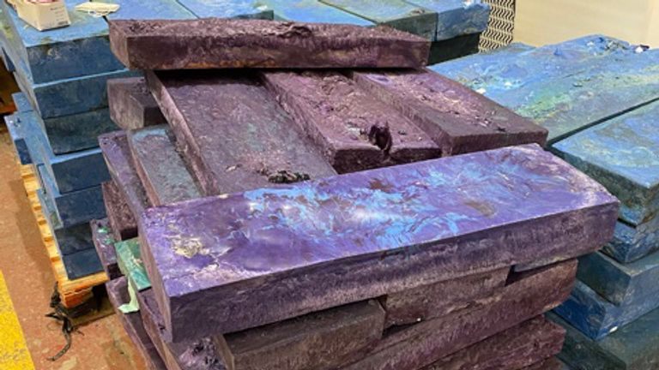

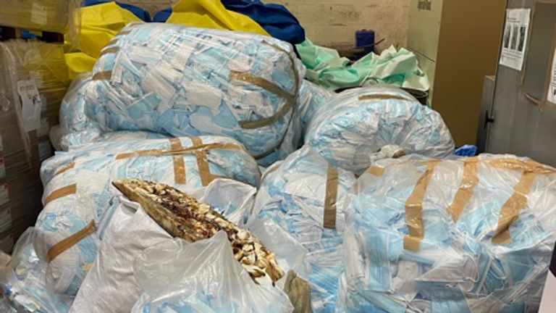

(Whitehead, 2021) (Cost Cutters, 2023)
TCG (n.d.) explains that used or defective polypropylene curtains, gowns, and face masks are melted and compressed into one-meter rectangular blocks by TCG using their equipment at 350 C. The polypropylene blocks may then be reconfigured into products like chairs, waste bins, and bottle caps. This technology has made it possible for a whole bag of discarded face masks to be placed in a machine and be transformed into a sterile block of plastic in just one hour, whereas it would take 450 years to decompose in a landfill. According to Life Science Hub Wales (2021) seven of TCG's sterimelt machines have been sent to NHS hospitals across the United Kingdom. An innovation like this could change the whole of the UK`s medical waste system not just the NHS hospitals if its adopted in several parts of the UK it can then be targeted at other health sectors also. Hospitals are larger facilities and they would be able to facilitate a large machine like the sterimelt in their facility but looking at medical waste from Nursing Homes, GP & Dental practices they would be unable to house such machinery. So the solution would be to set up several primary locations to repurpose medical waste using the sterimelt technology. This again could begin in Carmarthenshire and in Bristol to trial the system out then expand. The concept is that healthcare facilities will be provided with separate bins and biodegradable bags for any medical waste that may be reused, and they will be able to dispose of the medical waste in the appropriate container, while another large bin will be provided to be stored outside. And, once a week, repurposed medical waste will be collected and transferred to the sustainable medical waste facility where it will be melted down and reused. This will still be at a cost to businesses, but it is a sustainable method of disposing and giving medical waste a purpose rather than it ending up in landfill or incinerators. Looking ahead, what potential breakthroughs may this remarkable technology make by reusing other types of medical waste, as this is just the beginning?
Having sustainable waste facilities in several regions will be beneficial as you think how many Hospitals, GPs, Dental Practices are just in Carmarthenshire alone, How much medical waste will they produce? This propose business innovation can change how medical waste is manged and for all health sectors to take action on sustainable change.
Changes in medical waste management are necessary since many health sectors do not recycle because it is cheaper to send waste to landfills and incinerators, however this must stop. The proposed solution of biodegradable PPE and repurposing other medical waste such as face masks is a sustainable alternative for reducing, reusing, and eliminating medical waste.
Working with local governments and local authorities is essential to implementing this concept. They must support the idea and consider introducing legislation regarding medical waste regulations in order to support these innovations.
It would be achievable if a goal to have sustainable medical waste implemented throughout the United Kingdom by the year 2040, following a trial run in Bristol and Carmarthenshire.

Stakeholders & Funding
To make the innovation possible in the UK the options of funding this venture would be through business grants, start-up loans or addressing any potential investors on a sustainable business innovation. According to Gov.UK (2023) the government offers start-up loans of up to £25,000 to help establish or develop businesses that plan or want to start a business in the UK. As explained in the report trials would conduct in the South Wales region where according to Carmarthenshire County Council (2023) they offer business start-up grants of up to £10,000.
To make this solution possible the following stakeholders would need to be involved and have a role.
NHS & Private Health Sectors - These businesses will have the role of using biodegradable PPE, embracing environmentally friendly products, appropriately managing their medical waste in a sustainable manner and supporting sustainable changes.
Local Authorities – Support with grants and to work alongside to support sustainable methods of managing medical waste. According to Business Gateway (2023) A variety of services that businesses might need to use or be aware of are handled by local authorities. These include approving planning requests and commercial tariffs, as well as maintaining standards for health, safety, the environment, and trading.
Government – To assist with financing along with support and guidance. To support the adoption of sustainable methods for managing medical waste.
Manufactures – To ensure the Biodegradable PPE is up to a standard to be used in health care settings and withing rules and regulations. To ensure any equipment used to repurpose medical waste is adequate and in line with rules and regulations.
The Waste Management Sector – To ensure medical waste is being disposed or reused of correctly and in line with Health and Safety Regulations
Potential Investors – Financial resources, support and guidance.

Swot Analysis
This SWOT analysis will evaluate the strengths, weaknesses, opportunities, and threats of the Sustainable Medical Waste business innovation

Strengths | Weaknesses
- Environmentally Friendly  - Recycling of medical waste  - Reuse of medical waste  - Designated site for medical waste  - Regular collection of medical waste  - Reduction in medical waste in landfills  - Lack of Competitors  - Demand for more sustainable products  - Reduction in waste tax | - Separation of Medical Waste  - Unskilled workers
Opportunities | Threats
- Expansion to other areas  - Support from government  - Employment Opportunities  - Potential sales opportunity with the reuse of medical waste  - Potential with working with governments to bring in sustainable medical waste legislation  - Increasing environmental awareness  - future business opportunities in sustainable waste management | - Inappropriate recycling behaviour  - Costs  - Funding  - Travel Costs  - Travel Emissions
Based on the swot analysis, there are many more strengths and opportunities than weaknesses and threats.
Justification
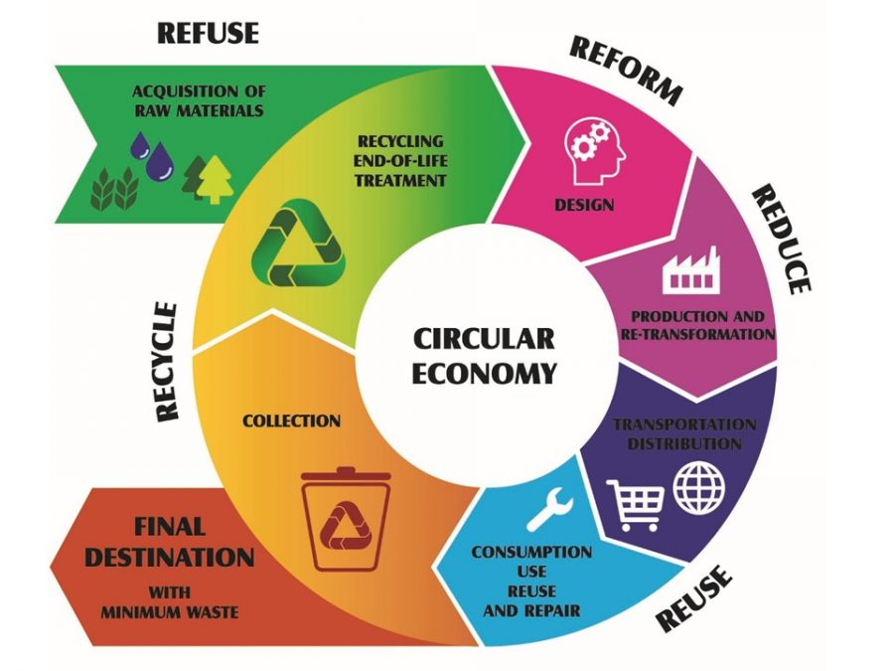
This is an excellent sustainable medical waste management solution for all health care facilities across the UK, and the ability to reuse medical waste is a fantastic way to contribute to the circular economy. As Zero Waste Scotland (2023) mentions the global climate emergency may be partially resolved by implementing a circular economy, in which systems, products, and services are created to maximise usefulness and reduce waste. Nothing is wasted, and everything has value in this holistic approach to life and conducting business. Instead of "create, use, discard," it might be stated as "make, use, remake."
(The Porto Protocol, 2020)
As this proposed concept will begin in Bristol and Carmarthenshire it would be their first medical waste facility capable of converting medical waste into something beneficial along with a facility to manufacture biodegradable PPE. The aim to have a sustainable business venture that minimises, reduces and repurposes medical waste, that is disposed of correctly by all health sectors which in turn will be advantageous as according to Right Away Rubbish Removals (2018) protection of the environment and improvement of public health are benefits of adequate waste management. It assists in reducing the amount of resources extracted, as well as the pollution and energy use that come with producing new materials. In addition to lowering greenhouse gas emissions, proper waste management contributes to improving the quality of the air and water. Medical waste may now be used as a resource for other purposes and PPE products will no longer linger in landfills for decades. Bringing in technologies for sustainable medical waste can boost job creation across the UK.
The drawbacks of this invention might include the need to go to various sites to collect used PPE since vehicles produce emissions and Improper disposal of sustainable medical waste in the health sectors but the benefits of sustainable medical waste management will exceed the drawbacks because we must implement this if we want to save our ecosystem and reduce the amount of medical waste that is discarded.
The report justifies that such a business innovation is necessary since there is a significant amount of medical waste discarded from the health sectors, and this sustainable innovation has the potential to improve the way medical waste is managed and to promote sustainable change.

Conclusion
This report on sustainable medical waste concludes that there are several strengths and opportunities for managing sustainable medical waste across the UK. There is a rising need for environmentally friendly technology, and by adopting the innovation technologies suggested in this research across the UK, less medical waste will end up in landfills or be incinerated, and by repurposing medical waste, it will have a sustainable purpose. The environment will benefit if stakeholders like governments and the health sector promote this invention and carry out its intended goal of managing sustainable medical waste in healthcare settings. The benefits of sustainable medical waste outweigh the drawbacks and thus sustainable medical waste management is the way forward.

