
Name: Irfan Sabir
Student number 2507088
Module code:LCLM4001
MUDULE: AS1

Task 1 – Reading Task Template
Upload your photo of your A3 in-class notes here:
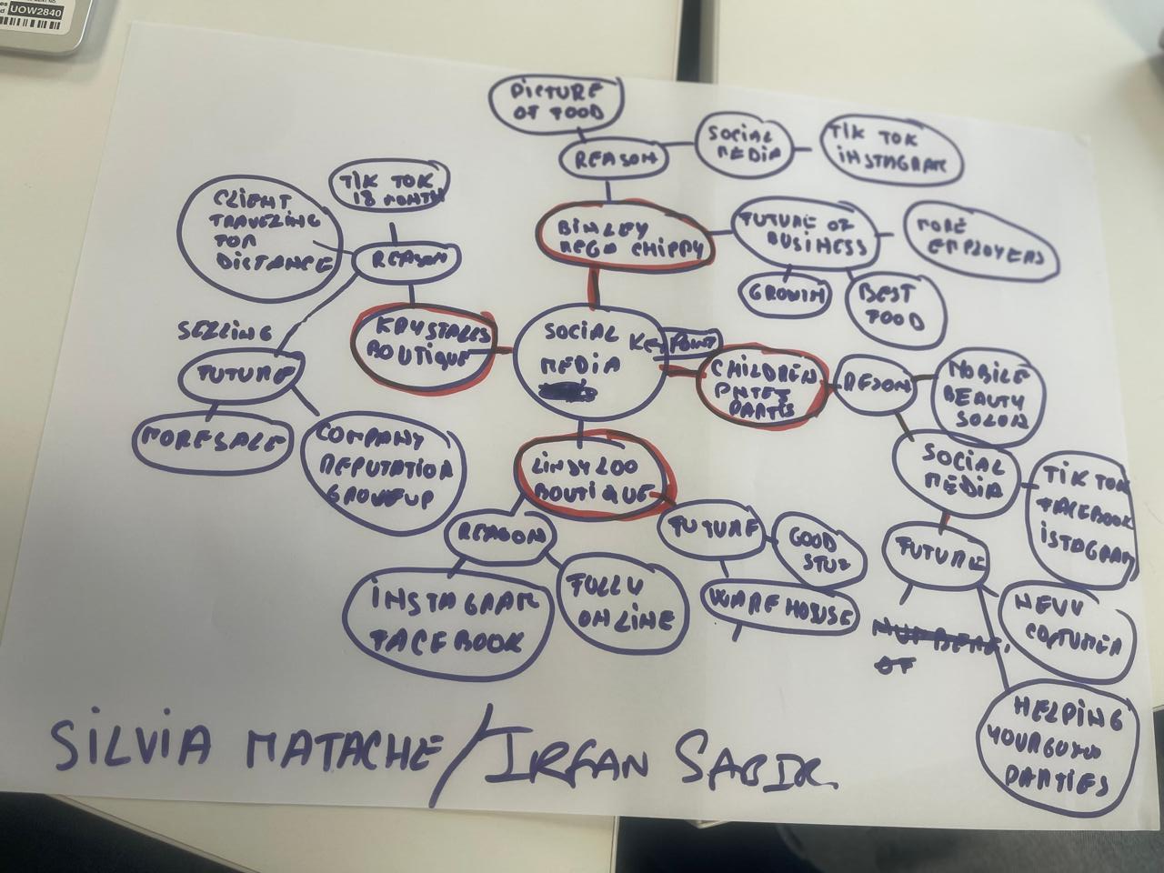

1. Answer these questions using the sentence starters below
a. What is the main idea of the text?
The main idea is that promote the business through different social media in which you can show your products easily online. This will help you to expand your business worldwide and help your community in creating more jobs. The basic concept is that social media sites like Instagram and TikTok can help businesses succeed by bringing in a significant number of new clients.

b. What are two key points?
One key point is Good quality and publicity of products by using social media. A notable fact is that after videos about them had been circulated and viewed by millions of people online, several Essex-based firms gained many new clients. For instance, people came for hours for a taste of the chicken burger at Honywood Sandwich Shop.
Another key point is growth of business after using these social media e.g. more employees, small warehouse to big warehouse and online business. This result gives us motivation for other and use new ideas for others. Another significant aspect is that social media encourages companies to build more real and personal connections with the customers they serve. Entrepreneurs urged customers to endorse their companies by sharing entertaining videos, daily updates, and personal experiences.
c. What part of the text did you find most important? Why?
The most important part is the use of social media for the business point of view. Nowadays social media plays an important role in advertising the products effectively. The examples of small businesses that earned success through social media are the most important element because they highlight the potential of social media. Businesses that were previously only recognised locally are now attracting customers from all around the UK and even internationally.
d. Was anything unclear or difficult to understand?
After becoming viral, I was not sure how companies would handle the unexpected increase in customers. The article outlines the advantages of social media success, but it does not go into much detail on the challenges that companies might face when their business suddenly increases, and they were not prepared for it.

e. How did your group help you understand the text better?
By talking about the different businesses included in the article and sharing our thoughts on why social media is such a powerful tool for advertising, my group helped me. I was able to gain a deeper understanding of the content by hearing different points of view. I learned from my group's discussion of other ideas on the topic, which increased understanding and gave me the chance to consider different points of view. I was able to learn new knowledge, make sense of my ideas, and improve them through the discussions we had. Sharing promoted creativity because each group members offered unique ideas and suggestions. Therefore, working together improved overall quality of the assignment and gave me more confidence about the topic.
3. One sentence reflection
Question: What did you find challenging about this task?
The most difficult part was breaking down the post into a few key points because there were numerous instances of companies using social media to accomplish success. Choosing the most important data without going into too much depth was hard.
Developing with good ideas and effectively structuring them was difficult for me. Evaluating everything and identifying what was most important to provide could be difficult at times. However, I was able to successfully complete the work with practicing and help from my group.
Listening to various ideas and choosing the most suitable thoughts to employ was the most challenging aspect of the discussion. It took some time to come to a decision on the key areas because every person had different points of view. We had to work together, share thoughts, and ensure that every individual had a chance to add to the discussion.

