
MASTER OF BUSINESS ADMINISTRATION
STRATEGIC MANAGEMENT LCMB7003
INDIVIDUAL REPORT ON TESLA
The lecturer’s name: Zulfiqar Khan (Weekdays) & Simon Chatterton (Weekends)
Name of student: Chitaliya Nidhi Dipakbhai
ID of student: 2432183
Word count: 5004 Words

Table of Contents
Section 1: Selection of Organisation and Target Market 4
1.1 Company Background: Tesla Inc 4
1.2 Why India? Strategic Justification 5
1.3 Strategic Rationale 8
Section 2: Comprehensive Strategic Analysis 9
2.1 PESTLE Analysis 9
2.2 Porter’s Five Forces Analysis 11
2.3 Internal Analysis of Tesla 14
2.3.1 VRIO Analysis 14
2.3.2 SWOT Analysis 15
2.3.3 Value Chain Analysis 16
2.4 Competitor Landscape 17
2.5 Critical Reflection on Frameworks 18
Section 3: Strategy Development and Formulation 19
3.1 Market Entry Strategy 19
3.2 Competitive Strategy [Porter] 20
3.3 STP Analysis 22
3.4 Strategic Initiatives 23
3.5 Risk Assessment & Mitigation 24
Section 4: Performance Evaluation Framework 25
4.1 Balance Scorecard 25
4.2 Triple Bottom Line (TBL) Framework 26
4.3 Dashboard Style KPI Sheet 28
Section 5: Summary 29
References 30

Section 1: Selection of Organisation and Target Market

1.1 Company Background: Tesla Inc
Tesla Inc. is one of the most powerful Electric Vehicle (EV) and clean-energy companies in the world, which was founded in 2003 and has its headquarters in Austin, Texas. The mission of the organisation, which is to help the world move towards sustainable energy, has influenced its product portfolio and global strategy. Tesla has several business units: electric cars, energy and energy storage, autonomous driving systems, and charging systems (Tesla, 2025). Tesla products and services, Model 3 and Model Y, are successful worldwide, with the company supplementing these models with such high-quality products as the Model S and Model X, as well as the energy offerings like Solar Roof, Powerwall, and the largest-scale Megapack systems, to cement the image of an integrated clean-technology company.
The competitive strength of Tesla lies in its vertical integration, battery technology, high-efficiency powertrains, and its distinct software-based approach, such as over-the-air updates and Full Self-Driving (FSD) features (SEC, 2025). By 2024, Tesla will have Gigafactories in the United States, China, Germany and Mexico, which shows its extensive manufacturing presence and extensive localisation strategy (Tesla, 2025b). In 2023, Tesla exported more than 1.8 million vehicles worldwide, and amid an ever-growing competition among EV makers like BYD, Hyundai, and conventional car manufacturers which switched to EV, Tesla continued to be a strong force in high-end EV markets.
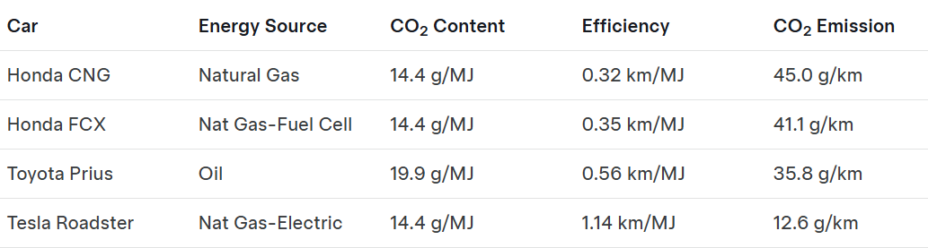
Figure 1: Power Plant Emissions aka “The Long Tailpipe”
(Source: Tesla, 2025)
Nevertheless, the global expansion plan of Tesla is still incomplete without a serious presence in the developing and growing markets. Although Tesla enjoys a strong market in North America, Europe, and China, the lacks presence in one of the largest automotive markets in the world, India represents a strategic gap (Tesla, 2025c). Tesla now has a promising opportunity to view India as a promising long-term growth and manufacturing diversification market with the introduction of new EV-friendly policies by the Indian government in 2023 24.

1.2 Why India? Strategic Justification
India has positioned itself as one of the most appealing markets to EV manufacturers in terms of its population size, economic direction, and sustainability endeavours. India has over 1.4 billion people, a growing urban middle-income, and is a huge consumer market with a growing demand to use modern and technologically advanced mobility. The GDP of India is estimated to be increasing at 6.5-7% annually between 2024 and 2028, which makes it among the fastest-growing major economies (World Bank, 2025). Increasing disposable income, especially in the metro cities like Mumbai, Delhi and Bengaluru, has provided a favourable environment to high-end automotive brands entering the market.
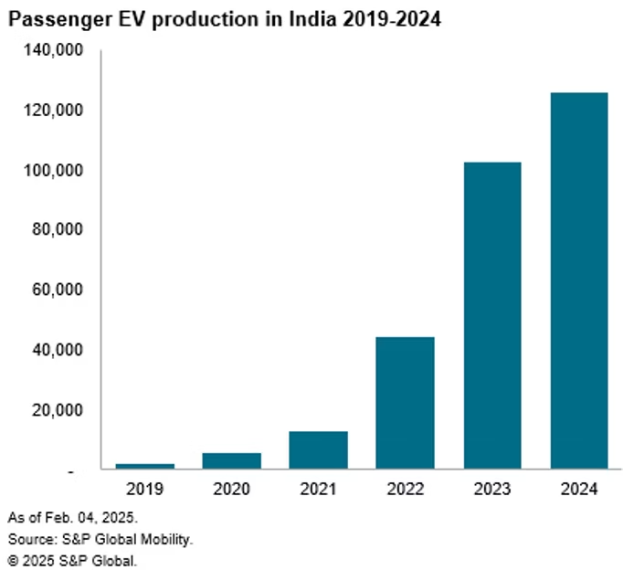
Figure 2: Passenger EV Production in India, 2024
(Source: S&P Global, 2025)
Policymaking-wise, the regulatory environment in India has also been shifting towards providing more favourable opportunities towards EV adoption. The FAME II (Faster Adoption and Manufacturing Electric Vehicles), state-based support subsidies, production-based incentives (PLI) to produce batteries, and low GST rates on EVs all provide a robust institutional framework for international EV participants. However, most importantly, the electric vehicle policy of 2024 offered concessional importation to the company that made the promise of establishing local production within a period of three years (S&P Global, 2025). The policy shift directly correlates with the expansion strategy of Tesla, which applies localisation to grow its business in Europe (Gigafactory Berlin) and China (Gigafactory Shanghai), and thus, India is now more convenient to reach than ever.
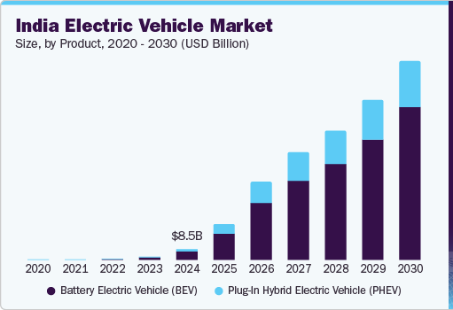
Figure 3: Indian Electric Vehicle Market
(Source: Grand View Research, 2025)
The EV market in India is expected to grow to US113 billion by the year 2029 with a compound annual growth rate (CAGR) of over 49% in passenger EVs (Grand View Research, 2025). The consumer mood is also changing: the increasing pollution of the air and the concern about the environment are pushing urban buyers to think about EVs as a more sustainable and technologically advanced choice to internal combustion engine (ICE) cars (Indian Brand Equity Foundation, 2025). Furthermore, the large number of talents in the software engineering and artificial intelligence sectors in India gives Tesla a chance to develop an R&D/software development centre to assist in training Autopilot and FSD models.
Entry into India is a strategy that diversifies the global presence of Tesla. Today, the company is also extremely dependent on China in terms of production and consumption, which makes it vulnerable to geopolitical conflict and regulatory instabilities (Indian Brand Equity Foundation, 2025). Locating a production hub in India will allow Tesla to hedge against geopolitical risk and tap into the domestic market, as well as into the South Asian and ASEAN regions overall, where EV adoption is increasing at a faster rate.
Therefore, India presents both market potential, policy measures, access to talent, and geopolitical diversification, thus being an attractive strategic destination for Tesla to consider in the next big move.

1.3 Strategic Rationale
The possible move by Tesla into India is aligned with the long-term vision, competitive advantage and global expansion strategy of the organisation. The reasoning can be analysed in four dimensions that are interconnected: market growth, cost advantages, technology leadership and sustainable ecosystem development.
The market development trend of India presents Tesla with an unmatched opportunity. With the automobile market being one of the largest in the world, with sales of over four million in the year with annually sales, the penetration of the high-end EV market would yield a huge income even in a minimal penetration. Although India is still very price-sensitive, the high-end and luxury market has been steadily increasing during the past five years, and consumers in urban areas are becoming more technologically conscious, sustainable, and brand-conscious, which are aspects of the Tesla value proposition (Fatehi and Choi, 2025). Moreover, the current EV penetration in India is less than 2% of passenger cars, indicating that there is a big untapped segment that can be exploited by the company once the infrastructure and affordability issues are sorted out.
Second, the local production in India will enable Tesla to reduce production and logistics expenses. In India, labour is cheaper than in the United States, Germany, and China, and engineering talent could be used to facilitate advanced production. The PLI incentives of the Indian government on the local production of batteries and components can also result in the cost being further lower, allowing Tesla to compete in a better way with the price-aggressive brands such as Tata Motors and MG Motor (Abdelazim, 2022). With localisation, Tesla manages to escape huge import tariffs, and its cars become more affordable and competent in terms of the market.
Third, Tesla has led the technological aspect of the industry, especially battery performance, software, Autopilot, and charging infrastructure, which may change the Indian EV market. The Indian EV market does not have a high-tech, software-driven ecosystem like the one that Tesla has. Tesla can distinguish itself by introducing Superchargers, updates via OTA, energy storage, and solar products, which would not be offered by its rivals that are hardware-oriented to a significant extent (Valenti, 2021). This improves the customer experience and creates an integrated mobility-energy ecosystem that makes the brand loyalty stronger.
Lastly, the strategic justification is not limited only to vehicles but also to the energy business of Tesla. The increasing energy consumption in India and the need to introduce renewable energy open up the prospects of Solar Roof systems, Powerwall systems, and Megapack systems (Chari and Ferreira, 2025). The entrance of Tesla is thus in line with the national sustainability program of India and promotes the overall economic and environmental goals.

Section 2: Comprehensive Strategic Analysis

2.1 PESTLE Analysis
Factor | Key data & points | Implications for Tesla
Political | India is a stable democracy with pro-EV policies: FAME-II and the PM E-DRIVE scheme (₹10,900–₹11,000 crore support) to spur EV demand, buses, 4-wheelers and charging infrastructure (Reuters, 2025). New policy allows limited imports at 15% duty (vs ~70% earlier) for firms committing to local manufacturing and investment (~US$500m) and starting operations within ~3 years (Government of India, 2025; Ministry of Heavy Industries, 2025). | Reduced short-term tariff encourages a phased import+localise approach; high compliance requirements mean Tesla must plan capex & local content targets to secure duty benefits.
Economic | India’s real GDP growth forecast ~6.4–7% (IMF / government forecasts); large market: population ≈ 1.46bn and rapid urbanisation (≈37% urban) (Worldometers, 2025). EV market valuations vary (multi-$bn) with forecasts showing very high CAGR (industry reports: ~40%+ in some forecasts to 2030) (Static.pib.gov.in, 2025). Currency volatility (INR) creates FX risk for imports. | Strong macro growth and scale justify long-term factory investment; high CAGR supports aggressive rollout, but FX and price sensitivity require localisation to protect margins.
Social | Large metro populations (Delhi ~34M, Mumbai ~22M, Bengaluru ~14M); growing urban middle/upper-middle classes and tech-savvy millennials who value sustainability and premium tech. Adoption clusters in Tier-1/Tier-2 cities (Statistics Times, 2025). | Target upper-middle, urban tech adopters initially (Delhi, Mumbai, Bengaluru); tailor marketing to aspirational sustainability and tech narratives.
Technological | India has a deep IT/engineering talent pool and an expanding charging network: ~25,000 public EV charging stations reported (Oct 2024), led by Karnataka, Maharashtra, and Delhi; ongoing investments in lithium exploration and domestic battery initiatives (government projects announced) (NITI Aayog, 2024). | Good talent base supports local R&D/software hubs; existing but sparse charging density means Tesla must invest heavily in Superchargers and partner with utilities/miners for battery supply security.
Legal | Strong emissions and vehicle safety regulations; complex land-acquisition and labour laws; compliance and local content rules tied to incentives. Regulatory timelines and approvals can be slow (Ministry of Heavy Industries, 2025). | Tesla must build a dedicated regulatory/Govt relations team, expect longer project lead times, and design legal-compliant localisation plans.
Environmental | Severe urban air pollution (high PM2.5 rankings) creates political & social urgency for EVs; national push for renewables and distributed storage aligns with Tesla Solar + Powerwall offerings (IQAir, 2025; IBEF, 2025). | Environmental urgency supports policy tailwinds and consumer narrative for Tesla’s integrated EV + home energy solutions; opens cross-sell & PR opportunities.
Table 1: PESTLE Analysis
(Source: Self-developed)

2.2 Porter’s Five Forces Analysis
Force | Evidence & data | Strategic implications for Tesla
Threat of New Entrants – Moderate | India EV market forecasts show explosive growth (IBEF: market projected from US$3.21bn in 2022 → US$113.99bn by 2029; very high CAGR) (Auto Car India, 2025). Entry capital is high (factory + battery assets), yet new entrants (BYD, MG/JSW, local JV players) are actively expanding product ranges. Regulatory incentives (PLI/PM E-DRIVE) lower barriers for firms that localise (IBEF, 2025b). | Despite high capex, rapid entrant activity means Tesla must act fast; phased import→localise reduces initial risk while securing first-mover premium positioning.
Supplier Power – Moderate | India currently imports many battery cells/critical materials; domestic cell capacity ambitions (target ~150 GWh by 2030) are underway, but limited today. Large local players (Reliance, TATA, JSW) are investing in giga-scale battery projects (Reliance, 2025; WRI India, 2025). | Short-term supplier dependence increases the bargaining power of cell exporters; Tesla should lock supply via local partnerships and consider vertical integration or offtake agreements.
Buyer Power – High | Market is price-sensitive; premium EVs are a niche vs mass ICE/low-cost EVs. Tata still commands a large share but is losing share to MG/JSW; premium buyers concentrated in metros (Delhi, Mumbai, Bengaluru) (Autocarpro, 2025; EV Reporter, 2025). Rapid growth means buyers have more choices. | Tesla must justify premium pricing with superior TCO, brand, tech and charging network; initial targeting should be upper-middle metro segments.
Threat of Substitutes – High | Affordable ICE/hybrid vehicles and rising petrol hybrids remain dominant; two-wheelers and low-cost EVs cover many urban transport needs. Charging infrastructure is still uneven despite rapid growth (public chargers ~25k–29k as of 2024–25) (Ministry of Heavy Industries, 2025b). | Tesla faces high substitution risk—must address TCO, range anxiety and urban charging convenience to convert buyers from ICE/hybrid alternatives.
Industry Rivalry – Moderate/High | Intense competition: Tata, MG (JSW), Mahindra, BYD are scaling model portfolios; Tata’s share fell (≈69% → ~53% FY24–25) while MG/JSW gained share. OEMs and oil producers plan large charger rollouts (government & private backing) (Reuters, 2025b). | Rivalry is accelerating—Tesla must differentiate via tech (software/FSD), vertical ecosystem (Superchargers, Powerwall/solar) and rapid localisation to protect margins.
Critical evaluation | Traditional Five Forces highlights structural pressures but underweights platform/software network effects (charging + OTA updates + energy ecosystem) that are crucial in EVs. Use alongside dynamic tools (ecosystem mapping, network effects analysis). | Complement Five Forces with capability/ ecosystem analysis to capture software and charging-network advantages.
Table 2: Porter’s Five Forces Analysis
(Source: Self-developed)

2.3 Internal Analysis of Tesla

2.3.1 VRIO Analysis
Resource / Capability | Valuable? | Rare? | Inimitable? | Organised? | Competitive Implication
Battery technology & powertrain efficiency | Yes – industry-leading range & energy density | Yes | High – proprietary chemistry & vertical integration | Yes | Sustained competitive advantage
Autopilot / FSD software | Yes – strongest ADAS data ecosystem | Yes | Yes – data scale hard to replicate | Yes | Sustained tech advantage
Brand reputation (innovation & luxury EV) | Yes | Moderately | Difficult – brand equity built over the years | Yes | Strong but not absolute advantage
Supercharger network | Yes | Yes | High–cost, scale-based | Yes | Sustained infrastructure advantage
Global manufacturing scale (Gigafactories) | Yes | No – rivals building fast | Moderate | Yes | Temporary cost advantage
R&D talent & software culture | Yes | Yes | Moderate | Yes | Strong tech capability
Table 3: VRIO Analysis
(Source: Self-developed)

2.3.2 SWOT Analysis
Strengths  - Strong global EV brand and advanced technology (Autopilot, OTA updates).  - Vertical integration in batteries and powertrain improves control and margins (Tesla, 2025).  - Supercharger ecosystem + energy solutions (Solar, Powerwall). | Weaknesses  - Premium pricing is unsuitable for India’s price-sensitive market (S&P Global, 2025).  - Limited local manufacturing at entry → higher import duties.  - Low local supplier base for high-grade EV components.
Opportunities  - India’s EV market is projected to grow to US$113bn by 2029 (Grandviewresearch, 2025).  - Government incentives for EV manufacturing & localisation.  - Rising tech-savvy urban middle class in metro cities. | Threats  - Strong competition from Tata, MG/JSW, BYD, and Hyundai (ACKO Drive, 2025).  - Currency volatility and regulatory unpredictability.  - Substitutes: ICE/hybrid vehicles remain dominant.
Table 4: SWOT Analysis
(Source: Self-developed)

2.3.3 Value Chain Analysis
The primary activities of Tesla create highly competitive value by having advanced inbound logistics (vertical integration by batteries, global supply networks) and very automated operations by Gigafactories. In the case of India, imported products will increase the costs at the initial stage, although the battery packs, motors, and charging stations can be localised to decrease reliance. Direct-to-consumer online marketing and sales make it cost-efficient in terms of dealership (Subrahmanyam, 2025). Tesla has a built-in after-sales value of OTA updates, remote diagnostics, and energy ecosystem (Solar + Powerwall), which builds long-term stickiness and reduces the cost of services relative to the traditional OEMs.
Tesla technology development has been the biggest differentiator in the support activities; software R&D, FSD algorithms and energy integration offer never-before-seen capabilities in the EV industry in India (Chen, 2022). Human resources is also geared towards engineering excellence and attracting the best talent in the world; the formation of an Indian R&D centrer intensifies that further. The weaknesses include procurement, as India does not produce any critical minerals, but it is possible to eliminate the risks with the help of collaboration with the local cell manufacturers and the governmental projects related to battery production (Jiang-Min, 2023). In general, Tesla's value chain is globalised but has to be localised in India in a strategic way that enables it to compete with other firms in terms of costs.

2.4 Competitor Landscape
Company | Market Position & Share | Key Models (Price Range) | Strengths | Weaknesses | Implication for Tesla
Tata Motors | Largest EV player (~53% FY24–25) | Nexon EV, Punch EV, Tiago EV (₹8–17 lakh) (Tata Motors, 2025) | Strong local supply chain; affordable EVs; extensive service network | Limited premium technology; low range vs global EVs | Tesla must differentiate through premium tech rather than price.
MG Motor / JSW MG | Fast-growing, strong in premium-mid (JSW Group, 2025) | MG ZS EV, Comet EV (₹7–25 lakh) | Strong design; global backing from SAIC; aggressive pricing | Limited brand trust vs Tata; service network is smaller | Tesla competes directly in the premium compact SUV space.
BYD | Global EV leader entering India (BYD, 2025) | Atto 3, Seal (₹30–45 lakh) | Excellent battery technology (Blade Battery); high range | Political sensitivity; limited localisation | Tesla faces strong tech competition, especially in range and battery.
Mahindra Electric | Emerging mid-premium competitor | XUV400 EV; Born-EVU upcoming (Mahindra Electric, 2025) | Strong domestic brand; new EV platform (INGLO) | Delayed EV expansion; limited charging ecosystem | Tesla benefits from Mahindra’s slower scale-up but must monitor future launches.
Hyundai/Kia | Premium EV entrants | Ioniq 5, Kona EV (₹24–48 lakh) (Hyundai, 2025) | Strong design; good global EV quality | Limited model variety; high pricing | Tesla must compete on brand, software, and ecosystem value.
Table 5: Competitor Landscape
(Source: Self-developed)

2.5 Critical Reflection on Frameworks
Although the strategic tools used, which are PESTLE, Porter's Five Forces, VRIO, SWOT and Value Chain, give systematic perspectives of Tesla with regard to future growth in India, the above frameworks have their drawbacks, which have to be mentioned. PESTLE provides a macro-environmental perspective, but is naturally descriptive and non-forecasting; regulatory, geopolitical, tensions, or other changes could occur quickly and decrease the accuracy of its forecast. Porter’s Five Forces, though it does have its purpose in evaluating the forces of competition, was initially created to evaluate the traditional manufacturing sectors, and only reflects on the digital and software-based forces of contemporary EV markets, where data ecosystems, charging infrastructure, and AI functionality influence competition in new ways. VRIO can be used to identify internal capability, but it depends a lot on subjective assessments of rarity and inimitability, which can alter as competitors increase in technological capability. SWOT is easy and integrative, though it can be oversimplified, and it has no prioritisation, which provides little information on trade-offs of the strategy. The Value Chain framework is a powerful tool to study the cost and differentiation drivers, but Tesla is vertically integrated and operates globally. Therefore, it is difficult to project the Value Chain onto the emerging EV supply ecosystem in India.
Altogether, all the frameworks have their useful insights that are complementary and should be synthesised instead of applied separately. Expansion strategy has to be designed with a dynamic and evidence-based interpretation that would fit the fast-moving EV environment in India.

Section 3: Strategy Development and Formulation

3.1 Market Entry Strategy
Tesla should use a hybrid market entry strategy, which is a combination of initial imports followed by localisation, as it offers the most balanced strategy of entering the rapidly growing EV market in India. Through the initial stage (Years 12), Tesla will take advantage of the re-evaluated policy of the Indian government on EV importation taxes that will reduce duty to companies which undertake future production inside the country (Lei, 2025). Through the importation of Model 3 and Model Y units at this time, Tesla will be able to test the elasticity of demand, gather market intelligence, and place the brand among early adopters without spending on large upfront capital expenditures (Akakpo et al. 2024). This gradual approach would be in line with the global strategy of Tesla to expand gradually, as was evident in Europe and China, where initial imports would be used to confirm the market readiness before constructing gigafactories.
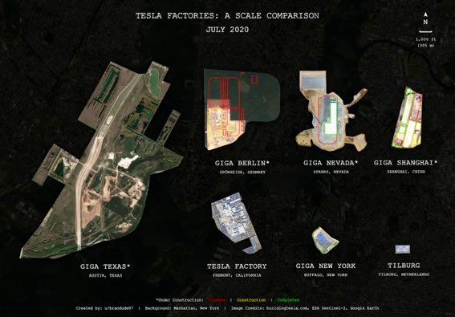
Figure 4: Tesla Factories
(Source: Han, 2021)
The second stage (Years 2-4) entails setting up Gigafactory India that reinforces local production, generation of jobs, and fulfils the available localisation demands. This shows in favour of the OLI paradigm by Dunning that India offers good location benefits such as cheap availability of skilled labour, high potential of solar energy and good government subsidies (Han, 2021). The high-equity type of entry is also recommended in EVs, as the production process is intensively controlled, particularly in terms of battery technology and software implementation, which aligns with the Root model of entry mode (Secomandi, 2024). In the last stage, Tesla has an opportunity to scale production locally to provide not only the local requirements but also to the export markets in South Asia, ASEAN, and the Middle East, which will increase the cost efficiency and resilience to competitors in the long term.

3.2 Competitive Strategy [Porter]
The competitive strategy Tesla should take in India ought to be that of a hybrid differentiation and selective cost optimisation, allowing the company to retain technological advancement and adjust to the price-sensitive nature of the Indian automobile market. The differentiation strategy is necessary since the main competitive strength of Tesla is its superior battery systems, full self-driving (FSD) software, Autopilot features and vertically integrated production model (Tjemkes, 2023). All these form a value proposition that the competition, especially Tata Motors, MG Motor and BYD, cannot easily imitate in the short run. The availability of a comprehensive network of Superchargers also strengthens the idea of exclusivity that Tesla may have, making the customers more loyal and minimising the perceived risk of switching to EVs (Borille, 2023).

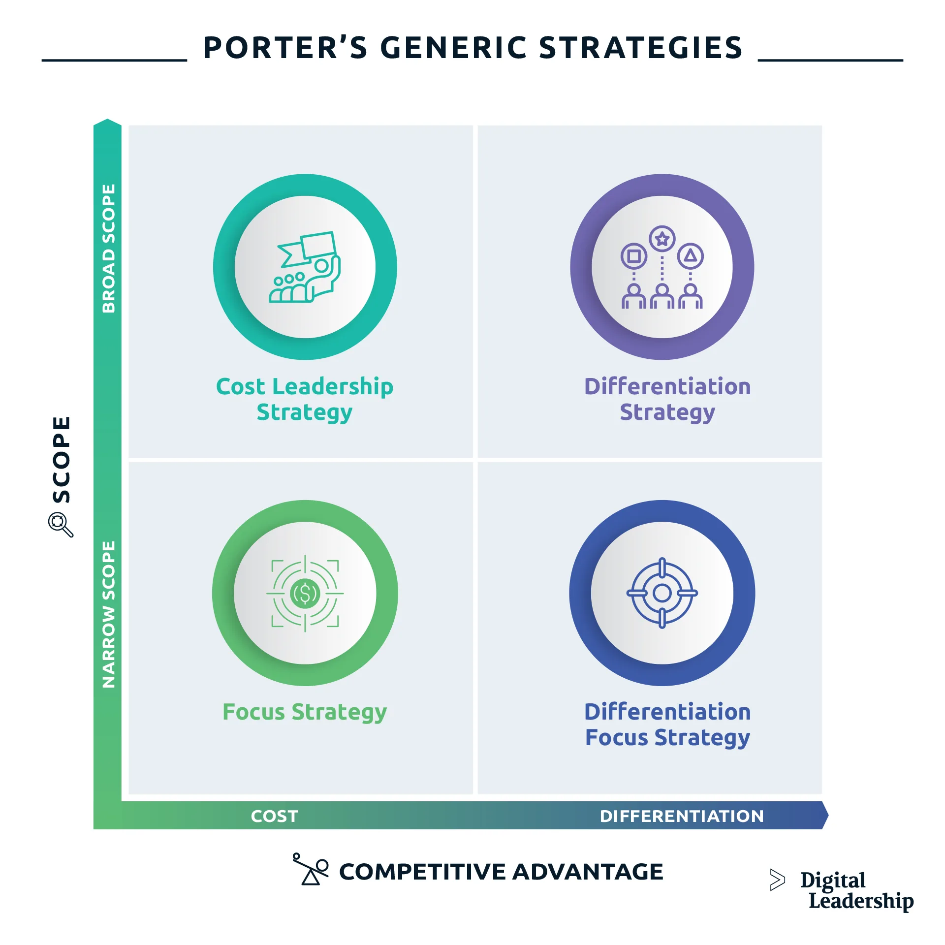
Figure 5: Porter’s Generic Strategies
(Source: Borille, 2023)
Nevertheless, since the level of competition and focus on prices among consumers in India is high, Tesla will need to incorporate specific cost optimisation strategies. Localisation of essential parts, creation of an Indian research and development centre and sourcing minerals or sub-components in India can help access and save a considerable amount of production and logistics expenditures (Hopkins and Lazonick, 2024). Such a strategy corresponds to the statement that differentiation can be complemented by the selective cost leadership to promote better penetration in the market, without weakening the technological advantage (Porter) (Wang et al. 2021). Moreover, products tailored to the local market can better reinforce the Tesla position in the high-end mass market, i.e., region-specific battery chemistries or more affordable versions. Tesla can maintain a competitive edge in the Indian EV market long term by implementing localisation through innovation-led differentiation and strategic localisation.

3.3 STP Analysis
Targeting, positioning, and effective segmentation are important in ensuring that the expansion strategy of Tesla is in line with the demographic and psychographic realities of the Indian market (Oya and Uchihira, 2023). The customer population of India is varied, yet the uptake of EVs is focused, as of now, on the urban professionals, early adopters of technology, sustainability-aware consumers, and high-income millennial groups. These groups are located mostly in Tier-1 and new Tier-2 cities like Delhi-NCR, Mumbai, Bengaluru, Hyderabad, Pune and Chennai- areas with greater disposable incomes, established charging networks, and greater environmental consciousness.
The targeting approach, which Tesla should take, should be the support of the upper-middle-income group that appreciates high design, performance, and sustainability. This market group exhibits a greater readiness to pay premium prices on international brands and superior technology attributes, and therefore, this group is the best market segment to start with (Čirjevskis, 2021). In the long run, as the local production decreases its prices, Tesla will have a chance to attract aspirational middle-income buyers who are willing to make a shift between ICE and electric mobility.
Based on Positioning, Tesla must continue being a global brand of an innovative, premium, and sustainable-oriented brand, but with an increased focus on the notion of accessible luxury based on the Indian context. This positioning separates Tesla both from the mass-market EV market leaders, such as Tata Motors and from the Chinese market competitors that are viewed as value brands (Gao, 2023). An effective positioning message grounded in leadership in technology, environmental responsibility, and long-term saving will help Tesla enhance its identity in the evolving EV ecosystem in India.

3.4 Strategic Initiatives
In order to perationalise its market entry and competitive strategy, Tesla needs to execute four high-impact strategic initiatives to address infrastructure gaps and the unique aspects of the Indian market. First, it is important to state that one of the key factors contributing to the lack of EV adoption is the lack of charging infrastructure, and that 500+ Supercharger stations should be set within the first year of the launch. By launching a powerful, high-charging network, Tesla will not only make the experience of early adopters more convenient but also strengthen the network effect that is already an edge the company has over its competitors, which will be difficult for them to duplicate. Second, establishing local partnerships on battery minerals and upstream supply chain materials will help Tesla reduce costs and conform to the localisation policies of India (Busch, 2021). The increasing exploration projects of lithium and rare-earth minerals in India would mean that Tesla could have long-term procurement avenues and would not rely on Chinese suppliers.
Third, the creation of a local R&D and software engineering hub will help Tesla to localise Autopilot functionality, user interfaces, and energy management systems to the conditions of the Indian roads. The IT talent pool that is partially present in India provides a low-cost innovation environment. Lastly, the proposal of Tesla solar roofs and Powerwall systems will be a complementary addition to the priorities of the government relating to renewable energy and will also offer cross-selling points that combine mobility with sustainable home energy solutions (Wang et al. 2021). All this helps to build the Tesla brand, corporate efficiency, and competitive positioning in the long term in India.

3.5 Risk Assessment & Mitigation
Risk Category | Description of Risk | Mitigation Strategy
Regulatory Shifts | Policy reversals, changing import duty structures, or localisation requirements may disrupt Tesla’s entry strategy. | Implement scenario planning; maintain government relations; diversify production timelines (Secomandi, 2024).
Supply Chain Disruptions | Dependence on imported batteries and components increases vulnerability to geopolitical or logistics disruptions. | Localise battery supply; develop Indian supplier partnerships; maintain multi-country sourcing (Tjemkes et al. 2023).
Infrastructure Limitations | Limited public charging infrastructure and grid constraints may affect EV adoption. | Rapid deployment of Tesla Superchargers; partner with utilities; invest in solar + Powerwall integration (Čirjevskis, 2021).
Table 6: Risk Assessment & Mitigation
(Source: Self-developed)

Section 4: Performance Evaluation Framework

4.1 Balance Scorecard
Perspective | Strategic Objective | KPIs | Targets (Year 1–3) | Strategic Actions
Financial | Increase market penetration and revenue from EV sales in India | Annual revenue growth (%) | 20% YoY | Introduce competitively priced Model 2; establish local assembly for cost reduction.
Financial | Reduce operational costs through localisation | Cost per unit reduction | 15% by Year 3 | Local sourcing of batteries; Gigafactory partnerships
Customer | Improve customer adoption of EVs | Customer acquisition rate | 100,000 units by Year 3 | Launch financing schemes; charging subsidies
Customer | Enhance customer satisfaction | CSAT score | 90% | Expand service centres; remote diagnostics
Internal Processes | Strengthen supply chain efficiency | Lead time from production to delivery | Reduce by 25% | Develop Indian vendor ecosystem; inland logistics optimisation
Internal Processes | Expand charging infrastructure | Charging stations installed | 1,500 by Year 3 | Partner with government & private firms
Learning & Growth | Build workforce capability | Employee training hours | 50 hours annually | Training on AI-enabled manufacturing
Learning & Growth | Foster innovation in India | R&D projects initiated | 5 per year | Create India Innovation Hub
Table 7: Balance Scorecard
(Source: Self-developed)

4.2 Triple Bottom Line (TBL) Framework
The corporate growth in India by Tesla is more in line with the first pillar of the Triple Bottom Line, which is environmental sustainability. Tesla can achieve a major reduction in carbon emissions and contribute to the net-zero goals in India, as well as replace mobility based on fossil fuels, by launching low-cost EVs and investing in local battery manufacturing. Tesla's commitment to the environment is improved by the use of renewable energy (solar charging), recycling lithium batteries, and encouraging the low-emission supply chains (Busch, 2021). Also, localisation of the manufacturing process reduces the emitted emissions due to imports, which allows cleaner production. These environmental performances bolster the brand legitimacy of Tesla in the market that is moving towards sustainable mobility.
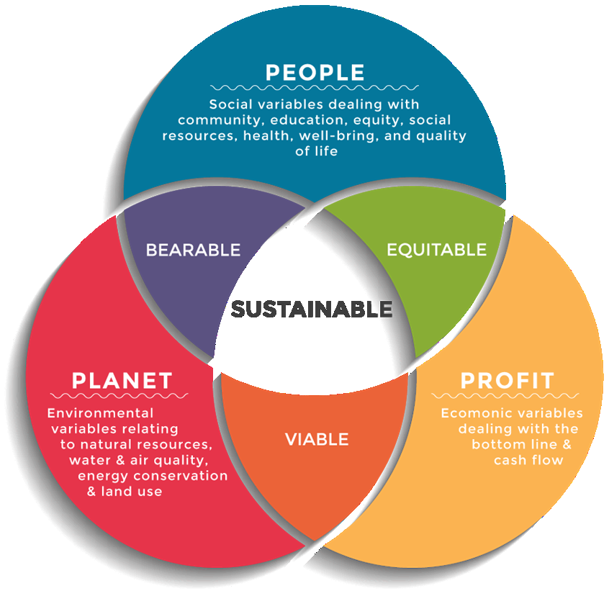
Figure 6: TBL Framework
(Source: Busch, 2021)
The TBL social and economic pillars are also the determining factors. Tesla entity brings about economic benefits in terms of job creation, development of local vendors, investment in infrastructure and high-value technology transfer into the Indian automotive industry. All these helps to stimulate the GDP contribution and bring more FDI in clean technology. Tesla promotes mobility behaviour change socially in terms of making clean transportation more accessible to everyone, enhancing road safety with the help of autonomous features, and minimising air pollution in cities (Busch, 2021). In addition, Community engagement can be enhanced by Corporate Social Responsibility (CSR) activities, including EV literacy programs, community access to charging, and STEM education. Collectively, the TBL framework makes the strategic activities of Tesla fair, profitable and environmentally friendly.

4.3 Dashboard Style KPI Sheet
KPI Category | Key Metrics | Target | Monitoring Tool | Frequency | Owner
Sales & Market Performance | Monthly EV sales, market share %, pre-orders | 8% market share by Year 3 | CRM + Sales Dashboard | Monthly | Sales Director
Customer Experience | CSAT score, service turnaround time, NPS | CSAT 90%, NPS +60 | Customer Analytics Dashboard | Monthly | Customer Success Lead
Operational Efficiency | Production cycle time, localisation rate %, cost per unit | 60% localisation by Year 3 | Manufacturing Dashboard | Weekly | Plant Manager
Sustainability KPIs | CO₂ reduction (tons), renewable energy usage, battery recycling rate | 30% recycling by Year 3 | Sustainability Dashboard | Quarterly | ESG Manager
Infrastructure Growth | Charging stations deployed, service centres added | 1,500 chargers by Year 3 | Infrastructure Tracker | Quarterly | Infrastructure Head
Workforce Development | Training hours, attrition rate, diversity ratio | 50 hours training; attrition <10% | HR Analytics Dashboard | Quarterly | HR Manager
Table 8: KPI Sheet
(Source: Self-developed)

Section 5: Summary
The opportunity of Tesla entering India is a strategically important opportunity promoted by the increasing demand in EVs, high government incentives and urbanisation. The Balanced Scorecard assists in aligning the objectives of Tesla on financial, customer and internal and learning perspectives to make performance measurement integrated and action-oriented. The Triple Bottom Line system also builds up the sustainability agenda by harmonising environmental responsibility, social contribution, and value creation of economic value creation. Tesla will have a tracking system to monitor the rate of EV adoption, the efficiency of its supply chain, its level of localisation, and the sustainability impact, which is a dashboard-style KPI sheet in combination with a monitoring system. The combination of these frameworks helps Tesla to make sure that its India strategy is quantifiable, holistic, and flexible enough to help the company build a long-term competitive advantage in the changing environment of the Indian market in the context of leveraging electric mobility.

References
Journals/Articles
Abdelazim, Z., 2022. Business Strategy-Automotive Business Case-Tesla. Available at SSRN 4453857.
Akakpo, A., Gyasi, E.A., Oduro, B. and Akpabot, S., 2024. A study of tesla—twenty-first century organizational strategy as nexus between foresight and futures thinking. In Futures Thinking and Organizational Policy, Volume 2: Case Studies for Managing Rapid Change in Social Media, Shift in Wealth and Government Instability (pp. 25-47). Cham: Springer Nature Switzerland.
Borille, L., 2023. Success and risk factors in strategic alliances: the case of alliances after the semiconductor shortage in the automotive industry.
Busch, L., 2022. Industry case analysis: Tesla’s strategy towards mass production of electric vehicles.
Chari, M. and Ferreira, V.F.M., 2025. Strategy as What a Business Should Do Over Time to Succeed: A Case Study of Tesla, Inc. American Business Review, 28(1), p.15.
Chen, Y., 2022, July. The impact of strategic alliance on corporate performance: Evidence from Tesla. In 2022 2nd International Conference on Enterprise Management and Economic Development (ICEMED 2022) (pp. 206-212). Atlantis Press.
Čirjevskis, A., 2021. Exploring critical success factors of competence-based synergy in strategic alliances: The Renault–Nissan–Mitsubishi strategic alliance. Journal of Risk and Financial Management, 14(8), p.385.
Fatehi, K. and Choi, J., 2025. International strategic alliance. In International Business Management: Succeeding in a Culturally Diverse World (pp. 231-254). Cham: Springer Nature Switzerland.
Gao, Y., 2023. A study of Tesla’s international marketing strategy based on the Stepps model. Highlights in Business, Economics and Management, 23, pp.971-979.
Han, J., 2021. How does Tesla motors achieve competitive advantage in the global automobile industry?. Journal of Next-generation Convergence Information Services Technology Vol, 10(5), pp.573-582.
Hopkins, M. and Lazonick, W., 2024. Tesla as a Global Competitor: Strategic Control in the EV Transition. Institute for New Economic Thinking Working Paper Series, (225).
Jiang-Min, D.I.N.G., 2023. Analyzing Tesla's International Business Strategies: A Closer Look at the Korean and Chinese Markets. The Journal of Economics, Marketing and Management, 11(5), pp.15-27.
Lei, C., 2025. Analysis of Tesla International Strategies. In Sustainable Data Management: Navigating Big Data, Communication Technology, and Business Digital Leadership. Volume 1 (pp. 237-246). Cham: Springer Nature Switzerland.
Oya, J. and Uchihira, N., 2023. Intellectual Property Strategy Required for Startups to Join a New Business Ecosystem: A Case Study of Tesla. IIAI Letters on Business and Decision Science, 3.
Secomandi, M.L., 2024. Strategic shifts in the US electric vehicle lithium-ion battery industry: Exploring how US policies and the US-China rivalry shaped firm strategies.
Subrahmanyam, S., 2025. Strategic Collaboration and Partnerships in R&D for Innovation. In Research and Development Practices in Innovation (pp. 283-314). IGI Global Scientific Publishing.
Tjemkes, B., Vos, P. and Burgers, K., 2023. Strategic alliance management. Routledge.
Valenti, M., 2021. Pursuing innovation through alliances and partnership in the automotive industry.
Wang, J., Duan, Y. and Liu, G., 2021. A study of specific open innovation issues from perspectives of open source and resources—The series cases of tesla. Sustainability, 14(1), p.142.
Websites
ACKO Drive, 2025. Tata, MG Motor, Mahindra Dominate India’s EV Retail in September 2025; BYD, Kia Complete Top Five as Tesla Enters Market. Available at: https://ackodrive.com/news/tata-mg-motor-mahindra-dominate-india-s-ev-retail-in-september-2025-byd-kia-complete-top-five-as-tesla-enters-market/ [Accessed on: 14-11-2025]
Auto Car India, 2025. November 2024 EV sales: Tata Motors loses market share to MG. Available at: https://www.autocarindia.com/industry/november-2024-ev-sales-tata-motors-loses-market-share-to-mg-433779 [Accessed on: 14-11-2025]
Autocarpro, 2025. India’s Passenger EV Market Hits New High In August 2025. Available at: https://www.autocarpro.in/analysis-sales/indias-passenger-ev-market-hits-new-high-in-august-2025-128326 [Accessed on: 14-11-2025]
BYD, 2025. About BYD. Available at: https://www.byd.com/en/about-byd [Accessed on: 14-11-2025]
EV Reporter, 2025. INDIA EV REPORT SALES TRENDS & INVESTMENTS. Available at: https://evreporter.com/wp-content/uploads/2025/05/EVreporter-India-EV-Report-FY24-25.pdf [Accessed on: 14-11-2025]
Government of India, 2025. CURRENT STATUS OF FAME-II SCHEME. Available at: https://www.pib.gov.in/PressReleasePage.aspx?PRID=2112237 [Accessed on: 14-11-2025]
Grandviewresearch, 2025. India Electric Vehicle Market (2025 - 2030). Available at: https://www.grandviewresearch.com/industry-analysis/india-electric-vehicle-market-report [Accessed on: 14-11-2025]
Hyundai, 2025. Concept THREE reshapes compact urban EV mobility. Available at: https://www.hyundai.com/worldwide/en [Accessed on: 14-11-2025]
IBEF, 2025. Automobile sector. Available at: https://www.ibef.org/industry [Accessed on: 14-11-2025]
IBEF, 2025b. Automobile Industry in India. Available at: https://www.ibef.org/industry/india-automobiles [Accessed on: 14-11-2025]
Indian Brand Equity Foundation, 2025. India's used car market hits 5.9 million units as SUVs, premium models fuel growth. Available at: https://www.ibef.org/news/india-s-used-car-market-hits-5-9-million-units-as-suvs-premium-models-fuel-growth [Accessed on: 14-11-2025]
IQAir, 2025. Air quality in India. Available at: https://www.iqair.com/in-en/india [Accessed on: 14-11-2025]
JSW Group, 2025. Accelerating Progress Smartly. Available at: https://www.jsw.in/jsw-mg-motor-india/ [Accessed on: 14-11-2025]
Mahindra Electric, 2025. Model Selection. Available at: https://www.mahindraelectricsuv.com/own-online/model-selection [Accessed on: 14-11-2025]
Ministry of Heavy Industries, 2025. Faster Adoption & Manufacturing of Electric Vehicles in India. Available at: https://heavyindustries.gov.in/en/fame-ii [Accessed on: 14-11-2025]
Ministry of Heavy Industries, 2025b. EV CHARGING STATIONS INSTALLED ACROSS THE COUNTRY. Available at: https://www.pib.gov.in/PressReleasePage.aspx?PRID=2151390 [Accessed on: 14-11-2025]
NITI Aayog, 2024. India Electric Mobility Index 2024: Tracking Electric Mobility Trends in Indian States. Available at: https://niti.gov.in/sites/default/files/2025-08/India-Electric-Mobility-Index-2024-Report.pdf [Accessed on: 14-11-2025]
Reliance, 2025. New Energy. Available at: https://www.ril.com/businesses/new-energy-materials [Accessed on: 14-11-2025]
Reuters, 2025. Tesla not keen on local production, minister says, as India finalises EV policy. Available at: https://www.reuters.com/world/india/india-finalises-new-ev-scheme-offers-import-tax-cuts-local-production-2025-06-02/ [Accessed on: 14-11-2025]
Reuters, 2025b. FACTBOX What are India's EV makers' plans for their charging networks? Available at: https://www.reuters.com/business/autos-transportation/what-are-indias-ev-makers-plans-their-charging-networks-2025-02-13/ [Accessed on: 14-11-2025]
S&P Global, 2025. India’s EV Market: Trends and Future Prospects. Available at: https://www.spglobal.com/automotive-insights/en/blogs/2025/03/india-ev-market-trends-future [Accessed on: 14-11-2025]
SEC, 2025. SECURITIES AND EXCHANGE COMMISSION: Washington, D.C. 20549. Available at: https://www.sec.gov/Archives/edgar/data/1318605/000162828025003063/tsla-20241231.htm [Accessed on: 14-11-2025]
Static.pib.gov.in, 2025. India shines as IMF upgrades GDP forecast to 7% in FY24-25. Available at: https://static.pib.gov.in/WriteReadData/specificdocs/documents/2024/jul/doc2024717350401.pdf [Accessed on: 14-11-2025]
Statistics Times, 2025. List of cities in India by population. Available at: https://statisticstimes.com/demographics/country/india-cities-population.php [Accessed on: 14-11-2025]
Tata Motors, 2025. Welcome to Tata Motors: India's leading name in innovative and integrated mobility solutions. Available at: https://www.tatamotors.com/ [Accessed on: 14-11-2025]
Tesla, 2025. Master Plans. Available at: https://www.tesla.com/master-plans [Accessed on: 14-11-2025]
Tesla, 2025b. SECURITIES AND EXCHANGE COMMISSION. Available at: https://ir.tesla.com/_flysystem/s3/sec/000162828025003063/tsla-20241231-gen.pdf [Accessed on: 14-11-2025]
Tesla, 2025c. Q3 2025 Update. Available at: https://assets-ir.tesla.com/tesla-contents/IR/TSLA-Q3-2025-Update.pdf [Accessed on: 14-11-2025]
World Bank, 2025. GDP (current US$). Available at: https://data.worldbank.org/indicator/NY.GDP.MKTP.CD?locations=IN [Accessed on: 14-11-2025]
Worldometers, 2025. India Population (1950 - 2025). Available at: https://www.worldometers.info/world-population/india-population/ [Accessed on: 14-11-2025]
WRI India, 2025. Lithium-ion Battery Manufacturing in India: Revisiting Missing Links. Available at: https://wri-india.org/perspectives/lithium-ion-battery-manufacturing-india-revisiting-missing-links [Accessed on: 14-11-2025]

