

Programme: | BSc Health and Social Care
Student ID: | 2421930
Module: | Changemakers: Building your Personal Brand for Sustainable Employment
Module code: | BMHP5015
Lecturer: | Parese Ahmed | Internal Verifier: | Dr Eleni Koutsogeorgou-Andreou
Assignment Title: | Component 1: Online Portfolio of Set Exercises

Task 1 – Personal Brand
My personal brand is my professional identity, which comes across to others through my values, skills, behaviours and experiences. Personal branding can boost employability if people formulate a credible value proposition to employers and make it attractive for them to hire the individual (Gorbatov, Khapova and Lysova, 2018). My brand is focused on care co-centred on the person, effective communication, reliability and learning by doing. My BSc Health and Social Care studies have developed my understanding of health, wellbeing and professional practice, while academic assignments have strengthened my research, critical-thinking and written communication skills.
My job aspiration is to gain employment in the health and social care sector to make a contribution to safe, respectful and person-centred support. This is consistent with NHS expectations, including staff showing compassion, communicating and being committed to better patient and service user experience (NHS, 2024). Nonetheless, with my current brand it still needs quite a bit of development as academic knowledge just does not portray evidence of being employment ready. So, then I have to build up my experience in practice, networking and my online professional profile.
I will build my brand by volunteering or gaining relevant work experience, feedback on my professional skills, a relevant upskilling on continuing professional development (CPD) and a professional profile on LinkedIn to evidence my skills and achievements (Anderson, 2015). The actions should make my personal brand more credible, visible and echo employer expectations, ensuring that what I say is backed up by real experience.

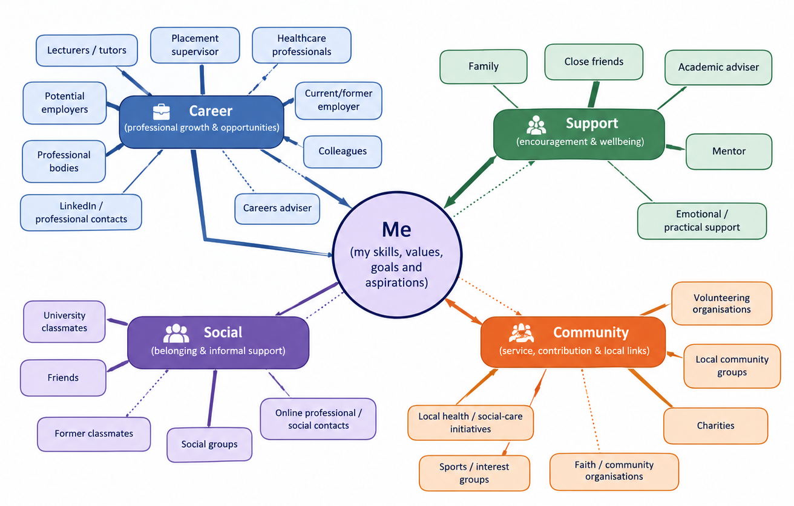
Task 2 - Network Map and Rationale
Figure 1: Personal career, support, social and community network map
My personal network (Figure 1) across career, support, and social/community dimensions, where connections matter for my professional growth, well-being, and opportunities. At present, some of my career contacts are university lecturers, classmates, and potential career contacts. Academic advice, feedback and employment links can be given by lecturers, and peers can share information and career pathways. It is a sign of the value of networking to gain knowledge, resources and opportunities that are outside of one's immediate reach (Wolff and Moser, 2009).
Close friends and family offer an emotional and practical support network that can help maintain motivation throughout the learning and career planning process. Social contacts can also be a source of informal knowledge and trust, and social networks in the community or volunteering may create chances to learn how to get along with others and show dedication to others.
My network is stronger in the personal and academic help areas than in the areas of direct professional help from employers and good health and social care practitioners. This restricts my opportunities to gain employment insights and mentoring. So, it is essential for me to plan my networking around career events, connections with relevant organisations, LinkedIn, and volunteering or placement opportunities. The more I can expand on these less strong connections, the wider and more career-appropriate my network will be.

Task 3- Blog

AI Scribes in the NHS: A New Tool, but Who Is Responsible?

Target audience: Newly qualified health and social care professionals entering UK practice
Consider taking part in a consultation and then typing for several minutes rather than listening to the person in front of you. Ambient voice technology (AVT), also referred to as an AI scribe, is driving it to become a health care issue because of this. AVT listens to a patient-professional interaction, generating a draft transcript or summary of their interaction (NHS, 2026b).
The amount of change is considerable. In January 2026, NHS England published performance data showing a 23.5% uptick in direct patient interaction time (DPI) and an 8.2% decrease in appointment length in testing across nine NHS sites and over 17,000 patient visits (NHS England, 2026). Also in July 2026, NHS England acknowledged that AVT would be procured in all 1,239 GP practices in the Midlands, marking AVT beyond the small experiments (NHS England, 2026a).
For newer professionals, this is self-evident, since that would free up more time to spend communicating, evaluating needs and cultivating therapeutic relationships. Nonetheless quick documentation does not necessarily translate into a safe care environment. The notes created by AI may have inaccuracies, and NHS England (2026b) has asked practitioners to proofread all the information in the patient record before incorporating any generated by AI. That is, it's the human professional, and not the technology, that is responsible.
Throughout, privacy and consent come into play. The patient's informed consent should be obtained if an ambient scribe is being used, and they may refuse. So, it is important to have the technology clearly explained, and a professional should take care not to make the assumption that efficiency is more important than patient choice (GOV. UK, 2026).
The important take-away is that digital skills have become a part of professional practice. Health and social care professionals, new to the field, should be aware of the advantages and disadvantages of AI and not be deceived by information, whilst safeguarding confidentiality. While AI should assist in professional judgments, don't replace them.
Being AI-ready for tomorrow should entail patients having a mindset that is both technology savvy and ethically inclined, and that they will maintain responsibility for all decisions made when caring for their patients.

Task 4- NHS Equality, Diversity and Inclusion Quiz
- What is the primary goal of the NHS Equality, Diversity, and Inclusion Improvement Plan?
The overall objective is to increase equality, diversity and inclusion within NHS employment practices and reinforce staff belonging. It addresses bias and disparities (NHS, 2023).

- How does the NHS EDI Improvement Plan propose to tackle the gender pay gap?
The Plan proposes analysing pay-gap data by protected characteristic and implementing improvement plans for sex, race and disability (High Impact Action 3; HIA 3). Progression is being supported by flexible working (NHS, 2023).

- What is meant by the term ‘intersectionality’ as used in the NHS EDI Improvement Plan?
Intersectionality acknowledges overlapping disadvantages associated with various characteristics or identities. These effects are taken into account by the NHS.

- Why is it important for the NHS to create a psychologically safe work environment?
Promoting psychological safety makes it safe for employees to speak up, voice concerns, and admit errors without consequences. This helps to maintain wellbeing and safety in care.

- How does the NHS EDI Improvement Plan suggest improving the experience of internationally recruited staff?
The Plan outlines clear pre-employment information, induction, and care for internationally recruited staff (High Impact Action 5). It ensures economic development for everyone equally (NHS Employers, 2023).

- What role does leadership play in advancing EDI objectives according to the NHS Improvement Plan?
Leaders are expected to be personally accountable for promoting EDI by identifying measurable goals to progress and monitoring workforce data. It reinforces responsibility.

- Identify one way the NHS EDI Improvement Plan aims to reduce health inequalities within the workforce.
One way is to lower the amount of bullying, heighten the level of civil behaviour, and improve the response to bullying and harassment. It tackles the inequalities that exist in the workplace relating to protected groups.

- Why does the NHS EDI Improvement Plan emphasise the importance of collecting and analysing data on protected characteristics?
Protected characteristics data is used to identify inequality, understand patterns, and inform interventions. It can also be measured to see if there is progress.

- Explain how flexible working policies can contribute to equality and inclusion in the NHS workforce.
The use of flexible working can assist in balancing work and caring responsibilities, health and wellbeing needs and different circumstances. It can help to maintain retention (NHS Employers, 2023).

- What is one strategy mentioned in the NHS EDI Improvement Plan to combat bullying and harassment in the workplace?
One approach could be to analyse bullying and harassment data at a protected characteristic level and create targets for reducing bullying and report on progress. It facilitates staff raising concerns.

Task 5- A Letter to Yourself
Dear Younger Me,
You're in an uncomfortable time right now, and you may find yourself feeling lost, anxious and uncertain about what to do next. In your current circumstance, you might believe that struggling is not strong enough. I'm telling you, though, that bad things can be a blessing and lead you to learn more about yourself.
There is one thing I would have you understand when you were younger: that emotional intelligence matters. Sorrow, anger, disappointment, or fear are not bad feelings to have. Don't try to suppress feelings, but be aware of them and understand them. Emotional intelligence allows you to regulate your emotions better, express them accurately, and be aware of the impact of your conduct on others. It would also have helped you listen and be supported when you felt the need.
I also want you to build up your resilience. There are things that you can't do, but things you can do. Failure is not the end when things do not go as you expected. Look at failures as a chance to learn, change and go again. Remember, help-seeking is not a bad thing; it is a good thing because you know that you need it.
You may have coped with that difficult phase with more confidence and patience if you had developed these qualities earlier. Most importantly, be kind to yourself! There's no need to have all things sorted out right now.

Keep pushing. You've got more strength than you know.

With hope,
Your Future Self

Task 6- Gantt Chart
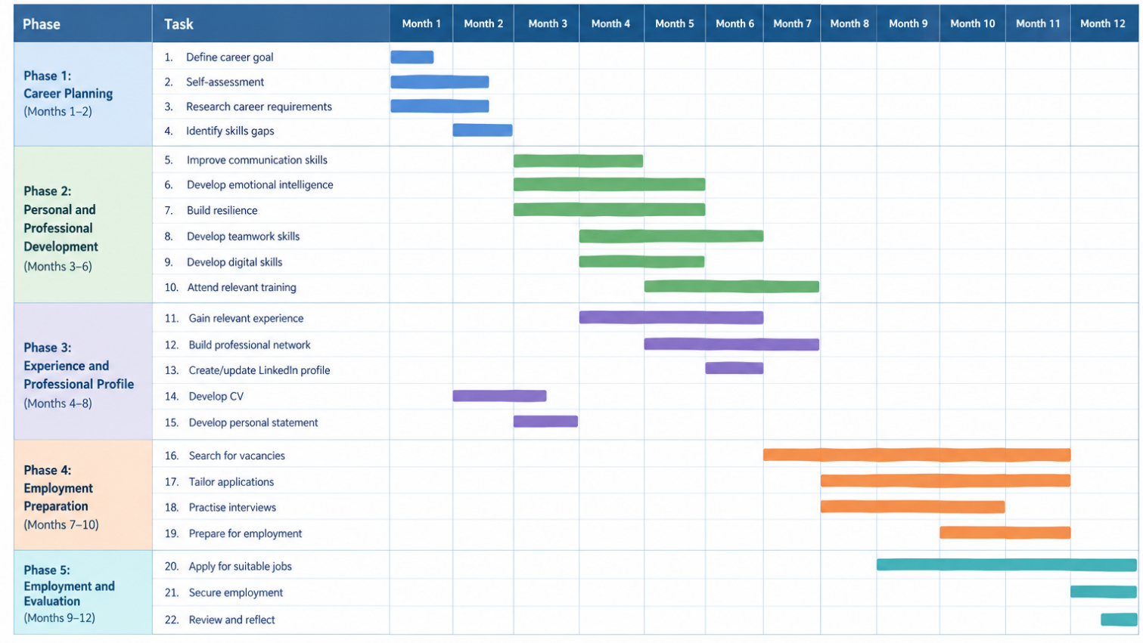
Career goal: To become a qualified Health and Social Care Professional working in a UK health or social care setting.
Figure 2: Gantt Chart for Achieving My Future Employment Goal in Health and Social Care

Task 7- Making Changes- Report
Report: Introducing a Daily Resident Safety Huddle in a Care Home
Introduction
As a care home manager, I would implement a ten-minute resident safety huddle in the morning at 9 am each day. The huddle would be a group with the nurse in charge, the care staff and other people available who were relevant (McGilton et al., 2023). It would aim to recognise individuals who are at risk of falls, mistakes of administration errors, worsening of condition, protective issues or inadequate care and plan for immediate action. This is a specific and doable change as it involves only a brief meeting each day and not a huge organizational change.
How the Change Will Be Achieved?
I would use Lewin's change model (unfreeze, move, refreeze). Lewin's model has been applied to the healthcare sector as well; a systematic review revealed that it was one of the two most commonly used change-management frameworks in healthcare research (Harrison et al., 2021).
When unfreezing, I would explain to staff why the change is needed, referencing the current incidents in the home, falls, and medication data. Staff would be asked to recognise areas for improvement in the current communication and put forward changes. This is key since by engaging employees you can lessen resistance and foster their ownership of the change.
The huddle would be implemented as a two-week trial during the move. At 9:00 am, staff would spend no more than 10 minutes answering 5 questions: Which residents are at risk today? What is the change that has occurred overnight? Do they have any medication or safeguarding issues? Are there individuals at risk of fall or decline? Who will take each action? The senior carer would have a basic huddle sheet and double-check later in the day.
If its evaluation results indicate benefits, the huddle will become part of the norm as the practice continues during refreezing. I would observe the fall incidents, missed-care issues, medication incidents, completed actions and staff attendance before and after the implementation.
Evidence That the Change Can Work
There is relevant evidence of this practice. NHS England (2019) defines a safety huddle as a brief, multidisciplinary meeting with a fixed duration aimed at enhancing communication, team working and surveillance of individuals at risk. An NHS case study goes on to show that a ten-minute daily safety huddle was successfully implemented in the morning at 9:00 am. Moreover, an NHS case study on multidisciplinary falls huddles showed that there was a 50% decline in falls when these huddles were introduced, highlighting the benefits of structured communication between teams in achieving safer patient care (NHS England; 2018). A recent randomised study from 2026 revealed that proactive huddles had positive effects on safety climate and were associated with fewer missed nursing care (Vexler et al., 2026). This evidence is primarily from health care settings and not care homes, but the principals involved, namely recognising early, communicating and acting together, are directly relevant to residential settings.
Skills Required and Barriers
The manager should be equipped with leadership, communication, emotional intelligence, teamwork and problem-solving abilities. There would have to be a sense of trust and confidence among staff to make claims without fear of being accused of something. Staffing issues, reluctance to meet again, irregular attendance, and the belief that 10 minutes is all that is needed are potential obstacles. These could be mitigated by limiting the huddle action to 10 minutes, giving a team a rotation as a leader, reminding people of the safety reasons for the huddle, and providing attendance and outcome metrics to show value. Overall, the daily safety huddle is a simple, measurable, evidence-informed change that can improve communication and help staff stay ahead of the curve to mitigate risk before harm occurs.

Reference List
Anderson, D. (2015) Stand Out: Design a personal brand. Build a killer portfolio. Find a great design job. Peachpit Press.
Gorbatov, S., Khapova, S.N. and Lysova, E.I. (2018) ‘Personal Branding: Interdisciplinary Systematic Review and Research Agenda’, Frontiers in Psychology, 9(9), pp.1–17. Available at: https://doi.org/10.3389/fpsyg.2018.02238.
GOV.UK (2026) MHRA clarifies regulatory status of ambient voice technologies used in the NHS. Available at: https://www.gov.uk/government/news/mhra-clarifies-regulatory-status-of-ambient-voice-technologies-used-in-the-nhs (Accessed: 08 October 2026).
Harrison, R., Fischer, S., Walpola, R. L., Chauhan, A., Babalola, T., Mears, S. and Le-Dao, H. (2021) ‘Where Do Models for Change management, Improvement and Implementation meet? a Systematic Review of the Applications of Change Management Models in Healthcare’, Journal of Healthcare Leadership, 13(2), pp. 85–108. Available at: https://doi.org/10.2147/JHL.S289176
McGilton, K. S., Krassikova, A., Wills, A., Bethell, J., Boscart, V., Escrig-Pinol, A., Iaboni, A., Vellani, S., Maxwell, C., Keatings, M., Stewart, S. C. and Sidani, S. (2023) ‘Nurse practitioner led implementation of huddles for staff in long term care homes during the COVID-19 pandemic’, BMC Geriatrics, 23, p. 713. https://doi.org/10.1186/s12877-023-04382-3
National Health Service [NHS] (2024) The NHS values. Available at: https://www.healthcareers.nhs.uk/working-health/working-nhs/nhs-constitution (Accessed: 08 October 2026).
National Health Service England [NHS] (2018) The Integrated Ward: a journey to improve patient care. Available at: https://www.england.nhs.uk/atlas_case_study/the-integrated-ward-a-journey-to-improve-patient-care/ (Accessed: 08 October 2026).
National Health Service England [NHS] (2019) Improving patient safety by introducing a daily Emergency Call Safety Huddle. Available at: https://www.england.nhs.uk/atlas_case_study/improving-patient-safety-by-introducing-a-daily-emergency-call-safety-huddle/ (Accessed: 08 October 2026).
National Health Service England [NHS] (2023) NHS equality, diversity and inclusion (EDI) improvement plan. Available at: https://www.england.nhs.uk/publication/nhs-edi-improvement-plan/ (Accessed: 08 October 2026).
National Health Service England [NHS] (2026) News- NHS backs AI notetaking to free up more face-to-face care. Available at: https://www.england.nhs.uk/2026/01/nhs-backs-ai-notetaking-free-up-more-face-to-face-care/ (Accessed: 08 October 2026).
National Health Service England [NHS] (2026a) News- Midlands leads the way on ambient voice technology. Available at: https://www.england.nhs.uk/midlands/2026/07/15/midlands-leads-the-way-on-ambient-voice-technology/ (Accessed: 08 October 2026).
National Health Service England [NHS] (2026b) Using AI-enabled ambient scribing products in health and care settings. Available at: https://digital.nhs.uk/data-and-information/information-governance/guidance/using-ai-enabled-ambient-scribing-products-in-health-and-care-settings (Accessed: 08 October 2026).
NHS Employers (2023, June 23) NHS Equality, Diversity and Inclusion (EDI) Improvement Plan | NHS Employers. Available at: https://www.nhsemployers.org/articles/nhs-equality-diversity-and-inclusion-edi-improvement-plan (Accessed: 08 October 2026).
Vexler, M., Drach-Zahavy, A. and Srulovici, E. (2026) ‘From talk to action: A randomized controlled design on the role of huddles in shaping safety climate and reducing missed nursing care’, Applied Nursing Research, 90, 152117. Available at: https://doi.org/10.1016/j.apnr.2026.152117
Wolff, H.G. and Moser, K. (2009) ‘Effects of networking on career success: a longitudinal study’, Journal of applied psychology, 94(1), p.196.

