Evidence-based Approaches to Policing Decisions

Describe the key Crime Prevention theories and explain how they might be applied in practice

Contents Page
What is Situational Prevention? 3
The Opportunity Structure For Crime 3
What is Rational Choice Theory? 4
What is Routine Activity Theory? 5
Implementation of Rational Choice Theory with the offence of Burglary and Theft 6
Implementation of Routine Activity Theory within Organised Crime 6
Evaluation 7
Reference List 10

What is Situational Prevention?
(Clarke, 1995) shows highly complex forms of crime require situational prevention techniques to reduce the opportunity of that crime taking place. There are many ways in which organisations such as the police and local authorities implement situational prevention techniques, one of these ways can be design and manipulation of the environment – how streets and buildings are designed, neighbourhood watch for example (making houses in a circular design so all residents can see each house. And making crime more difficult and riskier with less reward at stake. situational prevention contains 4 components, the foundation which is based on theories such as rational choice theory and routine activity theory, research and an action plan, studies in displacement, and opportunity-reducing techniques. the police and criminologists will work together with other professionals to put these measures in place.
The problem with crime prevention is that it could now potentially be seen as offensive to some individuals as it involves the police and local authority attempting to influence the behaviour of individuals. Instead of tackling common crime, the police could be seen as wasting resources and conflicting with the public interest, as the public would much before police on the beat than the use of situational prevention techniques and theories.

The Opportunity Structure For Crime
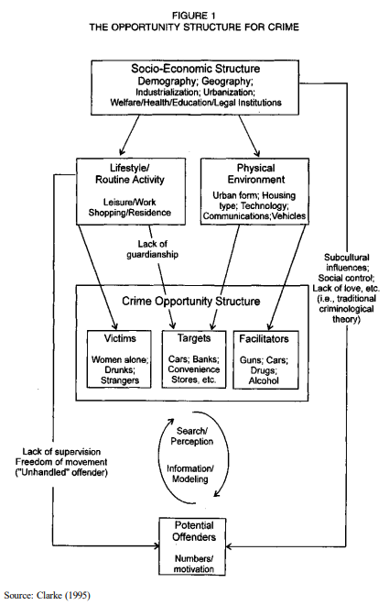
The diagram above created by shows that crime begins with the socio-economic structure, depending on urbanisation in the area and industrialisation of the area, this will then have an effect on the lifestyle and the routine activity of an individual it will also affect the physical environment itself, the housing and the technology in the area and the wealth will be dependent on the socio-economic structure. The routine activity of an individual will then lead to a crime opportunity structure this is dependent as well on the lack of guardianship. Youth individuals who lack supervision –parenting, teachers etc. and have subcultural influences – such as music or gangs could potentially become potential offenders and with the correct motivation could become direct defenders this is dependent on the suitable victim, target, and facilitators. ‘The Opportunity Structure for Crime’ can be linked to the situational crime prevention techniques discussed below (Clarke, 1995).

What is Rational Choice Theory?
The Rational Choice Theory was developed by (Cornish and Clarke 1986, The Reasoning Criminal) is a theory which shows that potential offenders take the rational choice to commit a crime which maximises the reward with the minimum risk of them getting caught. (College of Policing, 2022). Despite this, the theory assumes that criminals make the same thoughts and go through the same kind of thought processes as non-criminals when they commit acts of criminality Bryant.R and Bryant.S (2017, p.68).
Felson and Clarke (1998) offer an example of criminal needs when they describe all offenders have a goal when they commit an act of criminality. Offenders rarely have a full picture of the damage and cost they cause – due to having a limited judgement at the moment of committing an offence. Each criminal is in a specific category as they have different purposes and are all in different situations when committing an offence. A car thief arguably but not limited to can be split into multiple categories. Joyriders, people stealing the car for the valuables in the car, car resellers, people who resell car parts, or people using a stolen car to commit further criminal activity. Within all of these categories, criminals will all have a specific need for example a Joyrider might steal a car which is known to be fast, a part reseller might choose a popular car so the market is bigger to resell parts and the car reseller might choose a luxury car but not one that would stand out to police so they have value and less police attention.

What is Routine Activity Theory?
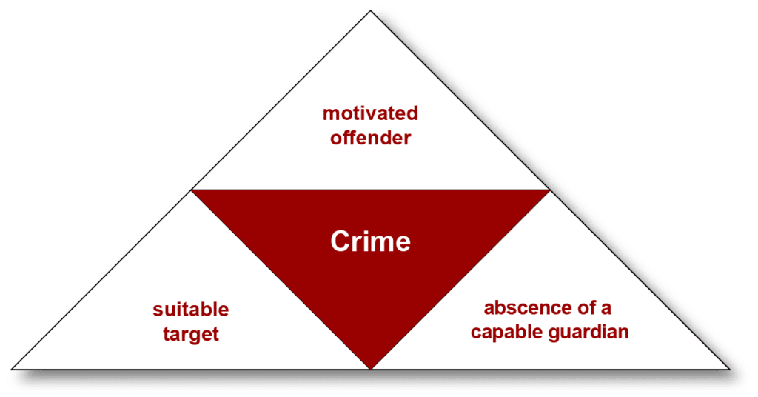
Routine Activity Theory is a theory which establishes the relationship between the individuals’ everyday activities and the individual criminal activity. Within Routine Activity Theory, a motivated offender, a suitable target, and a guardian’s absence make up the three necessary components of a criminal opportunity. When the three of these components coincide, this provides the likelihood for an individual to commit an offence especially when it fits into the everyday activity of the individual.
Routine Activity Theory Triangle Cohen and Felson, 1979
A suitable target is influenced using the four main elements, value, inertia, visibility, and access. A valuable target will contain someone or something of interest for example a criminal committing the act of theft would aim to steal a brand-new popular CD, rather than an old, outdated CD, even if they had the same monetary value it’s what the criminal values. A smaller weight of an item is preferred, a phone would be chosen over a TV for example, unless the criminal has a way of transporting larger items - inertia. Visibility, a thief will choose a target they have seen to have value, for example, if a member of the public gets money from an ATM or can see an item through a window. Access suggests the placement of items, entry options, and how easy is it for them to retrieve the goods (Felson and Clarke 1998).
Chamard (2010) refers to American Sociological Reviewn, Cohen and Felson, 1979, an increase of home burglaries within the 1960s was potentially a consequence of many Americans’ routine activities changing from activities within their household to more workforce / education-related activities. Moreover, an example of this is housewives who stayed at home began entering the workforce and post-secondary education, during this time it was also common for households to only have one person, meaning when they travelled houses were left without a ‘guardian’.
As mothers of children began moving into the workplace, children and teenagers were under less supervision thus increasing the chances of victimization and giving the youth more opportunity to commit criminal activity.

Implementation of Rational Choice Theory with the offence of Burglary and Theft
According to Felson and Clarke, (1998), opportunities for crime depend on movements in everyday activity this can be seen evidently in the case of burglary, for example, a pickpocket thief would move around crowds in a city centre, but a burglar would visit suburb areas in the afternoon and late evenings when residents of the houses are at work, education or asleep.
The offence of burglary can lead to opportunities for further offences to be committed. If a burglar steals a credit card, they can then sell that credit card to an individual who commits credit card fraud, a successful burglary committed on a house may encourage the individual to burgle the house at a later date. If an individual gets burgled and has property stolen it might encourage them to go out and get revenge and steal property to replace the value of the property stolen.
Clarke, (2012) reviews opportunity and crime – that is to say, “So what”? criminals regularly encounter opportunities related to their speciality – in this case, burglary, and theft – that person is more likely to seek more opportunities to commit the offence. If the opportunities fit into an individual’s regular schedule, they are more likely to attempt to make a living in a life of crime, this can turn a one-off offender to become a regular, more serious offender, who could turn to more serious offences to prevent being caught (armed robbery).

Implementation of Routine Activity Theory within Organised Crime
Clarke, (2012), highlights that situational crime prevention can be not only applied to street crimes but any form of crime, complex and serious offences can also be used, therefore I will attempt to implement the Routine Activity Theory to Organised Crime.
College of Policing (2022) implements the routine activity theory to deal with crimes such as stalking and harassment, employee theft and corporate crime. Analysts within the Police use crime prevention theories such as routine activity theory to assist with major crime investigations, volume crime, development in intelligence, investigations into complex and serious organised crime and vulnerability across local, regional, and national levels and tactical situations during crimes in action.
Implementation of Routine Activity Theory could provide insight into organised crime gangs and help authorities deter more serious crime from our streets.
Individuals who are involved in organised crime are motivated offenders not always for financial gain, some may be substance addicts and simply want to feed their addiction by completing activities for the gang. The offender of an organised crime group will always be motivated, whether they are willing to commit an offence or are being forced to commit an offence, the offender will always have a reward and hence will be motivated (Crown Prosecution Service, 2022).
Organised Crime Groups when committing offences such as Cyber Crime will specifically target vulnerable individuals for the target. Within this, I can apply the four elements of a suitable target provided by Felson and Clarke, (1998) ‘value, inertia, visibility, and access. According to the Routine Activity Theory, OCG in principle should target individuals with high financial value, they may have researched the victim and discovered they are elderly with little knowledge of technology. The target could give away sensitive information and details to the OCG this would give them visibility for the offence as they can get a picture of the type of person they are dealing with and how to make them more prone to a cyber scam. Finally, access of the individual, an individual with all their money in one bank account compared to, money split across multiple accounts would be more attractive as a suitable target as it is easier for the OCG to acquire (Crown Prosecution Service, 2022).
Organised Crime Groups rely on a lack of a guardian to remain undetected and profit from a volume of illicit crimes. Runners within an OCG who participate in county lines who are children might not necessarily have a lack of a guardian such as a police presence, but instead, a lack of effective parenting who let them go outside late at night and do not know what their child is getting up to is a lack of a proficient guardian (Argun and Dağlar, 2016). British Transport Police (2022) suggests children may use modes of transport such as train services to transport goods for OCGs, lack of a proficient guardian could include a lack of CCTV on stations/trains, especially in more remote areas. No British Transport Police presence on stations to detect the early signs of county lines could encourage more OCG behaviour in that area as the transportation of goods is less risk. Passengers on public transport may not be very observant when going to or from work, therefore if there is a lack of posters in stations or trains pointing out to be observant for vulnerable children on trains they may go unnoticed.

Evaluation
As previously stated, Clarke, (2012), suggests that situational crime prevention methods can be used on any type of offence, with this in mind professional investigating bodies such as the police could effectively implement these methods no matter what the offence is. Based on my findings, it could be argued that situational crime prevention techniques and theories can be applied to basic street crimes such as theft and burglary but also to more serious and complex crimes such as organised crime.

Reference List

Argun, U. and Dağlar, M., 2016. Examination of Routine Activities Theory by the property crime. International Journal of Human Sciences, 13(1), p.1190.
British Transport Police (2022) County Lines Campaign Poster Available at: https://assets.publishing.service.gov.uk/government/uploads/system/uploads/attachment_data/file/697846/train-1-county-lines-poster-a3-printready.pdf (Accessed: 04 April 2022).
Bryant.R and Bryant.S (2017) Blackstone’s Handbook for Policing Students 2017. Oxford: Oxford University Press
Chamard, S (2010). Routine activities. In E. McLaughlin, & T. Newburn The SAGE handbook of criminological theory (p. 210-224). SAGE Publications Ltd, https://dx.doi.org/10.4135/9781446200926.n12 (Accessed: 22 April 2022).
Clarke, R., 1995. Situational Crime Prevention. Crime and Justice, 19.
Clarke.R (2012). Opportunity makes the thief. Really? And so what? BMC, https://crimesciencejournal.biomedcentral.com/articles/10.1186/2193-7680-1-3 (Accessed: 05 May 2022).
College of Policing (2022) Intelligence management Available at: https://www.app.college.police.uk/app-content/intelligence-management/analysis/#:~:text=Routine%20activity%20theory,-Routine%20activity%20theory&text=This%20theory%20suggests%20that%20a,potential%20target%20without%20adequate%20protection (Accessed: 22 April 2022).
College of Policing (2022) What is situational crime prevention? Available at: https://www.college.police.uk/guidance/neighbourhood-crime/what-situational-crime-prevention#:~:text=Situational%20crime%20prevention%20focuses%20on,based%20on%20two%20related%20theories (Accessed: 22 April 2022).
Crown Prosecution Service (2022) Organised Crime – Strategy Available at: https://www.cps.gov.uk/organised-crime-strategy (Accessed: 25 April 2022).
Felson.M and Clarke.R (1998) Opportunity makes the thief. Practical theory for crime prevention. https://popcenter.asu.edu/sites/default/files/opportunity_makes_the_thief.pdf (Accessed: 22 April 2022).

