Blood Libel Essay
Does Giovanni Gasparro’s painting “The Martyrdom of St. Simon of Trento” attempt to revive medieval Christian antisemitism?
On the 24th of March 2020, Italian painter Giovanni Gasparro posted his latest painting, “The Martyrdom of St. Simon of Trento”, measuring 7 by 5 feet (213 by 152 cm). At that point in time, Gasparro’s paintings had been exhibited both in Italy and abroad for 20 years, in 2013 he received the Pio Alferano prize for young and talented artists. Gasparro has been described as a revivalist of Catholic Christian art, with his focus on the figurative rather than abstract and paintings reminiscent of Baroque artists. However, the new painting attracted controversy, as it portrayed in morbid detail the old antisemitic trope of blood libel. The lie of Jewish people killing, torturing and harvesting blood of non-Jewish children has transformed throughout history, as society became less focused on religion, the libel has secularized, became political and gained a new, vaguely scientific vocabulary. This essay will argue, however, that Gasparro’s scandalous painting is an attempt to conjure the ghost of Christian antisemitism, virtually unchanged since it arose in medieval Catholic Europe.
The painting depicts the crying young boy Simon gripped by the Jews, who laugh wickedly, as they wound the child. The Jews are easily identifiable by stereotypic features: hooked noses, peyot, wearing kippot, shtreimels and tallitot. Behind them, a menorah is lit. The top panel shows three sobbing angels descending with rose wreaths and a palm branch, symbols of martyrdom. The painting is impressive with its complex composition with multiple figures and dramatic tenebrism. The Jewish Encyclopedia defines blood libel as:
The accusation that the Jews — if not all of them, at all events certain Jewish sects — require and employ Christian blood for purposes which stand in close relation to the ritual, and that, in order to obtain such blood, they commit assault and even murder.
Allegations of ritual sacrifice against Jews pre-date Christianity. The first is in the letter of Josephus Flavius (c. 38-100 C. E.) against Apion. Here, Jews were accused of kidnapping and ‘fattening’ a Greek annually to be sacrificed at the Jerusalem Temple. First instance of similar allegations in Christian literature were made by Church father Democritus Tertullian (c. 160-220 C. E.), he spoke of Jews killing and eating babies. First instance of Jewish people accused of murdering a specific Christian child happened in 1144, after the death of William of Norwich. The story spread and similar allegations were made throughout Britain from 1168 to 1192. These were rumors that did not result in official trials and persecution. In May 1171 allegations of ritual murder in France led to 32 Jewish people in the local community being killed when they refused to convert to Christianity. This started the trend of blood libel causing Jewish persecution, murder and displacement.
Simon was a Christian two-year-old child, who went missing on March 23, 1475, in Trent. Rumors about Jewish involvement spread quickly. Three days later, Simon’s body was found by the Jews of Trent in a sewer near a synagogue. Autopsy concluded that Simon died of blood loss. A narrative emerged that Jews drained the boy of his blood to add to matzah for Pesach. His body was displayed at a church and was believed to perform miracles. As trials began, 22 Jewish people were arrested and tortured, between 1475 and 1476 all Jewish men were cruelly killed and all women and children were either forced to convert or were expelled. A local cult of the supposed martyr Simon quickly arose, promoted by the prince-bishop of Trent who insisted on Simon’s canonization as a saint. Pope Sixtus IV investigated the matter and prohibited continuing the trial. However, a cult was already in place. In 1588, Pope Sixtus V beatified Simon, allowing local observance in liturgy. In the Trent trials, one of the accused, named Tobias, was a physician himself and in his early testimony said that Simon likely died by drowning and the gruesome injuries to his body were the result of scavenging animals. Moreover, the supposed confessions were extracted through torture, exaggerated and fictionalized to be more impactful for the intended reader, the Pope, and convince him to canonize Simon as a saint. Accusations of ritual murder from earlier trials have also been denied and disproven throughout history.
The common iconography of blood libel in relation to Simon of Trent is the depiction of his alleged martyrdom in the hands of Jews. Jews in this narrative lack individuality, they are presented as a fictionalized collective entity, thus their guilt is also collective, both for supposedly killing Simon and Jesus Christ, who’s divinity they rejected. Thus, Jews are seen as incomplete and fragmented unless they become Christian. Jews were also vilified as forever seeking vengeance against Christendom, their rituals were misunderstood. Some writings went as far presenting Simon as akin to the new Jesus, sacrificed at an altar (even though synagogues do not have and altar), although Simon only parallels Jesus, while Jews are still seen as if they are one rather than multiple individual persons. Symbolism of Judaism was often made up in order to make it appear as inherently flawed and hostile. Jews were seen as the inverse of Christian, in the words of David Biale: ‘Jews became the dark side of this Christian celebration of the blood — and body — of Christ.’. Many of these features can be seen in Gasparro’s painting. The Jews wear religious clothing which interlocks their identity with their faith. Their appearance is likely painted from around four different models. The male figures have remarkably similar faces to one another. They are dressed differently, but not too differently. This allows the viewer to depersonalize Jews as one in the same, acting in unison. This enforces the idea of their collective guilt for any potential wrongdoing, as they are all to blame, they therefore all appear to deserve the same punishment. Their lack of individuality may also paint a narrative that they follow their rites blindly and makes it easier to dehumanize them for the viewer. The Jewish figures are also somewhat disembodied, as their dark clothes blend with the dark background, it seems that some hands appear out of nowhere. This links to the perception of the Jew as incomplete and fragmented, on the other hand, the Christian body of Simon is shown in its whole in the painting, so are the bodies of angels. This visually links him to the Divine. Paul Franks describes the painting as:
Gasparro’s portrait is the inverse of an adoration of the Christ child. Instead of being surrounded by adoring angels and angelic people, who keep a respectful distance, the Christ-like child is tormented and mutilated by demonic, cackling Jews…
This reinforces the concept of Judaism being the direct opposite of Christianity, as presumed Jewish ritual mirrors Christianity. Indeed, the child is Christ-like, as he is suspended in the same uncomfortable cruciform position, amplified by the white horizontal line of cloth Simon is strangled with. From the wound in his right side, blood is dripping, bearing a striking resemblance to the wound in the side of Jesus Christ. Simon’s holiness is shown through his burning halo, it indicates that this is not any regular child, like in many other cases of blood libel, but a saintly figure, although only beatified. In the painting, the Jews are shown equipped with various tools needed for the ritual: mainly knives, pliers, the scarf strangling Simon, as well as multiple bowls for collecting his blood. These are features of various portraits of Simon of Trent that appeared as the cult spread in the fifteenth century. They also bear resemblance to Arma Christi, images of Christ similar objects which were used to torture and crucify him.
In the modern increasingly secular society, antisemitism survives as it takes different shapes and approaches. Modern antisemitism is not as concerned with religion as it is with race and politics, the new blood libel adjusts accordingly. Nowadays, in popularized conspiracy theories of “Qanon believers”, Jews are disguised under the term ‘global elites’ and are accused of kidnapping, sex-trafficking and abusing children. It is also claimed that children’s bodies are harvested for a chemical known as adrenochrome, which is said to either be a potent narcotic or a type of “elixir of youth”. There is no scientific research showing that adrenochrome has any of these properties, it is also not extracted from the adrenal glands of living people. Jews, disguised as Zionists, are also accused of consuming the bodies and blood of Palestinian children, turning the Arab-Israeli conflict into another way to promote blood libel.
Gasparro has had interactions with the Catholic Church. In 2009, the Catholic Archdiocese commissioned Gasparro to decorate a damaged medieval church in L’Aquila. However, Bishop Ambrogio Spreafico, president of the commission of the Italian Episcopal Conference for ecumenism and dialogue, had disapproved of the painting, as it did not portray the values and message of the Catholic church. In 1965, the declaration “Nostra Aetate” was proclaimed by Pope Paul VI, which condemned antisemitism and rejected the idea of Jews’ collective responsibility for Christ’s death. The declaration encouraged interfaith dialogue and insisted:
Although the Church is the new people of God, the Jews should not be presented as rejected or accursed by God, as if this followed from the Holy Scriptures. All should see to it, then, that in catechetical work or in the preaching of the word of God they do not teach anything that does not conform to the truth of the Gospel and the spirit of Christ.
Therefore, it can be concluded, that Gasparro does not necessarily perpetuate the antisemitism of today, but rather that of the past. He perpetuates blood libel not because he dislikes Jewish people as an ethnic race but because of their religion, or what he assumes is their religion based on fictitious accounts. Gasparro’s portrayal of blood libel is as classical as his imitation of the old masters, not only does he copy their technique but their values and outlook, to the point that it is considered outdated even by the standards of the Catholic Church. It can be concluded that Gasparro attempts to revive medieval antisemitism, rather than inspire a modern one.
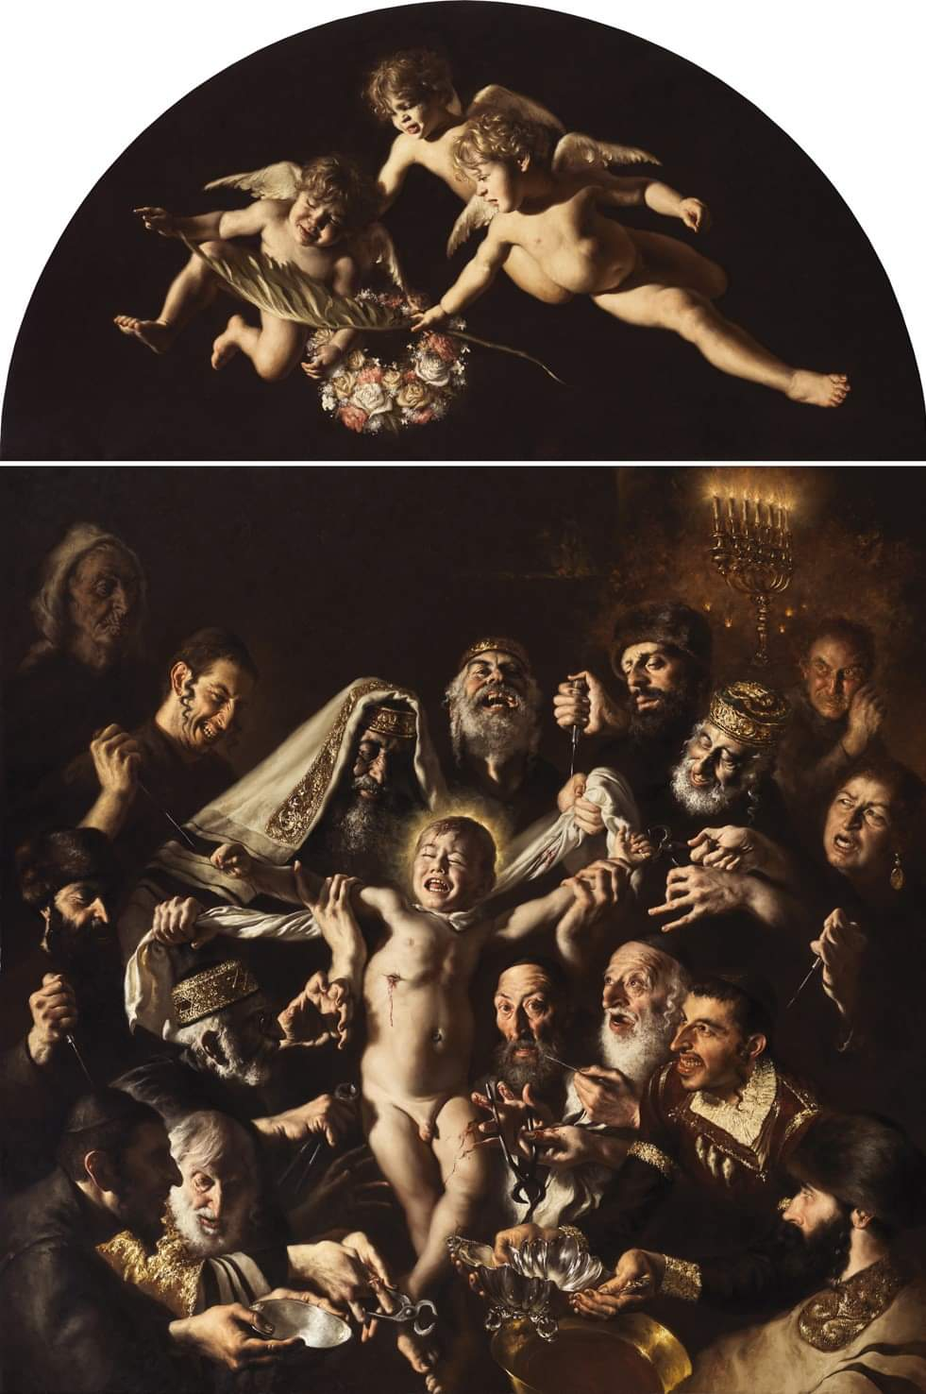
Image source: <https://www.osservatorioantisemitismo.it/multimedia/martirio-di-san-simonino-da-trento-simone-unverdorben-per-omicidio-rituale-ebraico/>

Paul Franks, ‘Blood Libel: Why is Facebook Permitting Antisemitism?’, Marginalia, 3 April 2020
Ben Cohen, ‘Italian Artist Giovanni Gasparro Revives Antisemitic Blood Libel With Graphic Painting of Medieval Child ‘Martyr’’, The Algemeiner, 26 March 2020
Franks, ‘Blood Libel…’
Cohen, ‘Italian Artist Giovanni Gasparro…’
Aaron Reich, ‘Italian artist accused of antisemitism for new painting of blood libel’, The Jerusalem Post, 27 March 2020
Reich, ‘Italian artist accused…’
Jeanette Kohl, ‘A Murder, a Mummy, and a Bust: The Newly Discovered Portrait of Simon of Trent at the Getty
Archive’, Getty Research Journal, 10 (2018), 37-60 (p. 43)
The Jewish Encyclopedia, Blood Accusation (2021)
Albert Ehrmann, ‘THE ORIGINS OF THE RITUAL MURDER ACCUSATION AND BLOOD LIBEL’, Tradition: A Journal of Orthodox Jewish Thought, 15. 4 (1976), 83–90 (p. 83) <http://www.jstor.org/stable/23258406> [Accessed 2 December 2024]
Ibid. p. 84-85
Samantha K. Seal, ‘MIRACULOUS HISTORY: FICTIONS OF TEXT AND BODY IN A RITUAL MURDER TRIAL’, Religion & Literature, 44.1 (spring 2012), 23-44 (p. 25)
Kohl, ‘A Murder…’, p. 38
Ibid, p. 39
Seal, ‘Miraculous history…’, p.
Ibid.,
Kohl, ‘A Murder…’, p.
14
Kohl, ‘A Murder…’, p.
Ibid, p.
14
7
Franks, “Blood Libel…”

