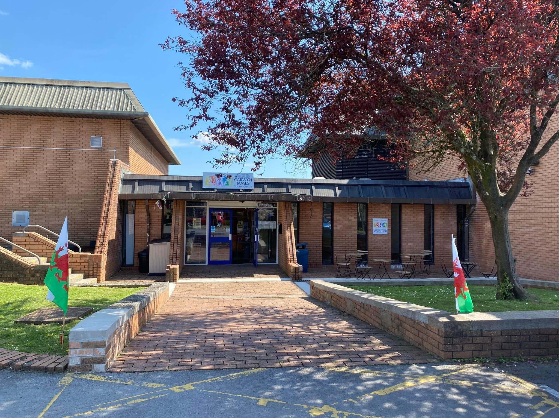  INTERNSHIP AND VOLUNTEERISM | Natalie Griffiths (2316480)  BMSP5022

Table of Contents
Introduction 1
Preparation for placement 1
placement objectives 3
Evaluation 3
Recommendations for improving 4
Conclusion 4
References 6

Introduction
The internship placement at Canolfan Carwyn was an invaluable experience that provided numerous opportunities for professional and personal growth. This report critically appraises the placement, reflecting on the objectives set at the beginning and evaluating the overall internship process. Recommendations for personal development are also included.
During my second year of university, I had the opportunity to complete a work placement at Canolfan Carwyn, this placement was part of my course programme at Trinity university, aimed at providing practical experience and insights into the professional world, ( Trinity University, 2025).
Canolfan Carwyn is a non-profit multi sports facility and is home of the Welsh Baton Twirling team. Canolfan Carwyn is a third sector organisation that provides help and raises money for social causes, they also rely on volunteers to carry out activities they organise, including their Vinted page where all the money raised goes back into the facilities, ( Canolfan Carwyn, 2025).

Preparation for placement
Running up to the start of my placement, we ran through some competency based interviewing processes as I have not done an interview for many years. This process really helped me with my confidence to speak clearly and overcome any difficult questions I may have encountered during the interview. Updating my CV before starting my work placement allowed me to reflect on what I have achieved throughout my career, reflecting on this would also help me in my interview process. Having already written a CV, this document needed to be updated. A CV is the first point of contact between me and my potential employer, therefore it is crucial that is up to date and relevant to the job description. As I have never worked in a 3rd sector organisation, this would be an excellent addition to my CV.
Learning about a Ghantt chart and how it would help me to plan my time ahead, I created my own Ghantt chart and highlighted any time off and when I would be in placement alongside any University lesson we had in the ten weeks, (Petersen,P.,1991). Conducting a pre-placement skills audit is a valuable process that helps me assess my existing skills and identify areas for improving before starting my work placement, (Griffiths, N, 2025). I began evaluating my current skills from previous experiences, such as education and work. This ensures that I am better equipped to manage any task and challenges I might have encountered. Knowing my strengths and weakness would help builds confidence, approaching the work placement with a productive mindset. A skills audit is a step towards continuous professional development. It encourages self-reflection and lifelong learning, which are essential for career success,( McGuire, al et, 2023.). Before starting our work placement, we had to go through all the necessary risk assessment forms that were needed to ensure that we follow all the safety regulations for the university, and for our safety in the work placement.
To secure my work placement, I approached Canolfan Carwyn, a community-focused organisation known for its vibrant activities and local engagement. My familiarity with the community hall stemmed from my frequent visits where my daughter attended her training sessions. This connection provided me with a unique opportunity to explore the possibility of a placement. Knowing the owner personally, I felt confident in reaching out to discuss the potential for work placement. I highlighted my interest in contributing to their ongoing projects and learning from their community driven initiatives. The owner appreciated my approach and the enthusiasm I brought to the table. They were more than happy to accommodate me. This encouraging feedback indicated the start of my journey with Canolfan Carwyn.

The specifics of the placement were then outlined to me: I would be finding emails and phone numbers of people who may want to use the facility known as the ‘warm space’. This space is a room located within the hall, or grounds depending on the weather, where people can gather together to talk, and have refreshments. Toys are available if small children accompany the adults. I was also required to participate in activities such as the Easter Fun Day. In this case, I was manning a stall as well as being in charge of the Easter Egg Hunt. This involved a lot of preparation and organisation. The children who participated were of all ages and some had disabilities. It was therefore a big responsibility, and I felt honoured that Canolfan Carwyn were willing to put so much trust in me.

placement objectives
One of my primary objectives was to enhance my skills in the third sector organisations, learning more about how these organisations operate and what is required for their success. I wanted to gain hands on the experience in working with a non-profit organisation, based in the community within the 6 weeks of me doing the ninety hours placement. I was particularly interested in learning about the operational aspects of Canolfan Carwyn. This included understanding how they plan and execute their projects, manage resources, and engage with the community. Observing and participating in these processes would provide me with valuable insights into the strategic and practical considerations involved in running a successful non-profit organisation.

Evaluation
I started my placement project with the Warm Space by trying to fill up the spaces each week. This did not go very well as there were long periods time when I was not achieving anything. This was not an effective use of my hours and would lead to periods of time when I was looking for other things to occupy myself. I would have liked to have something else to rely on as a backup project to keep me occupied, this significantly impacted on my experience. Despite my efforts to seek out additional responsibilities, the opportunities to contribute were limited. To try and make the most of my placement, I approached my supervisor to discuss any other tasks I could do, for example doing a few shifts there as a volunteer when needed. This resulted in me opening up for them one day and manning the desk for a few hours, I enjoyed the responsibility, however it was only for one session. Another task I undertook was helping a fellow volunteer to manage the donations for the community hall Vinted page, this was rewarding but not what I expected to be doing whilst undergoing my placement.
The opportunity to help during the Easter Fun Day allowed me to interact with stall holders and the public. This was a good experience for me as a learning curve. I realised that, although I am usually a talkative and outgoing person, in this situation, I lacked confidence to begin with. I realised I had to push myself to overcome my shyness. As the day progressed I eventually relaxed and was able to interact with the stall holders and the public in a confident manner. The Easter Egg Hunt enabled me to work with children of all ages, and I found that I was especially able to interact with those who had learning difficulties.
The periods of inactivity provided an unexpected opportunity for self-reflection. I learned to appreciate the importance of resilience and the ability to adapt to changing circumstances. This experience has strengthened my ability to manage uncertainty and find ways to stay productive, even in challenging situations. The placement, although not as active as I had hoped, contributed to my personal growth. I developed resilience and improved my ability to manage periods of inactivity. This experience has prepared me to face similar challenges in the future with a positive and proactive mindset. While the placement did not meet my expectations in terms of activity and engagement, it provided valuable lessons in adaptability and self-motivation. Moving forward, I will apply these lessons to future opportunities, ensuring I make the most of my experiences.

Recommendations for improving
To enhance the experience for future interns, I recommend that Canolfan Carwyn provide a more structured plan for intern tasks and projects. This could include a list of ongoing projects that interns can contribute to, ensuring they have meaningful work throughout their placement. Additionally, regular check-ins with supervisors could help identify areas where interns can assist and stay engaged. On a personal level, I wanted to develop my ability to work in a professional workplace and improve my communication skills. In future I would identify specific skills I wanted to develop and set clear goals for each one, whether it is improving technical skills or communication skills, having objectives will keep me focused and motivated. Being prepared to face the unexpected challenges and learn to navigate them with a positive attitude, this will enhance my ability to thrive in various professional environments.

Conclusion
The internship placement at Canolfan Carwyn has been an invaluable experience, offering numerous opportunities for both professional and personal growth. Despite some periods of inactivity, the placement provided essential lessons in resilience, adaptability, and self-motivation. Engaging in diverse tasks, from managing the Warm Space project to participating in the Easter Fun Day, allowed me to develop a deeper understanding of third sector organisations and their operations.
Through this experience, I have enhanced my ability to work in a professional environment, improved my communication skills, and learned to navigate unexpected challenges with a positive attitude. The insights gained from this placement will be instrumental in my future events, equipping me with the skills and confidence needed to thrive in various professional settings.
Moving forward, I am committed to stepping out of my comfort zone, setting ambitious goals, and continuously seeking opportunities for growth and development.

References

Canolfan Carwyn Sports Facility, (2025). Welcome to Y Gampfa, Drefach.
Sports hall | Canolfan Carwyn Sports Centre | Drefach

Corry, O. (2010). Defining and theorizing the third sector. In Third sector research (pp. 11-20). New York, NY: Springer New York. Defining-and-Theorizing-the-Third-Sector.pdf

Griffiths, N, (2025.) Pre Placement Skills Audit.
Assessment 1 - Pre Placement Skills Audit (1) jess.docx

McGuire, D., McVicar, O., & Tariq, U. E. H. (2023). Skills audits: an integrative literature review. Industrial and Commercial Training, 55(1), 34-46. https://doi.org/10.1108/ict-06-2021-0042

Petersen, P. B. (1991). The Evolution Of The Gantt Chart And Its Relevance Today. Journal of Managerial Issues, 3(2), 131–155. http://www.jstor.org/stable/40603907

University of Wales Trinity Saint David,(2025). Carmarthen Campus Life.
Carmarthen Campus Life | University of Wales Trinity Saint David

