Name Irene Quagraine ​
Student number -2434408​
Module code -LCHS 4003
Module Title- Introduction to Health and Social care
Lecture Name- Azida Zainol
Assignment Title -Portfolio
Task one- poster and Task two Essay

Contents
References 5
References 5

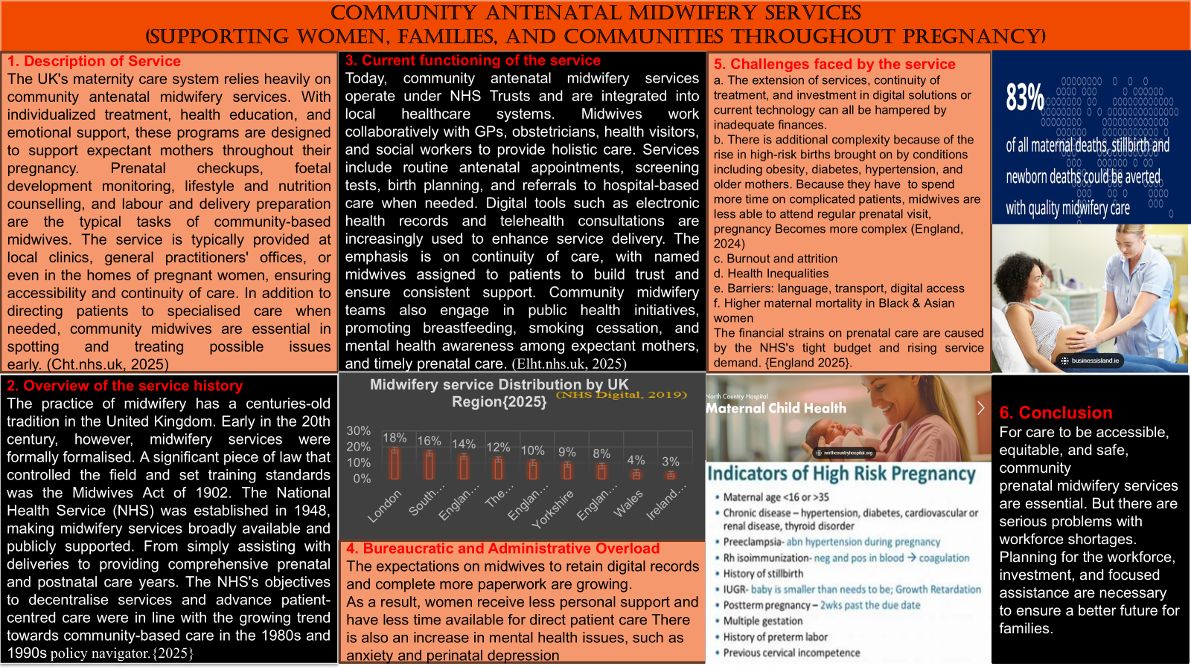

Essay

The Origin of the National Health Service (NHS): Historical Context, Foundational Principles, and Current Structure
The National Health Service (NHS) stands as one of the most transformative and enduring institutions in the United Kingdom’s social landscape. Established in the aftermath of World War II, the NHS was born out of a national desire to rebuild society on principles of equity, compassion, and collective welfare. Its creation marked a pivotal moment in public health policy, ensuring that healthcare would be accessible to all citizens, regardless of their financial status. This essay explores the historical context and foundational principles that led to the establishment of the NHS, critically examines its current structure, and evaluates its functioning in the face of modern challenges. (Harker and Powell, 2025)
The origins of the NHS are deeply rooted in the socio-political climate of post-war Britain. The devastation caused by World War II exposed severe inequalities in healthcare access and prompted a national movement toward comprehensive social reform. Central to this movement was the publication of the Beveridge Report in 1942, authored by economist William Beveridge. The report identified five major societal obstacles—referred to as the Five Giants—that hindered individual progress: Want (poverty), Ignorance (lack of education), Squalor (poor housing), Idleness (unemployment), and Disease (inadequate healthcare). (Policy Navigator, 2025a)
The Beveridge Report proposed the establishment of a welfare state that would address these issues through universal services. Among its most influential recommendations was the creation of a national health service. This vision was championed by Aneurin Bevan, the then Minister of Health, who oversaw the launch of the NHS on July 5, 1948. The NHS was founded on three core principles: healthcare should be free at the point of delivery, available to everyone, and based on clinical need rather than the ability to pay. These principles aimed to eliminate the fragmented and inequitable healthcare system that had previously existed, where access was often determined by financial means. (Weston, 2023)
Since its inception, the NHS has undergone significant structural changes to adapt to the evolving needs of the population. Today, the NHS operates as four distinct systems in England, Scotland, Wales, and Northern Ireland, each managed by its respective government. NHS England, the largest of the four, is overseen by the Department of Health and Social Care and is responsible for most healthcare services in the country.
A major structural reform occurred in 2022, when Integrated Care Boards (ICBs) replaced Clinical Commissioning Groups (CCGs). This change was aimed at improving coordination between health and social care providers, promoting more integrated and efficient service delivery. The NHS is organised into three levels of care: primary care, which includes services provided by general practitioners (GPs), pharmacists, and opticians; secondary care, which involves specialist services typically delivered in hospitals; and tertiary care, which encompasses highly specialised treatments such as oncology and neurosurgery. (The King's Fund, 2022)
Healthcare services are delivered through NHS Trusts and Foundation Trusts, with a growing emphasis on patient-centred care, digital health innovations, and community-based services. These developments reflect the NHS’s commitment to adapting its structure to meet contemporary healthcare demands.
Despite its foundational strengths and global reputation, the NHS faces a range of pressing challenges that threaten its sustainability. One of the most significant issues is staff shortages, which have led to increased workloads, longer waiting times, and widespread burnout among healthcare professionals. Additionally, funding constraints have limited the system’s ability to expand services and modernise infrastructure, while an ageing population and rising prevalence of chronic illnesses have placed further strain on resources. (NHS Support Federation, 2025b)
The NHS has also struggled with delays in treatment, particularly in areas such as elective surgeries and mental health services. These delays have impacted patient outcomes and satisfaction. Nevertheless, the NHS continues to be recognised as one of the world’s leading healthcare systems in terms of accessibility, quality of care, and equity.
To address these challenges, the NHS must invest in digital transformation, including electronic health records, telemedicine, and data-driven decision-making. It must also prioritise preventative care, modernise its facilities, and develop strategies to respond to emerging health threats, such as pandemics and climate-related health risks. (Daling water, 2020)
The NHS remains a powerful symbol of the United Kingdom’s commitment to social justice and public health. Its establishment in the post-war era reflected a profound belief that healthcare is a right, not a privilege. While its core principles continue to guide its mission, the NHS must evolve through policy reform, innovation, and strategic investment to meet the demands of a changing society. By addressing current challenges and embracing future opportunities, the NHS can continue to uphold its legacy as a cornerstone of equitable healthcare. (The King’s Fund, 2025)

References
- Bick, D., MacArthur, C. and Winter, H. (2009). Postnatal care: evidence and guidelines for management. Oxford: Wiley-Blackwell

References
Bick, D., MacArthur, C. and Winter, H. (2009). Postnatal care: evidence and guidelines for management. Oxford: Wiley-Blackwell
Bevir, M. and Waring, J. (2018). Decentring health policy : learning from British
- experiences in healthcare governance. Abingdon, Oxon: Routledge.

- Department of Health and Social Care (2023). NHS Workforce Statistics. Available at: https://www.gov.uk/government/statistics
- Department of Health and Social Care (2021). Midwifery Workforce Strategy. London: DHSC
- Dalin water, L. (2020). The NHS and contemporary health challenges from a multilevel perspective. Hershey, PA: IGI Global, Medical Information Science Reference.
- Harker, R. and Powell, T. (2025). The structure of the NHS in England. [online] House of Commons Library. Available at: https://commonslibrary.parliament.uk/research-briefings/cbp-7206/?utm_source

- Royal College of Midwives (2022). State of Maternity Services Report. London: RCM.
- NHS England (2023). Structure and Governance. Available at: https://www.england.nhs.uk/about/structure/
- NHS England (2023). Maternity Services. Available at: https://www.england.nhs.uk/maternity/ [Accessed 10 Apr. 2024].
- Policy Navigator. (2025a). Beveridge report | Policy Navigator. [online] Available at: https://navigator.health.org.uk/theme/beveridge-report?utm_
- NHS Support Federation (2025b). Staff Shortages - NHS Support Federation. [online] NHS Support Federation. Available at: https://nhscampaign.org/issues/staff-shortages/?utm_source=chatgpt.com [Accessed 19 Oct. 2025].

Sandall, J., Soltani, H., Gates, S., Shennan, A. and Devane, D. (2016). Midwife-led continuity models versus other models of care for childbearing women. Cochrane Database of Systematic Reviews.
- The King's Fund (2022). How Does The NHS in England Work? [online] The King’s Fund. Available at: https://www.kingsfund.org.uk/insight-and-analysis/animations/how-does-nhs-england-work [Accessed 19 Oct. 2025].
The King’s Fund. (2025). The Health And Care Outlook For 2025 | The King’s Fund. [online] Available at: https://www.kingsfund.org.uk/insight-and-analysis/blogs/health-care-outlook-2025?utm_source=chatgpt.com [Accessed 19 Oct. 2025].

World Health Organization (2020). Strengthening quality midwifery education for Universal Health Coverage 2030. Geneva: WHO.
- Weston, T. (2023). The NHS at 75: The past and future of its funding model. [online] House of Lords Library. Available at: https://lordslibrary.parliament.uk/the-nhs-at-75-the-past-and-future-of-its-funding-model/?utm_source=chatgpt.com.

