Research Proposal

The aim of this essay is to emphasise the various characteristics of the following materials, Timber, Steel and Concrete framing in a constructive environments. This essay will go into thorough detail concerning the advantages and disadvantages of the stated materials when used in construction. Additionally, outlining the key components of each individual material, describing the key qualities and properties. Furthermore, this essay intends to compare and contrast the stated properties against each other, in the hope of reaching a conclusion as to which material is the most beneficial and efficient in construction.

‘Timber frame is a well proven, versatile construction method with many benefits. It offers a number of advantages compared to many other materials’ (forestry.gov.uk, 2015). Firstly, speed of construction is a major advantage in timber frame construction, the build time on site is quicker, programmes of work are shorter and there is also a quicker return on investments. Furthermore, as it is manufactured in a factory controlled environment it is dimensionally accurate, health and safety is also increased due to the high control and there is reduced waste due to better material + waste management. Moreover, it has a sustainable method of construction with it being energy efficient & environmental friendly, it’s recyclable and has fast heating due to low thermal mass. Its lightweight construction also requires less expensive foundations. In addition, the drying out time is reduced, thus internal finishes completed quicker. The flexibility of the design can be managed well as extensions can be easily added and internal layouts can be readily adapted when required.
Despite, the previously stated advantages, there are several disadvantages regarding this particular material. Timber is susceptible to insect damage, as it can be a food source for many insect species. Timber in buildings can be attacked by a range of wood-boring insects resulting in structural weakening which can result from infestation. ‘Timber is more susceptible to fire than other building materials unless treated and maintained’ (Lassa.co.uk, 2015)
There are certain factors that can affect the physical properties of timber, the direction of the grain being one. The wood grows as fibres that run in the direction of the tree trunk. If they are parallel to the wood fibres then they are ‘‘with the grain’’, perpendicular to the wood fibres then they are ‘’against the grain’’. Moisture content is another factor that can affect the properties of timber. Wood is a hygroscopic material, meaning it absorbs moisture in humid environments and loses moisture in dry environments. Moisture content of wood is the weight of water it contains divided by its dry weight. The lower the moisture content, the higher the strength is. As moisture content of wood changes, wood shrinks and swells. Wood will continue to shrink or grow to reach equilibrium moisture content. This means that it acclimatises to its surrounding environment. A moisture meter is most commonly used to establish the moisture content of a particular batch of timber. These meters are usually attached to two probes which send an electrical current through the wood. Density of the timber varies with species and moisture content. As density increases, strength increases proportionally. Other factors that affect the properties of timber are knots and durability. Knots are formed by a branch that has been surrounded by growth of the trunk. Durability is defined as its resistance to decay and insect attack and varies with species; wood used in structural applications is treated to resist decay and attack from insect.
‘Timber framing dates back more than 2000 years to some Japanese shrines that are still standing. Over 3000 Timber Frame structures still exist in England that was built between 400 and 1100 A.D. Many timber frame buildings have lasted centuries, and ones built today are expected to exceed 300 years or so.’ (Benfieldattgroup.co.uk, 2015)

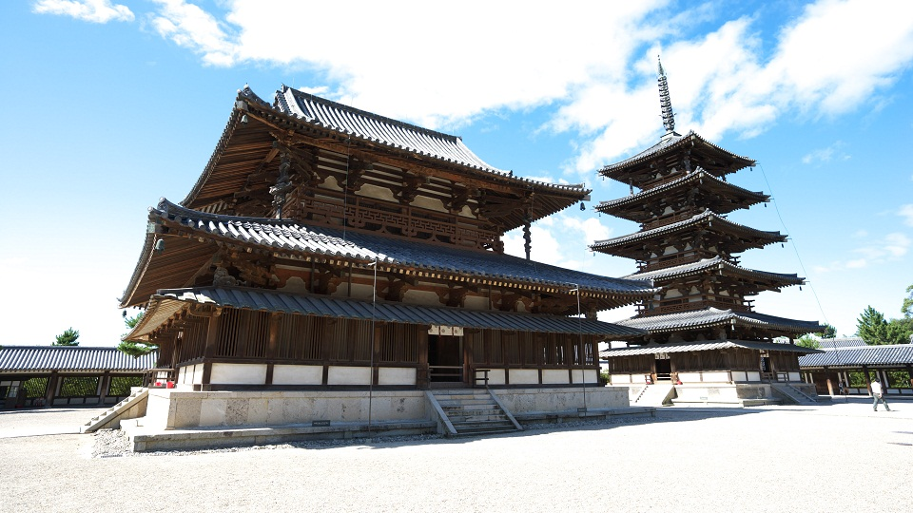

Concrete framing in construction has been around for hundreds and hundreds of years. The word concrete comes from the Latin word ‘concretus’ whereby meaning compact or condensed. The Pantheon in Rome is one the most famous concrete made buildings in the world, dating back to the 1st century BC. 
(Romeonsegways.com 2013)
Concrete is a composite construction material, composed of cement, which is the binding agent, coarse aggregate containing the gravel and crushed rock such as limestone or granite, fine aggregates, which is sand, water and chemical admixtures. Concrete comes in many types; plain mass, commonly used for dams, retaining walls etc. Lean concrete, which is a large ratio of aggregates, used for filling not structural. Structural concrete which is high in density. Reinforced concrete, which is assisted with steel for strength. Pre-stressed concrete is subjected to pre-placement compression to counteract expected tensile forces. Pre-cast concrete is seen in moulded channels and culverts. Water resistant concrete has a higher density when sprayed with lacquer, most used for water tanks. High density concrete utilises haematite using iron or steel as aggregates. High density types of concrete are used for shield walls or sea walls. Fibre reinforced concrete uses nylon, steel and carbon fibres as reinforcement. High alumina concrete has a high early strength and has good resistance to high temperatures and sulphates.

‘Reinforced concrete, as a structural material, is widely used in many types of structures. It is competitive with steel and timber if economically designed and executed.’ (Salehudin, Salehudin and profile, 2011) Commonly used worldwide, concrete has many advantages which make it popular in construction. As a material, it’s resistance to fire; higher than that of steel and timber. As well as being fire resistant, concrete is also weather resistant. It is durable, strong and needs little maintenance. ‘Concrete can withstand catastrophic loading and there is less movement with concrete structures, buildings have a longer life expectancy. They require lower maintenance and have greater resale value than other structures’ (Construction-greatopportunity.blogspot.co.uk, 2012). Using concrete as a constructive frame, it saves energy. ‘Industry studies prove that compared to steel construction, concrete buildings have decreased heating and cooling expenses. Over a 24 hour period, heat gain calculated by btu/ft², can be up to 50 percent less adding up to a substantial saving.’ (Construction-greatopportunity.blogspot.co.uk, 2012) Reinforced concrete, as a fluid material in the early stages, can be easily sculpted into a nearly unlimited spectrum of shapes and sizes.
However, despite the mentioned advantages, concrete material in construction displays numerous disadvantages. It is much affected by earthquake loads. In countries like America, Japan and China, which are most affected by earthquakes, concrete construction methods for tall buildings may not be the best choice. ‘It has a low tensile strength of about one-tenth of its compressive strength. Cracks develop in concrete due to shrinkage and the application of live loads.’ (Salehudin, Salehudin and profile, 2011)

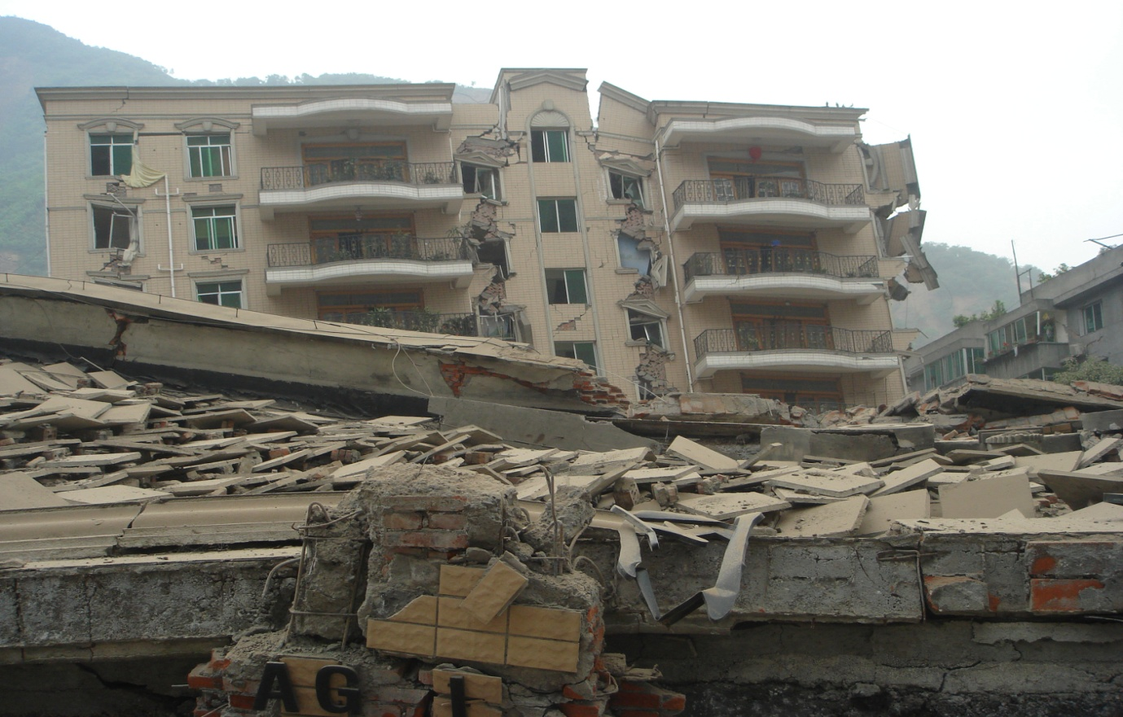
This picture showing the effects of an earthquake on a concrete building.

Steel comes in different classification of metals, ferrous and non-ferrous. Ferrous metals are those which contain iron, such as steel cast iron and wrought iron. Non-ferrous metals do not contain iron; these are materials like copper, lead, zinc, aluminium and chromium. In construction, steel, aluminium and copper are predominate. Steel is an alloy of iron and carbon. Iron carbide (cemenite) exists in sheets in its microstructure; this is very hard and brittle. These sheets are interwoven with iron to form a compound called pearlite. It is pearlite that gives steel its characteristic strength. The higher the pearlite, the stronger the steel. Steel has different types which are classified by their carbon content, these are; low carbon steel (less than 0.15% carbon), mild steel (0.15-0.25% carbon), medium carbon steel (0.25-0.50% carbon) and high carbon steel (0.5-0.9% carbon). Mild steel as a material is ductile and malleable, it’s tough and elastic, withstands shocks and impacts well and is equally strong in tension, compression and in shear. Mild steel is predominately used for reinforcements such as links, stirrups and mesh. High carbon steel as a material has increased tensile strength, resists corrosion better and is tougher than milder steel, but is more brittle and less ductile than milder steel. You will normally find high carbon steel used for tool bits like drills, blades, diggers and scoops.

Steel as a construction material, may be the best when comparing it to timber and concrete. ‘Steel frame construction offers many advantages over traditional reinforced concrete and timber with lower costs, sustainability and flexibility being amongst the many benefits of choosing steel framed buildings over the alternatives.’ (Reidsteel.com, 2015) Steel framing is very lightweight and strong (much lighter and stronger than concrete when strength to weight ratio is compared). ‘Steel can be assembled quickly and efficiently in all seasons. Components are pre-manufactured off site with minimal on-site labour. A whole frame can be erected in a matter of days rather than weeks, with a corresponding 20% to 40% reduction in construction time relative to on-site construction.’ (Livingsteel.org, 2015). It has excellent quality control making it precise and predictable. Using steel as your construction material, it can be built very tall and wide. The tallest building in the world is made up of steel.

(Burj Khalifa, Dubai)

Steel is endlessly recyclable and has added fire resistance which timber does not carry. These added fireproof methods are coatings, intumescent and sprayed. Intumescent coating is a paint spraying method produced from sodium silicates and graphite. Sprayed coatings are a vermiculite cement (calcium silicate or gypsum binder) or mineral fibre. Unlike concrete, steel is earthquake resistant. ‘It flexes under extreme loads rather than crushing or crumbling.’ ‘Steel is also energy efficient, as heat radiates quickly from steel roofing, creating a cooler home environment in hot climate areas. In cold climates, double steel panel walls can be well insulated to better contain the heat.’ (Livingsteel.org, 2015)

With all the listed advantages above, steel does bring its disadvantages in the construction industry. As a material, steel is expensive, much more expensive than masonry or concrete. The frames are more unstable, meaning their more liable to deformation and torsion. Steel needs fire protection and also needs a separate skin (walls and floors). ‘Maintenance of steel structures exposed to air and water, such as bridges, is susceptible to corrosion and should be painted regularly. Application of weathering and corrosion-resistant steels may eliminate this problem.’ (Hcgl.eng.ohio-state.edu, 2015) ‘Just like most construction materials, steel is prone to fracture. Constant tension and stress caused by the overall weight of a building contributes to the wear and tear of the steel.’ (eHow UK, 2015)

A Structural steel frame comes with different properties. The advantages lie in three areas, these are; in design, in construction and in use. In design has large spans with columns of small sections, has greater building heights and high load bearing capacity. Opening can be easily provided and the installation of services is simplified. In construction, there is an ease of fixing and cladding, it’s can be pre-fabricated and has an ease of erection. It has a shorter construction time and there’s a modest space demand on site. In use, steel has great flexibility and limited number of internal supports. It’s easy to dismantle or demolish and is recyclable.

In conclusion to the above research, getting the best out of your building is dependent on your environment. By using a timber based frame in the UK, it may not be used to its full potential when in use compared to a warmer climate but it is very common due to its quick and ease of assemble, low costs and insulation properties. By using a concrete based frame in the UK, you will find it works at a higher level compared to timber as it’s more weather resistant and durable. Concrete is also expected to have a longer life span than timber. By using a steel based frame in places such as the USA or China, you will see more advantages than disadvantages compared to concrete and timber as they are more susceptible to earthquakes and other disasters.

References
Anon, (2015). [online] Available at: http://www.forestry.gov.uk/pdf/Timber-frame-buildings-a-guide-to-the-construction-process_D496.pdf/$file/Timber-frame-buildings-a-guide-to-the-construction-process_D496.pdf
Benfieldattgroup.co.uk, (2015). Durability of Timber Framing and timber frame buildings. [online] Available at: http://www.benfieldattgroup.co.uk/knowledge-centre/technical-information/timber-frame-advantages/timber-frame-durability
Concrete, (2014). Advantages and Disadvantages of Reinforced Concrete - Civil Engineering. [online] Civiltoday.com. Available at: http://civiltoday.com/civil-engineering-materials/concrete/23-advantages-and-disadvantages-of-reinforced-concrete
Construction-greatopportunity.blogspot.co.uk, (2012). construction: frames. [online] Available at: http://construction-greatopportunity.blogspot.co.uk/2012/03/frames.html
eHow UK, (2015). The disadvantages of steel buildings | eHow UK. [online] Available at: http://www.ehow.co.uk/list_7456025_disadvantages-steel-buildings.html
Hcgl.eng.ohio-state.edu, (2015). [online] Available at: http://hcgl.eng.ohio-state.edu/~ceg532/chap1/chap1_2.htm.
Lassa.co.uk, (2015). The Advantages and Disadvantages of Timber Frame Extensions. [online] Available at: http://www.lassa.co.uk/the-advantages-and-disadvantages-of-timber-frame-extensions
Livingsteel.org, (2015). Building with steel. [online] Available at: http://livingsteel.org/building-with-steel
Livingsteel.org, (2015). Building with steel. [online] Available at: http://livingsteel.org/building-with-steel
Reidsteel.com, (2015). Prefabricated Steel Buildings & Construction Benefits | REIDsteel. [online] Available at: http://www.reidsteel.com/brochure.htm.
Romeonsegway.com, (2013). 10 Facts About The Pantheon | Rome on Segway Blog |. [online] Available at: http://romeonsegway.com/10-facts-about-the-pantheon/

Salehudin, M., Salehudin, M. and profile, V. (2011). Civil Engineering: Advantages and Disadvantages of Reinforced Concrete. [online] Bahkalimantap.blogspot.co.uk. Available at: http://bahkalimantap.blogspot.co.uk/2011/10/advantages-and-disadvantages-of.html

