
Applied Industrial Placement (SPORT)
M5X02295
Placement Portfolio Template

Student Name
Name – Jack Porter
P Number – 1702515
Organisation
Name – UWTSD Sport
Line Manager
Name – Andrew Thomas
Email – Andrew.thomas@uwtsd.ac.uk

TASK A – (Reflective Learning Log 1 - 500 words – First Experience of Placement)
Recommend to link the reflective experience to two different key themes.
My first placement experience was a coaching session at the LC2 in Swansea; other members of the class were also present at the session however we were split into smaller groups to cater for the number of children that would be present at the session that we were going to be coaching. My role within the group was to be the lead coach, while others in the group were acting as assistant coaches. We had spent some time together planning out or session and what type our session and what activities we would be delivering. We decided to deliver a session based around throwing skills whereby we would develop the children’s basic throwing skills by using fun games. I was feeling fairly confident going into the session as I have coaching experience with the university and I was familiar with the LC2 and how much space there was to use and I understood the standard of coaching that needed to be delivered, I felt happy and confident that me and my group had planned efficiently and that each member of my group knew there role and knew what part of the session they would be solo delivering or which activity had to set up for the next stage of the session. I feel our session went well and that each section was delivered clearly and everything ran smoothly, I feel like as a group we worked well together ensuring that we all motivated each other to do well. Looking back at the session there are a few changes I would have included which would be to add some question time at the end to make us aware of anything we can improve on as coaches. After the session I took some time to evaluate the session that had taken place ‘Evaluation is used to measure the expected changes and impact of the coaching over time. Evaluation is important to determine if your coaching is on track to meet the clients desired outcome, to understand “what works” and to identify if the coaching is meeting the expected changes and impacts.’(CleverMemo, 2015). After my evaluation of the session I realised that the session could have improved in a variety of areas such as splitting up tasks equally rather than allowing certain members of the group to not take a part of the session and only setting up parts of the session and not interacting with the children and allowing the other members of the group to do the coaching. I feel I performed well in the session taking a lead role which is something I’m not usually used to, however I feel it did me well to experience taking the lead. The others in my group did well to communicate throughout the session and ensuring everything was ready set up for each section of the session so we didn’t have to wait around and the children weren’t getting bored of waiting round. I feel like we worked well as a team which is vital in coaching ‘Teamwork – Coaches always give importance to teamwork. Teams are the driving force of companies and organisations. Teamwork is the combination of shared goals and collaboration of each person to achieve a desired result.’(professionalcoachtraining,2018). To conclude I feel the first placement session was a success on a personal level I feel my confidence grew as a lead coach and the ability to plan sessions thoroughly. I feel I learnt how to work in a group with others also putting ideas forward to the sessions planning. Next session I will try to take a backward step and allow others to take a lead to see how I work as an assistant coach in a group having already taken a lead role.

TASK A – (Reflective Learning Log 2 - 500 words – Mid Point Experience)
Recommend to link the reflective experience to two different key themes.
Ysgol Bae Baglan
My second experience of placement was a coaching session, the session was part of a half term camp ran by NPT pass based in Ysgol Bae Baglan as part of the coaching module, I was delivering a rugby session with 5 other members of the class. We were delivering to a group of 15 children with mixed abilities, in this session I decided to take a back step and allow others to be a lead coach as I had already experienced being the lead coach in the previous week and wanted to see how I would as an assistant coach, we started the session by introducing basic rugby passing and catching and developed throughout each taking separate parts of the session as our own and assisting each other, however we chose one member of the group to be the lead coach. I had mixed feelings going into this session as I knew the children had paid for a place at the camp so I wanted to make sure it was an enjoyable experience for them and they learned something about rugby from that session I was delivering I was also happy that the session was a rugby session as I know all the rules and skills having played myself and I felt confident about delivering a rugby session. I had researched the night before the area of the school and which area I could use to deliver my session I found that they had a 4g rugby pitch(Barry2016) which would be perfect for the space we needed, I was disappointed when we arrived to find that we were unable to use this area, however we used the space of the football AstroTurf which were adequate. I felt confident in my group as I had worked with the majority of them the previous week and was getting an understanding of everyone’s coaching skills and everyone’s strengths and weaknesses. I feel the event was a success as the children seemed to enjoy and they all took part with no complaints, as a reflection of the session as a whole I feel it worked very well and the session was well structured and all of my group played a fair part making sure everyone was chipping in and helping with coaching and setting up parts of the session. The session ran smoothly and we had planned efficiently and had catered for errors that could occur throughout the session, However we had not planned for the event of bad weather and what we would have done if there had been rain as our session was all based around outside and using the area we had set out and the amount of space we needed in future I would always ensure to plan ahead for this, I learned from this experience its always vital to have a contingency plan ‘A contingency plan is a course of action designed to help you respond effectively to a significant event that may or may not happen.’(EM-Soultions,2020). I feel in this session I personally planned the session well using my prior knowledge of rugby to add to the plan and helped others who didn’t have rugby experience, I feel that the session ran well throughout and everyone knew their role. To conclude the session was a success for me on a personal level as I feel I achieved all the goals I had planned for myself the previous week, I feel I am progressing well through placement. I feel that I worked well in a team and others around me also worked together using good communication. For my next session I will aim to plan more efficiently and add in contingency plans to all my future sessions.

TASK A – (Reflective Learning Log 3 - 500 words – Mid Point Experience)
Recommend to link the reflective experience to two different key themes.
Netball
For my third placement experience I was back at the LC2, delivering a coaching session based on netball for a group of Olfcha comprehensive school pupils, the pupils were all netball players so they already had a great knowledge of netball. As group we delivered a session based around the basic skills of netball which I had no experience of having never played, I had researched to the find the basic skills to give myself a slightly further my knowledge of the sport (TheUKrules,2020). Myself and my group then proceeded to plan a netball session in which I feel didn’t contribute as much as I had previously had due to the fact of my very limited knowledge of the sport, members of my group had experience of playing netball so understood the structure of how the session should look. My role throughout the session was to assist the coaches who had a greater knowledge of the sport and assist in any way I could. When the event started I was nervous as I had very little knowledge of the sport and how to deliver a good netball session and felt anxious about delivering some parts of the session incorrectly and teaching skills incorrectly, the other members of my group gave me confidence to help deliver small parts of the session by having quick interactions during parts of the session where weren’t delivering to discuss what I could do next and how to do so correctly. Looking back at the session as a whole I feel I grew with confidence throughout the session and showed an ability to adapt slightly to coaching a new sport. I feel that the session as a whole was positive however, on a personal level I don’t feel I performed as well as I could have due to confidence and lack of knowledge. The session went well and the pupils enjoyed and learned new skills from my group, they also gave us feedback and told us a group how they had enjoyed and feel like they have learned something new that they could take away from the session. On a personal reflection I feel I struggled in this session and didn’t help my group as much as I could have I believe this is due to lack of knowledge even after conducting personal research, this lead to a lack of confidence to take control of the session. The session ran smoothly throughout and everything was kept to a good timescale just as we had planned. To conclude I feel I learned from this experience how important it is to conduct research on topics and sports that you are aren’t fully aware of the rules and skills of to prepare yourself the best you can and to help your confidence for when you need to deliver a new sport. I will set myself personal goals for the next session which are to ensure I have prepared correctly and to the best of my ability, and also to involve myself more in sports I’m not fully aware of so I can learn while coaching with other coaches. ‘Goal setting can also work well when it comes to measuring and improving performance, and should really be present regardless of what level you are coaching at.’(CoachLogic,2018)

TASK A – (Reflective Learning Log 4 - 500 words – Near end of Experience)
Recommend to link the reflective experience to two different key themes.
Mentoring
Towards the end of my placement experience I changed roles from a coach to a mentor to other coaches in the group to get an idea of how the mentoring process works and this was also to help us as coaches learn from other students in the same position as us to improve our coaching skills, the mentoring process is vital in coaching to help coaches develop and learn from others. Coaching and mentoring can be effective approaches to developing coaches. Both have grown in popularity, with many employers using them to enhance the skills, knowledge and performance of their people around specific skills and goals.(CIPD, 2018). I was given a partner who I would be mentoring and my partner would also be mentoring me. We were watching each other coach a group of young children and taking notes and having a discussion with each other at the end about how we feel they performed and how they could improve. I felt nervous throughout when it was my turn to coach as I didn’t like the idea of someone watching me delivering a coaching session and I believe that affected my coaching that day and how I performed as a coach. When it was my turn to mentor I enjoyed the process of being the mentor and taking notes on my partner in comparison to when it was the other way round, I felt confident that I was making good notes to help my partner progress as a coach. I feel like the event was successful as I feel my partner helped me progress and I feel like I helped them progress further as a coach providing them with good tips for future sessions. Looking back at the experience I believe it has helped me and made me feel more confident as a coach being watched and it helped me in future sessions when delivering a session knowing all the things my partner picked up on which I wasn’t aware of in past sessions. I feel like as a mentor I provided my partner with good knowledge and ways to improve them as a coach. I feel my session didn’t go well as it could due to me feeling pressured and nervous due to the fact that I was being watched by members of the group. The whole process was a positive impact on me as I believe it helped me massively as a coach to progress further to improve my skills and how I coach and made me aware of other things to think about during the sessions I am delivering. For future sessions as a mentor and mentee I will set myself goals of becoming less nervous when I am delivering a session when being watched as I understand how the person watching is there to help me progress as a coach and improve my coaching skills, and as a mentor I will ensure that I make the person I am mentoring feel more comfortable so they perform to their full ability.

TASK A – (Add 250 words on link to future Continued Professional Development and Reference list based on total referenced material in Task A)
Continued Professional Development post placement (250 words - Link to pre placement module)
I will continue to practice coaching outside of university, I would continue to practice all the skills I have learned as coach so far and continue to work on the weaknesses I have identified. I will begin coaching at my local rugby club.

References from TASK A (10+ references)
- . https://clevermemo.com/blog/en/effective-coaching-evaluation/

- . https://professionalcoachtraining.com.au/the-importance-of-coaching-in-leadership-and-teamwork/

- . https://www.walesonline.co.uk/business/business-news/40m-ysgol-bae-baglan-project-11757248 (Sion Barry,2016)

- . https://www.em-solutions.co.uk/insights/why-is-contingency-planning-so-important/

- . https://www.theukrules.co.uk/rules/sport/netball/top-ten-regulations.html
- . https://www.coach-logic.com/blog/the-importance-of-goal-setting-in-learning-development

- . https://www.cipd.co.uk/knowledge/fundamentals/people/development/coaching-mentoring-factsheet

- .

- .

- .

- .

- .

TASK B – (YouTube Video – 10 x 1 min integrated video) (Experience, Roles, Improvements)
NOTE – Make sure the link works correctly
Website Link –

Link Password –

Video Duration –

Device used to create video –

Software used to create video –

Production contributors
Name | Position | Organisation

TASK B – (Picture Board – 5 pics (40MB upload limit to Turnitin) (Experience, Roles, Improvements)
Picture | Text (Paragraph)
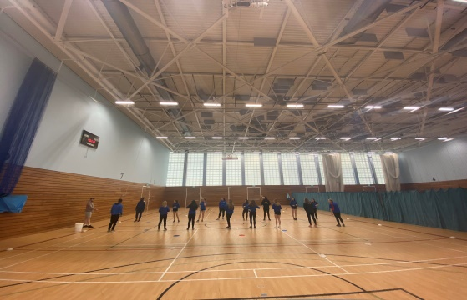 | In this session I am delivering a catching session to a group of UWTSD students, the session is based on the basics of catching and throwing.
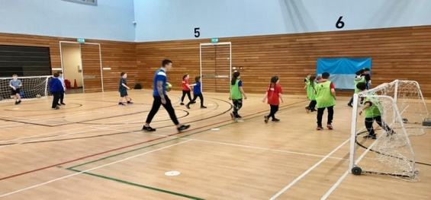 | In the image a football session is being delivered, based on shooting with the group being split into two teams having a small sided game.
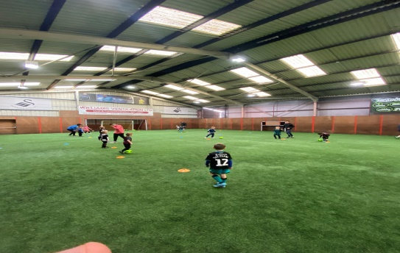 | In this image a football session is being delivered, In this session we delivered a passing and dribbling session to improve these skills. At meadow View sports complex.
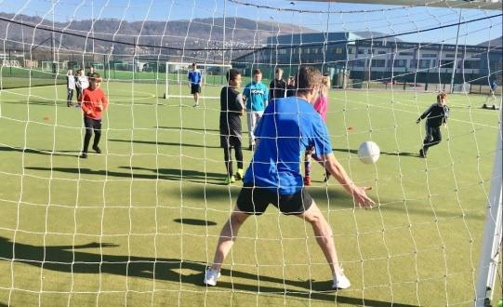 | In this image a football session is being delivered at Ysgol Bae Baglan, in this seesion we worked on shotting.
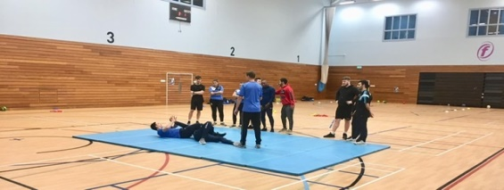 | In this image a Judo lesson in being taught, we are learning basic moves

TASK B – (Picture Board Cont.–5 pics (40MB upload limit to Turnitin) (Experience, Roles, Improvements)
Picture | Text (Paragraph)
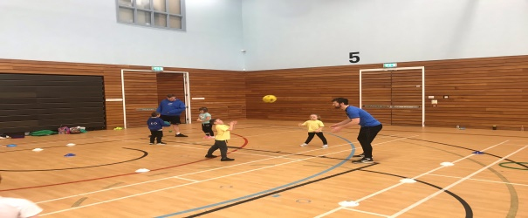 | This is a catching and throwing session, where we are aiming to develop the basic skills of the participants.
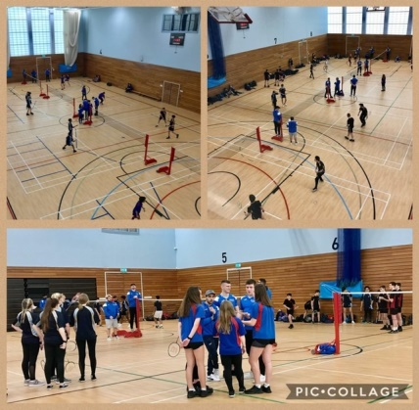 | A badminton tournament is being held here, at the LC2 indoor sports centre, where we as a class worked as referees.
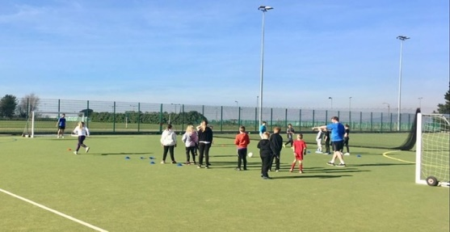 | This is a football session at Ysgol Bae Baglan, where passing skills where developed.
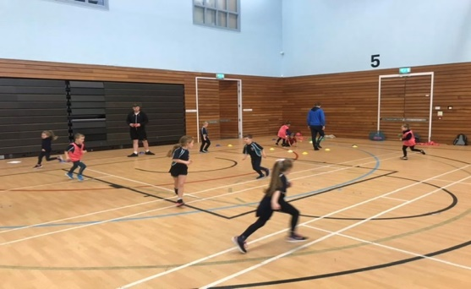 | This is a throwing session, held at LC2 indoor sports centre, the students motor skills and hand eye coordination were developed.
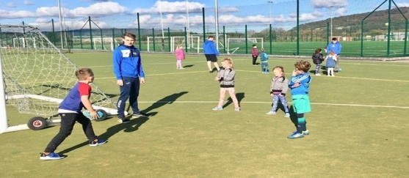 | Here we held a basic Rugby session, at Ysgol Bae Baglan, where we worked on basic Rugby skills, such as passing and catching.

TASK C Evidence – Employer Report (Signed),
NOTE – This will be compared against the report sent to the University.
NOTE – You will need to complete additional copies if you have more than one provider.

TASK C Continued Evidence – Employer Report (Signed),
NOTE – This will be compared against the report sent to the University.

TASK C Evidence – Ethics Form – Signed by Organisation and Lecturer
NOTE – You will need to complete additional copies if you have more than one provider.

TASK C Evidence – Ethics Form Continued

TASK C Evidence – Ethics Form Continued

TASK C Evidence – Ethics Form Continued

TASK C Evidence – Post Placement Review and Feedback
Dear Participant

Many thanks for your involvement in the work placement. I hope that you had a positive experience. The University of Wales Trinity Saint David reviews the provision annually for enhancement purposes and so we would be pleased to hear your feedback on any aspect of the placement.

Yours sincerely

Andrew Thomas, Placement Coordinator Sports Management Portfolio

Name of provider’s organisation:
Name of student:
What were the positive aspects?
Were there any problems?
Do you have any recommendations for enhancement for the future?
Signed:
Name in block capitals:
Position (please tick one): | ☐ Placement Provider  ☐ Student  ☐ Placem  nt Tutor |  | Date:

TASK C Evidence – Student Placement Induction Checklist
Student Name:

Name of Placement Provider organisation:
Placement Site Address:

Health & Safety Issues | No | Yes | Date
- Introduction to key staff members and their roles explained
- Location of welfare facilities (e.g. toilets, kitchen, rest room, showers, etc.)
- Emergency procedures
- Copy of safety policy received or location known
- Location of first aid facilities and contact for first aiders
- Fire procedures and location of fire-fighting equipment
- Accident/incident reporting and location of accident book
- Use/control measures for hazardous substances in the workplace (e.g. COSHH) – if applicable
- Display Screen Equipment Regulations and associated procedures – if applicable
- Manual handling procedures – if applicable
- Protective clothing/equipment arrangements – if applicable
- Instruction on equipment you will be using (list equipment)
- Specific training for tasks to be undertaken
- Specific information relating to risk assessments covering tasks to be undertaken
- Location of health and safety information and advice
- Specific disability related induction issues
- Other issues covered/to be covered please state:

As a minimum, the topics listed above should be included within the induction that you provide for the student on placement, preferably on their first day. Please check off the subjects as they are covered.

PLACEMENT PROVIDER CONFIRMATION

I confirm that the student has been provided with the induction specified above:
Signed:
Print Name:

Position: |  | Date:

STUDENT CONFIRMATION

I confirm that I have been provided with an appropriate induction as specified above:
Signed:
Print Name:

Position: |  | Date:

NOTE – If this is not completed please ask your supervisor on the placement to complete ASAP. However, please inform the placement coordinator at the earliest possible opportunity if this procedure does not take place.


UWTSD SPORT
Placement

