1803767 Scott Jones

12. Answer this question in a Word Document with a screenshot of Evidence.
- Is DHCP successful in Ha1 and Ha2?
NO
- Should be successful. If not Troubleshoot!
- From Ha1, ping Ha2. Is it successful?
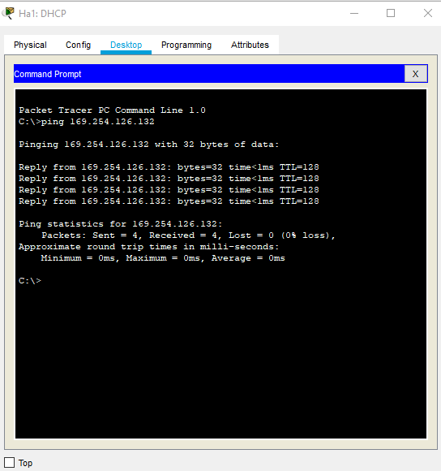

- From Ha2, ping Ra1. Is it successful?
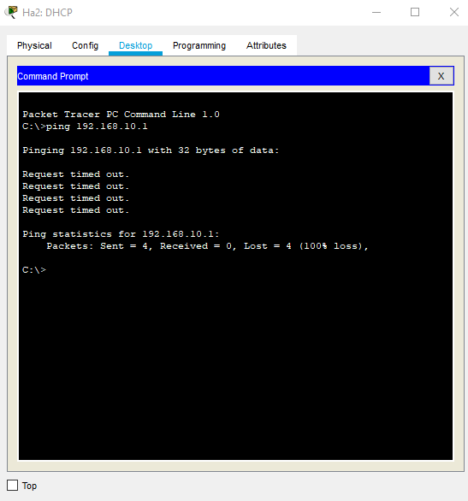

60% completion screenshot
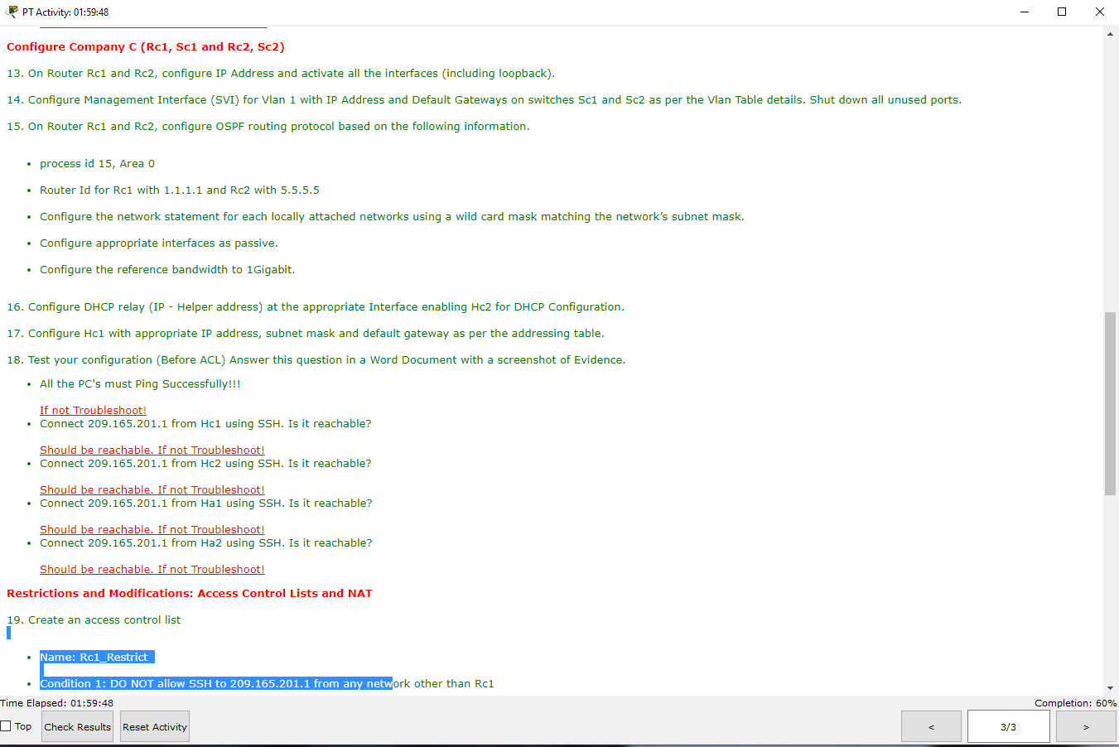

- Kept saying invalid login, used the correct password form the setup but not sure why it wasn’t working
- Connect 209.165.201.1 from Hc1 using SSH. Is it reachable? 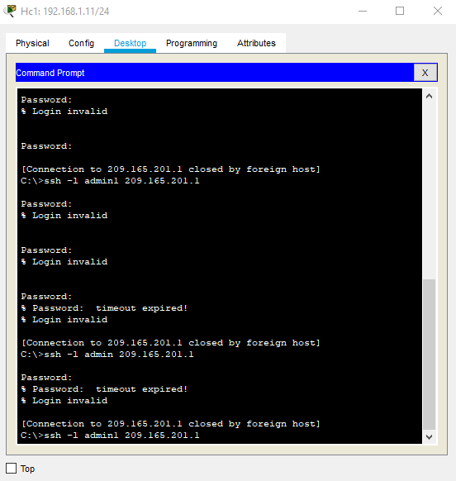
- Connect 209.165.201.1 from Hc2 using SSH. Is it reachable?
- Connect 209.165.201.1 from Ha1 using SSH. Is it reachable?
- Connect 209.165.201.1 from Ha2 using SSH. Is it reachable?

