Comparing with the direct exporting and the green-field strategy, which market entry mode is more suitable for Essential Ingredients Inc. to enter into Japanese market in 2019?



Content Page
Executive Summary 4
Working title 4
Project justification 4
Project Aims 4
Findings and Critical analysis 5
Secondary Research 5
Conclusion 6
Recommendations 6
Introduction to the company 7
Main findings: comparative analysis between two entry modes 17
The suitability of Direct Exporting Method 17
The suitability of Green-Field Investment 18
Marketing Mix 19
Product 19
Promotion 19
Place and location 20
Price 20
Process management 21
People 21
Evaluation 22
Recommendations 22
Conclusion 22
Bibliography 23

Executive Summary

Working title
Comparing with the direct exporting and the green-field strategy, which market entry mode is more suitable for Essential Ingredients Inc. to enter into Japanese market in 2019?

Project justification
As one of the fast-grown Small and Medium Enterprises (SME) in the US, Essential Ingredients has experienced an increase from 2014 to 2019 (Essentialingredients, 2019). Based on the classical company theory, survival and profitability are two major takes for a business organization (Drucker, 1994). The overall achievement has to be reached through market expansion. Therefore, the management and the board of directors have decided to enter into an international market. The core idea of market expansion is to have a greater profitability and to extend company’s size (Alexis, 1962). To conduct a marketing research for Essential Ingredients, a comparative analysis has to be proposed to tackle the key points. There are candidates, direct exporting and green-field investment, will be selected to be adapted in Japanese market through this research.

Project Aims

The general aim is to provide a marketing report for Essential Ingredients with recommendations to enter into Japanese market in 2019.

There are several project objectives:

1. To provide a market research including the external environment analysis including political factors, economic factors, social and cultural factors and technological factors in Japan.

2. To provide an analysis based on the internal environment for Essential Ingredients including the strengths, weaknesses, opportunities and threats

3. Conduct a comparative analysis for Essential Ingredients to evaluate the suitability between direct exporting method and green-field investment

4. To provide a recommendation to suggest which market entry mode is most suitable for Essential Ingredients to enter into Japanese market.

Findings and Critical analysis

Secondary Research
Due to the limitation to conduct interview with the management in Essential Ingredients, this project only provides secondary research to support research findings. The secondary research is based on the company’s annual report and the information from internet and journal articles. Through the market research, I found that the Japanese market is suitable for Essential Ingredients to enter by considering the external environment in Japan and internal environment in Essential Ingredients.

The major objective in this project is to conduct a comparative analysis to choose one of the market entry modes between direct exporting method and green-field investment (Marketing Intelligence & Planning, 1993). This analysis will be based on the tailored marketing mix for Essential Ingredients.

According to the result provided by this project, a recommendation will be followed to improve Essential Ingredients’ economics performance in Japanese market.

Conclusion
The direct exporting method is more favoured comparing with the green-field investment in the context of Japanese market.

Recommendations
- Some products should be revised to meet local needs, product adaptation would be necessary for Essential Ingredients.
- Considering the shipping method, some products with small size would be transported from the US to Japan

Introduction to the company
The development of information technology and transportation technology allows the globalization processing to other advanced stage (Straub, 2014). Within the global business environment, the competitions among companies are intensified in the local market (Emerald, 1990). For example, as a chemical and raw material seller in the US, Essential Ingredients is a SME which has limited budget and market share comparing with some international companies like 3M. In addition, the market size of chemicals and raw materials is expectedly to incline in the future (Milisavljevic, 2013). Therefore, Essential Ingredients will be benefit through this growth. The risk-taking ability would be strengthened.

Hence, to enter a new market would be desirable for Essential Ingredients. This project will be supported by the data collected through secondary research which is the only accessible method.

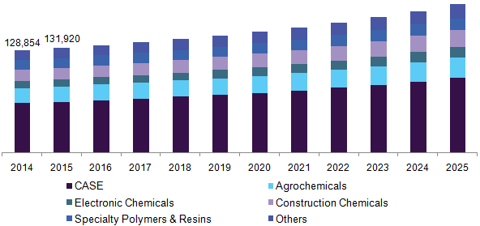
Figure 1.0 Market size of chemical and raw materials in the US (Grandview, 2019)

Current business review
As a fast-growing SME, Essential Ingredients has researched its peak revenue $70 million in the US market (Forbes, 2019). Considering the market size of chemicals and raw material sector, Essential Ingredients is not a market leader. The core idea of Essential Ingredients’ business pattern is a retailing seller and an intermediary cooperating with several major chemical and raw material suppliers in the US: Lubrizol, FloraTech, Momentive Performance Materials, Nouryon, Clariant, DuPont, Tate & Lyle BioProducts, Elementis Specialties Bontoux, Inc., Active Organics, Inc. and DuPont Industrial Biosciences (Essentialingredients, 2019). For those suppliers, Essential Ingredients has very close relationship to work with them. Since Essential Ingredients is capable to generate stable sales and revenues for those companies. The whole business mode adapted by Essential Ingredients is to function like an agent or an intermediary to sell the chemical products and raw materials for those suppliers. Essential Ingredients will extract a certain amount of commission from those suppliers (Essentialingredients, 2019).

Finding and critical analysis
In the finding and critical analysis section, the external environment analysis and the internal environment analysis would be contained to analyse the Japanese market. Based on the external and internal environment, the two market entry modes will be provided to the Japanese market. Finally, the corresponding marketing mix will be suggested to maximise the payoff which is expected to be obtained by Essential Ingredients.

Secondary research
In the Japanese market, Essential Ingredients only provides services (intermediary service or agent service) to directly export its suppliers’ products.
Therefore, the purpose of the direct exporting is to sell the suppliers’ product directly to the Japanese market. The green-field investment is to explore the new distribution and selling channel in Japan by establishes a branch in Asia-pacific area. To evaluate the suitability for a specific market entry mode, the secondary research will be carried out to provide information to make a better decision for Essential Ingredients. Those information is related to the analysis of external and internal environment. Some information of those two entry modes will be provided as well. In addition, a marketing mix will be obtained to justify the market entry mode adapted by Essential Ingredients.

PEST analysis
Political factors
For Essential Ingredients, management group only needs to regard the policies relating to the Foreign Direct Investments (FDI) and Trade policies between the US and Japan.
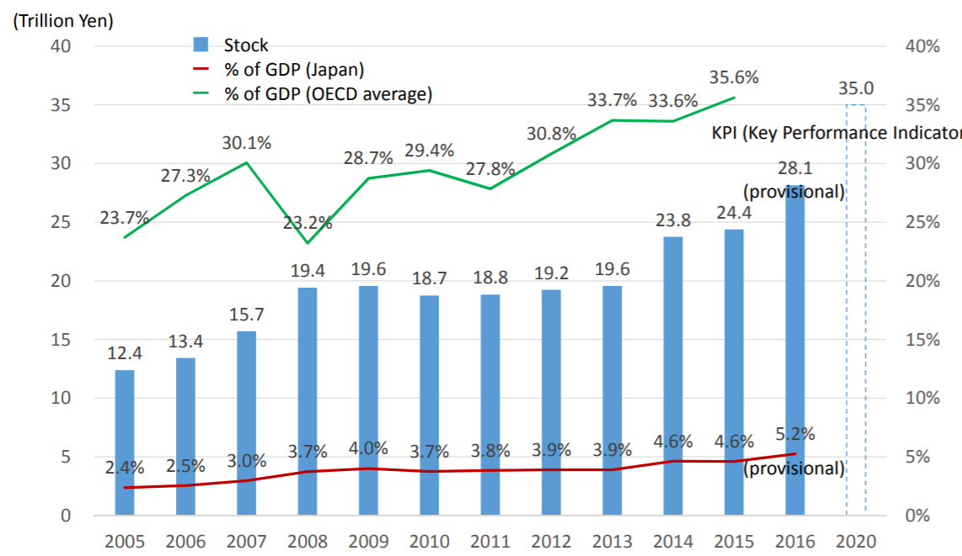
Figure 1.1: The Foreign Direct Investment Japan (InvestJapan, 2015)

Firstly, considering the current policies in Japan, Abenomics, there are three core values: Boost productivity, Drive Innovation and Trade and Energise Corporate Activities (Sarker et al., 2015). To explain those political factors, the idea of “boost productivity” shows that the work style reform tries to embrace the workers from diversified backgrounds, including senior workers and foreign labours (Hook, 1981). The current Japanese society is emphasising on the innovation and industrial revolution while the trade barrier was weakened (Nezu, 2007). As an innovative company who sells chemicals and raw materials, Essential Ingredients will be benefit through the policy-making in the Japanese market.

Secondly, the trade policies issued by Japanese government have five stages for a foreign enterprise from English-speaking country.

Overcome language barrier
The Japanese governments will offer QR codes printed on products from English-speaking countries for mobile phone scanning to have more detailed information from English to Japanese.

Better internet connectivity
The internet infrastructure has cover most public areas in Japan. Mobile phone users are free to scan QR codes in the WiFi Environment in Japan.

Enhance educational environment for foreign students
Japanese governments have established many international schools for international students from English-speaking countries. The expatriates’ offspring is capable to enjoy better education in the international schools in Japan.

Free provided advisor system
Publically hired investment advisors are freely provided by Japanese governments to foreign enterprises from the English-speaking countries.
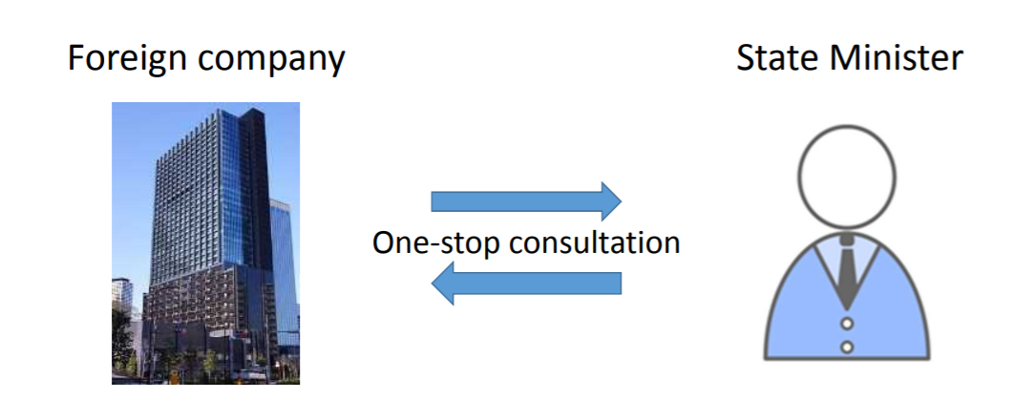
Figure 1.2 Investment Advisor Assignment Systems (InvestJapan, 2015)

Economic factors
Abenomics has been proposed to stimulate economic performance in Japan. Through the political factors, the economic performance and economic statics are boosted.

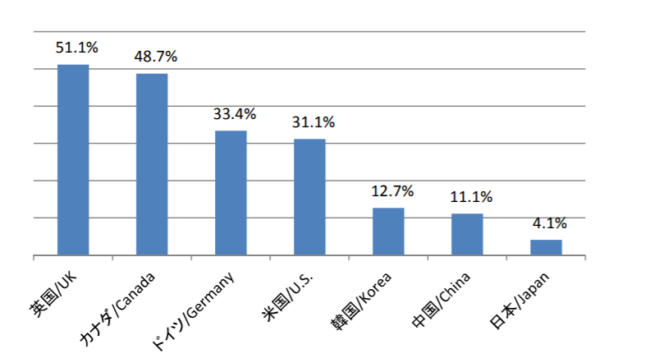
Figure 1.3: Inward Stocks as a percentage of GDP (Ministry of Foreign Affairs Japan, 2019)

A better business environment will be developed in Japan, all enterprises will be able to enjoy the wellbeing and benefits from local governments. In order to stimulate Japan economic performance, governments try to attract FDI by issuing favourable policies (Todo, 2011).

"Japan Revitalizing Policy 2013" made by the government, this policy has a target which is to double the FDI stocks to 35 trillion in 2020 expectedly (17. 8 trillion yen at the end of 2012) in the "Japan Revitalizing Policy 2013".

The other aspect of economic factors would be regarded as the GDP and GNP and other economic data in Japan to predict the purchasing power held by Japanese people.
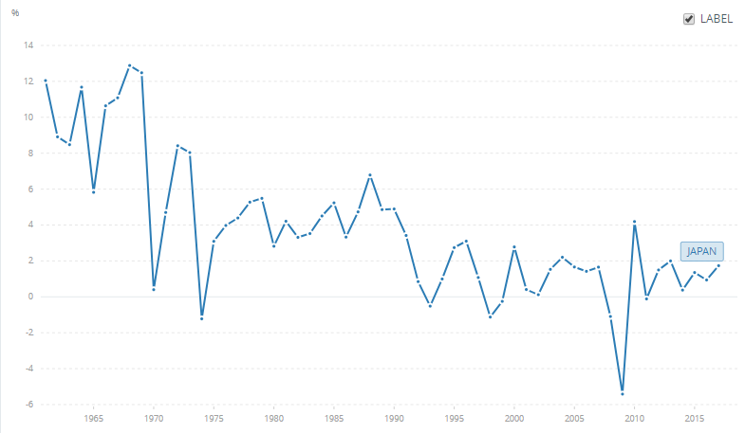
Figure 1.4: GDP growth annual % (Worldbank, 2019)

However, the economic data shows that the growth of GDP is in a recovery stage (even it keeps a low value, but citizens still have enough purchasing power).
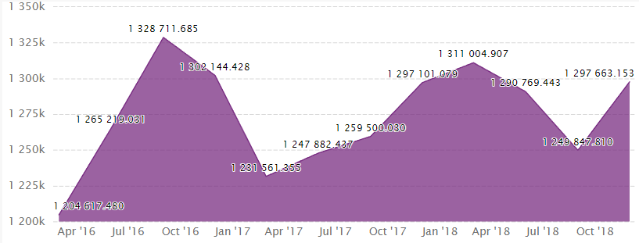 Figure 1.5 Japan Gross National product from 2016 to 2018 (Ceicdata, 2019)

The data presented in the figure 1.5 supports that Japanese citizens have adequate purchasing power to purchase products from Essential Ingredients. In general, the economic data suggests that Japanese economy is in a recovery stage with the policies attracting FDIs.

Social factors
In Japan, the word “globalisation” is to some extent equal to the word “westernisation” (Reader, 2006). The social cultural factors will support Essential Ingredients to establish a sustainable market share in terms of social aspect. Comparing with the local products, 43% Japan young men prefer the products from English-speaking countries (Reader, 2006). For example, even the products are similar, Japanese people are more willing to buy the products from the west. Consider the consumption of alcoholic beverage, Japanese people are intended to buy the brands from western countries rather than buy the sake (酒) from a local brand (Kanda and Okamura, 2014). Therefore, even the competitive landscape in Japan of chemicals and raw material is a little bit intensive, Essential Ingredients still has some natural advantages considering the social and cultural backgrounds (Jukić, 2019).

Technological factors
In 21th century, technological factors are sometimes focusing on the development of e-commerce and digital market in a specific country.

As the third largest e-commerce market, Japan is one of the fastest growing markets (Export.gov, 2019). “The growth rate has become stable over the past few years, with annual growth estimated at 9.1% in 2017. With Internet penetration estimated at 93.3% of the population, Japan represents a significant market opportunity (Export.gov, 2019).” Therefore, the technology of e-commerce is highly developed and advanced in Japan. The most famous business mode adapted by Japanese e-commerce is Business to Customer (B2C) amounted $137.6 billion in 2016 (Info Cubic, 2019).

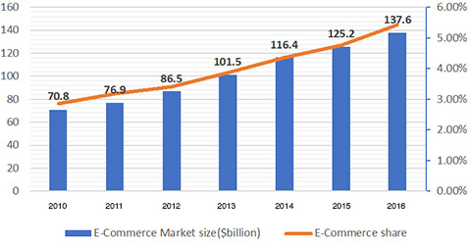
Figure 1.6: Japanese B2C market growth from 2010 to 2016 (Info Cubic, 2019)

As a distributer and retail seller, the growing trend of B2C market is favourable to establish an online store for generating more profit. Moreover, the quantity of potential customers in the M-commerce (digital market in mobile phone) and online shoppers are increasingly boosted. This trend of increasing number of potential customers is expected to grow even further for next coming years (Info Cubic, 2019).
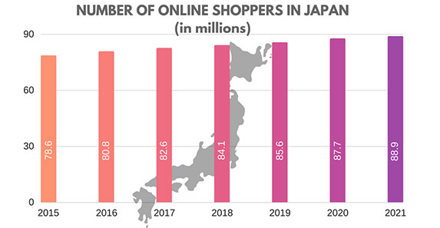
Figure 1.7: The number of online buyers in Japan from 2015 to 2021 (provisional) (Info Cubic, 2019)

Therefore, it is another advantage for Essential Ingredients. By having an increased customer pool with lower budget to establish an online store, Essential Ingredients is capable to reduce its cost even further. The potentials of the market (online market) are presenting a good expected profitability in the future.

Hence, considering the political factors, economic factors, social and cultural factors and the technological factors, a synthesised idea suggests that Japanese market is suitable and reasonable to be entered by Essential Ingredients. The presented advantages is overweigh the presented disadvantages overall.

SWOT analysis
Strengths
One of the major strengths acquired by Essential Ingredients is the industrial networking. Considering the industrial connection between Essential Ingredients and its suppliers, supplier’s revenues highly depend on Essential Ingredients’ distribution channel. Therefore, because Essential Ingredients is supported by those suppliers (some suppliers are international business organisations). In some sectors of person cares, Essential Ingredients’ product lines almost cover all the available products in the market. Essential Ingredients has its strength in product line, for example: in the natural oil sector, Essential Ingredients has 36 different types oil, including tea tree oil, clove bud oil, citronella etc. (Essential Ingredients, 2019). Therefore, it is very unlikely to have alternative products in many sectors of chemicals and raw material market in Japan.

Weaknesses
As the classical weakness equipped by an agent, Essential Ingredients does not have its own product. The major function of an agent is to distribute suppliers’ products. Therefore, Essential Ingredients’ economic performance strongly relates to the products provided by its suppliers. Within the relationship between Essential Ingredients and its suppliers, the imbalanced power can be defined as a major weakness showing that once the major suppliers (Bontoux Organics, Lubrizol and FloraTech) signed new contract with other agents, Essential Ingredients’ will no long have its advantages in product lines.

However, as a stakeholder who holders high stake, Essential Ingredients’ suppliers are focusing on the volume of sales generated by Essential Ingredients. Therefore, by entering the Japanese market and exploring a new market, Essential Ingredients’ suppliers will support Essential Ingredients to do this market extension.

Opportunities
As I have mentioned above, taking the external factors into account, the major opportunities for Essential Ingredients are related to the natural advantages in the external environment. Excepting the external opportunities, Essential Ingredients itself also has some opportunities.

The new contract signed between Essential Ingredients and Bontoux Organics is a significant opportunity for Essential Ingredients. The new contract reveals that Essential Ingredients has its monopolistic rights to sell certain Bontoux Organics’s products (Essential Ingredients, 2019). Those authorised products cover some major sub-sectors in personal cares, for example the “Bontoux Essential Oils”, as a newly developed and launched product, have more various uses comparing with its competitive products, it can be applied to body wash, facial wash, facial cleansers, luxury skin care and antiperspirant (Essential Ingredients, 2019). As a featured product, “Bontoux Essential Oils” is expected to be a best-seller in Japanese personal care market.

Threats
All the treats presented in a new market are potentially from the competitors. To compete a portion of market share, Essential Ingredients has to know the alternative products provided by its competitors: “Deep Cleaning Oil” provided by DHC (Price: 1,600 yen (120 ml)), “Kanebo Suisai Beauty Clear Powder” from Kanebo (Price: 1,080 yen for 15 pcs/ 2,160 yen for 32 pcs) and the most famous skin care product in the world “SK-II Facial Treatment Essence” (Price: 75ml 8,925 yen/160ml 18,360 yen/230ml 23,760 yen) (Naho, 2019). Tackling the low price market, moderate price market and luxury skin care market, those three products have already obtained very strong brand awareness in Japan skin care and personal care market. It seems difficult for Essential Ingredients to sell its suppliers’ product in this market.

Main findings: comparative analysis between two entry modes

The suitability of Direct Exporting Method
The direct exporting method in this context is to sell Essential Ingredients’ supplier’s products to the Japanese market directly.

There are major two advantages for Essential Ingredients to sell its suppliers’ product to Japan directly: matured shipping pathways and favourable trade policies. The shipping and transportation would be a major elements contributing the cost to the overall price which may reduce the core competency in terms of selling price. Therefore, exploring a new shipping pathway would be extremely expensive for a SME. To develop the bilateral trade between Japan and the US, CFS has developed a matured shipping pathways for international companies in the US and Japan (CFC, 2019).

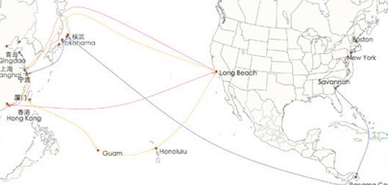
Figure 1.8: Shipping from the US to China and Japan (CFC, 2019)

Therefore, the shipping pathways provided by CFC is potentially profitable. Since the shipping pathways from the US to Japan is embedded in the shipping pathways from the US to Japan. In the future, the management group in Essential Ingredients can also consider to enter into China market.

On the other hand, the trade policy between the US and Japan presents other advantage for Essential Ingredients. The “Deregulation and Competition Policy: The Twin Essentials”, as a major component to reduce the trade barrier among WTO members, the international companies from both sides would enjoy the favourable policy of tariff deduction (PIIE, 2019).

The less control will be defined as a significant disadvantage acquired by Essential Ingredients to execute the direct exporting entering into Japan. Without having the direct control imposing on the Japanese market, Essential Ingredients may experience some unforeseeable problems, regulatory changes or some other problems reducing the profit as an example.

The suitability of Green-Field Investment
In this context, as a service provider, Essential Ingredients does not need to build a factory to produce intangible products to sell in the Japan. But, establishing a branch hiring local staff would be adapted as a Green-Field Investment (GFI) in Japan.

The main purpose of the Green-Field Investment is to set an office, as headquarter controlling Asia-Pacific market in Japan. Therefore, the major disadvantage is the cost to establish an office in Japan. However, the negative effects generated from this disadvantage can be ruled out. Since there are many suppliers, as the major stakeholders, that are capable to invest into this project (entering Japanese market) as a part of joint-venture. A new agreement relating to sharing risk and interest in Japanese market can be formed between Essential Ingredients and its suppliers.

There are two advantages to enter into Japanese market via GFI: a) future development b) direct control. In this market entry mode, the future development can be defined as a potential interest point. Because the geographic location of Japan is approaching to China. The potentials of the Japanese market can be regarded as a springboard from Japan to China which is the largest market in the world. The direct control imposed from Essential Ingredients allows company to protect its trademarks and rights in Japanese market.

Marketing Mix

Product
It is impossible to ship all available products in chemicals and raw materials from the US to Japan. Therefore, Essential Ingredients has to focus on a small range of product lines at first. Essential Ingredients has to consider its strength in terms of products. In general, Hair care, Oral Care, Skin Care and Body Wash are three major streams in Essential Ingredients’ product line which is the most sufficiently developed (Essential Ingredients, 2019). By using those featured products entering into Japanese market to build brand awareness and brand loyalty, Essential Ingredients will generate stable incomes in Japanese market at first.

Promotion
Considering the special features in Japan, the promotion method would be an embedded advertisement in video games. “The game industry in Japan is the third largest in the world, generating a total revenue of 12.5 billion dollars in 2017.”(Netherlands Enterprise Agency, 2018, p1) There lots of potential customers are playing video games in Japan. The different video games classify customers into different types. Essential Ingredients’ product line Japan is covering Hair care, Oral Care, Skin Care and Body Wash sectors. Hence, it is capable for Essential Ingredients to deliver advertisements the games relating to personal cares (“The Sims” for example).

Place and location
The place and location should be considered as a major issue to start from Tokyo or other cities.
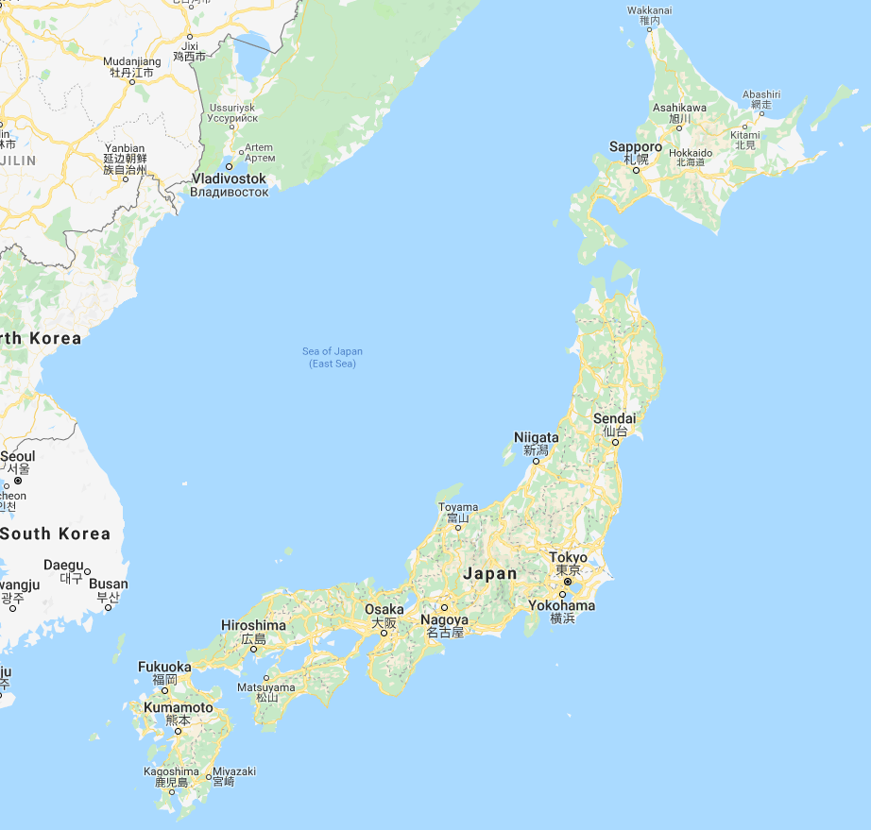
Figure 1.9: The major cities in Japan extracted from Google Map

Normally, international companies may place Tokyo as their primary choice when they are entering Japanese market. However, Fukuoka presents a better option for Essential Ingredients. Considering the business pattern adapted by Essential Ingredients, the offline retail selling would be irrelevant. Therefore, it is meaningless to choose capital city to develop a business. On the other hand, building an office in Fukuoka allows Essential Ingredients to extend its market to South Korea and China.

Price
Referring to the most successful case in personal care and skin care sector, The Ordinary, as a best example, shows that the low price strategy would be adapted to meet customers’ needs (The Ordinary, 2019). The low price strategy would be welcome in the Japanese market considering the economic situation which is in a recovery stage. The following figure shows that Japanese people’s buying behaviour is not focusing on personal care. Hence, it is unnecessary for them to buy luxury product for personal care.

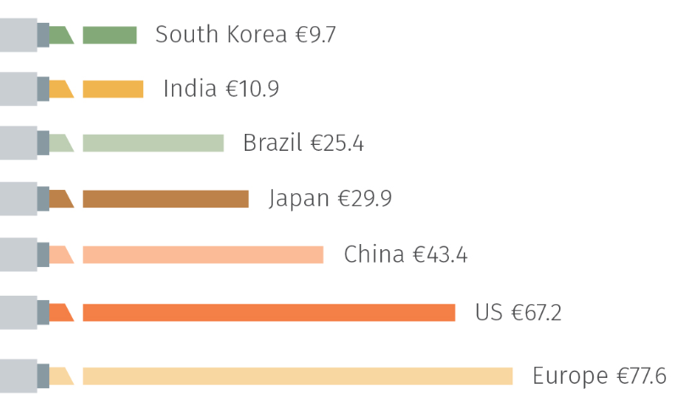
Figure 2.0 comparison among countries the consumption of personal cares (The Personal Care Association, 2019)

Process management
The packages of all products offered by Essential Ingredients are glass bottled. This means that distribution and transportation would be highly emphasised to reduce the unnecessary waste during the process. In addition, Essential Ingredients has to send a quality control team to write quality review by checking the randomly sampled products from transportations.

People
In terms of GFI, expatriates from the US would be main people taking the newly settled business in Japan. However, there are some limitations of sending expatriates to Japan. For example, expatriates’ children cannot get properly educated in Japan in English. However, the Japanese governments have developed some international schools for foreign workers, who are native English-speakers.

Evaluation
Considering the combination between marketing mix and advantages and disadvantages acquired by GFI and direct exporting, GFI presents a significant superiority comparing with other possibilities. In general, both external environment in Japan and internal environment in Essential Ingredients itself are showing that the suitable environment for Essential Ingredients to enter into Japan. On the other hand, the combination of marketing mix suggests that Japanese market is favourable for Essential Ingredients to enter through GFI.

Recommendations
Risk-sharing would be a core idea during the process of GFI, Joint-Venture contract between Essential Ingredients and its suppliers has to be signed before Essential Ingredients starting to enter into Japanese market. To explain more, the major risks from GFI are all relating to the costs and the investment at first stage, to mitigate the negative effect in this circumstance, Essential Ingredients would have a sustainable revenues from Japanese market.

Conclusion
This project has presented a marketing report for Essential Ingredients to explore an international market to increase its profit. There is no primary research due to some limitations. The secondary research was started from the PEST analysis and SWOT analysis to carry a foundation for Essential Ingredients. As a synthesised decision (considering all above factors from external and internal), Essential Ingredients has decided to enter into Japanese market. However, there are many options presenting on Essential Ingredients. By considering the two most similar options, Essential Ingredients has finally decided to enter into Japanese market via GFI to achieve more profit and to explore all potentials in Japan and China market.

Bibliography

Alexis, M. (1962). Marketing Laws and Marketing Strategy. Journal of Marketing, 26(4), p.67.

CFC (2019). Shipping Routes from China | CFC. [online] Cargofromchina.com. Available at: https://cargofromchina.com/shipping-routes/ [Accessed 11 Apr. 2019].

Drucker, P. (1994). The Theory of the Business. [online] Harvard Business Review. Available at: https://hbr.org/1994/09/the-theory-of-the-business [Accessed 6 Apr. 2019].

Essentialingredients (2019). Sales and revenue Essentialingredients. [online] Essentialingredients.com.
Available at: https://www.essentialingredients.com/products.aspx [Accessed 6 Apr. 2019].

Export.gov (2019). Japan - eCommerce | export.gov. [online] Export.gov. Available at: https://www.export.gov/article?id=Japan-E-Commerce [Accessed 11 Apr. 2019].

Emerald (1990). MANAGEMENT DEVELOPMENT. Library Management, 11(6), pp.47-48.

Forbes (2019). Essential Ingredients on the Forbes America's Best Small Companies List. [online] Forbes. Available at: https://www.forbes.com/companies/essential-ingredients/#608b4d5a66f6 [Accessed 6 April. 2019].

Grandview (2019). Specialty Chemicals Market Size, Share, Outlook | Industry Report, 2025. [online] Grandviewresearch.com. Available at: https://www.grandviewresearch.com/industry-analysis/specialty-chemicals-market [Accessed 7 April 2019].

Hook, G. (1981). Japanese politics. Tokyo Japan: Japan Foundation Office for the Japanese Studies Center.
Info Cubic (2019). E-Commerce in Japan. [online] Info Cubic. Available at: https://www.infocubic.co.jp/en/blog/e-commerce/e-commerce-japan/ [Accessed 11 Apr. 2019].

InvestJapan (2015). The Policy and Progress on the Foreign Direct Investment into Japan. 1st ed. [ebook] Tokyo: InvestJapan. Available at: https://www.mofa.go.jp/mofaj/files/000242162.pdf [Accessed 7 Apr. 2019].

Jukić, D. (2019). Strategic analysis of corporate marketing in culture management. Strategic Management, 24(1), pp.10-18.

Kanda, H. and Okamura, T. (2014). The Economic and Medical Costs of Alcohol Consumption in Japan. West Indian Medical Journal.

Netherlands Enterprise Agency (2018). Game Industry Japan. 1st ed. [ebook] Commissioned by the ministry of Foreign Afairs. Available at: https://www.rvo.nl/sites/default/files/2018/02/factsheet-game-industry-japan.pdf [Accessed 8 Apr. 2019].

Nezu, R. (2007). Industrial Policy in Japan. Journal of Industry, Competition and Trade, 7(3-4), pp.229-243.

PIIE (2019). US-Japan Trade: The Broader Context. [online] PIIE. Available at: https://piie.com/commentary/testimonies/us-japan-trade-broader-context [Accessed 11 Apr. 2019].

Reader, I. (2006). Imagining Japan: The Japanese Tradition and Its Modern Interpretation (review). Philosophy East and West, 56(2), pp.351-355.

Sarker, A., Ikeda, T., Abe, T. and Inoue, K. (2015). Design principles for managing coastal fisheries commons in present-day Japan. Ecological Economics, 117, pp.32-38.

Straub, R. (2014). The Great Transformation. Innovations: Technology, Governance, Globalization, 9(1-2), pp.55-63.

The Ordinary (2019). How does The Ordinary stay so affordable?. [online] Adorebeauty.com.au. Available at: https://www.adorebeauty.com.au/the-ordinary/guide/how-does-the-ordinary-stay-so-affordable [Accessed 8 Apr. 2019].

The Personal Care Association (2019). Personal Care Industry. [online] Cosmetics Europe - The Personal Care Association. Available at: https://www.cosmeticseurope.eu/cosmetics-industry/ [Accessed 8 Apr. 2019].

Marketing Intelligence & Planning. (1993). Marketing Intelligence & Planning, 11(10), pp.1-48.

Milisavljevic, M. (2013). Value oriented strategic marketing. Marketing, 44(4), pp.299-309.

