

Computer Systems

Fundamentals

Name: Iolo Williams

Student No: 2508067

L4- Study Skills

ACCA4028

Electrical and Electronic Degree Apprenticeship

TABLE OF CONTENTS
TABLE OF CONTENTS 2
LIST OF FIGURES 4
LIST OF TABLES 5
1 INTRODUCTION 6
2 TASK 1 - DESIGNING DESKTOP COMPUTER 7
2.1 Shopping list 7
2.2 Components contained in the shopping list 8
2.2.1 CPU 8
2.2.2 CPU Cooling 8
2.2.3 Motherboard 9
2.2.4 RAM 9
2.2.5 Storage 10
2.2.6 GPU 10
2.2.7 Power Supply 11
2.2.8 Case 12
2.2.9 Monitors 12
2.2.10 Keyboard & Mouse 13
2.2.11 Webcam Network connectivity and audio system 14
2.2.12 Software 15
3 TASK 2 – EVALUATION OF CYBERSECURITY 16
3.1 Identifying and evaluating cybersecurity hazards 16
3.1.1 Outdated firewall 16
3.1.2 Outdated firmware and default passwords 16
3.1.3 Sourcing from International suppliers 16
3.1.4 Outdated operating systems 16
3.1.5 Cybersecurity training 16
3.2 Risk Prioritisation 17
3.3 Cybersecurity Strategy 17
3.3.1 Outdated firewall 17
3.3.2 Firmware and default passwords 17
3.3.3 International suppliers 18
3.3.4 Outdated operating systems 18
3.3.5 Cybersecurity training 18
3.4 Incident Response Plan 18
3.4.1 Preparation 19
3.4.2 Analyse 19
3.4.3 Contain, Remediate, and Recover 19
3.4.4 Post-Incident Review 19
3.5 Applicable Cybersecurity Standards 20
4 Conclusion 21
REFERENCES 22
APPENDICIES 26
Appendix A – Research into ordering cybersecurity risks 26
A.1 List of figures 26
A.2 References 28

LIST OF FIGURES
Figure 1: INTEL Core i7-4700K 8
Figure 2: AXP90-X47 8
Figure 3: MB ASRock Intel 9
Figure 4: ADATA 16GB RAM 9
Figure 5: Samsung 990 PRO 1TB SSD 10
Figure 6: Sapphire technology GPU 10
Figure 7: ASRock intel ARC B570 GPU 11
Figure 8: MSI MAG A750L PCIE5 Power supply 11
Figure 9: Montech XR Case 12
Figure 10: LG Ultragear Monitor 12
Figure 11: Large curved monitor 13
Figure 12: Logitech MK270 Keyboard and mouse 13
Figure 13: Logitech C920 HD PRO Webcam 14
Figure 14: Logitech H390 Headset 14
Figure 15: UGREEN Ethernet Cable 5M 15
Figure 16: Chart to show plan for responding to cybersecurity incidents. 18

LIST OF TABLES
Table 1: Components 7
Table 2: Severity ordering system. 19

1 INTRODUCTION
This assignment focuses on designing a work-from-home desktop computer suitable for an electrical engineer. The system must run multiple engineering software packages efficiently while also supporting report writing and online video meetings with colleagues and clients. In the second task, various outdated or weak cybersecurity measures were assessed, along with the associated risks and recommended mitigation strategies.

2 TASK 1 - DESIGNING DESKTOP COMPUTER

2.1 Shopping list
To allow for effective design of the desktop computer, Table 1, shown below, was created. This allowed the student to document what parts were being selected as well as the price for each component, streamlining the design process.
Table 1: Components
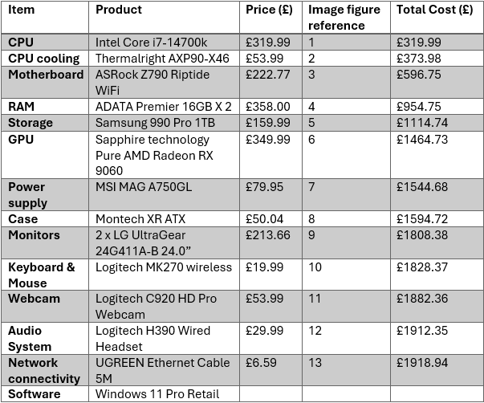

2.2 Components contained in the shopping list

2.2.1 CPU

Figure 1: INTEL Core i7-4700K
The student selected the Intel Core i7-14700K unlocked processor, which reaches 5.5 GHz processing speed, well above the 4 GHz minimum recommended for professional use [1]. Its 20 cores also exceed the requirements for complex 3D modelling tasks common in engineering workflows [2], ensuring strong performance and reliability for daily operations.

2.2.2 CPU Cooling

Figure 2: AXP90-X47
Although not essential for basic function, the student chose to include a CPU cooler to prevent thermal throttling and reduce the risk of CPU damage [3]. They selected the Thermalright AXP90-X46 air cooler instead of a water-cooling system due to its greater reliability, lower cost, and the reduced risk of leaks or pump failure [4].

2.2.3 Motherboard
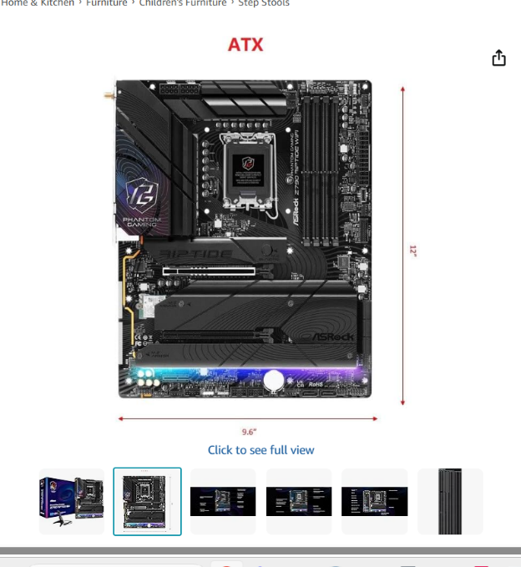
Figure 3: MB ASRock Intel
MB ASRock Intel 1700, the student chose this motherboard over others like the MSI PRO B760-P WIFI [5]. This was due to the ASRock supporting DDR5, while the MSI PRO B760-P WIFI only supported DDR4. As a result of this, a DDR4 system would not be as efficient when using 3D modelling software, which can contribute greatly to an engineer's daily routine [6]. DDR5 has another edge over DDR4, this being the Dual 32-bit subchannels vs DDR4’s single 64-bit, which improves data access efficiency by enabling the memory controller to process two independent 32-bit requests concurrently [7].

2.2.4 RAM
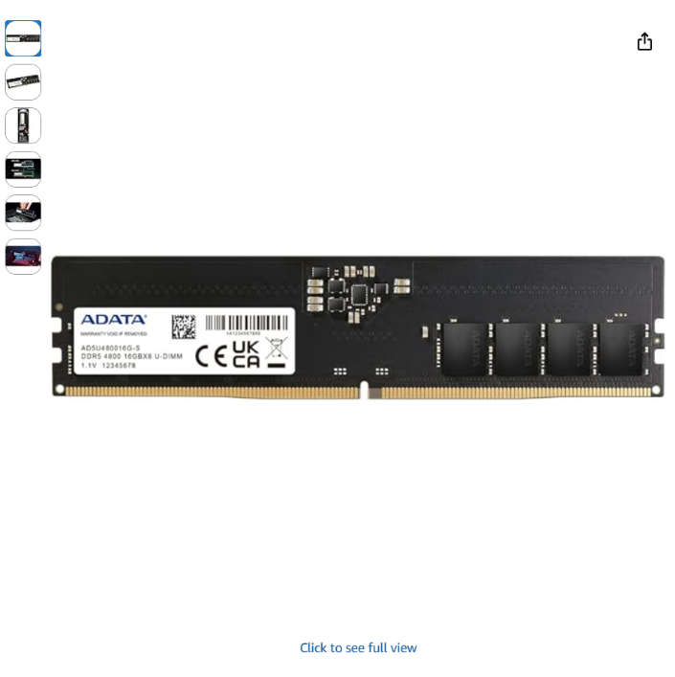
Figure 4: ADATA 16GB RAM
The student selected two 16 GB ADATA Premier DDR5 modules, shown in Figure 4, providing a total of 32 GB. Although a single 16 GB module was originally planned, the choice was reconsidered after learning that SOLIDWORKS recommends 32 GB for optimal performance, essential for completing engineering tasks [8].

2.2.5 Storage
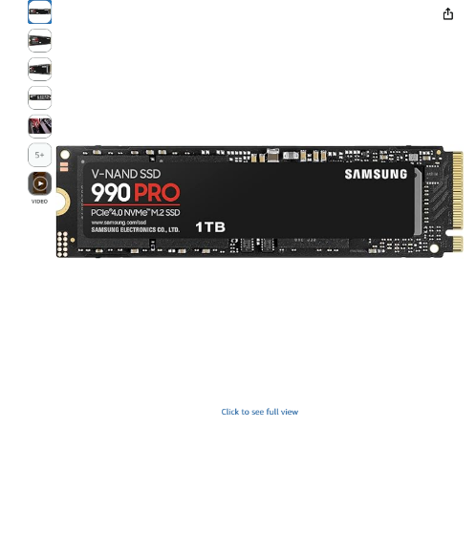
Figure 5: Samsung 990 PRO 1TB SSD
The Samsung 990 PRO 1TB NVMe Internal SSD was the ideal choice for the student when looking for an SSD due to its being a NVMe, making the SSD incredibly fast, helping the electrical engineer avoid slow loading times, allowing for less waiting around, and hence improving efficiency [9].

2.2.6 GPU
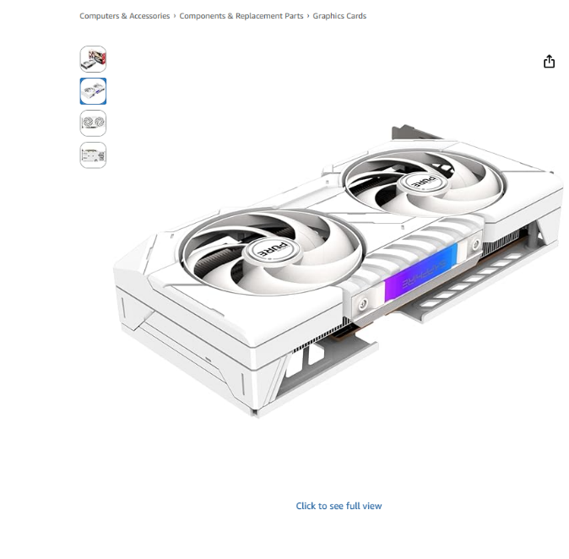
Figure 6: Sapphire technology GPU
The Graphics processor unit (GPU) is optimised for 3D graphics rendering and video processing [10]. The Sapphire technology Pure AMD Radeon RX 9060 is the selected piece of hardware, the 16GB of VRAM and 3290MHz GPU clock speed make it a well-priced yet high specification compared to other models like the ASRock Intel Arc B570 [11], which has a lower VRAM of 10GB and a GPU clock speed of 2600MHz, making it less effective at viewing large 3D models or carrying out complex electrical simulations[12].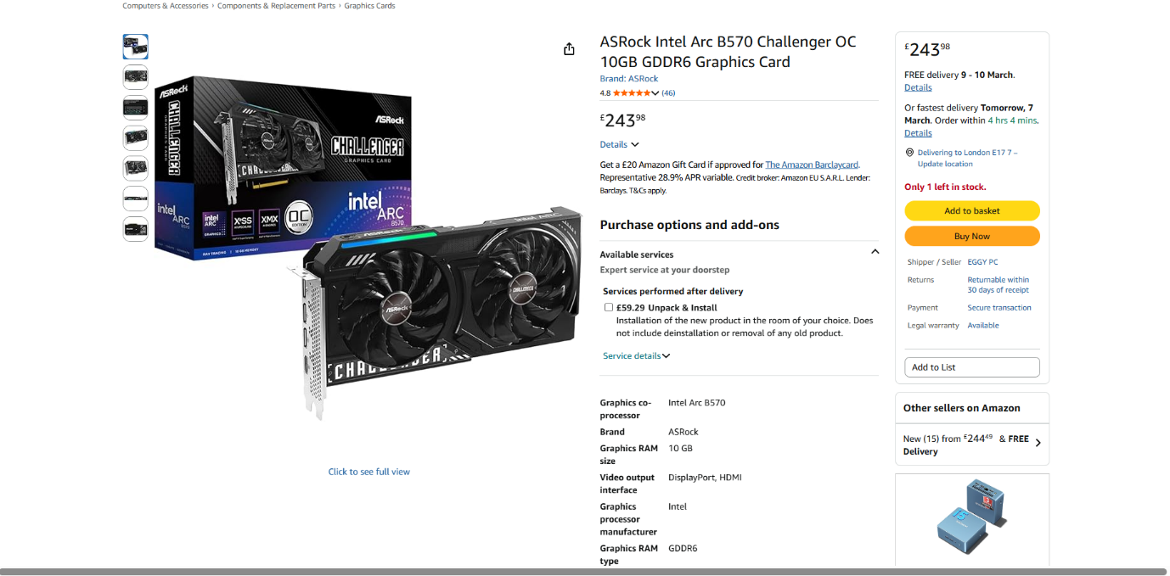
Figure 7: ASRock intel ARC B570 GPU

2.2.7 Power Supply
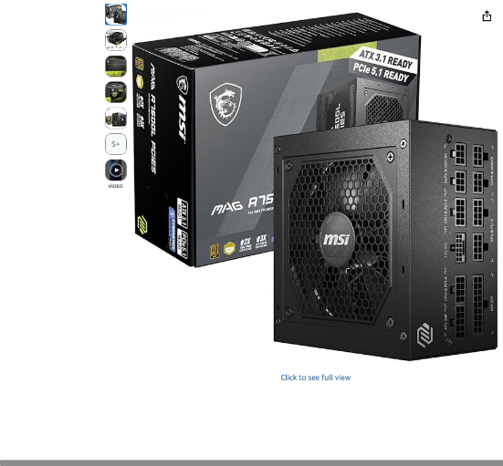
Figure 8: MSI MAG A750L PCIE5 Power supply
This power supply was chosen due to the large room for improvement capable with a 750W power supply according to [13] a sweet spot for PSU is roughly 1.25 to 1.4 times the total power taken by the PC this being roughly 540W there is plenty of room to improve parts in the desktop computer while not having to worry about the amount of power you need.

2.2.8 Case
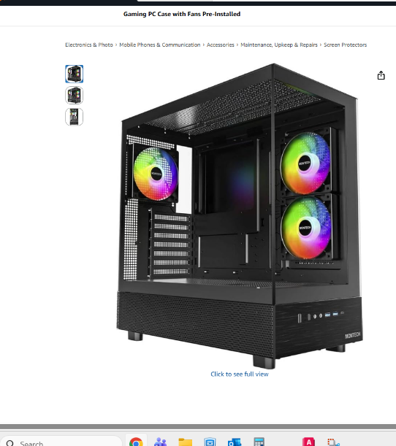
Figure 9: Montech XR Case
The Montech XR case was selected for its strong cooling performance, featuring four high-power fans and a mesh backing to enhance airflow. Since the CPU operates at high temperatures, substantial cooling is essential. The airflow provided by the Montech XR case helps maintain peak performance and prevents thermal-related slowdowns [14].

2.2.9 Monitors
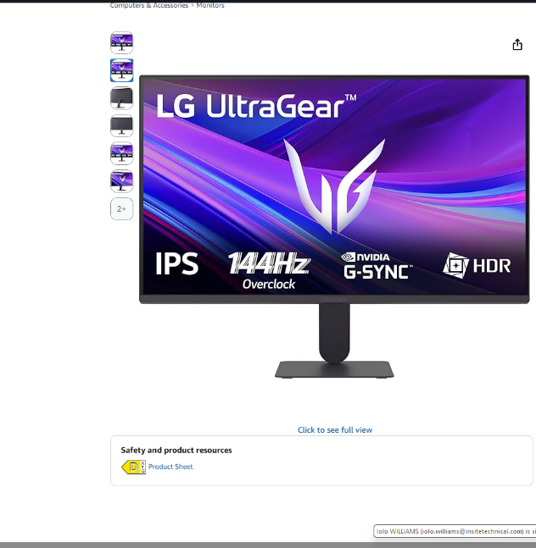
Figure 10: LG Ultragear Monitor
For the student, this choice was difficult to go for a singular, large curved screen like the AOC CU34G4Z Wide Quad HD34” shown in figure 15 below [15], or two smaller flat screens, which may allow for a more seamless workflow due to the separation and simpler design. The benefits of multiple flat screens outweigh the pros of a curved screen. Firstly, flat monitors are more space-efficient and easier to mount; also, a curved monitor may cause lines on CAD drawings to look skewed, possibly hindering the engineer's progress[16].
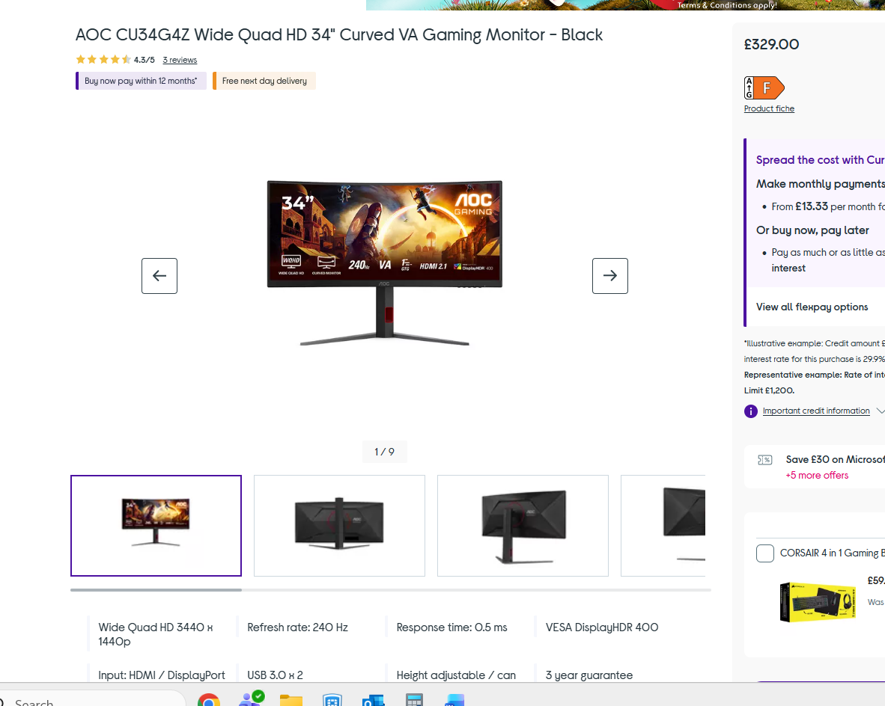
Figure 11: Large curved monitor

2.2.10 Keyboard & Mouse

Figure 12: Logitech MK270 Keyboard and mouse
The Logitech MK270 is selected due to its affordable price point, ergonomic design, strong battery life and, lastly, plenty of keys allowing for customisation if wanted by using shortcuts[17].

2.2.11 Webcam Network connectivity and audio system
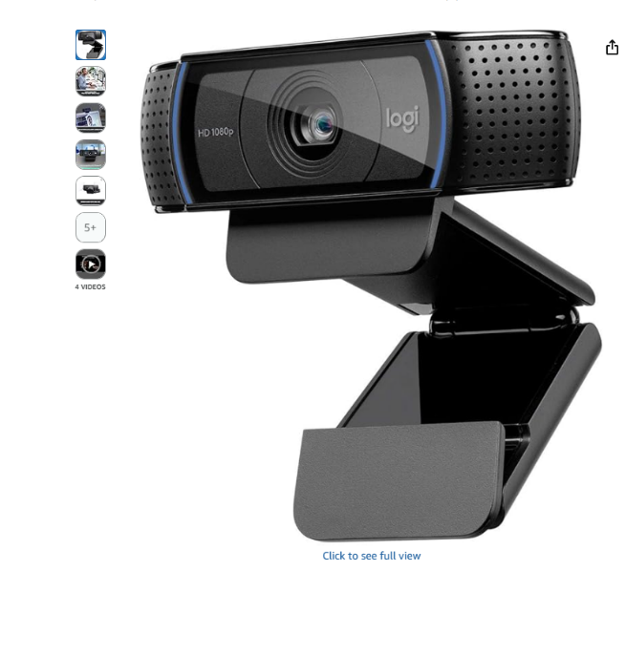
Figure 13: Logitech C920 HD PRO Webcam

Figure 14: Logitech H390 Headset
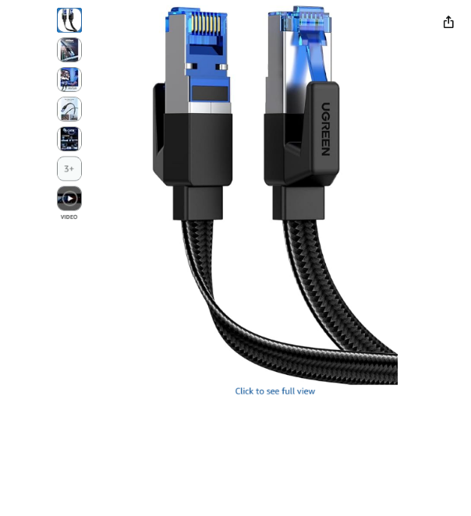
Figure 15: UGREEN Ethernet Cable 5M
The PC will use Cat 8 wired Ethernet connection to provide a stable and reliable connection to the web, much more efficiently than a wireless connection, which may buffer or crash presentations[19]. To ensure security when accessing the company server that will hold all the secure documents, a VPN will be installed to prevent unwanted disruption and allow for a safe connection to the LAN[20].

2.2.12 Software
Windows 11 Pro supports all required engineering software, including SolidWorks, PSpice, and LabVIEW. Since SolidWorks is the most demanding of the three, the student ensured reliable performance by selecting Windows 11 Pro [8]. The operating system also provides strong built-in security features to protect against cyber-attacks [21] and supports productivity tools such as Office 365, Word, and Excel for report writing, budgeting, and cable scheduling.

3 TASK 2 – EVALUATION OF CYBERSECURITY

3.1 Identifying and evaluating cybersecurity hazards

3.1.1 Outdated firewall
With firewall being a necessary contributor to the safety of online browsing, not using up-to-date software could have dire consequences. With limited protection from attackers, cybercriminals could easily steal sensitive data that may have major financial implications, damage to reputation, and even legal ramifications, possibly causing the company to shut down [22].

3.1.2 Outdated firmware and default passwords
Firstly, outdated firmware may not use the most advanced security features like WPA3 encryption, designed for protection against modern threats [23]. Next, if your router model is listed as end of life, any discovered vulnerabilities will remain unpatched, leaving it only a matter of time before they’re exposed by online attacks [23]. As a result of weak default passwords, Emergency Alert Systems have been activated [24]. Moreover, with a malware called Stuxnet that was able to attack industrial control systems (SCADA), which would have major consequences due to the nature of the systems they control [25].

3.1.3 Sourcing from International suppliers
With international suppliers often following different regulations when it comes to cybersecurity, this may cause breaches in the company’s security, with attackers compromising software updates provided by the international supplier. Data breaches via vendors occur when a vendor with inadequate security experiences a breach, leading to exposure of the company’s sensitive data[26], possibly resulting in large financial loss, like what happened with Marks & Spencer in April 2025[26].

3.1.4 Outdated operating systems
Cybercriminals often use the same attacking mechanism when attempting to gain access to operating systems, so using outdated software, there may already be known exploits putting your system at risk[27]. Furthermore, outdated operating systems could result in compliance fines or even business shutdowns[27]. Lastly, companies using outdated software like Windows 7 are three times more likely to receive ransomware attacks as opposed to people on more up-to-date software[27].

3.1.5 Cybersecurity training
With employees being the backbone of any company, ensuring their safety when browsing online is vital. With phishing attacks becoming more common, being able to spot one is key. The failure to identify phishing attacks could result in lost revenue due to system downtime or lost trust from clients, both devastating to business[28].

3.2 Risk Prioritisation
To aid in the students ordering decisions, they used information in Appendix A.
An outdated firewall can have the most consequences due to it being the first line of defence against attackers. Without an up-to-date firewall, attackers can easily gain access to a system, with no security boundaries preventing lateral movement between different network areas. This results in the exploitation of the entire network, having large repercussions [29].
Outdated operating systems often contain unpatched exploits that are known to a variety of attackers, leaving you defenceless even to automated hacking programmes. This also breaches key UK regulations such as the GDPR, resulting in major fines or company shutdown[30]. With this in mind, it is necessary to keep operating systems updated.
The last high-priority risk identified is using outdated firmware and default passwords. Oftentimes, attackers can easily gain access to a system with outdated firmware. With a weak default password, this becomes even easier. With 60% of passwords being cracked using common default passwords [31], this is an easy fix that could save your company millions.
The fourth in priority order is sourcing from international suppliers; while this can be incredibly risky, it is mitigated by the likelihood of consequences, as some international suppliers use high-quality security systems. When using international suppliers, it is important to research recommended suppliers to ensure safety.
Lastly, lacking cybersecurity training, this comes in as the least important, not due to the risks associated with phishing emails. But the impact of these can be reduced by using strong internal defences, meaning cyber security training isn’t as important as the more serious risks come from structural weaknesses like outdated firmware.

3.3 Cybersecurity Strategy

3.3.1 Outdated firewall
To resolve this, install next-generation firewalls, which allow for better malware detection, VPN support for remote access and the ability to block unwanted content, providing safe browsing for your staff[32].

3.3.2 Firmware and default passwords
To address these risks, the company should update all outdated firmware to ensure systems remain secure. Default passwords must also be replaced with strong alternatives at least 20 characters long and including numbers and symbols to maximise effectiveness [33]. Using multiple random words is additionally recommended to create robust passwords [33].

3.3.3 International suppliers
To reduce the possible impact, any international suppliers must follow standards like ISO/IEC 27001. Due to its nature of continuous improvement, the company can be assured that a supplier following this standard will constantly be in tip-top shape to combat any potential threat posed to the business[34].

3.3.4 Outdated operating systems
Every workstation in the company should be installed with the latest available version operating system and ensure they include modern security features like Secure Boot.

3.3.5 Cybersecurity training
To lessen the likelihood of a breach, the company should aim to implement training courses like the one offered by GRC solutions[35]. This will give employees greater knowledge and overall make their online browsing safer. Moreover, using regular phishing simulations to keep employees actively thinking will also be beneficial

3.4 Incident Response Plan
When creating this plan, I followed this chart from [36].
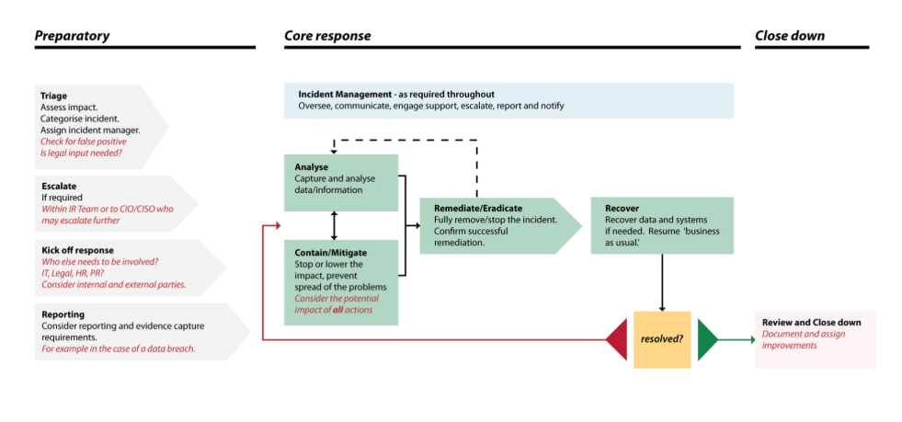
Figure 16: Chart to show plan for responding to cybersecurity incidents.

3.4.1 Preparation
NCSC recommends, in the preparation phase, having a list of contacts to help identify an incident and how to best recover from it[36]. Next, keep a constant and secure monitoring system in place to alert you of any event no matter the severity. To prioritise severity, Table 2, taken from [36] will offer insight into this.
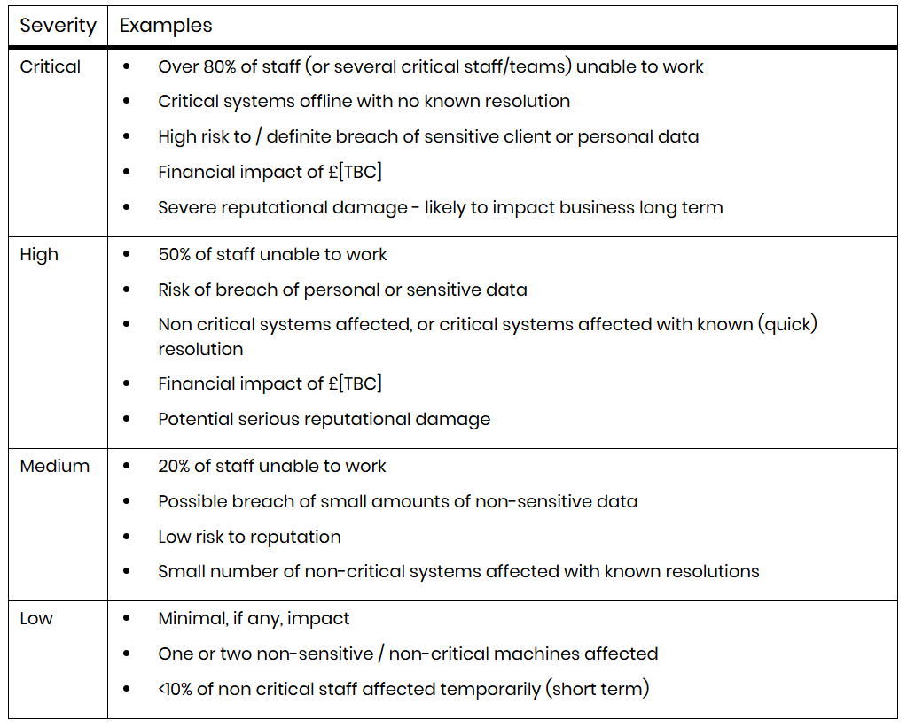
Table 2: Severity ordering system.

3.4.2 Analyse
This stage involves an in-depth technical analysis of the incident occurring[36]. Doing this to a high standard will enable a safer future, as experience in this area is highly beneficial. Analysis can be done by discovering how your affected systems would normally operate and searching for deviations from the normal operation.

3.4.3 Contain, Remediate, and Recover
Containment is often done by blocking activity, isolating systems or even taking the core business system offline to contain the incident[36]. Remediation involves removing the threat from your network; all actions must be done simultaneously, otherwise the attacker may bypass your removal attempts[36]. You should ensure this stage is successful before moving on to recovery. At this point, you can return to normal operating procedure and take all actions to be handled legally[36].

3.4.4 Post-Incident Review
In the aftermath of the incident, it is important to seek areas of improvement, such as security improvements, which could prevent the incident or if there was information missed in the analysis stage, all of which could possibly benefit the company in future[36].

3.5 Applicable Cybersecurity Standards
Previously mentioned standards, like ISO/IEC 27001 and GDPR, are followed strongly by this document as it includes categories such as training, supply chain risk management and strong network segmentation.

4 Conclusion
Throughout Task 1, the student concludes that computer components vary in price and specification, with a wide variety of options for different applications like 3D modelling or basic Microsoft 365 applications.
After completing Task 2, the student found many ways to improve cyber safety to help prevent himself and his friend’s become victim to a cyber-attack, improving their safety online.

REFERENCES
[1] S. Sirois, “What is Processor Speed and Why Does It Matter?,” www.hp.com, Dec. 18, 2018. https://www.hp.com/us-en/shop/tech-takes/what-is-processor-speed
[2] D. Horowitz, “CPU Cores: How Many Do I Need?,” Hp.com, Aug. 24, 2020. https://www.hp.com/us-en/shop/tech-takes/cpu-cores-how-many-do-i-need
[3] Intel, “PC Cooling: The Importance of Keeping Your PC Cool,” Intel. https://www.intel.com/content/www/us/en/gaming/resources/pc-cooling-the-importance-of-keeping-your-pc-cool.html
[4] “CPU Cooler Guide,” Premier Computers, Sep. 30, 2024. https://premiercomputers.co.uk/cpu-cooler-guide/ (accessed Mar. 11, 2026).
[5] “PRO B760-P WIFI DDR4,” www.msi.com. https://www.msi.com/Motherboard/PRO-B760-P-WIFI-DDR4/Specification
[6] “Kingston DDR4 vs DDR5 Performance: Which RAM Should You Buy?,” Laptopoutlet.co.uk, Aug. 06, 2025. https://www.laptopoutlet.co.uk/blog/kingston-ddr4-ddr5-ram-comparison.html (accessed Mar. 12, 2026).
[7] “Dual-Channel Architecture in DDR5,” Hiksemitech.com, 2025. https://www.hiksemitech.com/en/hiksemi/support/semiknow/dual-channel-architecture-in-ddr5.html
[8] Solidworks, “System Requirements,” SOLIDWORKS, Feb. 26, 2020. https://www.solidworks.com/support/system-requirements
[9] https://www.facebook.com/GeekomUK/about, “What Is 1TB SSD: What You Need To Know Before You Buy,” GEEKOM UK, Oct. 14, 2024. https://www.geekom.co.uk/what-is-1tb-ssd (accessed Mar. 12, 2026).
[10] W. Stallings and P. Zeno, Computer organization and architecture : designing for performance. Pearson, 2016.
[11] Asrock.com, 2026. https://www.asrock.com/Graphics-Card/Intel/Intel%20Arc%20B570%20Challenger%2010GB%20OC/ (accessed Mar. 12, 2026).
[12] Q. Wagner, “Top GPUs for CAD Workstations in 2025 – Micro-Vision Guide,” Micro-Vision Computers, Oct. 02, 2025. https://micro-vision.ca/resources/which-gpu-to-choose-for-cad-workstations/
[13] “How much extra wattage should a PSU have? - PCPartPicker,” Pcpartpicker.com, 2026. https://uk.pcpartpicker.com/forums/topic/77606-how-much-extra-wattage-should-a-psu-have (accessed Mar. 26, 2026).
[14] C. UK, “What is a PC Case? & How to Find the Right Case For You - Blog | CyberPowerPC UK,” Blog | CyberPowerPC UK, Mar. 13, 2026. https://www.cyberpowersystem.co.uk/blog/core-knowledge/what-is-a-pc-case/ (accessed Mar. 31, 2026).
[15] “AOC CU34G4Z Wide Quad HD 34" Curved VA Gaming Monitor - Black,” Currys.co.uk, 2025. https://www.currys.co.uk/products/aoc-cu34g4z-wide-quad-hd-34-curved-va-gaming-monitor-black-10279499.html (accessed Mar. 31, 2026).
[16] “Box.co.uk,” Box.co.uk, 2025. https://box.co.uk/blog/curved-vs-flat-monitors-buying-guide (accessed Mar. 31, 2026).
[17] tagnil, “A guide on how to pick the best keyboard for your needs,” Medium, Apr. 10, 2022. https://medium.com/@tagnil/a-guide-on-how-to-pick-the-best-keyboard-for-your-needs-89bbde5dcdba
[18] K. Hall, “Seven reasons to put your camera on in virtual and hybrid meetings - Global Integration,” Global Integration, Nov. 26, 2021. https://www.global-integration.com/insights/seven-reasons-to-put-your-camera-on-in-virtual-and-hybrid-meetings/
[19] “Wi-Fi vs. Ethernet: What I Learned While Testing Them Out at Home,” CNET, 2025. https://www.cnet.com/home/internet/wi-fi-vs-ethernet/
[20] Microsoft Azure, “What is a VPN? Why Should I Use a VPN?,” azure.microsoft.com, 2024. https://azure.microsoft.com/en-us/resources/cloud-computing-dictionary/what-is-vpn
[21] Microsoft, “Windows Security: Defender, Antivirus & More for Windows 11 | Microsoft,” Windows. https://www.microsoft.com/en-gb/windows/comprehensive-security?r=1
[22] J. Cohen, “The Hidden Dangers of Outdated Firewalls,” Kyber Security, Dec. 27, 2023. https://kybersecure.com/the-hidden-dangers-of-outdated-firewalls-a-wake-up-call-for-small-businesses/
[23] Serveline, “Outdated Router Security Risks: How Old Router Compromises Business Network,” Serveline.co.uk, Apr. 09, 2025. https://www.serveline.co.uk/blog/outdated-router-security-risks
[24] CISA, “Risks of Default Passwords on the Internet | CISA,” Cybersecurity and Infrastructure Security Agency CISA, Oct. 07, 2016. https://www.cisa.gov/news-events/alerts/2013/06/24/risks-default-passwords-internet
[25] “Stuxnet - SCADA malware,” Palo Alto Networks Blog, Oct. 04, 2010. https://www.paloaltonetworks.com/blog/2010/10/stuxnet-scada-malware/
[26] “Understanding Third-Party Cybersecurity Risks: A growing threat - Projective Group,” ProjectiveGroup, Jun. 03, 2025. https://www.projectivegroup.com/understanding-third-party-cybersecurity-risks-a-growing-threat/
[27]Target ICT Ltd and EA Target ICT, “The Security Risks of Running Outdated Software in 2025 : Blog - Target ICT Ltd,” Blog - Target ICT Ltd, Aug. 21, 2025. https://targetict.co.uk/blog/the-security-risks-of-running-outdated-software-in-2025.html (accessed Apr. 15, 2026).
[28] Rouge, “Risks of Not Having a Security Awareness Training Program,” MetaCompliance, Mar. 25, 2025. https://www.metacompliance.com/blog/cyber-security-awareness/risks-of-not-having-a-security-awareness-training-program
[29] J. Correia, “Lack of Network Segmentation in Cybersecurity,” TuxCare, Jan. 22, 2024. https://tuxcare.com/blog/segmentation-in-cybersecurity/
[30] “The British Data Protection Authority ICO considers operating systems that are no longer supported inadequate security. | International Network of Privacy Law Professionals,” International Network of Privacy Law Professionals, 2020. https://inplp.com/latest-news/article/the-british-data-protection-authority-ico-considers-operating-systems-that-are-no-longer-supported-inadequate-security/ (accessed Apr. 21, 2026).
[31] D. World, “Hackers are able to guess 60% of passwords,” Digitalisation World, Jul. 26, 2019. https://digitalisationworld.com/news/57410/hackers-are-able-to-guess-60-of-passwords (accessed Apr. 21, 2026).
[32] “This Outdated Firewall Is Too Old To Protect Your Business,” BIZFORCE Technologies, Mar. 05, 2021. https://bizforcetech.com/this-outdated-firewall-is-too-old-to-protect-your-business/
[33] “Digital tips: Password security,” Age UK. https://www.ageuk.org.uk/information-advice/work-learning/technology-internet/password-security/
[34] “ISO/IEC 27001 - ISO Consultancy For Certification | Welcome To IMSM,” ISO Consultancy for Certification, Oct. 10, 2017. https://www.imsm.co.uk/iso-27001/?_gl=1 (accessed Apr. 22, 2026).
[35] ITG Training, “Certified Cyber Security Foundation Training Course | GRC Solutions,” Grcsolutions.io, Feb. 13, 2025. https://uk.grcsolutions.io/product/certified-cyber-security-foundation-training-course?_gl=1 (accessed Apr. 23, 2026).
[36] “Step 1: Prepare for incidents,” Ncsc.gov.uk, 2020. https://www.ncsc.gov.uk/collection/small-business-guidance--response-and-recovery/step-1-prepare-for-incidents
[37] NCSC, “Plan: Your cyber incident response processes,” Ncsc.gov.uk, Sep. 19, 2019. https://www.ncsc.gov.uk/collection/incident-management/cyber-incident-response-processes

APPENDICIES

Appendix A – Research into ordering cybersecurity risks

A.1 List of figures
Figure_Apx 1: Risk assessment diagram 24
Figure_Apx 2: Example created using risk assessment matrix 25

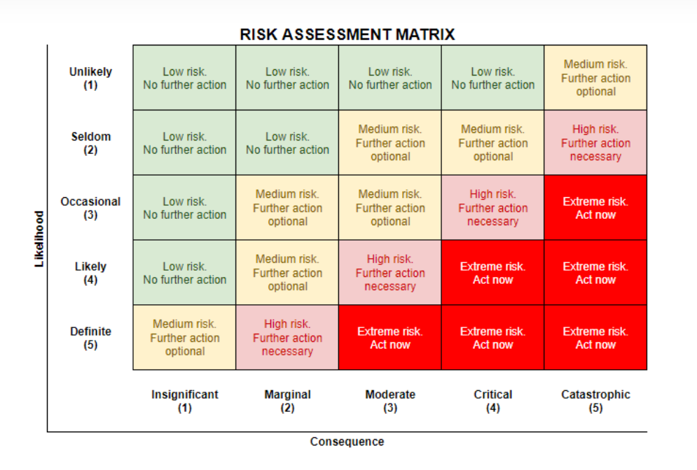
Figure_Apx 1: Risk assessment diagram
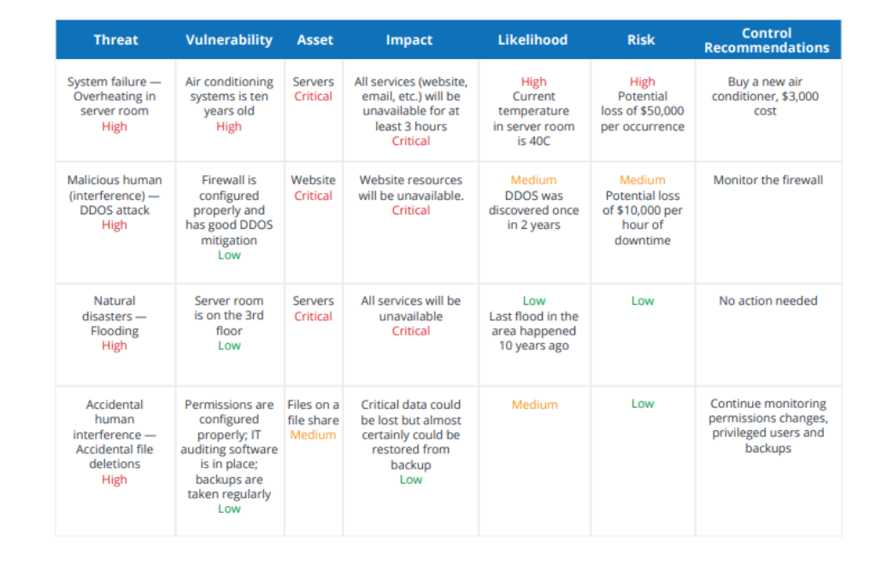
Figure_Apx 2: Example created using risk assessment matrix

A.2 References
[A-1] H. Sagstetter, “Top 6 Cybersecurity Risk Assessment Templates and Tips,” adeliarisk, Oct. 19, 2022. https://adeliarisk.com/cybersecurity-risk-assessment/

