Name:__Rubens Malaguti

Student Number: _2501521
__________________________________________________________

WORKSHEET 5 – TESTING (Hunting for Treasure)

For this worksheet, the program can be implemented in a number of different ways and demonstrate different features.
Create your own test set to demonstrate strengths and/or limitations of your solution. Use as many of the template boxes below as you need.

Test: 1 Correct guess on first attempt

Screenshot(s) of output:
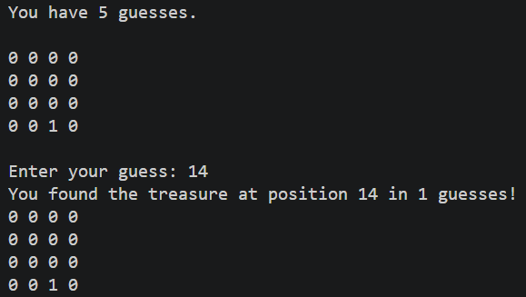
Result: Did the programme behave as expected ie syntactically and logically correct?
YES/NO (delete as appropriate)
If YES, comment on what happened.
If NO, what went wrong and why? Comment on how you would fix the problem.

Yes, the program behaved as expected since It printed "You found the treasure at position 14 in 1 guesses!", then it displayed the updated map and ended correctly

Test: 2 Wrong guess then correct guess
Screenshot(s) of output:
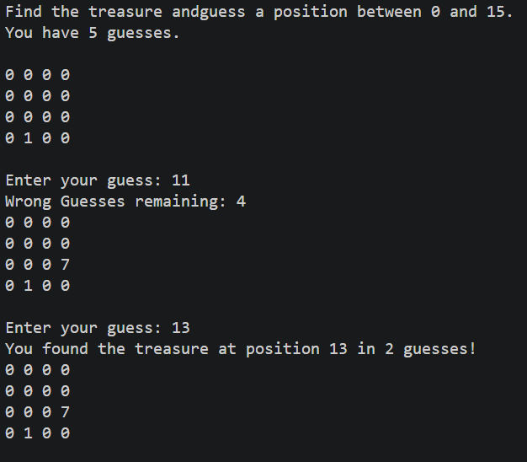
Result: Did the programme behave as expected ie syntactically and logically correct?
YES/NO (delete as appropriate)
If YES, comment on what happened.
If NO, what went wrong and why? Comment on how you would fix the problem.

Yes, the program behaved as expected since the map correctly marked the wrong guess position with a 7, then found the treasure on the second guess and displayed the correct message

Test: 3 Running out of guesses
Screenshot(s) of output:
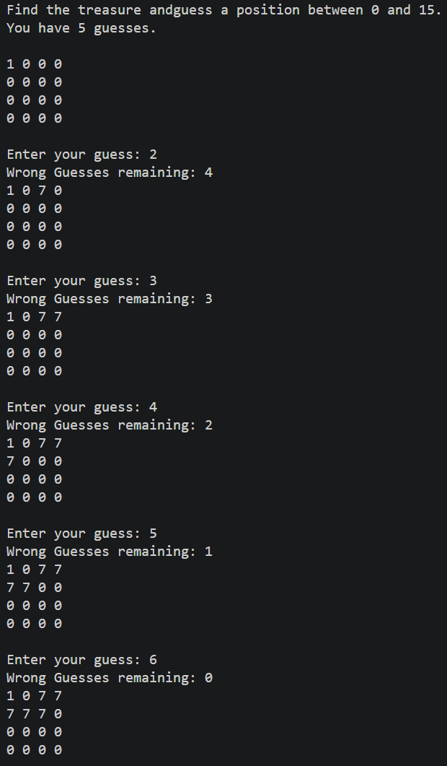
Result: Did the programme behave as expected ie syntactically and logically correct?
YES/NO (delete as appropriate)
If YES, comment on what happened.
If NO, what went wrong and why? Comment on how you would fix the problem.

Yes, the program behaved as expected, and after the 5 guesses, it ended. It would have been better to have a message printed like "Out of guesses, the treasure was at position 1”

Test: 4 Guess an already tried position
Screenshot(s) of output:
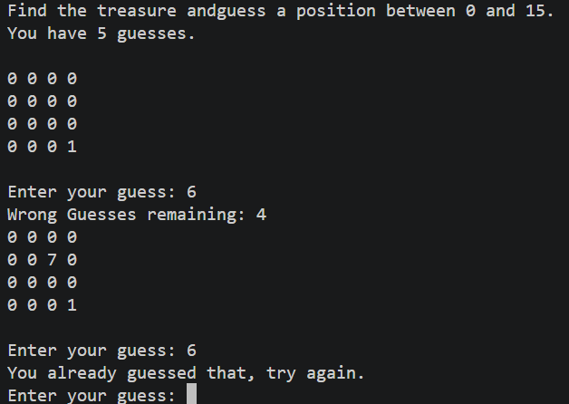
Result: Did the programme behave as expected ie syntactically and logically correct?
YES/NO (delete as appropriate)
If YES, comment on what happened.
If NO, what went wrong and why? Comment on how you would fix the problem.

Yes, the program behaved as expected, and it printed "You already guessed that, try again", and it did not count it as a guess, leaving the remaining guesses unchanged.

Test: 5 Enter a letter instead of a number
Screenshot(s) of output:
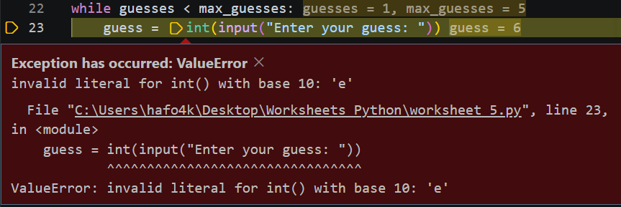
Result: Did the programme behave as expected ie syntactically and logically correct?
YES/NO (delete as appropriate)
If YES, comment on what happened.
If NO, what went wrong and why? Comment on how you would fix the problem.

No, the program did not behave as expected because it crashed with a ValueError, because int(input()) cannot convert a letter to a number.

Test: 6 Out of range guess
Screenshot(s) of output:
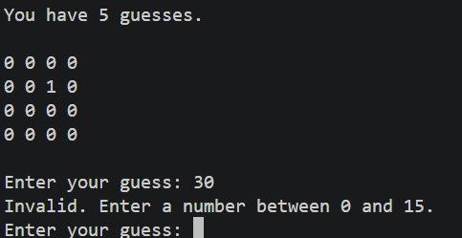
Result: Did the programme behave as expected ie syntactically and logically correct?
YES/NO (delete as appropriate)
If YES, comment on what happened.
If NO, what went wrong and why? Comment on how you would fix the problem.

Yes, the program behaved as expected, and when inputting 30 YES, it printed "Invalid. Enter a number between 0 and 15" and did not count it as a guess.

Final code:

[Copy and paste your code here – note, do not use a screenshot.

Note that there is no “before” and “after” code for this Worksheet because it is “Open” – not done in class. Therefore just post your final code below]

import random

map = [0] * 16
treasure = random.randint(0, 15)
map[treasure] = 1

guesses = 0
max_guesses = 5

def print_map():
print(map[0], map[1], map[2], map[3])
print(map[4], map[5], map[6], map[7])
print(map[8], map[9], map[10], map[11])
print(map[12], map[13], map[14], map[15])
print()

print("Find the treasure andguess a position between 0 and 15.")
print("You have", max_guesses, "guesses.")
print()
print_map()

while guesses < max_guesses:
guess = int(input("Enter your guess: "))

if guess < 0 or guess > 15:
print("Invalid. Enter a number between 0 and 15.")
elif map[guess] == 7:
print("You already guessed that, try again.")
elif map[guess] == 1:
guesses += 1
print("You found the treasure at position", guess, "in", guesses, "guesses!")
print_map()
break
else:
guesses += 1
map[guess] = 7
print("Wrong Guesses remaining:", max_guesses - guesses)
print_map()

if guesses == max_guesses and map[treasure] != 1:
print("Out of guesses, the treasure was at position", treasure)
map[treasure] = 1
print_map()

