Course Title: BA in Graphic Design
Programme: Contextual Practice
Module: Research in Practice ADAD5004
Student Name: Ching Yi Wong
Student Number: 2010182
Lecturer: Donna Williams

Assignment Title : Proposed question for Independent Project (Part One in Independent Project in Year Three)

3 key words: Branding, Trust, Responsibility
Word Count: 2432
In the following proposal the topics to be discussed revolve around 3 keywords, which are "branding", "trust", and "responsibility". Many haven't realised how far we've come as far as the advancement of technology goes. Humans have modernised technology at such a rapid rate in comparison to the last century after the industrial revolution. The laser printer was available 53 years ago, and surprisingly the mobile phone came not long after that, specifically 3 years later. It was 50 years ago that the mobile phone was invented costing about £3000 which was only available to a limited sector of people at the time; and just 33 years ago that the world wide web was invented. These inventions gave way to vast amounts of opportunities and convenience to how people communicate and share information in terms of design. Humans have come to develop astounding new phases in the adoption of such advancements that it's not unlikely that there is a clear extent of dependency on technology for our survival.

Branding

Branding is a composition of graphic design elements and business marketing practices. It is a way of identifying a business and for customers/consumers to recognise and experience the brand, distinguishable from other brands. A brand isn't just defined by its owners, but it largely entails how the audience perceives it, therefore creating recognisability and allowing a brand to be different from other competitors in the same market. People are customers of a business not because the product or service is a collection of attributes, but because these attributes with consistent branding, can bring a customer coming back for more, forming customer loyalty. Brand identity is the entirety of all the elements combined that the company creates to illustrate to its target audience who they are. This is not to be confused with brand image and branding, even though these terms are sometimes used interchangeably. The term branding refers to the marketing practice of actively shaping a distinctive brand. Graphic design plays a big part in the development of this process. Strong branding includes a good brand strategy which then helps make design decisions. This can be broken down into 3 parts; brand core, which includes its values, vision, and purpose; brand positioning, which includes its goals, market, and audience; and Brand persona, which includes tagline, voice, and personality. The brand core builds confidence for the consumers for their existence and sets the direction for future decision-making in terms of marketing strategy. This also sets expectations for its customers, as customers have different values, and each brand can distinguish itself from one other for customers to identify. They show this by giving people a reason for the brand to exist beyond generating revenue and introducing what guiding principles affect their choices for customers to get an idea of what kind of business they are and will be.

The graphic design looks at these core values in a business to understand specifically what kind of design would specifically be suited to them. For example, as a customer, a grocery store is for the general population and it's where everyone goes for their necessities. Logically, thinking, we'd think that no branding strategy is needed especially in terms of design to help customers decide on which grocery store to go to. However, that is not true. Successful brands can differentiate themselves from a large pool of competitors. Tesco’s brand purpose is "Serving our customers, communities, and planet a little better every day." Which they follow with, "We always keep customers at the heart of what we do, while also reflecting our responsibilities to the communities we serve and to society more broadly." (Tesco PLC 2022) They do extensive research on their target market which is the "cost-conscious everyday people" and provide customers with a wide range of products including not only grocery products to suit customers' wants and needs at a price that they are willing to pay for because of it. Tesco has a "Tesco Finest" line which serves to add value for customers so customers can get what they are paying for. We can establish that Tesco aims to serve the everyday man, but they aim to provide products and services just a little bit better from this information and the brand purpose they have set out for us. Tesco's finest range reflects that. Take Tesco Finest Roast & Ground Coffee Sumatra Java in the image below (Fig.1) (Tesco 2022):
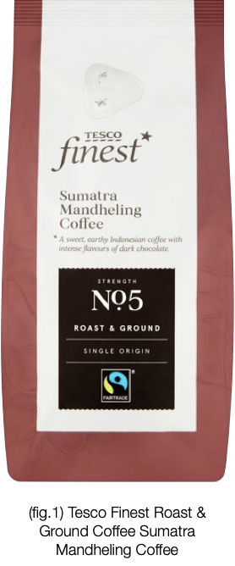

The label stays the same. A black serif font for "Finest" with the Tesco logo is placed above. The background of the label stays the same light grey/silver. While the body of the text is the same serif typography. The label and logo for this range stay consistent throughout all other products and conveys a sense of formality and prestige. The serif font adds to the tone of voice when paired with the description of a luxurious product, therefore reinforcing how the brand is perceived. Through their products they have communicated clearly that their brand offers a wide range of products for a wide audience, however, they are still able to offer greater quality as an option. From this, we can see how the brand differentiates from other companies and offers a sense of stability within the company to operate consistently through its brand core, positioning, and persona. The design of the brand identity communicates a consistent brand image to customers. When customers are made aware of the brand through design and perceive it as unique and relevant to a specific audience this can easily create value for them as it resonates with them on a personal level, thus achieving brand loyalty.

Trust

Trust is an important role in graphic design because designers cater to a specific audience to design accordingly. Designers are always designing with a purpose or function for a product and not purely for aesthetic reasons but with trust in mind most of the time which is what separates design from art. For example, when designing an e-commerce site, the main goal is for the customer to complete the process of browsing, adding to the cart, and finally completing the transaction. When designing for marketing, the main goal is to persuade, raise awareness, inform, etc. These actions that we want for the customers all need the element of trust. In this day and age, with the rapid digitisation of news, commercialisation, and media, graphic design plays a major role in completing this element of trust for users to buy into the brand.

According to a study by (Fimberg and Sousa, 2020) Businesses that design their website with the element of trust in account have a strategic advantage over businesses that don't. In this study, we can see patterns in how users react to a trust centred design and one that is not. The conclusion states that there is a strong positive correlation between the attractive contemporary design compared to the dull, outdated design. Showing that trust plays a huge part in e-commerce especially, when users have to share financial and personal information. This term is called Aesthetic-Esability (Moran, 2017) is coined by Nielsen Norman Group. The concept states that aesthetically pleasing interfaces create positive emotional responses which are perceived as easier to use, better quality, and more trustworthy. According to a study by Aurora Harley a Senior User Experience Specialist (Aurora Harley, 2016), the very same study conducted in 1999 of Communicating Trustworthiness in Web Design (Nielsen,1999) is still relevant today despite trends changing over time. The fundamental perception of a "quality" website hasn't changed and theorises to continue to be the same in the future. The 4 methods of communicating trustworthiness include Design Quality; Upfront Disclosure; Comprehensive, correct, and current; and Connection to the rest of the Web. The design quality is perceived through site organisation when information is presented to the user in a clear manner where it's easy to navigate so customers don't need to make as many decisions before clicking. This reduces the bounce rate. The visual design responds to trends that then become the norm however, the psychology of colour and typography doesn't change in the perception of value. Upfront disclosure relates to the experience of being able to find important details a customer may need, like fees, contact information, guarantees, or policies. An example could be to reveal shipping fees before checkout. This gives the customer more confidence to proceed as they have all the information they need. This gives the feeling of transparency to the customers. Asking for too much information before before providing any value can also be a breach of trust or not being upfront. For example, gated content where users have to answer questions like the location, they're in to pick a store or to sign up leaves a negative impression. Being upfront and showing essential information the user may want to view, shows an empathetic design, and increases the customer return rate. To show users the business is committed to helping customers, participants in the Harleys study preferred a large amount of relevant content because it showed that the organization was well informed and committed to helping its customers. For example, participants noted moving companies that presented moving tips were appreciated. This also boosts the business's credibility. These factors also correspond to the 10 Usability Heuristics for User Interface Design by Jakob Nielsen revised in 2020 (Nielsen, 1994) which are broad principles that elevate user experience and click confidence.

A concept known as contour bias can also subconsciously influence the decision-making of users through design. According to a book named "Universal Principles of Design, Revised, and Updated", humans have a subconscious mechanism that aims to protect us out of fear and to protect us against potential threats. A study within the book states that when humans are presented with pointed emotionally neutral objects (fig. 2) compared to rounded/curved objects the part of the brain called the amygdala which plays a role in a fear of processing is activated (Elam, Lidwell, Butler and Holden, 2010). When the subject stated their preference for functional magnetic resonance imaging, the degree of activation in the amygdala was proportional to the degree of angularity or sharpness of the object presented. It follows to state that whilst curved objects are preferred or seem friendlier pointed objects elicit stronger reactions in the brain where associative processing was prevalent. This shows a correlation that pointed objects require a deeper level of processing. However, responses from this don't completely mean a negative association with angular objects entirely, just that angular/sharp objects draw more attention and engage thought, whereas countered objects are better at eliciting positive emotional responses and an aesthetic impression. This could be due to how humans have evolved to protect themselves from potential threats or semiotics in association with sharp objects and danger.
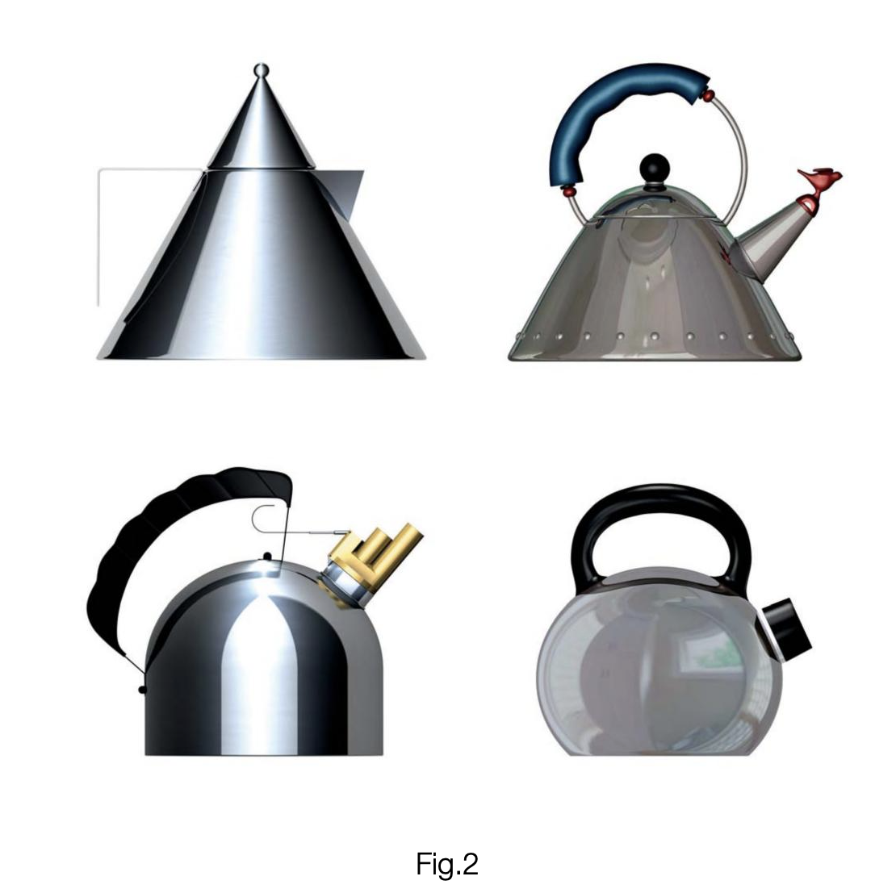

Responsibility

Knowing these concepts of the role of importance of graphic design, it is shown that graphic design is prominent in terms of but not limited to branding and marketing. It plays an important role in our lives to draw attention and can raise awareness of specific issues. Most importantly it serves a large role in universal communication. Graphic design has a large influence on user experience and/or interface design and has the ability to influence decision-making; form an informed impression of a business image and turn visitors into customers. Because of this graphic design contains much power over the influence of unconscious judgment and decision making. When there's so much influence over unconscious decision-making and judgment; should people be concerned about their safety, especially when using the internet? We can argue that graphic design influences but to what extent? To answer this, we need to explore the barriers of graphic design and most importantly to what extent graphic designers can be held accountable for the decisions of the user.

As graphic design is a tool for communication, the content designers are responsibly chosen to share. According to Uttam Kokil a user experience researcher, there is social responsibility in respect and concern for the well-being of private and public sectors, in large organizations and small, and on an individual basis. Respect and awareness of other languages and customs are examples of cultural responsibility in design. The culturally responsible design takes into account a group's history, language, conventions, habits, attributes, and behaviours. Although concepts and visual languages are taken from one culture, they can have different connotations in another. The Ad Council has been tackling key social issues since 1942. Campaigns like "Rosie the Riveter," "Smokey the Bear," and "Crash Test Dummies" have given the American audience important messages. The Ad Council is a private, non-profit organisation that draws on volunteer talent from the advertising and communications industries, media facilities, and business and non-profit resources.

Tibor Kalman, a graphic designer, encouraged fellow designers to accept responsibility for their work as designer citizens. Throughout his career, he encouraged designers to consider the consequences of their work and never take a client's product at face value. Graphic designers were inspired by Kalman to utilise their art to raise public awareness about several social issues.

Another example could be a case from 1956. At the time, President Dwight D. Eisenhower signed the Interstate Highway Act into law Eisenhower was resolved to build the cross-country highways that politicians had been contemplating for years, inspired by Germany's Reichsautobahnen. These "open roads of freedom" were typically routed directly through cities during the construction of the interstate network, resulting in infrastructural segregation that benefited rich districts at the expense of poor or minority neighbourhoods. Roads became barriers, quietly segregating residents based on their social position; such increasingly evident distinctions reinforced discriminatory sentiments and eventually destroyed neighbourhoods. The segmentation systematically reduced possibilities for those residents, disproportionately affecting persons of colour and negatively altering American racial dynamics. From this, we see an experience where designers didn't think about the long-term social and moral consequences of their work on the people they were designed for. As a result, individuals all around the world had severe negative consequences.

In conclusion, graphic design plays an important role in our community. It's found in our daily lives and has a significant impact on first impressions, decisions making, and judgment. An exploration of the role of graphic design and its importance was made. In graphic design, a good design is that which is dedicated to the greater good of humanity as a mediator between ideas and the physical world. Moral and ethical responsibilities are critical. Knowing this, "To what extent does graphic design have responsibility for the actions of its audience?" is the proposed question for the Year Three Independent Project.

Bibliography

- 99designs. 2022. What Is Brand Identity? And How to Develop a Great One.. [online] Available at: <https://99designs.co.uk/blog/tips/brand-identity/#brandidentity> [Accessed 9 March 2022].
- Albert, B., 2012. How Quick Are We to Judge? A Case Study of Trust and Web Site Design. [ebook] New York: New York Technology Council, pp.1-35. Available at: <https://web.archive.org/web/20180428043014id_/https://www.bentley.edu/files/centers/duc/ny-tech-presentation.pdf> [Accessed 18 April 2022].
- Bar, M. and Neta, M., 2006. Humans Prefer Curved Visual Objects. [ebook] Martinos Center at Massachusetts General Hospital, Harvard Medical School. Available at: <https://faculty.biu.ac.il/~barlab/papers/2006%20Bar%20-%20Curved.pdf> [Accessed 21 April 2022].
- Elam, K., Lidwell, W., Butler, J. and Holden, K., 2010. Universal Principles of Design, Revised and Updated: 125 Ways to Enhance Usability, Influence Perception, Increase Appeal, Make Better Design Decisions, and Teach through Design. Rockport Publishers, p.62.
- EVELYN MA. n.d. LinkedIn Recruiter Tool — Home. [online] Available at: <https://www.evelynma.com/linkedin-project> [Accessed 19 April 2022].
- Fimberg, K.F. and Sousa, S.C. (2020). The Impact of Website Design on Users’ Trust Perceptions. [online] Tallinn University, School of Digital Technologies, 25 Narva Rd, 10120 Tallinn, Estonia: Advances in Creativity, Innovation, Entrepreneurship and Communication of Design, pp.267–274. Available at: https://www.researchgate.net/publication/342684228_The_Impact_of_Website_Design_on_Users’_Trust_Perceptions [Accessed 20 Apr. 2022].
- Harley, A., 2022. Trustworthiness in Web Design: 4 Credibility Factors. [online] Nielsen Norman Group. Available at: <https://www.nngroup.com/articles/trustworthy-design/> [Accessed 20 April 2022].
- Kokil, U. (n.d.). THE SOCIAL AND CULTURAL RESPONSIBILITIES OF DESIGNERS | Chiaroscuro Magazine. [online] www.chiaroscuromagazine.com. Available at: https://www.chiaroscuromagazine.com/critique/social-and-cultural-responsibilities-designers.html [Accessed 26 Apr. 2022].
- McCarthy, M. and Mothersbaugh, D., 2002. Effects of typographic factors in advertising-based persuasion: A general model and initial empirical tests. 7th ed. [ebook] Wiley Periodicals, Inc., pp.663-691. Available at: <https://doi.org/10.1002/mar.10030> [Accessed 18 April 2022].
- Mistry, N. (2018). What is a designer’s Social Responsibility? [online] Yanko Design. Available at: https://www.yankodesign.com/2018/10/31/what-is-a-designers-social-responsibility/ [Accessed 26 Apr. 2022].
- Moran, K., 2017. The Aesthetic-Usability Effect. [online] Nielsen Norman Group. Available at: <https://www.nngroup.com/articles/aesthetic-usability-effect/> [Accessed 19 April 2022].
- NAWANGSARI, S., MOESTEEN, S. and WIBOWO, E., 2020. ANALYSIS OF THE INFLUENCE OF TECHNOLOGY ADVANCES AND E-COMMERCE WEB SERVICE AGAINST THE TRUST AND LOYALTY OF CUSTOMERS. [online] Jatit.org. Available at: <http://www.jatit.org/volumes/Vol98No11/13Vol98No11.pdf> [Accessed 24 April 2022].
- Nielsen, J., 1994. 10 Usability Heuristics for User Interface Design. [online] Nielsen Norman Group. Available at: <https://www.nngroup.com/articles/ten-usability-heuristics/> [Accessed 5 April 2022].
- ‌Shi, A., Huo, F. and Han, D., 2022. Role of Interface Design: A Comparison of Different Online Learning System Designs. [online] Frontiers in Psychogy. Available at: <https://doi.org/10.3389/fpsyg.2021.681756> [Accessed 23 April 2020].
- Tesco PLC, 2022. Tesco Finest Roast & Ground Coffee Sumatra Java Sumatra 227g. [image] Available at: <https://digitalcontent.api.tesco.com/v2/media/ghs/cced831b-a9c7-4281-a6be-995d1497342b/31c543bc-8e23-49c8-9ae7-34833e8cc400_551016063.jpeg?h=540&w=540> [Accessed 13 March 2022].
- Visual (2015). LEAP Design Limited. [online] LEAP Design Limited. Available at: http://www.leapdesign.biz/blog/2015/2/6/design-social-responsibility-ethical-discourse-in-visual-communication-design-practice [Accessed 23 Apr. 2022].
- Walker, T., 2019. The Effect of Typography on User Experience and Conversions. [online] CXL. Available at: <https://cxl.com/blog/the-effects-of-typography-on-user-experience-conversions/#:~:text=Good%20typography%20enhances%20the%20character,how%20those%20words%20are%20perceived.> [Accessed 3 April 2022].
- Weindel, J., 2016. Retail Brand Equity and Loyalty. Wiesbaden: Springer Fachmedien Wiesbaden, pp.57-83.

