

QUALITY ASSURANCE FAILURES IN MATERNITY CARE: A SERVICE IMPROVEMENT ANALYSIS OF THE SHREWSBURY AND TELFORD HOSPITAL NHS TRUST MATERNITY SCANDAL

Name: Kinjalkumari Nareshbhai Ahir
Student ID: 2522437
Module code: LCHS7006
Module title: Quality Assurance and Service Improvements
Lecturer’s name: Dr Fahad Khan

Table of Contents

1. Introduction 3
1.1 Background 3
1.2 Background of the selected company 3
1.3 Identification of quality issue 3
1.4 Aim and objective of the report 4
2. Understanding of the quality issue 4
3. Root cause analysis of the quality issue 4
3.1 Fishbone diagram (Cause-and-effect analysis) 4
3.2 Five Whys analysis 6
4. Donabedian model analysis 7
5. Strategic analysis 8
6. Recommendations 10
7. Conclusion 13
References 14

1. Introduction

1.1 Background
Healthcare quality and patient safety are considered as core mission for UK National Health Service (NHS). Quality assurance enables healthcare providers to ensure safety, effectiveness, timely response, and offer patient-centred care, while minimizing occurrence of harm (Falade et al. 2024). Maternity care presents an even greater case for adherence to top quality and safety standards; since, maternal and infant poor outcomes can result from substandard clinical care. NHS has embarked to enhance safety for patients through reinforcing clinical governance measures, relentless quality improvement, and greater organizational accountability (Auraaen et al. 2020). Such means enable health entities to be able to spot risks and to enhance their mode of service delivery and carry out lessons from negative incidents. Propelling healthcare providers to fortify their governance infrastructures, enhance incident reporting, and cultivate a favourable safety culture are some of the aims of national policies including NHS Patient Safety Strategy. However, several NHS maternity services have still faced quality failings over time, which point to a necessity for improved leadership, governance and quality improvements that are made to last.

1.2 Background of the selected company
The Shrewsbury and Telford Hospital NHS Trust maternity scandal is one of the patient safety failures in NHS history. Quality failures that occurred between 1973 and 2020 were investigated through Ockenden Review that examined 1,486 families and 1,592 clinical incidents (Lanyon Bowdler, 2026). The inquiry found that 201 babies and 9 mothers could possibly have survived, if right care had been given (Gov.UK, 2022). The review identified extensive failures in clinical governance, foetal monitoring, leadership, communication, and incident investigation that led to maternal and neonatal harm, which could have been prevented. These findings highlighted deeply ingrained weaknesses of entire organisation and failure to learn from previous incidents.

1.3 Identification of quality issue
The major quality issue is the constant inability of quality assurance, clinical governance, patient safety culture, and organizational learning to effectively function. As a result, there were preventable maternal and neonatal deaths, level of services deteriorated, and loss of public trust.

1.4 Aim and objective of the report
This report will be a critical evaluation of root causes for breakdowns in quality assurance that led to maternity scandal at Shrewsbury and Telford Hospital NHS Trust. This evaluation will be done through quality management theories and strategic analysis tools that will be used to propose evidence-based service improvement strategies. The objectives here are: to scrutinize quality assurance failures; to identify organisational root causes; to apply healthcare quality models that are appropriate; to weigh up strategic issues; to suggest changes that will improve services based on evidence; and to create an implementation strategy to enhance quality of maternity care and patient safety.

2. Understanding of the quality issue
Healthcare quality means providing a safe, effective, timely, efficient, equitable, and patient-centred care that results in better health outcomes. Clinical governance is a system through which NHS organisations uphold high standards to enhance leadership, accountability, risk management, and learning continuously (Auraaen et al. 2020). Patient safety aims at minimizing risk of patients getting harmed unintentionally during healthcare, meanwhile quality assurance is about making sure that services are always aligned with clinical standards through monitoring, auditing, and performance evaluation (WHO, 2023). Continuous quality improvement (CQI) helps a service to evolve constantly by highlighting system issues, carrying out changes that are grounded in evidence, and evaluating results (Hill et al. 2020). Recent studies show that companies that have strong governance and safety cultures get better patient outcomes and have fewer adverse events. However, Shrewsbury and Telford Hospital NHS Trust's quality failures were exposed despite national improvement initiatives; thus, leading to Ockenden Review, which analysed 1,592 incidents and found that governance and quality assurance weaknesses were a significant factor in preventive maternal and neonatal harm and loss of public confidence.

3. Root cause analysis of the quality issue

3.1 Fishbone diagram (Cause-and-effect analysis)
The Fishbone Diagram or Ishikawa Diagram (also called Cause-and-Effect Diagram) is a quality improvement tool that helps in listing down several factors that contribute to a single problem (Kumah et al. 2024). In healthcare, it makes an investigation easy and systematic. It simply means that rather than blaming any one person for the mistake, the causes are divided into different categories to get to the root of the problem. This method is helpful when looking into healthcare patient safety incidents that are complicated because it is known that most times healthcare failures are due to combination of various organisational, clinical, and managerial factors. In Shrewsbury and Telford Hospital NHS Trust, the Ockenden Review has looked at 1,592 clinical incidents involving 1,486 families and there were repeated failures caused by weaknesses across several organisational systems rather than individual clinical errors (Ockenden Maternity Review, 2022). So, the Fishbone Diagram offers a clear and orderly way of identifying such interconnected root causes; thereby, serving as a basis for developing service improvement strategies.
Category | Key Root Causes Identified
Leadership | Weak accountability, poor decision-making, limited leadership oversight
Governance | Ineffective clinical governance, inadequate audits, weak risk management
Staffing | Workforce shortages, inadequate competency, insufficient training
Communication | Poor multidisciplinary communication, ineffective escalation of concerns
Clinical Practice | Poor foetal monitoring, delayed intervention, inconsistent clinical decisions (De Vries et al. 2025)
Policies | Weak policy implementation, ineffective regulatory oversight
Culture | Defensive organisational culture, fear of reporting incidents, poor learning (Ugbebor et al. 2024)
Technology | Inadequate monitoring systems, limited use of safety information systems
Patient Outcomes | Preventable maternal deaths, neonatal deaths, reduced public trust
Table 1: Fishbone analysis applied to the Shrewsbury and Telford Maternity Scandal
(Source: Created by learner in Ms-word)
Based on these, weak clinical governance, ineffective leadership, poor learning in organisation and insufficient foetal monitoring were the main causes that contributed the most. These failings were responsible for 201 baby deaths, which could have been avoided and 9 maternal deaths; thus, emphasising need for quality improvement system-wide instead of blaming individuals.
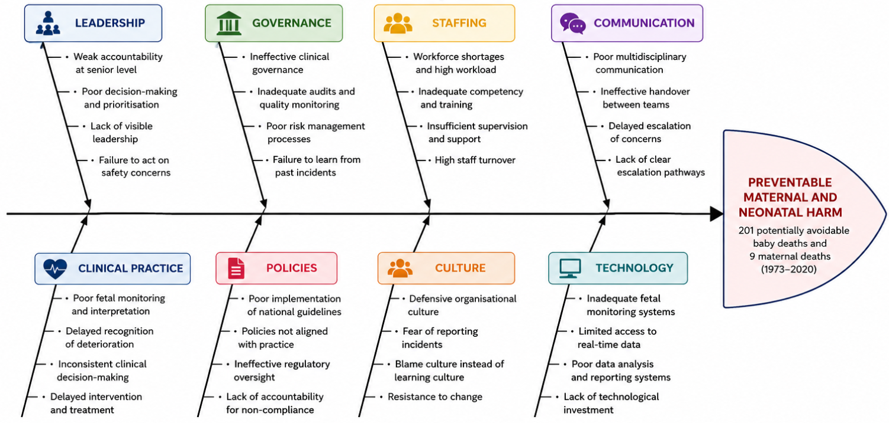
Figure 1: Fishbone diagram
(Source: Self-created)

3.2 Five Whys analysis
The Five Whys is a tool for root cause analysis that determines the most basic cause of a problem by asking the question "Why?" several times to trace back the problem to core issue in organisation (ASQ, 2026). It challenges healthcare organisations to stop at clinical failures and dig deeper to systemic weaknesses responsible for adverse events.
Question | Analysis
Problem | Why did mothers and babies experience preventable harm?
Why 1? | Clinical deterioration was not recognised promptly.
Why 2? | Foetal monitoring and escalation procedures were inadequate.
Why 3? | Staff lacked sufficient training, supervision and competency development.
Why 4? | Leadership failed to prioritise workforce capability and continuous learning.
Why 5? | Weak clinical governance and poor organisational learning allowed unsafe practices to continue for decades.
Table 2: Five Whys analysis of the selected case
(Source: Created by learner in Ms-word)
Five Why analysis has proved that the maternity crisis resulted from systemic failures, not from clinical staff errors alone. Deficiencies in governance, leadership, staff training, and quality assurance, resulted in risks to patient safety being ignored (Narwal, and Jain, 2021). To improve service quality long-term, effective governance and quality systems together with a culture of learning are essential to support greater staff accountability throughout maternity service.

4. Donabedian model analysis
Donabedian Model, an established framework used to measure quality of healthcare, categorizes health-related quality into three mutually dependent dimensions: structure, process and outcome (Yang et al. 2025). The model argues that quality of patient outcomes relates to resources available to an organization and clinical processes to be established in place. This framework would be applicable to analyse the Shrewsbury and Telford Hospital NHS Trust maternity scandal, due to its ability to identify how system failings have led to preventable harm rather than identifying a victim among healthcare workers.
Dimensions | Application to the Shrewsbury and Telford Maternity Scandal
Structure | Staffing deficiencies, weak clinical governance, poor leadership, poor infrastructure and lack of organisation support led to the organisation being less able to offer safe maternity care (Hameed et al. 2022).
Process | Poor multi-discipline communication, poor clinical judgement, poor foetal monitoring, poor escalation of care, and poor team working led to less safe and effective maternity care (Shamoradifar et al. 2022).
Outcomes | The failures have caused 201 preventable infant deaths and 9 mothers to die and led to more clinical negligence and erosion of patient confidence through damaging reputation of NHS maternity services.
Table 3: Application of the Donabedian Model
(Source: Created by learner in Ms-Word)
The analysis indicates how weaknesses in structures had directly led to processes becoming problematic, ultimately negatively impacting patient outcomes. Lack of resources and poor governance meant that clinical staff could not be properly supervised and clinical decisions made to support them would be delayed; consequently, the patients would be at increased risk (Nyawira et al. 2022). This highlights that organisational systems need to be addressed before improved clinical performance could be anticipated.
The key advantage of Donabedian Model is that it offers straightforward and effective methodology to assess quality in healthcare from an organisational and clinical perspective. It facilitates application of evidence-based quality improvement because it indicates required actions to be taken. However, this has disadvantages that it has assumed a simple causal linear relationship among structure, process and outcome. Yet, failures in complex healthcare systems are influenced by interactions among many cultural, policy elements, and organisational factors (Coles et al. 2020).
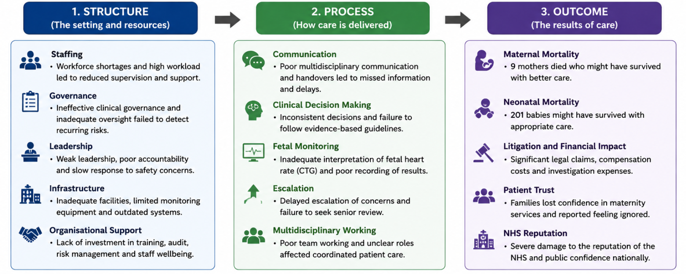
Figure 2: Donabedian model
(Source: Self-created)

5. Strategic analysis
Strategic planning is necessary for healthcare organisations as external and internal factors can significantly impact the care process and patient safety in a health care setting (Soyege et al. 2024). It makes for an organised method in which to make important choices by looking at existing assets, determining what is open to enhance, and getting ready for upcoming obstacles. Using a SWOT analysis as part of a management approach is appropriate to assess Shrewsbury and Telford NHS Trust maternity scandal because this technique will facilitate structured quality assessment (Bright, 2025). This allows management team to focus on which actions to undertake and where best to allocate resource-based on future quality and long-term goals after recommendations of the Ockenden Report into 1592 clinical incidents affecting 1486 families.
Strengths | Weaknesses
NHS quality framework, national maternity guidelines, skilled healthcare workforce, organisational learning opportunities | Governance failures, staffing shortages, communication failures, poor incident reporting, weak leadership (Bourne, 2025)
Opportunities | Threats
Digital monitoring systems, workforce development, policy reforms, patient engagement, AI-assisted monitoring (Reddy, 2026) | Litigation, workforce burnout, financial pressures, declining public trust, increasing maternity service demand
Table 4: SWOT analysis
(Source: Created by learner in Ms-Word)
SWOT analysis of existing NHS systems and guidance for national safety improvement to maternity care has showed that there is a strong foundation; however, it failed to sufficiently improve care and patient safety due to gaps in governance structures and processes, lack of appropriate staff and ineffective communication. Emerging digital technologies, continuous development, and improved policies may provide opportunities to develop robust clinical governance, facilitate organisational learning, and implement changes (Bhati et al. 2023). AI enables proactive monitoring, early identification of patient deterioration, and better support to clinical decisions. There is a range of threats that may challenge sustainable improvement, such as high cost of litigation, staff stress, funding restrictions, and escalating demand for maternity care services. SWOT supports service improvement through connecting organisations’ internal strengths and external opportunities whilst addressing internal gaps and external threats.
Benchmarking against best practice
Benchmarking allows healthcare organizations to measure their performance relative to known standards and high performers within the industry. Regarding the Shrewsbury and Telford Hospital NHS Trust, it would be possible to use findings from Ockenden Review and benchmark them against NHS England Maternity Safety Strategy and high performing NHS maternity services with good clinical governance, incident reporting, team working and ongoing staff training. When compared to these benchmarks, the Trust was deficient in terms of its leadership, culture for patient safety, and organizational learning. Such comparisons can provide insights into areas, where the Trust is lagging; therefore, provide a strong basis for initiating reforms, development of workforce, and sustainable quality improvement initiatives.

6. Recommendations
- Recommendation 1: Strengthen clinical governance
Clinical governance needs to be embedded into an organisation via the use of governance committees, the creation of safety dashboards, conducting regular clinical audits and through systems of clear accountability to provide appropriate oversight and tracking and management of any safety issues as soon as they arise (GGI, 2025).
Stage | Application
Plan | Establish governance committees, define quality indicators and audit schedules.
Do | Implement safety dashboards, conduct audits and monitor compliance.
Check | Review audit findings, patient safety indicators and governance performance.
Act | Improve policies, strengthen accountability and standardise successful practices.
Table 5: PDCA cycle for strengthening clinical governance
(Source: Created by learner in Ms-Word)
- Recommendation 2: Develop a positive patient safety culture
The organisation should have a Just Culture in which issues can be reported freely without fear of retribution (Murray et al. 2024). Staff should learn from incidents during regular review meetings, where a Just Culture requires psychological safety so that people are confident to report concerns.
Stage | Application
Plan | Develop reporting policies and staff awareness programmes.
Do | Introduce confidential reporting systems and learning meetings.
Study | Evaluate reporting rates, staff participation and learning outcomes.
Act | Refine reporting processes and expand successful practices across services.
Table 6: PDSA cycle for patient safety culture
(Source: Created by learner in Ms-Word)
- Recommendation 3: Improve workforce competency
Training on foetal monitoring skill, simulation, and leadership competencies should be mandatory. Professional training development should be strengthened in this area as it helps reduce preventable errors and improve the decision-making process during delivery (Willie, 2025).
Lean Principle | Application
Removal of waste | Eliminate duplicated training activities and inefficient work practices.
Standardisation | Introduce standard competency assessments and clinical protocols (Ten Cate et al. 2024).
Continuous improvement | Review staff performance regularly and update training programmes.
Table 7: Lean approach for workforce competency
(Source: Created by learner in Ms-Word)
- Recommendation 4: Improve clinical communication
Communication should be enhanced via SBAR handovers, multidisciplinary meetings and clear escalation routes (Almughamisi et al. 2025). Robust communication will facilitate the earlier recognition of the unwell patient and coordinate the management of maternal care.
Stage | Application
Define | Identify communication failures affecting patient safety.
Measure | Monitor communication errors and delayed escalations.
Analyse | Determine causes of communication breakdowns.
Improve | Introduce SBAR, multidisciplinary reviews and escalation protocols.
Control | Monitor compliance and sustain communication improvements.
Table 8: Six sigma (DMAIC) for clinical communication
(Source: Created by learner in Ms-Word)
- Recommendation 5: Strengthen incident reporting and organisational learning
Electronic incident reporting, Root Cause Analysis (RCA), multidisciplinary learning forums, and ongoing feedback should be embedded. Through Continuous Quality Improvement (CQI), future risks should be identified proactively, the organisation learn, and events should not be repeated (Samimi, 2025). The initiatives recommended should address the governance concerns identified within the Ockenden Review and will support improvement in patient safety to continue over time.
Recommendation | Quality improvement tool | Timeline | Responsible team | Expected outcome
Strengthen clinical governance | PDCA | 6 months | Executive board | Better governance oversight and accountability
Develop patient safety culture | PDSA | 6 months | Clinical leads | Improved incident reporting and learning culture
Improve workforce competency | Lean | 12 months | HR and education team | Higher staff competency and safer clinical practice
Improve clinical communication | Six sigma (DMAIC) | 9 months | Maternity team | Reduced communication errors and faster escalation
Strengthen incident reporting | Continuous quality improvement | Continuous | Governance team | Sustainable organisational learning and improved patient safety
Table 9: Implementation plan
(Source: Created by learner in Ms-Word)
The implementation plan highlights how to enhance quality and patient safety standards within Shrewsbury and Telford Hospital NHS Trust Maternity services. This proposal includes strengthened clinical governance via PDCA cycle, over six months so that Executive Board can improve monitoring, accountability, and compliance against standards of quality. Alongside this, PDSA cycle will be utilised over six months to support Clinical Leads in creating a patient safety culture by promoting reporting of events and learning at organisational level. Workforce competency over twelve months is improved by using Lean principles to standardise training programmes, optimise foetal monitoring skills, and to reduce wasteful processes. Moreover, maternity team can implement Six Sigma (DMAIC) over a nine-month period to reduce incidence of communication failure by standardising SBAR handovers and escalating processes to reduce clinical variation. Continuous quality improvement managed by Governance Team, over an ongoing basis will result in embedding routine use of electronic incident reporting, Root Cause Analysis, and consistent feedback cycles within the team, leading to an improved service.

7. Conclusion
It can be concluded from this report that Shrewsbury and Telford Hospital NHS Trust maternity scandal was primarily a product of chronic systemic issues, rather than merely isolated clinical errors. The analysis illustrated how the combination of weak clinical governance, ineffective management, poor communication, skills deficits, and insufficient organisational learning provided fertile ground for preventable maternal and neonatal harm to occur. The use of the Fishbone Diagram, 5 Whys analysis, the Donabedian Model and the SWOT analysis offered an all-inclusive overview of structural, process and strategic influences that can have a profound effect on the quality, safety, effectiveness and equity of healthcare services. By showing that a system-centred approach is key, it helped identify structural improvements needed for the avoidance of such future events. In addition, the subsequent recommendations made via the PDCA (Plan-Do-Check-Act), PDSA (Plan-Do-Study-Act) and the principles of Lean and Six Sigma, have created realistic ways to overcome barriers and bring about enhanced leadership and governance, skill development, communication and sustainable quality improvement initiatives. The success will depend upon sustained organizational engagement, effective leadership and decision-making, a patient safety culture and a genuine desire to provide a high standard of care.

References
Almughamisi, A.F., Alshehri, A.A.M., Alandijani, M.A., Alqarni, S.D., Alshehri, F.H., Alshehri, K.H., Alnefaie, A., Alshehri, A., Alrajhi, M., Albalawi, H. and Alqurashi, A., 2025. Multidisciplinary team group effort in healthcare; the role of emergency, clinical, and administrative professionals in improving outcomes and hospital performance. Saudi J Med Pharm Sci, 11(10), pp.928-41.
ASQ, 2026. Five Whys and Five Hows. Available at: https://asq.org/quality-resources/five-whys?srsltid=AfmBOoqMNk7rkqydqmtPMVV17Wt3YyoFnabxwakv5Aj4O-46SkvNTsJl [Accessed: 04.07.2026]
Auraaen, A., Saar, K. and Klazinga, N., 2020. System governance towards improved patient safety: key functions, approaches and pathways to implementation. OECD Health Working Papers, (120), pp.0_1-116.
Auraaen, A., Saar, K. and Klazinga, N., 2020. System governance towards improved patient safety: key functions, approaches and pathways to implementation. OECD Health Working Papers, (120), pp.0_1-116.
Bhati, D., Deogade, M.S. and Kanyal, D., 2023. Improving patient outcomes through effective hospital administration: a comprehensive review. Cureus, 15(10), p.e47731.
Bourne, P.A., 2025. Failed Leadership in Education and Politics: Assessing Impacts on Governance, Institutional Integrity, and Societal Development.
Bright, M., 2025. Whistleblowing in an empty room. Index on Censorship, 54(1), pp.52-57.
Coles, E., Anderson, J., Maxwell, M., Harris, F.M., Gray, N.M., Milner, G. and MacGillivray, S., 2020. The influence of contextual factors on healthcare quality improvement initiatives: a realist review. Systematic reviews, 9(1), p.94.
De Vries, R.G., Low, L.K., Chuey, M., Abdelnabi, S. and Lewallen, M., 2025. When Evidence Fails to Change Practice: Examining the Persistence of Continuous Fetal Monitoring. Qualitative Health Research, p.10497323251347137.
Falade, I.M., Gyampoh, G.K.S., Akpamgbo, E.O., Chika, O.C., Obodo, O.R., Okobi, O.E., Aguguo, J.C. and Chukwu, V.U., 2024. A comprehensive review of effective patient safety and quality improvement programs in healthcare facilities. Medical Research Archives, 12(7).
GGI, 2025. Clinical Governance – good practice. Available at: https://www.good-governance.org.uk/publications/insights/clinical-governance-good-practice [Accessed: 04.07.2026]
Gov.UK, 2022. Ockenden review: summary of findings, conclusions and essential actions. Available at: https://www.gov.uk/government/publications/final-report-of-the-ockenden-review/ockenden-review-summary-of-findings-conclusions-and-essential-actions [Accessed: 04.07.2026]
Hameed, W., Khan, B., Siddiqi, S., Asim, M. and Avan, B.I., 2022. Health system bottlenecks hindering provision of supportive and dignified maternity care in public health facilities. PLOS Global Public Health, 2(7), p.e0000550.
Hill, J.E., Stephani, A.M., Sapple, P. and Clegg, A.J., 2020. The effectiveness of continuous quality improvement for developing professional practice and improving health care outcomes: a systematic review. Implementation Science, 15(1), p.23.
Kumah, A., Nwogu, C.N., Issah, A.R., Obot, E., Kanamitie, D.T., Sifa, J.S. and Aidoo, L.A., 2024. Cause-and-effect (fishbone) diagram: a tool for generating and organizing quality improvement ideas. Global Journal on Quality and Safety in Healthcare, 7(2), pp.85-87.
Lanyon Bowdler, 2026. Shrewsbury & Telford Hospital NHS Trust Maternity Care Negligence Claims. Available at: https://www.lblaw.co.uk/medical-negligence/sath-maternity-negligence-claims/ [Accessed: 04.07.2026]
Murray, J., Sorra, J., Gale, B. and Mossburg, S., 2024. Ensuring patient and workforce safety culture in healthcare. Ensuring Patient and Workforce Safety Culture in Healthcare.
Narwal, S. and Jain, S., 2021. Building resilient health systems: patient safety during COVID-19 and lessons for the future. Journal of Health Management, 23(1), pp.166-181.
Nyawira, L., Tsofa, B., Musiega, A., Munywoki, J., Njuguna, R.G., Hanson, K., Mulwa, A., Molyneux, S., Maina, I., Normand, C. and Jemutai, J., 2022. Management of human resources for health: implications for health systems efficiency in Kenya. BMC health services research, 22(1), p.1046.
Ockenden Maternity Review, 2022. Final report of the Independent Review of Maternity Services at The Shrewsbury and Telford Hospital NHS Trust published. Available at: https://ockendenmaternityreview.org.uk/wp-content/uploads/2022/03/FINAL_PRESS_RELEASE_INDEPENDENT_MATERNITY_REVIEW_OF_MATERNITY_SERVICES_REPORT.pdf [Accessed: 04.07.2026]
Reddy, S., 2026. Foundation for Artificial Intelligence‐Driven Democratization of Healthcare Access. Learning Health Systems, 10(3), p.e70093.
Samimi, A., 2025. Application of failure mode and effects analysis (FMEA) for risk management in hospital laboratories. Medicinal, Psychological, and Health Research Journal (mphrj), 1(5), pp.160-168.
Shamoradifar, Z., Asghari-Jafarabadi, M., Nourizadeh, R., Mehrabi, E., Areshtanab, H.N. and Shaigan, H., 2022. The impact of effective communication-based care on the childbirth experience and satisfaction among primiparous women: an experimental study. Journal of the Egyptian Public Health Association, 97(1), p.12.
Soyege, O.S., Nwokedi, C.N., Tomoh, B.O., Mustapha, A.Y., Mbata, A.O., Balogun, O.D. and Iguma, D.R., 2024. Strategic planning in healthcare: A framework for sustainable growth and service excellence. International Journal of Multidisciplinary Research and Growth Evaluation, 5(06), pp.1579-1583.
Ten Cate, O., Khursigara‐Slattery, N., Cruess, R.L., Hamstra, S.J., Steinert, Y. and Sternszus, R., 2024. Medical competence as a multilayered construct. Medical Education, 58(1), pp.93-104.
Ugbebor, F., Aina, O., Abass, M. and Kushanu, D., 2024. Employee cybersecurity awareness training programs customized for SME contexts to reduce human-error related security incidents. Journal of Knowledge Learning and Science Technology ISSN: 2959-6386 (online), 3(3), pp.382-409.
WHO, 2023. Patient safety. Available at: https://www.who.int/news-room/fact-sheets/detail/patient-safety [Accessed: 04.07.2026]
Willie, M.M., 2025. Strategies for enhancing training and development in healthcare management. Advances in Human Resource Management Research, 3(1), pp.44-59.
Yang, J., Liu, F., Yang, C., Wei, J., Ma, Y., Xu, L., Xie, J. and Wang, J., 2025. Application of Donabedian Three‐Dimensional Model in Outpatient Care Quality: A Scoping Review. Journal of nursing management, 2025(1), p.6893336.

