Proposal Essay
By Sephrenia Canty
Student Number: 2306067
Course: BA Graphic Design
Module: Research in Practice
Module Code: ADAD5004
Word Count: Approx. 2300

In this essay I will be discussing the ways items from cosmetics and fashion can be used to bring attention to negative events and opinions. An example of this will be the use of red lipstick as a symbol for feministic political movements, another being the way clothing is used to show the truth of victims and lastly how shoes can show the scale of a tragedy. I will be referencing some traumatic events and will discuss some exhibitions that use these items to demonstrate the scale of the events being referenced.

Red Lipstick:

The colour red usually represents different emotions such as desire, passion and rage, however when it comes to cosmetics the meanings behind the colour can be even deeper. Red lipsticks have a long history with feminism, as at one point people had thought of it as being for prostitutes, with the suffragettes then deciding to use it in their protests alongside other items such as cigarettes. The lipstick was also used during the world war to boost morale and has been seen on all sorts of individuals as a way of boosting confidence. It has become a defining symbol of strength for women and lgbtq+ individuals across the world with the bright colour drawing attention with every movement it has been used in.

This century has seen many movements use red lipstick as a feminist symbol, namely a few different political movements. The mixing of cosmetics and politics is still frowned upon by certain individuals, with women who express their femininity and work or talk about politics being criticised by those who believe that individuals who love cosmetics and fashion to be incapable. This opinion is still around despite many proving it to be untrue, with the fight for equality being far from over. Ateh Jewel states in a newsletter about cosmetics in politics that when she presented a segment on chat show that “Some of the comments gave me 1953 and “under his eye” flashbacks making it clear I should stick my powdered nose out of politics and in my lane.” (Jewel, 2023). This viewpoint is used against women in all fields that are seen as ‘masculine’. Using cosmetics to show that that their misogynistic viewpoints are wrong through artistry and self-expression has helped bring many people together through a shared experience or beliefs.

The views around red lipstick are mixed, with women of different ethnicities being treated differently for wearing it. As a result, many don’t feel comfortable wearing such a bold colour due to comments they receive. Unfortunately, white women are more likely to be accepted wearing red and are seen as classy if they do, thus leading to some women refusing to wear the colour. Others are taking a stand against such opinions and are wearing it proudly, believing that it provides a boost of confidence. It’s likely that insulting comments against someone wearing red lipstick would prevent or discourage them from taking part in the movements created, especially with individuals within the LGBTQ+ being treated even worse as a result of their desire to self-express.

One of the movements was in the Basque region, where the RLR or the Red Lipstick Revolution was used for the 2016 elections in which the initial movement was for feministic political purposes, however the public would join in and show their support via internet posts by both men and women. This movement is similar to the previously mentioned movement in Portugal. The campaign states “The EH Bildu campaign has painted its lips red. You paint your lips red when you are in front of the mirror and you feel happy and content with what you see. You paint your lips red when you decide that you are going to love yourself the way you are. Strength, security, hope. As I understand it, this is what those who paint their lips red transmit.” (Ureta & Terradillos, 2021).

An example of the negative views and the resulting movement is, as stated in the article ‘The red lipstick movement’, “André Ventura—leader of the far-right populist party Chega—publicly insulted the left-wing candidate Marisa Matias, deriding her use of red lipstick, an overtly feminine make-up, as improper and a sign of lack of professionalism.” (Caldeira & Machado, 2023) leading to the Vermelho Em Belem (Red In Belem) movement where people of all genders in and outside of Portugal stood by Marisa Matias sharing photos of themselves wearing red lipstick. This occurred in 2021 and according to the article, was one of the first movements created in Portugal about feminism to reach widespread visibility.

Marisa Matias also used red in her political campaign, with red being the sole colour used in most of her campaign posters that year. The designs are reminiscent of the old advertisements for red lipsticks from brands like Elizabeth Arden and Max Facter that also highlight the red of the product being shown. Her designs went hand in hand with the movement Vermelho Em Belem, with her using said hashtag at the bottom of some of the campaign posters. Whilst unsuccessful that year, she did succeed in creating a positive movement around the use of cosmetics politics.

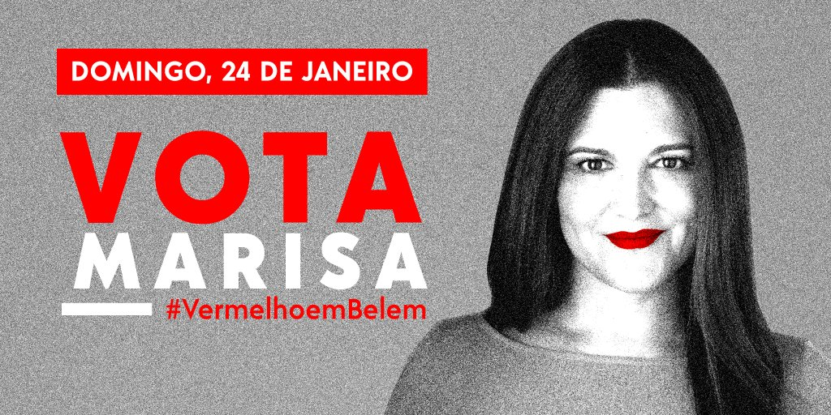
(Matias, 2021)

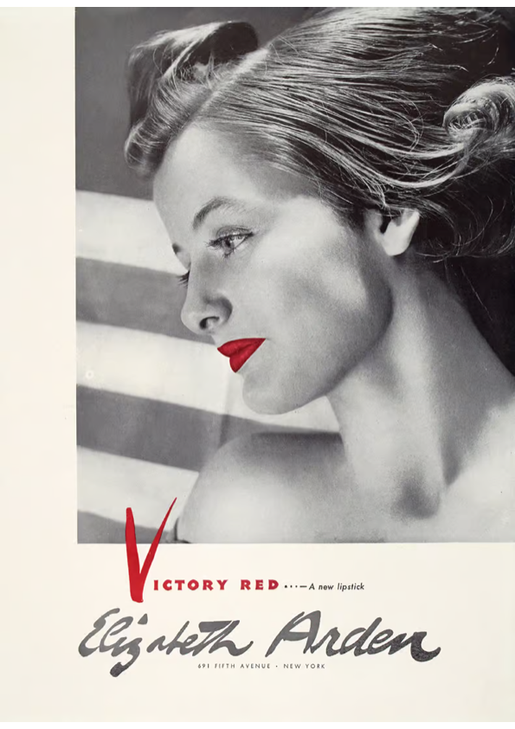
(Idacavage, 2018)

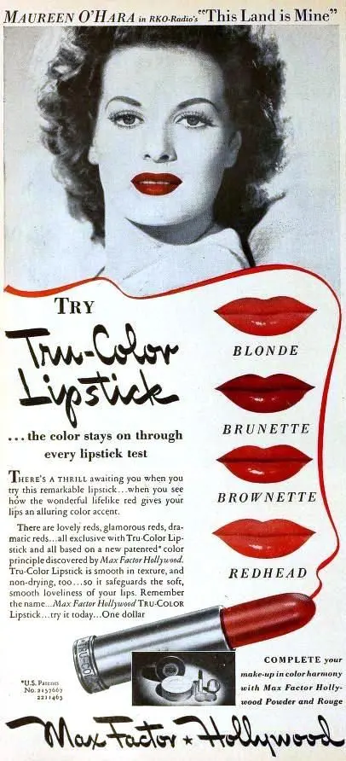
(Shipyard Millie's Vintage, 2022)

Both of these campaigns, several years apart, used red lipstick to bring a community together for feminism in politics and shows how a simple item can hold such a strong meaning and become an important symbol for so many people. The importance of using a symbol in protests allows for a shared experience across different backgrounds, especially with an item that is easier to access and use.

Clothing:

Clothing is used for functionality and self-expression, with various designs and styles to fit different scenarios, personalities and sizes. Many like to dress up on occasion, wearing clothes that make them feel good. They use styles and colours to reflect their mood and feelings, with many opting for more comfortable styles for day-to-day wear. However, certain individuals view some styles of clothing as excuses for their inappropriate actions. For a long time the phrases “what were you wearing” and “she was asking for it” have been about and have frustrated the victims of those crimes. Despite what some may say, anyone can be a victim of sexual assault, all ages and all genders. The clothes that they wear are often targets of conversation, with mocking questions being used to argue against the assaults and gaslight the victims despite the fact that the crimes would have been committed regardless of the clothes worn.

Those who question the clothing choices of the victims are often individuals who doubt what the victims say, causing further trauma potentially requiring further therapy. The people who think that the clothing one wears is an invitation for certain actions are very likely to be the ones to pardon others who commit the assaults in addition to committing assault themselves. The narrative surrounding these arguments has been told over and over and has caused many victims to face a lot of problems, especially since, as stated by Rachel Loney-Howes, “The unspeakability of rape is also perpetuated by the criminal justice system through its power to define what is and is not rape, thereby denying recognition and permission to claim their experience as rape for those whose experience falls outside sociocultural assumptions as well as legal definitions and interpretations of ‘real rape’.” (Loney-Howes, 2020). As a result of the varying definition in addition to people who refuse to believe them, many victims struggle to say their story let alone seek justice for what happened to them.

An exhibit called ‘What were you wearing’ shows the clothing that individuals wore at the time of their assault or rape, revealing the variety of ages and environments in which the crimes occurred. The designs of the online posts of the exhibit are simple, with the clothes laid out with a description of them, and a brief account of events beside them. The background is a plain pale blue reflecting the sadness that can be felt when reading through the victims’ stories. The people behind the exhibit state on the project’s website, “When survivors of sexual violence disclose their stories, they are often asked, “What were you wearing?” as if their clothing choice determines their consent.” (Susan B. Anthony Project, 2024). They aim to fight back against the people who perpetuate this narrative against the victims. Not only does this exhibit shed light to the experiences of many, but also gives the victims a safe space to share them without the judgement they may receive elsewhere.

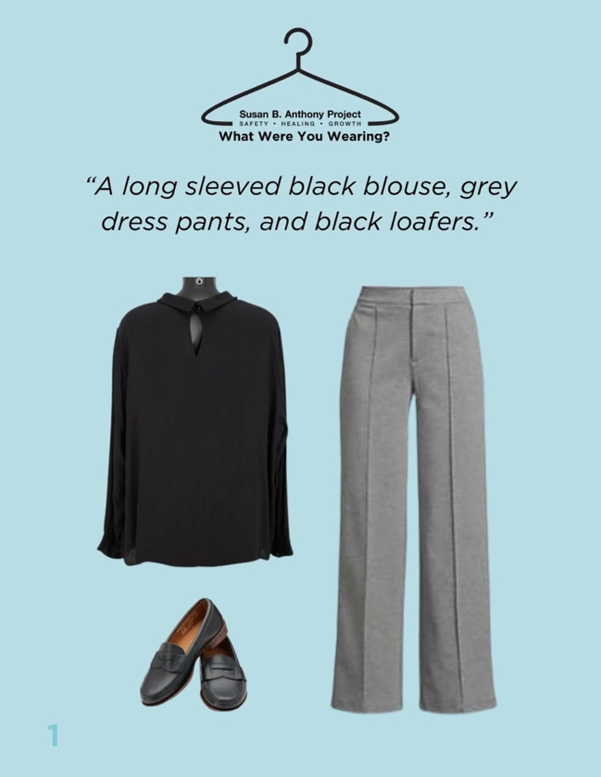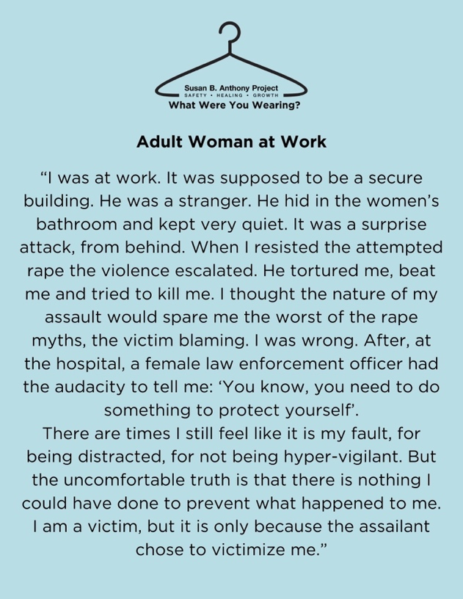
(Susan B. Anthony Project, 2024)

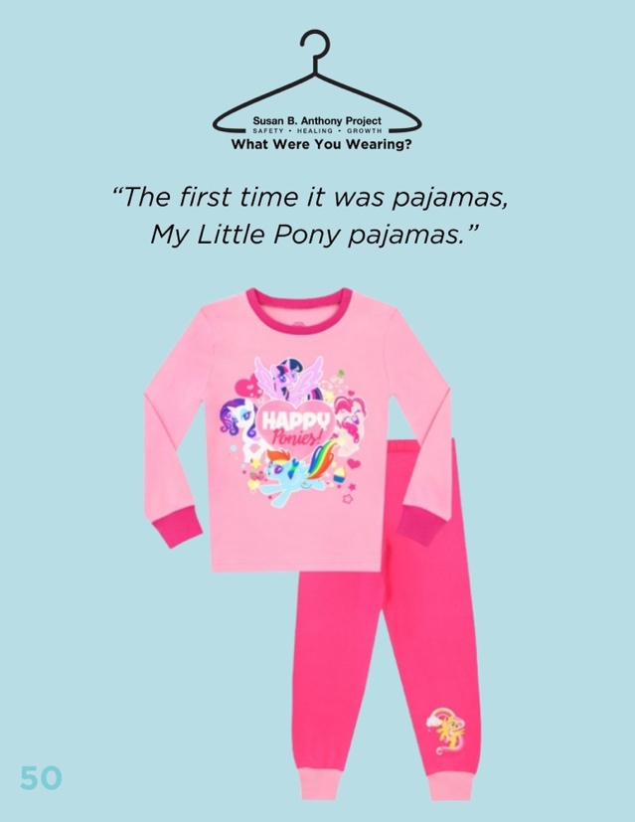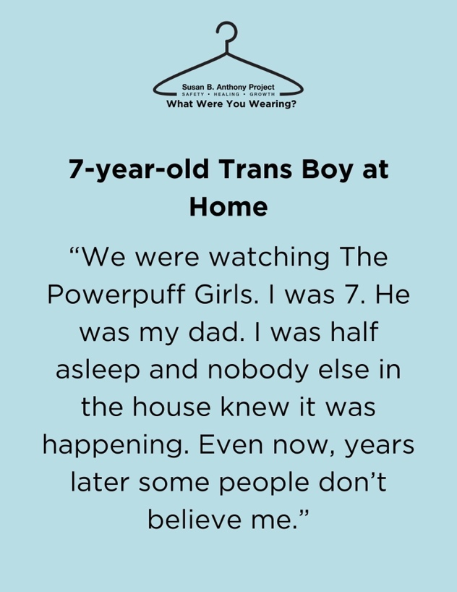
(Susan B. Anthony Project, 2024)

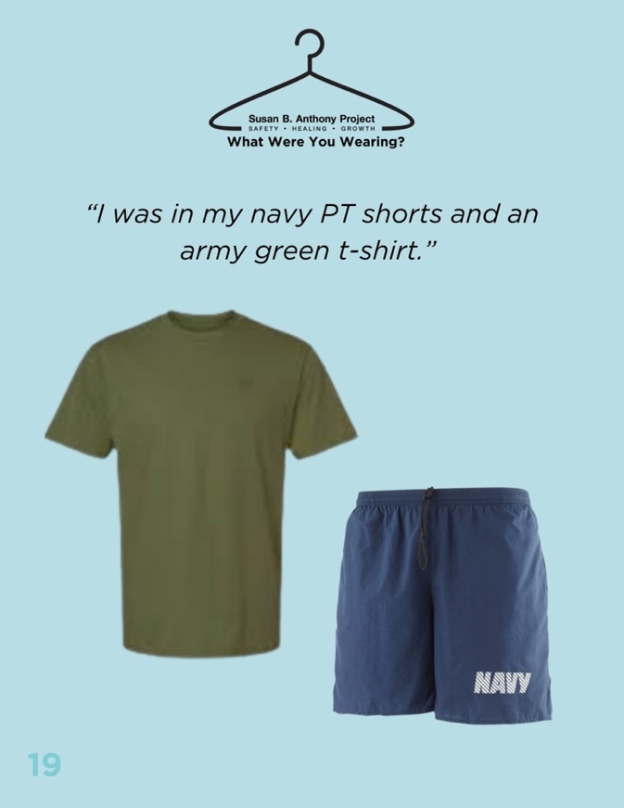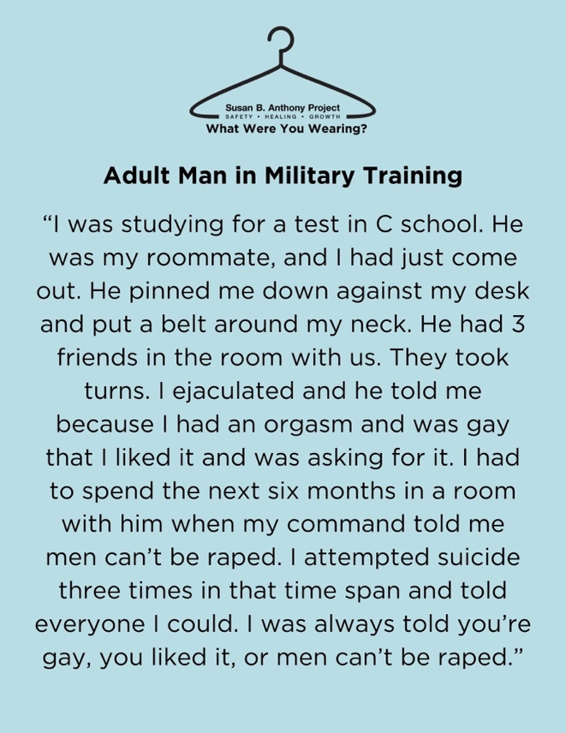
(Susan B. Anthony Project, 2024)

Certain individuals will take advantage of others regardless of clothing yet will argue later that if the person they assaulted hadn’t wanted it to happen, they should have dressed differently. The narrative needs be corrected and any amount of effort that goes to achieving this goal is incredibly important, no matter how simple or small. Clothing should bring comfort not trauma, be worn without judgement and not be blamed for the actions of people.

Shoes:

Footwear is a key part of someone’s wardrobe nowadays, with streets being unsafe to walk on without them in addition to how normalised they are in our day-to-day lives. Similar to clothing, there are many practical designs and impractical designs for different occasions with trainers/sneakers being a fairly popular choice. These shoes have been used in different types of protests across the world and are used to show various things such as the loss of lives in a more personal way than just using statistics. Most of the protests are political in nature, from about school shootings to wartime losses.

Some people are against what the protests that the shoes stand for. The school shooting protests for example, are for stricter gun laws in the United States, and yet a lot of people dislike that idea despite the casualties that occur every year. There are also people who want nothing to do with what’s happening in Gaza, and yet the number of shoes used in that protest were also in the thousands in addition to also referencing the loss of children specifically. Regardless of your opinion on these situations, the number of deaths of children that have occurred could have been prevented in most if not all of the school shootings, and war is not a good way to deal with conflicts.

Elina Chauvet is an artist who uses shoes in her installation called ‘Los Zapatos Rojos’ includes shows red shoes of all sizes and styles show the loss of individuals to gender-based violence. This all began, as stated by Adriana Rios Monsalve, as “an installation in memory of hundreds if not thousands of young women who disappeared, were tortured and then were killed in Juárez during 1990s and 2000s.” (Monsalve, 2025) and has since been replicated in other locations across the world. Chauvet states that the red has various meanings such as bloodshed but also love, hope and change. Some of the shoes are simply representations, whereas others are shoes of actual victims, painted red by family members or by Chauvet herself. The sight of hundreds of red shoes is shocking, especially knowing the abuse and violence that happened to the women and girls that they represent.

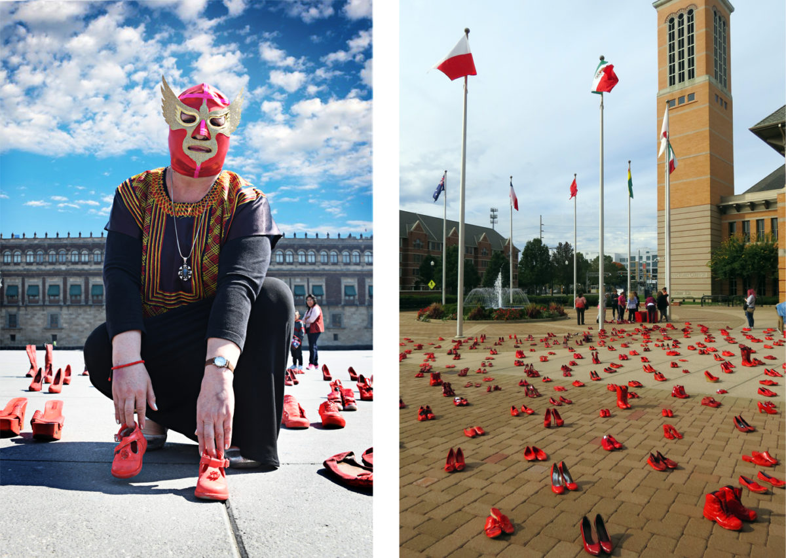
(Barajas, 2020)

Many protests that have used shoes use them as a way to show the consequences of other peoples’ actions. The impact the shoes have on the viewer is big, since that many empty shoes outside of a store is quite alarming and unusual without someone wearing them. Symbolising the people who should be wearing those shoes

Cosmetics and fashion have a lot of history and controversy surrounding them, with the protests that use them being a mix of social and political. People from all backgrounds use them to reflect on public and personal events on a large scale both online and in person.
The keyword I’ve chosen differ in the types of protests/movements that I chose to research, in addition to the fact that shoes and clothes are necessities whereas lipstick or any other cosmetic is not despite the fact that many people use all of them on a daily basis. Another difference would be as a result of sexism, as makeup is still seen as strange for men to wear in most cultures.
The protests I chose to look at vary in level of seriousness, with the exhibitions on clothes and shoes being incredibly heartbreaking and the lipstick movements being less serious yet still important to discuss.
The links between the chosen words are that they can all be used to show off wealth as all categories have luxury products, in addition to being used globally to display personality and beliefs. All of these items are simply everyday items for some, whereas for others they are items full of emotion, memories and symbolism.
When linked together, the key words can be used to demonstrate the use of personal items for protest, potentially linking the topic areas together too. They could also be linked by their importance to people, with the belongings of someone close holding a lot of sentimentality.
I could study other types of protests next year, or study different aspects of clothing and cosmetics. With the research that I did in preparation for this essay, I found more information on the history of lipstick that didn’t fit with the direction I ended up choosing.
The question that could be chosen for this essay could be in reference to the items being used to assist or motivate in protests or could be about how simple items can be used to bring people together against a problem.

How can items be used to speak out against violence?

Bibliography

- Barajas, J., 2020. pbs.org. [Online]
Available at: https://www.pbs.org/newshour/arts/this-artists-red-shoes-stand-in-for-all-the-women-lost-to-violence
[Accessed 27 4 2025].
-Caldeira, S. P. & Machado, A. F., 2023. The red lipstick movement: exploring #vermelhoembelem and feminist hashtag movements in the context of the rise of far-right populism in Portugal. Feminist Media Studies, Volume 23(8), p. 4252–4268.
-David, L., 2025. The victims' shoes trope and emerging solidarity in political protest. Nations and Nationalism, 31(1), pp. 64-78.
-Idacavage, S., 2018. Fashionista.com. [Online]
Available at: https://fashionista.com/2016/07/best-red-lipstick-history
[Accessed 27 4 2025].
-Jewel, A., 2023. An interest in beauty is seen as a sign you are stupid and uncultured but why can’t I love makeup and have an opinion on Putin and the gender pay gap?. Glamour Magazine, 28 February, p. NA.
-Loney-Howes, R., 2020. Online Anti-Rape Activism. s.l.:Emerald Publishing.
-Matias, M., 2021. x.com. [Online]
Available at: https://x.com/mmatias_/status/1352763001959555072
[Accessed 27 4 2025].
-Monsalve, A. R., 2025. instituteforpublicart.org. [Online]
Available at: https://www.instituteforpublicart.org/case-studies/red-shoes/
[Accessed 27 4 2025].
-Shipyard Millie's Vintage, 2022. Medium.com. [Online]
Available at: https://medium.com/@shipyardmillies/choosing-the-perfect-50s-style-red-lipstick-97bc4e1d1e93
[Accessed 27 4 2025].
-Susan B. Anthony Project, 2024. sbaproject.org. [Online]
Available at: https://sbaproject.org/what-were-you-wearing/
[Accessed 27 4 2025].
-Ureta, A. L. & Terradillos, J. O., 2021. Hashtivism’s potentials for mainstreaming feminism in politics: the Red Lips Revolution transmedia narrative. Feminist Media Studies, pp. 1139-1162.

