Module: Research Methods II

Module Code: ECPS5002

Title: Design and conduct a research study to explore the effect of emotional intelligence on memory for emotion-induced stimuli.

Abstract
This study was conducted to determine whether levels of emotional intelligence influenced recall of emotion-induced stimuli. Thirty participants who were either on a psychology or a psychology and counselling university course took part in this research task which consisted of (11M, 18F, 1N-B), aged 18- 51 (M= 30, S.D = 9.96). Upon completing a TEIQue-SF questionnaire and a mix of hot and cold cognition tasks. The participants levels of emotional intelligence were calculated, and a mixed multi-factorial design was utilised to investigate this information and a mixed ANOVA executed to examine these findings. Nevertheless, the results show the minute difference negative wording had on recall, which rejects the hypothesis and accepts the null hypothesis.

Introduction
This report will examine whether there is an impact between Emotional Intelligence (EI) and memory recall using emotion-induced stimuli. Peter Salovey and John Mayer first proposed EI in 1990 and developed a model in 1997 to investigate and construct validation where they defined EI as a mental ability separate from personal traits. (McMahan, 2000)
However, Lea et al. (2018) illustrated how EI is a combination of the rational side of the brain and the limbic system where emotions are situated, which, when harnessed, can improve thinking and result in better mental health. EI is the ability to manage and identify the emotions of those around you and your own. EI comprises emotional awareness, the knowledge to not only obtain but apply these emotions productively, such as problem-solving and thirdly managing emotions by regulating your own and others around you. (Roman & Roman, 2017)
Barrett's (2006b) theory is based on how the sub-emotional variables of arousal and valence are the foundation of emotional life. These variables are considered properties of stimuli, neurophysiological state, and conscious experiences. A combination of values on the sub-emotional variables is called "affective quality". This affective quality can cause a "core affect" on a person depending on the stimuli. Thus, the foundation of emotional life fuses to form a core effect, not specific emotions. Barrett emphasises that people can categorise an episode of core effect as fear or sadness depending on acquired conceptual knowledge such as emotion scripts. (Houwer & Hermans, 2013)
This study hypothesises that participants with higher emotional intelligence would achieve a higher recall of negative stimuli overall. There is also an expectation that participants with low EI would recall fewer words than those with high EI.

Method

Participants
Thirty students either studying Psychology or Psychology and Counselling university course volunteered to partake in this study. The participants consisted of one non-binary, eighteen females and eleven males. Which were recruited through the Experiment Management System (EMS), The age range was from eighteen to fifty-one (M=30, S.D=9.96).

Design
A 2 x 3 mixed-design ANOVA was performed to explore the effect of participants recall towards emotion-induced wording (Positive, Negative and Neutral) against levels of emotional intelligence (High/Low). This was a between-subjects factor with two levels: high and low. Participants would be categorised as low or high once the data is collected and the mean score calculated. Within-subjects factor had three levels which were positive, negative and neutral stimuli. Descriptive statistics for all variables concerned in this investigation are outlined in Table 1 below.

Table 1
Emotion Stimuli | Emotional Intelligence Groups
 | High |  | Low
 | M | SD | M | SD
Positive | 10.73 | 3.77 | 9.37 | 3.90
Negative | 9.73 | 4.31 | 9.53 | 3.44
Neutral | 8.91 | 2.98 | 7.63 | 3.00

Materials
Trait EI was measured through Trait Emotional Intelligence Questionnaire - Short Form (TEIqueSF) (Zampetakis, 2011). The TEIQueSF consisted of 30 items to which participants responded on a Likert seven-point scale (strongly agree to strongly disagree; see Appendix A for sample items), resulting in an assessment and providing a global trait EI score and scores on four specific factors (well-being, self-control, emotionality, and sociability) for example one of the statements for self-control is ‘I tend to change my mind frequently’. (Sullivan & Artino, 2013).
TEIQueSF was used to deliver comprehensive coverage of the trait EI sampling domain. The psychometric properties are ideal, and its robust four-factor structure shows functional identity across languages (Mikolajczak et al., 2009). It also exhibits discriminant validity by showing there was unrelated relationship. The reliability of the analysis was 0.627, which was uploaded onto Qualtrics for administration. Finally, a unique program called Superlab was used to assess memory recall of emotion-induced words.
Data was collected using the Qualtrics survey system and Superlab in a lab setting. In addition, a laptop was set up with the Qualtrics survey for the participant to efficiently switch between the Superlab task on the computer and the TEIQueSF on the laptop. The participant would first be given a consent form (see appendix B). Upon completion, they can be instructed how to complete the time-pressured task and be given an information sheet (see appendix C).
Three experimental trials were implemented using emotional stimuli ranging from positive, negative and neutral wording. These were then displayed individually for 200ms, alternating with a blank screen inserted between each word for 400ms. At the end of each emotional-induced stimuli presented, the participant was instructed to think of something using a prompt such as 'think of your favourite food' for one minute. The participant would then be informed that the Superlab would record the timing and then prompt them to perform the next task. Participants were then asked to recall as many of the 20 words they could and type them into a box supplied on screen, which would be repeated for the other two trials. Once all three trials were completed, a debrief form and information sheet would be given to the participant (see appendix D). The information given was then reiterated to the participants that their answers would be anonymised following online data protection guidelines (see appendix E). They were also informed that it would adhere to the ethical form created for this study (see appendix F).

Procedures
All research and tasks were carried out following online data protection guidelines (see appendix E) whilst also adhering to the ethical form created for this study (see appendix F). The task also adhered to The British Psychological Society ethical guidelines (see appendix G), the University of Wales Trinity Saint David policies (see appendix H) and were approved by the UWTSD School Research Ethics Committee.
Participants were recruited through EMS and then led to the psychology labs, where the study would be conducted. The laptop and computer required to complete both tasks would have the correct software uploaded ready. Upon arrival, the participants would be tested individually then the researcher would then provide an information sheet and carry out the consent procedure. Once finalised and all correct forms signed, demographic data such as age and gender would be collected before completing the TEIQue-SF through Qualtrics. Upon completion, the participant would then switch computers to use Superlab and complete the memory task by completing three trials. Once concluded, the participant would be given a debrief form and thanked for participating in the study.

Results
An alpha level of 0.5 was implemented for all statistical tests for this study. The data was analysed using a 2 x 2 Analysis of Variance (ANOVA) mixed design. One independent variable was emotional intelligence with two levels which were high and low. Another independent variable was the emotional stimuli, consisting of three levels: positive, negative, and neutral wording. The dependent variable in this study was the number of words correctly recalled.
The two-way interaction between levels of EI and the emotion-induced words was non-significant, F (2,56) =2.25, p>0.5 (=.12) np2=.07 thus, not reaching statistical significance.
The main effect of the emotion-induced words was non-significant (F (2,56) = .27, p> 0.5 (=.76) np2=.01), indicating that the number of emotion-induced words recalled was not affected by participants having low or high levels of EI. For example, how many positive, negative and neutral words were recalled.
There was no distinction between high and low EI groups, which rejects the hypothesis that low EI would recall fewer words than participants with high EI. The main effect of EI was non-significant, F (1, 28) = 1.1, p >0.5 (=.30) np2= .04. Cronbach alpha was .627, which indicates acceptable levels of reliability. If some data items were deleted, this would create a more reliable result. Yet, it would also mean it would not be replicable.
Nevertheless, the results show the minute difference negative wording had on recall, which rejects the hypothesis and accepts the null hypothesis. It also contradicts the hypothesis that low EI would recall fewer words comparatively against participants with high EI, therefore again accepting the null hypothesis.

Discussion
The results found that the hypothesis was rejected as there was no significant difference in participants who had either high or low EI and the number of words recalled from any of the three levels of emotion-induced stimuli as shown in table 1. There was also no significant difference with participants who had low EI and recalling fewer words than those who were categorised with EI.
Metacognitive abilities impact performance and behaviour; however, this is heavily influenced by the individual's emotional response, which may be due to past experiences, or potentially even revising their behaviour under the Hawthorne effect. (Houwer, 2012)
Another potential limitation could be low mood disorders such as depression as moods last longer than emotions. There is also emotional differentiation such as Alexithymia when a person lacks the ability to identify, distinguish, and appropriately describe their feelings and emotions. (Shreeve, 2012)
Barrett et al., (2001) have suggested that having the ability to regulate emotions, specifically negative ones, is a vital characteristic of those who display high EI. Working memory (WM) is seen as a set of mechanisms; however, EI factors are based on trait factors regarding the TEIQue. The Working Memory Capacity (WMC) is also where long-term memory can be retrieved through activating, rehearsing, and updating mental representations and action plans while performing complex tasks such as time-pressured tasks. (Engle, 2001)
Baddely (2012), who created the working memory system, explained that the central executive is a versatile and vital component of working memory and resembles an attentional system; however, it does not store information unlike the iconic memory.
Iconic memory can affect the results of this visual memory recall task because iconic memory is a sensory store that holds visual information for approximately 500 milliseconds compared to auditory information, which lasts roughly two full seconds. (Eysenck & Keane, 2015)
However, Sperling (1960) argued that iconic memory is preattentive, which Atkinson and Shiffrin accepted with their multi-store model, which dictates that attention occurs after stored information. However, Persuh et al. (2012) found that the sensory storage for iconic memory was critically disrupted if the participant simultaneously engaged in attention requiring tasks.
McCabe et al. (2010) found that individuals with high and low WMC differed in their attentional control. In addition, Sorqvist (2010) found that high-capacity individuals were better at controlling their internal and external distracting information and less likely than low-capacity individuals to exhibit goal neglect. (Ekman, 2012). Goal-oriented emotion regulation operates in two potential directions resulting in either a positive or negative effect on the emotional outcomes, especially those that can result in a hedonic reward.
Um et al. (2012) study found that positive emotions facilitate learning and contribute to academic accomplishment, being mediated by the levels of self-motivation and satisfaction with learning materials. The Pollyanna hypothesis suggests how positive stimuli are used more frequently in the early stages of development. The increased exposure to positive stimuli gives a greater experience in recalling the positive wording, thus improving EI. Lea et al. (2018) strengthened this argument by finding a correlation between EI and positive stimuli. They then noticed that participants with high EI responded better to positive stimuli than negative. Overall, they also found that EI is associated with a tendency for positive-induced stimuli over neutral stimuli. (Mavrou, 2021)
However, a study reported by D'Mello et al. (2014) found that negative learning-centred states such as confusion enhanced learning because of increased focus on learning material, resulting in higher performances on post-tests and transfer tests.
As this was a TEIQSF due to the time constraint, it would be beneficial to reserve the findings from this study until the full TEIQ had been tested. In addition, a gender and age composition were also unbalanced, which could have affected the results that could be adapted—for example, potentially changing the stimuli from words to visual stimuli as memory is retained for a longer time.
Finally, it could be assumed that students studying a psychology degree could already understand and obtain a higher EI. Potentially resulting in a higher chance of an unbalanced number of high EI than low EI groups skewing the validity.

Reference list
Atkinson, S. editor, & Tomley, S. (2017). The psychology book. DK Publishing.
Barrett, L. F., Mesquita, B., Ochsner, K. N., & Gross, J. J. (2007). The experience of emotion. Annual Review of Psychology, 58(1), 373–403. https://doi.org/10.1146/annurev.psych.58.110405.085709
Brace, N., Kemp, R., & Snelgar, R. (2018). Spss for psychologists: (and everybody else). Palgrave, an imprint of Springer Nature Limited.
Conducting research with human participants during covid-19. BPS. (2020, October). Retrieved November 25, 2021, from https://www.bps.org.uk/news-and-policy/conducting-research-human-participants-during-covid-19
D’Mello, S., Lehman, B., Pekrun, R., & Graesser, A. (2014). Confusion can be beneficial for learning. Learning and Instruction, 29, 153–170. https://doi.org/10.1016/j.learninstruc.2012.05.003
Ekman, P. (2012). Emotions revealed: Understanding faces and feelings. Weidenfeld & Nicolson.
Engle, R. W. (2001). What is working memory capacity? The Nature of Remembering: Essays in Honor of Robert G. Crowder., 297–314. https://doi.org/10.1037/10394-016
Eysenck, M. W., & Keane, M. T. (2015). Cognitive psychology: A Student's Handbook. Psychology Press, Taylor & Francis Group.
Harris, P. (2010). Designing and reporting experiments in psychology. Open University McGraw-Hill.
Houwer, J. D. (2012). Cognition & Emotion: Reviews of current research and theories. Psychology.
Houwer, J. de, & Hermans, D. (2013). Cognition and emotion: Reviews of current research and theories. Psychology.
Lea, R. G., Qualter, P., Davis, S. K., Pérez-González, J.-C., & Bangee, M. (2018). Trait Emotional Intelligence and attentional bias for positive emotion: An eye tracking study. Personality and Individual Differences, 128, 88–93. https://doi.org/10.1016/j.paid.2018.02.017
MacCann, C. (2010). Further examination of Emotional Intelligence as a standard intelligence: A latent variable analysis of fluid intelligence, crystallized intelligence, and emotional intelligence. Personality and Individual Differences, 49(5), 490–496. https://doi.org/10.1016/j.paid.2010.05.010
Mavrou, I. (2021). Emotional intelligence, working memory, and emotional vocabulary in L1 and L2: Interactions and dissociations. Lingua, 257, 103083. https://doi.org/10.1016/j.lingua.2021.103083
McMahan, G. M. L. (2000). Emotional intelligence, general intelligence, and personality: Assessing the construct validity of an emotional intelligence test using structural equation modeling. ProQuest Dissertations Publishing.
Mikolajczak, M., Roy, E., Verstrynge, V., & Luminet, O. (2009). An exploration of the moderating effect of trait emotional intelligence on memory and attention in neutral and stressful conditions. British Journal of Psychology, 100(4), 699–715. https://doi.org/10.1348/000712608x395522
Pallant, J. (2016). Spss survival manual: A step by step guide to data analysis using Ibm Spss. McGraw-Hill Education.
Power, M. J., & Dalgleish, T. (2016). Cognition and emotion: From order to disorder. Psychology Press.
Rohr, M., Tröger, J., Michely, N., Uhde, A., & Wentura, D. (2017). Recognition memory for low- and high-frequency-filtered emotional faces: Low spatial frequencies drive emotional memory enhancement, whereas high spatial frequencies drive the emotion-induced recognition bias. Memory & Cognition, 45(5), 699–715. https://doi.org/10.3758/s13421-017-0695-2
Roman, M., & Roman, V. (2017). Emotional Intelligence - What is it and why does it matter? ProQuest.
Shreeve, D. F. (2012). Reactive attachment disorder: A case-based approach. Springer.
Sullivan, G. M., & Artino, A. R. (2013). Analyzing and interpreting data from likert-type scales. Journal of Graduate Medical Education, 5(4), 541–542. https://doi.org/10.4300/jgme-5-4-18
Tyng, C. M., Amin, H. U., Saad, M. N., & Malik, A. S. (2017). The influences of emotion on learning and memory. Frontiers in Psychology, 8. https://doi.org/10.3389/fpsyg.2017.01454
Um, E. “R., Plass, J. L., Hayward, E. O., & Homer, B. D. (2012). Emotional design in multimedia learning. Journal of Educational Psychology, 104(2), 485–498. https://doi.org/10.1037/a0026609
V;, I. C. S. D. K. (n.d.). Reliability of the sliding scale for collecting affective responses to words. Behavior research methods. Retrieved December 31, 2021, from https://pubmed.ncbi.nlm.nih.gov/29372489/
Vuilleumier, P. (2005). How brains beware: Neural mechanisms of emotional attention. Trends in Cognitive Sciences, 9(12), 585–594. https://doi.org/10.1016/j.tics.2005.10.011
Working Party on Internet-mediated Research. (2021, June). Ethics guidelines for Internet-Mediated Research. BPS. Retrieved November 27, 2021, from https://www.bps.org.uk/news-and-policy/ethics-guidelines-internet-mediated-research
Zampetakis, L. A. (2011). Chapter 11 the measurement of trait emotional intelligence with Teique-SF: An analysis based on unfolding item response theory models. What Have We Learned? Ten Years On, 289–315. https://doi.org/10.1108/s1746-9791(2011)0000007016

Appendices

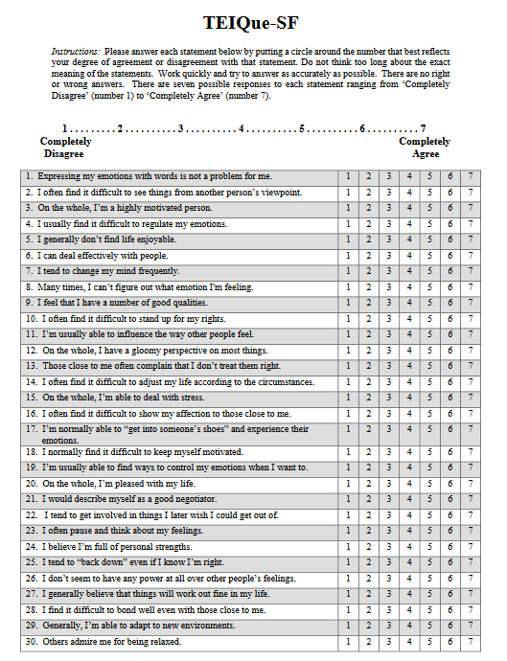
Appendix A

Appendix B

Centre for Psychology and Counselling
SA1 Campus
Swansea

Study Consent Form
I understand that this research study is being carried out by a group of 2nd year Psychology Students for the purpose of a module assessment, and that taking part in this study will involve completing a questionnaire assessing emotional intelligence and taking part in a computer-based task where I will view a variety of different words.
I understand that this study will take approximately 20 minutes to complete.
I understand that participation in this study is voluntary, and I am free to withdraw participation at any time during or before the end of the study without giving a reason.
I understand that once I complete the study my data will remain confidential and will not be traced back to me as a code will be assigned in place of my name and unique EMS identification number. The data collected will be stored indefinitely in accordance with the Data Protection Act.
I am aware that if I have concerns about the study, I can contact the researchers at any time during or after the study on:

Sabha Mahmood – 2006732@student.uwtsd.ac.uk
Lowri John – 2007011@student.uwtsd.ac.uk
Toni Hayward – 2009846@student.uwtsd.ac.uk
Eliesha Day - 21143516@student.uwtsd.ac.uk
Nia James - 1905403@student.uwtsd.ac.uk
Carly Evans - 1301958@student.uwtsd.ac.uk
or the module lead Stacey Coleman on (stacey.coleman@uwtsd.ac.uk), should I have any concerns.

I also understand that at the end of the study I will be provided with a debrief form.
Please tick the boxes below to confirm:

I am aged 18 years of age or over

I understand I can withdraw at any time without penalty

I understand my data will be held confidentially with a code assigned in place of my name

I understand all the above information on this consent form

I consent to taking part in this study

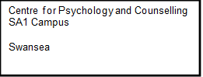
Appendix C

Study Information Sheet

This document provides key information regarding the study and provides details about what will be expected of you as a participant. Therefore, please read this information carefully before providing consent to take part.
The purpose of this study is to explore the effect of emotional intelligence on the recall of different types of stimuli. The aim of the study is to determine whether individuals who score highly on a measure of emotional intelligence will be better able to recall certain types of words.
During this study you will be required to do the following:
- Fill out an online demographic questionnaire asking you for basic demographic information
- Completing a measure of emotional intelligence
- Taking part in a task that assesses memory recall
At the end of the study you will be provided with the study debrief.
If you have any questions or concerns about this study, please contact the research supervisor Stacey Coleman on stacey.coleman@uwtsd.ac.uk.
If you are happy to take part in this study, please click the button below to direct you to the consent form for the study.
If you feel you want to leave the study, you can do so at any time by closing the browser on your computer or notifying the researcher. Once the study has ended you will be asked if you want your data to be saved as part of the study. If you agree then your data will be anonymised and therefore untraceable to later delete. If you do not wish for your data to be used, please ensure you inform the researcher.

Appendix D
Centre for Psychology and Counselling
SA1 Campus
Swansea

Study Debrief Sheet
The effect of emotional intelligence on memory recall for emotion-induced words

Thank you for taking part in this study.

The aim of this study was to determine whether levels of emotional intelligence influenced recall of emotion-induced stimuli. We specifically wanted to explore whether individuals with higher levels of emotional intelligence were better able to recall negative words. Previous research, such as that conducted by D'Mello et al (2014) has suggested that level of emotional intelligence can have an impact on the recall of emotion-induced stimuli, and words were chosen in this study to induce positive and negative emotions in participants, as well as neutral words used as a control condition.

If you wish to withdraw your data from the study you must tell the researcher now. After this point, all of your data will remain confidential, and we will not trace it back to you.

If taking part in this study has raised any questions, please speak to the researchers or contact the academic supervisor Stacey Coleman: stacey.coleman@uwtsd.ac.uk

Thank you once again for taking time to participate in this study.

Level Five Students

Sabha Mahmood – 2006732@student.uwtsd.ac.uk
Lowri John – 2007011@student.uwtsd.ac.uk
Toni Hayward – 2009846@student.uwtsd.ac.uk
Eliesha Day - 21143516@student.uwtsd.ac.uk
Nia James - 1905403@student.uwtsd.ac.uk
Carly Evans - 1301958@student.uwtsd.ac.uk

BSc Psychology
BSc Psychology and Counselling

University of Wales Trinity Saint David, Swansea

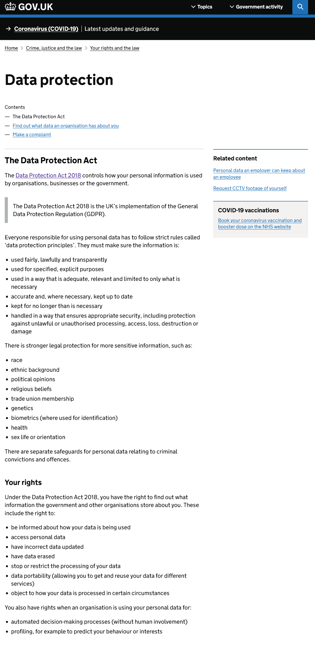
Appendix E

Appendix F
APPLICATION FOR ETHICAL APPROVAL

In order for research to result in benefit and minimise risk of harm, it must be conducted ethically. A researcher may not be covered by the University’s insurance if ethical approval has not been obtained prior to commencement.

The University follows the OECD Frascati manual definition of research activity: “creative work undertaken on a systematic basis in order to increase the stock of knowledge, including knowledge of man, culture and society, and the use of this stock of knowledge to devise new applications”. As such this covers activities undertaken by members of staff, postgraduate research students, and both taught postgraduate and undergraduate students working on dissertations/projects.

The individual undertaking the research activity is known as the “principal researcher”.

Ethical approval is not required for routine audits, performance reviews, quality assurance studies, testing within normal educational requirements, and literary or artistic criticism.

Please read the notes for guidance before completing ALL sections of the form.

This form must be completed and approved prior to undertaking any research activity. Please see Checklist for details of process for different categories of application.

SECTION A: About You (Principal Researcher)
1 | Full Name: |  | Eliesha Day  Nia Wyn James  Toni Hayward  Sabha Mahmood  Lowri John  Carly Evans
2 | Tick all boxes that apply: |  | Member of staff: | ☐ | Honorary research fellow: | ☐
 | Undergraduate Student | ☒ | Taught Postgraduate Student | ☐ | Postgraduate Research Student | ☐

3 | Institute/Academic Discipline/Centre: | Yr Athrofa: Centre for Psychology and Counselling
4 | Campus: | IQ, SA1, Swansea
5 | E-mail address: | 2114351@student.uwtsd.ac.uk  2009846@student.uwtsd.ac.uk  1905403@student.uwtsd.ac.uk  2006732@student.uwtsd.ac.uk  1301958@student.uwtsd.ac.uk  2007011@student.uwtsd.ac.uk
6 | Contact Telephone Number: | N/A
 | For students:
7 | Student Number: | 2114351  2009846  1905403  2006732  1301958  2007011
8 | Programme of Study: | BSc Psychology and Counselling
9 | Director of Studies/Supervisor: | Stacey Coleman

SECTION B: Approval for Research Activity
1 | Has the research activity received approval in principle?  (please check the Guidance Notes as to the appropriate approval process for different levels of research by different categories of individual) |  | YES | ☒ | NO | ☐
 |  |  |  |  | Date
2 | If Yes, please indicate source of approval (and date where known): Approval in principle must be obtained from the relevant source prior to seeking ethical approval | Research Degrees Committee |  | ☐
2 |  | Institute Research Committee |  | ☐
2 |  | Other (write in) – Stacey Coleman (Module lead) and External Examiner |  | ☒ | 27.09.21

SECTION C: Internal and External Ethical Guidance Materials
 | Please list the core ethical guidance documents that have been referred to during the completion of this form (including any discipline-specific codes of research ethics, location-specific codes of research ethics, and also any specific ethical guidance relating to the proposed methodology). Please tick to confirm that your research proposal adheres to these codes and guidelines. You may add rows to this table if needed.
1 | UWTSD Research Ethics & Integrity Code of Practice | ☒
2 | UWTSD Research Data Management Policy | ☒
3 | UWTSD Student Code of Conduct | ☒
4 | BPS Code of Human Research Ethics (2021) | ☒
5 | BPS Code of Ethics and Conduct (2018) | ☒
6 | BPS Ethics for Internet Mediated Research (2021) | ☒

SECTION D: External Collaborative Research Activity
If there are external collaborators then you should gain consent from the contact persons to share their personal data with the university. If there are no external collaborators then leave this section blank and continue to section E.
1 | Institution
2 | Contact person name
3 | Contact person e-mail address
4 | Is your research externally funded? |  | YES | ☐ | NO |  | ☐
5 | Are you in receipt of a KESS scholarship? |  | YES | ☐ | NO |  | ☐
6 | Are you specifically employed to undertake this research in either a paid or voluntary capacity? | Voluntary | YES | ☐ | NO | ☐
7 |  | Employed | YES | ☐ | NO | ☐
8 | Is the research being undertaken within an existing UWTSD Athrofa Professional Learning Partnership (APLP)? | If YES then the permission question below does not need to be answered. | YES | ☐ | NO |  | ☐
9 | Has permission to undertake the research has been provided by the partner organisation? | (If YES attach copy)  If NO the application cannot continue | YES | ☐ | NO |  | ☐

Where research activity is carried out in collaboration with an external organisation
10 | Does this organisation have its own ethics approval system? | YES | ☐ | NO | ☐
 | If Yes, please attach a copy of any final approval (or interim approval) from the organisation (this may be a copy of an email if appropriate).

SECTION E: Details of Research Activity
1 | Indicative title: | The effect of emotional intelligence on memory for emotion-induced stimuli
2 | Proposed start date: | 23rd November 2021 | Proposed end date: | January 2022
Introduction to the Research (maximum 300 words per section)
Ensure that you write for a Non-Specialist Audience when outlining your response to the points below:
- Purpose of Research Activity
- Proposed Research Question
- Aims of Research Activity
- Objectives of Research Activity
Demonstrate, briefly, how Existing Research has informed the proposed activity and explain
- What the research activity will add to the body of knowledge
- How it addresses an area of importance.
3 | Purpose of Research Activity  The purpose of this research study is to engage with and complete a Level Five module assessment task. This will involve designing and conducting a research study to collect data, then analysing and writing up the findings for a quantitative research report.  (this box should expand as you type)
4 | Research Question  Do levels of emotional intelligence affect recall of emotion-induced stimuli?  (this box should expand as you type)
5 | Aims of Research Activity  The aim of the research activity is to investigate the hypothesis that emotional intelligence affects an individual’s ability to recall emotion-induced words over neutral words.  (this box should expand as you type)
6 | Objectives of Research Activity  The purpose of this study is to further explore whether emotional intelligence has an effect on the recall of emotion-induced words. The connection between emotion and memory has been widely researched, suggesting that memories with an emotional connection have an effect an individual’s ability to recall information in contrast to neutral memories (Dougal & Rotello, 2007).  Reflecting this theory, research found that individuals are more likely to remember negative words over neutral words whilst performing a memory task (Kensinger & Corkin, 2004). However, further research argues that the ability to recall is not based solely on negative words but rather words that evoke emotion, either positive or negative (Khairudin et al., 2012).  It is also argued that emotional intelligence also influences memory and recall when connected to emotion. Indicating that individuals with higher emotional intelligence are able to recall neutral stimuli in comparison to individuals with lower scores of emotional intelligence (Toyota, 2011).  (this box should expand as you type)
Proposed methods (maximum 600 words)
Provide a brief summary of all the methods that may be used in the research activity, making it clear what specific techniques may be used. If methods other than those listed in this section are deemed appropriate later, additional ethical approval for those methods will be needed. You do not need to justify the methods here, but should instead describe how you intend to collect the data necessary for you to complete your project.
7 | All data collection will take place within the Psychology laboratories. Through the use of the Qualtrics survey creation platform, we will gather information using the Trait Emotional Intelligence Questionnaire – Short Form (TEIQue-SF) (Petrides, 2009). This 30-item form includes two items from each of the 15 facets of the TEIQue. Items were selected primarily on the basis of their correlations with the corresponding total facet scores, which ensured broad coverage of the sampling domain of the construct.  Prior to participants completing the emotional intelligence scale, they will be provided with an information sheet (appendix A) and a consent form (appendix B). Following the provision of full consent, participants will be asked to complete a short demographic questionnaire (gender and age) and then the TEI-Que.  Results from the TEIQue-SF will dictate which of two groups participants will be placed in, high or low levels of emotional intelligence. They will then be asked to take part in an experimental task which will be created through Superlab, where they will be shown emotion-induced stimuli. Three individual conditions will include positive words, negative words and neutral words. The stimuli words will be drawn from Affective Norms for English Words (ANEW) (Bradley & Lang, 1999) and each word will be two syllables long. The words can be seen in Appendix D.  Each condition will contain 20 words. Each individual stimulus will be displayed on screen for two seconds then separated by a blank screen for a period of 400m, this will be repeated for all three conditions. At the end of each condition a screen will ask participants to think of something for one minute (e.g., think of your favourite holiday destination). Participants will then be asked to write down as many of the words they can remember from the previous trial. For standardisation purposes, all participants, in both the high and low emotional intelligence groups, will be asked to participate in all three conditions. For counterbalancing purposes participants will be shown the three conditions in a different sequence.  Using Qualtrics and Superlab allows for standardisation within the study as each participant will be given the exact same information consistently, irrespective of the member of the group that will be collecting data.  Reliability will be ensured for the participant, as part of researcher's responsibility we will practice and adhere to the duty of care and follow the BPS guidelines. As well as ensuring the reputation of the university is not impacted on.  (this box should expand as you type)
Location of research activity
Identify all locations where research activity will take place.
8 | Psychology laboratories, SA1 Waterfront Campus, Swansea  (this box should expand as you type)
Research activity outside of the UK
If research activity will take place overseas, you are responsible for ensuring that local ethical considerations are complied with and that the relevant permissions are sought. Specify any local guidelines (e.g. from local professional associations/learned societies/universities) that exist and whether these involve any ethical stipulations beyond those usual in the UK (provide details of any licenses or permissions required). Also specify whether there are any specific ethical issues raised by the local context in which the research activity is taking place, for example, particular cultural and/or legal sensitivities or vulnerabilities of participants. If you live in the country where you will do the research then please state this.
9 | N/A  (this box should expand as you type)

10 | Use of documentation not in the public domain: Are any documents NOT publicly available? | NO | ☒
10 |  | YES | ☐
11 | If Yes, please provide details here of how you will gain access to specific documentation that is not in the public domain and that this is in accordance with the current data protection law of the country in question and that of England and Wales.  (this box should expand as you type)

 | Does your research relate to one or more of the seven aims of the Well-being of Future Generations (Wales) Act 2015? | YES | NO
12 | A prosperous Wales | ☐ | ☒
13 | A resilient Wales | ☐ | ☒
14 | A healthier Wales | ☐ | ☒
15 | A more equal Wales | ☐ | ☒
16 | A Wales of cohesive communities | ☐ | ☒
17 | A Wales of vibrant culture and thriving Welsh language | ☐ | ☒
18 | A globally responsible Wales | ☐ | ☒
19 | If YES to any of the above, please give details:
 | (this box should expand as you type)

SECTION F: Scope of Research Activity
 | Will the research activity include: | YES | NO
1 | Use of a questionnaire or similar research instrument? | ☒ | ☐
2 | Use of interviews? | ☐ | ☒
3 | Use of focus groups? | ☐ | ☒
4 | Use of participant diaries? | ☐ | ☒
5 | Use of video or audio recording? | ☐ | ☒
6 | Use of computer-generated log files? | ☐ | ☒
7 | Participant observation with their knowledge? | ☐ | ☒
8 | Participant observation without their knowledge? | ☐ | ☒
9 | Access to personal or confidential information without the participants’ specific consent? | ☐ | ☒
10 | Administration of any questions, test stimuli, presentation that may be experienced as physically, mentally or emotionally harmful / offensive? | ☐ | ☒
11 | Performance of any acts which may cause embarrassment or affect self-esteem? | ☐ | ☒
12 | Investigation of participants involved in illegal activities? | ☐ | ☒
13 | Use of procedures that involve deception? | ☐ | ☒
14 | Administration of any substance, agent or placebo? | ☐ | ☒
15 | Working with live vertebrate animals? | ☐ | ☒
16 | Procedures that may have a negative impact on the environment? | ☐ | ☒
17 | Other primary data collection methods. Please indicate the type of data collection method(s) below. | ☒ | ☐
 | Details of any other primary data collection method:  A task exploring the recall of emotion-induced stimuli through an experimental task created using Qualtrics. Qualtrics being the programme used to collate the data submitted by participants.  (this box should expand as you type) | ☒ | ☐
If NO to every question, then the research activity is (ethically) low risk and may be exempt from some of the following sections (please refer to Guidance Notes).

If YES to any question, then no research activity should be undertaken until full ethical approval has been obtained.

SECTION G: Intended Participants
If there are no participants then do not complete this section, but go directly to section H.

 | Who are the intended participants: | YES | NO
1 | Students or staff at the University? | ☒ | ☐
2 | Adults (over the age of 18 and competent to give consent)? | ☒ | ☐
3 | Vulnerable adults? | ☐ | ☒
4 | Children and Young People under the age of 18? (Consent from Parent, Carer or Guardian will be required) | ☐ | ☒
5 | Prisoners? | ☐ | ☒
6 | Young offenders? | ☐ | ☒
7 | Those who could be considered to have a particularly dependent relationship with the investigator or a gatekeeper? | ☐ | ☒
8 | People engaged in illegal activities? | ☐ | ☒
9 | Others. Please indicate the participants below, and specifically any group who may be unable to give consent. | ☐ | ☒
 | Details of any other participant groups:  (this box should expand as you type) | ☐ | ☒

Participant numbers and source
Provide an estimate of the expected number of participants. How will you identify participants and how will they be recruited?
10 | How many participants are expected? | A minimum of 30 participants are expected  (this box should expand as you type)
11 | Who will the participants be? | Participants will be students currently enrolled on a Psychology related degree programme within the Centre for Psychology and Counselling at the University of Wales Trinity Saint David  (this box should expand as you type)
12 | How will you identify the participants? | The study will be advertised through the Psychology department’s Experiment Management System (EMS). Eligible students can then voluntarily sign-up to take part in the study if they wish. The researcher will then use the participant’s Unique EMS Identity Code to identify participants.  (this box should expand as you type)

 | Information for participants: | YES | NO | N/A
13 | Will you describe the main research procedures to participants in advance, so that they are informed about what to expect? | ☒ | ☐ | ☐
14 | Will you tell participants that their participation is voluntary? | ☒ | ☐ | ☐
15 | Will you obtain written consent for participation? | ☐ | ☒ | ☐
16 | Will you explain to participants that refusal to participate in the research will not affect their treatment or education (if relevant)? | ☒ | ☐ | ☐
17 | If the research is observational, will you ask participants for their consent to being observed? | ☐ | ☐ | ☒
18 | Will you tell participants that they may withdraw from the research at any time and for any reason? | ☒ | ☐ | ☐
19 | With questionnaires, will you give participants the option of omitting questions they do not want to answer? | ☒☐ | ☐ | ☐
20 | Will you tell participants that their data will be treated with full confidentiality and that, if published, it will not be identifiable as theirs? | ☒ | ☐ | ☐
21 | Will you debrief participants at the end of their participation, in a way appropriate to the type of research undertaken? | ☒ | ☐ | ☐
22 | If NO to any of above questions, please give an explanation
Consent will be provided by participants through the selection of a series of consent options on Qualtrics.

(this box should expand as you type)

 | Information for participants: | YES | NO | N/A
24 | Will participants be paid? | ☐ | ☒ | ☐
25 | Is specialist electrical or other equipment to be used with participants? | ☐ | ☒ | ☐
26 | Are there any financial or other interests to the investigator or University arising from this study? | ☐ | ☒ | ☐
27 | Will the research activity involve deliberately misleading participants in any way, or the partial or full concealment of the specific study aims? | ☐ | ☒ | ☐
28 | If YES to any question, please provide full details
 | (this box should expand as you type)

SECTION H: Anticipated Risks

Outline any anticipated risks that may adversely affect any of the participants, the researchers and/or the University, and the steps that will be taken to address them.

If you have completed a full risk assessment (for example as required by a laboratory, or external research collaborator) you may append that to this form.
1 | Full risk assessment completed and appended? |  | Yes | ☐
1 |  |  | No | ☒
2 | Risks to participants  For example: sector-specific health & safety, emotional distress, financial disclosure, physical harm, transfer of personal data, sensitive organisational information
 | Risk to participants:  - The words that are used during the study may trigger an emotional response from the participant.  - The researcher will ensure the questions that are used during the study, are not of a sensitive nature.  - The Emotional Intelligence Scale queries participants on their own self- reported intelligence. This could potentially make the participant apprehensive about taking part, as they may think the data could get traced back to them.  - The study will take place in the psychology laboratories, which can only hold a small amount of people. Due to COVID-19, this may cause some concern for some participants who may worry about social distancing guidance.  (this box should expand as you type) | How you will mitigate the risk to participants:  Being specific on word choice by using empirically researched wording. Ensuring that the participant understands they can withdraw at any point of the study and their data can be redacted at any point. The debrief form provided will have the researchers and supervisor's details for further clarification and would provide after care if needed.  The questions will have no bias, remain relevant to the study and be asked in a sensitive nature.  Reiterating to the participant that the data collected will remain confidential and will be saved via the Qualtrics system until the end of data collection. Only anonymised and unidentifiable information will be downloaded from Qualtrics for the purpose of analysis and therefore would be unable to be traced back to them.  Ensuring that the only person in the lab at any time during data collection is the participant. ere are only two people at a time in the lab Time will also be allocated in between timeslots with timeslots in between to disinfect all surfaces and equipment; this will help can alleviate some stress as well as follow covid regulations.  (this box should expand as you type)
3 | If research activity may include sensitive, embarrassing or upsetting topics (e.g. sexual activity, drug use) or issues likely to disclose information requiring further action (e.g. criminal activity), give details of the procedures to deal with these issues, including any support/advice (e.g. helpline numbers) to be offered to participants. Note that where applicable, consent procedures should make it clear that if something potentially or actually illegal is discovered in the course of a project, it may need to be disclosed to the proper authorities
N/A

(this box should expand as you type)
4 | Risks to the investigator  For example: personal health & safety, physical harm, emotional distress, risk of accusation of harm/impropriety, conflict of interest
 | Risk to the investigator:  - Researcher emails will be provided to participants. Therefore, a potential risk could be the researcher receiving negative or unwelcomed emails from a participant.  - The student researchers may find themselves being asked for information outside of their scope of knowledge as an undergraduate student.  - There is potential for the student researcher to be accused of harm/impropriety if the participant feels they are not happy about something that has taken place during the research.  (this box should expand as you type) | How you will mitigate the risk to the investigator:  - Only university student email address will be provided, and not personal ones. If the researcher does receive any unwelcomed emails from a participant, this will be reported to the research supervisor (module lead) immediately.  - Any queries sent to the researchers that they are unable to deal with will be passed on to the research supervisor (module lead).  - It will be ensured that the student researcher follows all UWTSD and BPS researcher codes of conduct and research guidelines, and the study will not take place until all elements have been approved by the supervisor (module lead).  (this box should expand as you type)
5 | University/institutional risks  For example: adverse publicity, financial loss, data protection
 | Risk to the University:  - The reputation and integrity of UWTSD and the discipline of Psychology could be endangered if researchers do not adhere to codes of ethics and research protocols.  - Data could be exposed, leaked or used for other purposes.  (this box should expand as you type) | How you will mitigate the risk to the University:  - The University Ethics and Integrity Code of Practice and the BPS Code of Ethics and Conduct will be followed at every stage of the proposed study to minimise any potential risks to the Institution from arising. Professionalism will always be exhibited by all researchers.  - The data collected will be stored in accordance with UWTSD Research Data Management (RDM) rules and only used for the intended purpose, in compliance with ethical guidelines set out by UWTSD Research Ethics & Integrity Code of Practice policy and British Psychological Society (BPS) code of ethics. To minimise any risk to UWTSD and the psychology department, all collected data will be stored securely and initially saved on the Psychology laboratories’ computers. Electronic data transfer will only occur on anonymised data.  (this box should expand as you type)
6 | Environmental risks  For example: accidental spillage of pollutants, damage to local ecosystems
 | Risk to the environment:  - Covid implications of being in an enclosed lab  - Cleaning of physical equipment  (this box should expand as you type) | How you will mitigate the risk to environment:  The lab will only allow one person to be present at any time (which will be the participant whilst data is being collected) participant and one researcher at any given time to complete the experiment. Both the researcher and participant will sanitise hands before entering and leaving the lab.  Time slots will be allocated and followed with a break of ten minutes. This is to ensure enough time is given to clean all equipment, door handles and the rest of the lab following covid regulations. All cleaning products will be used following the correct guidelines and kept away from any electrical equipment.  (this box should expand as you type)

 | Disclosure and Barring Service
 | If the research activity involves children or vulnerable adults, a Disclosure and Barring Service (DBS) certificate must be obtained before any contact with such participants. | YES | NO | N/A
7 | Does your research require you to hold a current DBS Certificate? | ☐ | ☐ | ☒
8 | If YES, please give the certificate number. If the certificate number is not available please write “Pending”; in this case any ethical approval will be subject to providing the appropriate certificate number.

SECTION I: Feedback, Consent and Confidentiality

1 | Feedback  What de-briefing and feedback will be provided to participants, how will this be done and when?
At the end of the study all participants will be provided with debriefing information via Superlab that will thank the participant for their participation, it will remind them of their right to withdraw their data and will provide them with the contact details of the researcher. Participants will be informed that they are able to request a copy of the debrief form by contacting the research supervisor (Stacey Coleman) via email.

(this box should expand as you type)
2 | Informed consent  Describe the arrangements to inform potential participants, before providing consent, of what is involved in participating. Describe the arrangements for participants to provide full consent before data collection begins. If gaining consent in this way is inappropriate, explain how consent will be obtained and recorded in accordance with prevailing data protection legislation.
Providing the participant with an information sheet can help them to decide whether they want to take part in the study, an introduction to the study with general aims, concisely give an explanation to how the study is relevant. An explanation of what the participant is required to do and how long the study will take will be provided on Qualtrics before consent information is presented. It must be stated that participation is voluntary and explained that the participants have the right to withdraw during or after the study. A cConsent informationform will be provided via Qualtrics and requires participants to indicate that they have been fully informed about the study, with the information consent form clearly indicating the aims of the study, the participants rights to ask questions, the understanding that participation is voluntary and the right to withdraw at any time. Consent will also show they have an understanding of the confidentiality and anonymity of their participation. It will also state how data will be stored. Participants will be required to select all options to confirm informed consent before they can proceed with the study (see Appendix)

(this box should expand as you type)
3 | Confidentiality / Anonymity  Set out how anonymity of participants and confidentiality will be ensured in any outputs. If anonymity is not being offered, explain why this is the case.
All participants information and involvement in the research will be confidential and used only for this specific research study. All information and data collected will be anonymised and stored in a password secure file on researchers’ personal devices.

(this box should expand as you type)

SECTION J: Data Protection and Storage

 | Does the research activity involve personal data (as defined by the General Data Protection Regulation 2016 “GDPR” and the Data Protection Act 2018 “DPA”)? | YES | NO
1 | “Personal data” means any information relating to an identified or identifiable natural person (‘data subject’). An identifiable natural person is one who can be identified, directly or indirectly, in particular by reference to an identifier such as a name, an identification number, location data, an online identifier or to one or more factors specific to the physical, physiological, genetic, mental, economic, cultural or social identity of that natural person. Any video or audio recordings of participants is considered to be personal data. | x | ☐
 | If YES, provide a description of the data and explain why this data needs to be collected:
2 | Data on participant age and gender will be collected as this forms a standard reporting measure in psychology reports within the participant subsection of the method. According to the UWTSD Research Data Management Policy, this constitutes personal data. However, this data will not be attached to any identifying data about the participant. In addition, this data is collected only for the purpose of providing descriptive data and upon completion of data collection, a mean age score will be calculated and aggregate data on gender will be used.  (this box should expand as you type)
 | Does it involve special category data (as defined by the GDPR)? | YES | NO
3 | “Special category data” means sensitive personal data consisting of information as to the data subjects’ –  (a) racial or ethnic origin,  (b) political opinions,  (c ) religious beliefs or other beliefs of a similar nature,  (d) membership of a trade union (within the meaning of the Trade Union and Labour Relations (Consolidation) Act 1992),  (e) physical or mental health or condition,  (f) sexual life,  (g) genetics,  (h) biometric data (as used for ID purposes), | ☐ | x
 | If YES, provide a description of the special category data and explain why this data needs to be collected:
4 | N/A  (this box should expand as you type)

 | Will data from the research activity (collected data, drafts of the thesis, or materials for publication) be stored in any of the following ways? |  | YES | NO
5 | Manual files (i.e. in paper form)? | ☐ | ☒
6 | University computers? | ☐ | ☒
7 | Private company computers? | ☐ | ☒
8 | Home or other personal computers? | ☒ | ☐
9 | Laptop computers/ CDs/ Portable disk-drives/ memory sticks? | ☐ | ☒
10 | “Cloud” storage or websites? | ☒ | ☐
11 | Other – specify: | ☐ | ☒
12 | For all stored data, explain the measures in place to ensure the security of the data collected, data confidentiality, including details of backup procedures, password protection, encryption, anonymisation and pseudonymisation:
Personal computers of researchers are password protected. Correspondence between researchers will remain confidential within group and will be conducted via Microsoft Teams which is only accessible to the individual researchers via a personal password. Collected data will be password protected and stored securely on each lead researcher’s computer which areis protected by a personal pin/password. At the point where data is required to be collated ready for analysis, data will be electronically transferred to one SPSS datasheet and saved by each researcher in order to conduct the analysis. Data in this anonymised form will also be saved within a password protected folder on the researchers’ laptops.

Transfer of data from Qualtrics to SPSS spreadsheets will only be carried out with anonymised data and transferred between researchers via Microsoft Teams cloud sharing. At the end of the project all electronic data will be stored by the UWTSD Psychlabs team and then destroyed once the module assessment has been reviewed by the end of year examination board.

(this box should expand as you type)

 | Data Protection
 | Will the research activity involve any of the following activities: | YES | NO
13 | Electronic transfer of data in any form? | ☒ | ☐
14 | Sharing of data with others at the University outside of the immediate research team? | ☐ | ☒
15 | Sharing of data with other organisations? | ☐ | ☒
16 | Export of data outside the UK or importing of data from outside the UK? | ☐ | ☒
17 | Use of personal addresses, postcodes, faxes, emails or telephone numbers? | ☐ | ☒
18 | Publication of data that might allow identification of individuals? | ☐ | ☒
19 | Use of data management system? | ☐ | ☒
20 | Data archiving? | ☐ | ☒
21 | If YES to any question, please provide full details, explaining how this will be conducted in accordance with the GDPR and Data Protection Act (2018) (and any international equivalents, where appropriate):
In accordance with the GDPR, Transfer of data from Qualtrics to SPSS spreadsheets will only be carried out with anonymised data and transferred between researchers via Microsoft Teams cloud sharing. At the end of the project all electronic data will be stored by the UWTSD Psychlabs team and then destroyed once the module assessment has been reviewed by the end of year examination board.

(this box should expand as you type)
22 | List all who will have access to the data generated by the research activity:
Stacey Coleman

Eliesha Day
Toni Hayward
Sabha Mahmood
Lowri John
Nia James
Carly Evans

(this box should expand as you type)
23 | List who will have control of, and act as custodian(s) for, data generated by the research activity:
Stacey Coleman

(this box should expand as you type)
24 | Give details of data storage arrangements, including security measures in place to protect the data, where data will be stored, how long for, and in what form. Will data be archived – if so how and if not why not.
All electronic data will be anonymised before proceeding with any further study of the information to ensure confidentiality. This information will be stored on a Teams cloud sharing facility exclusive to the researchers. For ease of access this information will also be stored on the research lead’s personal laptop, which is password protected. The information will be stored within an encrypted file on this laptop.
Once the assessment has been reviewed by the appropriate examination board, the data will be destroyed (in all but exceptional circumstances this will then mean within 10 months of data collection).

(this box should expand as you type)
25 | Please indicate if your data will be stored in the UWTSD Research Data Repository (see https://researchdata.uwtsd.ac.uk/ ). If so please explain. (Most relevant to academic staff)
As this is a module experiment that is not expected to produce research-standard data, it does not require archiving for public use nor does it require to be maintained for a period required for data in the public domain. Therefore, after review of the materials by the External Examiners regarding the research reports produced by each student, and after the experiment assessment has been reviewed by the appropriate examination board, the data will be destroyed (in all but exceptional circumstances this will then mean within 10 months of data collection).

(this box should expand as you type)
26 | Confirm that you have read the UWTSD guidance on data management (see https://www.uwtsd.ac.uk/library/research-data-management/) | YES | ☒
27 | Confirm that you are aware that you need to keep all data until after your research has completed or the end of your funding | YES | ☒

SECTION K: Declaration
The information which I have provided is correct and complete to the best of my knowledge. I have attempted to identify any risks and issues related to the research activity and acknowledge my obligations and the rights of the participants.

In submitting this application I hereby confirm that I undertake to ensure that the above named research activity will meet the University’s Research Ethics and Integrity Code of Practice which is published on the website: https://www.uwtsd.ac.uk/research/research-ethics/
1 | Signature of applicant: | Eliesha Day  Nia Wyn James  Toni Hayward  Sabha Mahmood  Lowri John  Carly Evans | Date:  31/10/21

For STUDENT Submissions:
2 | Director of Studies/Supervisor: | Stacey Coleman | Date:  15.11.21
3 | Signature: |  | Date:  15.11.21

For STAFF Submissions:
4 | Academic Director/ Assistant Dean: |  | Date:
5 | Signature: |  | Date:

Checklist: Please complete the checklist below to ensure that you have completed the form according to the guidelines and attached any required documentation:
☒ | I have read the guidance notes supplied before completing the form.
☒ | I have completed ALL RELEVANT sections of the form in full.
☒ | I confirm that the research activity has received approval in principle
☐ | I have attached a copy of final/interim approval from external organisation (where appropriate)
☐ | I have attached a full risk assessment (where appropriate) ONLY TICK IF YOU HAVE ATTACHED A FULL RISK ASSESSMENT
☒ | I understand that it is my responsibility to ensure that the above named research activity will meet the University’s Research Ethics and Integrity Code of Practice.
☒ | I understand that before commencing data collection all documents aimed at respondents (including information sheets, consent forms, questionnaires, interview schedules etc.) must be confirmed by the DoS/Supervisor, module tutor or Academic Director.

RESEARCH STUDENTS AND STAFF ONLY
All communications relating to this application during its processing must be in writing and emailed to pgresearch@uwtsd.ac.uk , with the title ‘Ethical Approval’ followed by your name.
You will be informed of the outcome of your claim by email; therefore it is important that you check your University and personal email accounts regularly.
STUDENTS ON UNDERGRADUATE OR TAUGHT MASTERS PROGRAMMES should submit this form (and receive the outcome) via systems explained to you by the supervisor/module leader.

This form is available electronically from the Academic Office web pages: https://www.uwtsd.ac.uk/academic-office/appendices-and-forms/

Appendix G
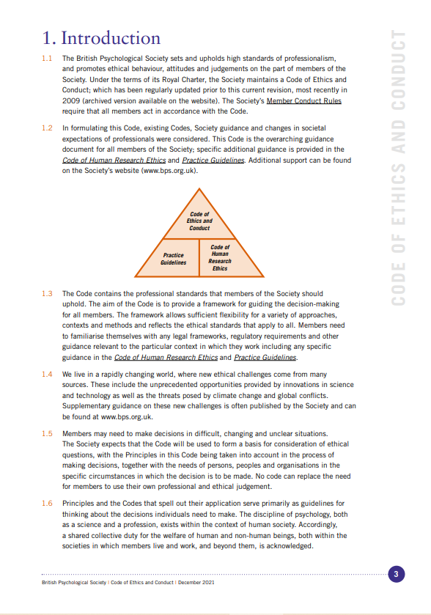

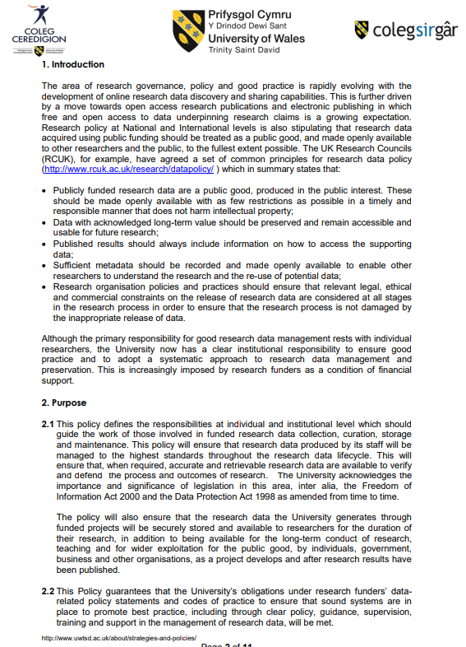
Appendix H

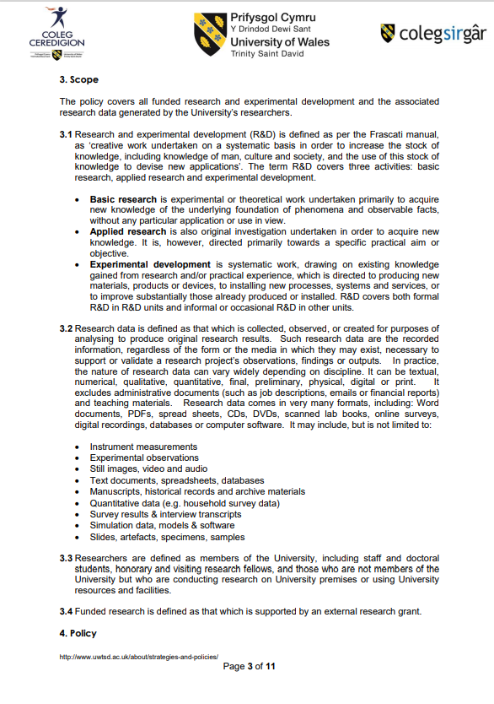

Appendix I
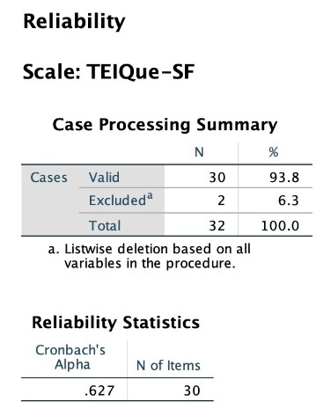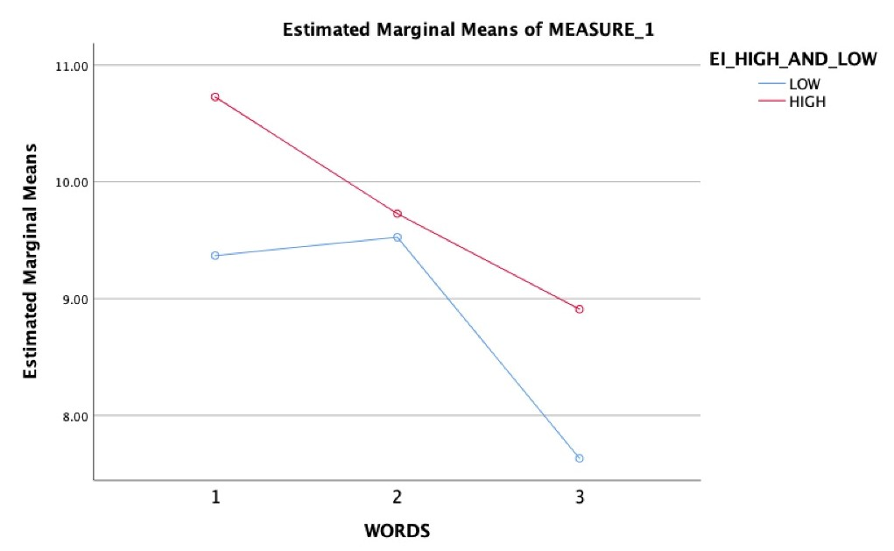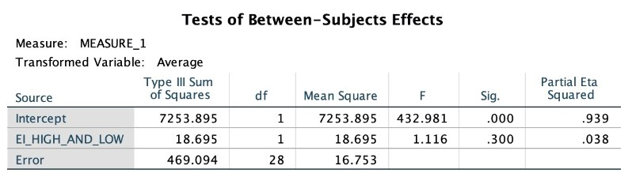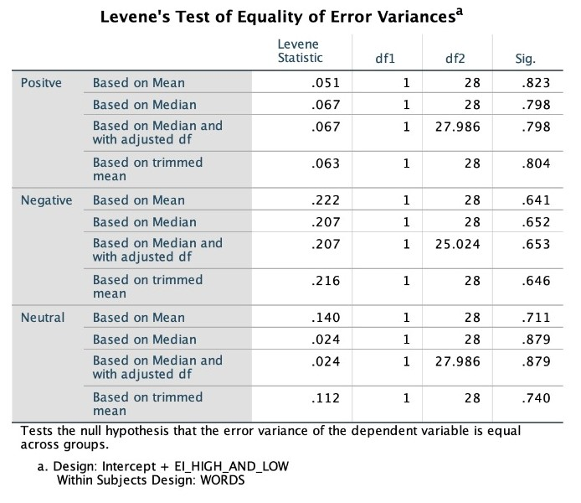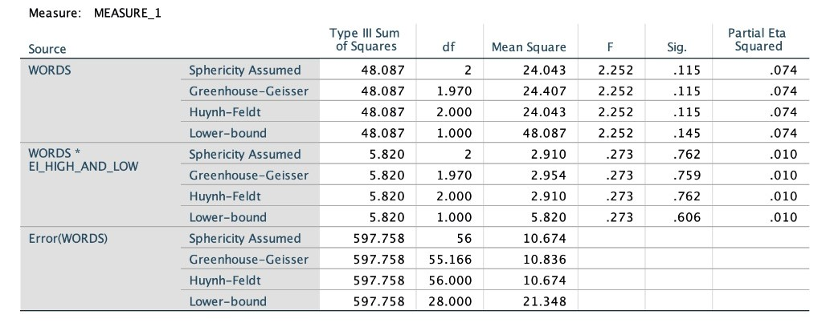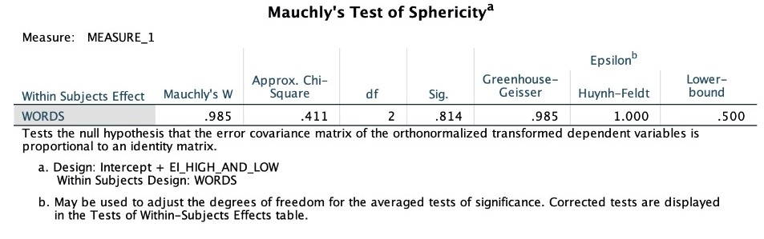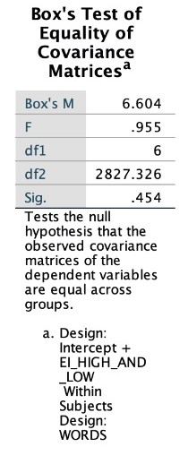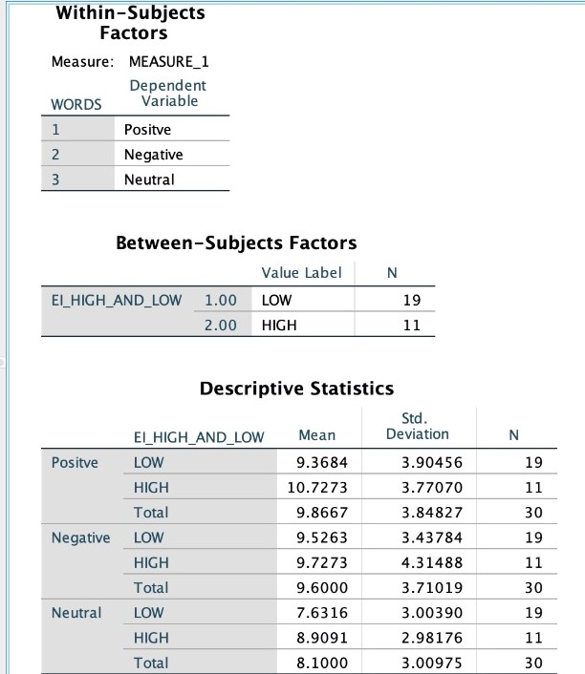

Appendix J
List of Words Used in Experimental Recall Task

Words have been taken from the Affective Norms for English Words (ANEW; Bradley & Lang, 1999) and all have a similar valence score per trial. For example, each of the positive words chosen have a valence mean of between 7 and 9, the negative words chosen have a valence score between 1 and 3, and the neutral words have a valence score between 4.5 and 5.5.

The numbers contained at the end of each word are the valence scores associated with each word.

ANEW – Words to be used in experimental task
Positive |  | Neutral |  | Negative
Beauty | 7.82 | Ankle | 5.27 | Afraid | 2.00
Desire | 7.69 | Locker | 5.19 | Blister | 2.88
Friendly | 8.43 | Kettle | 5.22 | Crisis | 2.74
Handsome | 7.93 | Paper | 5.20 | Demon | 2.11
Rainbow | 8.14 | Doctor | 5.20 | Hostile | 2.73
Secure | 7.57 | Errand | 4.58 | Lonely | 2.17
Lucky | 8.17 | Banner | 5.40 | Mistake | 2.86
Wealthy | 7.70 | Headlight | 5.24 | Riot | 2.96
Success | 8.29 | Iron | 4.90 | Upset | 2.00
Joyful | 8.22 | Journal | 5.14 | Wicked | 2.96
Lively | 7.20 | Statue | 5.17 | Trouble | 2.17
Diamond | 7.92 | Office | 5.24 | Vandal | 2.71
Grateful | 7.37 | Taxi | 5.00 | Sinful | 2.93
Honest | 7.70 | Machine | 5.09 | Guilty | 2.63
Cuddle | 7.72 | Nonsense | 4.61 | Enraged | 2.46
Sunrise | 7.86 | Patent | 5.29 | Destroy | 2.64
Pleasure | 8.28 | Reserved | 4.88 | Blackmail | 2.95
Nature | 7.65 | Wagon | 5.37 | Coward | 2.74
Laughter | 8.45 | Curtains | 4.83 | Stupid | 2.31
Kindness | 7.82 | Basket | 5.45 | Toothache | 1.98

