DS 1 Template

My Screenshots/Photos
- Please add 4–6 screenshots or photos of your digital life.
- You can use your phone or laptop.
- For each screenshot, write one or two sentences explaining what it shows.

Screenshot/Photo 1
YouTube
I use you tube to watch videos, learn new things, listen to music and find useful information.

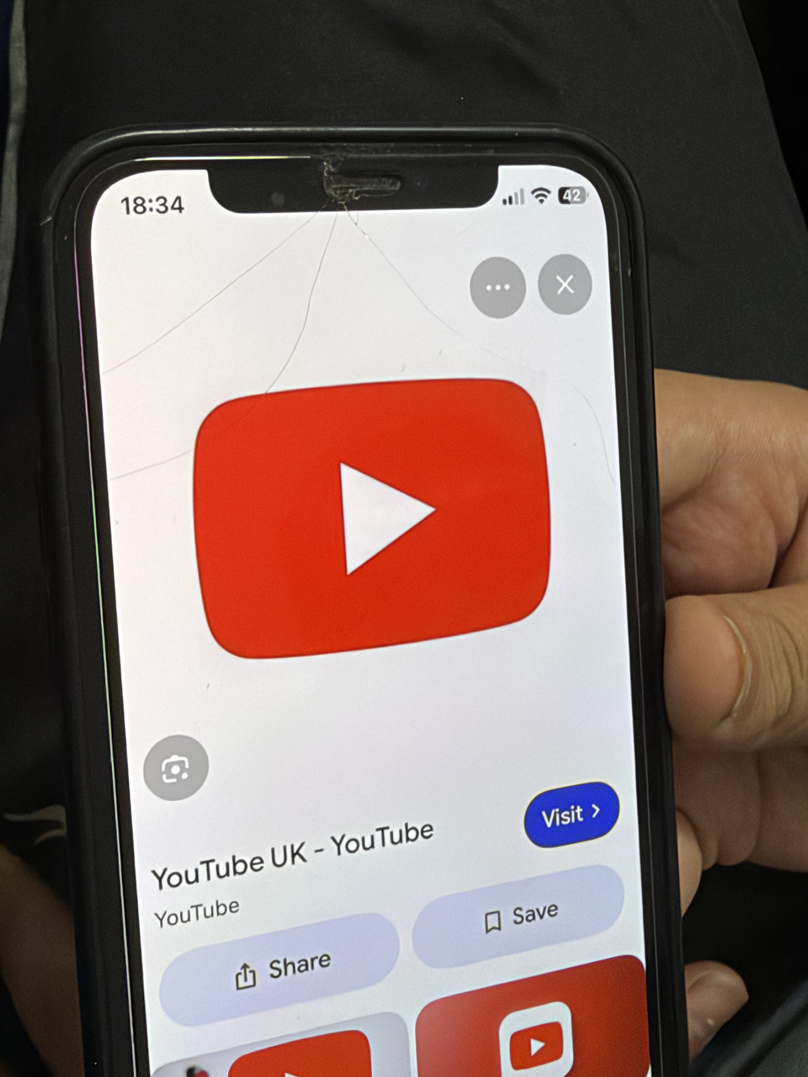

Screenshot/Photo 2
Iphone 17
The smartphone is a piece of techlogy that helps me in my daily digital life as its camera can easily take photographs of important things like documents passwords.
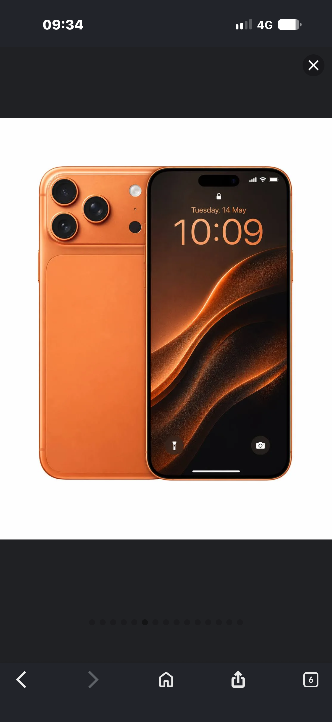
[Write what this shows of your digital life]

Screenshot/Photo 3
Laptop
This is important tocology because its use are quite important compared to other devices like a iPhone because it has more features than phone.
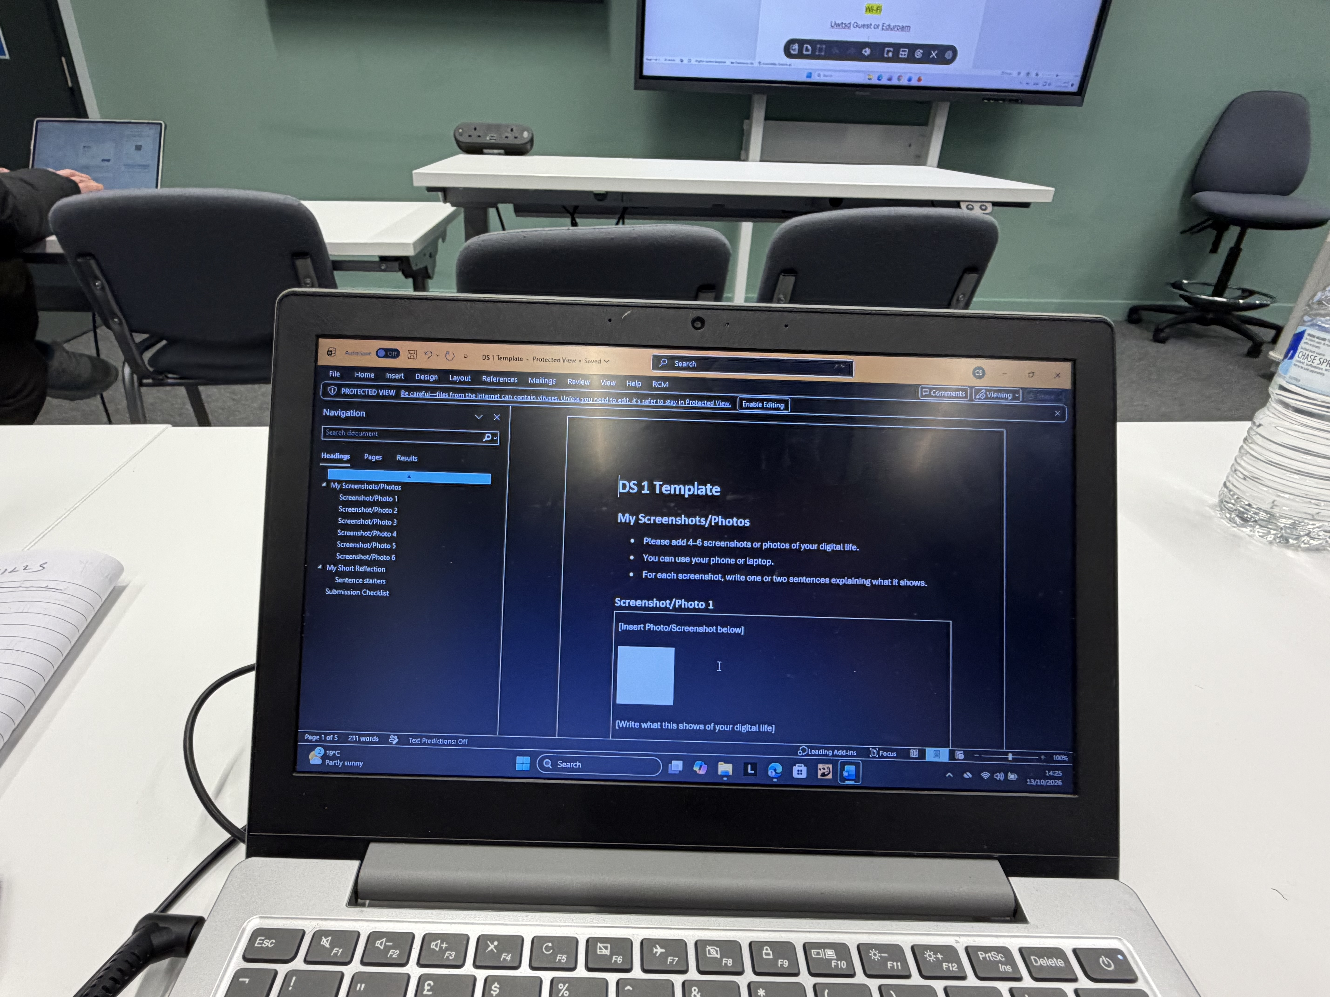
[Write what this shows of your digital life]

Screenshot/Photo 4
Tv
This a large device able to stream live sports events like the world cup and the NBA or you can watch movies. This also has ports HDMI and other cables just as important and is able to play games pair with console and lots of different things it can do.
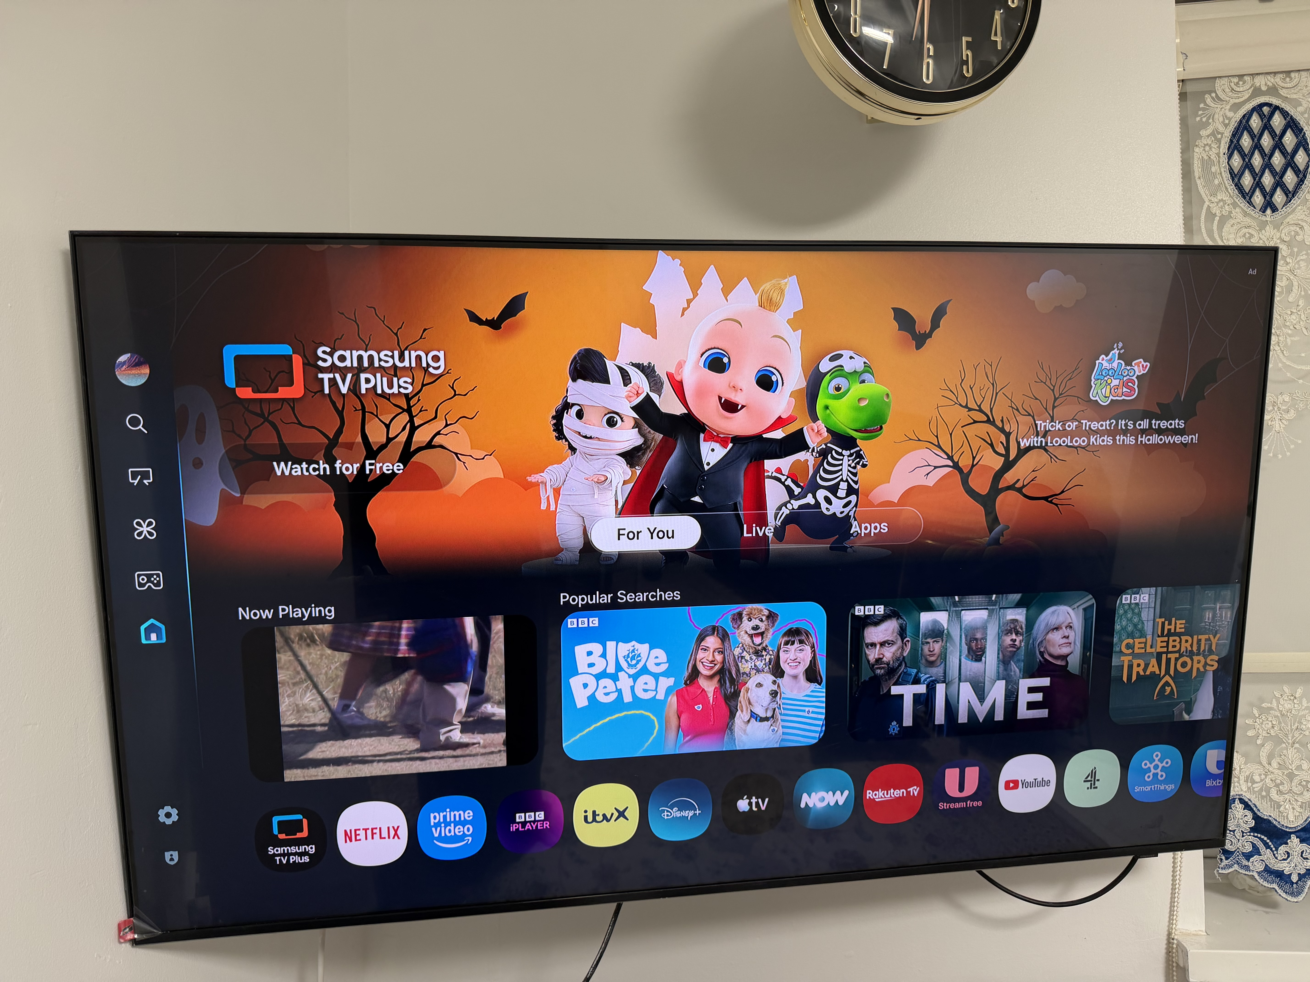

Screenshot/Photo 5
Gmail
It is an app that allows important emails to be sent from apps on important thins they want you to see or an important email from the council on something you have to do.
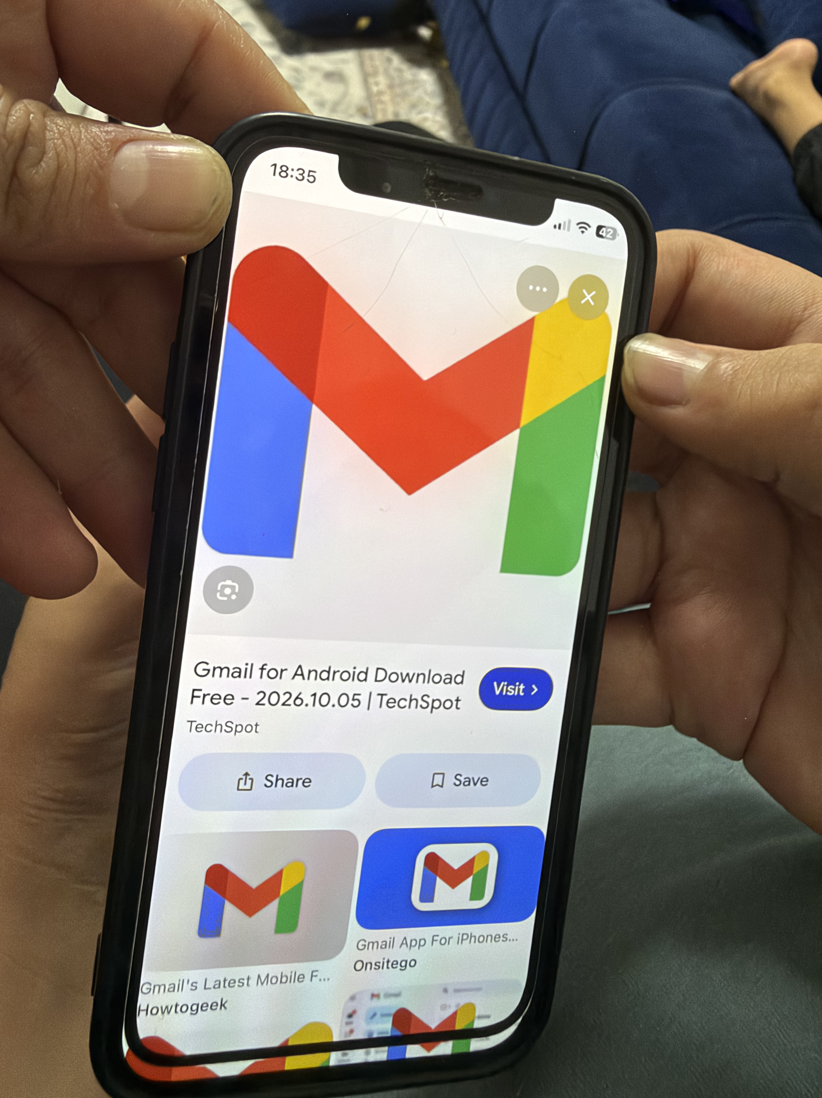

Screenshot/Photo 6
[Insert Photo/Screenshot below]

[Write what this shows of your digital life]

My Short Reflection
- Write 5–8 simple sentences about your digital life.
- You can use the sentence starters below if helpful.
- I use digital tools to study and connect with my friends
- I feel confident when I browse the internet for information
- I want to improve my skills in managing data online
- I often use these tools: laptop and educational websites
- I sometimes feel nervous about keeping my personal data secure
- Digital skills are important for me because they are useful for my future career.

Sentence starters
- I use digital tools to …
- I feel confident when I …
- I want to improve …
- I often use these tools: …
- I sometimes feel nervous about …
- I hope this module will help me …
- Digital skills are important for me because …
You can write more if you want.

Submission Checklist
Before you submit, please check:
​​​ ☐ I added 4–6 screenshots
☐ I wrote short sentences for each screenshot
☐ I wrote my short reflection
☐ My work is my own
☐ My file opens correctly
​​☐ My file opens correctly

