
LCHS4003 HEALTH AND SOCIAL CARE
COMPONENT 2

STUDENT ID: 2433268
STUDENT NAME: Haniffa Bibi

LECTURER’S NAME: Mrs Azida Zainol
DATE OF SUBMISSION: 14/11/2025

WORD COUNT: 1502

Table of Contents
Introduction 2
Section 1: Effective Communication 2
Section 2: Administrative Skills & Record Keeping 3
Section 3: Collaborative Working 5
Conclusion 6
References 7

Introduction
Mrs. Mann is a 72 years old woman who recently underwent a successful hip surgery and she was discharged by the hospital to recover. Mrs. Mann’s current condition with living situation can be explained as that she lives alone in her home, however she receives twice a day visits by a domiciliary care agency for assisting mobility.
The issue of inconsistent documentation in Mr. Mann’s records and communication breakdown increased a concern about delayed medication. This issue is currently internally under review for addressing key reasons behind it that can help to mitigate with adequate medication for Mrs. Mann.
The report showcases a purpose to explore the importance of communication, administration through accurate documentation and collaborative working for offering safety care to Mrs. Mann in her recovery time. The report will help to examine how communication, administration and collaboration skills can help care team to prevent errors in healthcare.

Section 1: Effective Communication
Communication in care
Communication shows a high importance in care as it helps to ensure that needs of patients have been met accurately to offer a healthy life. Suryanti et al., (2025, p.23) mentioned that communication in care is a necessary element to develop trust between patients and healthcare professionals by ensuring continuity of service by maintaining safety. The case study showcases that due to poor communication, the care agency provided delayed medication to Mrs. Mann that can negatively affect her by compromising safety. Moreover, good communication in a healthcare setting requires active listening and empathy that can help to ensure high-quality treatment effectively (Fisher et al., 2025, p.17). Hence, communication has a key significance for Mrs. Mann to ensure quality care delivery that can ultimately help to live a healthy life.
Barriers for Mrs. Mann
Mrs. Mann speaks a little English as her mother tongue is Urdu that creates a language barrier for her and as a result, it led to increased misunderstandings in medication. Supporting this, communication failures in 60% of US hospitals led to adverse effects of poor medication as of 2024 (The Conversation, 2025). Moreover, cultural sensitivity is another key barrier for Mrs. Mann as it influenced her beliefs on her daughter’s interpretation of the medication process that also resulted in increased misunderstandings. Equality Act 2010 denotes that healthcare professionals need to provide equal care to patients for promoting equality (Legislation, 2025). Hence, failure to understand language barriers faced by the victim can create indirect discrimination based on Equality Act 2010 and healthcare professionals need to focus on it.
Interpreters and visual ads
Mrs. Mann can be provided with visual ads like videos, pictorial guides and translated leaflets to avoid communication gaps that can help to achieve proper care by improving coordination effectively. Beside this, the daughter of Mrs. Mann should engage a professional female interpreter as it can help to ensure that information regarding medication is properly conveyed to achieve desired health outcomes positively.
Application of Berlo (1960) Model
Based on the current scenario of Mrs. Mann, Berlo’s communication model can be applied to improve communication effectiveness for better care outcomes. As denoted by Bhimani (2024, p.15), Berlo’s model helps to manage successful exchange of ideas between sender and receiver to minimise misunderstandings due to poor communication. As per this module, the care agency of Mrs. Mann is a source, while she is receiver and it is necessary to develop a bonding between these two to strengthen quality of care. Therefore, reasonable adjustments based on Berlos’ model with professional interpreters who understand Urdu can help Mrs. Mann to gain appropriate medication.
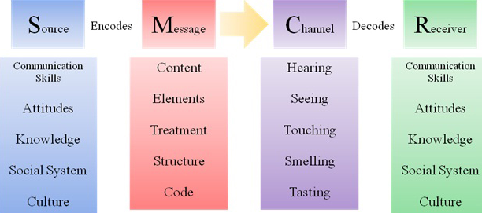
Figure 1: Berlo’s communication model
(Source: Inspired from Bhimani, 2024)

Section 2: Administrative Skills & Record Keeping
Significance of accurate documentation
Accurate documentation plays a crucial role in offering quality care of patients by focusing on patient safety through keeping medical data precisely. Goyal et al., (2024, p.2) accurate medical documentation plays a notable role in offering a person-centered care to patients by ensuring quality and continuity. In Mrs. In Mann's case, accurate documentation can be essential for accessing updated information to develop her condition by achieving excellent treatment from the care team. As per Data Protection Act 2018, it is a legal responsibility for healthcare professionals to store patients’ personal data securely (Legislation, 2025). Moreover, enabling accurate documentation for Mrs. Mann can help to maintain transparency and trust in healthcare by managing faster recovery. Yet again, inadequate record keeping can reduce trust for patients due to clinical errors that can result in serious injuries.
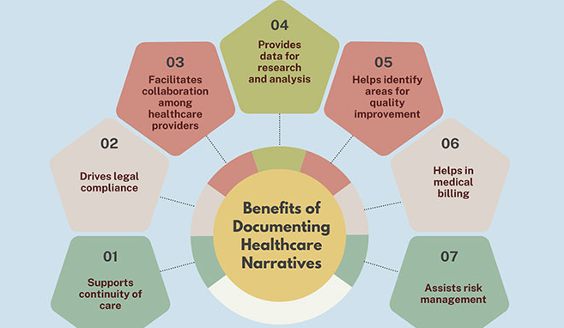
Figure 2: Benefits of accurate documentation
(Source: Inspired from Goyal et al., 2024)
Risk of poor records
As per Mrs. Mann's case, incomplete record keeping might create risks like physical harm, legal consequence, and trust loss and communication breakdown. Ernawati and Novratilova (2025) denoted that poor record keeping can cause serious consequences in healthcare such as clinical errors due to inappropriate doses of medication. It can also lead to delayed delivery that has been observed in Mrs. Mann’s care who also received delayed medication due to incomplete records. The medical staff involved in this case might face legal consequences like disciplinary action and it requires proof to ensure regulatory breaches. As per NMC code 2018, nurses must keep accurate records and it is a professional integrity for making appropriate decisions (NMC, 2024). Thus, adequate record keeping has a high significance in healthcare as it can help to make factual decisions for ensuring safety of patients.
Frameworks on record keeping
The care team must follow Caldicott principles as it states about ways followed by nurses to handle information of patients in social care. As per Caldicott principles principle, patients should be informed about how their medical information is shared and for what purpose (GOV UK, 2025). Apart from this, CQC standards in the case of Mrs. Mann also has a high significance as it helps to maintain authenticity in keeping medical records to provide high quality care. The CQC commission mandates to maintain accuracy in delivering high-quality care to patients by managing professional integrity through adequate record keeping (CQC, 2024). Yet again, failure to do that can result in a negative consequence for healthcare organisations associated with it due to regulatory breaches that lead to compromisation. Therefore, these frameworks can help Mrs. Mann to get adequate medication by managing an excellent record keeping for boosting care.

Section 3: Collaborative Working
Multi-agency collaboration
The use of multi-agency collaboration plays a crucial role in offering a safe and person-centered care to meet complex needs of patients like Mrs. Mann. Townley et al., (2025, p.3) stated that multi-agency collaboration is important for guiding healthcare professionals to enhance continuity of care by avoiding delayed medication. Focus on collaboration with care agency, family of Mrs. Mann and GP could help to prevent delayed medication to support her in medication. Thus, effective collaboration among agencies can help to manage communication gaps by faster responding to changes in Mrs. Mann’s conditions to meet medical needs effectively.
Approaches to care
Mrs. Mann’s care team might take approaches like regular communication, use of digital systems, shared care plans and family involvement to enhance medication progress. Based on regular communication, Shannon and Weaver’s model can be used to improve relationships between healthcare professionals and patients (Verma and Malik, 2024, p.6). Beside this, a shared care plan will help to get up-to-date information about Mrs. Mann’s medication to ensure positive progress. Based on Health and Care Act 2022, it is a key duty of healthcare professionals to ensure safety of patients by meeting necessary requirements (GOV UK, 2025). Hence, these approaches would be effective for Mrs. Mann to reduce delays in medication and make adequate decisions.
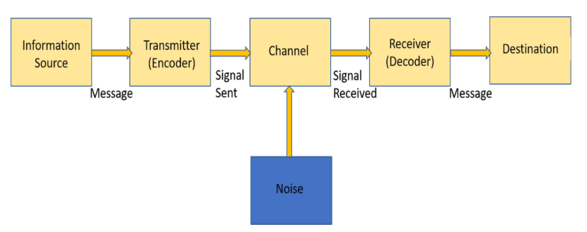
Figure 3: Shannon and Weaver’s model
(Source: Module 6 Lecture note)
Challenges and strategies
Poor communication, inadequate documentation and culture barriers can be key challenges for Mrs. Mann to get a positive care plan. Organi et al., (2024, p.6) mentioned that cultural barriers in a healthcare setting can negatively affect patients by reducing trust due to miscommunication resulting in declined health outcomes. However, the care team can use strategies like standardised record-keeping, clear communication and cultural training to overcome these challenges more effectively.

Conclusion
It can be concluded that communication based on Mrs. Mann’s case plays a notable role in offering adequate medication to ensure a stable mental health position. Management of an accurate documentation for Mrs. Mann is a key admin skill that can help to coordinate care effectively without delays. Collaboration with a care team, Mrs. Mann’s daughter, GP and physiotherapist is significant for maintaining coherence in care plans by providing prompt updates. Lessons on cultural barriers, accurate documentation, inter-professional communication and patient-centered care have been learned from Mrs. Mann’s case that can help to improve future healthcare service delivery. Apart from this, regular reviews with continuous learning would benefit Mrs. Mann to inform about changes in care for ensuring faster recovery after her coherent plans on care. Therefore, it is clear that communication, administration and collaboration are crucial elements for helping Mrs. Mann in faster recovery through supporting complete documentation.

References
Bhimani, T.S. (2024) ‘Communication Strategies for Stakeholder Management in Project Management’. International Journal of Applied Business and Management Studies, 9(2), pp.13-23. Available at: https://www.ijabms.com/wp-content/uploads/2024/12/02_Bhimani_PB.pdf
CQC (2024) CQC standards. Available at: https://www.cqc.org.uk/about-us/fundamental-standards (Accessed: 3 November 2025).
Ernawati, E. and Novratilova, S. (2025) ‘Analysis of risk factors for incomplete inpatient medical records using the fishbone method’. Science Midwifery, 13(1), pp.111-118. Available at: https://midwifery.iocspublisher.org/index.php/midwifery/article/download/1861/1408
Fisher, E., Chick, I., Fossey, J. and Spector, A. (2025) ‘Barriers and facilitators to implementing cognitive stimulation and reminiscence therapy for dementia in care homes: systematic review’. International Journal of Geriatric Psychiatry, 40(7), p.e70124.Available at: https://onlinelibrary.wiley.com/doi/pdf/10.1002/gps.70124
GOV UK (2025) Health and Care Act 2022. Available at: https://www.legislation.gov.uk/id/ukpga/2022/31 (Accessed: 3 November 2025).
GOV UK (2025) The Caldicott Principles. Available at: https://www.gov.uk/government/publications/the-caldicott-principles (Accessed: 3 November 2025).
Goyal, S., Rastogi, E., Rajagopal, S.P., Yuan, D., Zhao, F., Chintagunta, J., Naik, G. and Ward, J. (2024) ‘Healai: A healthcare llm for effective medical documentation’. In Proceedings of the 17th ACM International Conference on Web Search and Data Mining (pp. 1167-1168). Available at: https://openreview.net/pdf?id=7canGHSDQ2
Legislation (2025) Data Protection Act 2018. Available at: https://www.legislation.gov.uk/ukpga/2018/12/contents (Accessed: 4 November 2025).
Legislation (2025) Equality Act 2010. Available at: https://www.legislation.gov.uk/ukpga/2010/15/contents (Accessed: 4 November 2025).
NMC (2024) The Code: Professional standards of practice. Available at: https://www.nmc.org.uk/standards/code/ (Accessed: 3 November 2025).
Organi, Z.K., Nazarenia, M. and Aghaee, F. (2024) ‘Understanding the challenges of language barriers in healthcare’. Interdisciplinary Studies in Society, Law, and Politics, 3(3), pp.28-35. Available at: http://193.36.85.187:8089/index.php/isslp/article/view/56
Suryanti, P., Perdana, M.H.G., Ati, H.D.L., Akbar, M.F., Anum, A. and Miranda, Z. (2025) ‘Overcoming Loneliness in Old Age: The Use of Communication Technology in Nursing Homes’. Devotion: Journal Corner of Community Service, 3(4), pp.97-103. Available at: https://doi.org/10.54012/devotion.v3i4.530
The Conversation (2025) One in ten patient safety incidents. Available at: https://theconversation.com/one-in-ten-patient-safety-incidents-in-hospitals-due-to-poor-communication-our-new-study-252467 (Accessed: 4 November 2025).
Townley, C., Grace, R. and Keidar, T. (2025) ‘Uncharted territory: The experiences of health and social care practitioners in a multi-agency collaboration to support integrated service provision for children and young people in a disadvantaged community’. Health Policy, p.105299. Available at: https://doi.org/10.1016/j.healthpol.2025.105299
Verma, K. and Malik, P. (2024) ‘The Sadharanikaran Model of Communication within the Indigenous Knowledge System: An Appraisa’. Bodhi': An Interdisciplinary Journal, 10(4), pp.49-64. Available at: https://nepjol.info/index.php/BOHDI/article/view/80186/61387

